5E-14.147 Notice of Pesticide Application.
(1) In accordance with Section 482.2265(2), F.S., a notice shall be posted in a conspicuous location at the time of application of a pesticide to a lawn or to exterior foliage. The following example represents the required physical makeup of the notice.
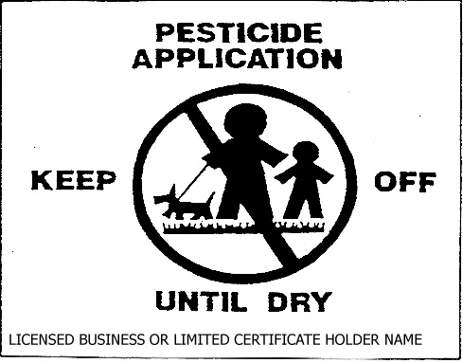
(2) In addition to the example of notice the following requirements shall apply:
(a) Minimum size 4''  5''.
(b) Constructed of rigid durable weatherproof material.
(c) Background and lettering shall be of contrasting color.
(d) The size of print and symbol shall be in conformity with the example.
(e) The business name of the licensee making the pesticide application shall be clearly set forth on the notice.
(f) The notice may be made part of a larger sign containing additional information.
Rulemaking Authority 482.051, 482.2265(2) FS. Law Implemented 482.2265(2) FS., Section 1, Chapter 92-203, Laws of Florida. History–New 10-25-90, Formerly 10D-55.147, Amended 8-11-93.

