5H-22.004 Adoption of Logo Emblem and Directional Sign.
The logo emblem and directional sign depicted below are hereby designated and adopted as the Florida Farm Winery logo emblem and directional sign.
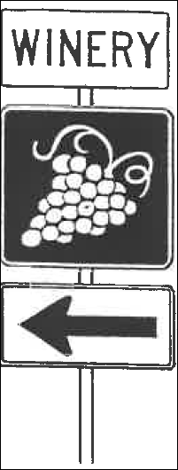
Rulemaking Authority 599.004 FS. (1992), as created by Section 30, Chapter 92-151, Laws of Florida. Law Implemented 599.004(2)(a) FS. (1992), as created by Section 30, Chapter 92-151, Laws of Florida. History–New 10-13-92.

