Notice of Proposed Rule
FISH AND WILDLIFE CONSERVATION COMMISSION
Manatees
RULE NO.: RULE TITLE:
68C-22.012: Volusia and Associated County (Parts of Putnam, Lake, Seminole and Flagler) Zones
68C-22.028: Flagler County Zones
PURPOSE AND EFFECT: The purpose of the proposed rule making action is to improve protection of manatees and manatee habitat in Flagler County by limiting allowable motorboat speed in portions of the county. (This action would also amend the rule for Volusia County to remove from this rule existing boat speed zones in Flagler County.) These actions are being proposed after considering recommendations made by the Flagler County Local Rule Review Committee that was formed pursuant to Section 379.2431(2)(f), F.S. The effect of the action would be to limit allowable motorboat speed in portions of the county during the warm season, including 2.7 linear miles of Slow Speed on the Intracoastal Waterway (ICW). The warm season would be defined as May through September 7 (to include Labor Day). Adoption of the proposed rule would add about 15 minutes to the time it currently requires to transit the county in the ICW during the warm season, with no change during the rest of the year. Additional information is available at: http://myfwc.com/wildlifehabitats/managed/manatee/rulemaking/.
SUMMARY: The proposed action would: [1] remove the existing zones in the extreme southern end of Flagler County that are a part of the rule for Volusia County; and [2] establish new zones in this area and other portions of Flagler County that would be in effect only from May 1 through September 7. The proposed zones would include 2.7 linear miles of Slow Speed zones on the ICW. Zones would be established in the vicinity of the Hammock Dunes Parkway Bridge, in the general area between Silver Lake and the State Road 100 (Moody Blvd) Bridge (including Lehigh Canal), and in the southernmost roughly 2.1 miles of Flagler County.
SUMMARY OF STATEMENT OF ESTIMATED REGULATORY COSTS AND LEGISLATIVE RATIFICATION: A Statement of Estimated Regulatory Costs (SERC) has not yet been prepared by the agency. Any person who wishes to provide information regarding the statement of estimated regulatory costs, or to provide a proposal for a lower cost regulatory alternative must do so in writing within 21 days of this notice. The agency has determined that the proposed rule is not expected to require legislative ratification based on the nature of the rule and the preliminary information and analysis conducted to date.
RULEMAKING AUTHORITY: 379.2431(2) FS.
LAW IMPLEMENTED: 379.2431(2) FS.
A HEARING WILL BE HELD BY COMMISSION STAFF AT THE DATE, TIME AND PLACE SHOWN BELOW:
DATE AND TIME: February 29, 2012, 6:00 p.m.
PLACE: Flagler County Board Chambers, 1769 E. Moody Blvd., Bldg 2, Bunnell, FL 32110
THE FINAL PUBLIC HEARING WILL BE HELD BY THE COMMISSION AT THE DATE, TIME AND PLACE SHOWN BELOW:
DATES AND TIME: April 25-26, 2012, 8:30 a.m. – 5:00 p.m.
PLACE: Plantation Golf Resort and Spa, 9301 West Fort Island Trail, Crystal River, FL 34429
Another notice will be published in the F.A.W. if the date or location of the final hearing changes. The Commission’s agenda for this meeting will indicate the specific day when this item is scheduled to be addressed.
Pursuant to the provisions of the Americans with Disabilities Act, any person requiring special accommodations to participate in either of these hearings is asked to advise the agency at least 5 days before the hearing by contacting the FWC at (850)488-6411. If you are hearing or speech impaired, please contact the agency using the Florida Relay Service, 1(800)955-8771 (TDD) or 1(800)955-8770 (Voice).
THE PERSON TO BE CONTACTED REGARDING THE PROPOSED RULE IS: Mr. Chris Boland, Florida Fish and Wildlife Conservation Commission, Imperiled Species Management Section, 620 South Meridian Street, Tallahassee, Florida 32399-1600. Comments may be submitted by e-mail to ManateeRuleComments@MyFWC.com (please reference Flagler County in the subject line).

THE FULL TEXT OF THE PROPOSED RULE IS:
68C-22.012 Volusia County and Associated County (Parts of Putnam, Lake, and Seminole and Flagler) Zones.
(1) The Commission designates those portions of the St. Johns River basin and the Halifax/Indian River and Tomoka River basin within Volusia and adjacent counties, as described below, as areas where manatees are frequently sighted. The Commission has further determined that they are assumed to inhabit these waters periodically or continuously. This rule is for the purpose of regulating the speed and operation of motorboats in portions of these designated areas in Volusia County as well as in counties adjacent to Volusia County in portions of the St. Johns River basin and in portions of the Halifax/Indian River and Tomoka River basin. In addition to Volusia County, waters within the following counties are regulated within the provisions of this rule: Putnam, Lake, and Seminole (St. Johns River basin); and Flagler (Halifax River). In balancing the rights of fishermen, boaters, and waterskiers to use these waterways for recreational and commercial purposes (as applicable under Section 379.2431(2)(k) Section 370.12(2)(j), F.S.) with the need to provide manatee protection, the Commission has examined the need for higher speed travel corridors through regulated areas. Such corridors are provided in those areas where the Commission determined, on the basis of all available information, (1) there is a need for the corridor and (2) the corridor will not result in serious threats to manatees or their habitat (as defined in Rule 68C-22.001, F.A.C.). Higher speed corridors are not provided in areas where both of the above findings were not made.
(2) No change.
(3) For the purpose of regulating the speed and operation of motorboats within portions of the Halifax River, Indian River basin and Tomoka River zones are established as follows:
(a) SLOW SPEED ZONE (Year-round) – The following described zones shall include all navigable waters and all associated and navigable tributaries, lakes, creeks, coves, bends, backwaters, canals, mosquito ditches, and boat basins, unless otherwise designated or excluded:
1. Halifax River, Halifax Creek and Smith Creek Area: All waters of Smith Creek, Halifax Creek, and the Halifax River, excluding the main marked channel of the Atlantic Intracoastal Waterway (designated for regulation under paragraph (3)(d)1., below), southerly of the Flagler County/Volusia County line a line which bears North 67° 00' 00" East (True) located 2000 feet South 29° 00' 00" East (True) of Red Intracoastal Waterway Channel Marker “22” (latitude 29° 26' 28" North, longitude 81° 06' 58" West), northerly of a line which bears North 72° 00' 00" East (True) running through Green Intracoastal Waterway Channel Marker “9” (latitude 29° 19' 54" North, longitude 81° 04' 06" West) and easterly of the general contour of the easterly shoreline of the islands lying westerly of the Intracoastal Waterway Channel between the general contour of the shoreline of the southernmost tip of a peninsula (approximate latitude 29° 22' 28" North, approximate longitude 81° 05' 12" West) and a point which lies 600 feet South 72° 00' 00" West (True) from the aforementioned Green Intracoastal Waterway Channel Marker “9”;
2. Area westerly of Smith Creek: All waters within the backwater area lying southwesterly of a line which bears approximately North 30° 00' 00" West (True) from the general contour of the shoreline at the northernmost tip of an island (approximate latitude 29° 25' 56" North, approximate longitude 81° 06' 40" West) to the general contour of the shoreline of the westerly bank of Smith Creek and southwesterly of a line which bears approximately South 15° 00' 00" East (True) from the general contour of the shoreline at the southeastern tip of an the aforementioned island (approximate latitude 29° 25' 32" North, approximate longitude 81° 06' 29" West) to the general contour of the shoreline of the westerly bank of Smith Creek, near Green Intracoastal Waterway Channel Marker “23” and southerly of the Flagler County/Volusia County line;
3. through 25. No change.
(b) through (c) No change.
(d) MAXIMUM 30 MPH/25 MPH NIGHTTIME ZONE (Year-round) – Waters of the Halifax River, Indian River, and Tomoka River basin as follows:
1. Halifax Creek/Halifax River Area: All waters within the main marked channel of the Atlantic Intracoastal Waterway southerly of the Flagler County/Volusia County line a line which bears North 67° 00' 00" East (True) located 2000 feet South 29° 00' 00" East (True) of Red Intracoastal Waterway Channel Marker “22” (latitude 29° 26' 28" North, longitude 81° 06' 58" West) and northerly of a line which bears North 72° 00' 00" East (True) running through Green Intracoastal Waterway Channel Marker “9” (latitude 29° 19' 54" North, longitude 81° 04' 06" West);
2. through 7. No change.
(e) and (f) No change.
(4) through (6) No change.
(7) Maps depicting the zones described in this rule are available on the agency’s website at http://myfwc.com. The maps are intended only as visual aids and do not have regulatory effect; therefore, in the event of conflict between the maps and the descriptions of the zones provided by this rule, the rule text shall prevail. The zones described in Rule 68C-22.012(1), (2), and (3), are depicted on the following maps, labelled "Manatee Protection Zones – St. Johns River Basin, Volusia and Associated Counties,” dated May 1994, and “Manatee Protection Zones – Halifax and Indian River Areas, Volusia and Associated Counties,” dated May 1994, which shall replace the previously published maps. (Maps provided are intended as depictions of the abovedescribed zones. In the event of conflict between the two, the above descriptions shall prevail.)
Rulemaking Authority 379.2431(2) FS. Law Implemented 379.2431(2) FS. History–New 3-19-79, Formerly 16N-22.12, Amended 12-5-89, 7-25-91, 6-23-94, Formerly 16N-22.012, Amended 5-31-95, Formerly 62N-22.012, Amended__________.

68C-22.028 Flagler County Zones.
(1)(a) The Commission hereby designates the waters within Flagler County, as described below, as areas where manatee sightings are frequent and where the best available information supports the conclusion that manatees inhabit these areas on a regular or periodic basis. The primary purpose of this rule is to protect manatees from harmful collisions with motorboats and from harassment by regulating the speed and operation of motorboats within these designated areas. A secondary purpose is to protect manatee habitat.
(b) In consideration of balancing the rights of fishers, boaters, and water skiers to use the waters of the state for recreational and commercial purposes (as applicable under Section 379.2431(k), F.S.), with the need to provide manatee protection, the Commission has examined the need for limited lanes, corridors, or unregulated areas that allow higher speeds through or within regulated areas. Such lanes, corridors, or areas are provided in those locations where the Commission determined they are consistent with manatee protection needs.
(2) The following zones are established, which include all associated and navigable tributaries, lakes, creeks, coves, bends, backwaters, canals, channels and boat basins, and other waterways unless specifically excluded or otherwise designated for more restrictive regulation. As used in this rule, ICW means the Intracoastal Waterway Coordinates used in the descriptions of zone boundaries are referenced to the North American Datum of 1983 (NAD83).
(a) SLOW SPEED (May 1 – September 7)
1. Hammock Dunes Parkway Area – All waters, including in the ICW channel, south of a line that bears 70° from a point (approximate latitude 29° 34’ 49” North, approximate longitude 81° 11’ 34” West) on the western shoreline of the ICW approximately 2,700 feet north of the Hammock Dunes Parkway Bridge, north of a line that bears 70° from a point (approximate latitude 29° 34’ 21” North, approximate longitude 81° 11’ 21” West) on the western shoreline of the ICW approximately 300 feet south of the Hammock Dunes Parkway Bridge, and east of the Palm Harbor Parkway Bridge;
2. Lehigh Canal Area – All waters of Lehigh Canal; and those waters east of the ICW channel south of Red ICW Channel Marker “6” (approximate latitude 29° 30’ 50” North, approximate longitude 81° 09’ 00” West) and north of a line that bears 70° from a point (approximate latitude 29° 29’ 36” North, approximate longitude 81° 08’ 32” West) on the western shoreline of the ICW approximately 1,800 feet south of Lehigh Canal, including all waters of the waterbody east of the ICW in the vicinity of Green ICW Channel Marker “13”;
3. State Road 100 Area – All waters, including in the ICW channel, south of a line that bears 70° from a point (approximate latitude 29° 29’ 36” North, approximate longitude 81° 08’ 32” West) on the western shoreline of the ICW approximately 1,800 feet south of Lehigh Canal and north of a line that bears 70° from a point (approximate latitude 29° 28’ 34” North, approximate longitude 81° 08’ 12” West) on the western shoreline of the ICW approximately 500 feet south of the SR 100 (Moody Blvd) Bridge; and,
4. Vicinity of Gamble Rogers State Recreation Area – All waters, including in the ICW channel except as otherwise designated in (2)(b) below, south of a line that bears 70° through Red ICW Channel Marker “20” (approximate latitude 29° 27’ 08” North, approximate longitude 81° 07’ 37” West) and north of the Flagler County/Volusia County line.
(b) MAXIMUM 25 MPH (May 1 – September 7) – Those waters in the marked ICW channel south of a line that bears 70° from a point (approximate latitude 29° 26’ 36” North, approximate longitude 81° 07’ 03” West) on the western shoreline of the ICW approximately 900 feet north of Red ICW Channel Marker “22” and north of the Flagler County/Volusia County line.
(3) Maps depicting the zones described in this rule are available on the agency’s website at http://myfwc.com. The maps are intended only as visual aids and do not have regulatory effect; therefore, in the event of conflict between the maps and the descriptions of the zones provided by this rule, the rule text shall prevail.

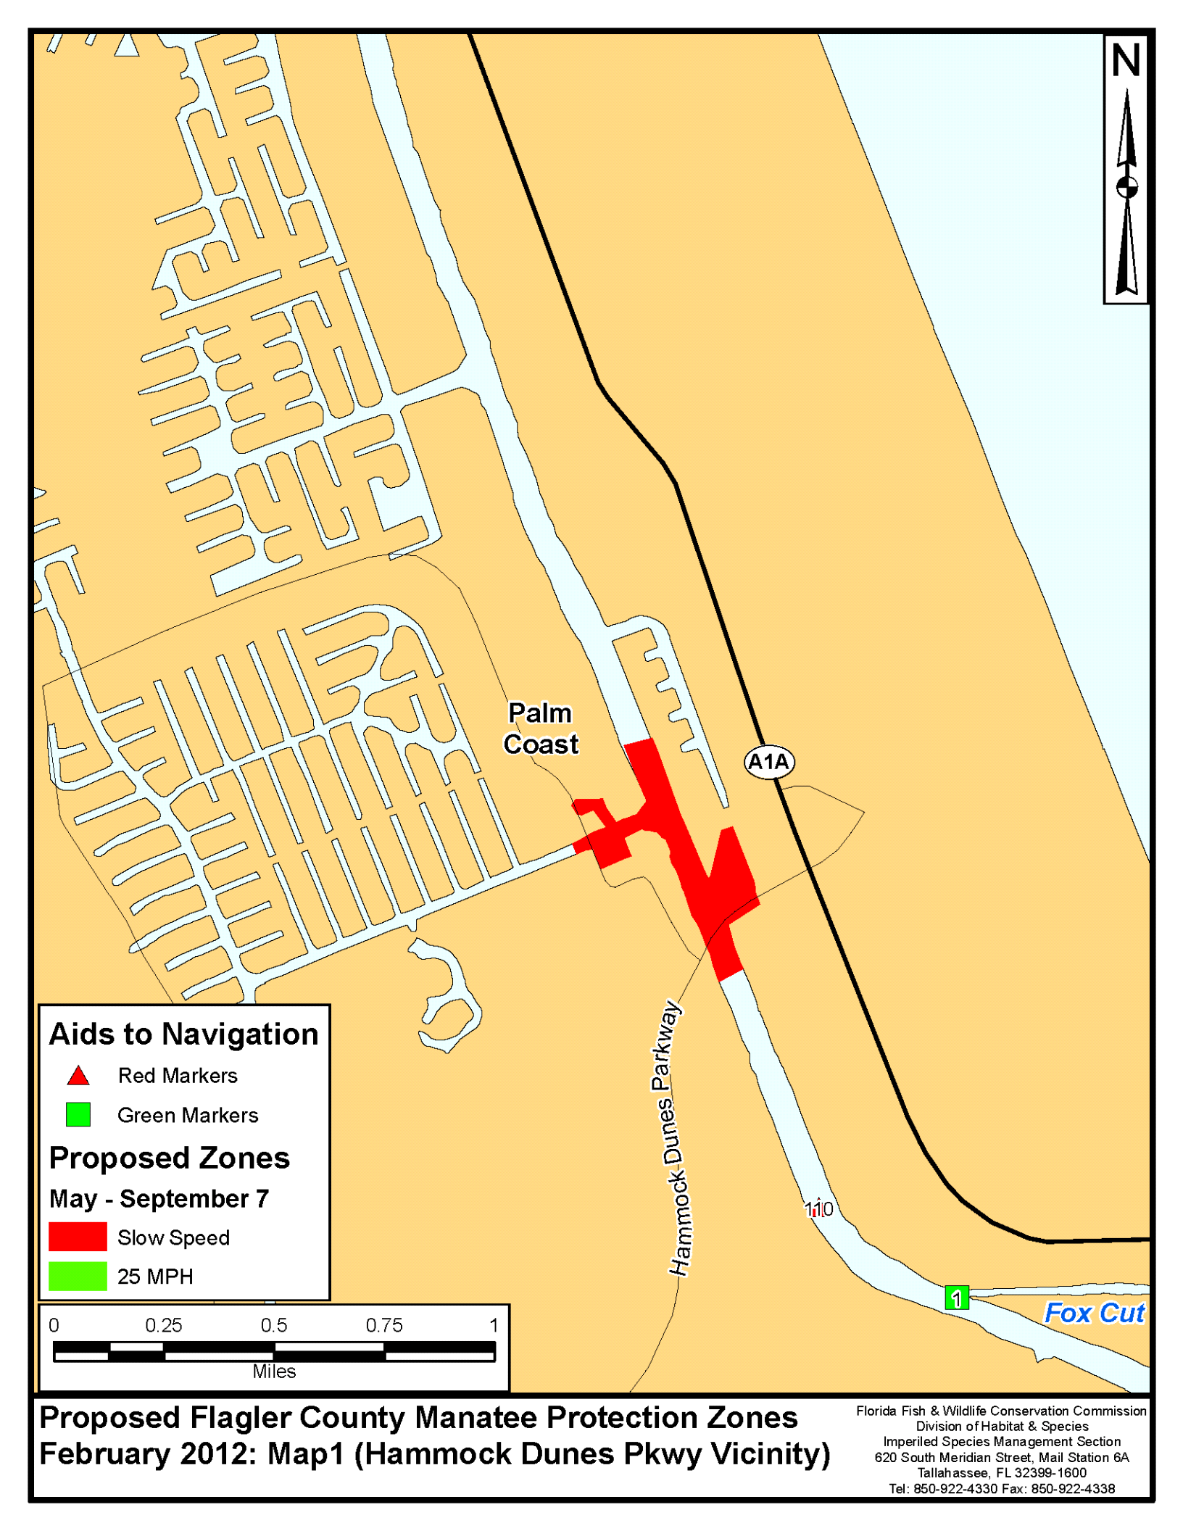

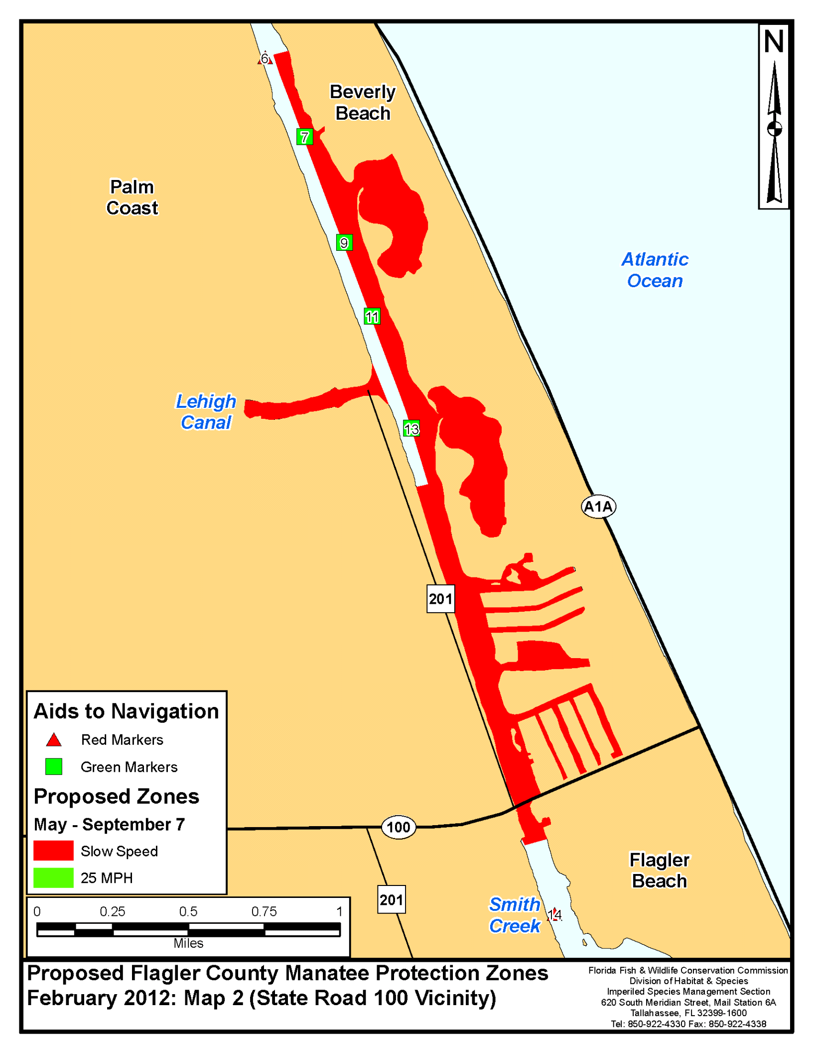

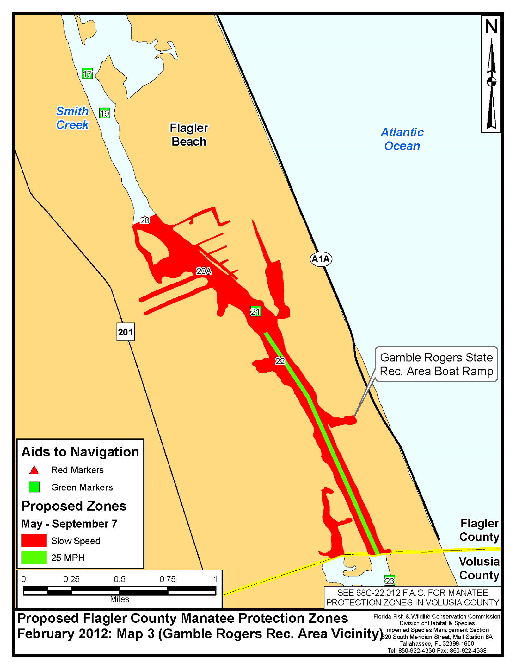

Rulemaking Authority 379.2431(2) FS. Law Implemented 379.2431(2) FS. History–New________.

NAME OF PERSON ORIGINATING PROPOSED RULE: Mr. Eric Sutton, Director of the Division of Habitat and Species Conservation
NAME OF AGENCY HEAD WHO APPROVED THE PROPOSED RULE: Commissioners of the Florida Fish and Wildlife Conservation Commission
DATE PROPOSED RULE APPROVED BY AGENCY HEAD: November 17, 2011
DATE NOTICE OF PROPOSED RULE DEVELOPMENT PUBLISHED IN FAW: February 4, 2011

