Notice of Development of Rulemaking

WATER MANAGEMENT DISTRICTS
South Florida Water Management District
RULE NO.: RULE TITLE:
40E-2.010: Review of Consumptive Use Permit Applications
40E-2.011: Policy and Purpose
40E-2.031: Implementation
40E-2.041: Permits Required
40E-2.091: Publications Incorporated by Reference
40E-2.101: Content of Application
40E-2.331: Modification of Permits
40E-2.341: Revocation of Permits
40E-2.381: Limiting Conditions
40E-2.451: Emergency Authorization
40E-2.501: Permit Classification
PURPOSE AND EFFECT: To update the District’s rules to ensure that its rules are correct and comply with statutory requirements, in accordance with Section 120.74, F.S. Specifically, the amendments: 1) update references to repealed rules; 2) update titles of referenced rule chapters; 3) correct typographical errors; 4) update delegation pursuant to Sections 373.079(4) and 373.083(5), F.S.; 5) update rules to incorporate forms in accordance with Section 120.55(1)(a)4. and 5., F.S.; and 6) add ePermitting option to be consistent with other rules.
In addition, the amendments update the “Basis of Review for Water Use Permit Applications within the South Florida Water Management District,” incorporated by reference in Rule 40E-2.091, F.A.C., as follows: 1) update references to repealed rules; 2) update delegation pursuant to Sections 373.079(4) and (5), F.S.; 3) clarify types of permits; 4) correct typographical errors; 5) delete sections regarding basin expiration dates; 6) update rules to reflect compliance reports should be submitted every 10 years rather than 5, in accordance with Section 373.236(3), F.S.; 7) change definition of “Xeriscape” to "Florida Friendly Landscaping" pursuant to Section 373.185, F.S.; 8) update name of map; 9) move Figure 3-4 and re-label Figures 3-5 and 3-6; 10) update rules to incorporate forms in accordance with Section 120.55(1)(a)4. and 5., F.S.; 11) add e-Permitting option to be consistent with other rules; and 12) delete outdated contact information.
SUBJECT AREA TO BE ADDRESSED: Consumptive/Water Use permitting.
RULEMAKING AUTHORITY: 120.54(5), 120.60, 373.044, 373.113, 373.118, 373.171, FS.
LAW IMPLEMENTED: 120.54(5), 120.60, 373.042, 373.0421, 373.079, 373.083, 373.103(1), 373.109, 373.196, 373.203, 373.216, 373.219, 373.223, 373.224, 373.226, 373.229, 373.232. 373.233, 373.236, 373.239, 373.244, 373.246, 373.249, 373.250, FS.
IF REQUESTED IN WRITING AND NOT DEEMED UNNECESSARY BY THE AGENCY HEAD, A RULE DEVELOPMENT WORKSHOP WILL BE NOTICED IN THE NEXT AVAILABLE FLORIDA ADMINISTRATIVE WEEKLY.
Pursuant to the provisions of the Americans with Disabilities Act, any person requiring special accommodations to participate in this workshop/meeting is asked to advise the agency at least 5 hours before the workshop/meeting by contacting: South Florida Water Management District Clerk, 3301 Gun Club Road, West Palm Beach, FL 33406, 1(800)432-2045, ext. 2087 or (561)682-2087. If you are hearing or speech impaired, please contact the agency using the Florida Relay Service, 1(800)955-8771 (TDD) or 1(800)955-8770 (Voice).
THE PERSON TO BE CONTACTED REGARDING THE PROPOSED RULE DEVELOPMENT AND A COPY OF THE PRELIMINARY DRAFT IS: Paulette Glebocki, Lead, Hydrogeologist, South Florida Water Management District, 3301 Gun Club Road, West Palm Beach, FL 33406, pglebock@sfwmd.gov, 1(800)432-2045, ext. 6941, or (561)682-6941. For procedural questions contact Jan Sluth, Senior Paralegal, South Florida Water Management District, 3301 Gun Club Road, West Palm Beach, FL 33406, jsluth@sfwmd.gov, 1(800)432-2045, ext. 6299, or (561)682-6299
THE PRELIMINARY TEXT OF THE PROPOSED RULE DEVELOPMENT IS:
40E-2.010 Review of Consumptive Use Permit Applications.
Consumptive use permit applications are processed pursuant to Section 120.60, Florida Statutes and, Part VI of Chapters 40E-1 and 28-106 28-107, F.A.C.
Rulemaking Specific Authority 120.54(5), 120.60 FS. Law Implemented 120.54(5), 120.60 FS. History–New 7-2-98, Amended ________.
40E-2.011 Policy and Purpose.
(1) through (2) No change.
(3) Additional rules relating to water use are found in Chapter 40E-5, F.A.C., (Artificial Recharge), Chapter 40E-8, F.A.C., (Minimum Flows and Levels (MFLs)), Chapter 40E-10, F.A.C., (Water Reservations), Chapters 40E-20, F.A.C., (General Water Use Permits), 40E-21, F.A.C., (The Water Shortage Plan), 40E-22, F.A.C., (Regional Water Shortage Plans) and 40E-24 (Mandatory Year-Round Landscape Irrigation Conservation Measures) 40E-23, F.A.C., Water Resource Caution Areas).
(4) Standards for the construction, repair and abandonment of water wells are found in Chapters 40E-3, F.A.C. (Water Wells) and 40E-30 (General Permits for Water Wells), F.A.C.
Rulemaking Authority 373.044, 373.113, 373.171 FS. Law Implemented 373.103(1), 373.203, 373.216, 373.249 FS. History– New 9-3-81, Formerly 16K-2.01, Amended 7-4-82, 2-24-85, 11-18-91, 8-1-02, 8-31-03, 7-2-09,_________.
40E-2.031 Implementation.
(1) The effective dates for the water use permitting program established in this chapter are:
(a) If the use or withdrawal of water exceeds 100,000 gallons per day, the effective dates are:
1. January 12, 1977, for the portion of the District formerly within the Ridge and Lower Gulf Coast Water Management District,
2. March 2, 1974, for the remainder of the District;
(b) If the use or withdrawal of water does not exceed 100,000 gallons per day, the effective date is January 14, 1979.
(2) The effective dates specified in subsection (1) are used to determine the two year period provided in Section 373.236, F.S. 373.266, Florida Statutes, for existing water users to file initial applications.
Rulemaking Specific Authority 373.044, 373.113 FS. Law Implemented 373.103(1), 373.216, 373.226 FS. History–New 9-3-81, Formerly 16K-2.011, Amended________.
40E-2.041 Permits Required.
(1) through (2) No change.
(3) Under certain circumstances the District Board or the Executive Director may issue a temporary water use permit pursuant to Rule 40E-2.441, F.A.C., and Section 373.244, Florida Statutes.
Rulemaking Specific Authority 373.044, 373.113 FS. Law Implemented 373.079, 373.083, 373.103(1), 373.219, 373.244 FS. History–New 9-3-81, Formerly 16K-2.03(1), (2), Amended________.
40E-2.091 Publications Incorporated by Reference.
The “Basis of Review for Water Use Permit Applications within the South Florida Water Management District – ______ March 18, 2010,” (hyperlink), is incorporated by reference herein, and incorporates the following forms: is hereby published by reference and incorporated into this chapter. A current version of this document is available upon request.
(1) Form 0188-QMQ, Quarterly Report of Withdrawals, ___(date)____, ___(hyperlink)___(referenced in Section 4.1);
(2) Form 0188-QASR, Quarterly Report of Injections and Withdrawals for Aquifer Storage and Recovery (ASR) Wells, ___(date)____, ___(hyperlink)___(referenced in Section 4.1);
(3) Form 0188-QMON, Quarterly Report of Monitoring Requirements, ___(date)____, ___(hyperlink)___(referenced in Section 4.2);
(4) Form 0188-QMQF, Quarterly Report of Withdrawals from Wells and Surface Water Pumps, ___(date)____, ___(hyperlink)___(referenced in Section 4.1);
(5) Form 0188-QCROP, Report of Planting and Harvest of Seasonal Crops, ___(date)____, ___(hyperlink)___(referenced in Section 5.2.3);
(6) Form 0188-QBWDR, Quarterly Report of Bulk Water Delivered and Received, ___(date)____, ___(hyperlink)___(referenced in Section 4.1).
The “Basis of Review for Water Use Permit Applications within the South Florida Water Management District” and forms incorporated therein are available at no cost by contacting the South Florida Water Management District Clerk’s Office, 3301 Gun Club Road, West Palm Beach, FL 33406, 1(800)432-2045, ext. 6436 or (561)682-6436.
Rulemaking Authority 373.044, 373.113, 373.118, 373.171 FS. Law Implemented 373.042, 373.0421, 373.109, 373.196, 373.219, 373.223, 373.224, 373.229, 373.232, 373.233, 373.236, 373.239, 373.250 FS. History–New 9-3-81, Formerly 16K-2.035(1), Amended 2-24-85, 11-21-89, 1-4-93, 4-20-94, 11-26-95, 7-11-96, 4-9-97, 12-10-97, 9-10-01, 12-19-01, 8-1-02, 6-9-03, 8-31-03, 4-23-07, 9-13-07, 2-13-08, 10-14-08, 7-2-09, 3-15-10, 3-18-10,________.
1.1 Objectives
Chapter 373, Florida Statutes (F.S.), enables and directs the District to regulate the use of water within its jurisdictional boundaries. The purpose of the water use regulatory program is to ensure that those water uses permitted by the District are reasonable-beneficial, will not interfere with any presently existing legal uses of water, and are consistent with the public interest pursuant to Section 373.223, F.S. The District has adopted rules for regulating the consumptive use of water, which are set forth in Chapters 40E-2 and 40E-20, Florida Administrative Code. The Basis of Review is incorporated by reference into Chapter 40E-2. The Basis of Review must be read in conjunction with Chapters 40E-2 and 40E-20, as applicable. The objective of the Basis of Review is to further specify the general procedures and information used by District staff for review of water use permit applications. All criteria in the Basis of Review applies to processing individual permit applications, and specified criteria applies to processing of general permit notices of intent. The criteria contained herein are flexible, with the primary goal being to meet District water resource objectives.
In addition, procedures for processing water use permit applications are set forth in Chapters 40E-0 and 40E-1, F.A.C. Rules 40E-1.603 and 40E-1.606. Rule 40E-1.610 provides procedures for permit renewals and Rule 40E-1.6107 sets forth procedures for permit transfers.
1.3.1 Third Party Interests
Frequently, other governmental entities, organizations, or affected citizens have an interest in the outcome of a permit action. Third party interests that would be substantially affected by issuance of a requested permit will have the opportunity to request an administrative hearing, pursuant to Sections 120.569 and 120.57(1), F.S. Rule 40E-1.521, prior to issuance of the permit. In order to obviate any delays in permit issuance, discussions with such entities regarding their water resource concerns prior to or during permit application review is encouraged. Issuance of a water use permit by the District does not relieve the Applicant of the responsibility to obtain all necessary federal, state, local, or other District permits or authorizations.
1.3.2.1 Competition within the Central Florida Coordination Area (CFCA)
In adopting the interim CFCA rules, the District acknowledges the increasing stress on the water resources in the CFCA and the mandate of the Legislature to foster the development of additional water supplies and avoid the adverse effects of competition. However, the interim CFCA rules do not abrogate the rights of the District Governing Board or of any other person or entity under Section 373.233, F.S., Competing Applications. The CFCA regulatory framework provides a comprehensive strategy for interim allocations of available groundwater and expeditious development of supplemental water supply projects, as defined in Section 1.8, to minimize competition and thereby provide greater certainty of outcome than competition.
1.6 Professional Certification of Supporting Documents
All final plans, calculations, analyses, or other geologic/engineering documents, submitted as part of a permit application are required to be signed and sealed by an appropriate registered professional pursuant to Section 373.117, 373.1175, or Chapter 492, F.S., as appropriate.
1.7 Application Review Process
The District has established two categories procedures for issuing permits based on the quantity of water permitted: individual and standard general. These two procedures include permit issuance by (1) the Governing Board for individual permits and (2) District staff for general permits General permits include: (1) (minor standard general permits for uses of 3 million gallons per month or less;, (2) major standard general permits for uses greater than 3 million gallons per month up to 15 million gallons per month;, and (3) dewatering general permits). Individual permits must be obtained for water use activities that are not exempt pursuant to Rule 40E-2.051, F.A.C., and do not fall within the thresholds for general permits established in Rule 40E-20.302, F.A.C.
The permit application will be processed pursuant to Chapters 40E-0 and 40E-1 Rule 40E-1.603, F.A.C., for individual and general permits. These rules set forth procedures for filing applications, requests for additional information, permit application modification, public noticing of permit applications, and requests for administrative hearings.
(Remainder of section remains unchanged)
1.7.2.2 Special Duration Factors
A. 1. through 3. No change.
4. For irrigation uses permit applications filed before the applicable Basin Application Date in Section 1.7.3, the permit duration will be limited to the Basin Expiration Date;
5. through 8. renumbered 4 through 7. No change.
B.1. No change.
2. Lower East Coast Regional Water Supply Planning Area: Biscayne/Surficial Aquifer System to the extent that withdrawals result in induced seepage from the Central and Southern Florida Project, except when stormwater discharge or wet season discharge occurs; Lake Okeeechobee; Central and Southern Florida Project; the Caloosahatchee River/Canal; and the Saint Lucie River/Canal.
3. and 4. No change.
C. through E. No change.
1.7.2.3 Compliance Reports
A. Where necessary to maintain reasonable assurance that the conditions for issuance of a permit can continue to be met over the duration of a 20 year permit, the District shall require the permittee to submit a compliance report pursuant to subsection 373.236(3), F.S., no more than once every ten five years. The permit shall be conditioned to assure compliance with the initial conditions for issuance, including implementation of schedules for Water Need and Demand Methodologies under Section 2.0, maintaining updated water conservation and efficiency requirements, and updated allocation methodologies, pursuant to District rules.
The compliance report shall contain sufficient information to maintain reasonable assurance that the permittee's use of water will continue to meet Chapters 40E-2 and 40E-20, F.A.C., as applicable, for the remaining duration of the permit. The compliance report shall, at a minimum, include all of the information specifically required by the permit limiting conditions.
B. No change.
C. No change.
1.7.3 Basin Expiration Dates
1.7.3.1 Definitions
A. Irrigation Permit Expiration Basin - Geographic area where Individual and major Standard General Water Use Permits for the irrigation use class have a specified Irrigation Basin Expiration Date.
B. Basin Application Date -The date, specified below in Section 1.7.3.3, after which complete applications for Individual and major Standard General Water Use Permits for the irrigation use class shall be reviewed under newly adopted rules.
C. Basin Expiration Date - The date of expiration, specified below in Section 1.7.3.3, of Individual and major Standard General Water Use Permits for the irrigation use class located in the specified Irrigation Permit Expiration Basin.
1.7.3.2 Policy and Purpose
This Section addresses application and expiration procedures associated with Individual and major Standard General Water Use Permits for the irrigation use class during the transition from the use of Basin Expiration Dates to use of permit durations based on the date of permit application. These criteria establish Irrigation Permit Expiration Basins, Basin Expiration Dates, Basin Application Dates, and application procedures for Individual and major Standard General Water Use Permits for the irrigation use class.
The Irrigation Permit Expiration Basins are defined considering a number of factors including commonality of supply source, resource concerns, and work-load management. By establishing the Irrigation Permit Expiration Basins, the District specifically does not intend to establish any priority or preference between individual users or basins. The District recognizes individual user concerns regarding availability of shared resources across basin lines may warrant flexibility in the timing of permit application and review. Thus, procedures to address such concerns are detailed below.
1.7.3.3 Basin Expiration and Application Dates
A. An Individual and major Standard General Water Use Permit for the Irrigation Use Class shall expire on the Basin Expiration Date for the Irrigation Permit Expiration Basin in which the permitted project is located.
B. Individual and major Standard General Water Use Permits for the Irrigation Use Class issued pursuant to applications that are completed before the Basin Application Date shall have a permit expiration date commensurate with the Basin Expiration Date.
C. The District shall provide notice to Individual and major Standard General Water Use Permit holders for the Irrigation Use Class of the expiration date of their permits 30 days prior to the Basin Application Date applicable to their project. Notice shall be made by mail or by publication in a newspaper of general circulation in the affected area.
D. The following table identifies the Irrigation Permit Expiration Basins and states the applicable Basin Application Dates and Basin Expiration Dates.

Irrigation Permit Expiration Basin | Basin Application Date | Basin Expiration Date
Upper East Coast Basin A | October 30, 2003 | February 28, 2004
Upper East Coast Basin B | February 28, 2004 | June 30, 2004
Upper East Coast Basin C | June 30, 2004 | October 30, 2004
Lower West Coast Basin A | October 30, 2004 | February 28, 2005
Lower West Coast Basin B (excluding projects  located within the Lake Okeechobee Basin) | February 28, 2005 | June 30, 2005
Lower West Coast Basin C | June 30, 2005 | October 30, 2005
Lower West Coast Basin D | October 30, 2005 | February 28, 2006
Lower West Coast Basin E (excluding projects  located within the Lake Okeechobee Basin) | February 28, 2006 | June 30, 2006
Broward County Basin | June 30, 2006 | October 30, 2006
Dade / Monroe Basin | October 30, 2006 | February 28, 2007
Palm Beach County Basin | February 28, 2007 | June 30, 2007
Kissimmee Basin A | October 30, 2007 | February 28, 2008
Kissimmee Basin B | February 28, 2008 | June 30, 2008
Kissimmee Basin C | June 30, 2008 | October 30, 2008
Lake Okeechobee Basin | October 30, 2008 | February 28, 2009

1.7.3.4 Lake Okeechobee Basin
Permittees located within the Lake Okeechobee Basin using water, in whole or in part, from sources other than Lake Okeechobee, the Caloosahatchee River, the St. Lucie River/Canal, or integrated conveyance systems that are hydraulically connected to either Lake Okeechobee, the Caloosahatchee River or the St. Lucie River/Canal, may elect to have their permit applications reviewed concurrently with other water use applications located within the same Irrigation Permit Expiration Basin.
1.7.3.5 Irrigation Permit Expiration Basin Descriptions
(1) Lower West Coast Basin A is described in Figure 2.
(2) Lower West Coast Basin B is described in Figure 3.
(3) Lower West Coast Basin C is described in Figure 4.
(4) Lower West Coast Basin D is described in Figure 5.
(5) Lower West Coast Basin E is described in Figure 6.
(7) Upper East Coast Basins A, B, and C are described in Figure 7.
(8) Palm Beach County Basin is described in Figure 8.
(9) Broward County Basin is described in Figure 9.
(10) Kissimmee Basins A, B, and C are described in Figure 10.
(11) Dade/Monroe Basin is described in Figure 11.
(12) Lake Okeechobee Basin is described in Figure 12.

Figure 1

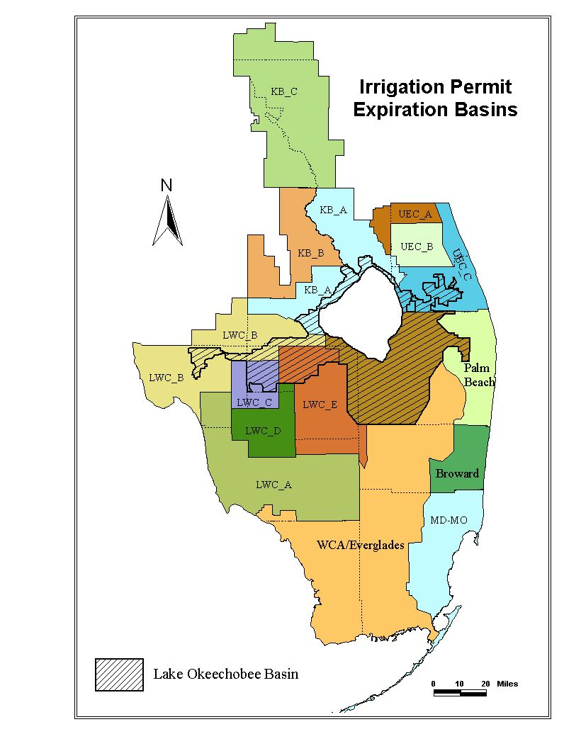

Figure 1

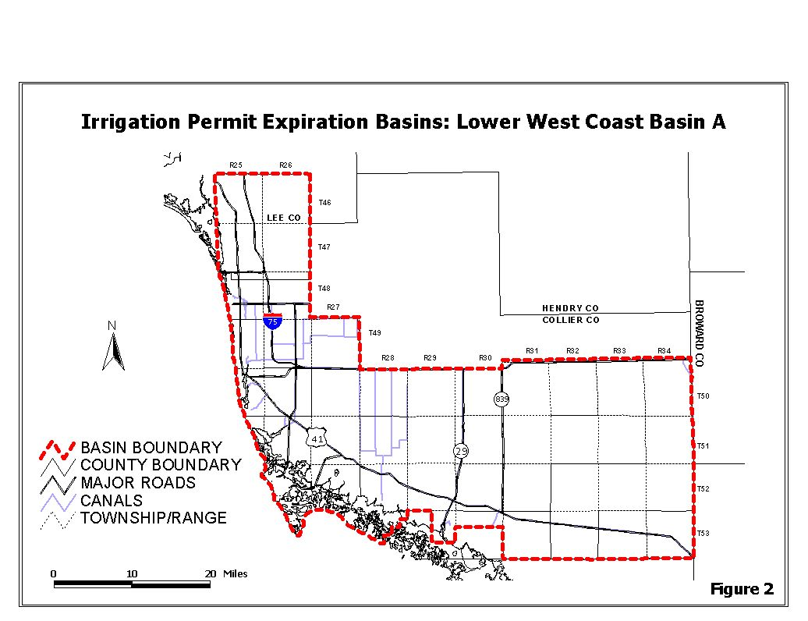
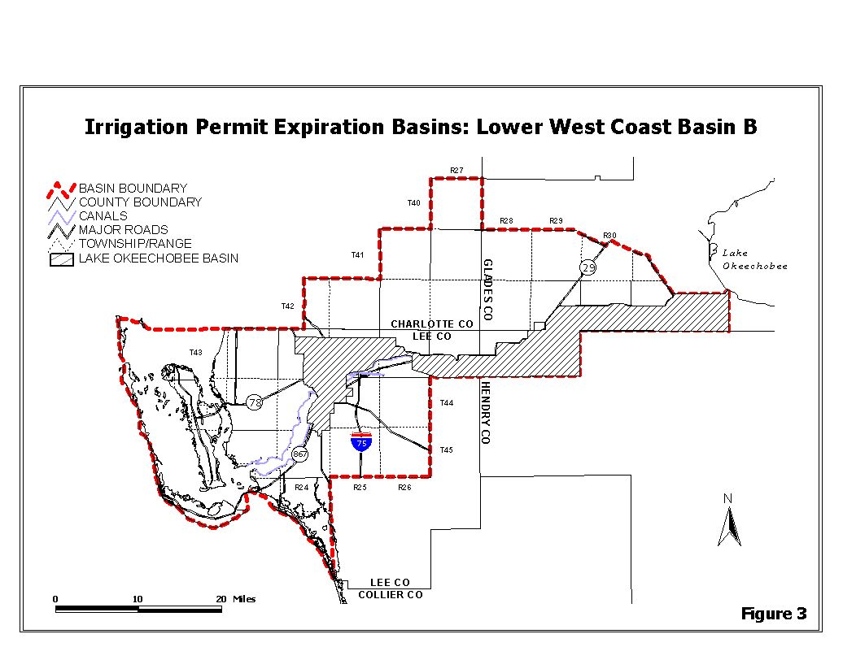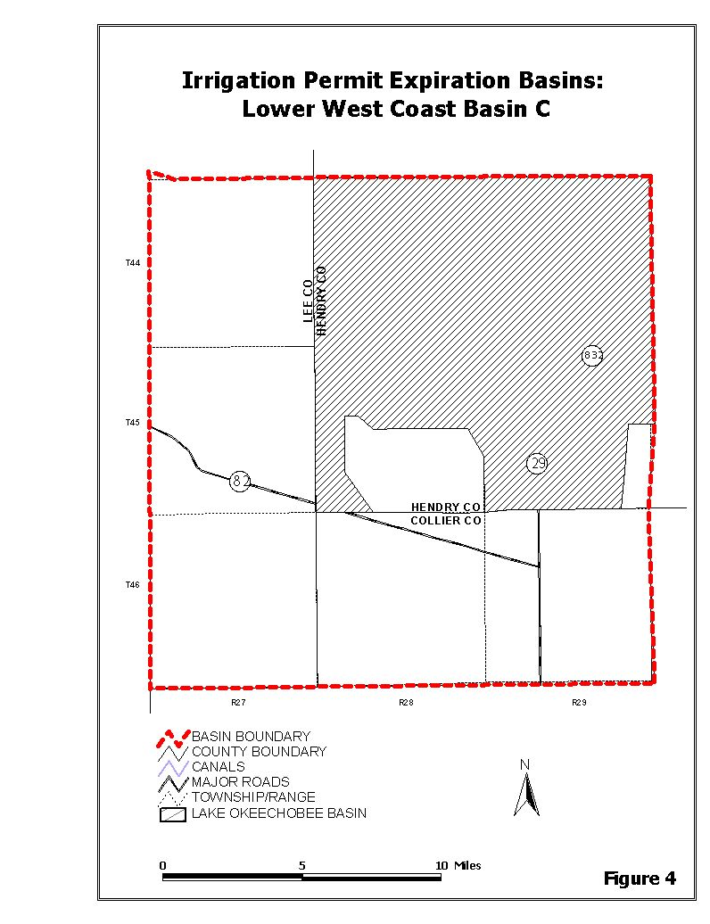
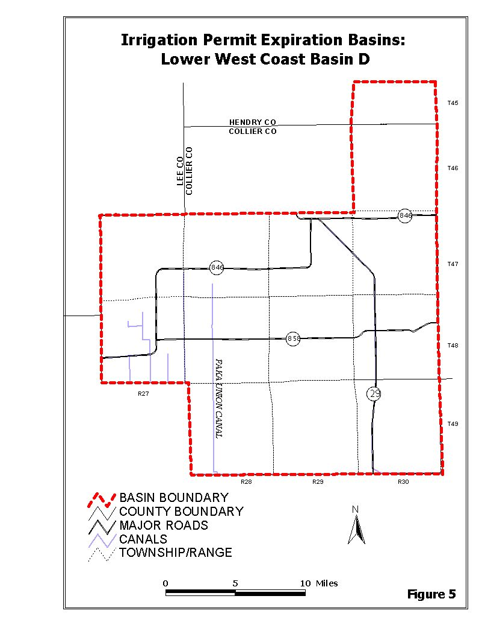
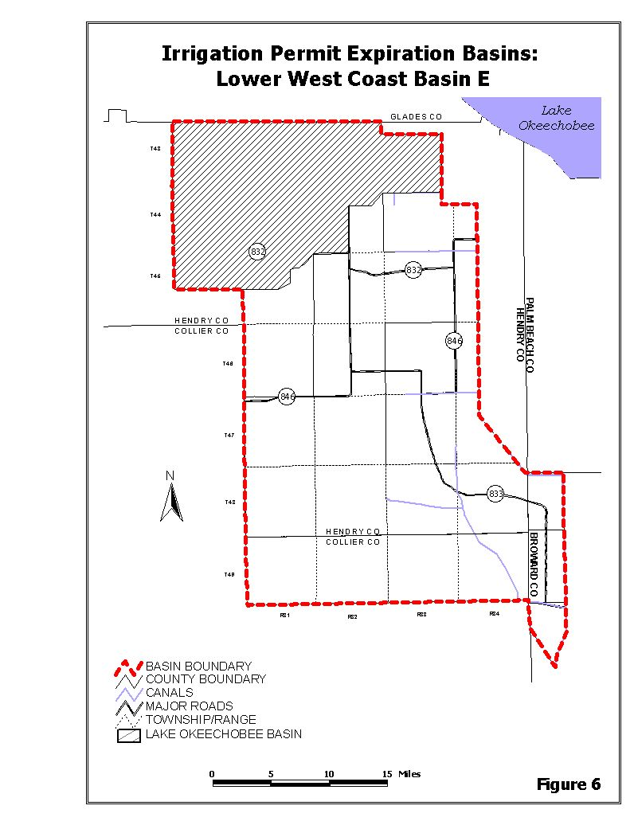

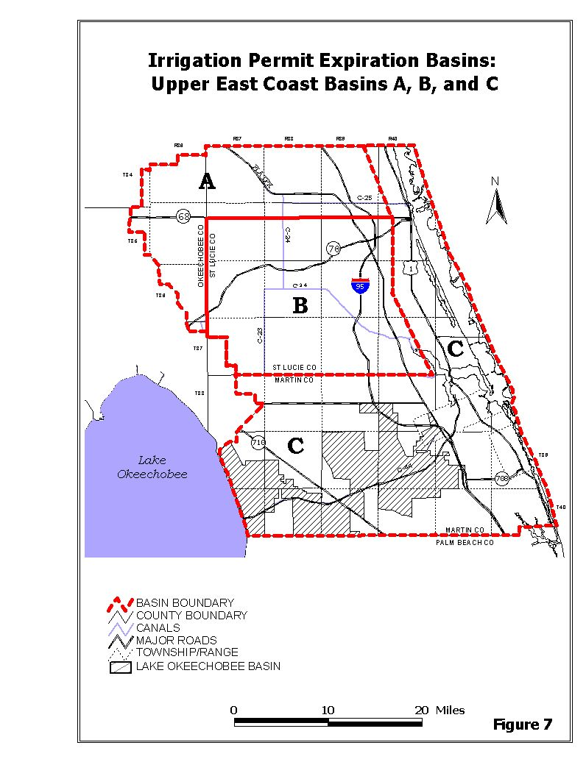
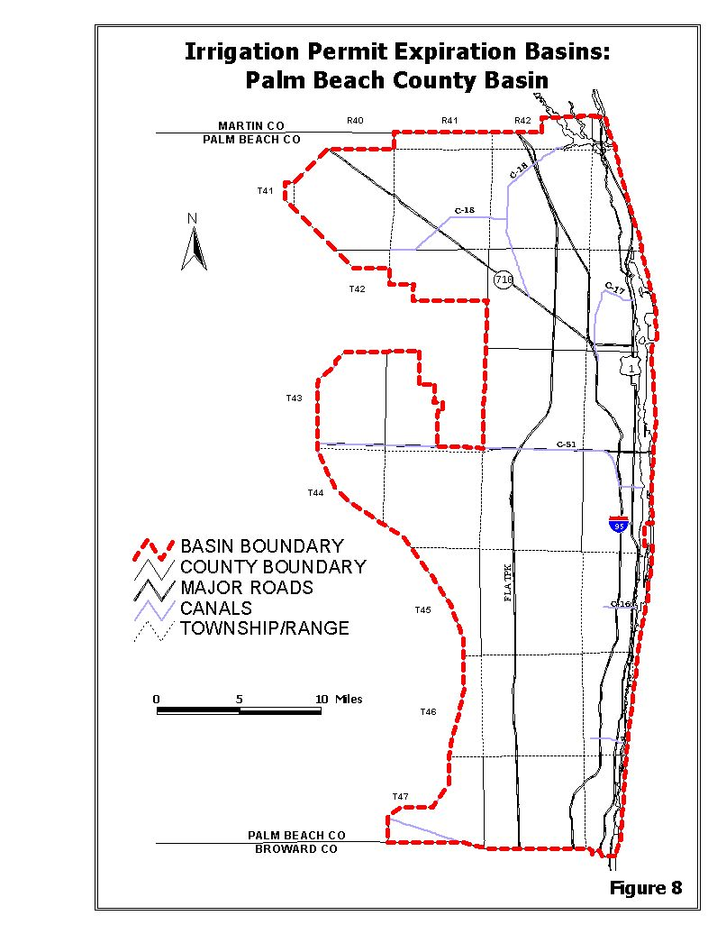
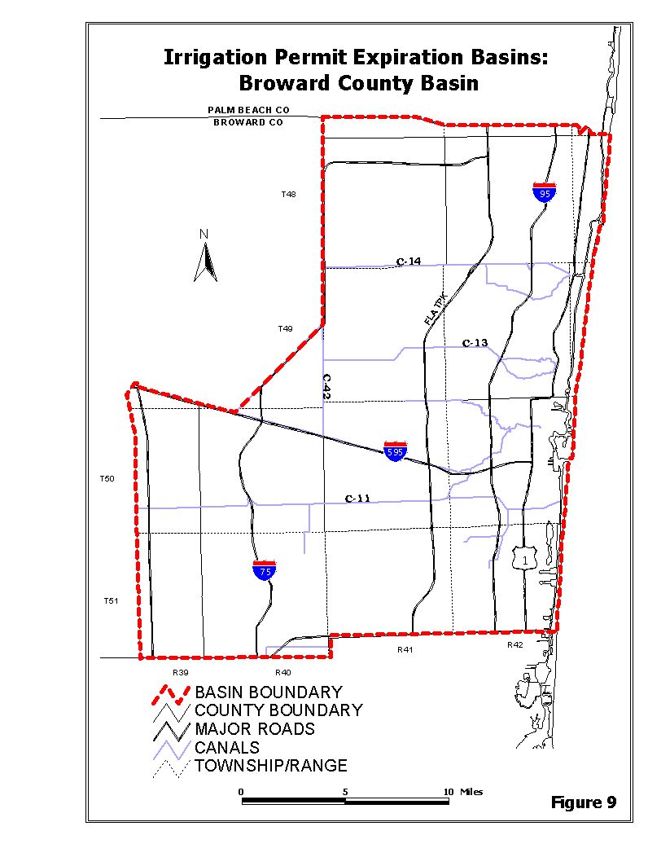
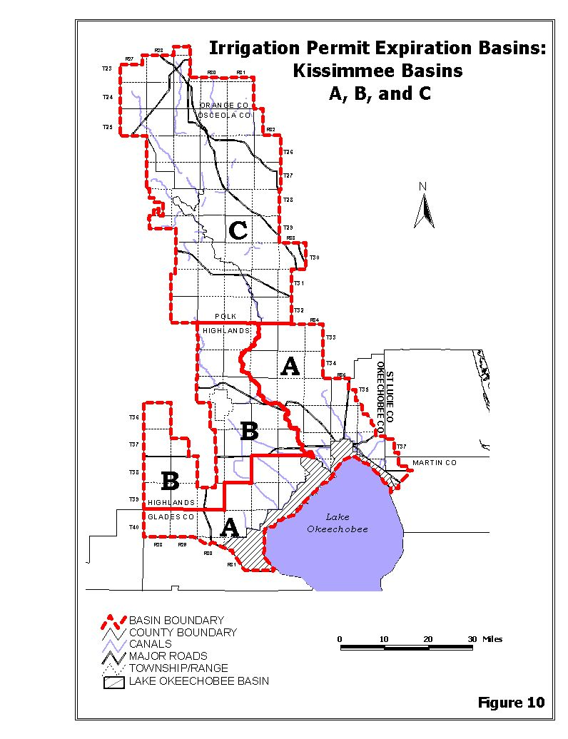
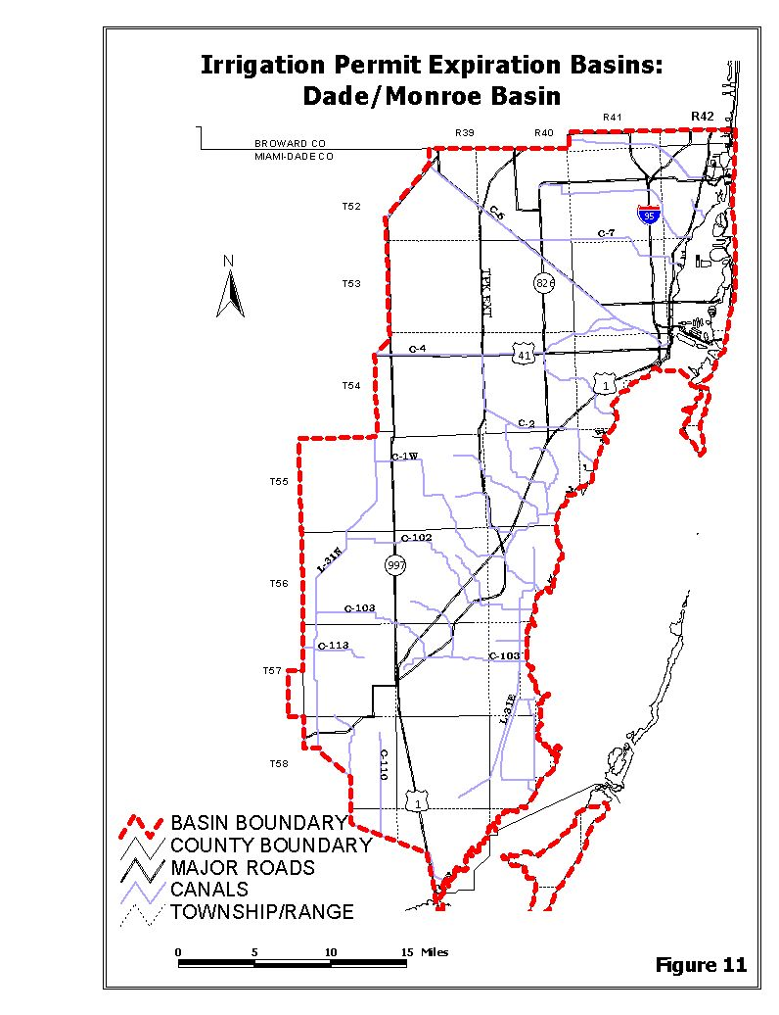
(Move to Section 3.2.1(G), remove Irrigation Permit Expiration Basins: from title and renumber as Figure 3-5)

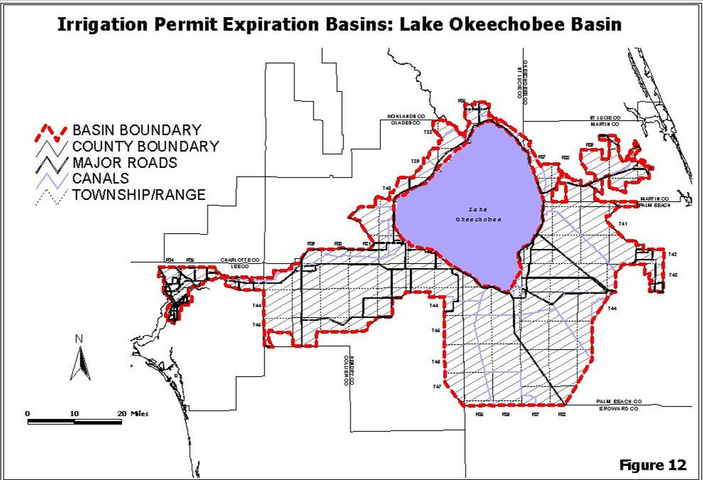

1.7.3.6 Basin Boundary Overlap
For projects that cross Irrigation Permit Expiration Basin boundaries, the District shall assign a Basin Expiration Date and Basin Application Date that best addresses resource issues. A permit shall be assigned the Basin Expiration Date and Basin Application Date of the Irrigation Permit Expiration Basin in which:
i. adverse resource impacts are likely to occur;
ii. resource competition is a concern;
iii. the majority of the withdrawal facilities are located, or;
iv. the majority of the project's irrigated acreage is located if the withdrawal facilities are split equally between the basins.
1.7.3.7 User Rights
A. The District does not intend, by adoption of these rules, to create a priority or preference between water users within different basins, however, it is possible that projects located in an adjacent basin having an earlier Basin Expiration Date and Basin Application Date may affect user rights by providing the ability to apply, and get a permit, before another affected user outside the designated basin is otherwise authorized to apply for a permit. Thus, if due to basin boundary lines water user rights are affected, a water user may elect to have its permit application reviewed concurrently with other water use applications within an adjacent basin. The manner in which user rights may be affected include contribution to cumulative drawdown impacts which may trigger water resource protection rules such that there may be insufficient water available for allocation to all permit applicants.
B. Water users shall have the burden of identifying those projects which may affect their water use rights.
1.7.4 Permit Renewals
Applications for permit renewal shall be made pursuant to Rule 40E-1.610, F.A.C., any time within six months prior to permit expiration. Permittees are encouraged to apply for renewal at least 90 days prior to the expiration date, except as provided in Section 1.7.3. Permits for which renewal applications have been submitted shall remain in effect past the expiration date until final agency action on the application is taken.
1.8 Definitions
Allocation Coefficient through Existing Legal Use of Water – No change.
Florida-Friendly Landscaping – A landscaping method that details nine landscape principles that conserve water, protect the environment, and promote planting native flora adaptable to local conditions. The principles are described in Section 373.185, F.S.
The definitions set forth in Chapter 40E-8, F.A.C., shall be incorporated into the Basis of Review.
Flow Meter through Wind Stress Damage – No change.
Xeriscape – A landscaping method that maximizes the conservation of water by the use of site-appropriate plants and an efficient watering system. The definitions set forth in Chapter 40E-8, F.A.C., shall be incorporated into the Basis of Review.
2.1 Demonstration of Need
To receive a general or individual permit, an applicant must demonstrate that the proposed water use is a reasonable-beneficial use of water, as required by Section 373.223, F.S. In order to demonstrate that a water use is reasonable-beneficial, the Applicant must show “need” for the water in the requested amount. This chapter describes the factors involved in determining whether there is need and for determining the appropriate permit allocation, or "demand," for a particular water use.
For twenty year duration permits, the permitee shall ensure that, on a continual basis, the conditions for permit issuance are met for the duration of the permit, including requirements for attaining the maximum reasonable-beneficial use of water, preventing inefficient uses of water, and ensuring that uses continue to be consistent with the public interest. Every ten five years the permittee shall be required to evaluate and update the water use based on current District rules regarding efficiency of use and reasonable demands.
Demonstration of "need" requires consideration of several factors, including: 1) legal control over the project site, facilities, and for public water supplies, the proposed service area, and 2) compatibility of the proposed water use with the land use at the project site or area to be supplied water. Demonstration of "demand" is dependent on the specific water use classification requirements set forth in Sections 2.2 through 2.8.
2.3.1 Water Conservation Plans
All individual permit applicants for landscape and golf course irrigation projects shall develop a conservation program incorporating the following mandatory elements. This conservation program must be submitted at the time of permit application.
A. The use of Florida-Friendly Xeriscape landscaping principles for proposed projects and modifications to existing projects where it is determined that Florida-Friendly landscaping Xeriscape is of significant benefit as a water conservation measure relative to the cost of Florida-Friendly landscaping Xeriscape implementation and meets the requirements of Section 373.185(2)(a)-(f), F.S.
B. No change.
C. The limitation of all lawn and ornamental irrigation to the hours and days specified in Rule 40E-24.201, F.A.C., or alternative landscape irrigation conservation measures adopted by local government ordinance in accordance with Rule 40E-24.301, F.A.C.
2.5.3 Long-Term Dewatering Individual Permits
Long-term dewatering individual permits apply to projects that exceed the thresholds and criteria described in Basis of Review, Sections 2.5.1 and 2.5.2 above. These permits must be approved by the District Governing Board. Two types of individual dewatering permits are available from the District. For projects where all the dewatering activities are defined at the time of the permit application, the applicant may apply for a “standard” Individual Permit. For long-term, multi-phased projects, with undefined activities or no contractor at the time of the permit application, the applicant may apply for a “master” Individual Permit.
Applicants for all individual dewatering permits must satisfy the conditions of issuance for Individual Permits (Rule 40E-2.301, F.A.C.)., and may not commence dewatering prior to approval of the permit by the Governing Board. In order to provide reasonable assurances that water reserved in Rule 40E-10.041, F.A.C., will not be withdrawn, all water from the dewatering activity shall be retained on site. If the applicant demonstrates that retaining the water on site is not feasible, the project shall be modified to demonstrate pursuant to Section 3.11 that reserved water will not be withdrawn. The applicant may elect to begin dewatering for a single period of only 90 days in areas of the project, that meet the No-Notice criteria specified in Section 2.5.1 of this Basis of Review, once an application for an Individual dewatering permit has been submitted to the District.
The applicant must provide the information required for the Dewatering General Permit, as specified in Section 2.5.2. In addition, the applicant shall provide estimates of the maximum monthly and annual dewatering withdrawals for the project and will be required to submit records of monthly withdrawals for each dewatering pump to the District. Staff shall not specify maximum monthly or annual withdrawal volumes in the recommended permit conditions presented to the Governing Board.
A. “Standard” Individual Permits
The applicant shall specify all proposed dewatering activities for the project in terms of depth, duration, and areal extent of dewatering and proposed routing of dewatering water, the estimated magnitude and extent of drawdown, proposed recharge/storage areas, and the potential for harm. The applicant may proceed with all dewatering activities once the permit has been approved by the Governing Board.
B. “Master” Individual Permits
Due to project uncertainties, the applicant may not be able to specify all aspects of the proposed dewatering activities at the time of the permit application. In order to receive a “master” dewatering permit, the applicant must meet all conditions of issuance and specify the depth, duration, and areal extent of dewatering, the proposed routing of dewatering water, the estimated magnitude and extent of drawdown, proposed recharge/storage areas, and the potential for harm for “typical” dewatering activities for the project. In addition, the applicant shall provide an estimated project schedule showing dewatering activities and calculated estimated maximum monthly and annual dewatering withdrawals. After approval of the permit by the Governing Board, the applicant shall be required by limiting condition to supply site-specific dewatering plans for each proposed dewatering activity to the District for review and approval at least two weeks prior to dewatering. The applicant may not initiate dewatering prior to receiving written notification from District Staff, that the proposed dewatering activity is consistent with the “master” permit approved by the Governing Board.
(No change to Table 2-3 Dewatering Permits)
2.6.1 Water Conservation Plans
Introductory paragraph – No change.
A. No change.
B. Where the local government operating the public water supply utility, pursuant to Section 125.568 or 166.048, F.S., determines that Florida-Friendly Landscaping Xeriscape would be of significant benefit as a water conservation measure relative to the cost of Florida-Friendly Landscaping Xeriscape implementation, the local government operating the public water supply utility is required to adopt a Florida-Friendly Landscaping Xeriscape landscape ordinance meeting the requirements of Section 373.185(2)(a)-(f), F.S. In the event such a Florida-Friendly Landscaping Xeriscape ordinance is proposed for adoption, the permit Applicant shall submit the draft ordinance to the District for determination of compliance with Section 373.185(2)(a)-(f), F.S. If the ordinance which the local government has or proposes to adopt includes an alternative set of requirements which do not encompass those contained in Section 373.185(2)(a)-(f), F.S., eligibility for the incentive program will not be achieved. The District, in compliance with Section 373.185, F.S., offers the following incentive program, to those local governments who are eligible, consisting generally of information and cost-benefit analysis assistance. Specifically, the information provided interested parties will consist of an explanation of the costs and benefits of Florida-Friendly Xeriscape landscapes; the types of plants suitable for Florida-Friendly Xeriscape landscapes within the local government's jurisdiction; the types of irrigation methods suitable for Florida-Friendly Xeriscape landscaping and the use of solid waste compost. Further, if requested, the District will assist local governments in determining whether the benefits of requiring Florida-Friendly Xeriscape landscaping outweigh the costs within that local government's jurisdiction; this assistance may consist of economic considerations, technical information or referral to other agencies that can provide information the local government may need to perform its cost benefit determination. The Governing Board finds that the implementation and use of Florida-Friendly Xeriscape landscaping, as defined in Section 373.185, F.S., contributes to the conservation of water. The Governing Board further supports adoption of local government ordinances as a significant means of achieving water conservation through Florida-Friendly Xeriscape landscaping.
C. through I. No change.
3.2.1 Restricted Allocation Areas
A. through D. No change.
E. In addition to all other applicable consumptive use statutory and rule provisions, the following restrictions shall apply when allocating water by permit for water use withdrawals within the Northern Palm Beach County Service Area and Lower East Coast Service Areas 1, 2 or 3.
This section is a component of recovery strategies for MFLs minimum flows and levels for the Everglades and the Northwest Fork of the Loxahatchee River, as set forth in Chapter 40E-8, F.A.C., and assists in implementing the objective of the District to ensure that water necessary for Everglades restoration and restoration of the Loxahatchee River Watershed is not allocated for consumptive use upon permit renewal or modification under this rule.
(1) through (6) No change.
(7) Permit applicants must meet the requirements of any established MFL minimum flow and level and water reservation, if applicable.
F. No change.
G. The following restrictions shall apply when allocating surface water derived from the Lake Okeechobee Waterbody for consumptive use within the Lake Okeechobee Basin as delineated in Figure 3-5 defined in Section 1.7.3. This rule is a component of the recovery strategy for MFLs minimum flows and levels for Lake Okeechobee, as set forth in Chapter 40E-8, F.A.C., to address lower lake management levels and storage under the U. S. Army Corps of Engineers’ interim Lake Okeechobee Regulation Schedule (LORS), adopted to protect the public health and safety (April 28, 2008). Compliance with this rule along with the other criteria contained in the Basis of Review implements the objectives of the District to protect the public health and safety, to prevent interference among legal users of Lake water, to be consistent with the MFL recovery strategy as defined in Rule 40E-8.421, F.A.C., and to ensure that water necessary for Everglades restoration is not allocated for consumptive use.
(1) The rule applies to applications for new projects, existing unpermitted projects, modifications to existing projects, and permit renewals for existing projects located within the Lake Okeechobee Basin as delineated in Figure 3-5 described in Section 1.7.3, that propose to use surface water from the “Lake Okeechobee Waterbody,” defined as:
(a) through (b) No change.
(2) through (3)(c)(iii) No change.
(iv) Unassigned, Terminated, or Reduced Base Condition Water Use. The requested allocation is for available base condition water use calculated pursuant to subsection 3.2.1(G)(2), above, that was not authorized by an existing permit (i.e. “unassigned”), permitted base condition water use that has been made available through a permit which was terminated after January 1, 2008, or water made available pursuant to a modification made after January 1, 2008 which reduced the permitted base condition water use of an existing permit. In the event of competition for allocation of available base condition water use, those projects that seek an allocation of water in volumes equal to or less than that which was previously permitted to that project and/or used by that project shall be a positive consideration when determining which project best serves the public interest. Prior to February 28, 2010, the Governing Board reserves the right to restrict the re-allocation of terminated base condition water use if it determines that such water is demonstrated to improve the performance of a MFL minimum flow and level waterbody under recovery in terms of shortening the frequency or duration of projected MFL minimum flow and level violations or improve the performance of meeting a restoration target as defined in an approved District restoration plan or project while also considering if alternative water supplies are available, whether the proposed use is ancillary to an agricultural use and other relevant public interest considerations. On or after February 28, 2010, the Governing Board reserves the right to restrict the re-allocation of unassigned, terminated, or reduced base condition water use, if it determines that such water is demonstrated to improve the performance of a MFL minimum flow and level waterbody under recovery in terms of shortening the frequency or duration of projected MFL minimum flow and level violations or improve the performance of meeting a restoration target as defined in an approved District restoration plan or project while also considering if alternative water supplies are available, whether the proposed use is ancillary to an agricultural use and other relevant public interest considerations.
(4) Incompatible Use Type: Requested allocations for new public water supply uses that exceed the thresholds in subsection 40E-20.302(1)(a), F.A.C., or increases in existing uses above the project’s base condition water use calculated pursuant to subsection (2)(a) above, shall not be permitted from the Lake Okeechobee Waterbody.
(5) Requests for temporary increases over the project’s base condition water use from the Lake Okeechobee Waterbody shall be granted to accommodate increased demands during a reasonable time period while alternative sources are constructed provided all other consumptive use permit criteria are satisfied. The duration of the temporary increase shall be determined based on a construction schedule for the alternative source to be implemented with due diligence and defined in permit conditions. Additionally, the permit shall include requirements to reduce the allocation to the base condition water use in accordance with this construction schedule.

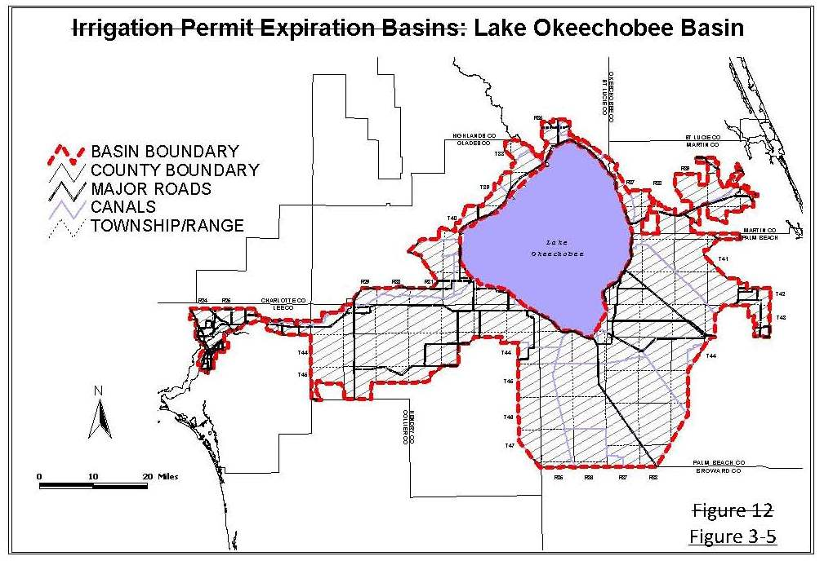

3.4 Saline Water Intrusion
A water use permit application will be denied if the application requests freshwater withdrawals that would cause harm to the water resources as a result of saline water intrusion. Harmful saline water intrusion occurs when:
A. No change.
B. Withdrawals result in the sustained upward movement of saline water. Sustained upward movement is the level of movement that persists when the withdrawals have ceased. When the saline interface occurs beneath the point of withdrawal, the maximum maximim amount of pumpage from any well shall be constrained as follows:
(Remainder of section remains unchanged)
3.9.1 Evaluations for Minimum Flow and Level (MFL) Water Bodies Subject to a Recovery Strategy
Evaluations for direct or indirect withdrawals from MFL water bodies that are subject to a recovery strategy:
A. Permit Renewals: A request for renewal of an existing permitted allocation, which directly or indirectly withdraws water from a MFL water body, shall meet the requirements of this section if:
(1) the impact of the withdrawal of water will be corrected through implementation of a recovery strategy; and
(2) the level of impacts from the allocation approved in the expiring permit are no greater under the requested renewal.
If the level of certainty under the expiring permit is changed to a 1 in 10 year level of certainty by rule (e.g. a golf course irrigation level of certainty changed from a 1 in 5 to a 1 in 10 year level of drought) the levels of impact from the withdrawal of water under the expiring permit shall be normalized to a 1 in 10 drought level of certainty in order to evaluate the impact of the withdrawal of water.
3.9.2 Evaluations for Minimum Flow and Level (MFL) Water Bodies Subject to a Prevention Strategy
Evaluations for direct or indirect withdrawals from MFL water bodies that are subject to a prevention strategy:
A. Permit Renewals – A request for renewal of an existing permitted allocation that directly or indirectly withdraws water from a MFL water body shall meet the requirements of this section if the level of impacts from the allocation approved in the expiring permit are no greater under the requested renewal. If the level of certainty under the expiring permit is changed to a 1 in 10 year level of certainty by rule (e.g. a golf course irrigation level of certainty changed from a 1 in 5 to a 1 in 10 year level of drought) the levels of impact from the withdrawal of water under the expiring permit shall be normalized to a 1 in 10 drought level of certainty in order to evaluate the impact of the withdrawal of water.
B. No change.
3.11.1 Picayune Strand and Fakahatchee Estuary
A permit applicant shall provide reasonable assurances that the proposed use will not withdraw water reserved under Rules 40E-10.041(1) and (2), F.A.C., except that water uses less than 100,000 gallons per day associated with land management or public access/recreation shall be permittable. Compliance with the following criteria constitutes reasonable assurances that water reserved in Rules 40E-010.041(1) and (2), F.A.C., will not be withdrawn. Water not reserved under Rules 40E-10.041(1) and (2), F.A.C., shall be allocated pursuant to Subsections A and B.
For this section, the following definitions apply:
Direct Withdrawals from Groundwater: water pumped from a well(s) constructed within the boundaries of the Picayune Strand or Fakahatchee Estuary into the water table or unconfined portions of the Lower Tamiami aquifer.
Indirect Withdrawals from Groundwater: a) a groundwater withdrawal from a well(s) constructed outside the boundaries of Picayune Strand and Fakahatchee Estuary into the water table or Lower Tamiami aquifer that results in a 0.1 foot or greater drawdown in the water table aquifer at any location underlying the Picayune Strand or the Fakahatchee Estuary as determined by an evaluation conducted pursuant to Section 1.7.5.2.A. or b) a groundwater withdrawal that causes a water table drawdown of 0.1 foot or greater underlying any canal identified in Figure 3-6 3-5, as determined by an evaluation conducted pursuant to Section 1.7.5.2.A.
Direct Withdrawals from Surface Water: Withdrawal of surface water from facilities physically located within the Picayune Strand or Fakahatchee Estuary boundaries.
Indirect Withdrawal from Surface Water: Withdrawal of surface water from any canal identified in Figure 3-6 3-5.
A.1. through 8. No change.
B. Model Impact Evaluation. If required by Section A, the applicant shall demonstrate water reserved for the Picayune Strand and Fakahatchee Estuary will not be withdrawn by conducting the following model impact evaluation. A pre-application meeting between the applicant and District staff is strongly recommended to be conducted prior to initiating model development.
1. Defining Scope of Model Evaluation
(a) For groundwater withdrawals, identify the cone of influence of the proposed withdrawal per Section 1.7.5.2.A. Based on this analysis, the Applicant shall identify which reservation inflow locations (set forth in Figures 1 and 2 in Rule 40E-10.021, F.A.C.) and conveyance system(s) identified on Figure 3-6 3-5 are potentially influenced by the proposed withdrawal.
(b) For surface water withdrawals, identify the reservation inflow locations, reservation water body (set forth in Figures 1 and 2 in Rule 40E-10.021, F.A.C.), and conveyance system(s) identified on Figure 3-6 3-5 that are potentially influenced by the proposed withdrawal.
2. (a) through (f) No change.
3. Impact Evaluation. Once the model is calibrated, applicants shall demonstrate that water reserved for the Picayune Strand and Fakahatchee Estuary will not be withdrawn, based on the following:
(a) “Without scenario”: All existing legal uses at the effective date of the rule shall be represented using the allocation in the permit. For the purposes of this evaluation and subsection (b) the annual allocation shall be distributed on a monthly basis based on the use type. For a public water supply use type, the monthly distribution shall be calculated based on the measured monthly pumpage divided by the annual total pumpage using the average of the three most recent representative years. Representative years shall not include years with water shortage restrictions, years with plant failures or other years that are not representative of normal pumpage. For an irrigation use type, the monthly distribution shall be determined using the Blaney-Criddle distribution calculated for each project pursuant to “Part B Water Use Management System Design and Evaluation Aids” of the Volume III, Permit Information Manual for Water Use Permit Applications referenced in the “Basis of Review for Water Use Permit Applications within the South Florida Water Management District”, which is incorporated by reference in Rules 40E-2.091 and 40E-20.091, F.A.C., the annual allocation and the associated monthly distribution shall be simulated using the calibrated model developed in accordance with the criteria identified in Subsection 3.11.1.B.2 in order to generate a daily flow data for each represented inflow location identified in Subsection 3.11.1. These data shall be presented as daily hydrographs as well as seasonal and period of record flow probability curves.
(b) through (c) No change.
4. through 5. No change.

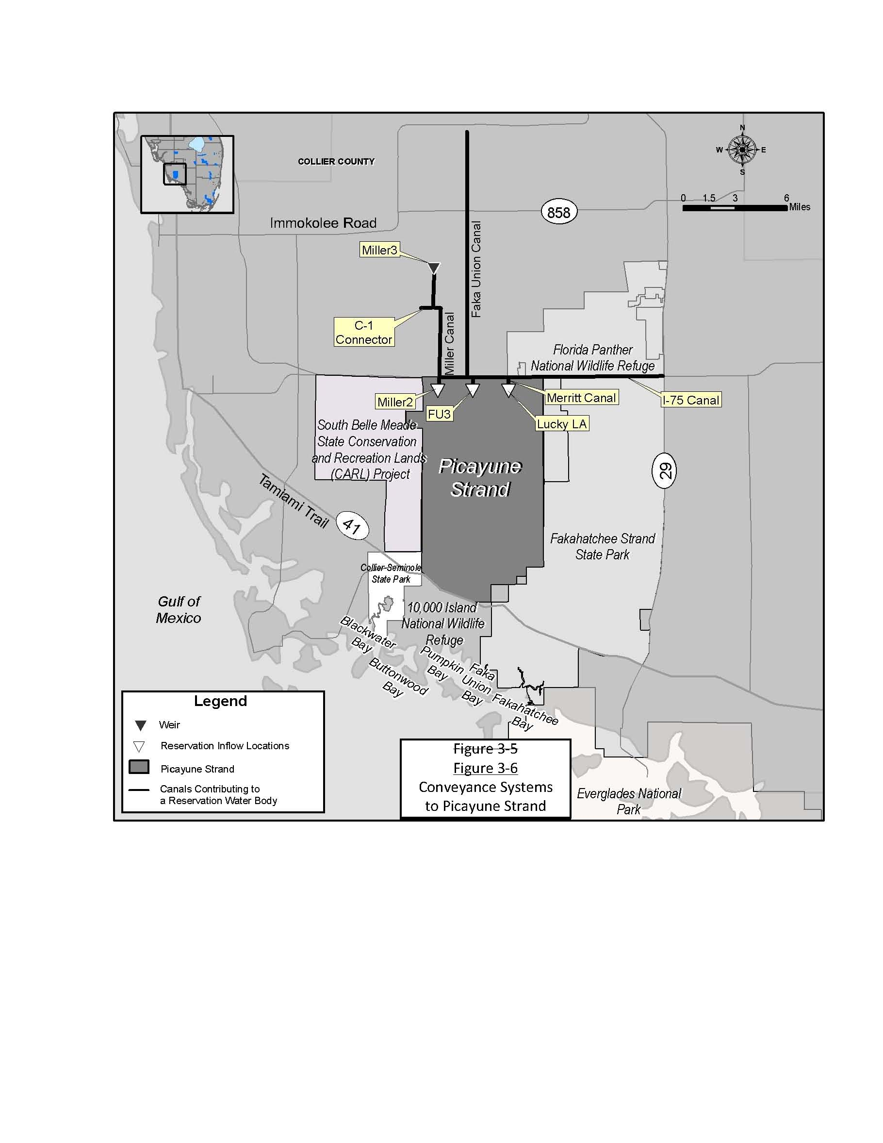

4.1 Withdrawal Quantity
Proper accounting for water use is essential to establish that the use is a reasonable-beneficial use of the resource and in the public interest. In addition, proper accounting of the various water uses enables the District to better estimate water use and to implement water shortage plans.
All Permittees with a maximum monthly allocation of greater than 3.0 million gallons, or irrigation water users located within the South Dade County Water Use Basin (as designated in Figure 21-11, Chapter 40E-21, F.A.C.), with a maximum monthly allocation of greater than 15.0 million gallons, are required to monitor and report withdrawal quantities from each withdrawal facility or point of diversion. Permittees shall submit the following forms, if applicable, electronically or at the address provided below:
0188-QMQ, Quarterly Report of Withdrawals, __(date)___, (hyperlink);
0188-QASR, Quarterly Report of Injections and Withdrawals for Aquifer Storage and Recovery (ASR) Wells, ___(date) , (hyperlink);
0188-QMQF, Quarterly Report of Withdrawals from Wells and Surface Water Pumps, ___(date)___, (hyperlink);
0188-QBWDR, Quarterly Report of Bulk Water Delivered and Received, ___(date)___, (hyperlink).
These forms are incorporated by reference herein and are available at no cost by contacting the South Florida Water Management District Clerk’s Office, 3301 Gun Club Road, West Palm Beach, FL 33406, (800) 432-2045, ext. 6436 or (561) 682-6436.
(Remainder of section remains unchanged)
4.2 Saline Water Monitoring
The purpose of saline water monitoring is to ensure that harmful saline water intrusion, whether lateral from a surface or groundwater saline source, vertical from an aquifer containing lower quality water, or a combination of both, does not occur. Saline water monitoring is accomplished by routine sampling of the discharge water from production wells or from separate monitor wells. However, in areas of known saline water movement, separate monitor wells are required to be designed and constructed expressly for the purpose of saline water intrusion monitoring. The dissolved chloride concentration and the water level elevation, referenced to National Geodetic Vertical Datum, shall be measured. Frequency of measurements may be weekly, monthly, or quarterly, and will be identified in the permit limiting conditions. The data shall be reported using Form No. 0188-QMON, Quarterly Report of Monitoring Requirements, ___(date)___, ___(hyperlink)___, incorporated by reference in paragraph 40E-2.091(1)(a), F.A.C.

A. through G. No change.
H. Staff evaluation indicates saline water may come in contact with a fresh water source (per Section 3.4.1 of this Basis of Review) as a result of the proposed use.
(Remainder of section remains unchanged)
5.1 Standard Permit Conditions
A. through N. No change.
O. Permittee shall notify the District in writing within 30 days of any sale, conveyance, or other transfer of ownership or control of the real property on which the permitted activities are located. All transfers of ownership are subject to the requirements of Rule 40E1-1.6107, F.A.C.
(Remainder of section remains unchanged)
5.2 Special Permit Conditions
Permittee shall submit all data as required by the implementation schedule for each of the limiting conditions to: S.F.W.M.D. at www.sfwmd.gov/ePermitting, or the Regulatory Support Bureau, MSC 9611, Supervising Hydrogeologist – Water Use Compliance, Water Use Division (4320), P. O. Box 24680, West Palm Beach, FL 33416-4680 or by e-mail to wucomp@sfwmd.gov.
5.2.1 Public Water Supply
A. through G. No change.
H. For uses with an annual allocation greater than 10 MGD and a permit duration of 20 years, every ten five years from the date of permit issuance, the permittee shall submit a water use compliance report for review and approval by District Staff to SFWMD at www.sfwmd.gov/ePermitting, or the Regulatory Support Bureau, MSC 9611, P. O. Box 24680, West Palm Beach, FL 33416-4680, which addresses the following:
1. through 2. No change.
5.2.3 Irrigation
A. No change.
B. Landscape and Ggolf course irrigation is prohibited between the hours of 10:00 A.M. and 4:00 P.M., except as follows:
a) through e) No change.
C. No change.
D. The permittee shall complete Form No. 0188-QCROP, a "Report of Planting and Harvest of Seasonal Crops", ____(date)___, ___(hyperlink)____, incorporated by reference in paragraph 40E-2.091(1)(a), F.A.C., form and submit it with the appropriate "Quarterly Report of Withdrawals From Wells and Surface Water Pumps" (Form No. 0188-QMMQF) form.
E. For uses with an annual allocation greater than 10 MGD and a permit duration of 20 years, every ten five years from the date of permit issuance the permittee shall submit a water use compliance report for review and approval by District Staff to SFWMD at www.sfwmd.gov/ePermitting, or the Regulatory Support Bureau, MSC 9611, P.O. Box 24680, West Palm Beach, FL 33416-4680, which addresses the following:
1. and 2. No change.
F. No change.
G. Landscape irrigation shall be restricted to the hours and days specified in Rule 40E-24.201, F.A.C., or alternative landscape irrigation conservation measures adopted by local government ordinance in accordance with Rule 40E-24.301, F.A.C.
5.2.8 Well Construction
A. Permittee shall secure a well construction permit prior to construction, repair, or abandonment of all wells, as described in Chapters 40E-3 and 40E-30, F.A.C.
B. through D. No change.
E. Within six months of permit issuance, the Permittee shall plug and abandon the following wells in accordance with Chapters 40E-3 or 40E-30, F.A.C.: (individual wells identified based on project specifications).
F. through H. No change.
40E-2.101 Content of Application.
(1) Applications for permits required by this chapter shall be filed electronically at www.sfwmd.gov.ePermitting, or at the South Florida Water Management District Regulation Reception Desk, 3301 Gun Club Road, West Palm Beach, FL 33406, or at any of the District’s Service Centers. The addresses and phone numbers of the District’s Service Centers are online at www.sfwmd.gov, “Locations.” with the District.
(a) The application, Form No. 0645-W01, Water Use Permit Application, __(date) , __(hyperlink) shall include the following forms, if applicable contain:
Form No. 0645-G60, Table A Description of Wells, __(date)___, (hyperlink), for permits with wells;
Form No. 0645-G61-1, Table B Description of Surface Water Pumps, __(date)___, (hyperlink), for permits with pumps;
Form No. 0645-G61-2, Table C Description of Culverts, __(date)___, (hyperlink), for permits with irrigation culverts;
Form No. 0645-G65, Table D Crop Information, __(date)___, (hyperlink), for agricultural permits;
Form No. 0645-G74, Table E Water Received From or Distributed to Other Entities, __(date)___, (hyperlink), (2) for public water supply permits;
Form No. 0645-G69, Table F Past Water Use & Table G Projected Water Use, __(date)___, (hyperlink), for public water supply permits;
Form No. 0645-G70, Table H Projected Water Use, __(date)___, (hyperlink), for public water supply permits;
Form No. 0645-G71, Table I Water Treatment Method and Losses, __(date)___, (hyperlink), for public water supply permits;
Form No. 0645-G72, Table J Aquifer Storage and Recovery, __(date)___, (hyperlink), for public water supply permits; and
Form No. 0645-G73, Table K Water Supply System Interconnections, _(date)___, (hyperlink), for public water supply permits.
(a) The following parts of Form 0645 Water Use Permit Applications, as incorporated by reference in Rule _____________ 40E-1.659, F.A.C.;
1. Part RC-1A Administrative Information for Water Use Permit Applications;
2. Part RC-1W Application for a Water Use Permit;
(b) through (d) No change.
(2) No change.
(3) Applicants for a Dewatering Water Use permit shall electronically file or file with the District Form 0445, _____(date)____, __(hyperlink)______, Mining/Dewatering Permit Application.
(4) The forms identified in subsections (1) and (3) above are incorporated by reference herein and are available at no cost by contacting the South Florida Water Management District Clerk’s Office, 3301 Gun Club Road, West Palm Beach, FL 33406, (800)432-2045, ext. 6436, or (561)682-6436.
Rulemaking Specific Authority 373.044, 373.113, 373.171 FS. Law Implemented 373.103(1), 373.219, 373.223, 373.229 FS. History– New 9-3-81, Amended 12-1-82, 2-24-85, 11-21-89, Repromulgated 1-4-93, Amended 4-20-94, 8-1-02,________.
40E-2.331 Modification of Permits.
(1) through (3) No change.
(4)(a) Modification of an existing water use permit shall be approved by letter, provided the permit is in compliance with all applicable limiting conditions and the modification request:
1. through 4. No change.
5. Does not result in a modification of the permit which must be approved by the Governing Board pursuant to Section 373.239(2), F.S.
6. No change.
(b) No change.
Rulemaking Authority 373.044, 373.113 FS. Law Implemented 373.079, 373.083, 373.223, 373.229, 373.239 FS. History–New 9-3-81, Formerly 16K-2.09(1), Amended 4-20-94, 7-11-96, 4-9-97, 12-10-97, 8-1-02, 4-23-07, 2-13-08, 7-2-09, 3-15-10,________.
40E-2.341 Revocation of Permits.
Violations of this chapter may result in the revocation or suspension of the authorization in whole or in part in accordance with the provisions of Chapter 373, including Sections 373.119 and 373.243, Florida Statutes, Chapter 120, Florida Statutes, and Rules 40E-1.609 and 28-106.2015 28-107.004, F.A.C.
Rulemaking Specific Authority 373.044, 373.113 FS. Law Implemented 120.60(6), 373.103(4), 373.219, 373.229 FS. History– New 4-20-94, Amended 7-2-98,________.
40E-2.381 Limiting Conditions.
The District Board shall impose on any permit granted under this chapter such reasonable standard and special permit conditions as are necessary to assure that the permitted use or withdrawal will be consistent with the overall objectives of the District, will not be harmful to the water resources of the District, is reasonable-beneficial, will not interfere with any presently existing legal uses, and is consistent with the public interest. Standard permit conditions in Section 5.1 of the “Basis of Review for Water Use Permit Applications within the South Florida Water Management District”, incorporated by reference in Rule 40E-2.091, F.A.C., shall be set forth in the permit. Special permit conditions, including those specified in Section 5.2 of the “Basis of Review for Water Use Permit Applications within the South Florida Water Management District”, incorporated by reference in Rule 40E-2.091, F.A.C., shall be set forth in the permit.
Rulemaking Specific Authority 373.044, 373.113, 373.171 FS. Law Implemented 373.042, 373.0421, 373.079, 373.083, 373.219(1) FS. History–New 9-3-81, Amended 2-24-85, 7-26-87, 4-20-94, 7-11-96, 4-9-97, 12-10-97, 9-10-01, 8-1-02, 4-23-07, 2-13-08,________.
40E-2.451 Emergency Authorization.
(1) Permission to begin use, withdrawal, or diversion of water prior to the issuance of a permit may be applied for in writing, when emergency conditions exist which would justify such permission. However, no such permission shall be granted unless the use, withdrawal, or diversion is already being considered for a permit under Rule 40E-2.041, F.A.C. A serious set of unforeseen or unforeseeable circumstances must exist to create an emergency. Mere carelessness or lack of planning on the part of the applicant shall not be sufficient grounds to warrant the granting of emergency authorization.
(2) Emergency authorizations shall be administered pursuant to Rule 40E-0.108 40E-1.6115, F.A.C.
Rulemaking Specific Authority 373.044, 373.113 FS. Law Implemented 120.60(5), 373.219 FS. History–New 9-3-81, Formerly 16K-2.11, Amended 4-20-94, 7-2-98,________.
40E-2.501 Permit Classification.
Each water use permit shall be classified according to source, use and method of withdrawal. The source use and method of withdrawal classes are listed in Rules 40E-21.631 40E-21.611 through 40E-21.691, F.A.C.
Rulemaking Specific Authority 373.044, 373.113 FS. Law Implemented 373.246 FS. History–New 9-3-81, Formerly 16K-2.12(2), Amended 7-4-82,________.

