Notice of Proposed Rule

WATER MANAGEMENT DISTRICTS
Southwest Florida Water Management District
RULE NO.: RULE TITLE:
40D-2.091: Publications Incorporated by Reference
40D-2.101: Content of Application
40D-2.351: Transfer of Permits
40D-2.801: Water Use Caution Areas
PURPOSE AND EFFECT: The purpose and effect of the rulemaking is to correct the legal descriptions and maps and figures of the boundaries of the Southern Water Use Caution Area (SWUCA), the most impacted area of the SWUCA and the Northern Tampa Bay Water Use Caution Area.
SUMMARY: Discrepancies have been discovered between the boundaries of the Southern Water Use Caution Area (SWUCA) as adopted by rule and the District’s Geographic Information System (GIS) feature classes representing the SWUCA. The discrepancies were investigated and it was determined that several corrections or clarifications should be made to the legal description, and maps and figures contained in and incorporated in Rules 40D-1.6105, 40D-1.659, 40D-2.091, 40D-2.101, 40D-2.351 and 40D-2.801, F.A.C., and Part B, Basis of Review, Water Use Permit Information Manual, including permit applications and forms.
SUMMARY OF STATEMENT OF ESTIMATED REGULATORY COSTS AND LEGISLATIVE RATIFICATION:
The Agency has determined that this will not have an adverse impact on small business or likely increase directly or indirectly regulatory costs in excess of $200,000 in the aggregate within one year after the implementation of the rule. A SERC has not been prepared by the agency.
The Agency has determined that the proposed rule is not expected to require legislative ratification based on the statement of estimated regulatory costs or if no SERC is required, the information expressly relied upon and described herein: There are no costs to the regulated public as a result of the proposed amendments. Therefore, this rulemaking will not result in any adverse economic impacts or regulatory cost increases that require legislative ratification.
Any person who wishes to provide information regarding a statement of estimated regulatory costs, or provide a proposal for a lower cost regulatory alternative must do so in writing within 21 days of this notice.
RULEMAKING AUTHORITY: 373.044, 373.113, 373.118, 373.171 FS.
LAW IMPLEMENTED: 373.036, 373.0363, 373.042, 373.0421, 373.079(4)(a), 373.083(5), 373.116, 373.117, 373.1175, 373.118, 373.149, 373.171, 373.185, 373.216, 373.217, 373.219, 373.223, 373.227, 373.228, 373.229, 373.236, 373.239, 373.243, 373.250, 373.705, 373.709, 373.715, 403.0877 FS.
IF REQUESTED WITHIN 21 DAYS OF THE DATE OF THIS NOTICE, A HEARING WILL BE SCHEDULED AND ANNOUNCED IN THE FAW.
Pursuant to the provisions of the Americans with Disabilities Act, any person requiring special accommodations to participate in this workshop/meeting is asked to advise the agency at least 5 days before the workshop/meeting by contacting: The Southwest Florida Water Management District, Human Resources Director, 2379 Broad Street, Brooksville, Florida 34604-6899, telephone (352)796-7211, ext. 4702 or 1(800)423-1476 (FL only), ext. 4702; TDD (FL only) 1(800)231-6103 or email to ADACoordinator@swfwmd.state.fl.us. If you are hearing or speech impaired, please contact the agency using the Florida Relay Service, 1(800)955-8771 (TDD) or 1(800)955-8770 (Voice).
THE PERSON TO BE CONTACTED REGARDING THE PROPOSED RULES IS: Barbara Martinez, Office of General Counsel, 7601 Highway 301 North, Tampa, FL 33637-6759, (813)985-7481 (4660) (OGC #2011042)
THE FULL TEXT OF THE PROPOSED RULES IS:
40D-2.091 Publications and Forms Incorporated by Reference.
(1) The following publications are hereby incorporated by reference into this chapter, and are available from the District’s website at www.WaterMatters.org or from the District upon request:
(a) Water Use Permit Information Manual Part B, Basis of Review for Water Use Permit Applications (also referred to as the WUP Basis of Review) ( )(12-12-11).
(b) No change.
(2) No change.
Rulemaking Authority 373.044, 373.113, 373.118, 373.171 FS. Law Implemented 373.036, 373.0363, 373.042, 373.0421, 373.079(4)(a), 373.083(5), 373.116, 373.117, 373.1175, 373.118, 373.149, 373.171, 373.185, 373.216, 373.217, 373.219, 373.223, 373.227, 373.228, 373.229, 373.236, 373.239, 373.243, 373.250, 373.705, 373.709, 373.715 FS. History–New 10-1-89, Amended 11-15-90, 2-10-93, 3-30-93, 7-29-93, 4-11-94, 7-15-98, 7-28-98, 7-22-99, 12-2-99, 8-3-00, 9-3-00, 4-18-01, 4-14-02, 9-26-02, 1-1-03, 2-1-05, 10-19-05, 1-1-07, 8-23-07, 10-1-07, 10-22-07, 11-25-07, 12-24-07, 2-13-08, 2-18-08, 4-7-08, 5-12-08, 7-20-08, 9-10-08, 12-30-08, 1-20-09, 3-26-09, 7-1-09, 8-30-09, 10-26-09, 11-2-09, 1-27-10, 4-27-10, 5-26-10, 6-10-10, 6-30-10, 6-16-11,________.
40D-2.101 Content of Application.
(1) through (2) No change.
(a) Individual Water Use Permit.
Application for a new or renewal of an existing Individual Water Use Permit shall be made using the Individual Water Use Permit Application, Form No. LEG-R.029.01 (____) (12/10). Applicants shall also submit one or more of the following Supplemental Forms as appropriate for each type of water use proposed in the permit application:
1. through 5. No change.
(b) General Water Use Permit.
Application for a new or renewal of an existing general WUP shall be made using the General Water Use Permit Application Form, No. LEG-R.028.01 ( ) (12/10). Applicants shall also submit one or more supplemental forms listed in paragraph (2)(a) above as appropriate for each type of water use proposed in the permit application. Applicants seeking an initial, renewal, or modification of a general WUP for a combined annual average daily water demand of less than 100,000 gallons per day for public supply use may submit the Small General Water Use Permit Application – Public Supply Attachment, Form No. LEG-R.045.00 (12/09), in lieu of the Water Use Permit Application Supplemental Form – Public Supply, Form LEG-R.033.01 (09/09).
(c) Small General Water Use Permit.
Application for a new small general WUP shall be made using the Small General Water Use Permit Application Form, No. LEG-R.027.01( ) (12/10). To renew a small general WUP issued solely for agricultural use, application shall be made using the Application to Renew a Small General Water Use Permit for Agricultural Use Form, No. LEG-R.036.01 (12/10). Application to renew all other small general WUPs shall be made using the Small General Water Use Permit Application Form, No. LEG-R.027.01 ( ) (12/10). One or more of the following Attachment Forms for a specific water use shall be submitted with the application form if the application proposes one of the specified water uses:
1. through 4. No change.
(d) No change.
(3) through (4) No change.
(5) Optional Application Forms.
The following forms may be used by applicants in support of permit applications, are hereby incorporated by reference and are available from the District’s website at www.WaterMatters.org or from the District offices:
(a) through (b) No change.
(6) Southern Water Use Caution Area Application Forms.
In addition to the permit application and information forms identified in subsections (1)-(5) above, all applicants for permits in the Southern Water Use Caution Area (SWUCA) shall submit the “Supplemental Form – Southern Water Use Caution Area,” Form No. LEG-R.007.02 ( ) (4/09) incorporated herein by reference. Applicants in the SWUCA shall also submit the following application and supplemental forms as appropriate for the intended water use type as described in Chapters 3 and 4 of the Water Use Permit Information Manual, Part B “Basis of Review.” All SWUCA application and supplemental information forms may be obtained from the District’s website at www.WaterMatters.org or from District offices:
(a) Net Benefit Supplemental Form – Southern Water Use Caution Area, Form No. LEG-R.010.01 ( ) (4/09); and
(b) Southern Water Use Caution Area Ground Water Replacement Credit Application, Form No. LEG-R.011.01 (____)(4/09)
(7) No change.
Rulemaking Authority 373.044, 373.113, 373.171 FS. Law Implemented 373.0363, 373.116, 373.117, 373.1175, 373.216, 373.229, 373.236, 403.0877 FS. History–Readopted 10-5-74, Amended 10-24-76, 1-6-82, 2-14-82, Formerly 16J-2.06, Amended 10-1-89, 10-23-89, 2-10-93, 7-15-99, 1-1-03, 1-1-07, 11-25-07, 9-10-08, 7-1-09, 8-30-09, 10-26-09, 1-27-10, 4-27-10, 6-16-11,________.
40D-2.351 Transfer of Permits.
(1) Notwithstanding the provisions of Rule 40D-1.6105, F.A.C., persons who wish to continue an existing, permitted water use and who have acquired ownership or legal control of permitted water withdrawal facilities or the land on which the facilities are located must apply to transfer the permit to themselves within 45 days of acquiring ownership or legal control of such water withdrawal facilities or such land. The applicant shall request such transfer using the “Application to Transfer a Water Use Permit,” Form No. LEG-R.002.04 (____) (04/09), incorporated herein by reference. Copies of the form can be obtained from the District’s website at www.watermatters.org or from District offices. The District will transfer the permit provided all aspects of the permit except for ownership remain the same. All terms and conditions of the permit shall become binding on the transferee.
(2) through (4) No change.
Rulemaking Authority 373.044, 373.113 FS. Law Implemented 373.219 FS. History–New 10-1-89, Amended 2-10-93, 3-30-93, 2-1-05, 10-19-05, 11-25-07, 8-30-09,________.
40D-2.801 Water Use Caution Areas.
(1) through (2) No change.
(3) The regions described in this rule have been declared WUCAs by the District Governing Board. This rule reaffirms the declaration of WUCAs and creates conditions to be applied to water users in those areas.
(a) Northern Tampa Bay Water Use Caution Area.
To address groundwater withdrawals that have resulted in lowering of lake levels, destruction or deterioration of wetlands, reduction in streamflow and salt water intrusion, the Governing Board declared portions of northern Hillsborough County, southwestern Pasco County and all of Pinellas County a WUCA on June 28, 1989, pursuant to Resolution Number 934. The Governing Board approved expansion of the boundaries of the WUCA in June 2007.
1. The boundary for the Northern Tampa Bay Water Use Caution Area is as follows:
All of Pinellas County;
All of Pasco County; and
That portion of Hillsborough County within the following sections; (all Townships are South; all Ranges are East);
Township 27, Range 17: All Sections;
Township 27, Range 18: All Sections;
Township 27, Range 19: All Sections;
Township 27, Range 20: All Sections;
Township 27, Range 21: All Sections;
Township 27, Range 22: All Sections;
Township 28, Range 17: All Sections;
Township 28, Range 18: All Sections;
Township 28, Range 19: All Sections;
Township 28, Range 20: All Sections;
Township 28, Range 21: All Sections;
Township 28, Range 22: All Sections;
Township 29, Range 17: All Sections;
Township 29, Range 18: All Sections;
Township 30, Range 17: All Sections;
Township 30, Range 18: All Sections;
Township 30, Range 19: Section 5 West of the Hillsborough Bay Westerly Shoreline;
Township 30, Range 19: Section 6:
Township 29, Range 22: All Sections North of State Road 60;
Township 29, Range 21: All Sections North of State Road 60;
Township 29, Range 20: All Sections North of State Road 60;
Township 29, Range 19: Sections 1 through 20, 30 and 31, Section 21 West of the Hillsborough Bay Westerly Shoreline, Section 24 North of State Road 60, Section 29 West of the Hillsborough Bay Westerly Shoreline and Section 32 West of the Hillsborough Bay Westerly Shoreline and all remaining Sections except 22, 23, 25, 26, 27 and 34 through 36.
2. through 4. No change.
(b) Southern Water Use Caution Area (SWUCA). To address lowered lake levels, stream flows and ground water levels, water quality degradation and adverse impacts to water users, the Governing Board declared all or portions of Manatee, Sarasota, DeSoto, Hardee, Charlotte, Highlands, Hillsborough and Polk Counties within the District’s boundaries a WUCA on October 26, 1992, pursuant to Resolution Number 92-10.
1. As shown in Figure 2-1, the boundary for the Southern Water Use Caution Area is as follows:
All of Manatee, Sarasota, Charlotte, Hardee, DeSoto, and Highlands Counties within the boundaries of the Southwest Florida Water Management District, and that portion of Hillsborough County within the following sections (all Townships are South; all Ranges are East):
Township 29, Range 19: Section 21 East of the Hillsborough Bay Easterly Shoreline, Sections 22 and 23, Section 24 All whole or partial Sections South of State Road 60, Sections 25 through 28, Section 29 East of the Hillsborough Bay Easterly Shoreline, Section 32 East of the Hillsborough Bay Easterly Shoreline and Sections 33 through 36;
Township 29, Range 20: All whole or partial Sections South of State Road 60;
Township 29, Range 21: All whole or partial Sections South of State Road 60;
Township 29, Range 22: All whole or partial Sections South of State Road 60;
Township 30, Range 19: Sections 1 through 4, Section 5 East of the Hillsborough Bay Easterly Shoreline and Section 7 through 36; All Sections;
Township 30, Range 20: All Sections
Township 30, Range 21: All Sections;
Township 30, Range 22: All Sections;
Township 31, Range 18: All Sections;
Township 31, Range 19: All Sections;
Township 31, Range 20: All Sections;
Township 31, Range 21: All Sections;
Township 31, Range 22: All Sections;
Township 32, Range 17: Section 36;
Township 32, Range 18: All Sections;
Township 32, Range 19: All Sections;
Township 32, Range 20: All Sections;
Township 32, Range 21: All Sections;
Township 32, Range 22: All Sections;
Township 33, Range 15: All Sections;
Township 33, Range 16: All Sections;
and that portion of Polk County within the Southwest Florida Water Management District and within the following sections:
Township 26, Range 25: Section 36 South of Interstate 4;
Township 26, Range 26: All whole or partial Sections 28, 29, 31 and 32 South of Interstate 4, and All of Section 33;
Township 27, Range 23: All whole or partial Sections South of Interstate 4;
Township 27, Range 24: All whole or partial Sections South of Interstate 4;
Township 27, Range 25: All whole or partial Sections South of Interstate 4;
Township 27, Range 26: Sections 4 through 9, Sections 16 through 21, Sections 28 through 36, and Partial Sections 25 through 27 South of State Road 600 (US Route 17/92) All Sections;
Township 27, Range 27: Sections 25 through 28, Partial Sections 29 and 30 South of State Road 600 (US Route 17/92), and Sections 31 through 3636;
Township 27, Range 28: Section 31;
Township 28, Range 23: All Sections;
Township 28, Range 24: All Sections;
Township 28, Range 25: All Sections;
Township 28, Range 26: All Sections;
Township 28, Range 27: All Sections;
Township 28, Range 28: All Sections;
Township 29, Range 23: All Sections;
Township 29, Range 24: All Sections;
Township 29, Range 25: All Sections;
Township 29, Range 26: All Sections;
Township 29, Range 27: All Sections;
Township 29, Range 28: All Sections;
Township 29, Range 29: Sections 19, 30, 31;
Township 30, Range 23: All Sections;
Township 30, Range 24: All Sections;
Township 30, Range 25: All Sections;
Township 30, Range 26: All Sections;
Township 30, Range 27: All Sections;
Township 30, Range 28: All Sections;
Township 30, Range 29: Sections 5, 6, 7, 8, 18, 19, 30, 31;
Township 31, Range 23: All Sections;
Township 31, Range 24: All Sections;
Township 31, Range 25: All Sections;
Township 31, Range 26: All Sections;
Township 31, Range 27: All Sections;
Township 31, Range 28: All Sections;
Township 31, Range 29: Section 6;
Township 32, Range 23: All Sections;
Township 32, Range 24: All Sections;
Township 32, Range 25: All Sections;
Township 32, Range 26: All Sections;
Township 32, Range 27: All Sections;
Township 32, Range 28: All Sections;
2. As shown in Figure 2-1, the area for the MIA of the Southern Water Use Caution Area is as follows:
Township 30, Range 19, Sections 2 through 36;
Township 30, Range 20, Sections 17 through 22; and 27 through 36;
Township 31, Range 18, all sections;
Township 31, Range 19, all sections;
Township 31, Range 20, all sections;
Township 31, Range 21, Sections 6 through 8; 17 through 20; and 29 through 32;
Township 32, Range 17: Section 36;
Township 32, Range 18, all sections;
Township 32, Range 19, all sections;
Township 32, Range 20, all sections;
Township 32, Range 21, Sections 5 through 7;
Township 33, Range 16, all sections;
Township 33, Range 17, all sections;
Township 33, Range 18, all sections;
Township 33, Range 19, all sections;
Township 33, Range 20, all sections;
Township 33, Range 21, Sections 19, 30, 31;
Township 34, Range 15, all sections;
Township 34, Range 16, all sections;
Township 34, Range 17, all sections;
Township 34, Range 18, all sections;
Township 34, Range 19, all sections;
Township 34, Range 20, all sections;
Township 34, Range 16, all sections;
Township 34, Range 17, all sections;
Township 34, Range 18, all sections;
Township 34, Range 19, all sections;
Township 34, Range 20, all sections;
Township 34, Range 21, Sections 6 through 8; 17 through 20; and 29 through 32;
Township 35, Range 16, all sections;
Township 35, Range 17, all sections;
Township 35, Range 18, all sections;
Township 35, Range 19, all sections;
Township 35, Range 20, all sections;
Township 35, Range 21, Sections 5 through 8; 17 through 20; and 30;
Township 36, Range 17, all sections;
Township 36, Range 18, all sections;
Township 36, Range 19, Sections 1 through 24; and 27 through 32;
Township 36, Range 20, Sections 2 through 10; and 17 and 18;
Township 37, Range 17, Sections 1 through 18;
Township 37, Range 18, Sections 1 through 10; and 17 and 18.
Township 34, Range 21, Sections 6 through 8; 17 through 20; and 29 through 32;
Township 35, Range 16, all sections;
Township 35, Range 17, all sections;
Township 35, Range 18, all sections;
Township 35, Range 19, all sections;
Township 35, Range 20, all sections;
Township 35, Range 21, Sections 5 through 8; 17 through 20; and 30;
Township 36, Range 17, all sections;
Township 36, Range 18, all sections;
Township 36, Range 19, Sections 1 through 24; and 27 through 32;
Township 36, Range 20, Sections 2 through 10; and 17 and 18;
Township 37, Range 17, Sections 1 through 18;
Township 37, Range 18, Sections 1 through 10; and 17 and 18.
3. through 7. No change.
(c) No change.
Rulemaking Authority 373.044, 373.113, 373.171 FS. Law Implemented 373.042, 373.0421, 373.171, 373.216, 373.219, 373.223 FS. History–Readopted 10-5-74, Formerly 16J-3.30, Amended 10-1-89, 11-15-90, 3-1-91, 7-29-93, 1-1-03, 1-1-07, 10-1-07, 2-13-08, 4-7-08, 5-26-10, 6-16-11,_________.
Figure 2-1
Boundaries of the Southern Water Use Caution Area, Ridge Lakes Area
and Most Impacted Area

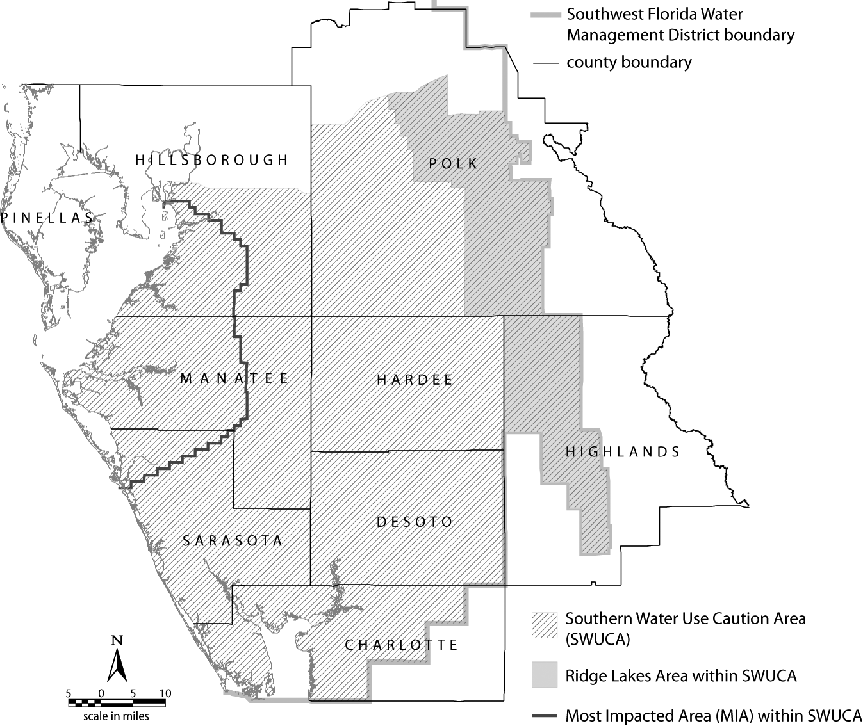
Figure 2-3 Dover Plant City Water Use Caution Area

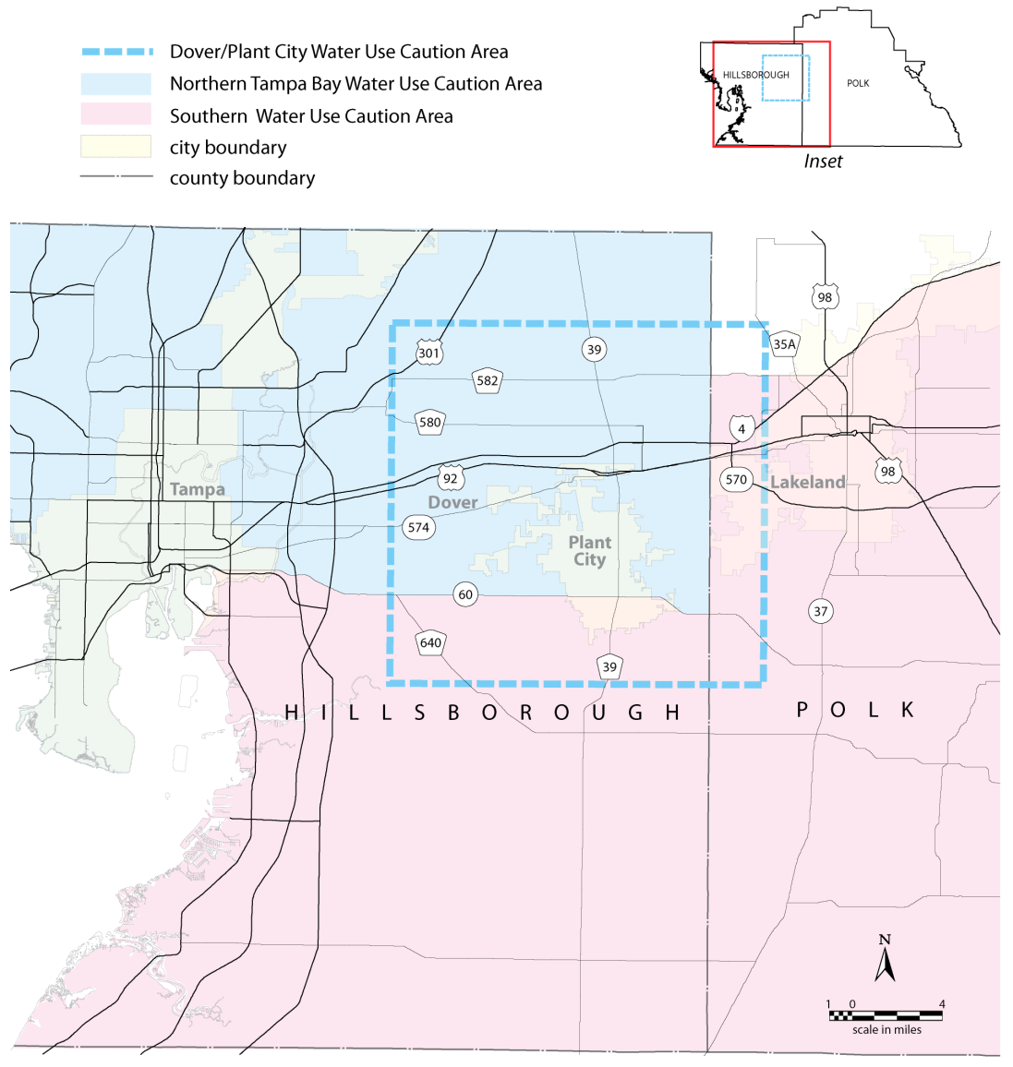
Figure 7.3-1

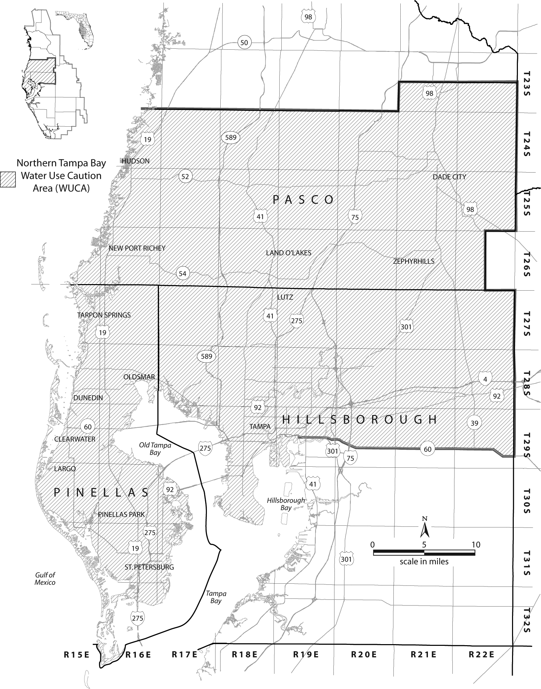
NAME OF PERSON ORIGINATING PROPOSED RULE: Christopher Pettit, Senior Attorney
NAME OF AGENCY HEAD WHO APPROVED THE PROPOSED RULE: Southwest Florida Water Management District Governing Board
DATE PROPOSED RULE APPROVED BY AGENCY HEAD: September 27, 2011
DATE NOTICE OF PROPOSED RULE DEVELOPMENT PUBLISHED IN FAW: April 27, 2012

