62-330.441 Noticed General Permit for Public Navigation Channel and Canal Infrastructure by the West Coast Inland Navigation District within Lee County.
(1) A general permit is hereby granted to the West Coast Inland Navigation District (“WCIND”) to dredge public navigation channels and canals within the trafficsheds and secondary channel systems listed in Table 1 and shown in Figures 1 through 48 of Antonini, Gustavo A., Robert A. Swett, and David Fann, 2008, Maps of Lee County Noticed General Permit Trafficshed Channels and Secondary Channels, SGEF-173, Florida Sea Grant College Program, Gainesville, Florida (30 October 2008), which is hereby incorporated by reference. Additional information on the background, methodology, and data used in identifying the trafficsheds and secondary channel systems that are the subject of this general permit is described in the following reports:
(a) Antonini, Gustavo A, and Paul Box, 1996, A Regional Waterway Systems Management Strategy for Southwest Florida, TP-83, Florida Sea Grant College Program, Gainesville, Florida;
(b) Swett, Robert A., David A. Fann, Gustavo A. Antonini and Lana Carlin Alexander, 2000, Regional Waterway Management System for Lee County, Phase I, TD-3, Florida Sea Grant College Program, Gainesville, Florida;
(c) Swett, Robert A., David A. Fann, Gustavo A. Antonini and Lana Carlin Alexander, 2001, Regional Waterway Management System for Lee County, Phase 2, TD-4, Florida Sea Grant College Program, Gainesville, Florida;
(d) Fann, D.A., R.A. Swett, and G.A. Antonini, 2002. Regional Waterway Management System for Lee County, Phase 3. TD-5, University of Florida, Gainesville, FL: 21 Florida Sea Grant.
Copies of the above documents may be obtained by contacting environmental resource permit program staff in the Department’s South District Office (Fort Myers) and from the Department's Internet site at http://www.dep.state.fl.us/legal/Rules/rulelistnum.htm. This general permit is not required for maintenance dredging that qualifies for an exemption under Section 403.813(1)(f), F.S.
(2) This general permit is further limited as follows:
(a) For purposes of this general permit, the term “public navigation channels and canals” shall consist of the Intracoastal Waterway and those trafficsheds and secondary channel systems identified on the maps in SGEF-173, which have been determined by the WCIND Board to make a significant contribution to public boating traffic.
(b) The area to be dredged shall not contain any living communities of true stony coral (order Scleractinia), hydrocoral (order Milleporina), octocoral (subclass Octocorallia), or soft coral (Alcynoacea, Gorgonacea and Pennatulacea), sponge beds (Porifera), oyster bars (Crassostrea spp.), or macroalgae of the family Caulerpaceae. This shall not prevent dredging of incidental individual specimens of corals, sponges, or oysters. To the extent individual or clumped oysters, corals, or sponges are to be dredged, they shall be relocated to the maximum extent practicable in accordance with paragraph (3)(c) of this general permit. In addition, the dredging alignments shall be located so as to not adversely affect coral and sponge communities and oyster bars as a result of sloughing of channel side slopes. Seagrass within the proposed dredged area shall be relocated in accordance with paragraph (3)(c) of this general permit.
(c) To the maximum extent practicable, dredging alignments shall follow existing channels and previously dredged areas and avoid and minimize impacts to seagrass communities (Potamogetonaceae, Hydrocharitaceae and Cymodoceae sp.). Dredging alignments also shall be located to minimize the potential for erosion to adjacent seagrass communities as a result of sloughing of channel side slopes.
(d)1. The “No Internal Combustion Motor Zones” (NICMZs) shown and described in the attached Exhibit A, which reflect the boundaries approved in Resolution 07-09-49 of the Lee County Board of County Commissioners on September 25, 2007, are hereby established by this general permit. Within these NICMZs, the use of electric motors is permitted, but operators of all vessels equipped with internal combustion motors (e.g.: gasoline or diesel motors) for propulsion must turn off the internal combustion motor and, if possible to do so, tilt or raise the internal combustion motor out of the water.
2. Prior to any dredging authorized by this general permit within an Aquatic Preserve, WCIND shall demonstrate that the NICMZ(s) within that aquatic preserve have been established and marked in the field. Nothing in this rule shall be construed to relieve WCIND from obtaining sign permits required by the Florida Fish and Wildlife Conservation Commission (FWC). For this purpose, DEP authorizes WCIND to apply to FWC for all required sign permits to mark the boundaries of the NICMZs established by this general permit. WCIND shall be responsible for installing and maintaining all permitted signs.
3. WCIND will design and implement a program to monitor seagrasses within the NICMZs using various scientifically approved methods after consultation with DEP and FWC staff. The monitoring shall be designed to establish the baseline coverage of seagrasses by species, the number and coverage of prop scarring, and document any change in coverage over time. At a minimum, the first monitoring will occur within 90 days after the boundaries of the NICMZs have been marked with signage as provided in the preceding section of this general permit, and thereafter every two years for a total of ten years. The monitoring plan shall include metrics that can be used to quantitatively establish the relative success or failure of seagrass restoration and protection following establishment of the NICMZs.
(e) Dredging alignments shall not exceed the maximum depths shown in Table 1. All dredging alignments shall not exceed a maximum top width of 30 feet and a maximum bottom width of 20 feet. Overdredging to achieve the final authorized depth and width is not allowed. An as-built survey of the dredging alignment shall be submitted to the Department as provided in paragraph (3)(h) below.
(f) No more than 8,500 cubic yards of dredged material shall be cumulatively removed through authorizations by this general permit over a five-year period within each trafficshed or secondary channel system, beginning with the first project authorized under this general permit within the trafficshed or secondary channel system. Within 30 days following the completion of the as-built survey required in paragraphs (2)(e) above and (3)(h), below, a report shall be submitted to the South District office of the Department that includes the volume of material excavated from each channel and canal within the trafficshed or secondary channel system, and the cumulative total volume of material excavated for the trafficshed or secondary channel system under this general permit within the previous five years. This report shall be included with any subsequent notices to dredge channels or canals within the same trafficshed or secondary channel system.
(g) The dredging activity is restricted to Class III Waters, or Class II Waters that are classified by the Department of Agriculture and Consumer Services under Chapter 62R-7, F.A.C., as unclassified, prohibited, restricted, or conditionally approved for shellfish harvesting.
(h) This general permit shall not apply to dredging within the limits of areas subject to currently valid individual ERP dredging permits.
(3) All work under this general permit shall be conducted in conformance with the general conditions of Rule 62-341.215, F.A.C., and the following specific conditions.
(a) Each dredging event for a trafficshed or secondary channel system shall require a separate notice to use this general permit. Multiple areas within a single trafficshed or secondary channel system may be included in one notice. Each notice shall be submitted with the following:
1. Scaled plan and cross-sectional drawings that clearly identify the length, width, and depth (referenced to mean lower low water) of the area or areas to be dredged within each channel and canal; locations of any hydraulic pipelines between the dredge areas and the dredged material disposal sites; and identification of the channels, canals, and names of the trafficsheds or secondary channel system that are to be dredged from Table 1.
2. Identification of the source document described in subsection 1 and reference data that specifically describe the work proposed for dredging within the trafficshed or secondary channel system. All document titles, page numbers, figures, and other relevant information to the trafficshed or secondary channel system must be identified.
3. The location, dimensions, and estimated volumes of dredged material disposal sites, including the location of any water quality or habitat restoration as described in paragraph (3)(d) of this general permit and any relocation areas required under paragraph (2)(b) of this general permit. If dredged material fill will be transported over water by barge, the notice will include assurance that the barge will be designed and sized to prevent discharge of dredged material runoff, prop or hull dredging, and discharge during the loading and unloading of material. If stockpile areas are to be used for temporary disposal and transport, the type and volume capacity of such stockpile areas, including controls that will be used to prevent dredge material runoff also must be described. The notice must provide assurance any temporary stockpile areas will have no impacts to jurisdictional wetlands or surface waters.
4. The estimated volume of each proposed dredging area.
5. Identification of any special water classifications for the areas to be dredged, such as the water class (Rule 62-302.400, F.A.C.); shellfish classification under Chapter 62R-7, F.A.C.; Aquatic Preserve, state park, or state recreation area designation under Chapter 258, F.S.; and Outstanding Florida Water or Outstanding National Resource Water designation under Rule 62-302.700, F.A.C.
6. A resource inventory of the dredging alignments which has been prepared or updated between May through September within one year prior to the proposed dredging. The resource inventory must be conducted by an individual experienced and knowledgeable in benthic communities and seagrass identification. The resource inventory must identify the presence and location of seagrasses, oysters, coral communities, sponge beds, and macroalgae of the family Caulerpaceae. This resource inventory must also include all areas within any requested mixing zones associated with the dredging project (including outfall pipes from the dredge material disposal area), and all areas that will be occupied by dredging equipment (including cables, pipelines, dredges, barges, and stockpiling/disposal of dredged material). The resource inventory assessment within channels will be conducted as follows, although the WCIND may use equivalent assessment methods upon receiving prior written approval from the Department:
a. The assessment will be conducted along a minimum of two transects within the dredging alignment. The transects will be along a line parallel with and 5 feet within the sides of the dredging alignment;
b. The resource inventory assessment within any requested mixing zones shall be conducted along grid transects every 10 feet throughout the length and width of the requested mixing zone; and
c. The resource inventory shall be qualitative in nature but shall include identification and location of corals, sponges, and oysters to be relocated pursuant to paragraph (2)(b) of this general permit, and include general identification and location of the extent of seagrass areas and a qualitative description of their relative extent of coverage, and density. The resource inventory shall be completed and submitted a minimum of 30 days prior to the pre-application meeting required by paragraph (3)(b) of this general permit.
7. Identification of the extent and location of all previous dredging within the past five years authorized pursuant to this noticed general permit within the trafficshed or secondary channel system; the date of all such dredging events; the estimated cubic yards excavated from each distinct portion of the trafficshed or secondary channel system pursuant to this general permit; and the permit numbers assigned to such prior use of this general permit for the trafficshed or secondary channel system.
8. The estimated date the dredging activities are planned to begin and the estimated length of time it will take to complete the project. If the project will be accomplished in phases, the estimated starting and ending date of each phase must also be submitted.
9. A plan for monitoring water quality minimally consisting of monitoring at the dredge site, at the location of any waters receiving outfall from dredged material disposal sites, and at background and down-gradient locations in the water body where dredging is occurring and surrounding the dredged material disposal sites. The monitoring shall be designed primarily to measure in-situ turbidity, but is subject to modification based on the pre-application meeting discussion with the Department to ensure the plan is capable of detecting any potential water quality violations from the work. If the dredge area is in close proximity to a facility or location likely to cause a discharge of toxic materials, the water quality monitoring as well as best management practices proposed shall be designed to contain deleterious substances during dredging. Results of the monitoring and a copy of the logs shall be submitted in accordance with the provisions in paragraph (3)(f) of this general permit.
10. A description of the resources to be relocated pursuant to paragraphs (2)(b) and (3)(c) of this general permit, the methods to be used for their relocation, and the locations to which they will be relocated.
(b) A minimum of 30 days prior to submittal of a notice to use this general permit, the WCIND and Lee County shall conduct at least one pre-application meeting with the South District Department Environmental Resources Permitting staff to discuss project designs, implementation details, and any resource concerns, including approval of any resource relocation in accordance with paragraph (2)(b) of this general permit or water quality or habitat restoration sites in accordance with paragraph (3)(d) of this general permit. For a proposed project within an aquatic preserve, this meeting shall include the appropriate aquatic preserve manager or their designee. In the event the pre-application meeting adequately addresses all Department questions or concerns, the Department will inform the WCIND that the notice may be submitted immediately for review.
(c) To the extent seagrass, corals, sponges or clumped oysters are within the dredging footprint, they shall be relocated to the maximum extent practicable. Seagrass, oysters, corals, and sponges must be relocated only into areas previously approved in writing by the Department. Relocation shall be done in a manner that avoids adverse impacts to water quality and adjacent submerged resources. If seagrasses are relocated, the donor site within the dredge area and the recipient location of the seagrass transplant shall be described in the application and in the pre-application meeting required under paragraph (3)(b) of this general permit. Any relocation performed pursuant to this paragraph shall be described in a detailed report to the South District office of the Department within 60 days of project completion. The report shall describe the methods used, the donor site within the dredge area, and the recipient location of the transplant. The WCIND shall provide copies to the South District office of the Department of any follow up monitoring or studies performed on the success of the transplants.
(d) All dredged material resulting from the activities authorized by this general permit shall be removed and deposited on a self-contained, upland dredged material disposal site. The only exceptions to the use of a self-contained, upland dredged material disposal site shall be: seagrass, oyster, coral, or sponge relocations as required by this general permit; or where dredged materials are to be used as part of a water quality or habitat restoration plan authorized by the Department or a water management district under Part IV of Chapter 373, F.S., in which case any discharge of dredged material shall be in compliance with all terms of that authorization. In all cases, the dredging operation, the discharge of dredged material, and the dredged material disposal site shall be designed, located, and operated such that there are no water quality violations in wetlands or other surface waters outside of a mixing zone established under paragraph (3)(e) of this general permit.
(e) In areas outside of aquatic preserves, violations of state water quality standards shall be prevented immediately outside of a mixing zone of no more than 150 meters in radius from the dredge site and from any discharge point associated with a dredge material disposal area. To the greatest extent practicable, the mixing zone shall be restricted to the limits of the dredging alignment. Within aquatic preserves, violations of state water quality standards immediately outside the area of active work shall be prevented. This shall minimally consist of the use of erosion and sediment control devices, turbidity curtains or similar devices, and other best management practices, all of which shall be located immediately surrounding the area of active work and maintained in a functional condition. In addition, dredge pumping rates and volumes shall be managed to minimize discharges from dredged material disposal sites; and the management of dredged material disposal site dikes, berms, and water control structures so as to minimize erosion, breaches, and discharges. In all cases, mixing zones shall be designed to avoid living communities of stony corals [true stony corals (order Scleractinia) hydrocorals (order Milleporina)], and octocorals (subclass Octocorallia), sponge bed communities (Porifera), oyster bars (Crassostrea spp.), macroalgae of the family Caulerpaceae, and seagrass (Potamogetaceae, Hydrocharitaceae and Cymodoceae).
(f) At all times during active dredging, the collection, analysis, and monitoring of the water quality samples required under this general permit must be conducted and performed by individuals who have prior training and experience in collecting and analyzing water quality samples using the Standard Operating Procedures accessible at the Department’s Internet site and in accordance with Chapter 62-160, F.A.C. Such qualified individual(s) shall be on site at all times necessary to ensure full compliance with the requirements of this noticed general permit. In the event the water quality monitoring required under this general permit detects violations of state water quality standards, dredging shall cease immediately until the source of the violation is identified, measures taken to avoid future violations, and the receiving waters again meet applicable water quality standards. Weekly reports describing the hours of dredging accomplished and the results of the required monitoring will be provided to the South District office of the Department. Any violations of state water quality standards and/or other requirements of this noticed general permit shall be immediately reported to the South District office of the Department.
(g) The permittee shall be responsible for ensuring that all contractors and other entities implementing this general permit comply with the following standard manatee and marine turtle conditions:
1. The permittee shall instruct all personnel associated with the project of the potential presence of manatees and the need to avoid collisions with manatees. All construction personnel shall be responsible for observing water-related activities for the presence of manatees.
2. The permittee shall advise all construction personnel that there are civil and criminal penalties for harming, harassing, or killing manatees, which are protected under the Marine Mammal Protection Act of 1972, the Endangered Species Act of 1973, and the Florida Manatee Sanctuary Act of 1978. If the dredging activity results in any manatee being harmed, harassed, or killed as a result of construction activities, the Department will refer the matter to the Florida Fish and Wildlife Conservation Commission (FWC) for appropriate action.
3. Siltation barriers shall be made of material in which manatees and turtles cannot become entangled, shall be properly secured, and shall be monitored regularly to avoid manatee entrapment. Barriers associated with any activities authorized by this general permit shall not block manatee entry to or exit from manatee feeding areas and the following manatee warm water refuge areas:
a. Entrance of the Chiquita Canal (which provides access to the Eight Lakes area) within the Cape Coral Southwest Trafficshed.
b. The defined manatee protection speed zone within the Franklin Locks East Trafficshed and all waters of the Caloosahatchee River within 1/4 mile east of the easternmost end of the Franklin Lock & Dam.
c. Matlacha channel (which provides access to the Matlacha Isles canal system) including the Matlacha Isles canal system in the vicinity of the Boat Lift within the Matlacha Isles/Cape Coral (northwest) Trafficshed.
d. Mouth and remainder of the Orange River within the Orange River Trafficshed.
e. All waters within the Mullock Creek Trafficshed.
4. All vessels associated with the project shall operate at “no wake idle” speeds at all times while in water where the draft of the vessel provides less than four-foot clearance from the bottom, and such vessels shall follow routes of deep water whenever possible.
5. If a manatee is sighted within 100 yards of the project area, precautions shall be implemented by the permittee and the contractor to ensure protection of manatees. These precautions shall include not operating any equipment closer than 50 feet to a manatee, and immediately shutting down equipment if a manatee comes within 50 feet of the equipment. Activities will not resume until the manatees have departed the project area of their own volition.
6. Any collision with or injury to a manatee or marine turtle shall be reported immediately to the FWC at 1(888)404-FWCC (1(888)404-3922).
7. Temporary signs concerning manatees shall be posted prior to and during dredging activities. All signs are to be removed by the permittee upon completion of the project. A sign measuring at least three feet by four feet which reads “Caution: Manatee Area” shall be posted in a location prominently visible to water-related construction crews. A second sign shall be posted if vessels are associated with the construction, and shall be placed visible to the vessel operator. The second sign shall be at least 8 inches by 11 inches and read: Caution: Manatee Habitat. Idle speed is required if operating a vessel in the construction area. All equipment must be shutdown if a manatee comes within 50 feet of the operation. A collision with or injury to a manatee shall be reported immediately to the FWC at 1(888)404-FWCC (1(888)404-3922). Specific information on obtaining these signs may be obtained by contacting the FWC.
8. Specific personnel shall be designated as manatee observers. The designated observer(s) shall be dedicated only for this task, must be on site during all in-water dredging activities, and will advise personnel to cease operation upon sighting a manatee within 50 feet of any in-water construction activity. The observer(s) shall wear polarized sunglasses during all dredging to aid in observation, and shall work in shifts of no longer than 5 hours each. Observers shall maintain a log detailing manatee sightings, work stoppages, and other protected species-related incidents. If approved by the Department after consultation with the FWC, the WCIND shall be allowed to implement alternative measures for observing for the presence of manatees when such measures provide reasonable assurance that manatees will not be adversely affected by the alternative methodology.
9. A report, summarizing all activities noted in the observer logs, the location and name of project, and the dates and times of work shall be submitted within 30 days following project completion, to the FWC’s Imperiled Species Management Section at: 620 South Meridian Street, 6A, Tallahassee, Florida 32399-1600, or e-mailed at fcmpmail@myfwc.com.
10. No nighttime mechanical dredging, such as clamshell, shall occur. Movement of a work barge or other associated vessels shall not be performed after sunset, when the possibility of spotting manatees is negligible.
11. All channels designated as Cape Coral Southwest, Franklin Locks East, Matlacha Isles/Cape Coral (northwest), Mullock Creek, and Orange River shall be prohibited from being dredged between November 15th and March 31st of any year due to the high numbers of manatees present at these warm water refuges in the wintertime. When these areas are being dredged between April 1st and November 14th, the manatee protection measures outlined above for all other channel dredging shall be followed.
(h) An as-built survey shall be initiated within two weeks and shall be completed within 60 days after completion of dredging to document depths and widths established by the dredging. The Department shall grant additional time as reasonable to complete the survey upon submittal of written documentation of the existence of inclement weather or situations beyond the control of the permittee that prevented the timely completion of the survey, the submittal of a new timeline for completing the survey.
(i) Within 90 days of completion of each authorized dredge event under this general permit, the affected trafficshed or secondary channel system shall be marked along its entire length with aids to navigation. Markers shall be placed in a manner to facilitate safe navigation and protection of submerged natural resources. In channels dredged to less than 4 foot MLLW depth, signage that identifies areas of shallow water shall be installed, using language such as “Controlling Depth 3 feet, Local Knowledge Required,” “Use Caution,” or “Stay in Channel.” Nothing in this rule shall be construed to relieve the WCIND from obtaining permits for markers and signs required by the FWC.
(j) WCIND shall provide an as-built report and survey detailing all work performed under this authorization and its compliance with the conditions and criteria of this general permit.
(k) All reports and information required by this authorization shall be submitted to the South District DEP office.
(l) WCIND will facilitate an update of the Lee County Boaters Guide to reflect the NICMZs established by this general permit. The update will also include computer internet links to additional boater information that will enhance water quality and protection of resources within the aquatic preserves that are the subject of this general permit. WCIND will facilitate the distribution of the updated Boaters Guide to local marinas, commercial boat rental operations, and local residents.
(m) Works under this general permit shall not commence until the Department has provided written confirmation within 30 days that the notice required under paragraph (3)(a) meets all the applicable terms and conditions of this general permit.
(4) WCIND is advised that, pursuant to Section 556.105, F.S., excavating contractors are required to provide certain information concerning the excavation through the one-call notification system not less than two, nor more than five, business days before beginning any excavation.
(5) A Letter of Consent is granted in accordance with subparagraphs 18-21.005(1)(c)10., 15. and 16., F.A.C., by the Board of Trustees of the Internal Improvement Trust Fund (BOT), for the West Coast Inland Navigation District to enter upon and use state-owned submerged lands to the extent necessary to complete the permitted activities. A Letter of Consent also is granted in accordance with subparagraphs 18-21.005(1)(c)15. and 16., F.A.C., from the BOT to Lee County and the West Coast Inland Navigation District to establish, mark, and enforce the NICMZs depicted in Exhibit A.
(6) In accordance with Section 253.77, F.S., dredged material removed from sovereign submerged lands under this general permit is exempt from the payment of severed dredged material fees. However, dredged material with economic value, such as beach quality sand, shall be used for public purposes to the maximum extent practicable.

Table 1. Trafficsheds, Secondary Channel Systems, Dredge Depth Limits, and Trafficshed Report Identification Numbers

Trafficshed or Secondary Channel System Name | NGP Dredge Depth (ft) | All Channels Length (ft) | Public Channel Length (ft) | Anticipated NGP Dredge Length (ft) | Public Channel Length in AP (ft) | Anticipated Dredge Length in AP (ft) | Anticipated Dredge Length Outside AP (ft) | Anticipated Dredge Length in AP Sea Grass (ft) | Anticipated Dredge Length in Any Sea Grass (ft)
Back Channel-South Estero Bay | 3 | 18,252 | 18,252 | 178 | 18,252 | 178 | 0 | 0
Big Carlos Pass & Vicinity | 4.5 | 9,354 | 9,354 | 0 | 8,082 | 0 | 0 | 0
Bokeelia (east) | 4.5 | 33,027 | 8,499 | 535 | 6,227 | 450 | 86 | 0 | 0
Bokeelia (west) | 3.5 | 48,391 | 13,807 | 1,982 | 13,807 | 1,982 | 0 | 68 | 68
Caloosa Isle Marina | 5.0 | 28,326 | 8,343 | 2,539 | 0 | 0 | 2,539 | 0
Cape Coral Southwest | 6.0 | 359,431 | 10,603 | 1,521 | 0 | 0 | 1,521 | 0
Central Estero Bay | 2.5 | 18,437 | 18,437 | 385 | 18,437 | 385 | 0 | 0
Chantry Canal | 4.5 | 76,137 | 11,315 | 458 | 0 | 0 | 458 | 0
Compass Rose | 4.5 | 1,172 | 1,172 | 0 | 97 | 0 | 0 | 0
Deep Lagoon | 6.0 | 37,861 | 9,242 | 491 | 0 | 0 | 491 | 0
Demere Key | 3.5 | 21,647 | 19,721 | 1,052 | 18,927 | 896 | 156 | 735 | 735
East Fort Myers | 7.0 | 26,534 | 2,588 | 1,622 | 0 | 0 | 1,622 | 0
Estero Island-Bayside Channels | 4.5 | 11,955 | 11,955 | 853 | 0 | 0 | 853 | 0
Everest Canal | 5.0 | 124,094 | 4,928 | 2,494 | 0 | 0 | 2,494 | 0
Fish Tale Marina | 4.0 | 7,391 | 1,849 | 0 | 305 | 0 | 0 | 0
Fish Trap Bay 2 | 2.5 | 8,893 | 3,213 | 520 | 3,213 | 520 | 0 | 0
Fort Myers Yacht Basin | 7.0 | 7,941 | 7,941 | 4,987 | 0 | 0 | 4,987 | 0
Franklin Locks East | 5.0 | 38,843 | 2,478 | 1,405 | 0 | 0 | 1,405 | 0
Getaway | 5.0 | 2,604 | 2,604 | 1,066 | 0 | 0 | 1,066 | 0 | 191
Hancock Creek | 5.0 | 57,956 | 26,613 | 2,778 | 0 | 0 | 2,778 | 0
Hogue | 4.0 | 3,115 | 3,115 | 345 | 3,115 | 345 | 0 | 0
Hurricane Bay East | 4.5 | 8,602 | 8,602 | 917 | 8,474 | 917 | 0 | 0
Hurricane Bay West | 5.0 | 8,750 | 8,750 | 1,369 | 0 | 0 | 1,369 | 0
Imperial River-Lower | 3.5 | 31,336 | 15,203 | 661 | 9,225 | 661 | 0 | 0
Imperial River-Upper | 2.5 | 37,630 | 9,913 | 713 | 0 | 0 | 713 | 0
Imperial Shores | 2.5 | 15,526 | 4,106 | 1,685 | 4,106 | 1,685 | 0 | 0
Marsh Point | 3.0 | 17,783 | 5,729 | 1,201 | 0 | 0 | 1,201 | 0
Matanzas Harbor | 5.5 | 5,103 | 5,103 | 66 | 0 | 0 | 66 | 0
Matlacha (northwest) | 4.5 | 26,245 | 1,457 | 654 | 1,457 | 654 | 0 | 0
Matlacha (southwest 2) | 3.5 | 10,670 | 2,719 | 180 | 2,719 | 180 | 0 | 0
Matlacha Isles/Cape Coral (northwest) | 4.0 | 265,603 | 14,057 | 1,729 | 8,399 | 1,550 | 257 | 0
Mullock Creek | 2.5 | 42,168 | 11,374 | 2,099 | 10,161 | 2,099 | 0 | 0
Normandy Canal | 5.0 | 33,982 | 11,878 | 4,068 | 0 | 0 | 4,068 | 0
North Matlacha | 4.5 | 62,864 | 62,864 | 84 | 62,864 | 84 | 0 | 0
Orange River | 6.5 | 46,750 | 3,595 | 100 | 0 | 0 | 100 | 0
Pelican Landing | 2.5 | 3,992 | 3,992 | 1,169 | 3,992 | 1,169 | 0 | 0
Plato Canal | 5.5 | 109,235 | 18,520 | 5,487 | 0 | 0 | 5,487 | 0
Punta Rassa/Connie Mack Island | 5.0 | 28,784 | 14,869 | 4,084 | 0 | 0 | 4,084 | 0 | 103
Redfish Point | 6.0 | 33,806 | 13,023 | 4,436 | 0 | 0 | 4,436 | 0
Rookery Trace | 3.5 | 8,496 | 8,496 | 1,028 | 1,621 | 819 | 231 | 0
Roosevelt Channel-Bayside | 3.0 | 2,249 | 1,509 | 0 | 1,292 | 0 | 0 | 0
Roosevelt Channel-North | 5.0 | 27,369 | 17,918 | 694 | 17,918 | 694 | 0 | 0
Saint James City (east) | 5.0 | 23,006 | 16,137 | 3,266 | 0 | 0 | 3,266 | 0
Saint James City (south 1) | 5.0 | 52,518 | 18,385 | 6,531 | 5,459 | 502 | 6,030 | 252 | 252
Siesta Isles | 5.0 | 17,962 | 1,088 | 713 | 0 | 0 | 713 | 0
South Estero Bay | 4.0 | 27,694 | 27,694 | 327 | 27,694 | 327 | 0 | 0
South Matlacha | 3.5 | 71,465 | 71,465 | 889 | 28,408 | 381 | 508 | 381 | 381
Sunset Bay | 2.5 | 2,681 | 2,440 | 376 | 2,440 | 376 | 0 | 0

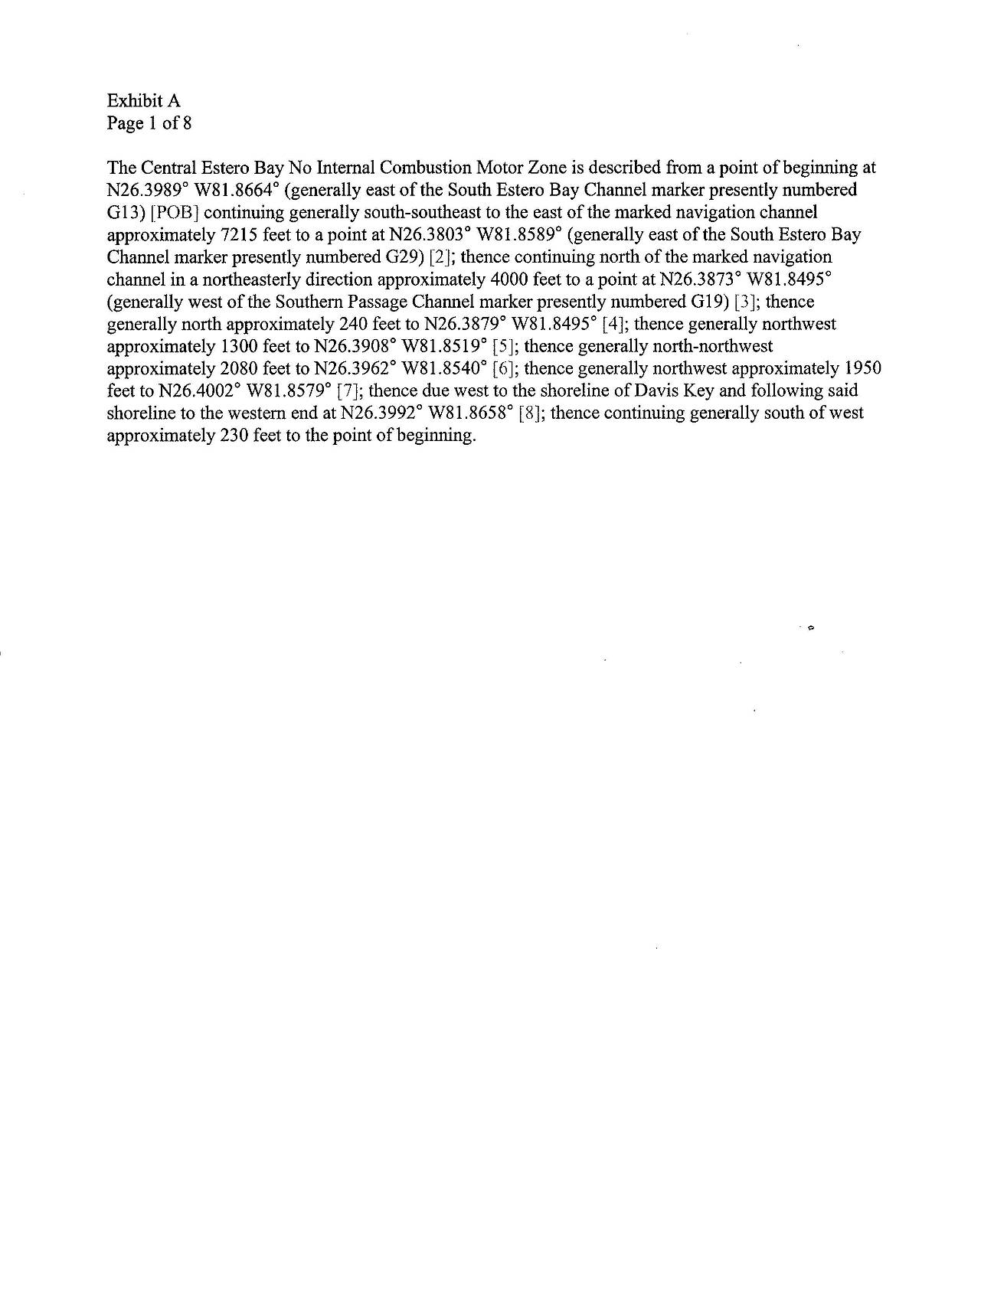
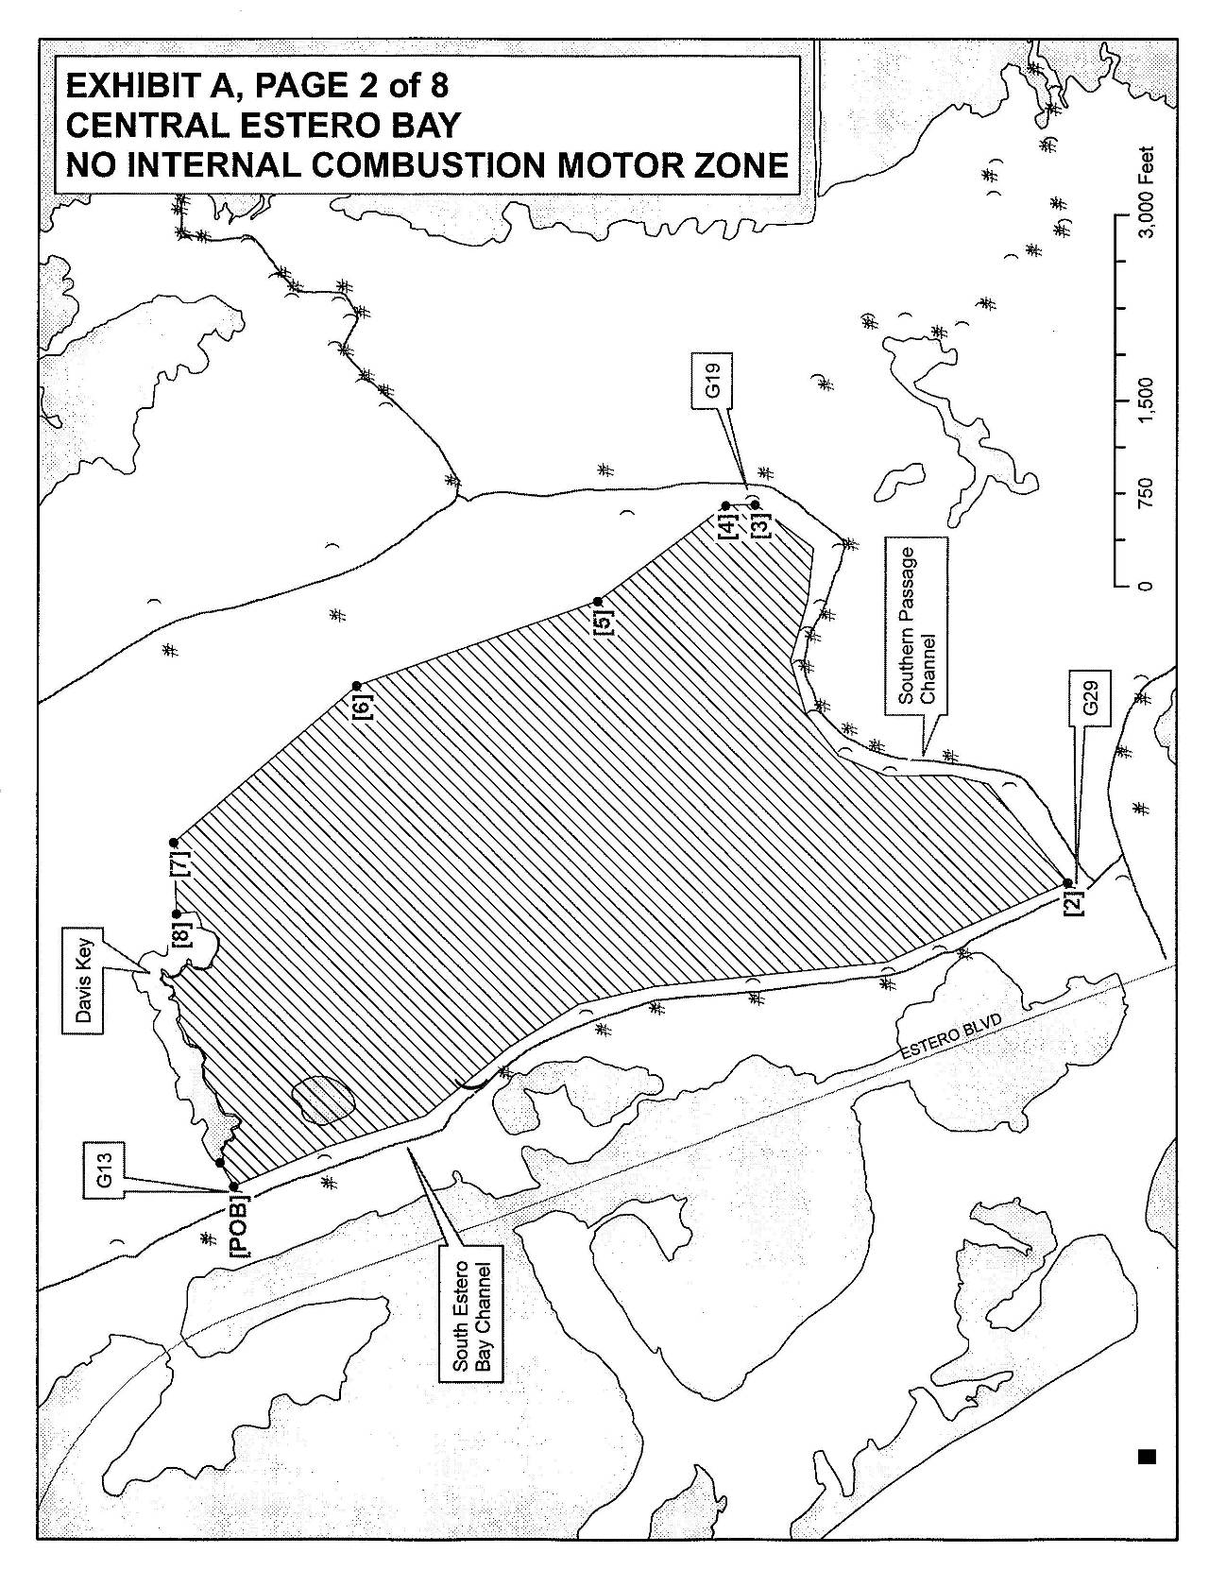

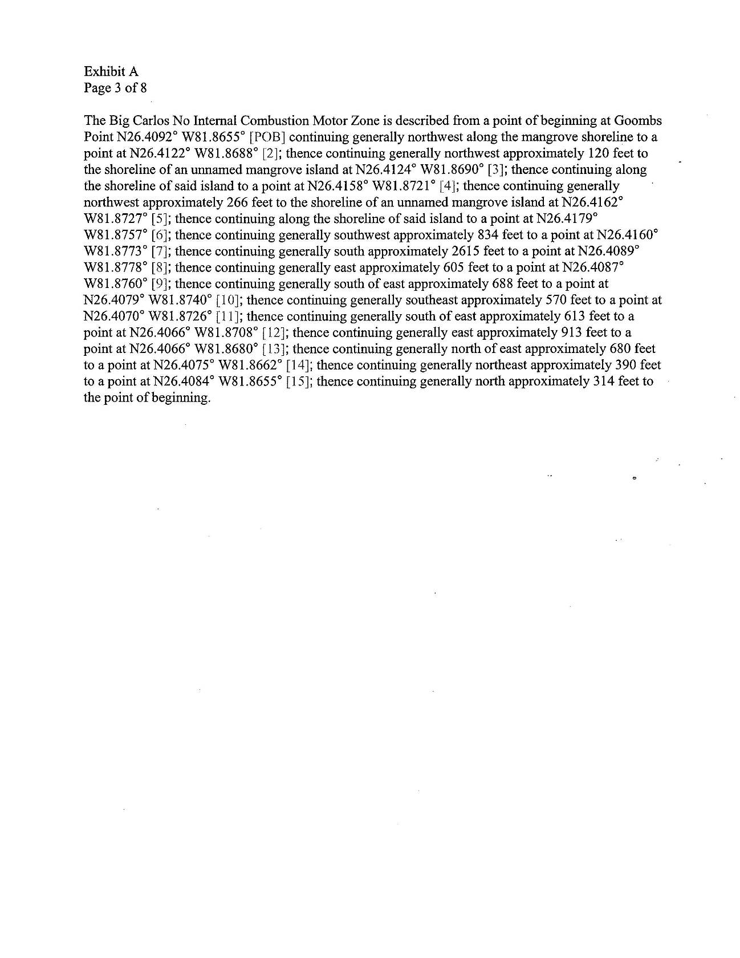
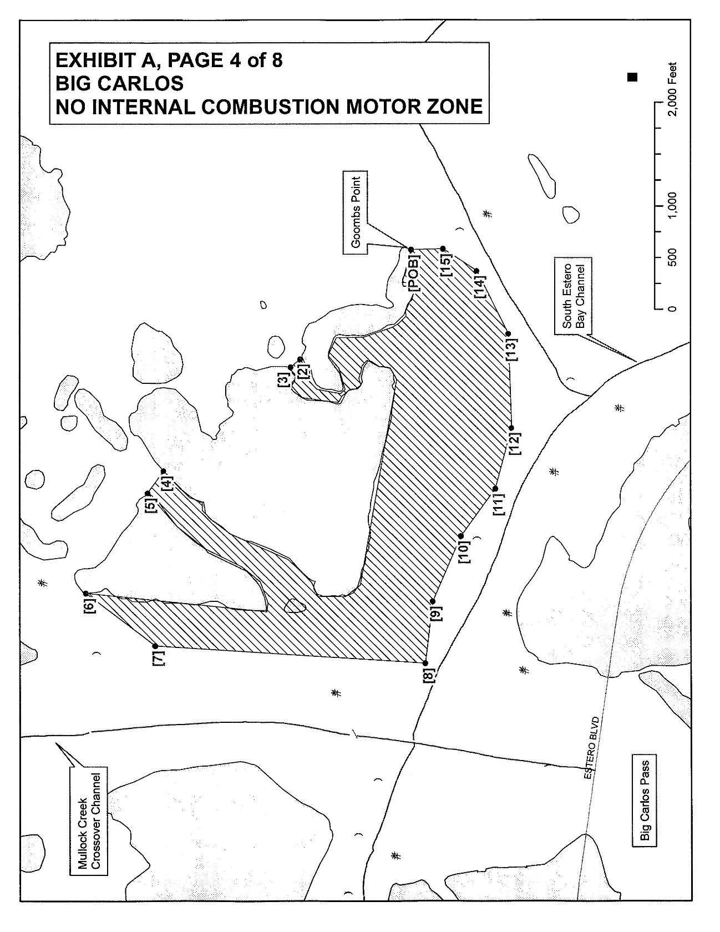
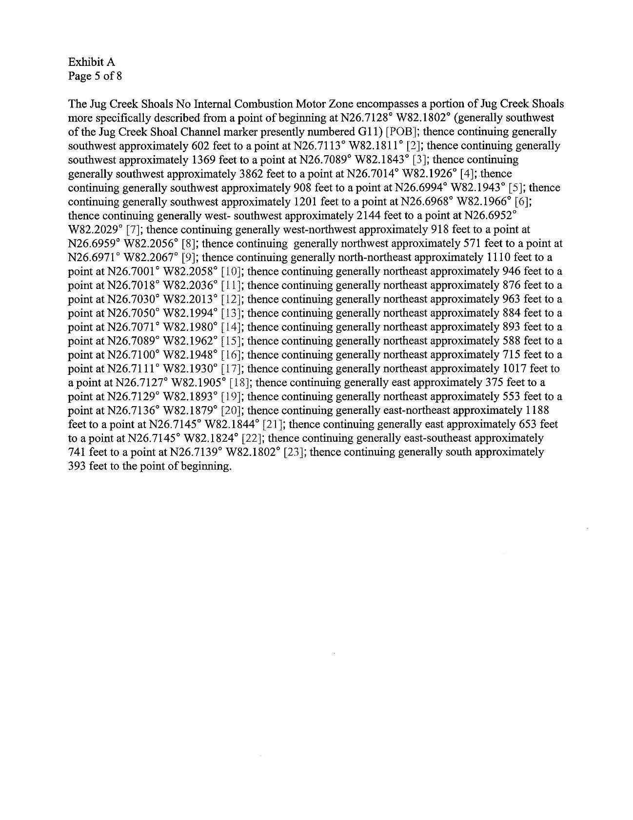
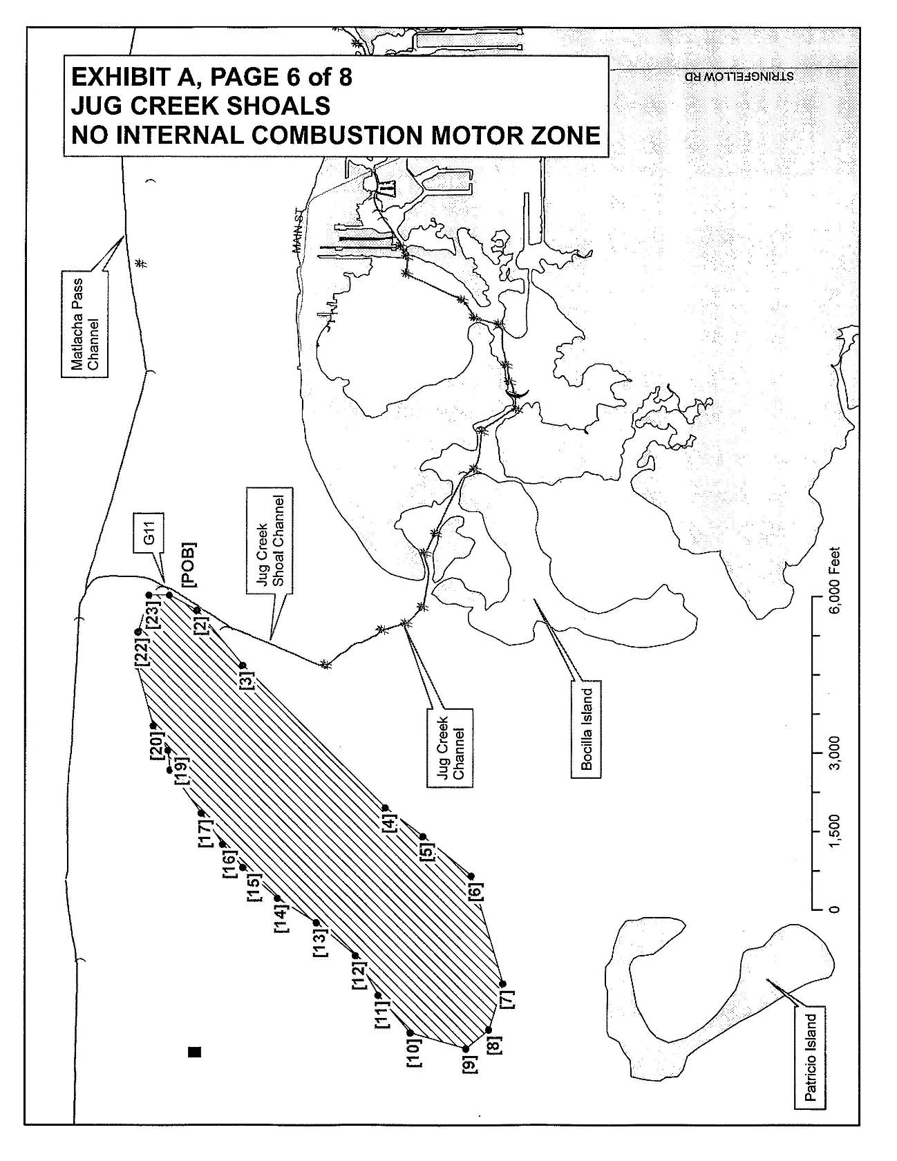
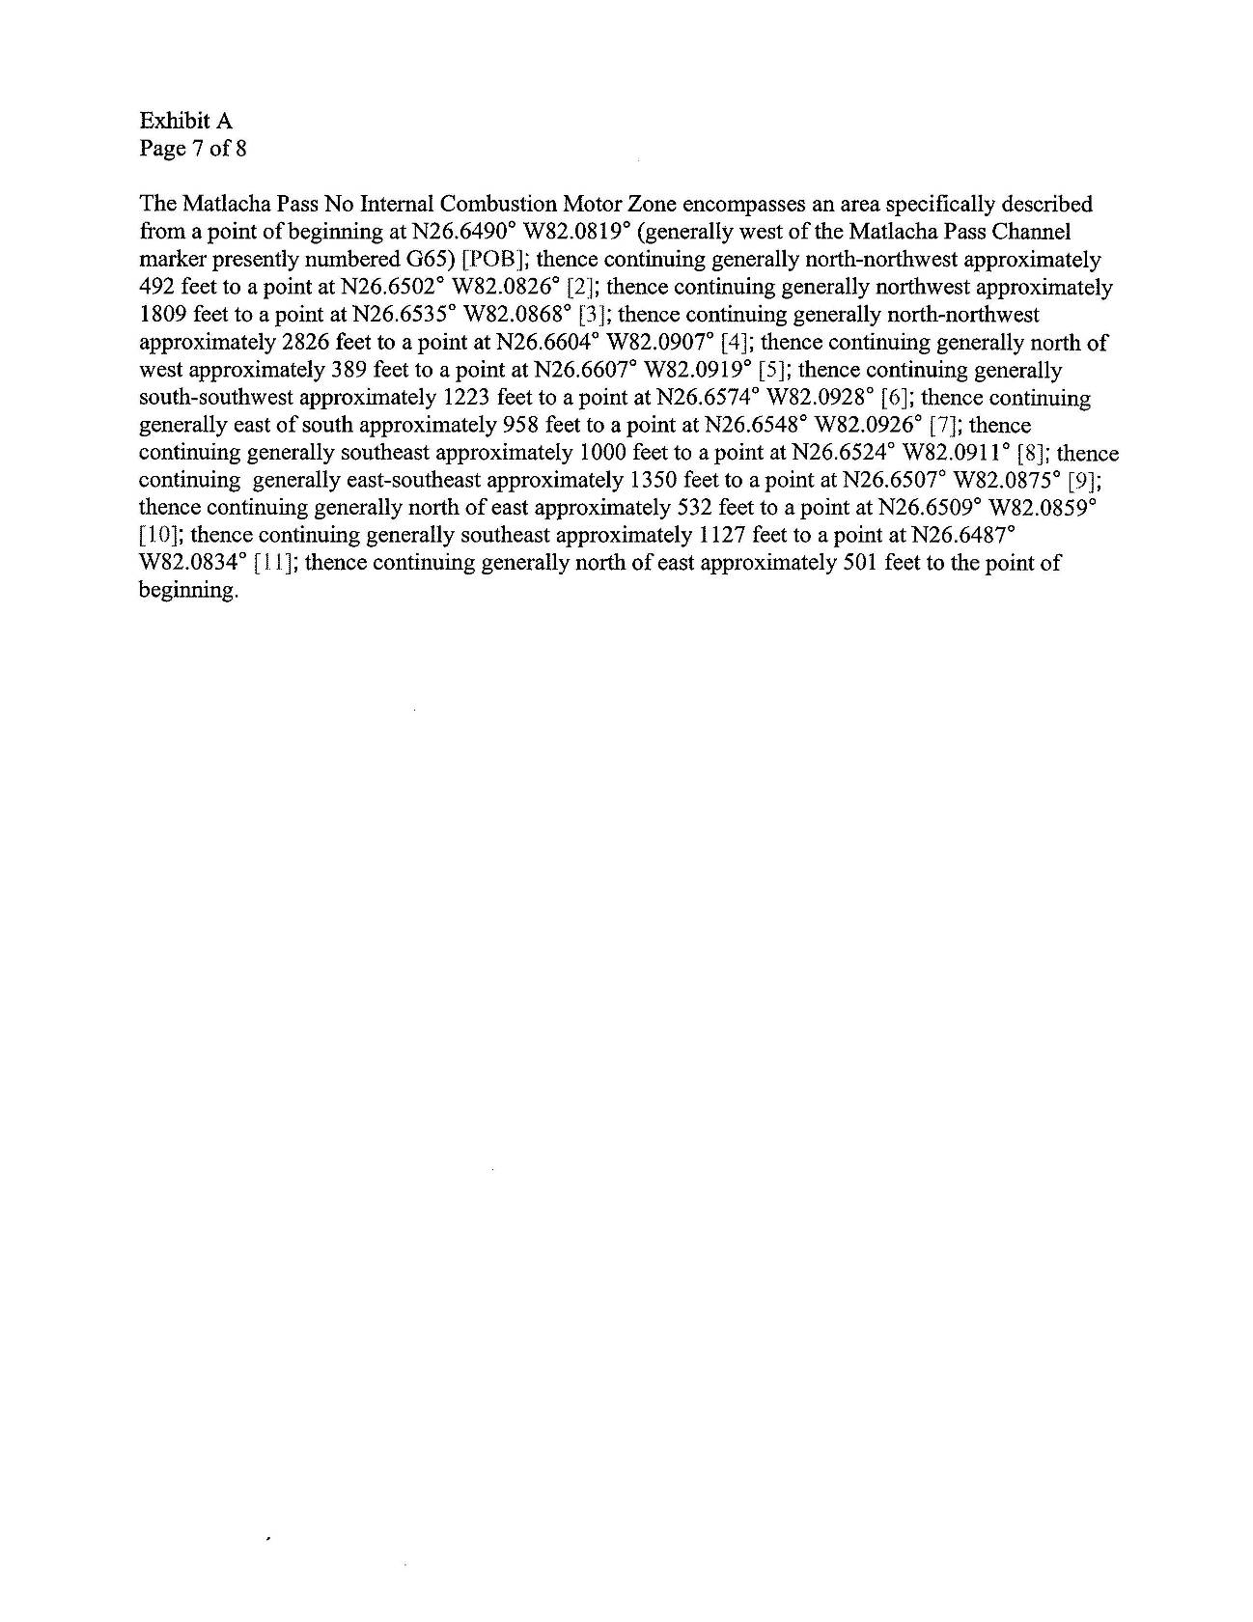
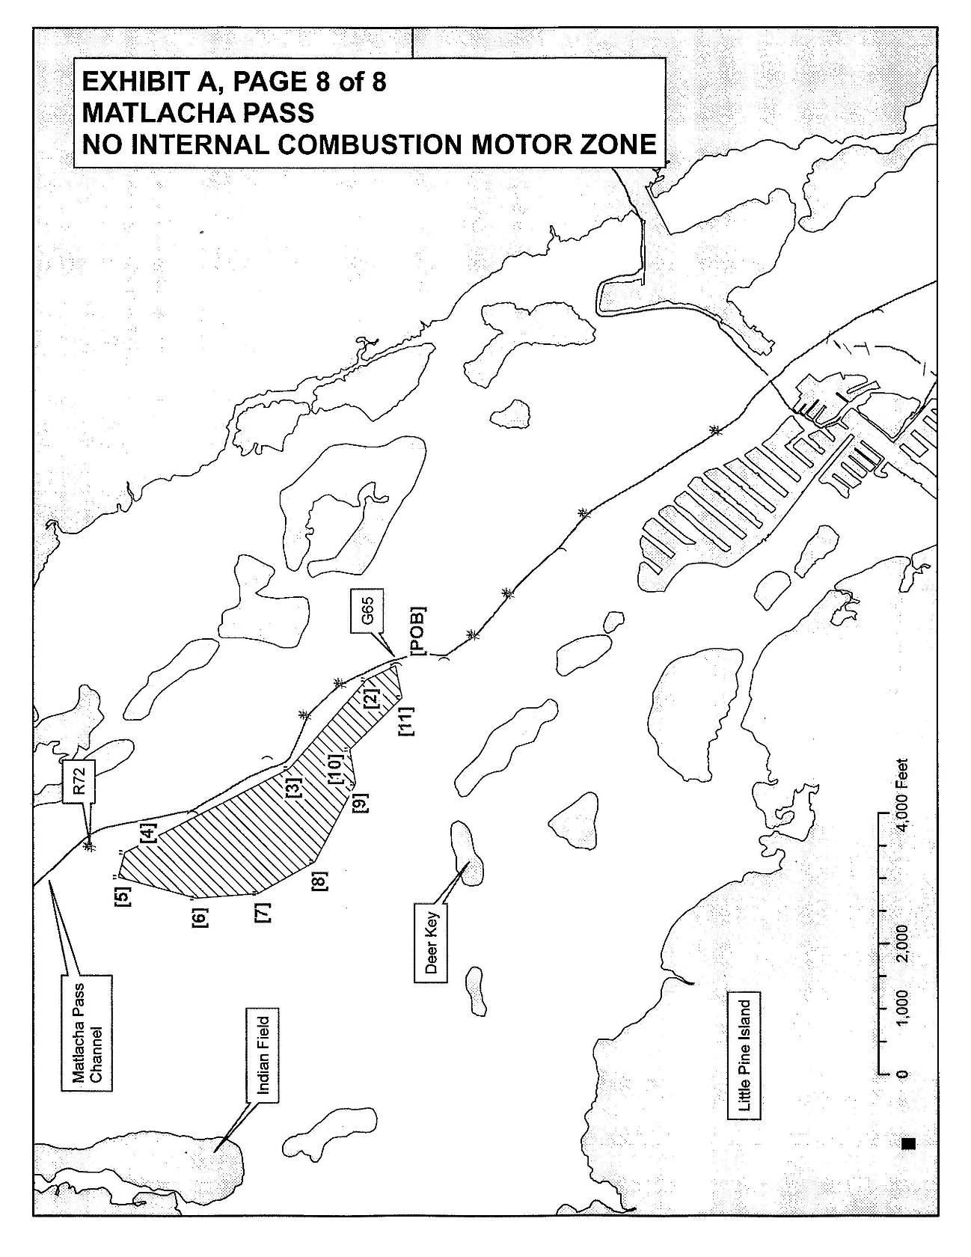
Rulemaking Authority 373.026(7), 373.043, 373.118(1), 373.406(5), 373.414(9), 373.418, 403.805(1), 403.814(1) FS. Law Implemented 253.002, 253.77(1), 253.77(4), 258.42, 373.118(1), 373.406(5), 373.413, 373.414(1), 373.414(1)(b), 373.414(9), 373.416, 373.426, 403.061(34), 403.813(3), 403.814(1) FS. History–New 2-18-10, Formerly 62-341.494.

