68D-24.144 Monroe County Boating Restricted Areas.
(1) For the purpose of regulating the anchoring of vessels in and adjacent to the Newfound Harbor Channel (also known as Pine Channel) within Monroe County, the following boating restricted area is established:
Newfound Harbor Channel (Pine Channel) – Anchoring of all sailboats and other vessels with masts is prohibited in Newfound Harbor Channel (Pine Channel), shoreline to shoreline, between Big Pine Key and Little Torch Key, from the centerline of US Highway 1 south to a line drawn from the southernmost point on Little Torch Key to the southernmost point on Big Pine Key (a distance approximately 6,000' feet south of the centerline of US Highway 1), as depicted in Drawing A. If the overhead power lines are removed, the zone established in this paragraph shall no longer be in force or effect.
(2) For the purpose of regulating the speed and operation of vessel traffic on the Florida Intracoastal Waterway (ICW) in Monroe County, the following boating restricted area is established:
Jewfish Creek: A Slow Speed Minimum Wake boating restricted area in and adjacent to the ICW, bounded on the north by a line drawn perpendicular to the centerline of the ICW 300' feet north of the north end of the Jewfish Creek (US Highway 1) Bridge fender system to a line drawn perpendicular to the centerline of the ICW 800' feet south of the south end of the Jewfish Creek (US Highway 1) Bridge fender system, as depicted in Drawing B.
(3) The boating restricted areas are depicted on the following maps:
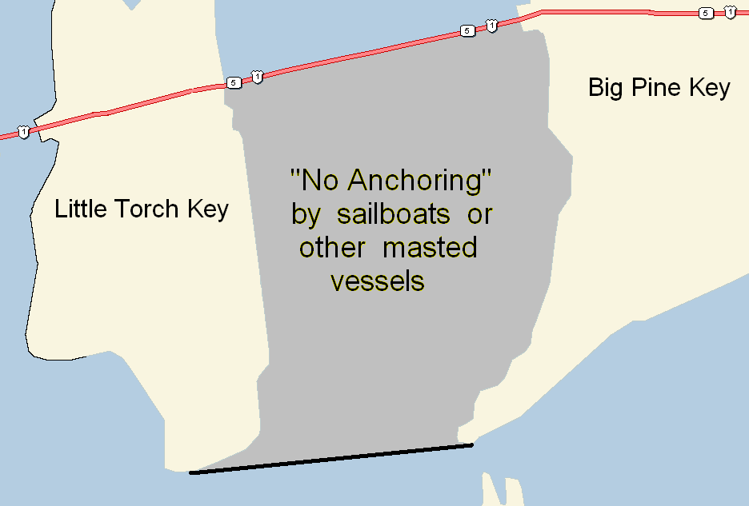
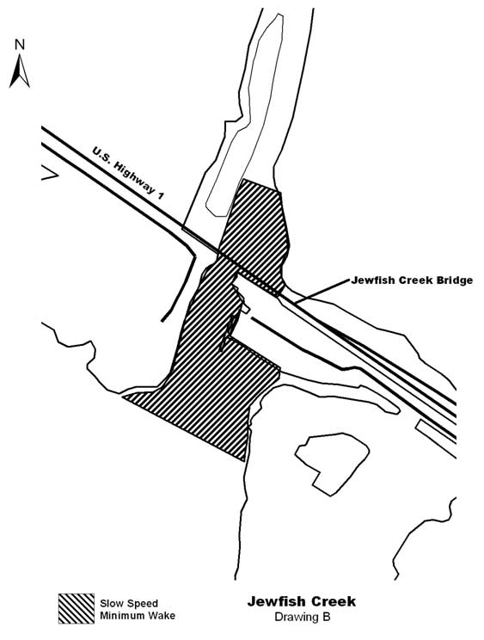
Rulemaking Authority 327.04, 327.46 FS. Law Implemented 327.46 FS. History–New 1-10-07, Amended 8-7-12.

