40E-8.421 Prevention and Recovery Strategies.
(1) At the time of adoption of this rule, the existing flow or level for certain specified water bodies is below, or within 20 years is projected to fall below, the applicable MFL. For this reason, Section 373.0361, F.S., requires regional water supply plans to contain recovery and prevention strategies, including water resource development and water supply development projects that are needed to achieve compliance with MFLs during the planning period. The implementation of such projects will allow for the orderly replacement or enhancement of existing water sources with alternative supplies in order to provide sufficient water for all existing and projected reasonable-beneficial uses, consistent with Section 373.0421, F.S.
(a) MFLs and recovery and prevention strategies will be implemented in phases with consideration of the District’s missions in managing water resources, including water supply, flood protection, environmental enhancement and water quality protection, as required by Section 373.016, F.S.
(b) MFLs are implemented to prevent significant harm to the water resources and, where applicable, the ecology of the area due to further withdrawals (Sections 373.042 and 373.0421, F.S.). A consumptive use permitting program is implemented to prevent harm to the water resource (Section 373.219, F.S.). A water shortage program is implemented to prevent serious harm to the water resource (Sections 373.175 and 373.246, F.S.). Additionally, the protection of water resources will, in part, be achieved through the reservation of water for fish and wildlife or public health and safety (Section 373.223(4), F.S.). The conceptual model identifying the relationships between these water resource protection requirements is set forth in Figure I in this Part.
(c) The rules implementing water resource protection tools, including Chapters 40E-2, 40E-8, 40E-20, 40E-21, 40E-22, F.A.C., and the “Basis of Review for Consumptive Use Permits Within the South Florida Water Management District”, incorporated by reference in Rules 40E-2.091 and 40E-20.091, F.A.C., identify the specific factors and conditions that will be applied and considered in implementing the conceptual model. Due to the extreme variations in water resource conditions, climatic conditions, hydrologic conditions, and economic considerations that will be faced when implementing these rules, it is critical to apply such criteria flexibly and to reserve for the governing board the ability to implement water resource protection and allocation programs considering all of the District’s missions under Chapter 373, F.S., and to balance water supply, flood protection, resource protection and water quality protection needs. Implementation of the recovery and prevention strategies will be achieved in compliance with the assurances to consumptive users and to natural systems contained in the LEC Plan and the LWC Plan.
(d) The phasing and timetables for implementation of structural components in recovery and prevention strategies contained in approved regional water supply plans are found to meet the requirements in Section 373.0421(2), F.S., for the expeditious and practicable recovery of the MFLs.
(e) Upon completion of each project or project phase of a recovery or prevention plan the District will certify the availability of water, as defined in subsection 40E-8.021(5), F.A.C.
(f) In order to ensure that the actual and projected performance of prevention and recovery strategies approved in the regional waters supply plans is sufficient to meet water resource needs, including MFLs, and the existing and projected reasonable-beneficial uses, the District will update recovery and prevention strategies on a periodic basis, based on new information and system performance. The performance of the recovery and prevention strategies in comparison to the performance projected in the regional water supply plans, will be assessed by the District for each recovery or prevention strategy phase. Based on the actual performance and new information obtained regarding the water resources, the District will review and revise, if necessary, recovery and prevention strategies through the regional water supply plan update process every five years, or sooner, as required by Section 373.0361, F.S. At that time, the governing board will determine if rule modifications to the MFL or recovery and prevention strategies are necessary to continue to meet the requirements of Sections 373.042 and 373.0421, F.S.
Figure 1: Conceptual Relationship Among the Harm, Serious Harm and Significant Harm Standards
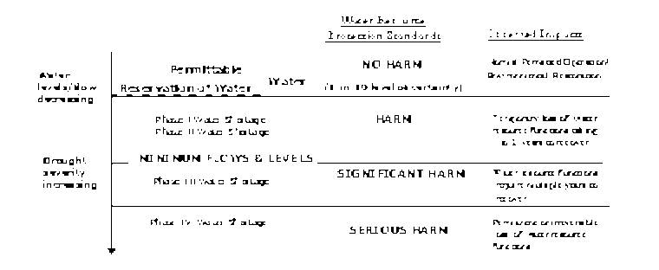
(2) The Everglades, Lake Okeechobee, and the Caloosahatchee River.
(a) The Everglades, Lake Okeechobee and Caloosahatchee River have experienced or are projected to experience MFL violations. As a result, the LEC Plan and the LWC Plan contain approved recovery strategies, pursuant to Section 373.0421, F.S. Included in these recovery and prevention strategies is the CERP.
(b) MFLs within the Everglades, Lake Okeechobee, and the Caloosahatchee River, that are part of or served by the C&SF Project, will not be achieved immediately upon adoption of this rule largely because of the lack of adequate regional storage, including U.S. Army Corps of Engineers’ regulation schedule effects, or ineffective water drainage and distribution infrastructure. Although not all locations within the Everglades are currently in violation of the proposed MFL, the Everglades, as a whole, is subject to a recovery strategy. The LEC Plan identifies the structural and non-structural remedies necessary for the recovery of MFL water bodies. These structural and non-structural remedies are also intended to restore the Everglades, Lake Okeechobee and the Caloosahatchee River above the MFLs, through Chapter 373, F.S., authorities of the District.
(c) The projected long-term restoration of flows and levels in the Everglades resulting from implementation of the LEC Plan and the CERP is documented in the LEC Plan, and are intended to more closely approximate “pre-drainage” conditions. The planned components include implementing consumptive use and water shortage programs, removing conveyance limitations, implementing revised C&SF Project operational programs, storing additional freshwater, reserving water for the protection of fish and wildlife, and developing alternative sources for water supply. These components will be implemented over the next 20 years, resulting in a phased restoration of the affected areas.
(d) The District, as the U.S. Army Corps of Engineers’ local sponsor of the C&SF Project, is charged with implementing the CERP, in accordance with the Water Resources Development Act of 2000 (WRDA), Title VI entitled “Comprehensive Everglades Restoration,” and in accordance with State law. Assurances regarding water availability for consumptive uses and protection of natural systems are set forth in WRDA, Chapter 373, F.S., CERP and the LEC Plan, which will be followed by the District in implementing this chapter. Additional quantities of water for both consumptive uses and the natural systems made available from the CERP and other water resource development projects will be documented and protected on a project basis. For project components implemented under CERP, the additional quantity, distribution and timing of delivery of water that is made available for the natural system for consumptive use, will be identified consistent with purposes of the CERP. Under State law, water reservations and water allocations to consumptive uses will be utilized to protect water availability for the intended purposes.
(e) Lake Okeechobee. Under implementation of the Water Supply and Environment (WSE) lake regulation schedule assumptions, the Lake Okeechobee MFL was not projected to be violated and an MFL prevention strategy was adopted. However, due to changes in the Lake Okeechobee Regulation Schedule (LORS), which received final approval in April 2008, the Lake MFL is projected to be violated and an MFL recovery strategy is necessary. This recovery strategy will remain in effect until the MFL criteria is met pursuant to Section 373.0421, F.S. The Lake Okeechobee MFL recovery strategy shall consist of four components, as fully described in the LEC Regional Water Supply Plan, Appendix H, as updated in October 2008. These components consist of:
1. Environmental enhancement projects to be implemented during extreme low Lake stages,
2. Regulatory constraints on consumptive use of Lake water,
3. Water shortage restrictions as described in Chapter 40E-22, F.A.C., and
4. Capital projects that improve storage capacity both within and adjacent to the Lake.
(3) Biscayne Aquifer. The LEC Plan contains an approved prevention strategy for the Biscayne Aquifer pursuant to Section 373.0421, F.S., which consists of the following:
(a) Maintain coastal canal stages at the minimum operation levels shown in Table J-2 of the LEC Plan;
(b) Apply conditions for permit issuance in Chapter 40E-2 or 40E-20, F.A.C., to prevent the harmful movement of saltwater intrusion up to a 1-in-10 year level of certainty;
(c) Maintain a ground water monitoring network and utilize data to initiate water shortage actions pursuant to Rule 40E-8.441, F.A.C. and Chapters 40E-21 and 40E-22, F.A.C.;
(d) Construct and operate water resource and water supply development projects; and
(e) Conduct research in high risk areas to identify where the portions of the saltwater front is adjacent to existing and future potable water sources.
(4) Lower West Coast Aquifers. The LWC Plan identifies a prevention strategy for the LWC Aquifers, pursuant to Section 373.0421, F.S., as follows:
(a) Establish “no harm” maximum permittable levels for each aquifer (regulatory levels) for a 1-in-10 year level of certainty;
(b) Implement rule criteria to prevent harm through the consumptive use permitting process, including conditions for permit issuance in Rule 40E-2.301, F.A.C.;
(c) Construct and operate water resource and supply development projects; and
(d) Implement the water shortage plan in Chapter 40E-21, F.A.C., as needed to prevent serious harm during drought conditions in excess of a 1-in-10 year level of certainty.
(5) St. Lucie River and Estuary. The following is the prevention strategy for the St. Lucie River and Estuary:
(a) Discharges from the North Fork will be managed within the operational protocols of the Ten Mile Creek Project scheduled to be completed by 2004. Flow targets will be consistent with the CERP performance requirements for Indian River Lagoon.
(b) A research and monitoring strategy for the North and South Forks of the St. Lucie River will be developed and implemented in coordination with the Upper East Coast Regional Water Supply Plan update.
(6) Northwest Fork of the Loxahatchee River Recovery Strategy: Purpose and Intent.
(a) The Northwest Fork of the Loxahatchee River is currently not meeting the MFL and requires implementation of a recovery strategy to achieve the MFL as soon as practicable, consistent with Section 373.0421, F.S. The recovery strategy consists of projects contained within the following approved plans: the Lower East Coast Regional Water Supply Plan (LEC Plan), the Comprehensive Everglades Restoration Plan (CERP), and the Northern Palm Beach County Comprehensive Water Management Plan (NPBCCWMP). Four phases of recovery are identified in the Technical Documentation to Support Development of Minimum Flows and Levels for the Northwest Fork of the Loxahatchee River, November 2002, which are projected to increase flows to meet the MFL for the Northwest Fork of the Loxahatchee River. As part of the recovery strategy, as provided in this rule, the consumptive use permitting and water shortage requirements in this Chapter and Chapters 40E-2, 40E-20, 40E-21, F.A.C., and the “Basis of Review for Water Use Permit Applications within the South Florida Water Management District”, incorporated by reference in Rules 40E-2.091 and 40E-20.091, F.A.C., including Section 3.2.1.E. regarding Restricted Allocation Areas for Lower East Coast Everglades Waterbodies and North Palm Beach County/Loxahatchee River Watershed Waterbodies, shall apply to consumptive use direct and indirect withdrawals from surface and groundwater sources from the Northwest Fork of the Loxahatchee River and those areas directly tributary to the Northwest Fork.
(b) In addition to implementation of this MFL recovery strategy, the District commits to restore freshwater flows to the Northwest Fork of the Loxahatchee River above the MFL through Chapter 373, F.S., and the Comprehensive Everglades Restoration Plan and its associated authorities. The District will continue to partner with the Florida Department of Environmental Protection in establishing a practical restoration goal and plan for the Loxahatchee River watershed. Recognizing that natural seasonal fluctuations in water flows are necessary to ensure that the functions of the Loxahatchee River are protected, this restoration goal and plan will include a more complete set of seasonally managed flow criteria for the river that are driven primarily by natural rainfall and runoff patterns within the watershed.
(c) The District shall continue to operate the G-92 structure and associated structures to provide approximately 50 cfs or more over Lainhart Dam to the Northwest Fork of the Loxahatchee River, when the District determines that water supplies are available.
(d) Additionally, it is the intent of the District to continue the current operational protocols of the G-92 structure so as not to reduce the historical high, average and low flows as estimated over the 30 year period of rainfall record used as the basis for the MFL for the Northwest Fork of the Loxahatchee River.
(e) It is the District’s intent to implement, along with other partners, projects to meet the practical restoration goal developed according to paragraph (b). Projects contained in the Comprehensive Everglades Restoration Plan, the LEC Plan and the NPBCCWMP will provide increased storage and conveyance within the basin with a goal of providing more water for restoration of the Northwest Fork of the Loxahatchee River.
(f) To protect water made available for the recovery and restoration of the Loxahatchee River through implementation of these associated projects, the District intends to adopt water reservations for the Loxahatchee River, pursuant to Section 373.223(4), F.S., on a project by project basis over the next 20 years. In addition, the SFWMD intends to adopt an initial reservation to protect existing water used for protection of fish and wildlife, consistent with the practical restoration goal identified for the Loxahatchee River, by 2004. Future reservations related to the Loxahatchee River will be consistent with the reservations being developed for restoration of the Everglades under CERP, and will reflect the needs of the natural system through a range of hydrologic conditions. These water reservations are intended to prevent the future allocation to consumptive uses the freshwater intended for restoration of the Loxahatchee River. The reservations will be implemented through the consumptive use permit program, operational protocols, water shortage rules, and other appropriate provisions in Chapter 373, F.S.
(g) As reservations are adopted to restore the Loxahatchee River beyond that to be achieved by the MFL, the District shall revise the MFL and associated prevention and recovery strategy, as appropriate, under Sections 373.042 and 373.0421, F.S., to be consistent with the reservation.
(7) Lake Istokpoga. The water levels in Lake Istokpoga are controlled by operation of water control structures (G-85 and, primarily, S-68) as guided by a regulation schedule adopted by the U.S. Army Corps of Engineers and implemented by the District. The existing regulation schedule, typical regional weather patterns, and present levels of inflows from area creeks make violation of the Lake’s minimum level unlikely; no such events have occurred since implementation of the Lake regulation schedule. Analysis of the current regulation schedule and operational policies for the Lake indicate the proposed Lake Istokpoga minimum level will be met for the foreseeable future. Therefore, the prevention strategy for Lake Istokpoga consists of continuation of the current operational plan and regulation schedule. The District, in coordination with other appropriate agencies, should also plan and operate extreme Lake drawdowns for environmental purposes in a manner that, to the greatest extent possible, avoids an MFL violation. If significant changes to the Lake’s water level management occurs due to new information, altered operational plans, or regulation schedule, a re-evaluation of the minimum level criteria will be conducted. This re-evaluation will occur as part of the next Lake Istokpoga MFL update which is scheduled to occur in 2010, or sooner, if significant changes to Lake management are proposed.
(8) Florida Bay. Under existing system conditions, violations of the MFL are not anticipated to occur. Therefore, a prevention strategy is contained in this rule. In addition to the prevention strategies identified in subsection 40E-8.421(1), F.A.C., the following actions will be taken:
(a) Modifications to operations for improved management of freshwater discharges to the headwaters of Taylor Slough and the southeast Everglades should consider the MFL, in coordination with:
1. The Modified Waters Deliveries to Everglades National Park project and the C-111 Canal project, and any associated operational and construction plans pursuant to these projects;
2. The C-111 Canal Spreader Acceler8 and CERP Projects;
3. The CERP Florida Bay and Florida Keys Feasibility Study.
(b) The SFWMD, in cooperation with other management agencies, will continue field monitoring and research to assess salinity, water level, and flow conditions and biological resource response in the region specified above.
(c) The update of the LEC Plan (anticipated in 2006) will contain a description of the elements, scheduling, and funding of the research and monitoring program and additional details of the prevention strategy for Florida Bay pursuant to Section 373.0421, F.S.
(d) These MFL criteria will be reviewed and may be revised no later than five years after adoption based on new information from the CERP Florida Bay and Florida Keys Feasibility Study or other scientific data that may become available. After the initial review, the MFL criteria will be reviewed at subsequent five-year intervals in conjunction with updates to the LEC Plan.
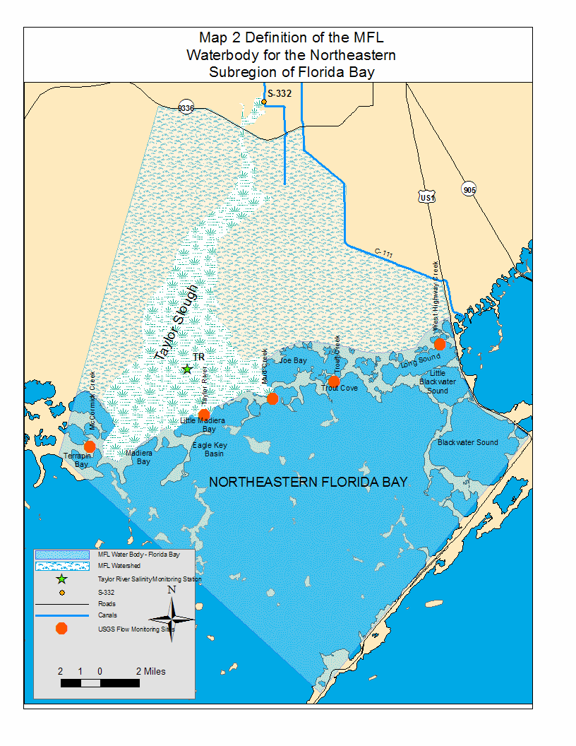
Rulemaking Authority §§ 9, 10 P.L. 83-358, 373.044, 373.113, 373.171 FS. Law Implemented 373.016, 373.036, 373.0361, 373.042, 373.0421, 373.175, 373.216, 373.219, 373.223, 373.246 FS. History–New 9-10-01, Amended 11-11-02, 4-1-03, 1-19-06, 12-12-06, 4-23-07, 10-14-08, 10-23-12.

