68D-24.164 Volusia County Boating Restricted Areas.
(1) For the purpose of regulating the speed and operation of vessel traffic on the Florida Intracoastal Waterway (ICW) bordering eastern Volusia County, including the Indian River and the Halifax River, the following Boating Restricted Areas are established:
(a)1. Ormond Beach: A Slow Speed Minimum Wake boating restricted area from shoreline to shoreline, bounded on the north by a line drawn perpendicular to the centerline of the ICW 300 feet north of the north end of the Highbridge Road Bridge fender system to a line drawn perpendicular to the centerline of the ICW 300 feet south of the centerline of the Highbridge Road Boat Ramp, as depicted in drawing A.
2. Daytona Beach: An Idle Speed No Wake boating restricted area from the western shoreline to the eastern limit of the right-of-way of the ICW from a line drawn perpendicular to the centerline of the ICW 200 feet north of the Main Street Bridge to a line which is 600' feet northerly of and parallel to the centerline of northern span of the Seabreeze Bridge (S. R. 430), as depicted in drawing B.
3. New Smyrna Beach: An Idle Speed No Wake boating restricted area in and adjacent to the ICW, bounded on the north and west by the western shoreline of the Indian River North, bounded on the south by the northern shoreline of Chicken Island and a line drawn due west from the western end of Chicken Island, and bounded on the east by a line drawn due north from the eastern end of Chicken Island, as depicted in drawing C.
4. Edgewater: An Idle Speed No Wake boating restricted area from the western shoreline to the eastern limit of the right-of-way of the ICW from a line drawn perpendicular to the centerline of the ICW 300' feet north of the Kennedy Park boat ramp to a line drawn perpendicular to the centerline of the ICW 500 feet south of the Menard May Park boat ramp, as depicted in drawing D.
(b) Volusia County is authorized to install and maintain Slow Speed Minimum Wake or Idle Speed No Wake markers, as identified herein, and Resume Normal Safe Operation markers at the beginning and end of each of these restricted areas.
(2) The restricted areas are depicted on the following maps:
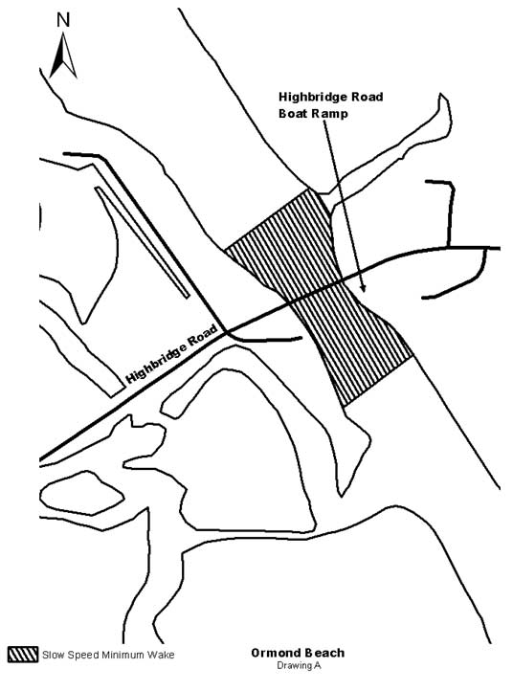
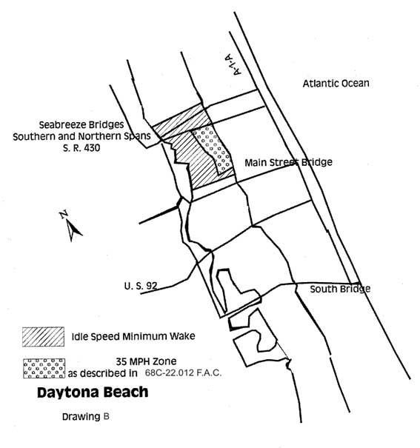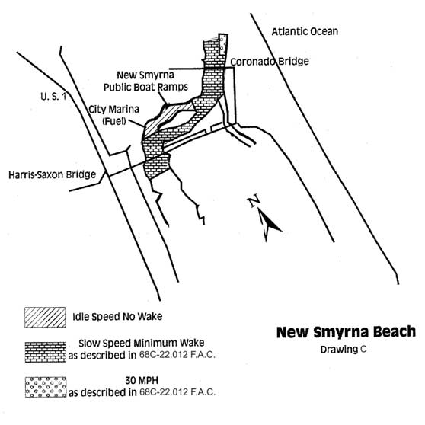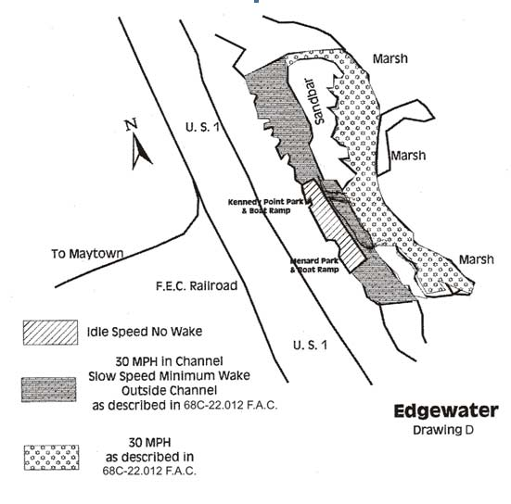
Rulemaking Authority 327.04, 327.46 FS. Law Implemented 327.46 FS. History–New 4-2-87, Formerly 16N-24.009, 62N-24.009, Amended 4-12-99, Formerly 62N-24.164, Amended 10-28-12.

