Notice of Meeting/Workshop Hearing

OTHER AGENCIES AND ORGANIZATIONS
GMB Engineers & Planners, Inc.
The Florida Department of Transportation (FDOT) will hold a public information meeting regarding the Corridor Planning Study for the US 27 Reliever to which all persons are invited.
DATE AND TIME: Wednesday, January 30, 2013, 5:30 p.m. – 6:30 p.m.
PLACE: FDOT District 5 – Leesburg Operations, 1405 Thomas Avenue, Leesburg, Florida 34748
GENERAL SUBJECT MATTER TO BE CONSIDERED: The purpose of the meeting is to provide interested persons an opportunity to engage in the Corridor Planning Study and/or submit comments concerning the US 27 Reliever. Currently, FDOT has begun a Corridor Planning Study to evaluate Rolling Acres Road as a north/south traffic reliever for US 27 (Rolling Acres Road to SR 44). Maps, drawings and other information will be on display. FDOT representatives and consultant staff will be available to further explain the purpose of this study, answer questions, and receive comments.
Public participation is solicited without regard to race, color, national origin, age, sex, religion, disability or family status. Persons who require special accommodations under the Americans with Disabilities Act or persons who require translation services (free of charge) should contact John Moore, FDOT Project Manager at 133 South Semoran Blvd., Orlando, FL 32807, or toll-free (800) 780-7102 at least seven days prior to the meeting.
If you have questions about this project or meeting, please contact John Moore at the number above or via email at john.moore@dot.state.fl.us.
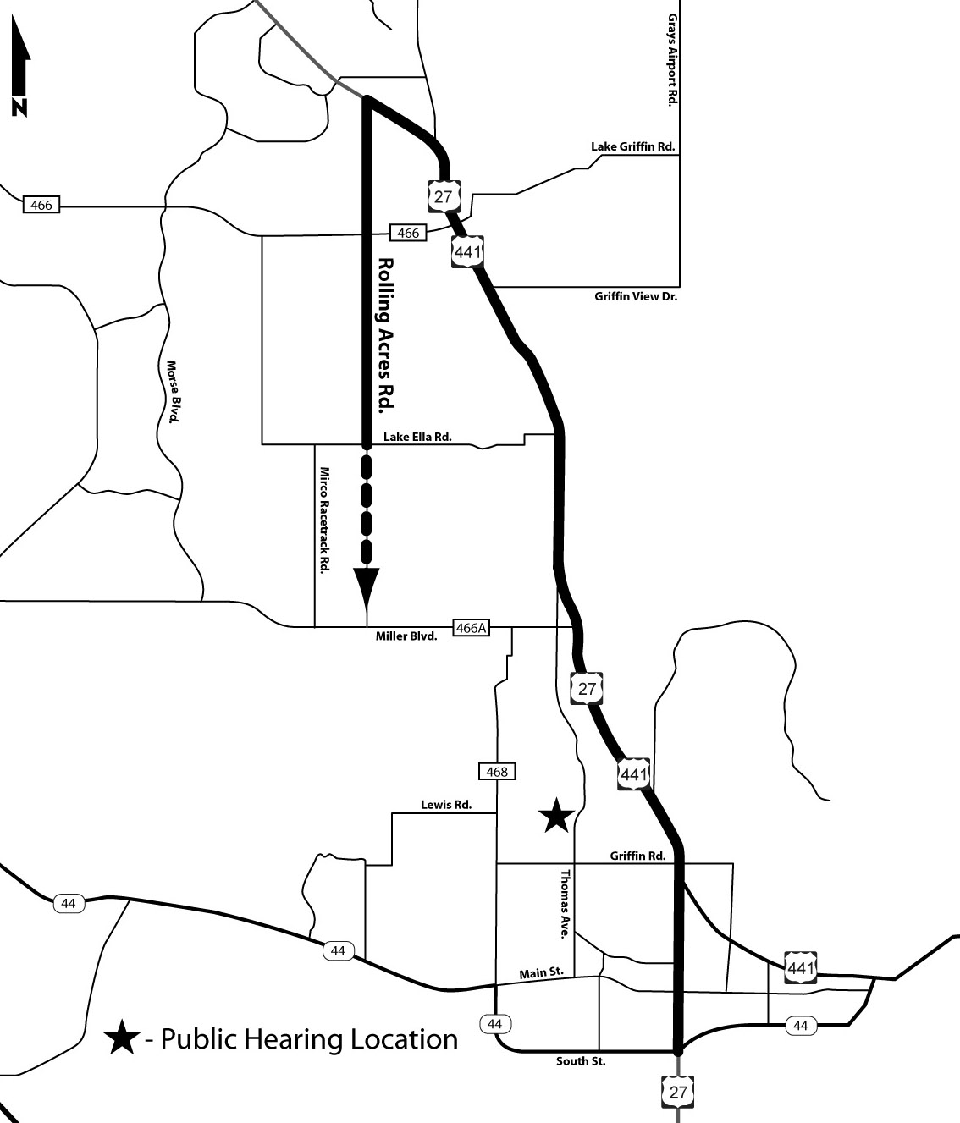
You may also contact Steve Olson, District Five Public Information Director, toll-free at (800) 780-7102 or via email at steve.olson@dot.state.fl.us. Additional project information can be found at www.cflroads.com.

