Notice of Proposed Rule

FISH AND WILDLIFE CONSERVATION COMMISSION
Vessel Registration and Boating Safety
RULE NO.: RULE TITLE:
68D-24.011 Okeechobee Waterway Boating Restricted Areas
PURPOSE AND EFFECT: The purpose and effect of this rule amendment is to provide for public safety at the Clewiston Lock Structure, adjacent to the Okeechobee Waterway within Hendry County. Additionally, the rule amendment will correct inconsistencies between the geographic description and map for the Palm City Bridge Boating Restricted Area in Martin County.
SUMMARY: This rule amendment extends, changes the restriction type and rewrites the geographic description for the Clewiston Lock Structure Boating Restricted Area. Additionally, the rule, as adopted on January 20, 2009, contained an error in the geographic description for the Palm City Bridge Boating Restricted Area. This rule amendment will correct the direction referenced for the northern boundary of the zone.
SUMMARY OF STATEMENT OF ESTIMATED REGULATORY COSTS AND LEGISLATIVE RATIFICATION:
The Agency has determined that this will not have an adverse impact on small business or likely increase directly or indirectly regulatory costs in excess of $200,000 in the aggregate within one year after the implementation of the rule. A SERC has not been prepared by the agency.
The Agency has determined that the proposed rule is not expected to require legislative ratification based on the statement of estimated regulatory costs or if no SERC is required, the information expressly relied upon and described herein: The proposed rule will make minor corrections to the rule text, will make only a slight increase to the footprint of the zone and will slightly increase the regulated speed. These changes will result in no discernible economic impact.
Any person who wishes to provide information regarding a statement of estimated regulatory costs, or provide a proposal for a lower cost regulatory alternative must do so in writing within 21 days of this notice.
RULEMAKING AUTHORITY: 327.46 FS.
LAW IMPLEMENTED: 327.04, 327.46 FS.
IF REQUESTED WITHIN 21 DAYS OF THE DATE OF THIS NOTICE, A HEARING WILL BE SCHEDULED AND ANNOUNCED IN THE FAR.
THE PERSON TO BE CONTACTED REGARDING THE PROPOSED RULE IS: Captain Richard Moore, Florida Fish and Wildlife Conservation Commission, Division of Law Enforcement, Boating and Waterways Section, 620 South Meridian Street, Tallahassee, Florida 32399-1600

THE FULL TEXT OF THE PROPOSED RULE IS:

68D-24.011 Okeechobee Waterway Boating Restricted Areas.
(1) For the purpose of regulating the speed and operation of vessel traffic on the Okeechobee Waterway, the following Boating Restricted Areas are established:
(a) through (b) No change.
(c) Palm City Bridge – A Slow Speed Minimum Wake boating restricted area, shoreline to shoreline, in and adjacent to the Okeechobee Waterway, bounded on the northwest by a line drawn parallel to and 300 feet east northwest of the centerline of the Palm City Bridge (SR 714), and bounded on the southeast by a line drawn parallel to and 1,500 feet southeast of the centerline of said bridge, as depicted in drawing C.
(d) through (j) No change.
(k) Clewiston Lock Structure – An Idle Speed No Wake boating restricted area from shoreline to shoreline, in and adjacent to the Okeechobee Waterway and Cauley Cut in the vicinity of Hurricane Gate and Lock Structure S-310 in Clewiston, Hendry County, within the boundaries set forth below, as depicted in drawing K:
1. In Cauley Cut, from shoreline to shoreline, from the confluence of Cauley Cut and the Okeechobee Waterway Rim Canal to a line drawn parallel to the centerline of the Okeechobee Waterway Rim Canal 150 feet northeast of the confluence of Cauley Cut and the Okeechobee Waterway Rim Canal;
2. In the Route 1 Approach Channel leading northeast toward Port Mayaca, from shoreline to shoreline, from the confluence of Route 1 Approach Channel and the Okeechobee Waterway Rim Canal to a line drawn parallel to the centerline of the Okeechobee Waterway Rim Canal 150 feet northeast of the confluence of Route 1 Approach Channel and the Okeechobee Waterway Rim Canal;
3. In the Okeechobee Waterway Rim Canal, from shoreline to shoreline, from a line drawn perpendicular to the center line of the Rim Canal 150 feet southeast of Lock Structure S-310 to a line drawn perpendicular to the center line of the Rim Canal 150 feet northwest of the intersection of the Route 1 Approach Channel and the Okeechobee Waterway Rim Canal; and
4. In the Industrial Canal, from shoreline to shoreline, from the Okeechobee Waterway Rim Canal to and including the Lock Structure.
(k) Clewiston Lock Structure – A Slow Speed Minimum Wake boating restricted area from shoreline to shoreline, in and adjacent to the Okeechobee Waterway in Clewiston, Hendry County, bounded on the northeast by a line drawn perpendicular to the centerline of the Route 1B Approach Channel 150 feet northeast of the confluence of the Okeechobee Waterway Rim Canal and Route 1B Approach Channel, bounded on the north by a line drawn 150 feet north of the confluence of both forks of Cauley Cut and the Okeechobee Waterway Rim Canal, bounded on the northwest by a line drawn perpendicular to the Okeechobee Waterway Rim Canal 300 feet northwest of the centerline of the Hoover Dike Road City Ramp, bounded on the south by a line drawn across the southern entrance to the S-310 Navigation Lock (Clewiston Lock) and bounded on the southeast by a line drawn perpendicular to the centerline of the Okeechobee Waterway Rim Canal 300 feet southeast of the northeastern fender of the S-310 Navigation Lock (Clewiston Lock), as depicted in drawing K.
(l) through (n) No change.
(2) The boating restricted areas are depicted in the following drawings:
Drawings A through J: No change.

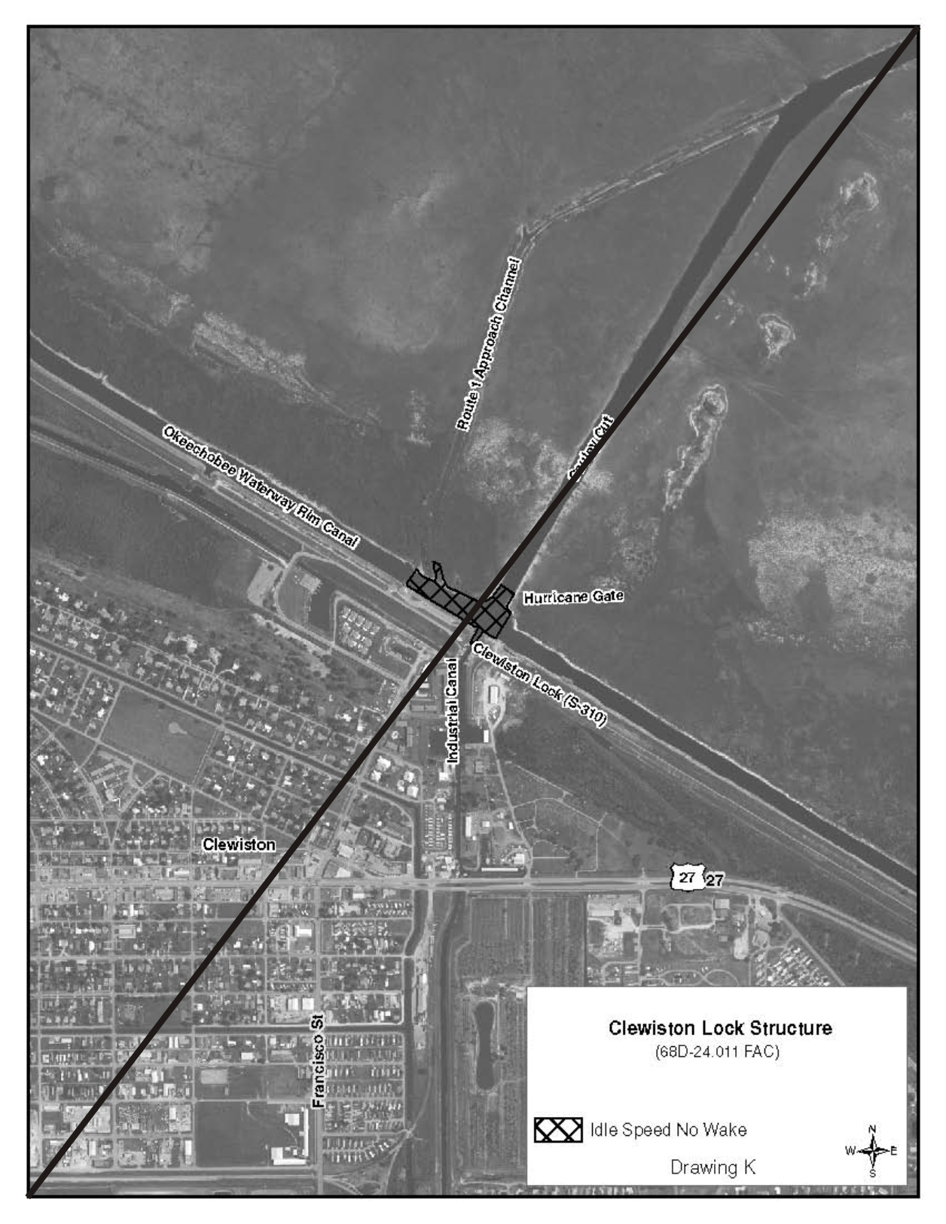
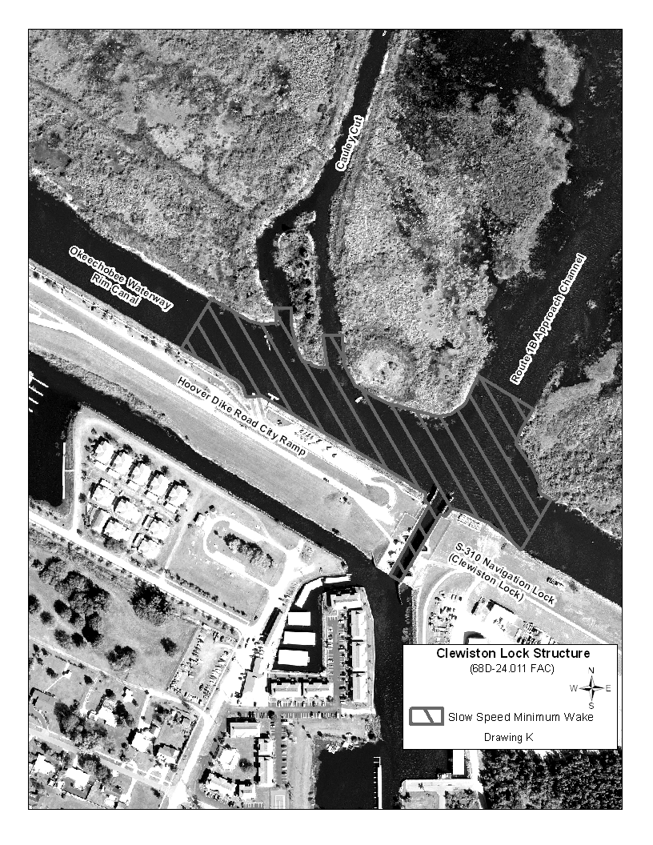

Drawings L through N: No change.
Rulemaking Specific Authority 327.46 FS. Law Implemented 327.04, 327.46 FS. History–New 1-5-88, Formerly 16N-24.011, Amended 1-8-96, Formerly 62N-24.011, Amended 10-2-00, 10-23-05, 1-20-09,________.

NAME OF PERSON ORIGINATING PROPOSED RULE: Captain Richard Moore, Florida Fish and Wildlife Conservation Commission, Division of Law Enforcement, 620 South Meridian Street, Tallahassee, Florida 32399-1600
NAME OF AGENCY HEAD WHO APPROVED THE PROPOSED RULE: Florida Fish and Wildlife Conservation Commission
DATE PROPOSED RULE APPROVED BY AGENCY HEAD: December 6, 2012
DATE NOTICE OF PROPOSED RULE DEVELOPMENT PUBLISHED IN FAR: August 31, 2012

