68D-24.143 Martin County Boating Restricted Areas.
(1) For the purpose of regulating the speed and operation of vessel traffic on and adjacent to the Intracoastal Waterway in Martin County, Florida, the following Boating Restricted Areas are established:
(a) Jensen Beach Causeway – A Slow Speed Minimum Wake boating restricted area from shoreline to shoreline bounded on the north by a line drawn perpendicular to the centerline of the Florida Intracoastal Waterway 300' feet north of the centerline of the Jensen Beach Causeway (SR 707A) Bridge and on the south by a line drawn perpendicular to the centerline of the Florida Intracoastal Waterway 300' feet south of said bridge, as depicted in drawing A.
(b) N.E. Ocean Boulevard – A Slow Speed Minimum Wake boating restricted area from shoreline to shoreline bounded on the north by a line drawn perpendicular to the centerline of the Florida Intracoastal Waterway 300' feet northwest of the N.E. Ocean Boulevard (SR A1A) Bridge and on the south by a line drawn perpendicular to the centerline of the Florida Intracoastal Waterway 300' feet south of said bridge, as depicted in drawing B.
(c) Hobe Sound Bridge – A Slow Speed Minimum Wake boating restricted area from shoreline to shoreline bounded on the north by a line drawn perpendicular to the centerline of the Florida Intracoastal Waterway 300' feet north of the centerline of the Hobe Sound (SR 708) Bridge and on the south by a line drawn perpendicular to the centerline of the Florida Intracoastal Waterway 300' feet south of said bridge, as depicted in drawing C.
(d) Jupiter Island – A Slow Speed Minimum Wake boating restricted area from shoreline to shoreline bounded on the north by a line drawn perpendicular to the centerline of the Florida Intracoastal Waterway 4,350' feet south of the Hobe Sound (SR 708) Bridge and bounded on the south by a line drawn perpendicular to the centerline of the Florida Intracoastal Waterway 8,295' feet south of said bridge, as depicted in drawing D. The boating restricted area established in this paragraph is applicable only to vessels 35 feet or more in length.
(e) Blowing Rocks – A Slow Speed Minimum Wake boating restricted area from shoreline to shoreline bounded on the north by a line drawn perpendicular to the centerline of the Florida Intracoastal Waterway 500' feet north of the centerline of the fuel dock located at 26° 58.749'' N/80° 05.354'' W and on the south by a line drawn perpendicular to the centerline of the Florida Intracoastal Waterway 500' feet south of said fuel dock centerline, as depicted in drawing E. The boating restricted area established in this paragraph is applicable only to vessels 35' feet or more in length and in effect only from November 1 through April 30 each year. If the fuel dock is closed and its use as a public fueling facility discontinued, the boating restricted area established in this paragraph shall no longer be in force or effect.
(2) The boating restricted areas described in Rule 68D-24.143, F.A.C., are depicted on the following drawings:
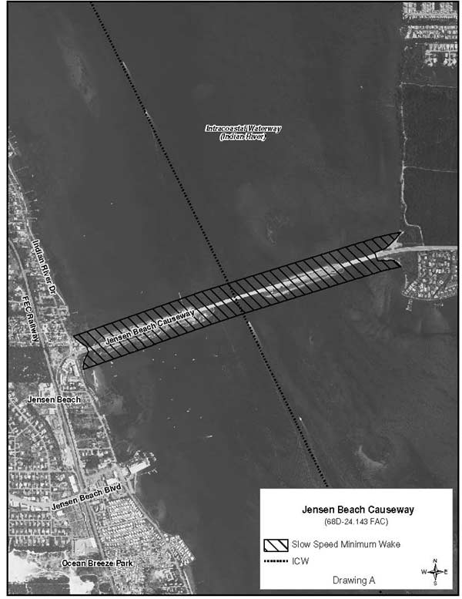
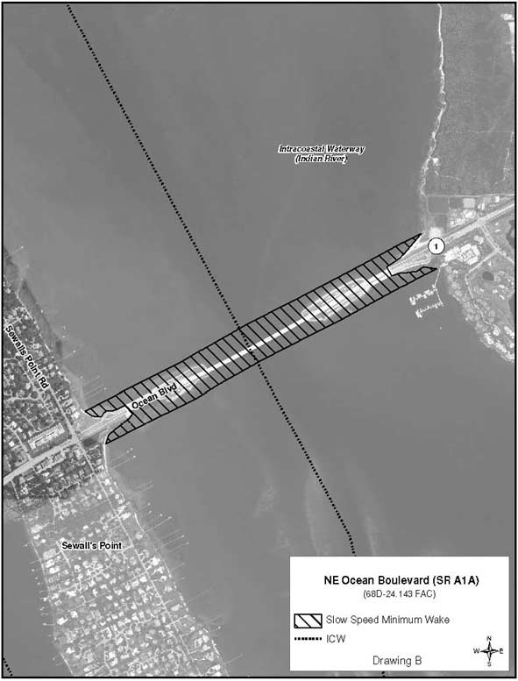
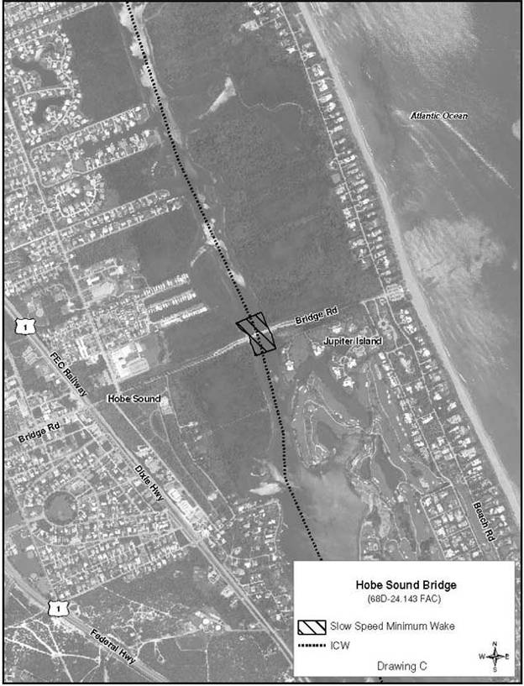
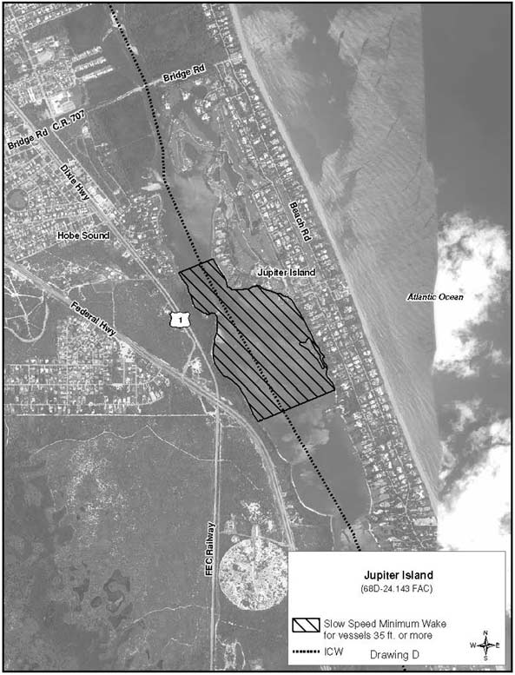
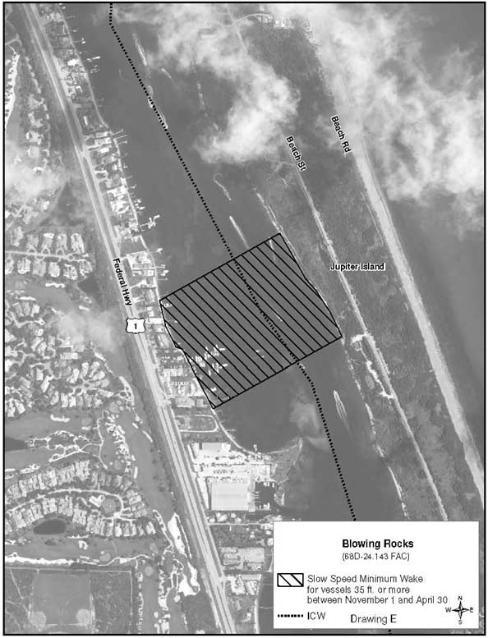

Rulemaking Authority 327.04, 327.46 FS. Law Implemented 327.46 FS. History–New 2-25-96, Formerly 62N-24.143, Amended 1-20-09, 4-22-13.

