Notice of Proposed Rule

FISH AND WILDLIFE CONSERVATION COMMISSION
Vessel Registration and Boating Safety
RULE NO.: RULE TITLE:
68D-24.008 Broward County Boating Restricted Areas
PURPOSE AND EFFECT: The purpose of this rule amendment is to reduce vessel speeds on the Florida Intracoastal Waterway within Broward County where necessary to manage and promote the use of this state waterway for safe boating. Specifically, the effect of this rule amendment is to make minor increases to the footprint of the zones found in (1)(a)1.,(a) 2.a., (a)5. and (a)14., formally (a)9., to match historical boundaries established by regulatory markers. The effect is also to transfer Rule 68D-24.006, F.A.C., Fort Lauderdale Boating Restricted Areas, into Rule 68D-24.008, F.A.C. Additionally, the effect is to make minor technical changes to provide clarity throughout the rule to the order of the geographic descriptions and the restricted speed terminology as well as updating all the rule maps and removing the authority for Broward County to mark the zones. Also, the effect is to include rule language that excludes water bodies such as canals and boat basins from shoreline to shoreline boating restricted areas.
SUMMARY: This rule amendment extends five (5) zones in the Florida Intracoastal Waterway in Broward County. The amendment also transfers zones currently found in Rule 68D-24.006, updates the rule maps, modifies the order of the geographic descriptions and restricted speed terminology, removes the authority for Broward County to mark the zones and includes language to exclude water bodies such as canals and boat basins.
SUMMARY OF STATEMENT OF ESTIMATED REGULATORY COSTS AND LEGISLATIVE RATIFICATION:
The Agency has determined that this will not have an adverse impact on small business or likely increase directly or indirectly regulatory costs in excess of $200,000 in the aggregate within one year after the implementation of the rule. A SERC has not been prepared by the agency.
The Agency has determined that the proposed rule is not expected to require legislative ratification based on the statement of estimated regulatory costs or if no SERC is required, the information expressly relied upon and described herein: The proposed rule will match zone boundaries established in the rule to historical boundaries established by regulatory markers.
Any person who wishes to provide information regarding a statement of estimated regulatory costs, or provide a proposal for a lower cost regulatory alternative must do so in writing within 21 days of this notice.
RULEMAKING AUTHORITY: 327.04, 327.46 FS.
LAW IMPLEMENTED: 327.46, 327.72, 327.73(1) FS., Ch. 86-364, Ch. 89-428, Laws of Florida.
IF REQUESTED WITHIN 21 DAYS OF THE DATE OF THIS NOTICE, A HEARING WILL BE SCHEDULED AND ANNOUNCED IN THE FAR.
THE PERSON TO BE CONTACTED REGARDING THE PROPOSED RULE IS: Captain Richard Moore, Florida Fish and Wildlife Conservation Commission, Division of Law Enforcement, Boating and Waterways Section, 620 South Meridian Street, Tallahassee, Florida 32399-1600
THE FULL TEXT OF THE PROPOSED RULE IS:
68D-24.008 Broward County Boating Restricted Areas.
(1) For the purpose of regulating speed and operation of vessels and for the purpose of alleviating public safety problems arising from increased vessels traffic on and adjacent to the Florida Intracoastal Waterway in Broward County, Florida, the following year-round boating restricted areas are established. The boating restricted areas exclude all associated tributaries, creeks, canals, backwaters, channels, boat basins and other waterways unless otherwise designated or specifically described for inclusion:
(a)1. Hillsboro Boulevard Bridge – An Idle Speed No Wake zone from shoreline to shoreline, in and adjacent to the Florida Intracoastal Waterway, bounded on the north by a line drawn perpendicular to the centerline of the Florida Intracoastal Wwaterway 750 feet north of the Hillsboro Boulevard Bridge and bounded on the south by a line drawn perpendicular to the centerline of the Florida Intracoastal Wwaterway 825 625 feet south of said bridge as depicted in drawing A.
2. Hillsboro Inlet Zones –
a. An Idle Speed No Wake zone from shoreline to shoreline, in and adjacent to the Florida Intracoastal Waterway, from shoreline to shoreline bounded on the north by a line drawn perpendicular to the centerline of the Florida Intracoastal Waterway 100 9,750 feet north of latitude 26° 17.339’ North, longitude 80° 4.842’ West (approximately located at Channel Marker “68”) the intersection of the centerline of the Hillsboro Inlet channel and the centerline of the Florida Intracoastal Waterway, and on the south by a line drawn perpendicular to the centerline of the Florida Intracoastal Waterway 1,050 feet southwest of the intersection of the centerline of the Hillsboro Inlet channel and the centerline of the Florida Intracoastal Waterway, as depicted in drawing B.
b. A Slow Speed Minimum Wake zone from shoreline to shoreline, in and adjacent to the Florida Intracoastal Waterway, from shoreline to shoreline and including all waters of the Hillsboro Inlet, bounded on the northwest by a line drawn from headland to headland across the northwestern end of the Hillsboro Iinlet at its confluence with the Florida Intracoastal Waterway, and on the southeast by a line drawn perpendicular to the centerline of the inlet channel 150 feet northwest of the seaward extremities of the Hillsboro Inlet jetties, as depicted in drawing B.
c. A Slow Speed Minimum Wake zone from shoreline to shoreline, in and adjacent to the Florida Intracoastal Waterway, from shoreline to shoreline bounded on the north by a line drawn perpendicular to the centerline of the Florida Intracoastal Waterway 1,050 feet south of the intersection of the centerline of the Hillsboro Inlet channel and the centerline of the Florida Intracoastal Waterway and on the south by a line drawn perpendicular to the centerline of the Florida Intracoastal Waterway 1,425 feet north of the North East 14th Street Bridge in Pompano Beach, as depicted in drawing B.
3. North East 14th Street Bridge – An Idle Speed No Wake zone from shoreline to shoreline, in and adjacent to the Florida Intracoastal Waterway, from shoreline to shoreline bounded on the north by a line drawn perpendicular to the centerline of the Florida Intracoastal Waterway 1,425 feet north of the North East 14th Street Bridge in Pompano Beach and on the south by a line drawn perpendicular to the centerline of the Florida Intracoastal Waterway 300 feet south of said bridge, as depicted in drawing B.
4. Atlantic Boulevard Bridge – An Idle Speed No Wake zone from shoreline to shoreline, in and adjacent to the Florida Intracoastal Waterway, bounded on the north by a line drawn perpendicular to the centerline of the waterway 1,350 feet north of the Atlantic Boulevard Bridge and bounded on the south by a line drawn perpendicular to the centerline of the Florida Intracoastal Wwaterway 500 feet south of said bridge, as depicted in drawing C.
5. East Commercial Boulevard Bridge – An Idle Speed No Wake zone from shoreline to shoreline, in and adjacent to the Florida Intracoastal Waterway, bounded on the north by a line drawn perpendicular to the centerline of the Florida Intracoastal Wwaterway 750 feet north of the East Commercial Boulevard Bridge and bounded on the south by a line drawn perpendicular to the centerline of the Florida Intracoastal Wwaterway 700 600 feet south of said bridge, as depicted in drawing D.
6. Oakland Park Boulevard Bridge – An Idle Speed No Wake zone from shoreline to shoreline, in and adjacent to the Florida Intracoastal Waterway, and extending 1,500 feet north and south of the Oakland Park Boulevard Bridge, as depicted in drawing E.
7. Sunrise Boulevard Bridge –
a. An Idle Speed No Wake zone from shoreline to shoreline, in and adjacent to the Florida Intracoastal Waterway, from a line drawn perpendicular to the centerline of the Florida Intracoastal Waterway 2,250 feet north of the Sunrise Boulevard Bridge to a line drawn perpendicular to the centerline of the Florida Intracoastal Waterway 1,500 feet south of said bridge, as depicted in drawing F.
b. A Slow Speed Minimum Wake zone to be in effect year-round on Saturdays, Sundays and holidays as defined in Rule 68D-24.002, F.A.C., from shoreline to shoreline, in and adjacent to the Florida Intracoastal Waterway, from a line drawn perpendicular to the centerline of the Florida Intracoastal Waterway 1,500 feet south of the Sunrise Boulevard Bridge to a line drawn perpendicular to the centerline of the Florida Intracoastal Waterway 1,500 feet north of the East Las Olas Bridge, as depicted in drawing F.
8. East Las Olas Bridge – An Idle Speed No Wake zone from shoreline to shoreline, in and adjacent to the Florida Intracoastal Waterway, from a line drawn perpendicular to the centerline of the Florida Intracoastal Waterway 1,500 feet north of the East Las Olas Bridge to a line drawn perpendicular to the centerline of the Florida Intracoastal Waterway 3,300 feet south of said bridge, as depicted in drawing F.
9. Stranahan River – A Slow Speed Minimum Wake zone from shoreline to shoreline, in and adjacent to the Florida Intracoastal Waterway, from a line drawn perpendicular to the centerline of the Florida Intracoastal Waterway 3,300 feet south of the East Las Olas Bridge to a line drawn perpendicular to the centerline of the Florida Intracoastal Waterway 1,500 feet north of the 17th Street Causeway Bridge, as depicted in drawing G.
10. 17th Street Causeway Bridge – An Idle Speed No Wake zone from shoreline to shoreline, in and adjacent to the Florida Intracoastal Waterway, from a line drawn perpendicular to the centerline of the Florida Intracoastal Waterway 1,500 feet north of the 17th Street Causeway Bridge to a line drawn perpendicular to the centerline of the Florida Intracoastal Waterway 800 feet south of said bridge, as depicted in drawing G.
11.6. Dania Beach Boulevard Bridge – An Idle Speed No Wake zone from shoreline to shoreline, in and adjacent to the Florida Intracoastal Waterway, bounded on the north by a line drawn perpendicular to the centerline of the Florida Intracoastal Waterway 850 feet north of the Dania Beach Boulevard Bridge and bounded on the south by a line drawn perpendicular to the centerline of the Florida Intracoastal Waterway 1,940 feet south of said bridge, as depicted in drawing EH.
12.7. Sheridan Street Bridge – A Slow Speed Minimum Wake zone from shoreline to shoreline, in and adjacent to the Florida Intracoastal Waterway, bounded on the north by a line drawn perpendicular to the centerline of the Florida Intracoastal Waterway, 850 feet north of the Sheridan Street Bridge and bounded on the south by a line drawn perpendicular to the centerline of the Florida Intracoastal Waterway 750 feet south of said bridge, as depicted in drawing FI.
13.8. Hollywood Boulevard Bridge – An Idle Speed No Wake zone from shoreline to shoreline, in and adjacent to the Florida Intracoastal Waterway, bounded on the north by a line drawn perpendicular to the centerline of the Florida Intracoastal Waterway at 2,570 feet south of the Sheridan Street Bridge and bounded on the south by a line drawn perpendicular to the centerline of the Florida Intracoastal Waterway 740 feet south of the Hollywood Boulevard Bridge, as depicted in drawing GJ.
14.9. Hallandale Beach Boulevard Zones –
a. An Idle Speed No Wake zone from shoreline to shoreline, in and adjacent to the Florida Intracoastal Waterway, bounded on the north by a line drawn perpendicular to the centerline of the Florida Intracoastal Waterway 2,800 feet north of the Hallandale Beach Boulevard Bridge and bounded on the south by a line drawn perpendicular to the centerline of the Florida Intracoastal Waterway 1,8501,325 feet north of said bridge, as depicted in drawing HK.
b. A Slow Speed Minimum Wake zone from shoreline to shoreline, in and adjacent to the Florida Intracoastal Waterway, bounded on the north by a line drawn perpendicular to the centerline of the Florida Intracoastal Waterway 300 feet north of the Hallandale Beach Boulevard Bridge and bounded on the south by a line drawn perpendicular to the centerline of the Florida Intracoastal Waterway 300400 feet south of said bridge, as depicted in drawing HK.
(b) Thirty (30) miles per hour/fifteen inch (15") wake zone –
1. This paragraph applies to all waters of the New River Canal and the Florida Intracoastal Waterway within Broward County.
2. Except where other speed limits or operation restrictions have been lawfully established, the maximum speed on these waters is thirty (30) miles per hour.
a. Any person who operates a vessel in excess of the thirty (30) miles per hour maximum speed limit is guilty of a noncriminal infraction, punishable by a civil penalty. The amount of the civil penalty shall be computed in accordance with the provisions pertaining to penalties for unlawful speed under Section 318.18(3), F.S.
b. For the purposes of enforcement of this subparagraph, law enforcement officers may use aircraft, vessels, manual or electronic timing devices, or radar. If radar is used, the provisions of Section 316.1906, F.S., shall be complied with.
c. This subparagraph shall not be interpreted to mean that thirty (30) miles per hour is a safe speed for all vessels under all circumstances. Inland Navigation Rule 6, as adopted pursuant to subsection 327.33(3), F.S., requires that every vessel shall at all times be operated at a safe speed. Compliance with Inland Navigation Rule 6 may require speeds well under thirty (30) miles per hour.
3. The maximum allowable wake created by any vessel on these waters, regardless of the speed or size of the vessel, is fifteen inches (15") in vertical height, measured from the ambient tide level to the crest of the vessel’s wake at a distance of not less than twenty-five feet (25') from the vessel. Violation of this subparagraph is a misdemeanor of the second degree, punishable as provided in Section 775.082 or 775.083, F.S. For purposes of enforcement of this subparagraph, law enforcement officers may use mechanical, electronic, or photographic measuring devices.
4. No person may operate any vessel on these waters in such a manner as to exceed a maximum sound level of eighty (80) dBA, measured at a distance of not less than fifty feet (50') from the vessel. Violation of this subparagraph, or refusal to submit to a sound level test when requested to do so by a law enforcement officer is a misdemeanor of the second degree as provided in Chapter 89-428, Laws of Florida, punishable as provided in Section 775.082 or 775.083, F.S.
(2) Exemption – This rule section shall not apply to any person operating a vessel as a participant in, or during officially sanctioned trial runs preceding or following, a lawfully permitted regatta or boat race.
(3) Broward County is authorized to install and maintain appropriate regulatory markers as directed by the Division of Law Enforcement within such boating restricted areas.
(3)(4) The boating restricted areas described in Rule 68D-24.008 are depicted on the following drawings:

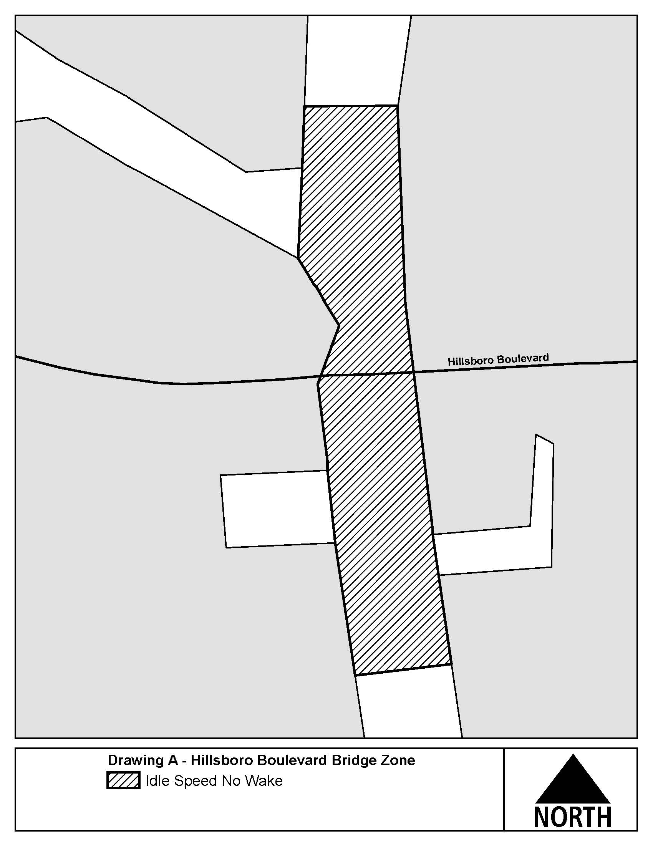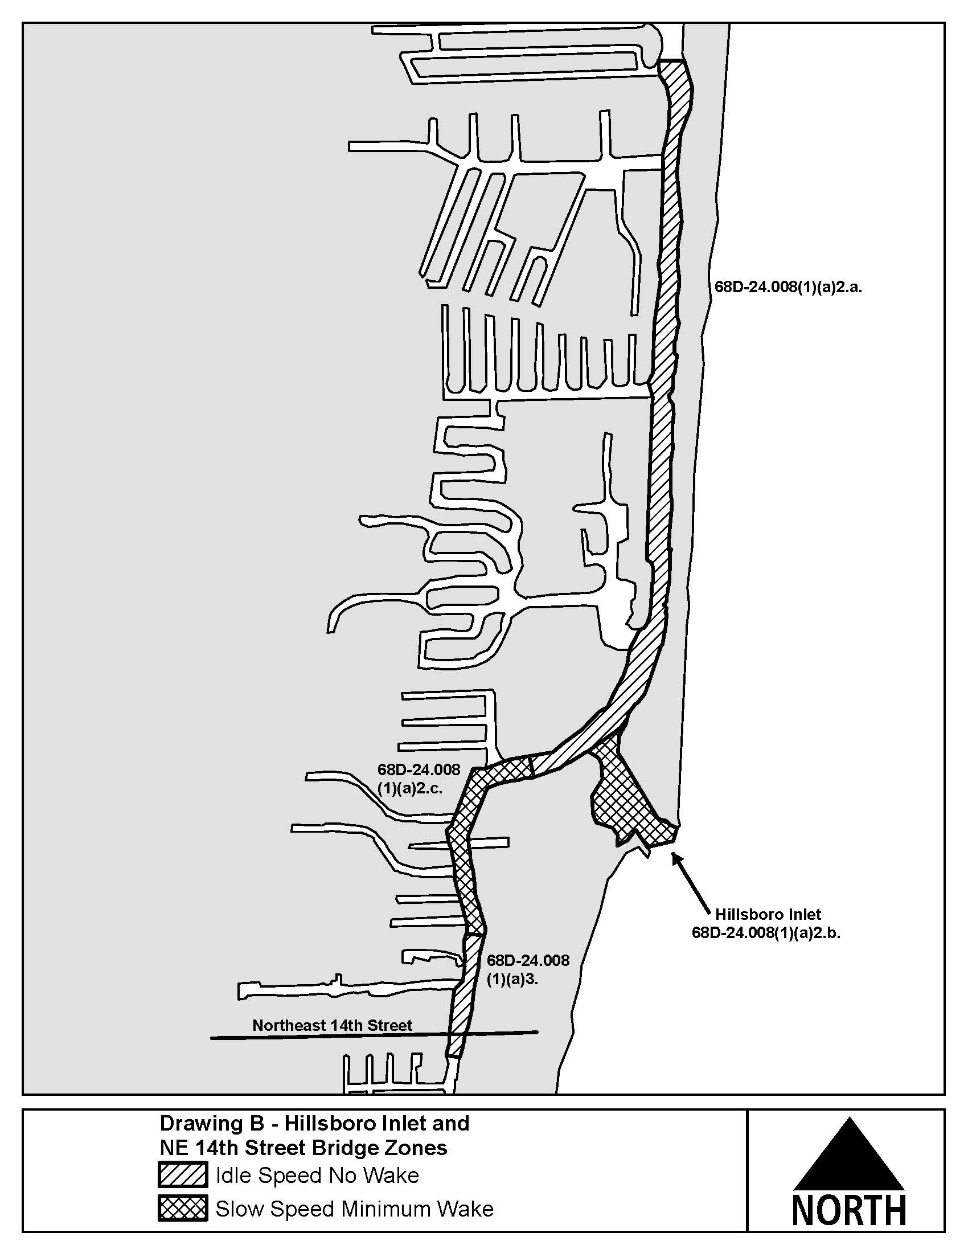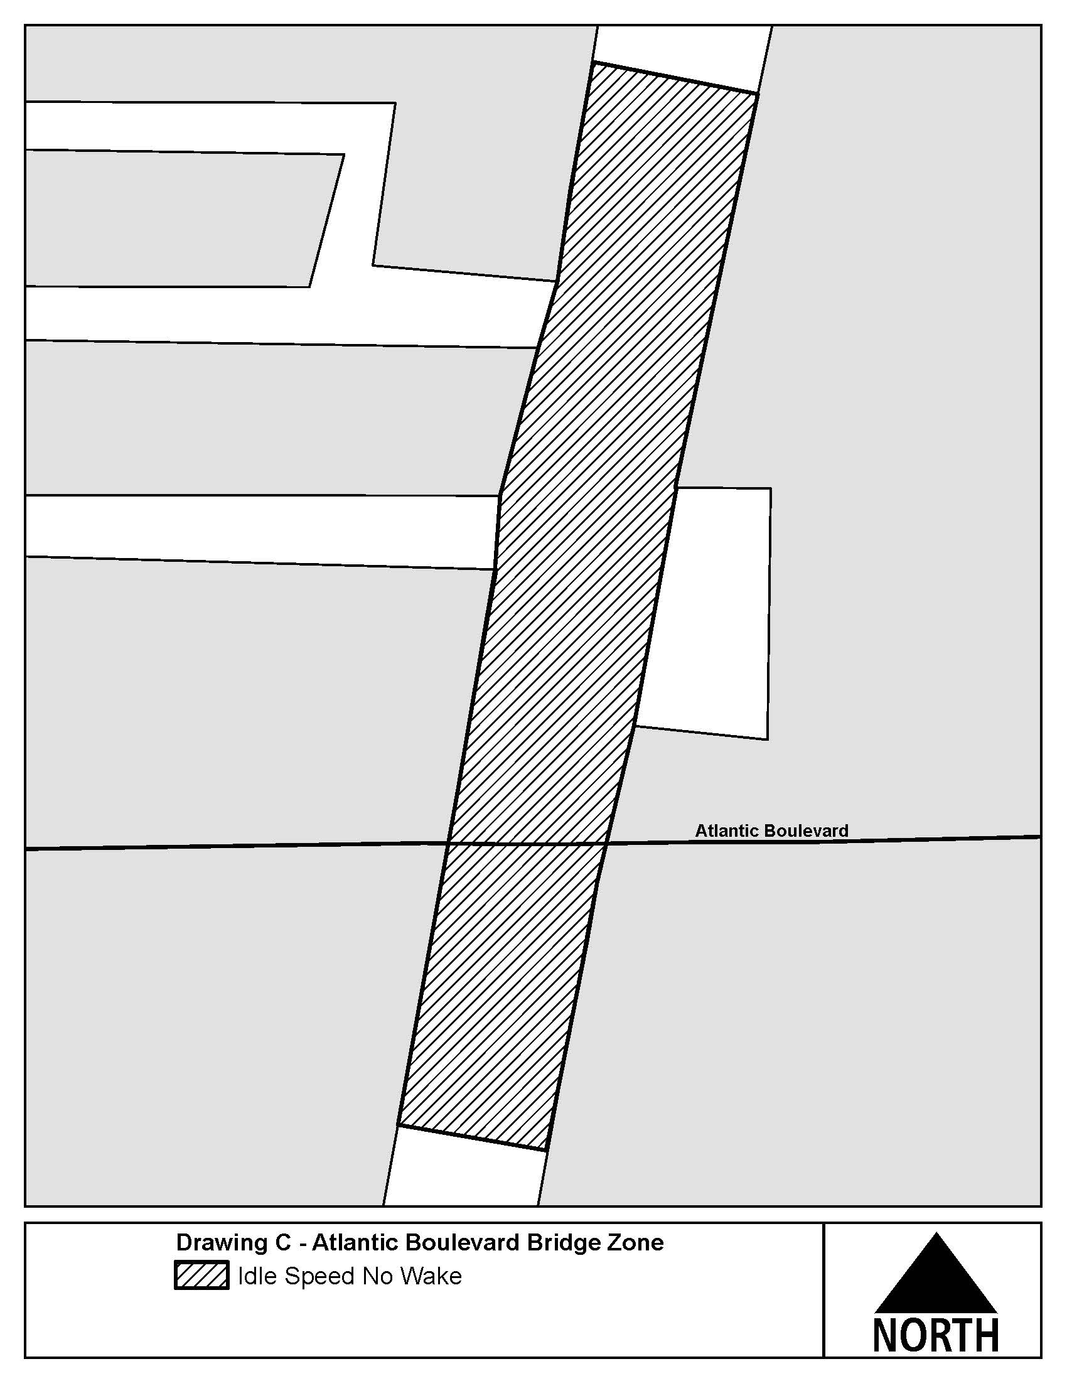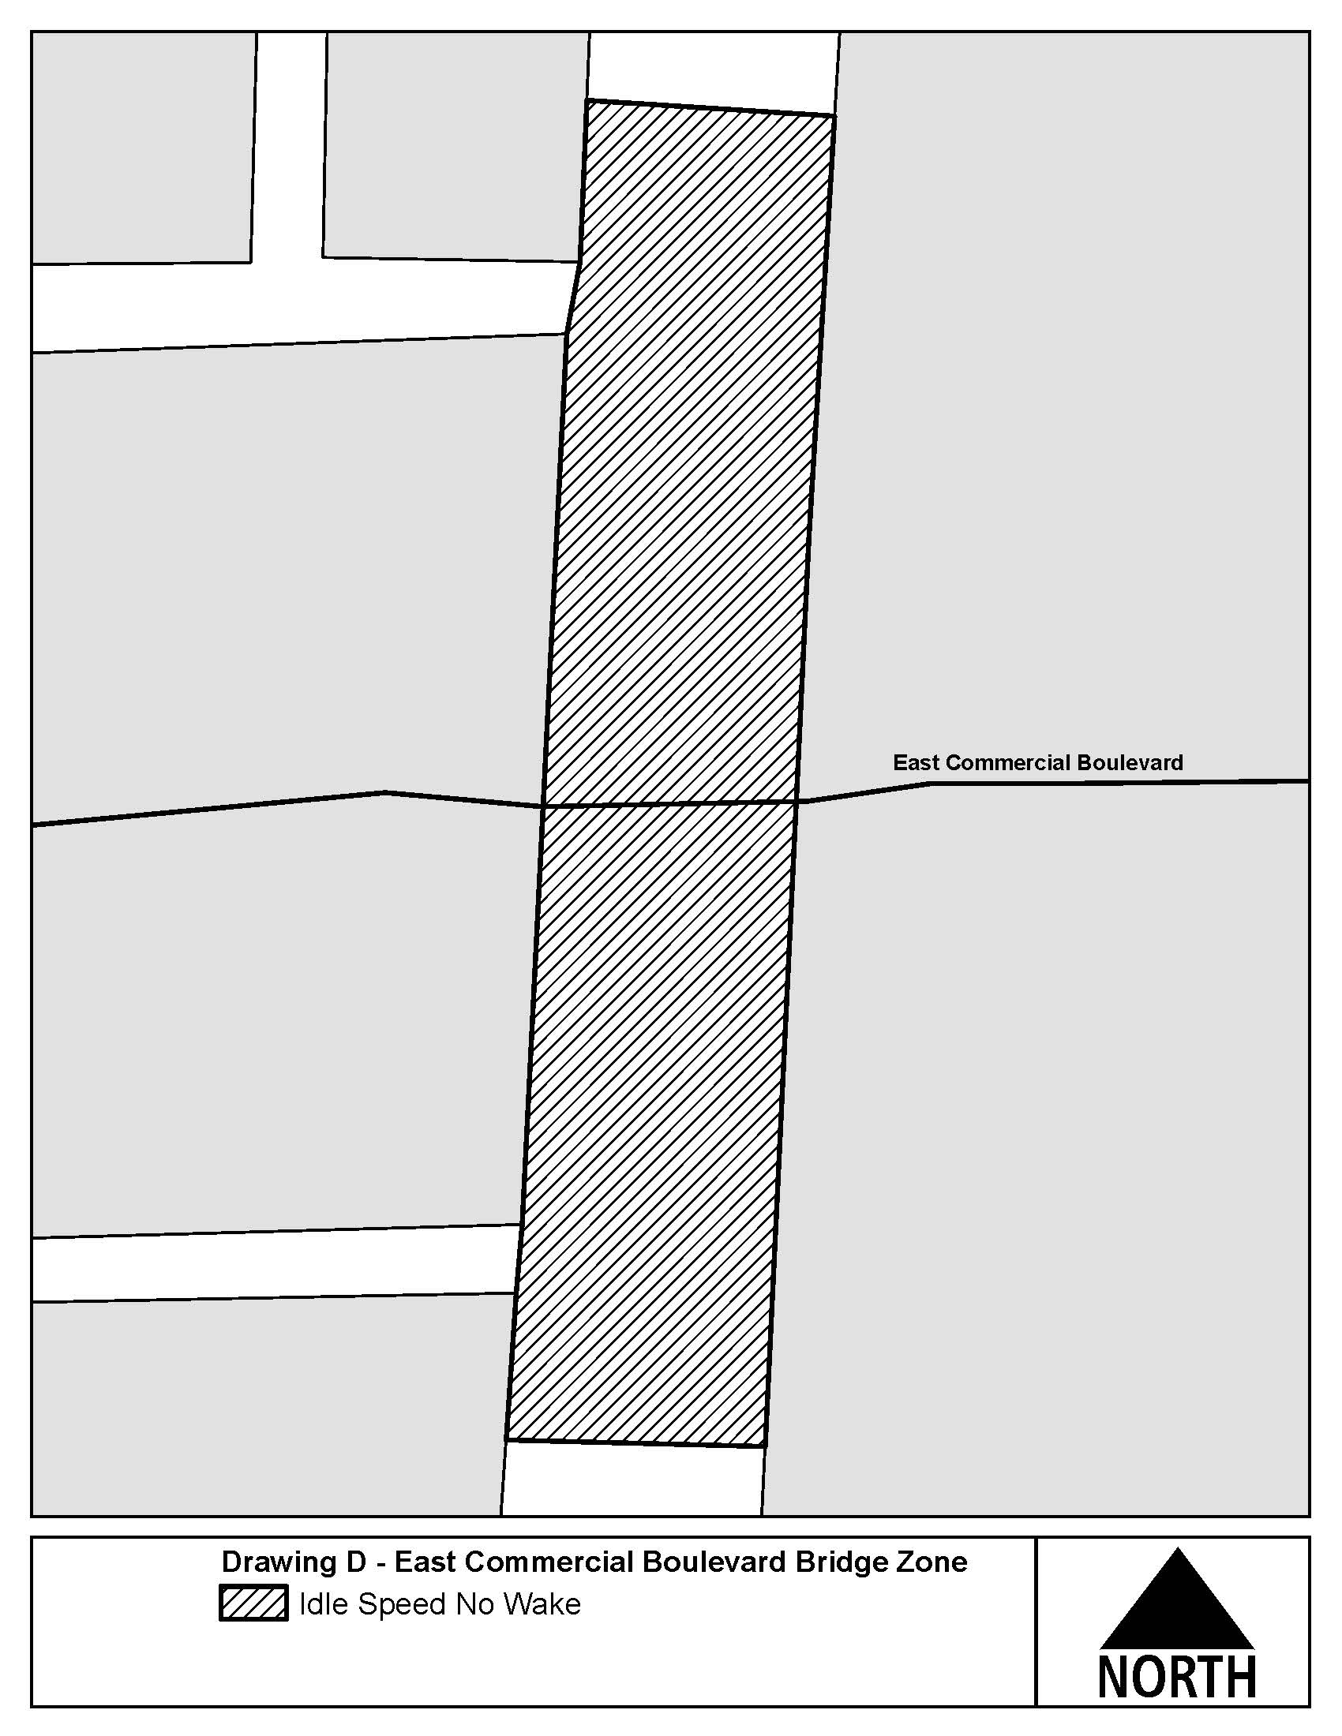
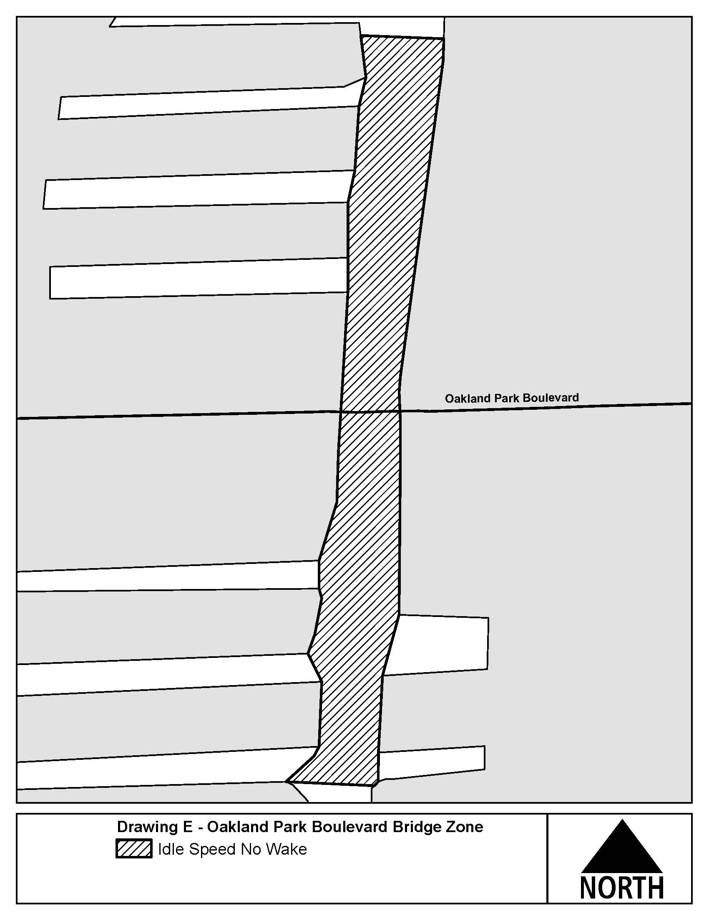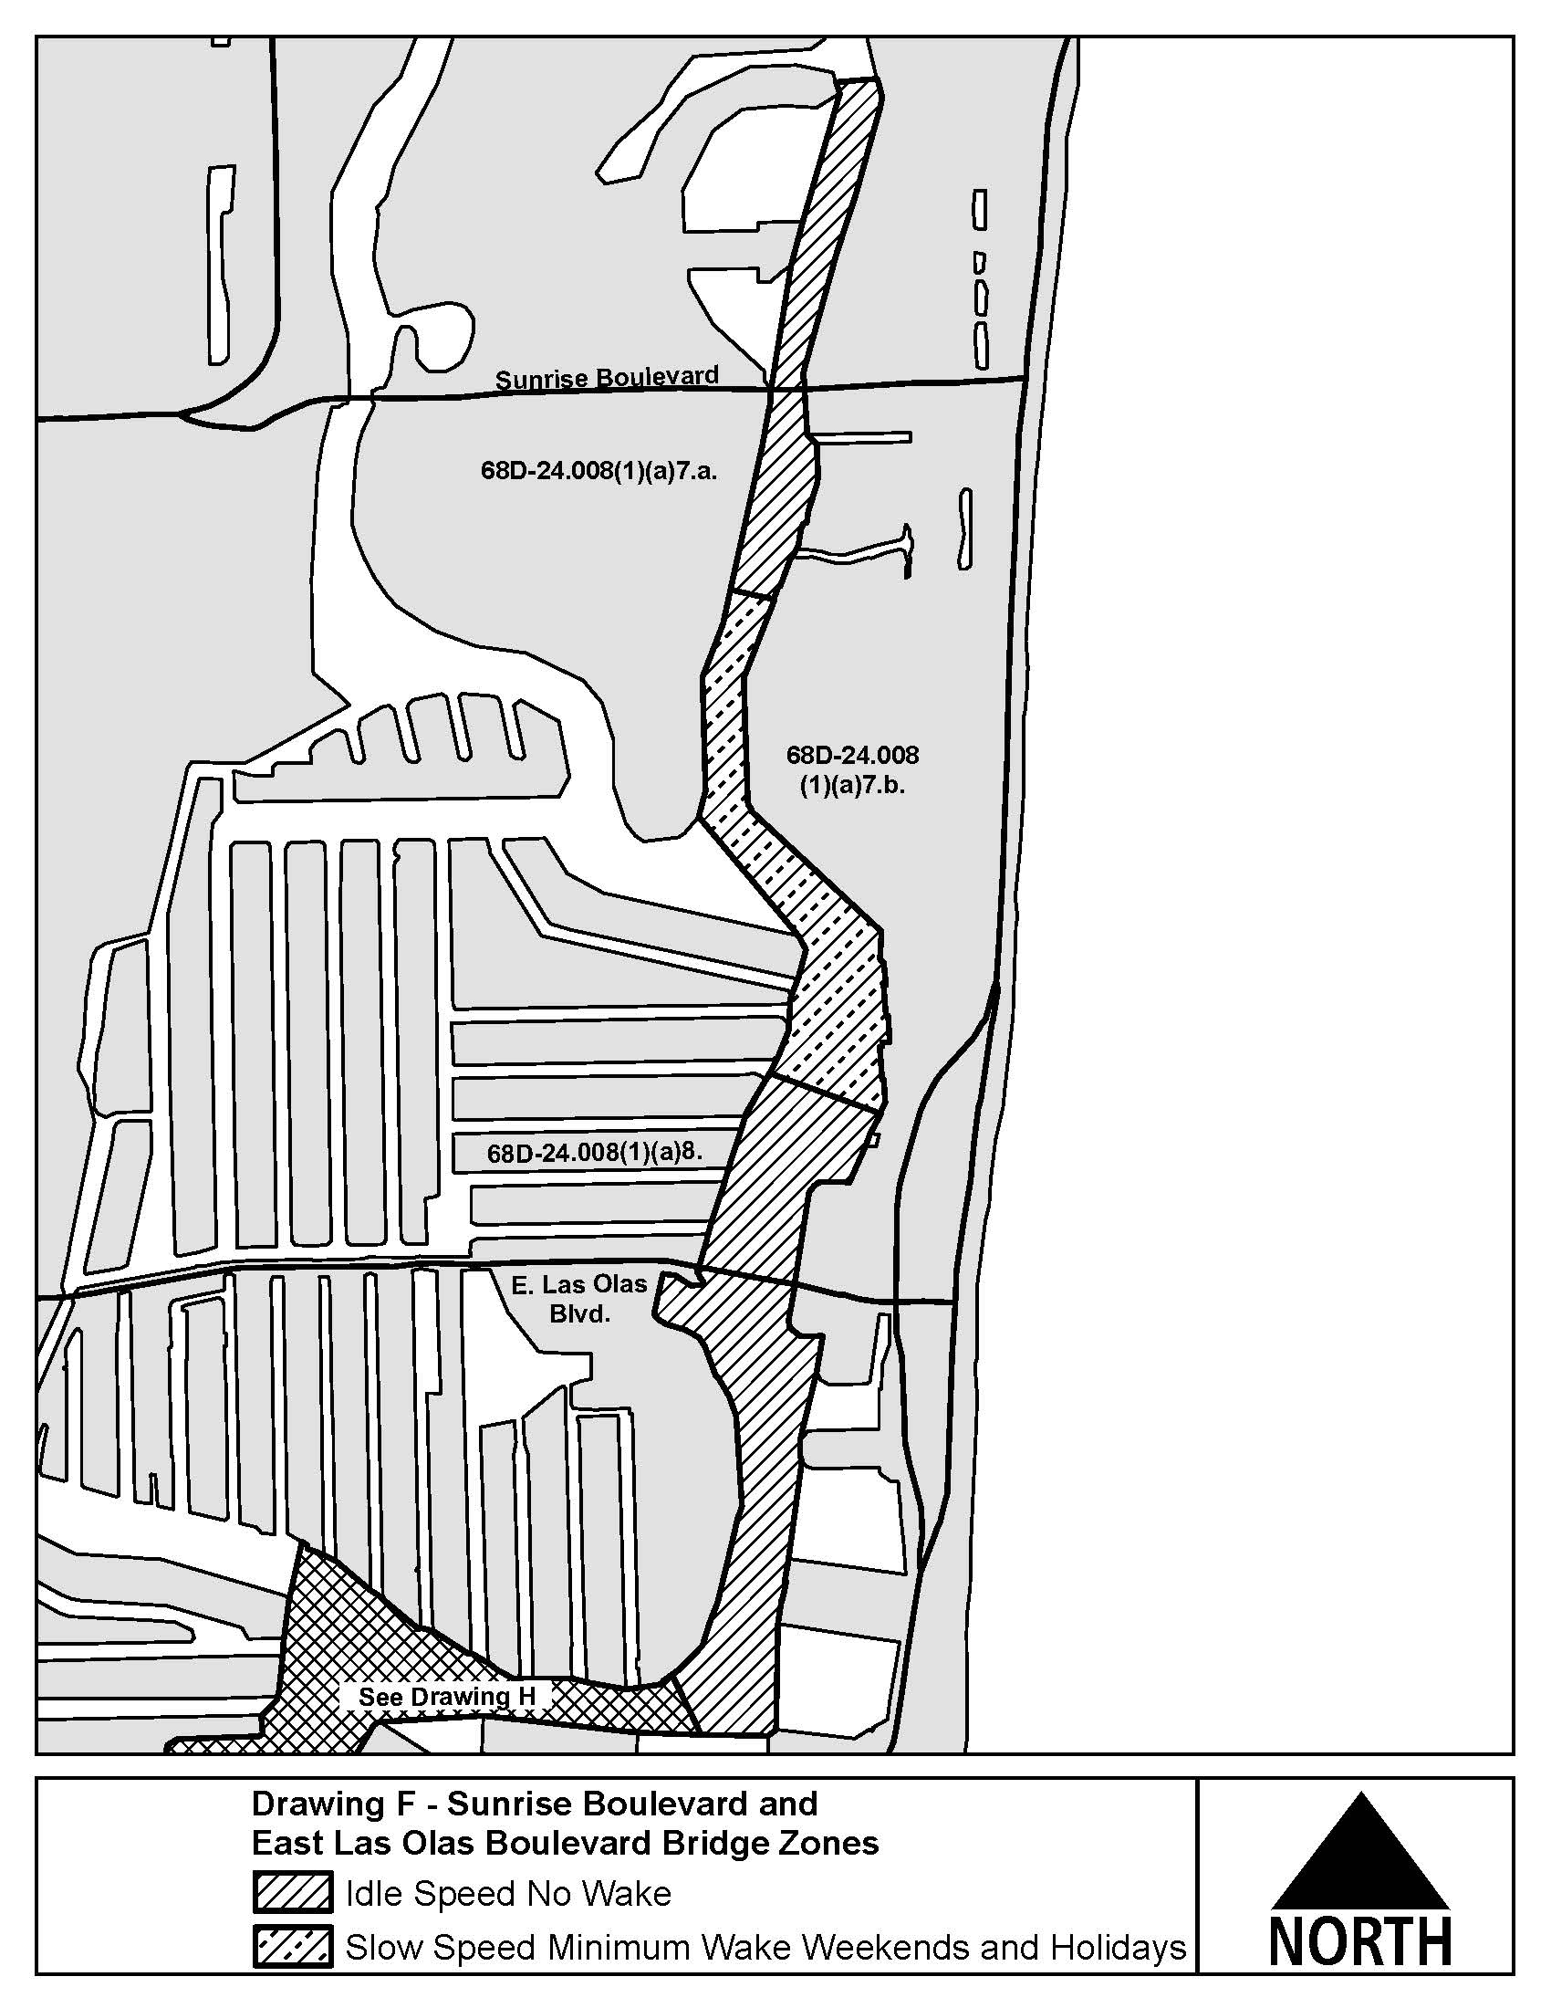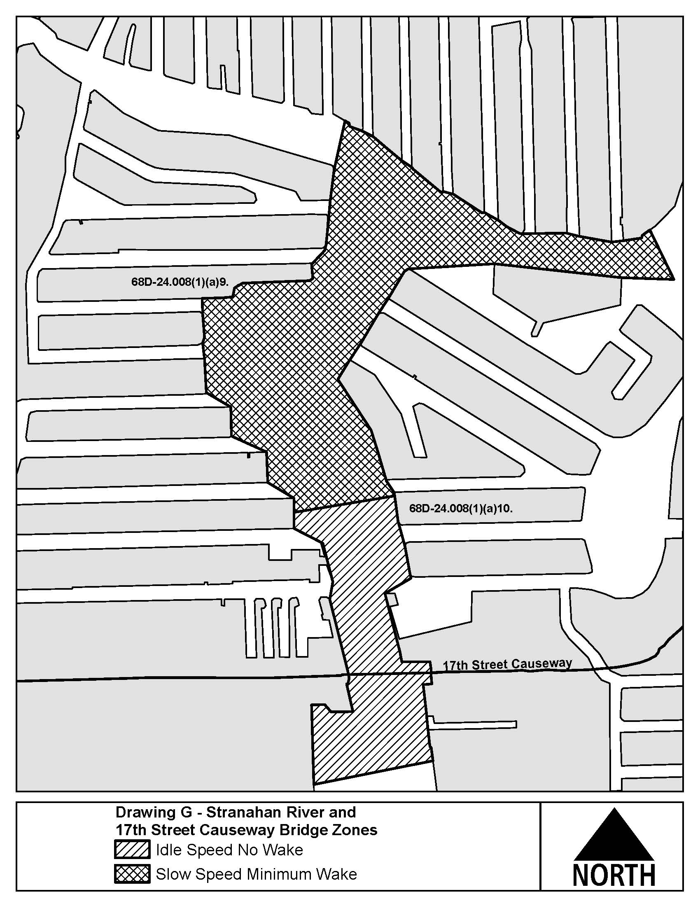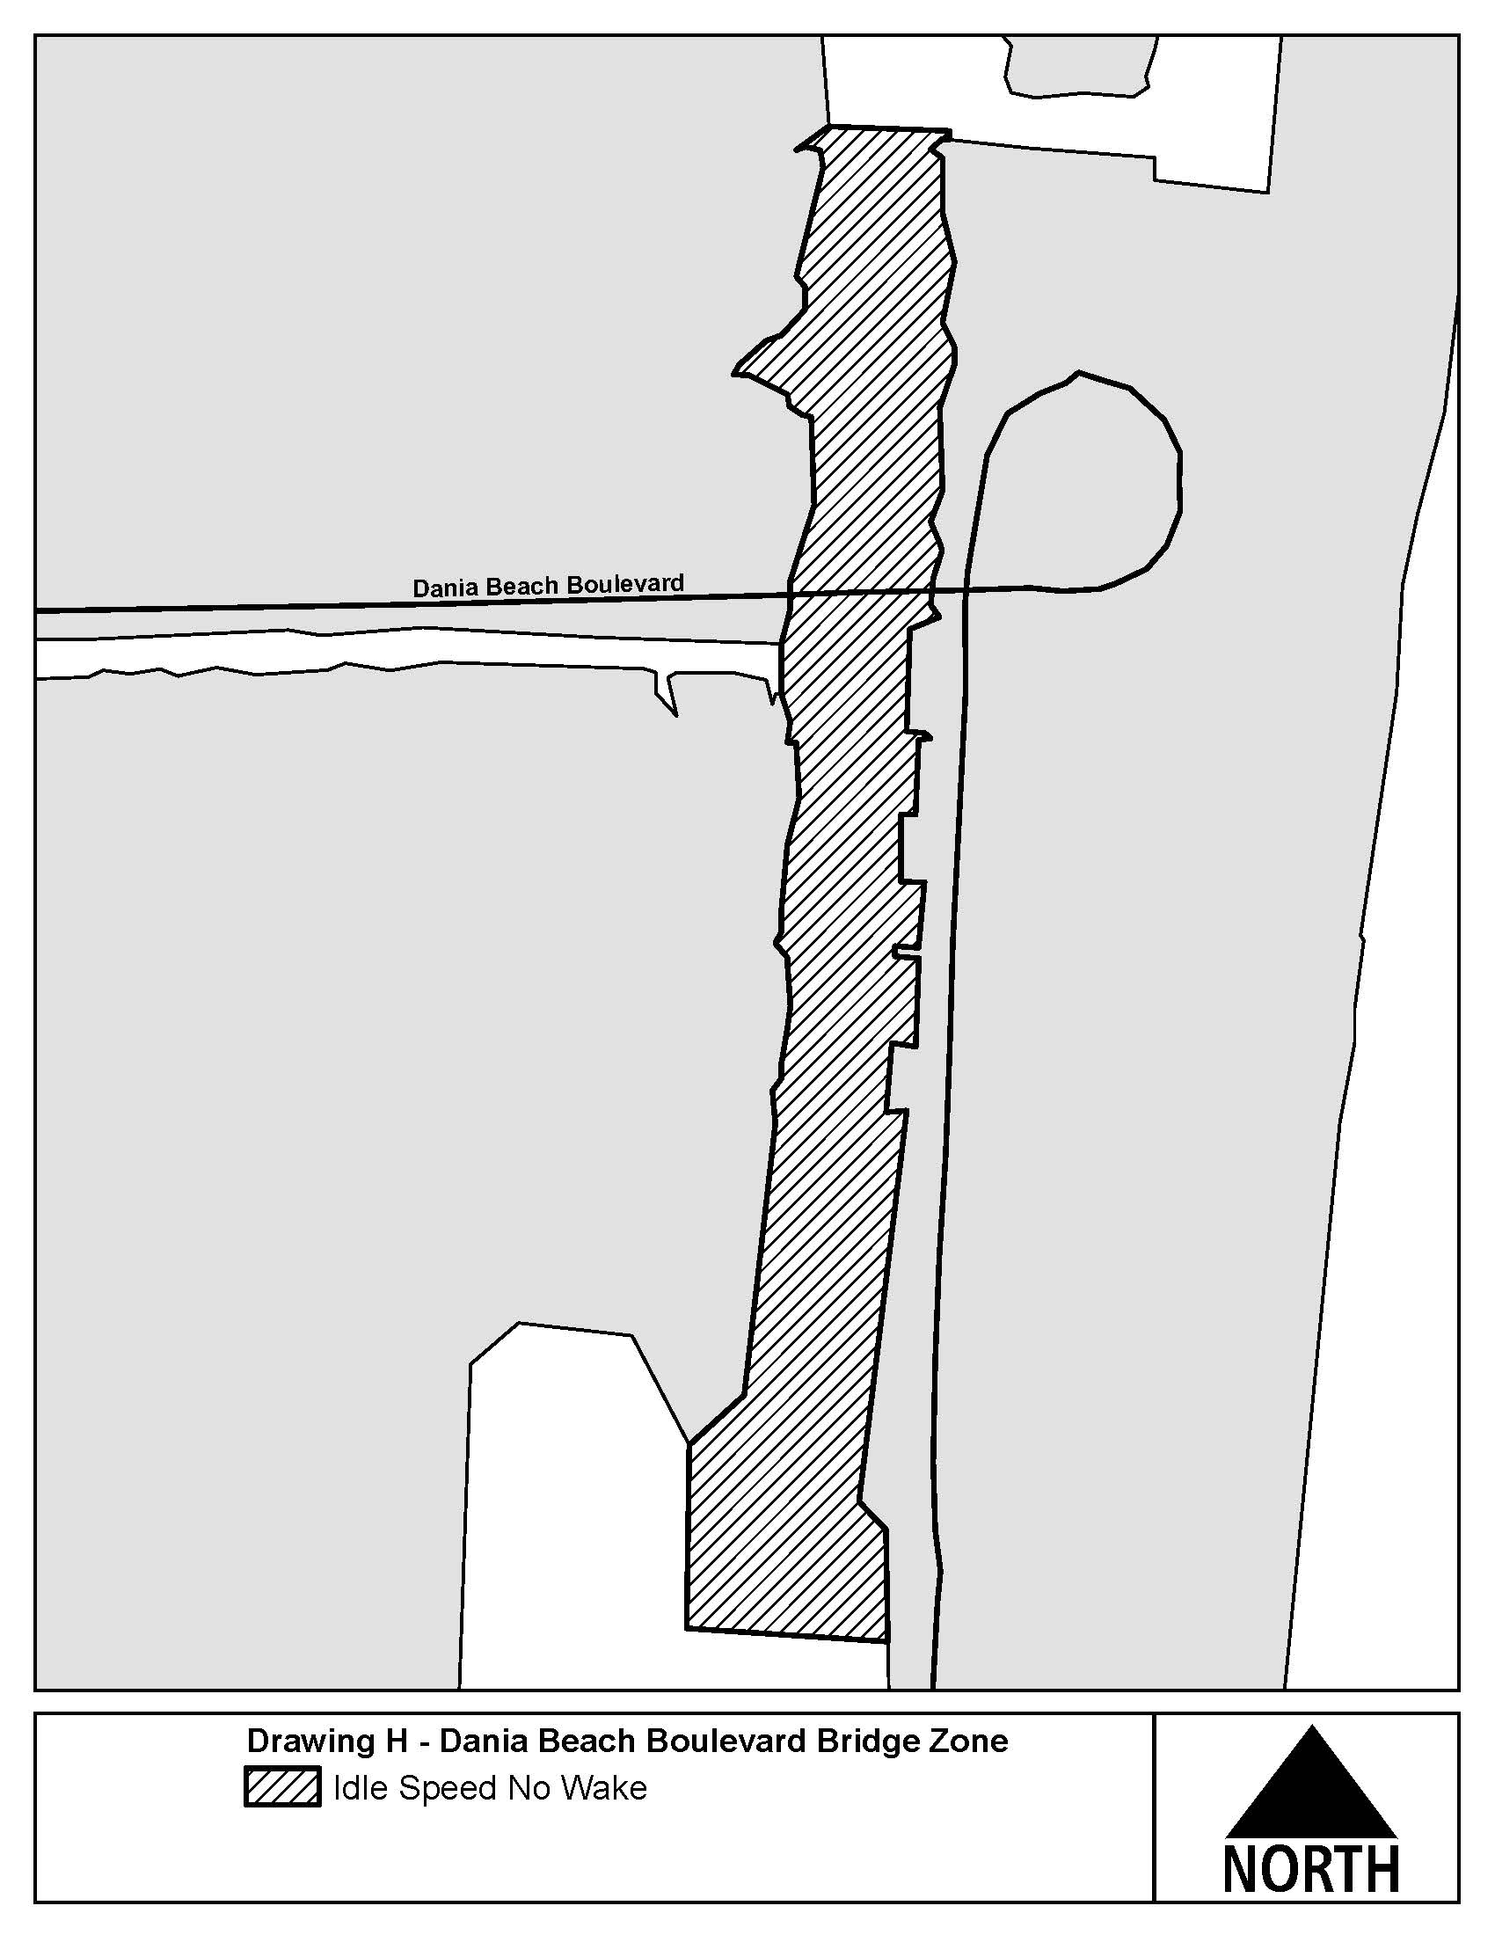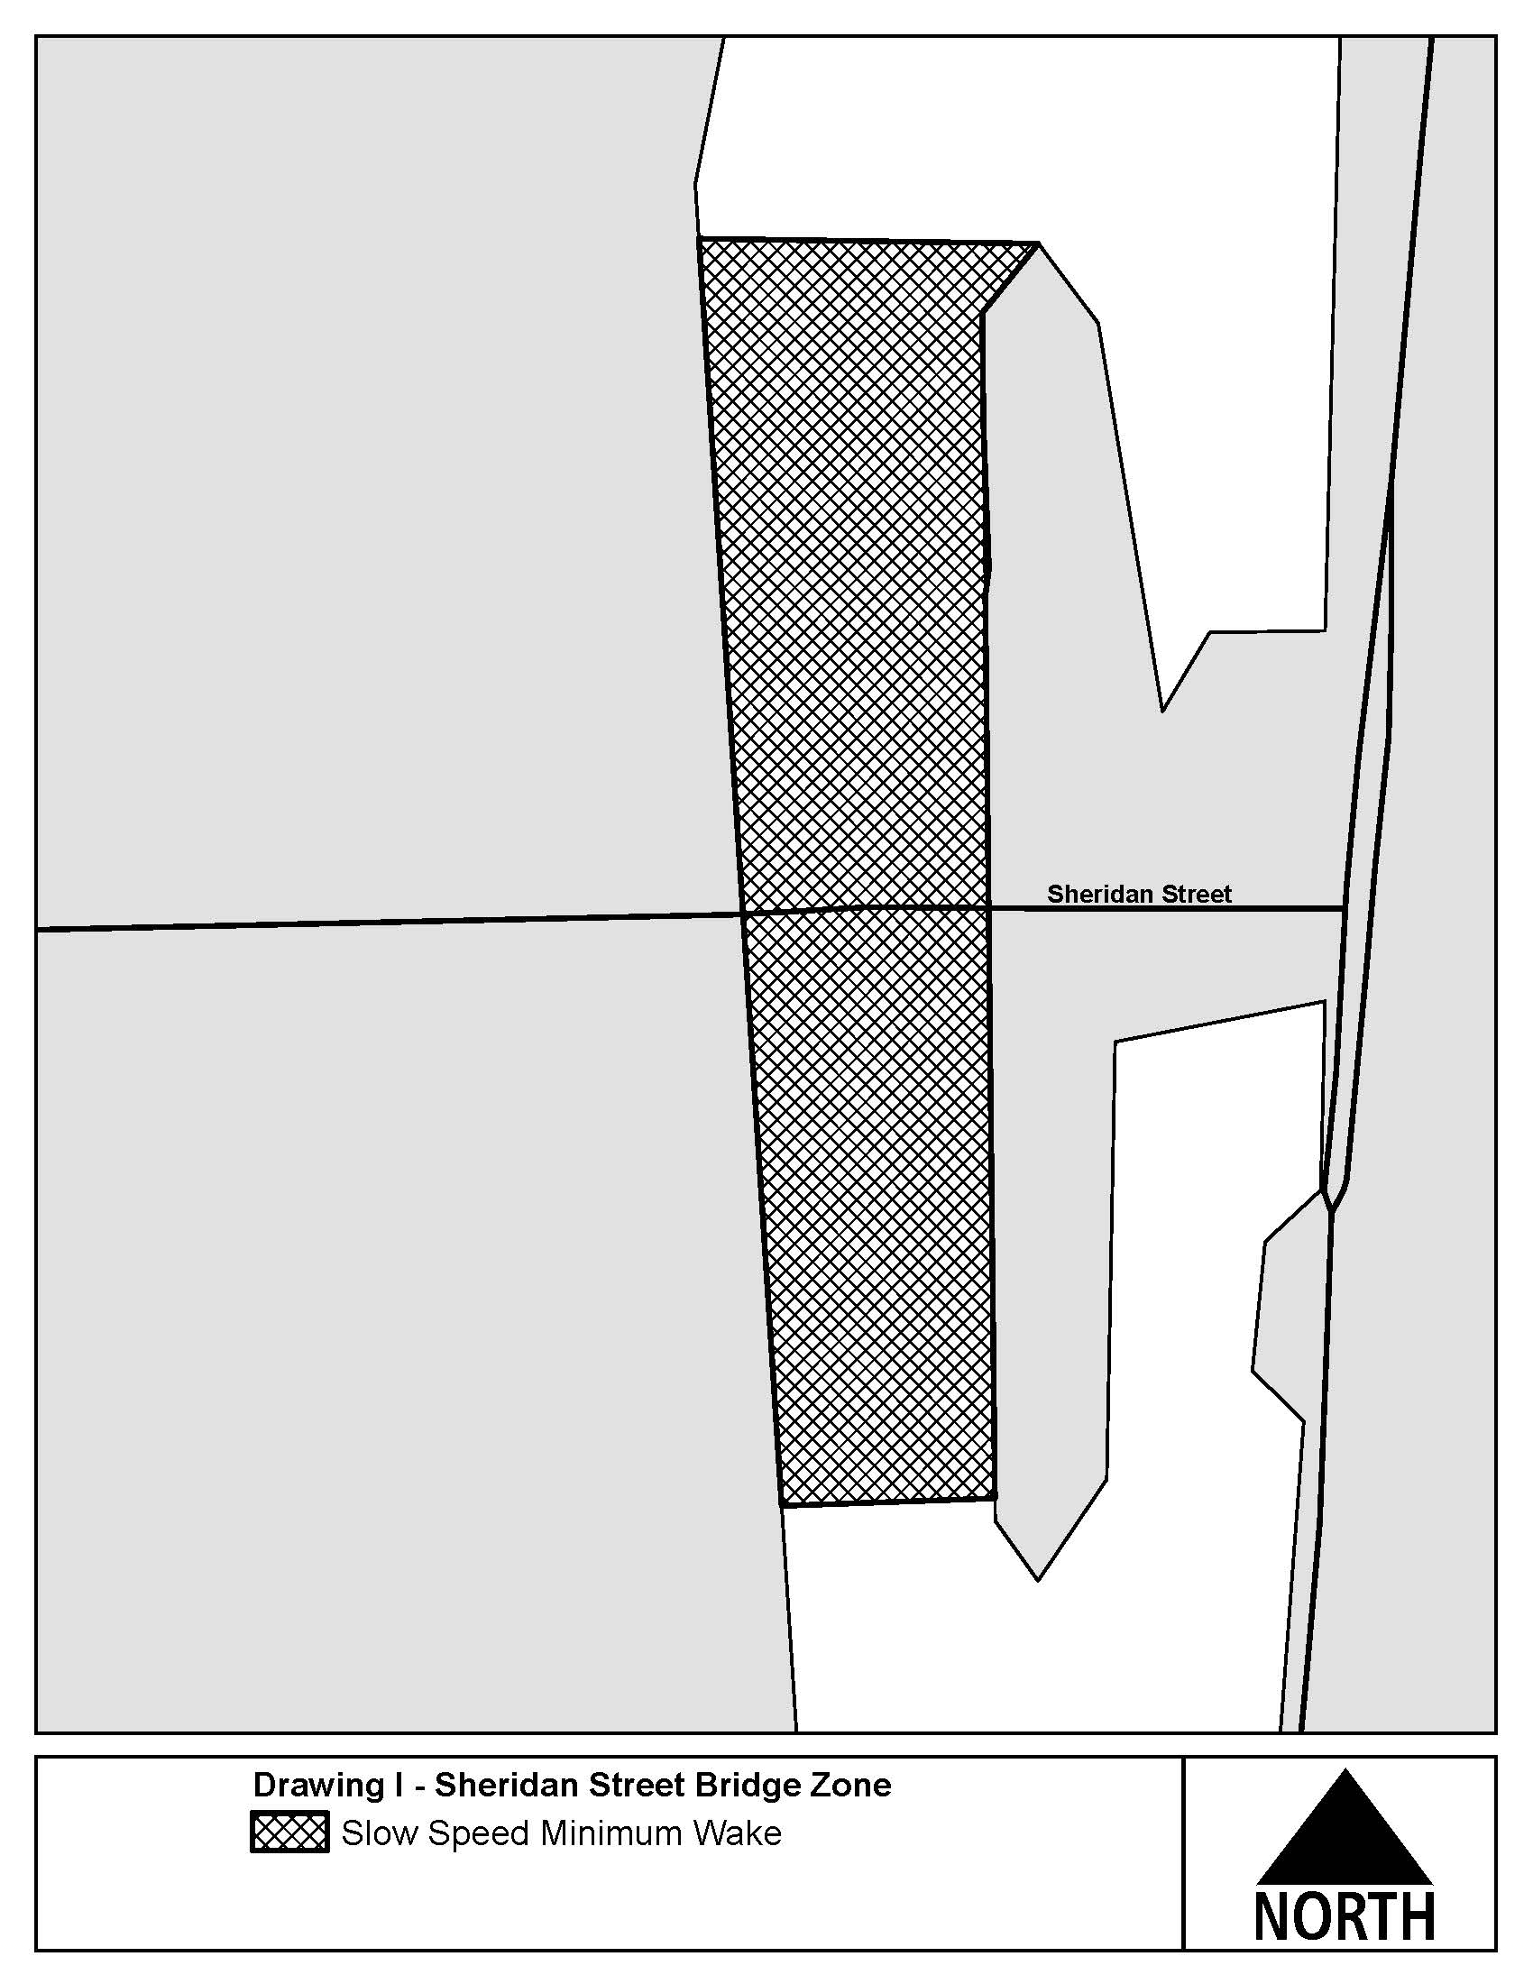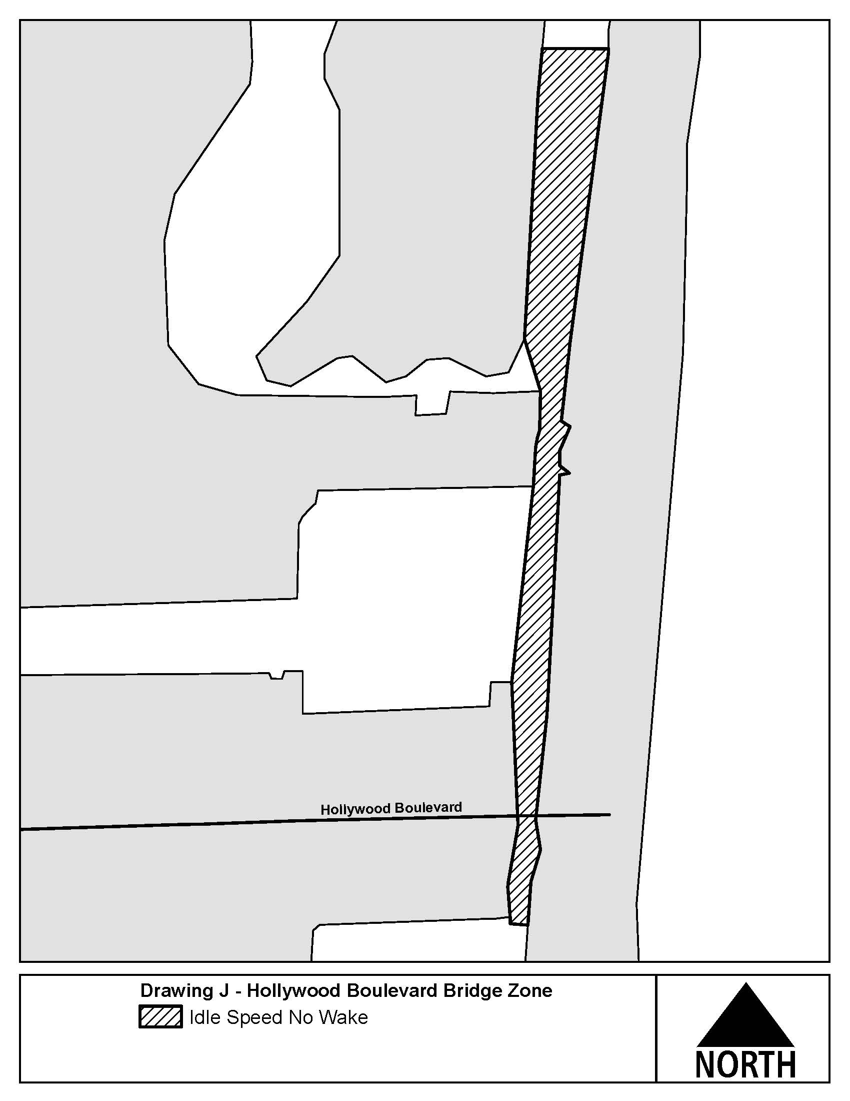
Rulemaking Specific Authority 327.04, 327.46, 37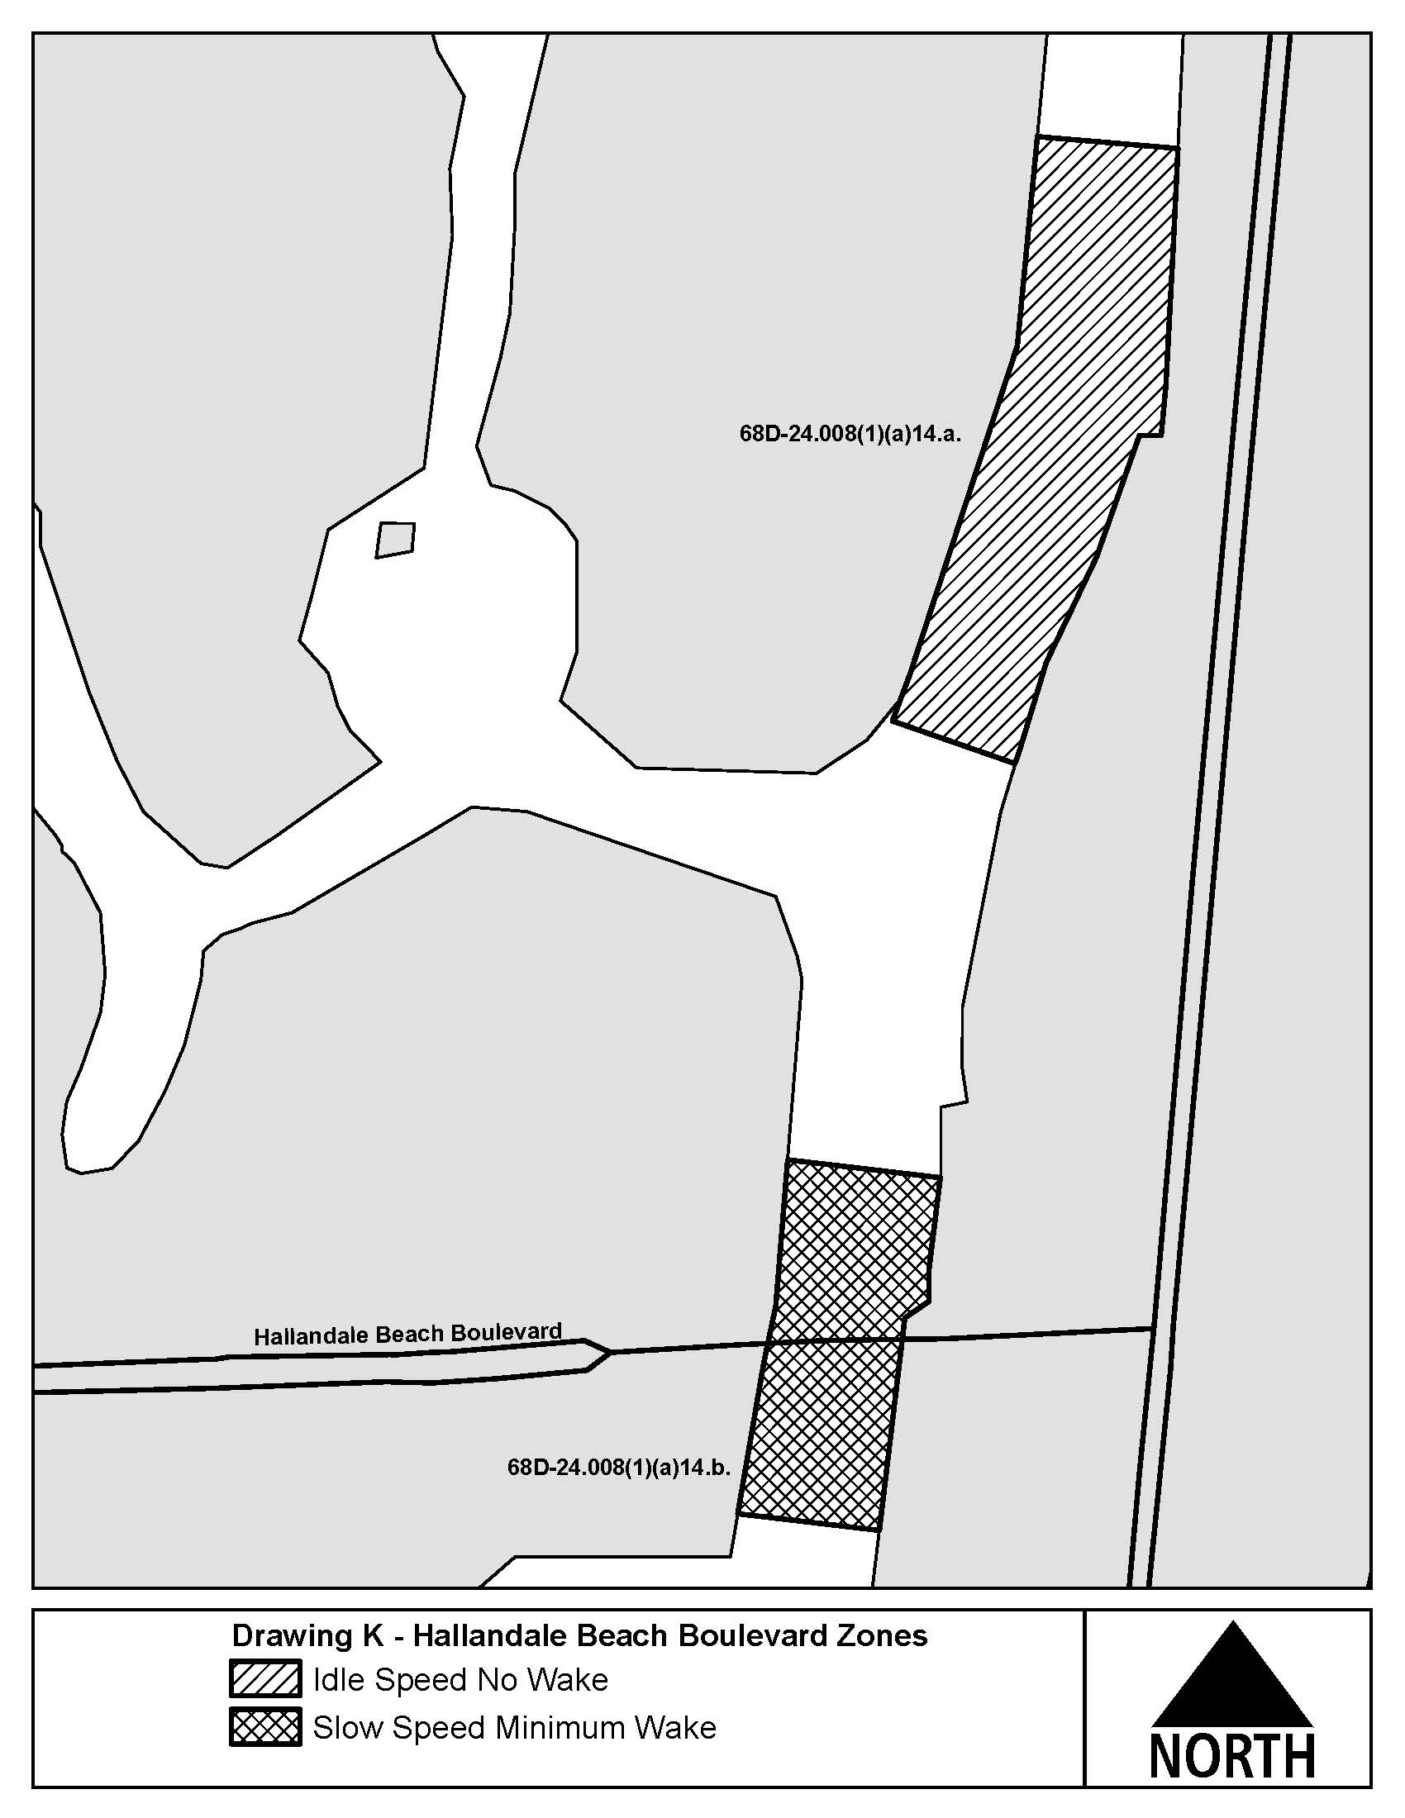0.021 FS. Law Implemented 327.46, 327.72, 327.73(1) FS., Ch. 86-364, Ch. 89-428, Laws of Florida. History–New 11-9-86, Amended 6-14-93, Formerly 16N-24.008, Amended 12-18-94, Formerly 62N-24.008, Amended_________.

NAME OF PERSON ORIGINATING PROPOSED RULE: Captain Richard Moore, Florida Fish and Wildlife Conservation Commission, Division of Law Enforcement, 620 South Meridian Street, Tallahassee, Florida 32399-1600
NAME OF AGENCY HEAD WHO APPROVED THE PROPOSED RULE: Florida Fish and Wildlife Conservation Commission
DATE PROPOSED RULE APPROVED BY AGENCY HEAD: April 18, 2013
DATE NOTICE OF PROPOSED RULE DEVELOPMENT PUBLISHED IN FAR: February 1, 2013

