Notice of Proposed Rule

FISH AND WILDLIFE CONSERVATION COMMISSION
Vessel Registration and Boating Safety
RULE NO.: RULE TITLE:
68D-24.010: Pinellas County Boating Restricted Areas
PURPOSE AND EFFECT: The purpose of this rule amendment is to reduce vessel speeds on the Florida Intracoastal Waterway within Pinellas County, where necessary, to manage and promote the use of this state waterway for safe boating. The amendments, as a result of public comment, are more substantial than anticipated, and include the following: the expansion of “channel only” boating safety zones of the Pinellas Bayway Bridges, Belleair Causeway Bridge, and Honeymoon Island Causeway Bridge to include the entire width of bridge spans within the Intracoastal Waterway and the expansion of the “channel only” zone between the Treasure Island Causeway Bridge and Corey Causeway Bridge to “shoreline to shoreline”; The boating safety zone surrounding the Memorial Causeway Bridge will be increased by an additional 500 feet south of the bridge due to changes in maritime and bridge infrastructure; Increases to the footprint of the zones found in subparagraphs (1)(a)4. and (1)(a)5. to match historical boundaries established by regulatory markers; The removal of the 30 MPH channel only restriction throughout the County; New language that excludes water bodies such as canals and boat basins for shoreline to shoreline zones; The splitting of zone descriptions into multiple paragraphs for clarity; Updates of all the rule maps and the removal of the responsibility of Pinellas County and the City of Clearwater to mark the zones.
SUMMARY: This rule amendment extends one (1) zone and widens five (5) zones in the Florida Intracoastal Waterway in Pinellas County. It changes rule language to reflect historical marking of two (2) additional zones, removes the 30 MPH channel only restriction, adds exclusionary language for shoreline to shoreline zones and splits zone descriptions into multiple paragraphs for clarity. The amendment also updates the rule maps and removes the responsibility of Pinellas County and the City of Clearwater to mark the zones.
SUMMARY OF STATEMENT OF ESTIMATED REGULATORY COSTS AND LEGISLATIVE RATIFICATION:
The Agency has determined that this will not have an adverse impact on small business or likely increase directly or indirectly regulatory costs in excess of $200,000 in the aggregate within one year after the implementation of the rule. A SERC has been prepared by the agency.
The Agency has determined that the proposed rule is not expected to require legislative ratification based on the statement of estimated regulatory costs or if no SERC is required, the information expressly relied upon and described herein:
Any person who wishes to provide information regarding a statement of estimated regulatory costs, or provide a proposal for a lower cost regulatory alternative must do so in writing within 21 days of this notice.
RULEMAKING AUTHORITY: 327.46, FS.
LAW IMPLEMENTED: 327.46, FS.
IF REQUESTED WITHIN 21 DAYS OF THE DATE OF THIS NOTICE, A HEARING WILL BE SCHEDULED AND ANNOUNCED IN THE FAR.
THE PERSON TO BE CONTACTED REGARDING THE PROPOSED RULE IS: Captain Richard Moore, Florida Fish and Wildlife Conservation Commission, Division of Law Enforcement, Boating and Waterways Section, 620 South Meridian Street, Tallahassee, Florida 32399-1600
THE FULL TEXT OF THE PROPOSED RULE IS:

(Substantial rewording of the Rule 68D-24.010follows. See Florida Administrative Code for present text.)

68D-24.010 Pinellas County Boating Restricted Areas.
(1) The following year-round zones are established regulating the speed and operation of vessel traffic on and adjacent to the Florida Intracoastal Waterway within Pinellas County. The zones exclude all associated tributaries, creeks, canals, channels, backwaters, boat basins and other waterways unless otherwise designated or specifically described for inclusion:
(a) SLOW SPEED MINIMUM WAKE ZONES
1. Pinellas Bayway (SR679) (SR 682) Bridges–
a. All waters in and adjacent to the Florida Intracoastal Waterway from a line drawn perpendicular to the centerline of the Florida Intracoastal Waterway 500 feet southeast of the Pinellas Bayway (SR 679) Bridge, to a line drawn perpendicular to the centerline of the Florida Intracoastal Waterway 1,500 feet northwest of said bridge, bounded on the northeast by a line drawn parallel to the Florida Intracoastal Waterway from a point (27 41.748N, -82 42.986W) and bounded on the southwest by the southwestern shoreline as depicted in drawing A.
b. All waters in and adjacent to the Florida Intracoastal Waterway from a line drawn perpendicular to the centerline of the Florida Intracoastal Waterway 500 feet south of the Pinellas Bayway (SR 682) Bridge, to a line drawn perpendicular to the centerline of the Florida Intracoastal Waterway 500 feet north of said bridge, bounded on the east by the eastern shoreline and bounded on the west by a line drawn parallel to the Florida Intracoastal Waterway from a point (27 42.563N, -82 43.583W), as depicted in drawing A.
2. Corey Causeway (SR 699) Bridge to Treasure Island Causeway (SR 150) Bridge –All waters in and adjacent to the Florida Intracoastal Waterway, from shoreline to shoreline, from a line drawn perpendicular to the centerline of the Florida Intracoastal Waterway 800 feet southeast of the Corey Causeway (SR 699) Bridge, to a line drawn perpendicular to the centerline of the Florida Intracoastal Waterway 500 feet north of the Treasure Island Causeway (SR 150) Bridge, as depicted in drawing B.
3. Tom Stuart (Welch) Causeway (SR 150) Bridge – All waters in and adjacent to the Florida Intracoastal Waterway from a line drawn perpendicular to the centerline of the Florida Intracoastal Waterway 1,600 feet southeast of the Tom Stuart (Welch) Causeway (SR 666) Bridge, to a line drawn perpendicular to the centerline of the Florida Intracoastal Waterway 1,000 feet northwest of said bridge, bounded on the northeast by a line drawn parallel to the Florida Intracoastal Waterway from a point (27 48.455N, -82 47.660W) and bounded on the southwest by a line drawn parallel to the Florida Intracoastal Waterway from a point (27 48.377N, -82 47.743W), as depicted in drawing C.
4. Park Boulevard (SR 694) Bridge – All waters in and adjacent to the Florida Intracoastal Waterway, from shoreline to shoreline, from a line drawn perpendicular to the centerline of the Florida Intracoastal Waterway 7,000 feet southeast of the Park Boulevard (SR 694) Bridge, to a line drawn perpendicular to the centerline of the Florida Intracoastal Waterway 3,500 feet north of said bridge, including the backwater immediately adjacent to Bayhaven Drive, as depicted in drawing D.
5. Indian Rocks (SR 688) Bridge – All waters in and adjacent to the Florida Intracoastal Waterway, from shoreline to shoreline, from a line drawn perpendicular to the centerline of the Florida Intracoastal Waterway 8,300 feet south of the Indian Rocks (SR 688) Bridge, to a line drawn perpendicular to the centerline of the Florida Intracoastal Waterway 1,900 feet north of said bridge, as depicted on drawing E.
6. Belleair Causeway (CR-416) Bridge – All waters in and adjacent to the Florida Intracoastal Waterway from a line drawn perpendicular to the centerline of the Florida Intracoastal Waterway 500 feet south of the center bridge span of the Belleair Causeway (CR-416) Bridge, to a line drawn perpendicular to the centerline of the Florida Intracoastal Waterway 500 feet north of the center bridge span of said bridge, bounded on the east by a point (27 54.932N, -82 49.797W) and following the contour of the eastern shoreline north to a point (27 54.954N, -82 49.750W) then running parallel to the channel from said point to the terminus of the north boundary and bounded on the west by a line drawn parallel to the Florida Intracoastal Waterway from a point (27 55.007N, -82 49.973W), as depicted in drawing F.
7. Memorial Causeway (SR 60) Bridge -
a. All waters in and adjacent to the Florida Intracoastal Waterway from a line drawn perpendicular to the centerline of the Florida Intracoastal Waterway 1,215 feet southwest of Memorial Causeway (SR 60) Bridge, to a line drawn perpendicular to the centerline of the Florida Intracoastal Waterway 920 feet northeast of said bridge, bounded on the west by a line drawn parallel to the Florida Intracoastal Waterway from a point (27 58.018N, -82 48.429W) and bounded on the east by the City of Clearwater shoreline, as depicted in drawing G.
b. All waters in and adjacent to the Florida Intracoastal Waterway from a line drawn perpendicular to the centerline of the Florida Intracoastal Waterway 920 feet northeast of the Memorial Causeway (SR 60) Bridge, to a line draw perpendicular to the Florida Intracoastal Waterway 3,700 feet north of said bridge, bounded on the west by the boundaries of the marked channel of the Florida Intracoastal Waterway and bounded on the east by the City of Clearwater Shoreline, as depicted in drawing G.
8. Honeymoon Island Causeway (SR 586) Bridge – All waters in and adjacent to the Florida Intracoastal Waterway from a line drawn perpendicular to the centerline of the Florida Intracoastal Waterway 500 feet south of the Honeymoon Island Causeway (SR 586) Bridge, to a line drawn perpendicular to the centerline of the Florida Intracoastal Waterway 500 feet north of said bridge, bounded on the east by a line drawn parallel to the Florida Intracoastal Waterway from a point (28 3.068N,-82 47.621W) and bounded on the west by a line drawn parallel to the Florida Intracoastal Waterway from a point (28 3.070N,-82 47.829W), as depicted in drawing H.
(2) The boating restricted areas are depicted in the following drawings:

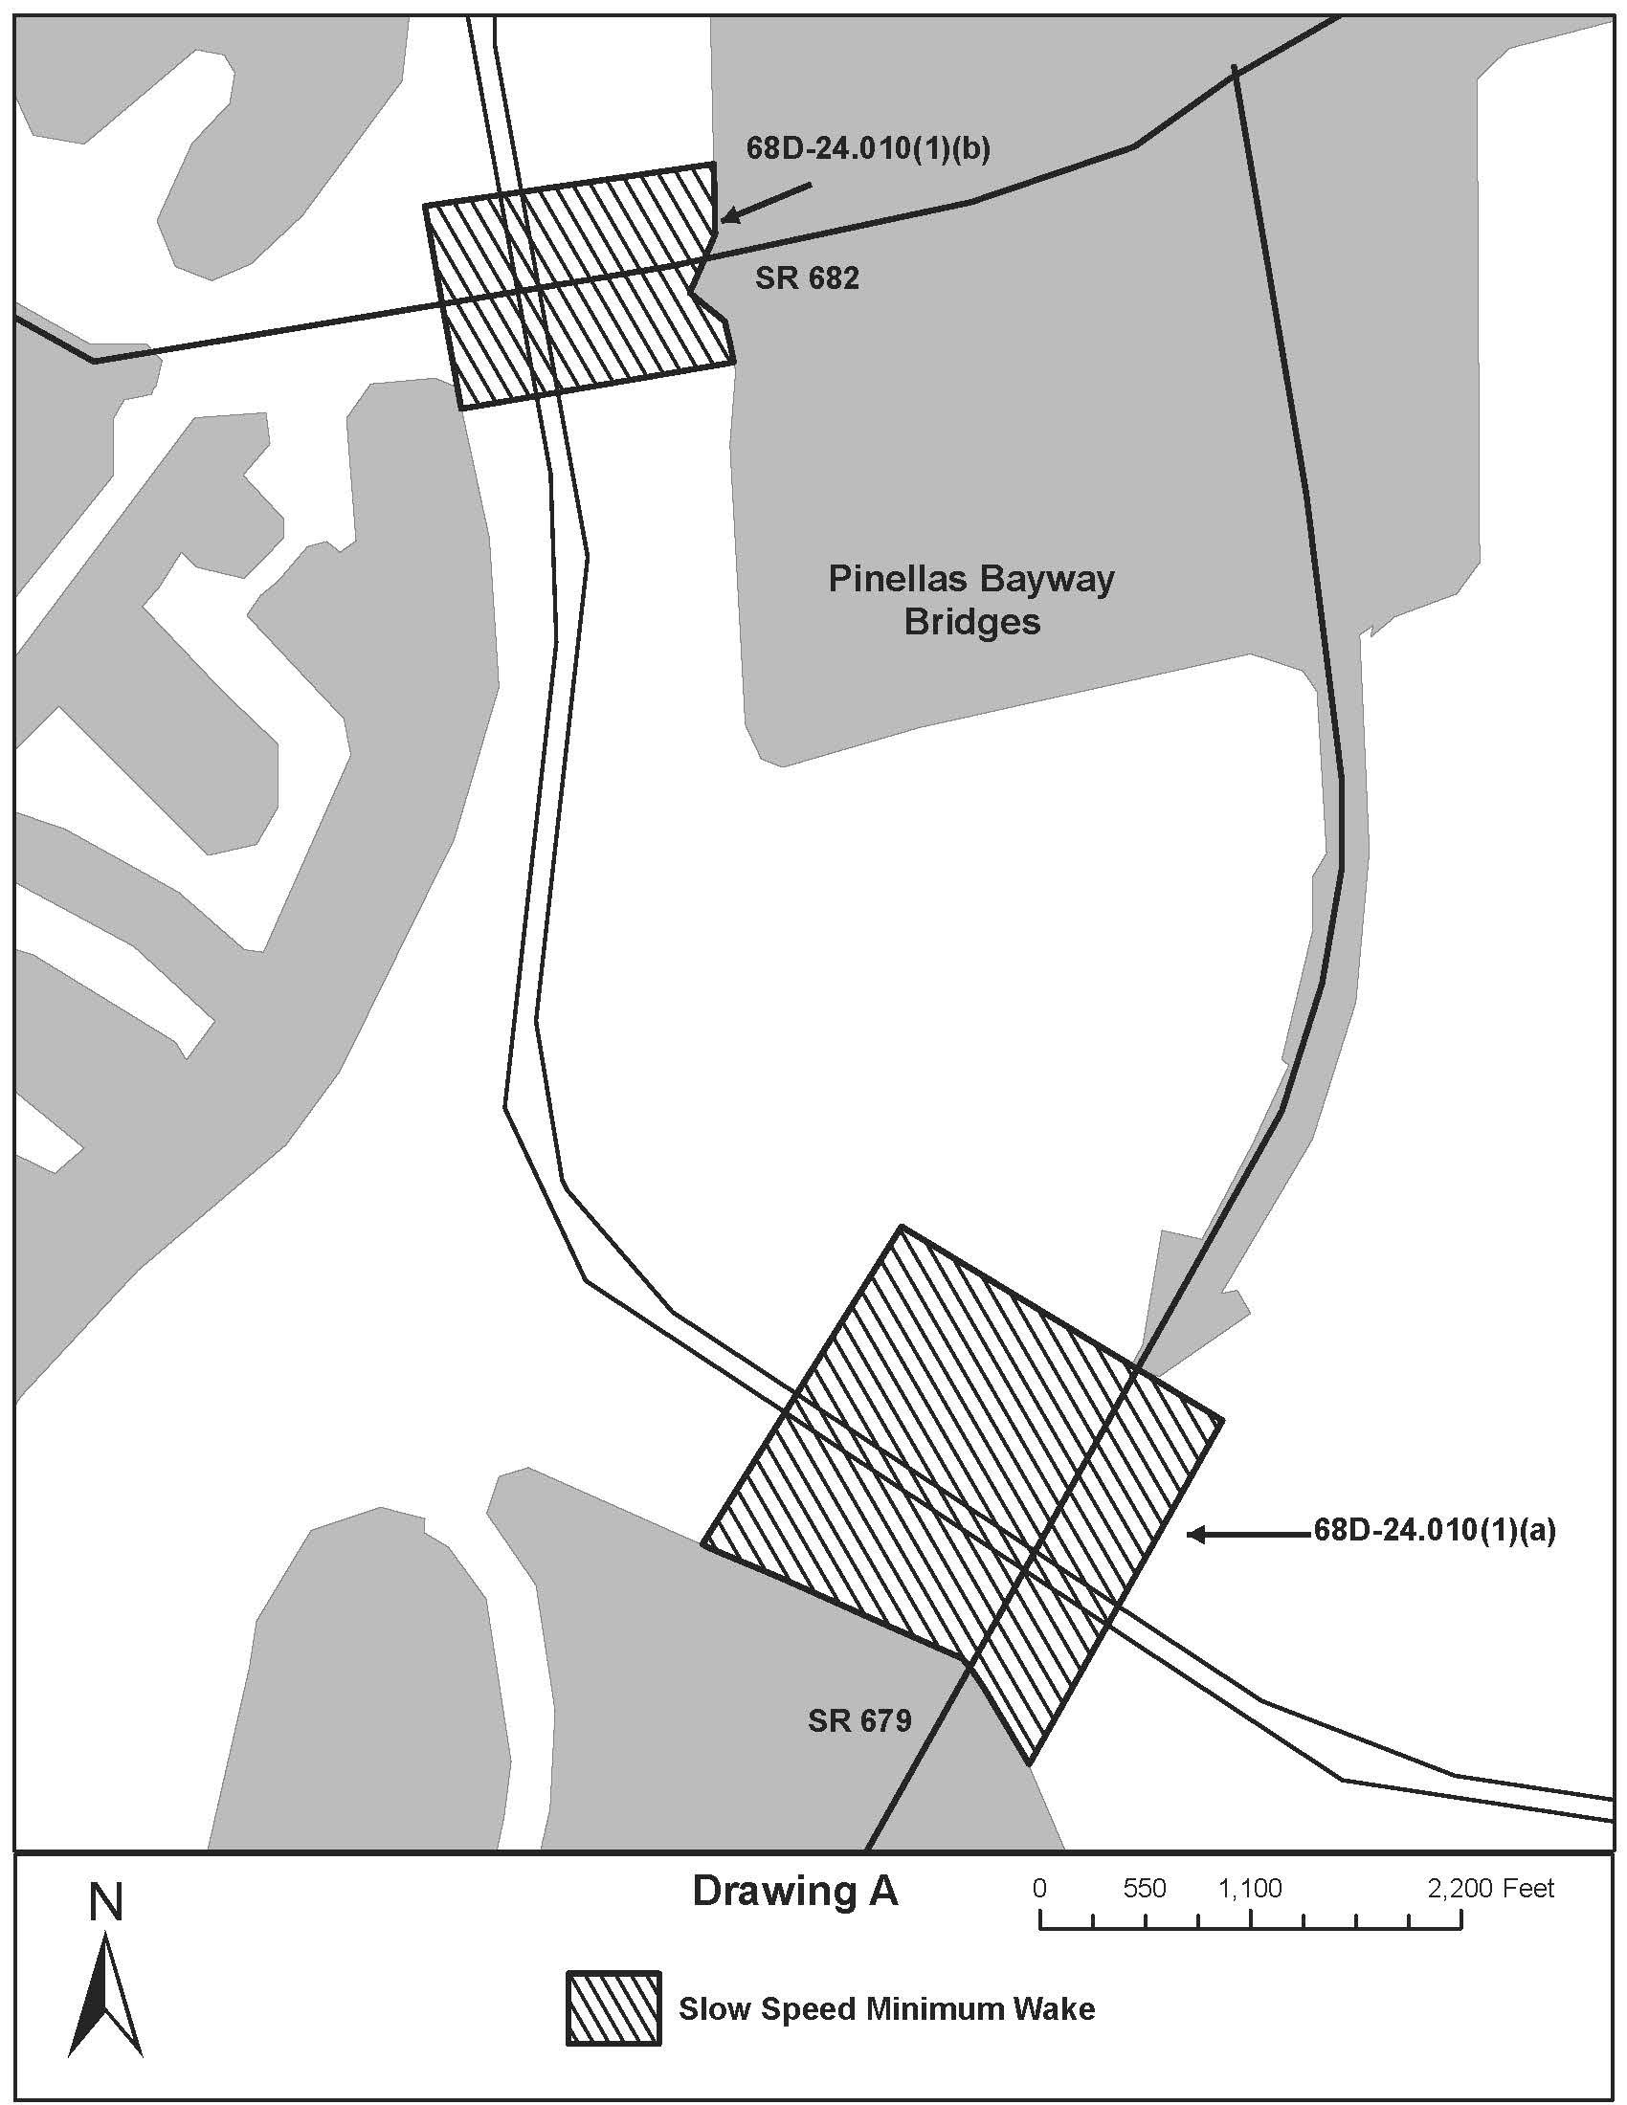
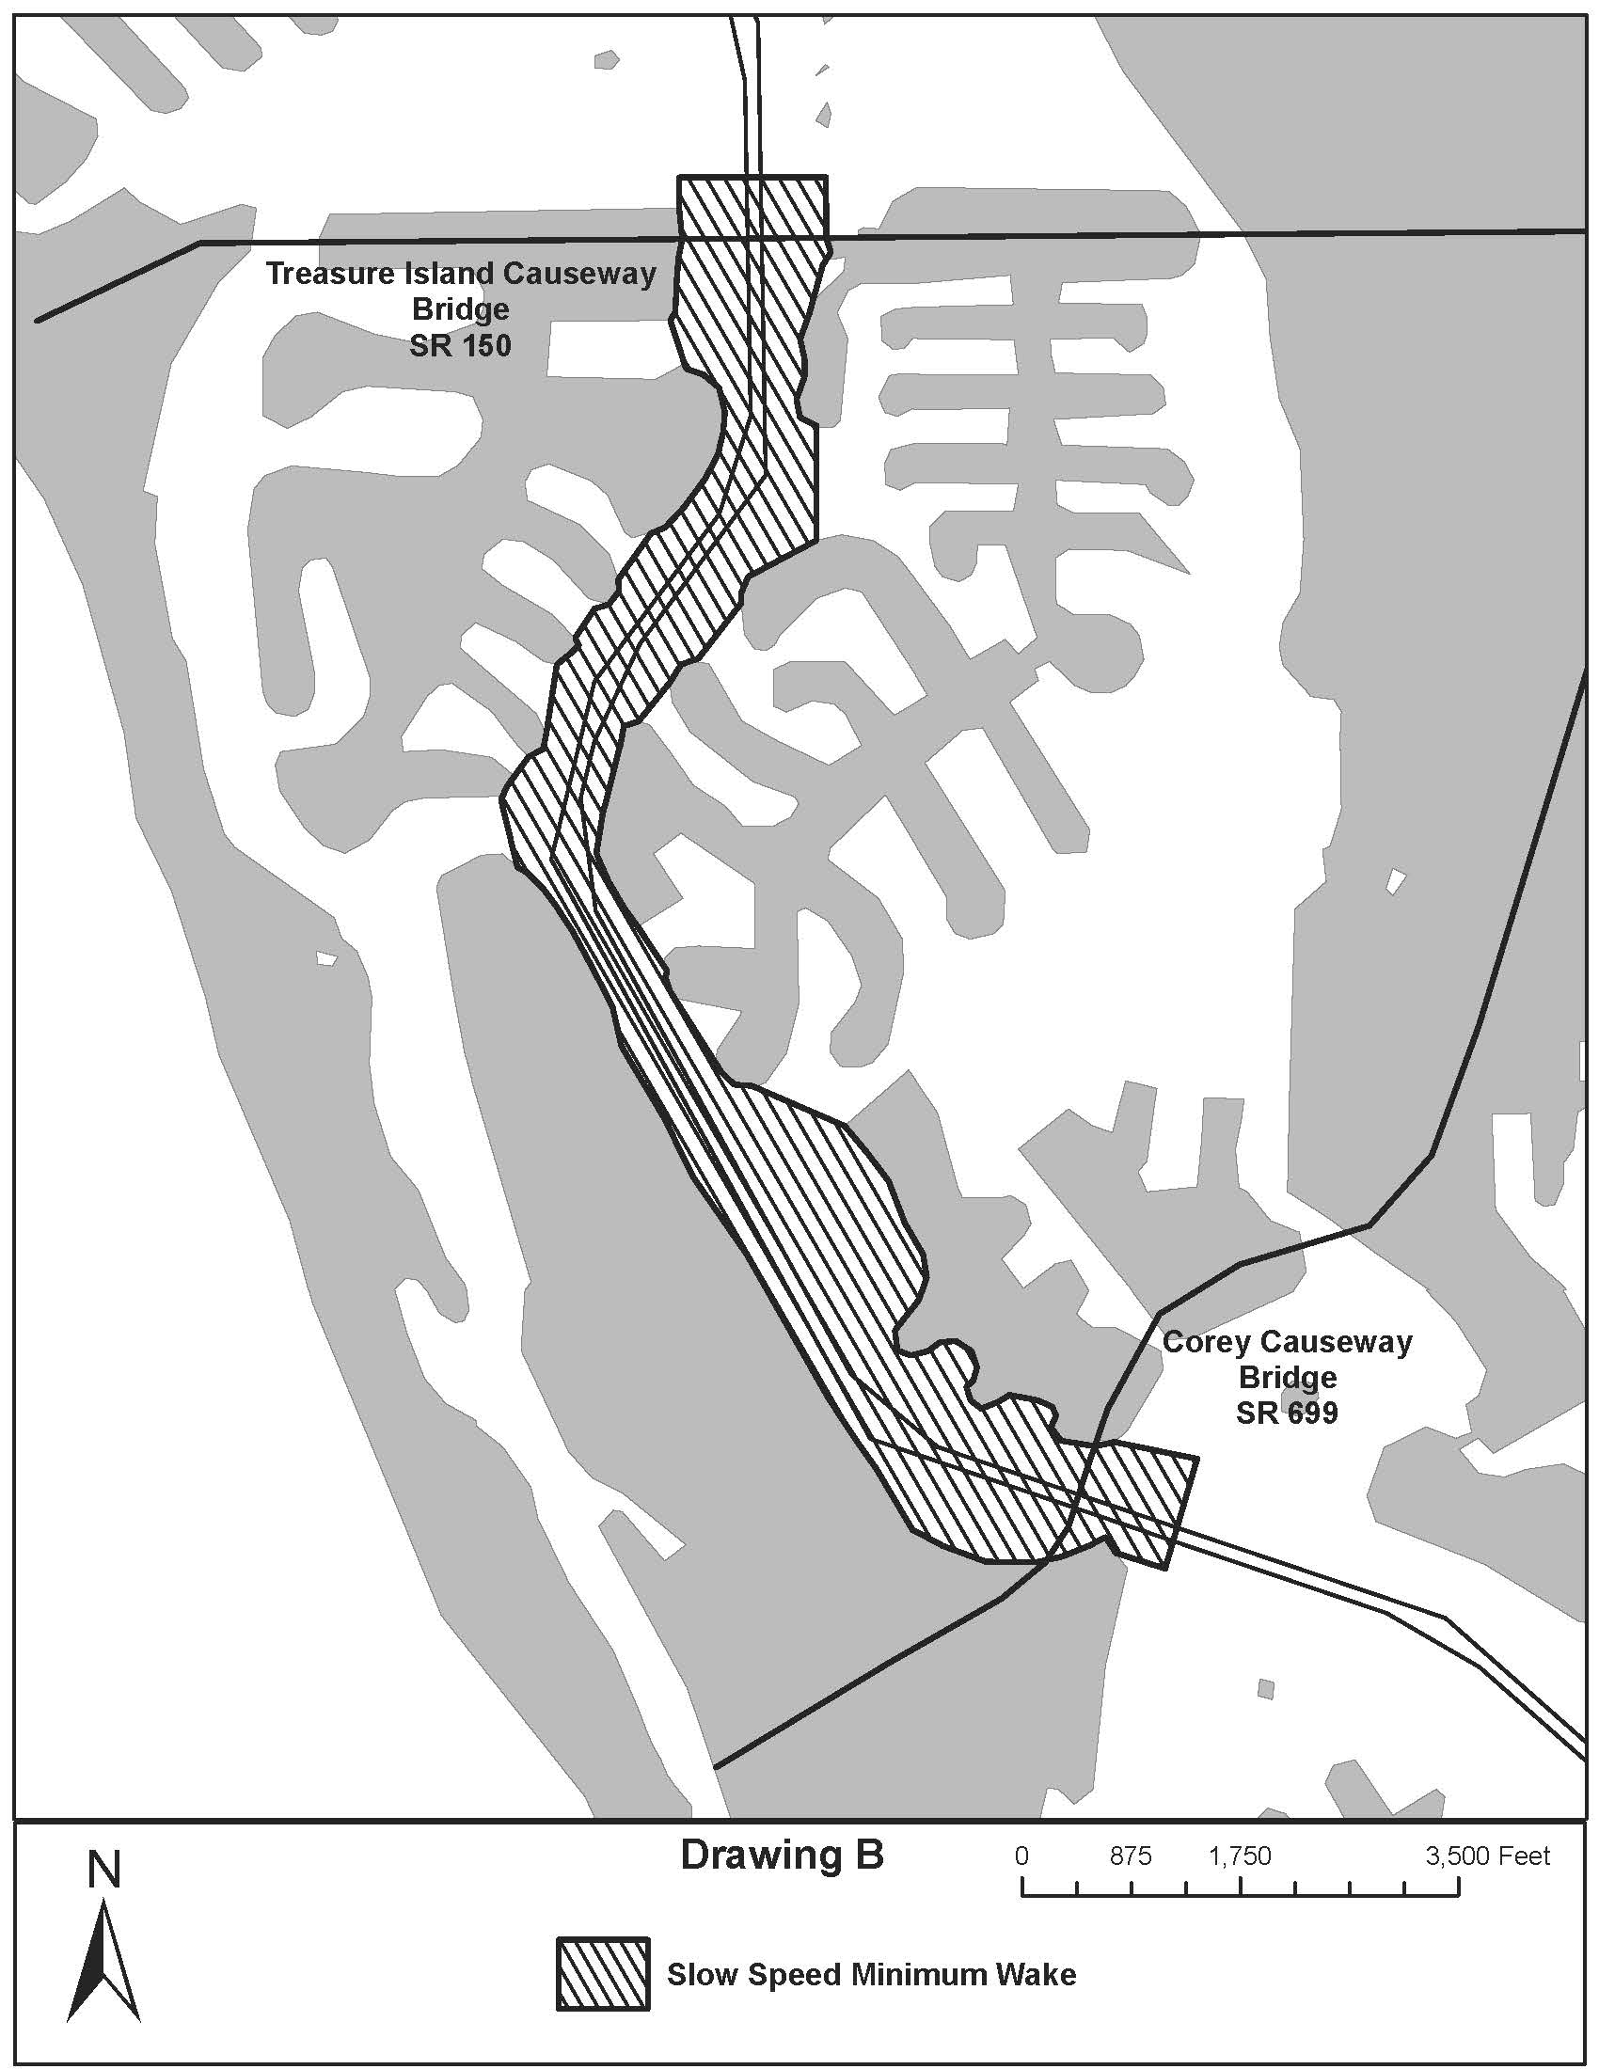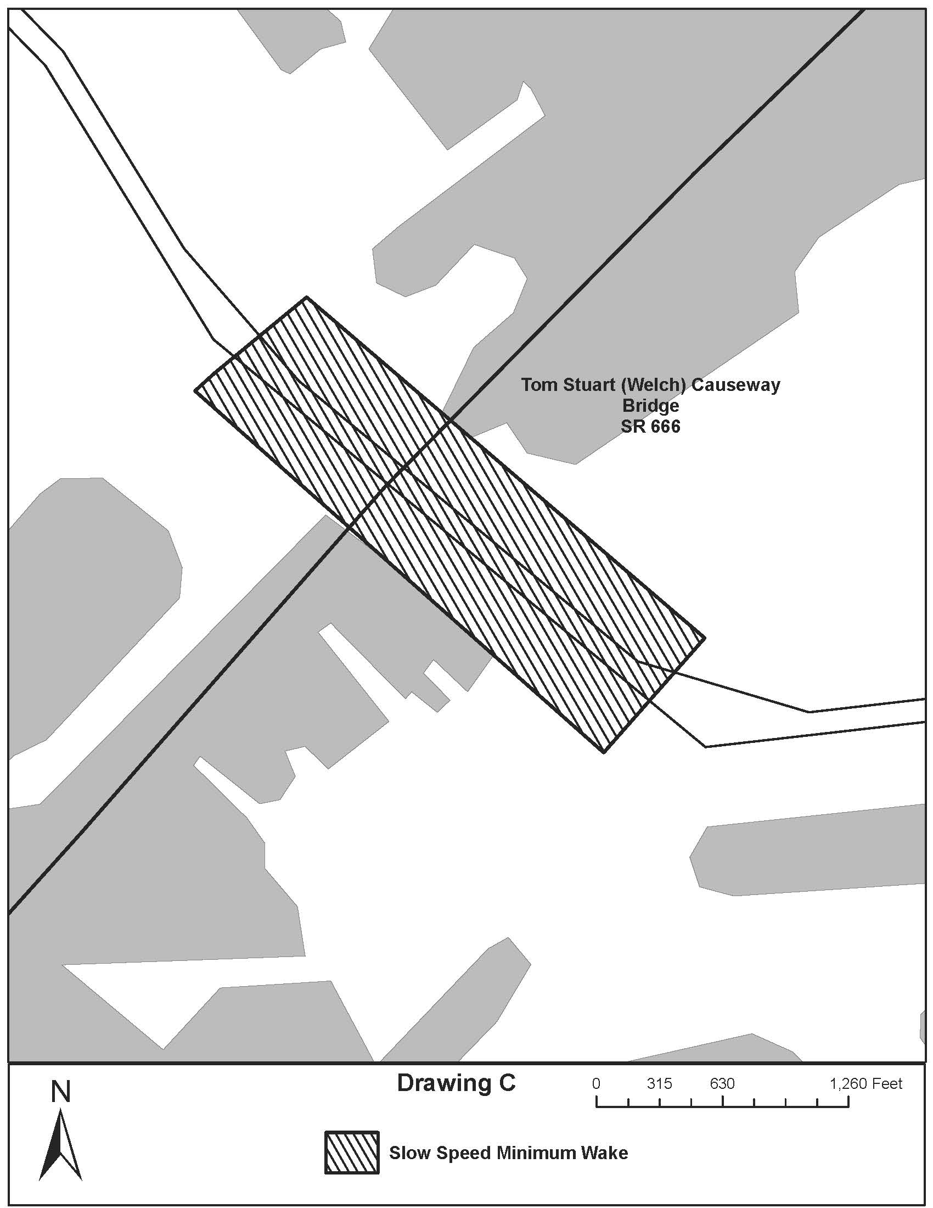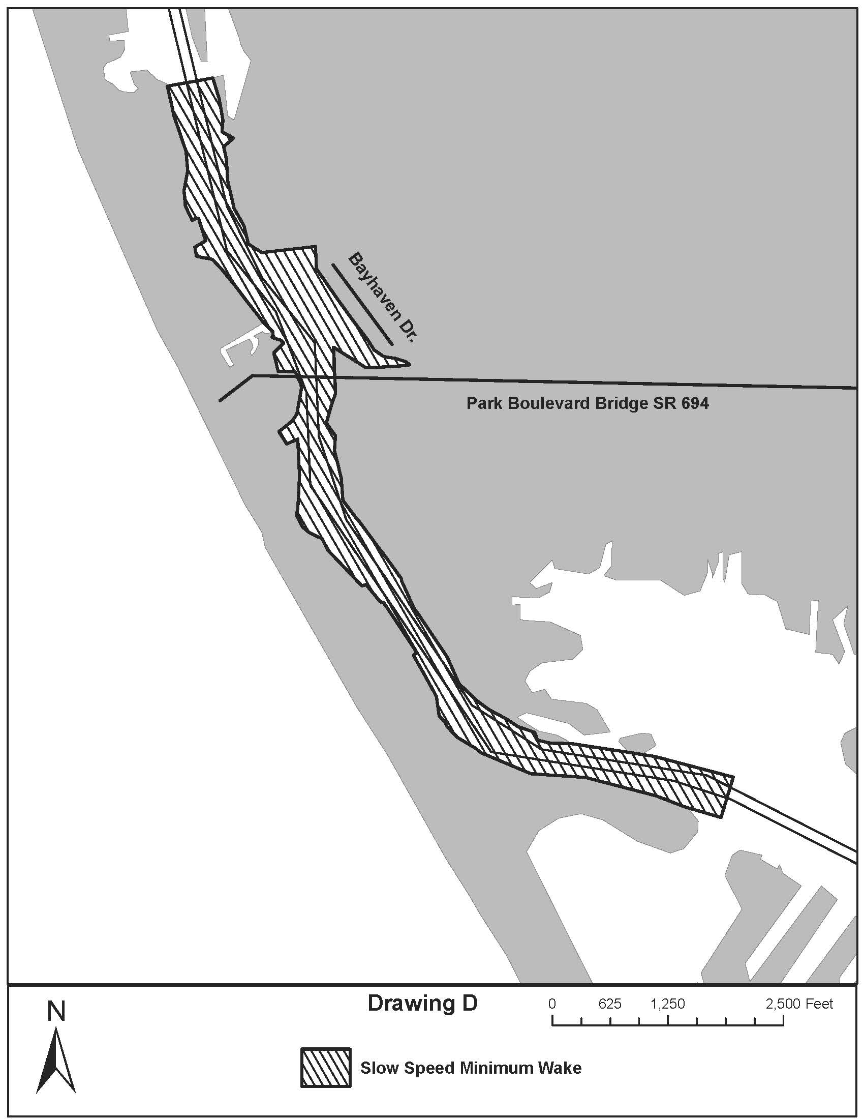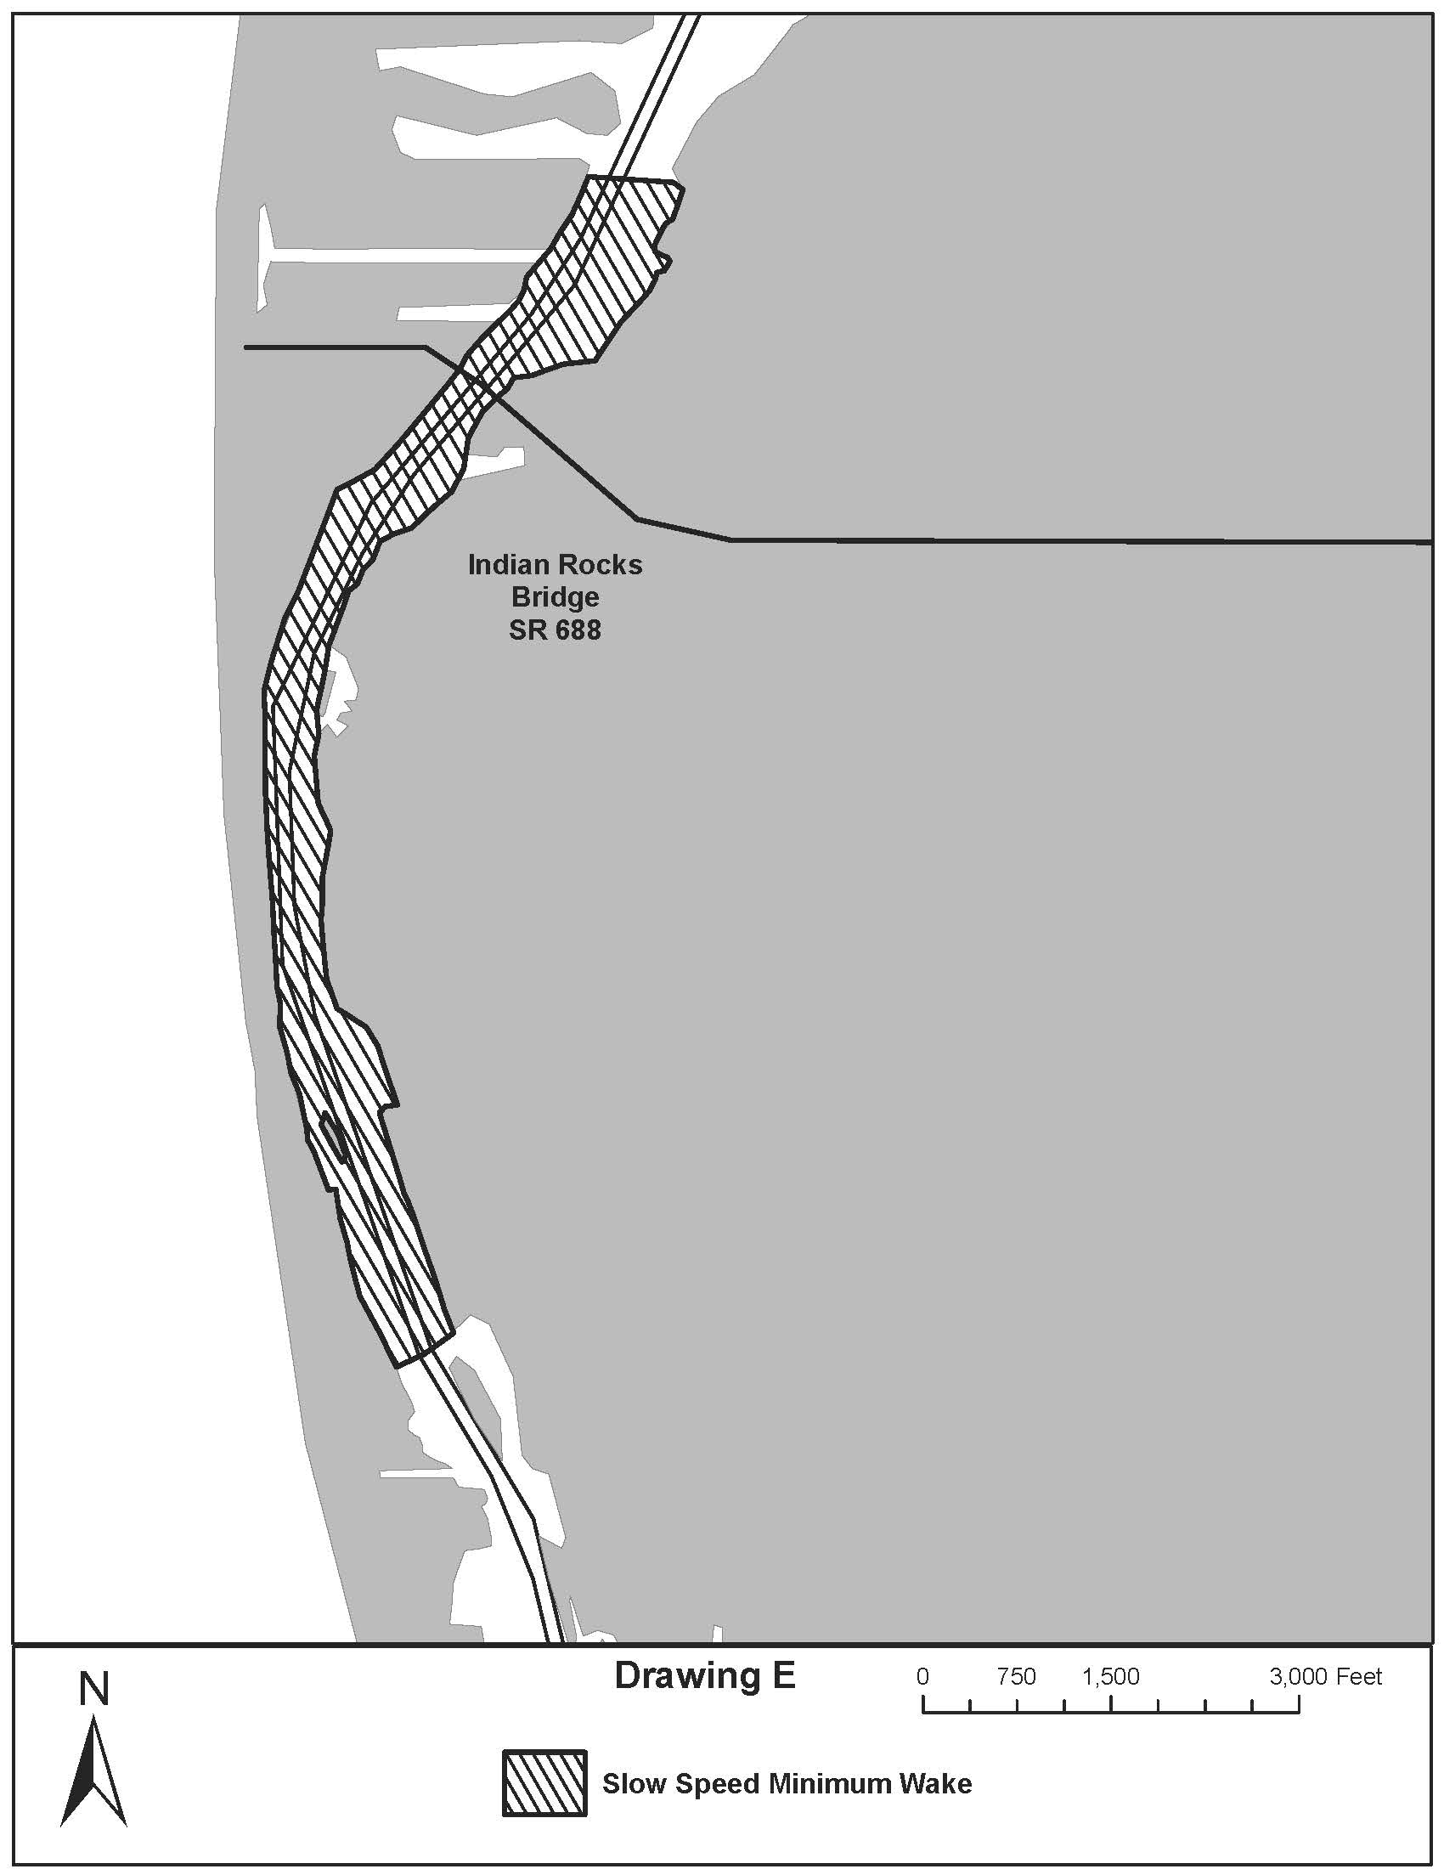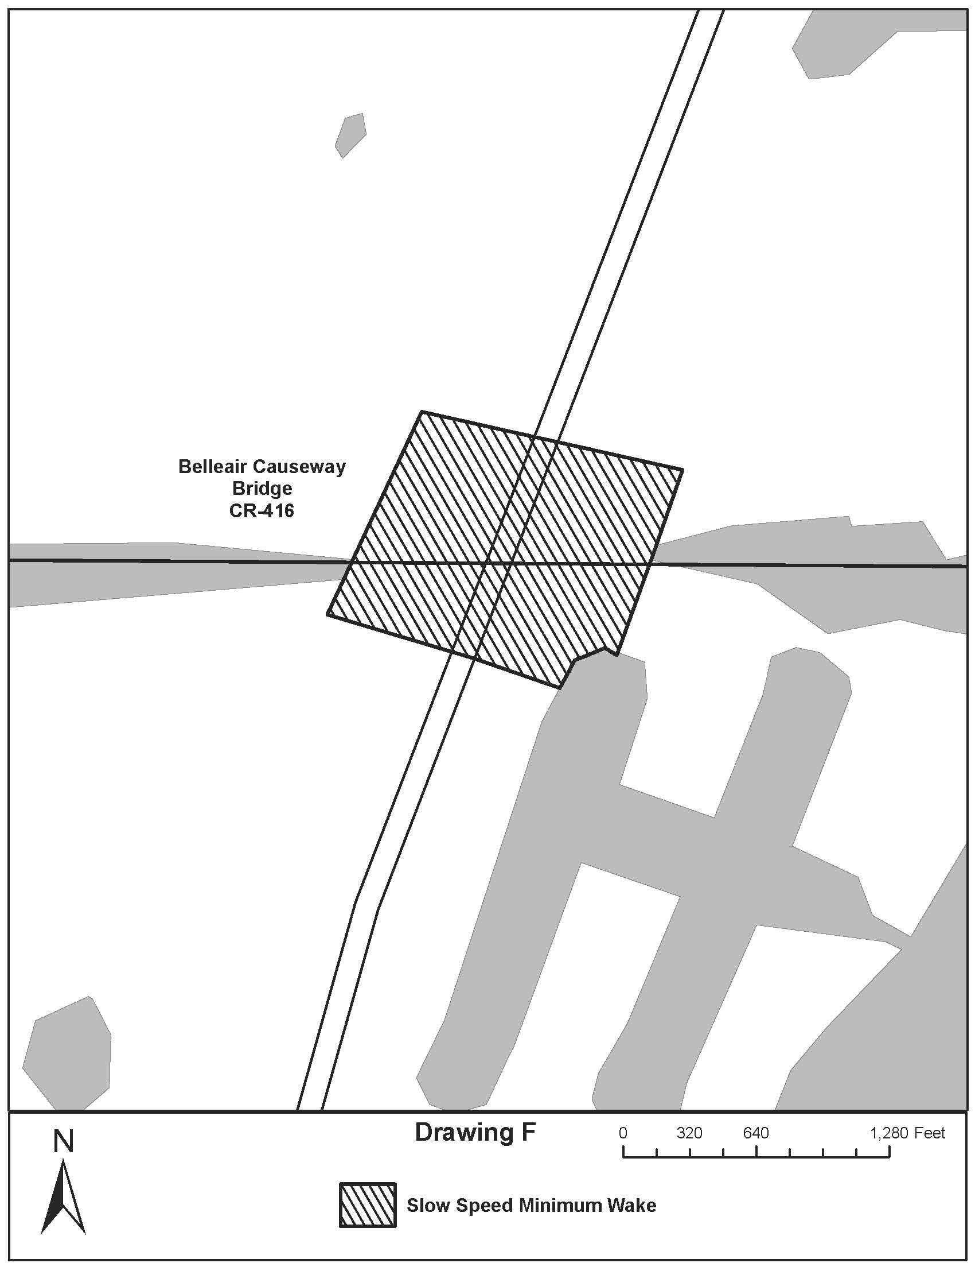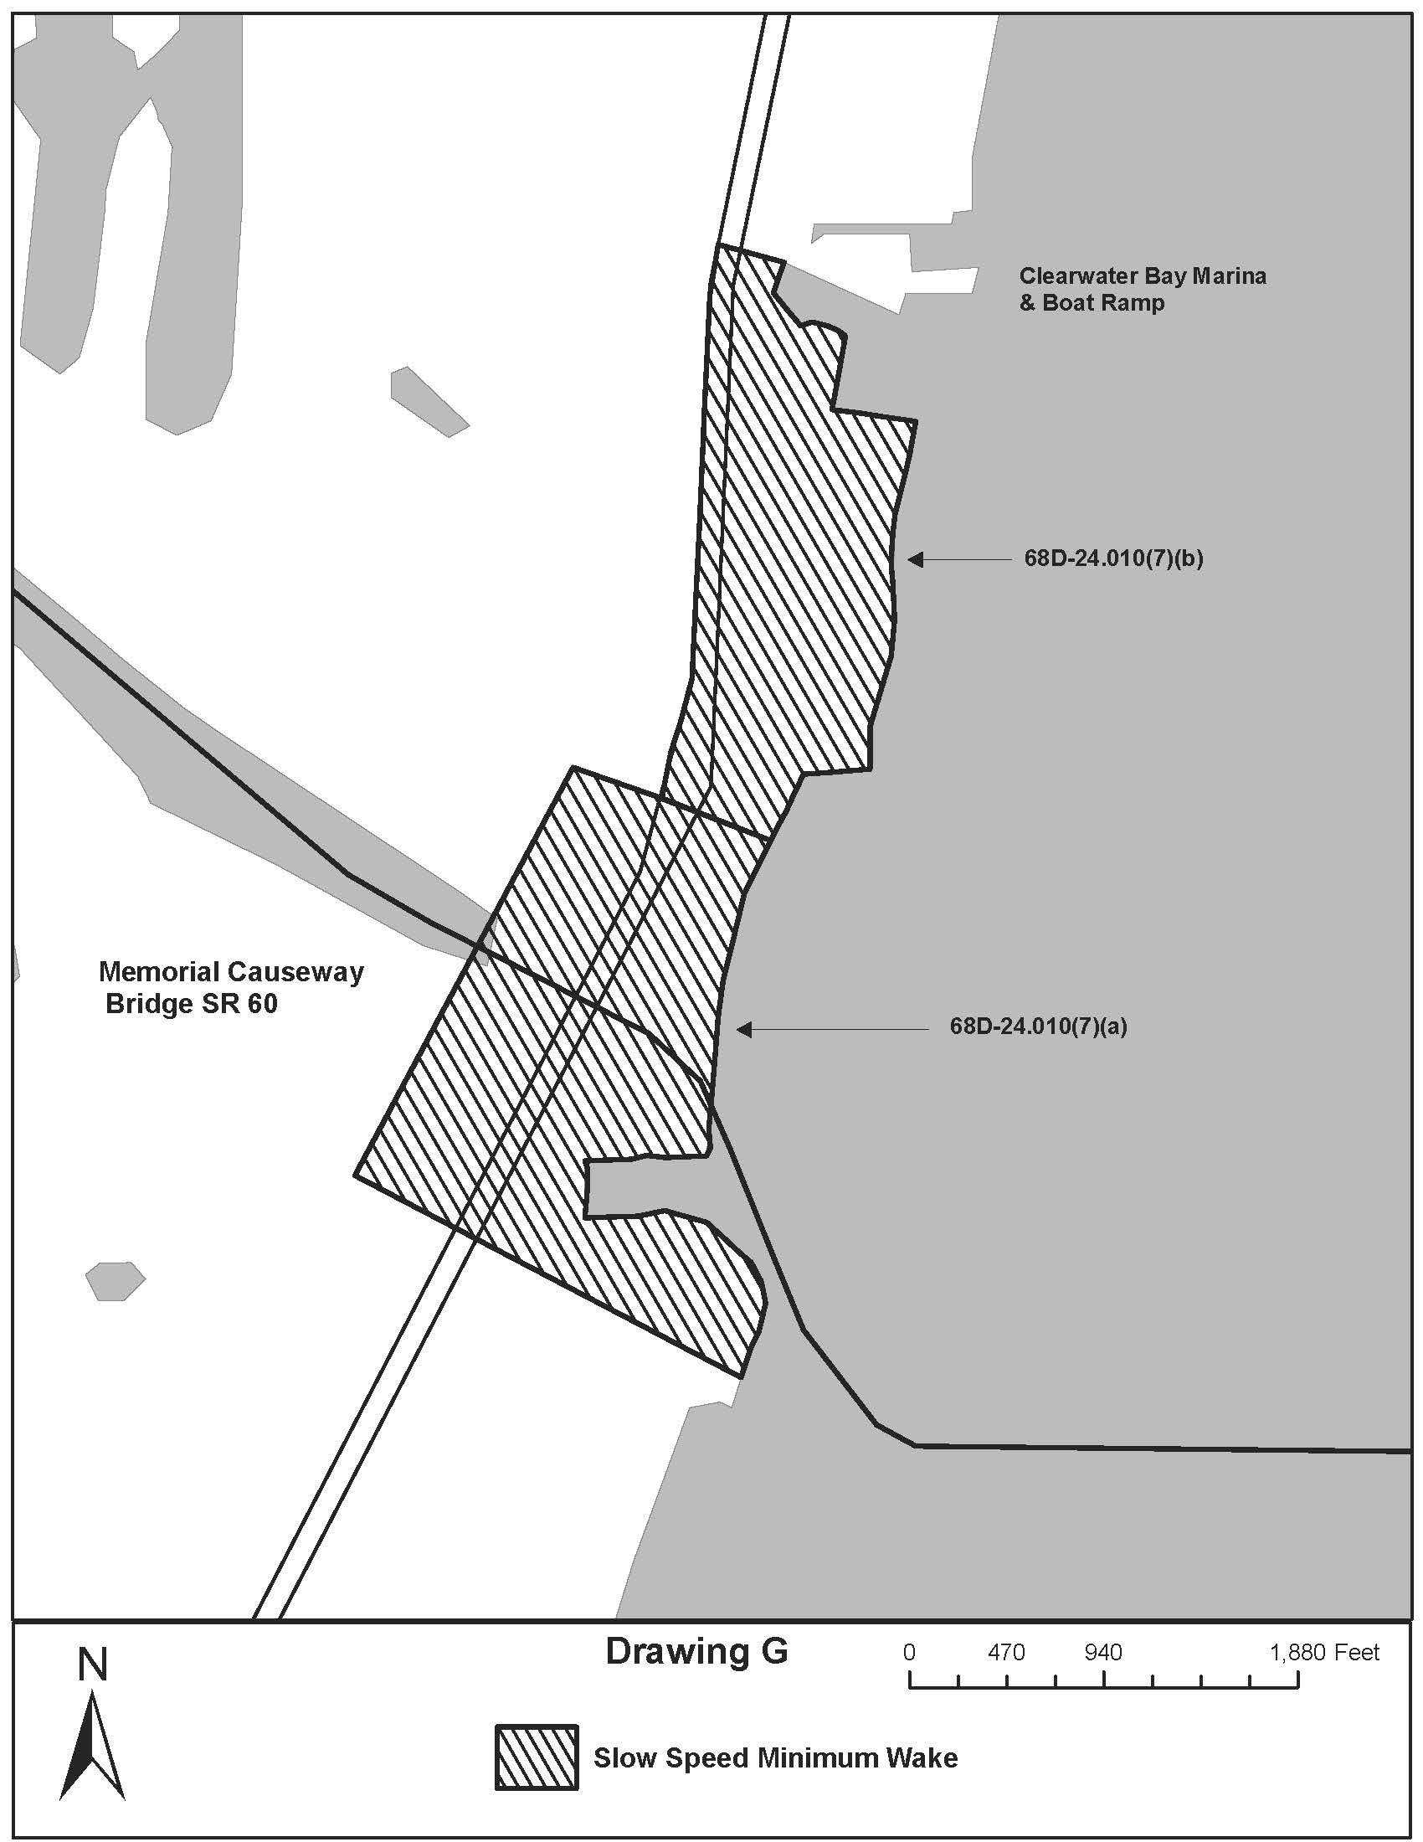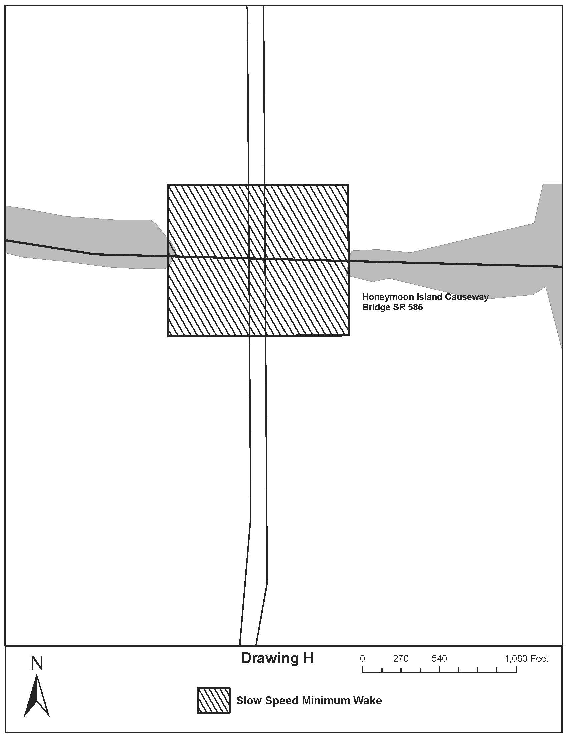
Rulemaking Specific Authority 327.46 FS. Law Implemented 327.46 FS. History–New 9-18-88, Amended 12-7-89, Formerly 16N-24.010, Amended 10-1-96, Formerly 62N-24.010, Amended 10-2-00,________.
NAME OF PERSON ORIGINATING PROPOSED RULE: Captain Richard Moore, Florida Fish and Wildlife Conservation Commission, Division of Law Enforcement, 620 South Meridian Street, Tallahassee, Florida 32399-1600
NAME OF AGENCY HEAD WHO APPROVED THE PROPOSED RULE: Florida Fish and Wildlife Conservation Commission
DATE PROPOSED RULE APPROVED BY AGENCY HEAD: April 18, 2013
DATE NOTICE OF PROPOSED RULE DEVELOPMENT PUBLISHED IN FAR:

