68D-24.011 Okeechobee Waterway Boating Restricted Areas.
(1) For the purpose of regulating the speed and operation of vessel traffic on the Okeechobee Waterway, the following Boating Restricted Areas are established:
(a) SE Ocean Boulevard – A Slow Speed Minimum Wake boating restricted area from shoreline to shoreline, in and adjacent to the Okeechobee Waterway, bounded on the north by a line drawn perpendicular to the centerline of the Okeechobee Waterway 300 feet north of the centerline of the S.E. Ocean Boulevard (SR A1A) bridge, and bounded on the south by a line drawn perpendicular to the centerline of the Okeechobee Waterway 300 feet south of the centerline of said bridge, as depicted in drawing A.
(b) Stuart “Roosevelt Bridge” Area – A Slow Speed Minimum Wake boating restricted area from shoreline to shoreline, in and adjacent to the Okeechobee Waterway, bounded on the east by a line drawn parallel to and 300 feet east of the centerline of the Roosevelt Bridge (US Highway 1), bounded on the northwest by a line drawn from Britt Point to Arbeau Point across the mouth of the North Fork of the St. Lucie River at its confluence with the Okeechobee Waterway, and bounded on the southwest by a line drawn across the Okeechobee Waterway from Arbeau Point to Bessy Point 3,000 feet southwest of the centerline of North Dixie Highway (SR 707) bridge, as depicted in drawing B.
(c) Palm City Bridge – A Slow Speed Minimum Wake boating restricted area, shoreline to shoreline, in and adjacent to the Okeechobee Waterway, bounded on the northwest by a line drawn parallel to and 300 feet northwest of the centerline of the Palm City Bridge (SR 714), and bounded on the southeast by a line drawn parallel to and 1,500 feet southeast of the centerline of said bridge, as depicted in drawing C.
(d) St. Lucie Lock and Dam Structure, the Florida Turnpike and I-95 Bridges.
1. A Slow Speed Minimum Wake boating restricted area from shoreline to shoreline, in and adjacent to the Okeechobee Waterway, bounded on the northeast by a line drawn parallel to and 1,000 feet northeast of the centerline of the eastern span of the northbound traffic lane of I-95 and bounded on the southwest by a line drawn perpendicular to the centerline of the Okeechobee Waterway 300 feet northeast of the St. Lucie Lock and Dam Structure, as depicted in drawing D.
2. An Idle Speed No Wake boating restricted area from shoreline to shoreline, in the Okeechobee Waterway in and adjacent to the St. Lucie Lock and Dam Structure, bounded on the northeast by a line drawn perpendicular to the centerline of the Okeechobee Waterway 300 feet northeast of the St. Lucie Lock and Dam Structure and bounded on the southwest by a line drawn perpendicular to the centerline of the Okeechobee Waterway 300 feet southwest of the St. Lucie Lock and Dam Structure, as depicted in drawing D.
(e) Arundel Bridge (S. W. 96th Street) – A Slow Speed Minimum Wake boating restricted area from shoreline to shoreline, in and adjacent to the Okeechobee Waterway, bounded on the northeast by a line drawn perpendicular to the centerline of the Okeechobee Waterway 300 feet northeast of the centerline of the Arundel Bridge (S. W. 96th Street), and bounded on the southwest by a line drawn perpendicular to the centerline of the Okeechobee Waterway 300 feet southwest of the centerline of said bridge, as depicted in drawing E.
(f) Timer Powers Park and Boat Ramp – A Slow Speed Minimum Wake boating restricted area from shoreline to shoreline, in and adjacent to the Okeechobee Waterway, bounded on the northeast by a line drawn perpendicular to the centerline of the Okeechobee Waterway 500 feet northeast of the centerline of the Timer Powers Boat Ramp and bounded on the southwest by a line drawn perpendicular to the centerline of the Okeechobee Waterway 500 feet southwest of the centerline of the Timer Powers Boat Ramp, as depicted in drawing F.
(g) SR 710 and Seaboard Coast Line (CSX) Railroad Trestle – A Slow Speed Minimum Wake boating restricted area from shoreline to shoreline, in and adjacent to the Okeechobee Waterway, bounded on the northeast by a line drawn perpendicular to the centerline of the Okeechobee Waterway 300 feet northeast of the centerline of the SR 710 bridge, and bounded on the southwest by a line drawn perpendicular to the centerline of the Okeechobee Waterway 300 feet southwest of the centerline of the Seaboard Coast Line (CSX) Railway Trestle, as depicted in drawing G.
(h) FEC Railroad Trestle – A Slow Speed Minimum Wake boating restricted area from shoreline to shoreline, in and adjacent to the Okeechobee Waterway, bounded on the east by a line drawn perpendicular to the centerline of the Okeechobee Waterway 300 feet east of the centerline of the FEC Railroad Trestle, and bounded on the west by a line drawn perpendicular to the centerline of the Okeechobee Waterway 300 feet west of the centerline of said trestle, as depicted in drawing H.
(i) US 441/US 98 Bridge and Port Mayaca Lock – An Idle Speed No Wake boating restricted area from shoreline to shoreline, in and adjacent to the Okeechobee Waterway, east of the Port Mayaca lock structure and within the right-of-way of the Okeechobee Waterway west of said lock structure, bounded on the east by a line drawn parallel to and 300 feet east of the centerline of the US 441/US 98 bridge, and bounded on the west by a line drawn perpendicular to the centerline of the Okeechobee Waterway 300 feet west of the lock structure, as depicted in drawing I.
(j) Torry Island Bridge – A Slow Speed Minimum Wake boating restricted area from shoreline to shoreline, in and adjacent to the Okeechobee Waterway in Palm Beach County, bounded on the north by a line drawn perpendicular to the centerline of the Okeechobee Waterway 400 feet north of Torry Island Bridge in Belle Glade, Palm Beach County, and bounded on the south by a line drawn perpendicular to the centerline of the Okeechobee Waterway 1,400 feet south of said bridge, as depicted in drawing J.
(k) Clewiston Lock Structure – A Slow Speed Minimum Wake boating restricted area from shoreline to shoreline, in and adjacent to the Okeechobee Waterway in Clewiston, Hendry County, bounded on the northeast by a line drawn perpendicular to the centerline of the Route 1B Approach Channel 150 feet northeast of the confluence of the Okeechobee Waterway Rim Canal and Route 1B Approach Channel, bounded on the north by a line drawn 150 feet north of the confluence of both forks of Cauley Cut and the Okeechobee Waterway Rim Canal, bounded on the northwest by a line drawn perpendicular to the Okeechobee Waterway Rim Canal 300 feet northwest of the centerline of the Hoover Dike Road City Ramp, bounded on the south by a line drawn across the southern entrance to the S-310 Navigation Lock (Clewiston Lock) and bounded on the southeast by a line drawn perpendicular to the centerline of the Okeechobee Waterway Rim Canal 300 feet southeast of the northeastern fender of the S-310 Navigation Lock (Clewiston Lock), as depicted in drawing K.
(l) Liberty Point – A Slow Speed Minimum Wake boating restricted area from shoreline to shoreline, in and adjacent to the Okeechobee Waterway Rim Canal and Mayaca Cut in Glades County, bounded on the west by a line drawn perpendicular to the centerline of the Okeechobee Waterway Rim Canal 300 feet west of Liberty Point, on the southeast by a line drawn perpendicular to the centerline of the Rim Canal 600 feet southeast of Liberty Point, and on the east by a line drawn perpendicular to the centerline of the Mayaca Cut 150 east of its confluence with the Rim Canal, as depicted in drawing L.
(m) Moore Haven Lock Structure and Vicinity – A Slow Speed Minimum Wake boating restricted area from shoreline to shoreline, in and adjacent to the Okeechobee Waterway Rim Canal, the Old Moore Haven Canal and associated canals, and the Caloosahatchee River in the vicinity of the Moore Haven Lock and flood control structure S-77 in Glades County, within the boundaries set forth below, as depicted in drawing M:
1. In the Okeechobee Waterway Rim Canal, shoreline to shoreline, from a line drawn perpendicular to the centerline of the Okeechobee Waterway Rim Canal 1,800 feet northwest of the centerline of the Moore Haven Lock Gates canal (26° 50' 45.2'' N/81° 05' 24.2''W), to a line drawn perpendicular to the centerline of the Okeechobee Waterway Rim Canal 500 feet southeast of the centerline of the Alvin Ward boat ramp (26° 50' 21.8'' N/81° 04' 46.9''W), including the area shoreline to shoreline 500 feet north from the Okeechobee Waterway Rim Canal into the Old Moore Haven Canal (26° 50' 40.9'' N/81° 05' 14.4''W), and including the Moore Haven Locks canal;
2. In the lock structure and approaches, shoreline to shoreline, from the Okeechobee Waterway Rim Canal to the Caloosahatchee River;
3. In the approaches and spillway of flood control structure S-77, shoreline to shoreline, from the Okeechobee Waterway Rim Canal to the Caloosahatchee River; and,
4. In the Caloosahatchee River, shoreline to shoreline, from the river’s northern terminus at the lock structure to a line drawn perpendicular to the centerline of the river 1,450 feet downstream of the centerline of the US 27 Bridge, (26° 49' 48.3'' N/ 81° 05' 30.2''W), including the area, shoreline to shoreline, in the Old Moore Haven Canal south of the Okeechobee Waterway Rim Canal to the Old Moore Haven Canal’s terminus.
(n) SR 29 Bridge – A Slow Speed Minimum Wake boating restricted area in the Caloosahatchee River (Okeechobee Waterway), from shoreline to shoreline from a line drawn parallel to and 500 feet east of the centerline of the SR 29 bridge as it crosses the Caloosahatchee River to a line drawn parallel to and 2,056 feet west of the centerline said bridge, as depicted in drawing N.
(2) The boating restricted areas are depicted in the following drawings:
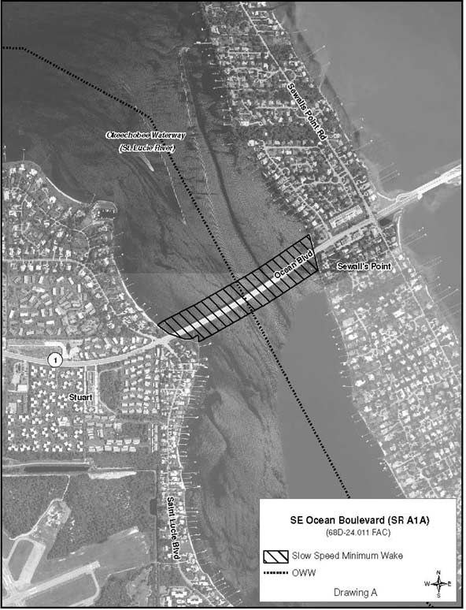
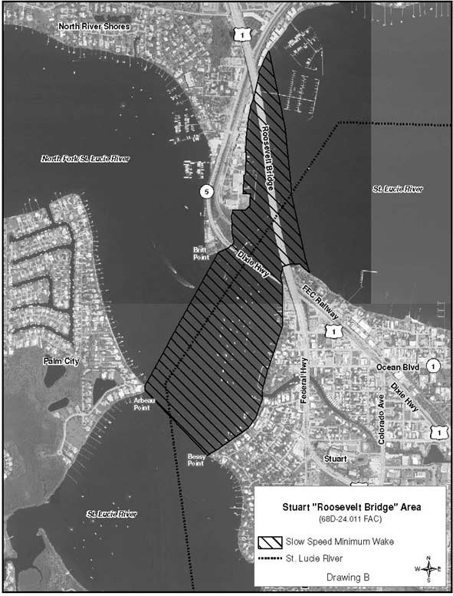
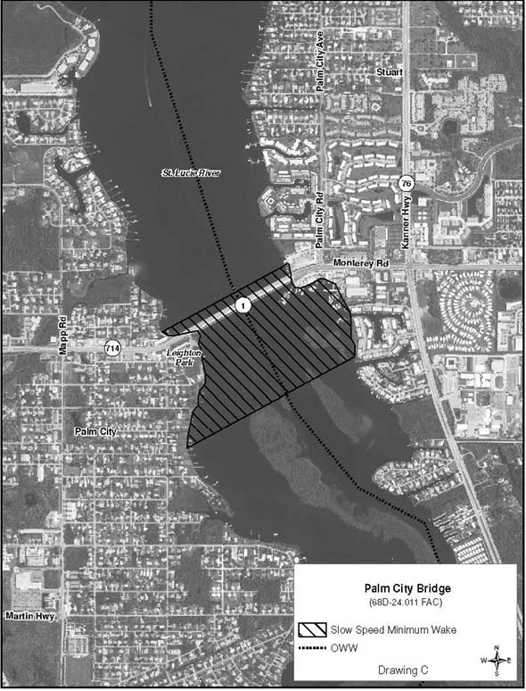
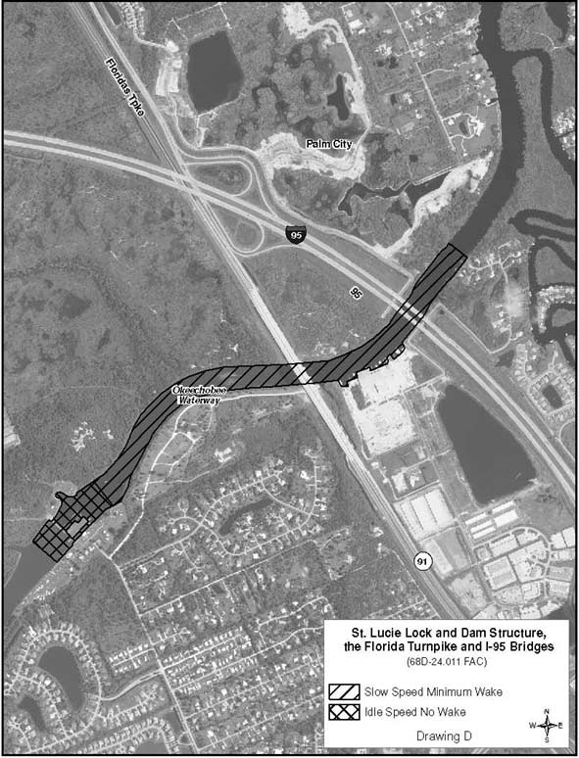
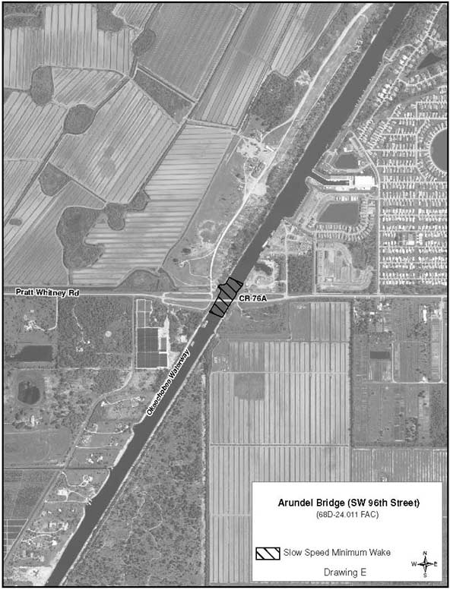
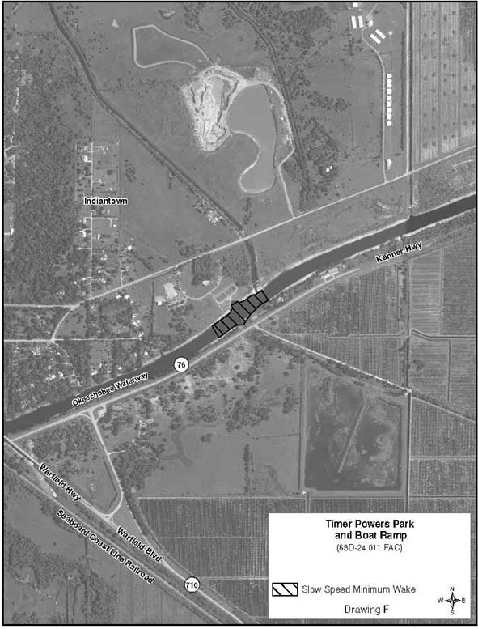
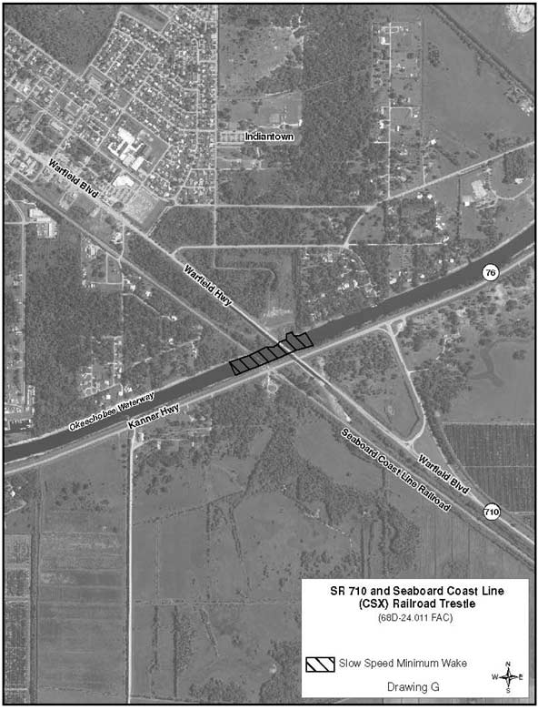
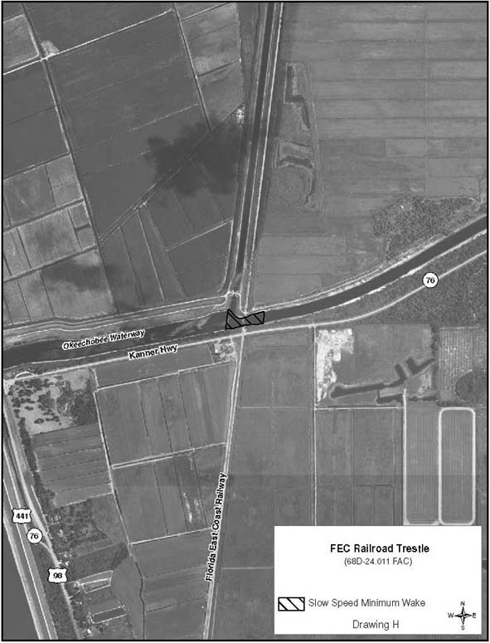
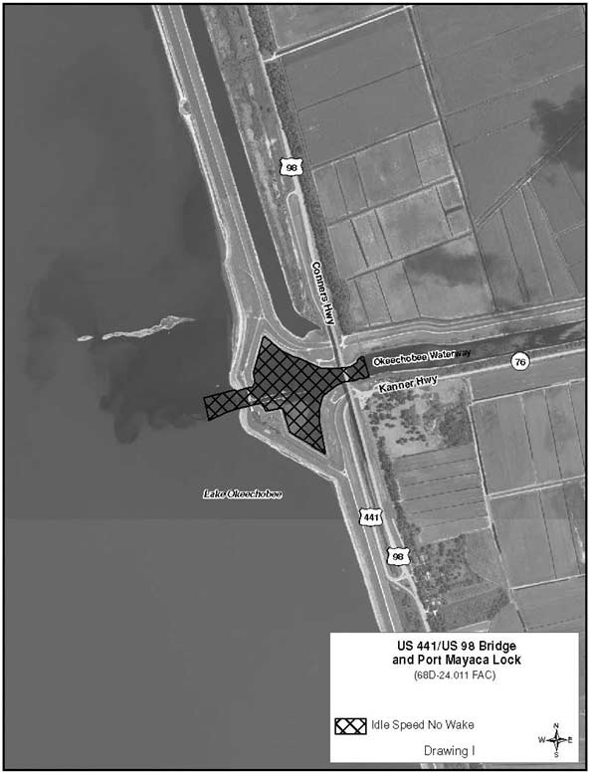
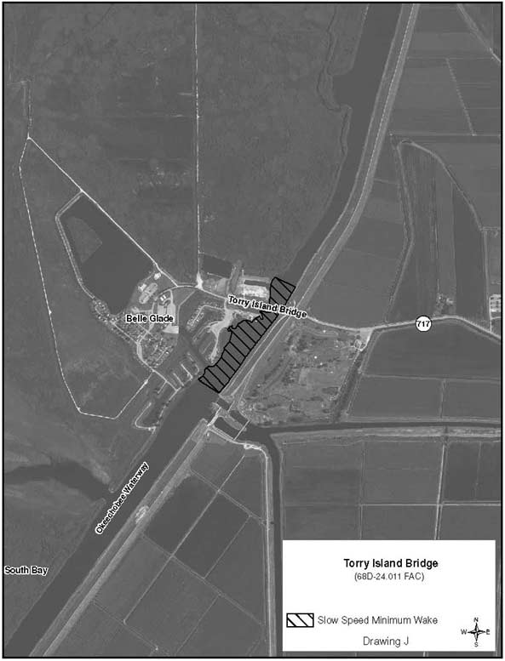
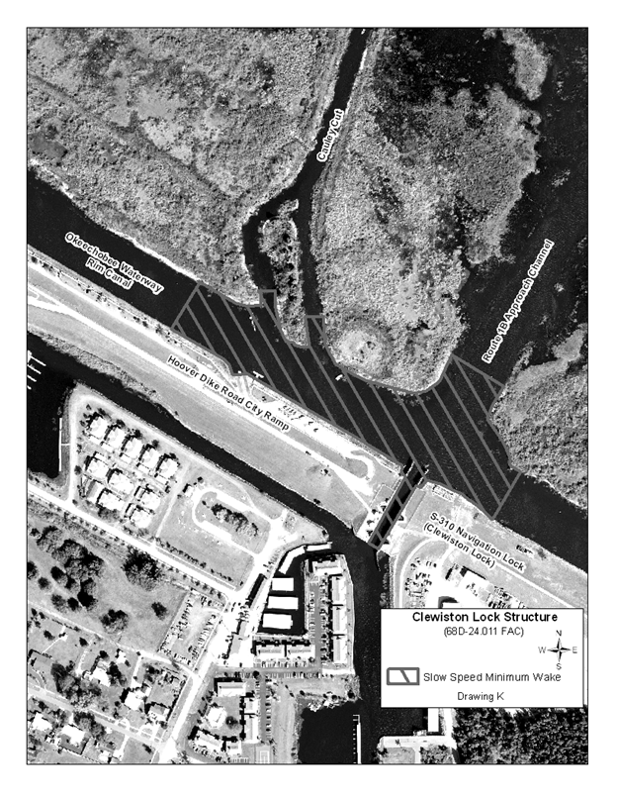
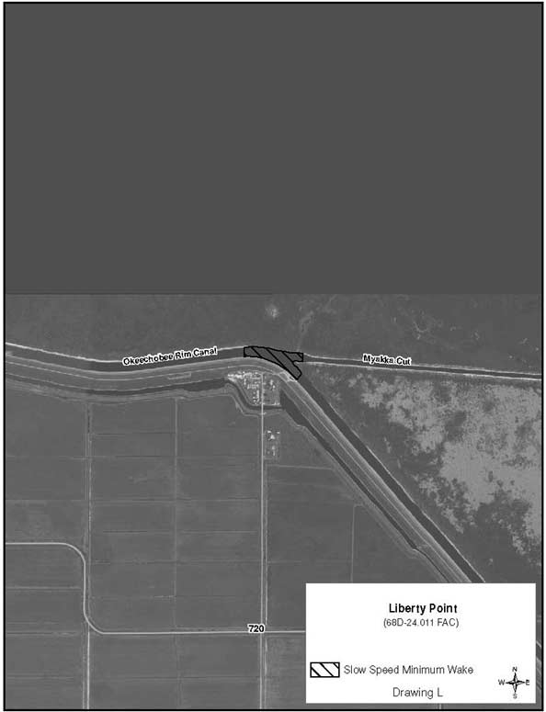
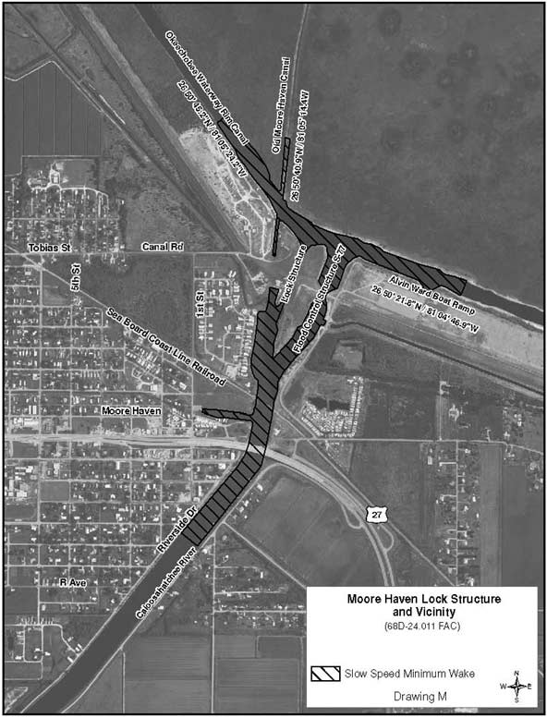
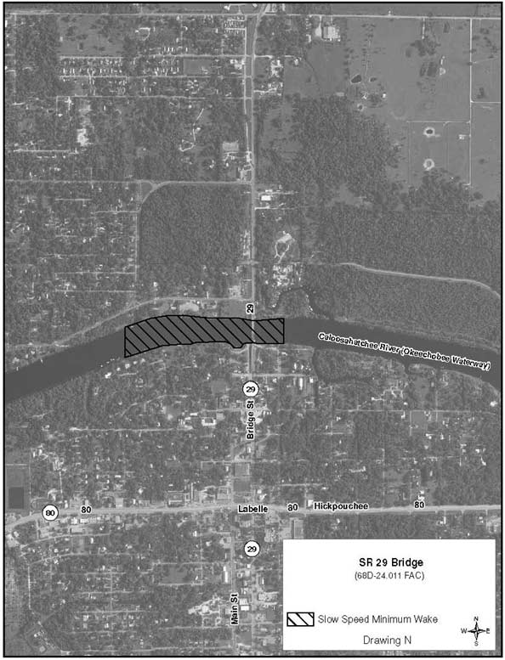
Rulemaking Authority 327.04, 327.46 FS. Law Implemented 327.46 FS. History–New 1-5-88, Formerly 16N-24.011, Amended 1-8-96, Formerly 62N-24.011, Amended 10-2-00, 10-23-05, 1-20-09, 5-12-13.

