Notice of Variances and Waivers

DEPARTMENT OF MANAGEMENT SERVICES
Technology Program
RULE NO.: RULE TITLE:
60FF-5.003 State Grant Programs (Transferred to 60FF1-5.003)
BEFORE THE FLORIDA DEPARTMENT OF MANAGEMENT SERVICES DIVISION OF TELECOMMUNICATIONS
PETITION FOR VARIANCE FROM RULE 60FF-5.003
Petitioner, Charlotte County, by and through its undersigned counsel, pursuant to Section 120.542, Florida Statutes, hereby requests a variance from Rule 60FF-5.003, Florida Administrative Code, and in support of thereof states:
1. Charlotte County applied for and received a grant, Grant S4-11-06-03 ESI Net Install.
2. Rule 60FF-5.003(b)6., Florida Administrative Code, states "[e]xpiration of the right to incur costs: Two years from receipt of award and funds."
3. Charlotte County has been diligently working with Cassidian to get this project accomplished by the deadline. However, the deadline is June 30, 2013, and while the project is close to being installed, it will not be possible to have it completed in time.
4. When the grant was requested, the Cassidian ESI Net was in beta testing in Catawba, North Carolina. It was expected to be finished soon after the grant was applied for; however, there were delays in the beta testing.
5. In order to move forward on this project, Charlotte County agreed to be a beta test site for Cassidian, issued a Purchase Order, and received the equipment.
6. The technical issues are complex and have taken more time than projected and scheduled. More specifically, Cassidian and Intrado immediately began working on the technical specifications to be able to deliver the calls through the Cassidian equipment. However, the engineers have had to consider various technical options to make the project work due to the diverse nature of our ESinet (County fiber, microwave network and Intrado lEN network) and the PSAP setups that we cannot afford to lose.
7. Intrado indicated that they are close to having a solution, but they will not be able to have it ready by June 30, 2013, because their engineers are not available until July 29,2013, at the earliest. In the meantime, however, Cassidian can install their equipment so it will be ready when Intrado is able to connect and deliver calls to it.
8. The State's rule limiting the "expiration of the right to incur costs" to "two years from receipt of award and funds" needs to be varied to allow more time because of the unique situation presented by Cassidian and Intrado experiencing complex technological difficulties with beta testing, integrating systems, and installing a new interface, all of which are outside of Charlotte County's control. Strict application of the two year time frame would create a substantial hardship for Charlotte County or would violate the principles of fairness. A substantial hardship is present because the two year time limit rule presents an economical and technological hardship to the County. Charlotte County does not have sufficient funds to pay for this project and it requires the grant funding for completion. Additionally, the principles of fairness would be violated by the literal application of the rule because the rule affects Charlotte County in a manner significantly different from the way it affects other counties. Counties that are not upgrading to Next Generation technology do not have to worry about complex technological difficulties experienced with beta testing, integrating systems, and installing a new interface.
9. In compliance with Subsection 120.542, Florida Statutes, Charlotte County hereby states:
a. The rule from which a variance is requested is 60FF-5.003, Florida Administrative Code.
b. The type of action requested is a variance of the rule to allow the grant to survive an additional ninety (90) to one-hundred eighty (180) days. The requested variance is only temporary.
c. The specific facts that would justify the rule variance are stated in paragraphs 3 through 8 above.
d. The variance would serve the purpose of the underlying statute. The underlying statute, Paragraph 365.172.(6)(a)3.b., Florida Statutes, allows monies to be used by the board as needed to provide grants to counties for the purpose of upgrading E911 systems. The requested monies would serve these purposes. Extending the grant an additional ninety (90) to one-hundred eighty (180) days would allow Charlotte County to take the next step and move forward with Next Generation technologies. Charlotte County currently has 9-1-1 calls being delivered to our agency via IP, converted to CAMA, and then converted back to IP. It is Charlotte County's goal to remove all legacy technology and remove the CAMA trunks that have fully functional IP to IP connectivity. Installing this new ESI Net Interface Module will allow this to occur. With a dedicated public safety grade IP network to an IP enabled CPE, a whole host ofNext Generation services are possible. This includes text messaging, A9-1-1 Media, and A9-l-1 data applications, and it becomes possible for policy based routing. Additionally, Charlotte County would be grateful to have the opportunity to begin receiving text messaging as well as other Next Generation information as soon as it is provided by the cellular companies, which should be in the very near future. Not only does Charlotte County want to be leaders in the industry by being able to deliver Next Generation services to our community, but having this technology in place will result in a time savings for the caller from when the call is placed to the time it is received in the PSAP. By reducing the hardware that the calls have to pass through, it will ultimately reduce the time taken before the call is answered in the dispatch center. In addition to time reduction, it will also reduce chances for a single point of failure due to additional hardware required to convert IP to CAMA and back to IP.
10. The County's address is: Charlotte County, 18500 Murdock Circle #573, Port Charlotte, FL 33948-1094, phone number (941)743-1330 and fax number (941)743-1550. The County's point person of contact for this petition shall be the undersigned attorney at the contact information provided below.
WHEREFORE, based on these facts and circumstances, Charlotte County hereby requests a ninety (90) to one-hundred eighty (180) day extension from the date of approval in order to schedule the engineers and have the interface installed.

Respectfully submitted,
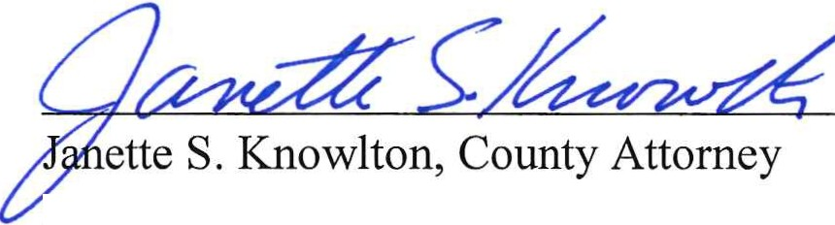

County Attorney's Office
18500 Murdock Circle #573
Port Charlotte, FL 33948-1094
(941)743-1330 [PH]
(941)743-1550 [FAX]

