Notice of Change/Withdrawal

FISH AND WILDLIFE CONSERVATION COMMISSION
Vessel Registration and Boating Safety
RULE NO.: RULE TITLE:
68D-24.010 Pinellas County Boating Restricted Areas
NOTICE OF CHANGE
Notice is hereby given that the following changes have been made to the proposed rule in accordance with subparagraph 120.54(3)(d)1., F.S., published in Vol. 39, No. 80, April 24, 2013, issue of the Florida Administrative Register. A public hearing was held on June 12-13, 2013 in Lakeland and will conclude on September 4-6, 2013 in Pensacola.

Rule 68D-24.010 is being changed in the following way:

68D-24.010 Pinellas County Boating Restricted Areas.
(1) The following year-round zones are established regulating the speed and operation of vessel traffic on and adjacent to the Florida Intracoastal Waterway within Pinellas County. The zones exclude all associated tributaries, creeks, canals, channels, backwaters, boat basins and other waterways unless otherwise designated or specifically described for inclusion:
(a) SLOW SPEED MINIMUM WAKE ZONES
1. Pinellas Bayway (SR679) (SR 682) Bridges–
a. All waters in and adjacent to the Florida Intracoastal Waterway from a line drawn perpendicular to the centerline of the Florida Intracoastal Waterway 500 feet southeast of the Pinellas Bayway (SR 679) Bridge, to a line drawn perpendicular to the centerline of the Florida Intracoastal Waterway 1,500 feet northwest of said bridge, bounded on the northeast by a line drawn parallel to the Florida Intracoastal Waterway from a point (27 41.748N, 82 42.986W) and bounded on the southwest by the southwestern shoreline as depicted in drawing A.
b. All waters in and adjacent to the Florida Intracoastal Waterway from a line drawn perpendicular to the centerline of the Florida Intracoastal Waterway 500 feet south of the Pinellas Bayway (SR 682) Bridge, to a line drawn perpendicular to the centerline of the Florida Intracoastal Waterway 500 feet north of said bridge, bounded on the east by the eastern shoreline and bounded on the west by a line drawn parallel to the Florida Intracoastal Waterway from a point (27 42.563N, 82 43.583W), as depicted in drawing A.
2. Corey Causeway (SR 699) Bridge to Treasure Island Causeway (SR 150) Bridge –All waters in and adjacent to the Florida Intracoastal Waterway, from shoreline to shoreline, from a line drawn perpendicular to the centerline of the Florida Intracoastal Waterway 800 feet southeast of the Corey Causeway (SR 699) Bridge, to a line drawn perpendicular to the centerline of the Florida Intracoastal Waterway 500 feet north of the Treasure Island Causeway (SR 150) Bridge, as depicted in drawing B.
3. Tom Stuart (Welch) Causeway (SR 666 SR 150) Bridge – All waters in and adjacent to the Florida Intracoastal Waterway from a line drawn perpendicular to the centerline of the Florida Intracoastal Waterway 1,600 feet southeast of the Tom Stuart (Welch) Causeway (SR 666) Bridge, to a line drawn perpendicular to the centerline of the Florida Intracoastal Waterway 1,000 feet northwest of said bridge, bounded on the northeast by a line drawn parallel to the Florida Intracoastal Waterway from a point (27 48.463N, 82 47.657W 27 48.455N, -82 47.660W) and bounded on the southwest by a line drawn parallel to the Florida Intracoastal Waterway from a point (27 48.383N, 82 47.741W 27 48.377N, -82 47.743W), as depicted in drawing C.
4. Park Boulevard (SR 694) Bridge – All waters in and adjacent to the Florida Intracoastal Waterway, from shoreline to shoreline, from a line drawn perpendicular to the centerline of the Florida Intracoastal Waterway 6,270 7,000 feet southeast of the Park Boulevard (SR 694) Bridge, to a line drawn perpendicular to the centerline of the Florida Intracoastal Waterway 3,050 3,500 feet north of said bridge, including the backwater immediately adjacent to Bayhaven Drive, as depicted in drawing D.
5. Indian Rocks (SR 688) Bridge – All waters in and adjacent to the Florida Intracoastal Waterway, from shoreline to shoreline, from a line drawn perpendicular to the centerline of the Florida Intracoastal Waterway 7,340 8,300 feet south of the Indian Rocks (SR 688) Bridge, to a line drawn perpendicular to the centerline of the Florida Intracoastal Waterway 1,790 1,900 feet north of said bridge, as depicted on drawing E.
6. Belleair Causeway (CR-416) Bridge – All waters in and adjacent to the Florida Intracoastal Waterway from a line drawn perpendicular to the centerline of the Florida Intracoastal Waterway 500 feet south of the center bridge span of the Belleair Causeway (CR-416) Bridge, to a line drawn perpendicular to the centerline of the Florida Intracoastal Waterway 500 feet north of the center bridge span of said bridge, bounded on the east by a point (27 54.924N, 82 49.801W 27 54.932N, -82 49.797W) and following the contour of the eastern shoreline north to a point (27 54.954N, 82 49.750W) then running parallel to the channel from said point to the terminus of the north boundary and bounded on the west by a line drawn parallel to the Florida Intracoastal Waterway from a point (27 55.007N, 82 49.970W 27 55.007N, -82 49.973W), as depicted in drawing F.
7. Memorial Causeway (SR 60) Bridge -
a. All waters in and adjacent to the Florida Intracoastal Waterway from a line drawn perpendicular to the centerline of the Florida Intracoastal Waterway 1,215 feet southwest of Memorial Causeway (SR 60) Bridge, to a line drawn perpendicular to the centerline of the Florida Intracoastal Waterway 920 feet northeast of said bridge, bounded on the west by a line drawn parallel to the Florida Intracoastal Waterway from a point (27 58.018N, 82 48.429W) and bounded on the east by the City of Clearwater shoreline, as depicted in drawing G.
b. All waters in and adjacent to the Florida Intracoastal Waterway from a line drawn perpendicular to the centerline of the Florida Intracoastal Waterway 920 feet northeast of the Memorial Causeway (SR 60) Bridge, to a line draw perpendicular to the Florida Intracoastal Waterway 3,315 3,700 feet north of said bridge, bounded on the west by the boundaries of the marked channel of the Florida Intracoastal Waterway and bounded on the east by the City of Clearwater Shoreline, as depicted in drawing G.
8. Honeymoon Island Causeway (SR 586) Bridge – All waters in and adjacent to the Florida Intracoastal Waterway from a line drawn perpendicular to the centerline of the Florida Intracoastal Waterway 500 feet south of the Honeymoon Island Causeway (SR 586) Bridge, to a line drawn perpendicular to the centerline of the Florida Intracoastal Waterway 500 feet north of said bridge, bounded on the east by a line drawn parallel to the Florida Intracoastal Waterway from a point (28 3.068N, 82 47.621W) and bounded on the west by a line drawn parallel to the Florida Intracoastal Waterway from a point (28 3.070N, 82 47.829W), as depicted in drawing H.
(2) The boating restricted areas are depicted in the following drawings:

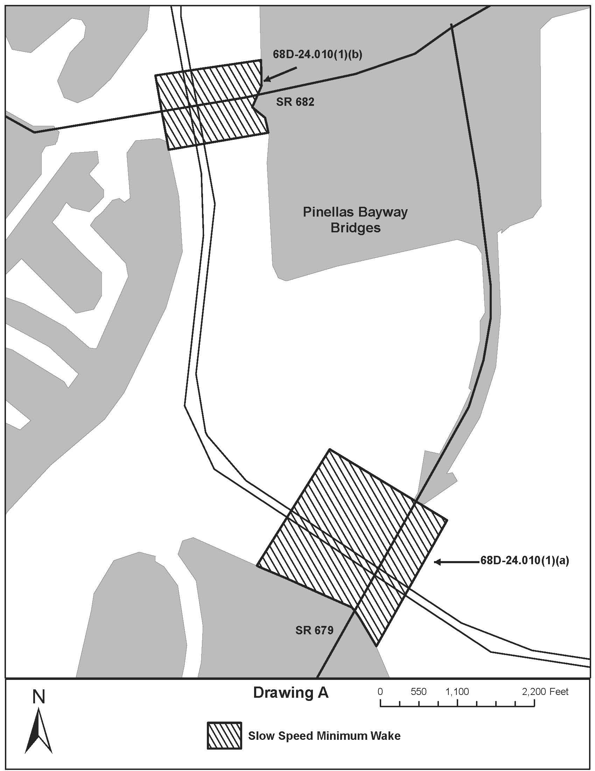
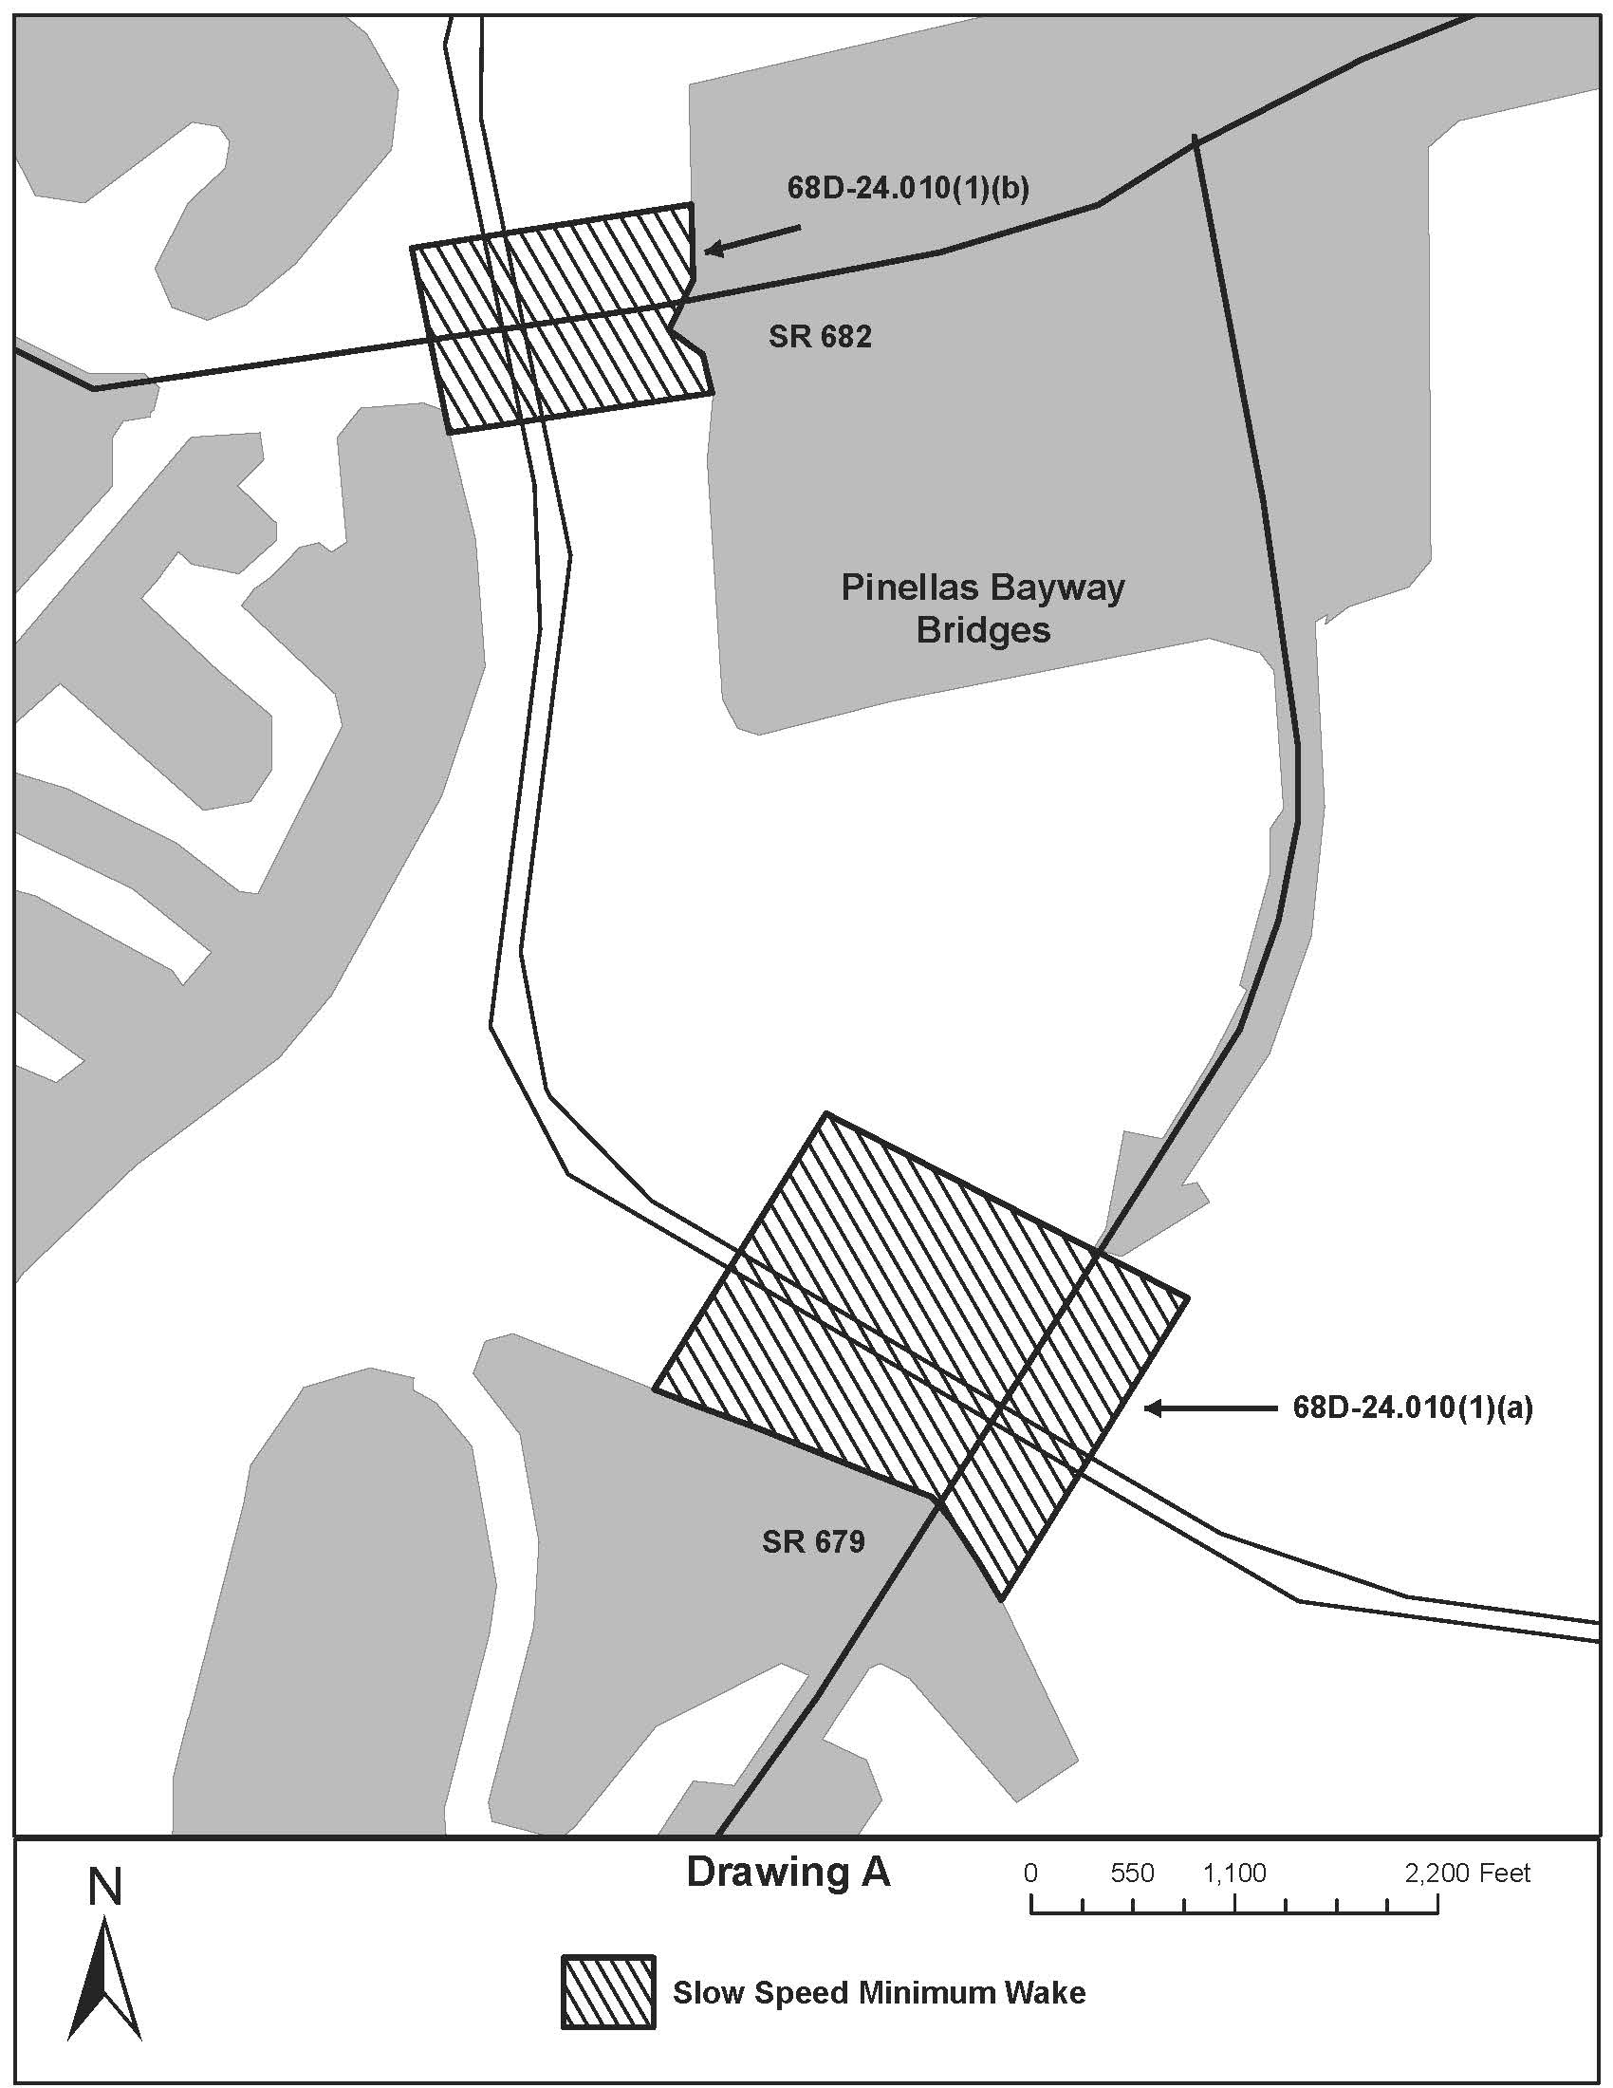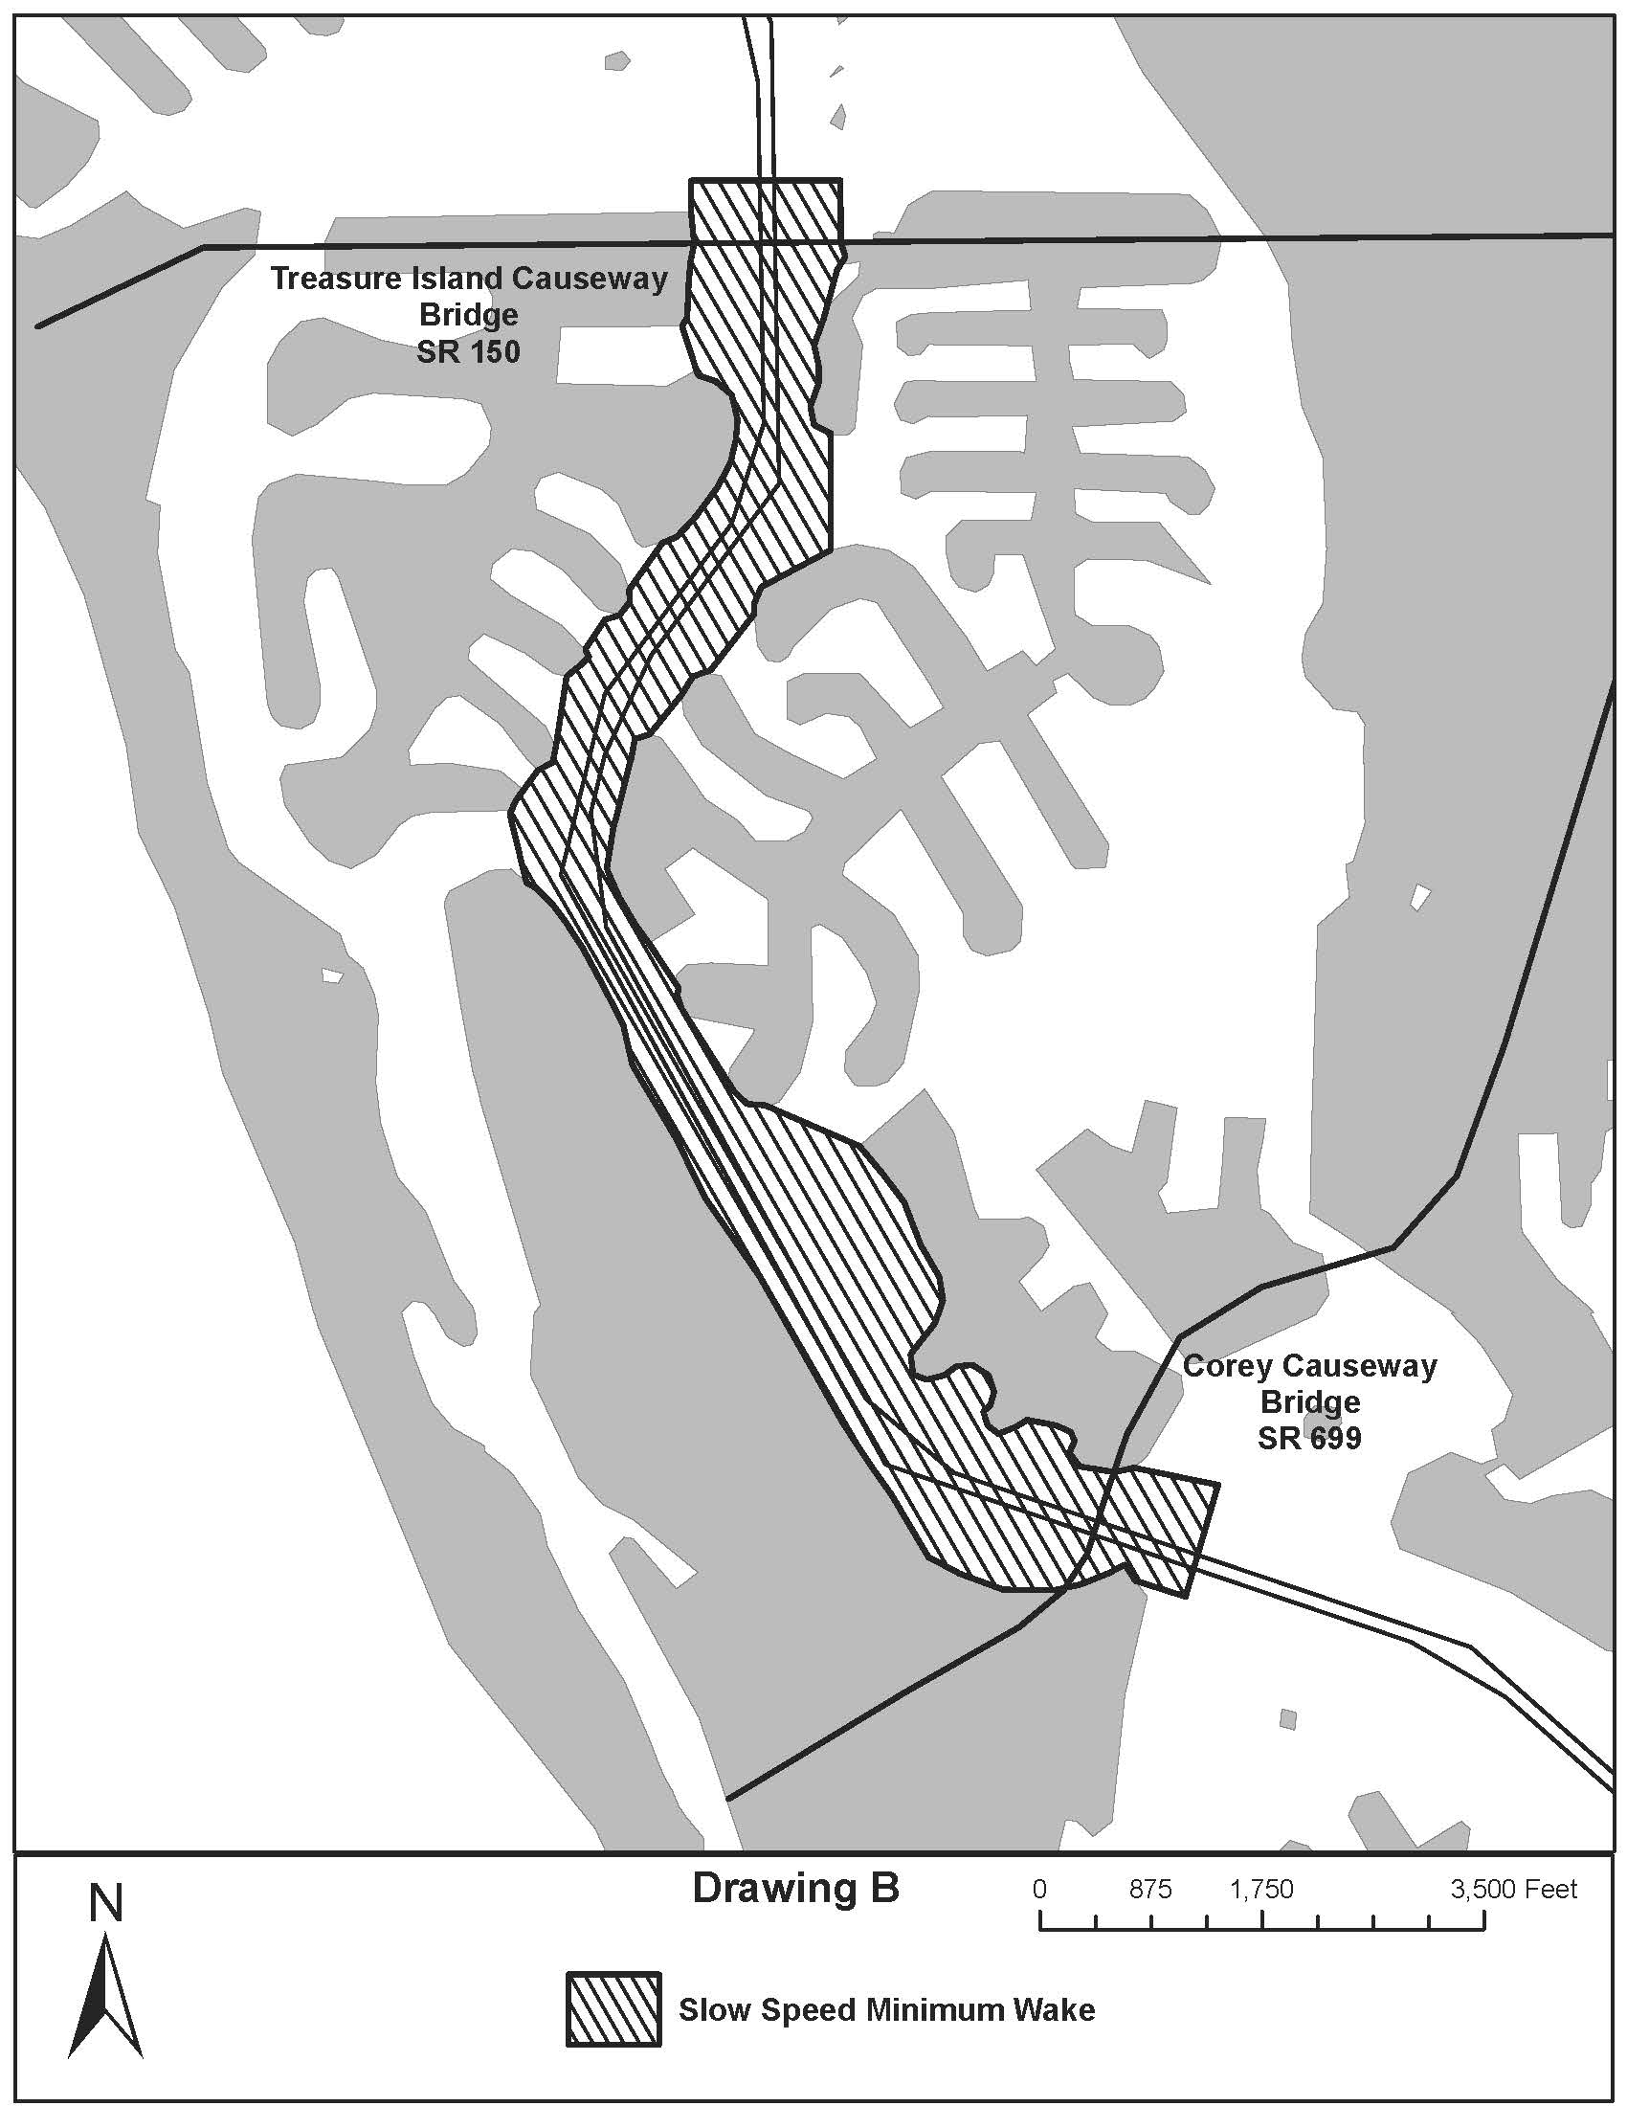
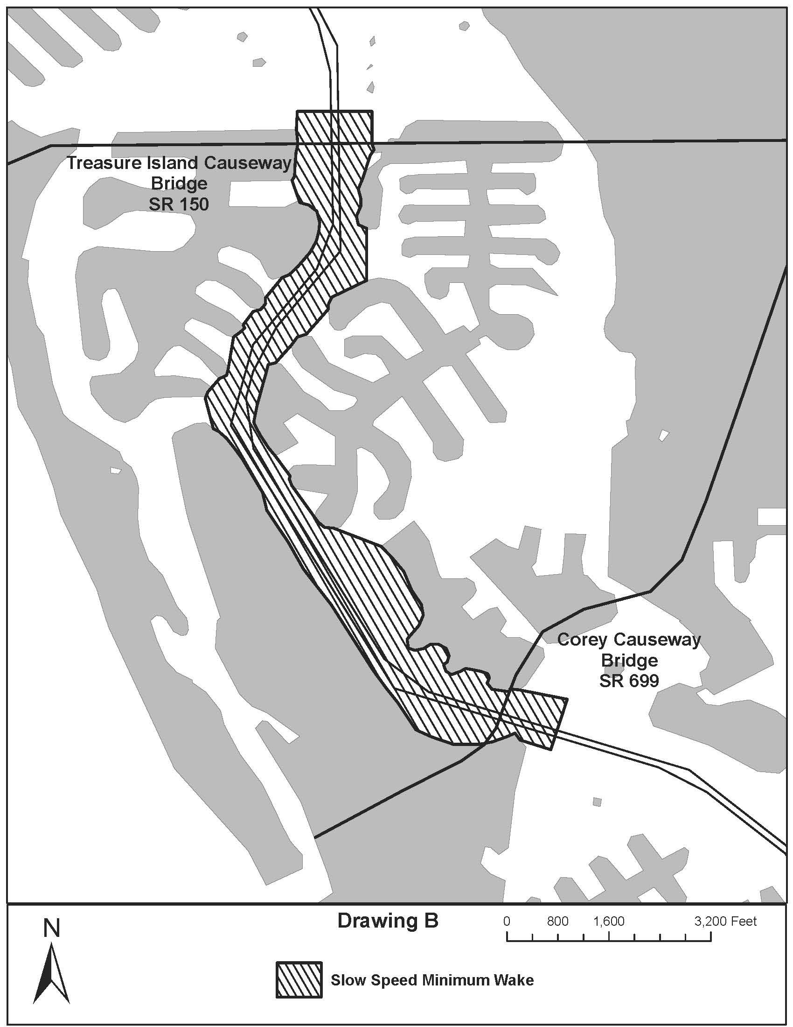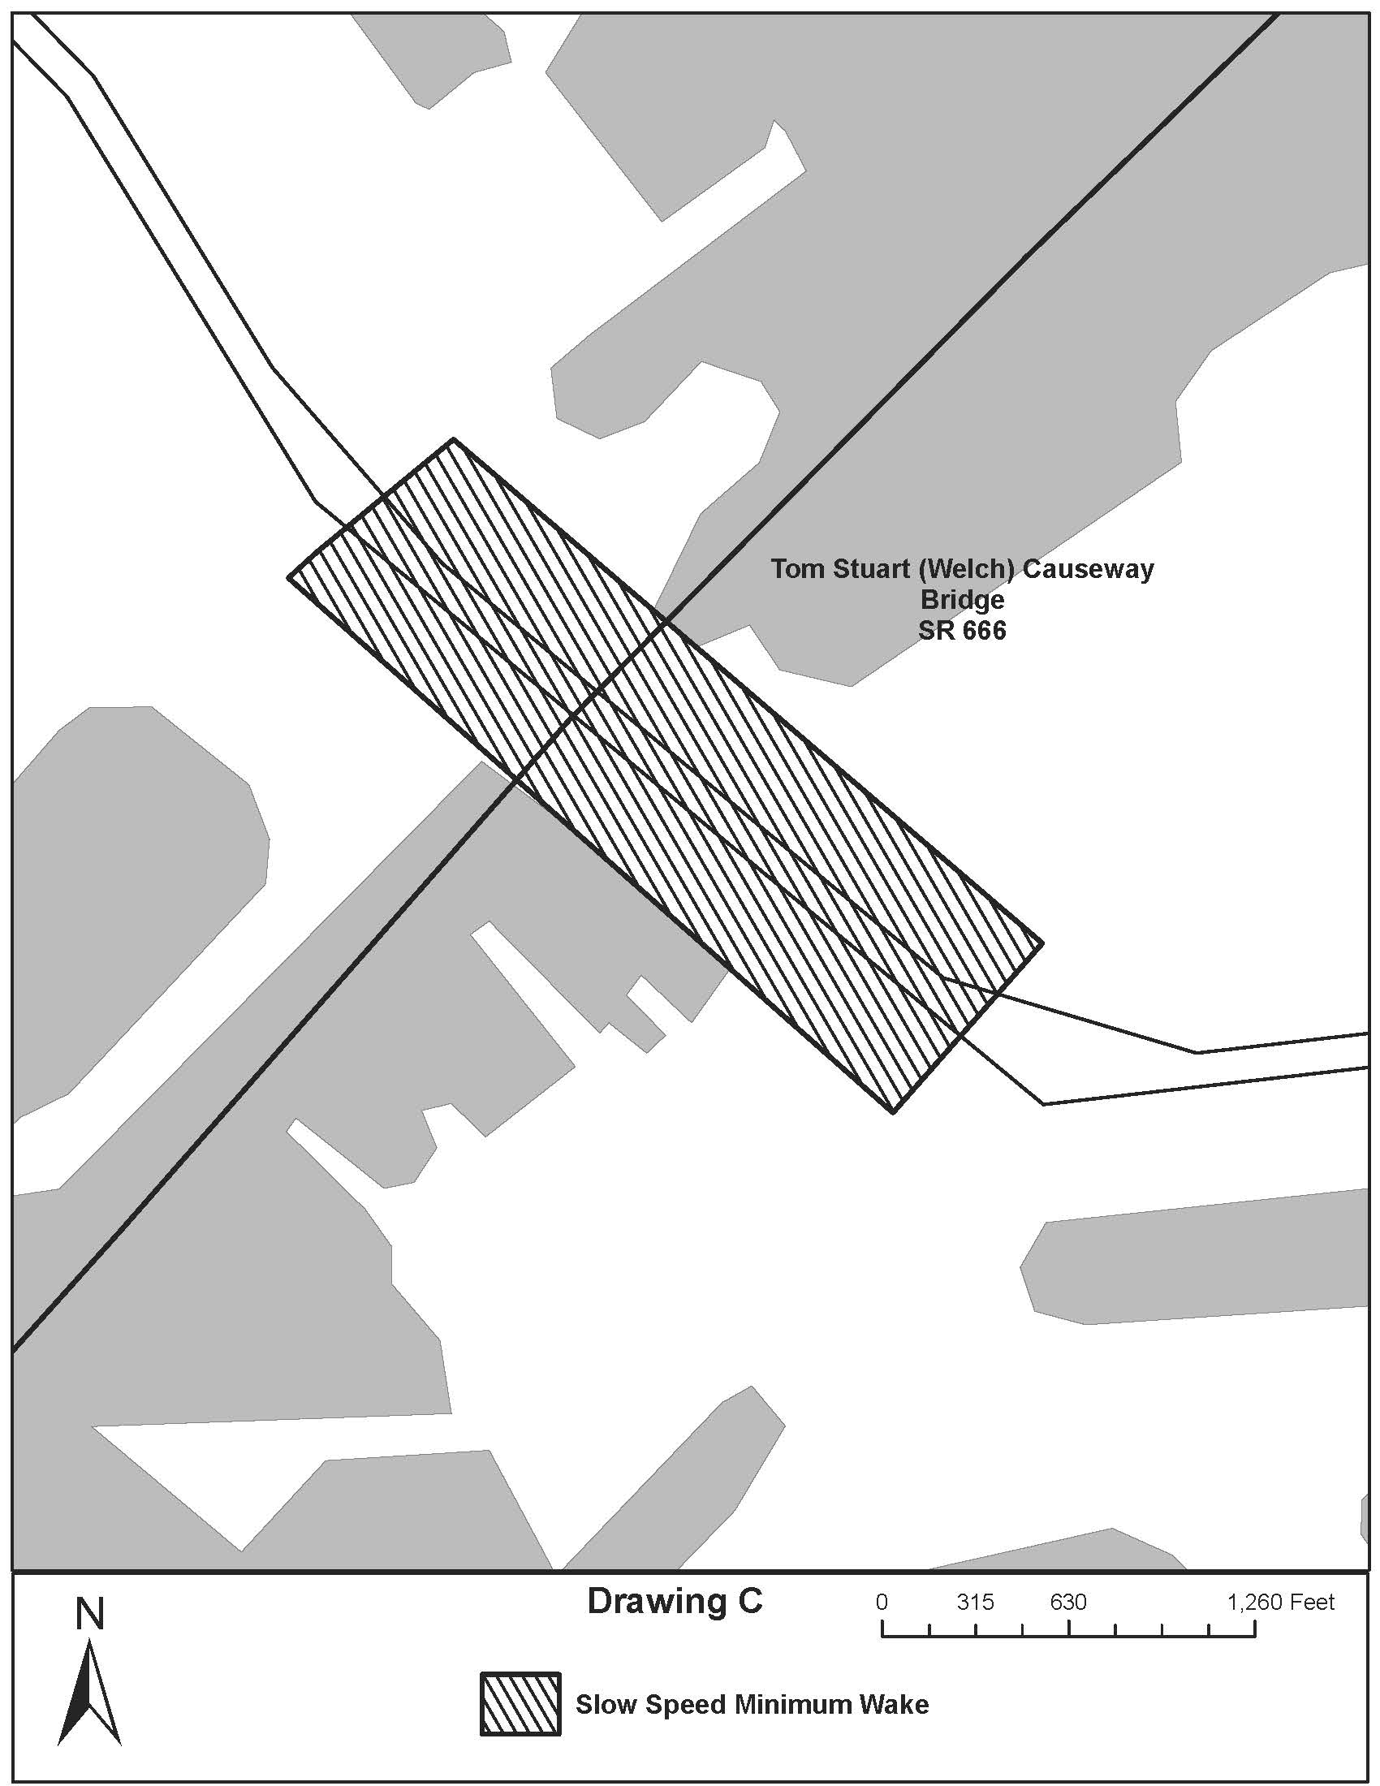
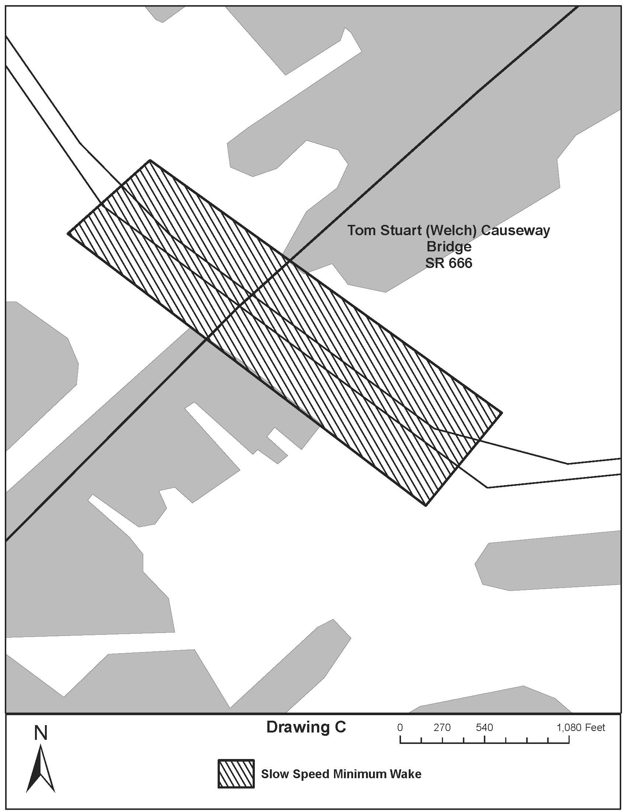
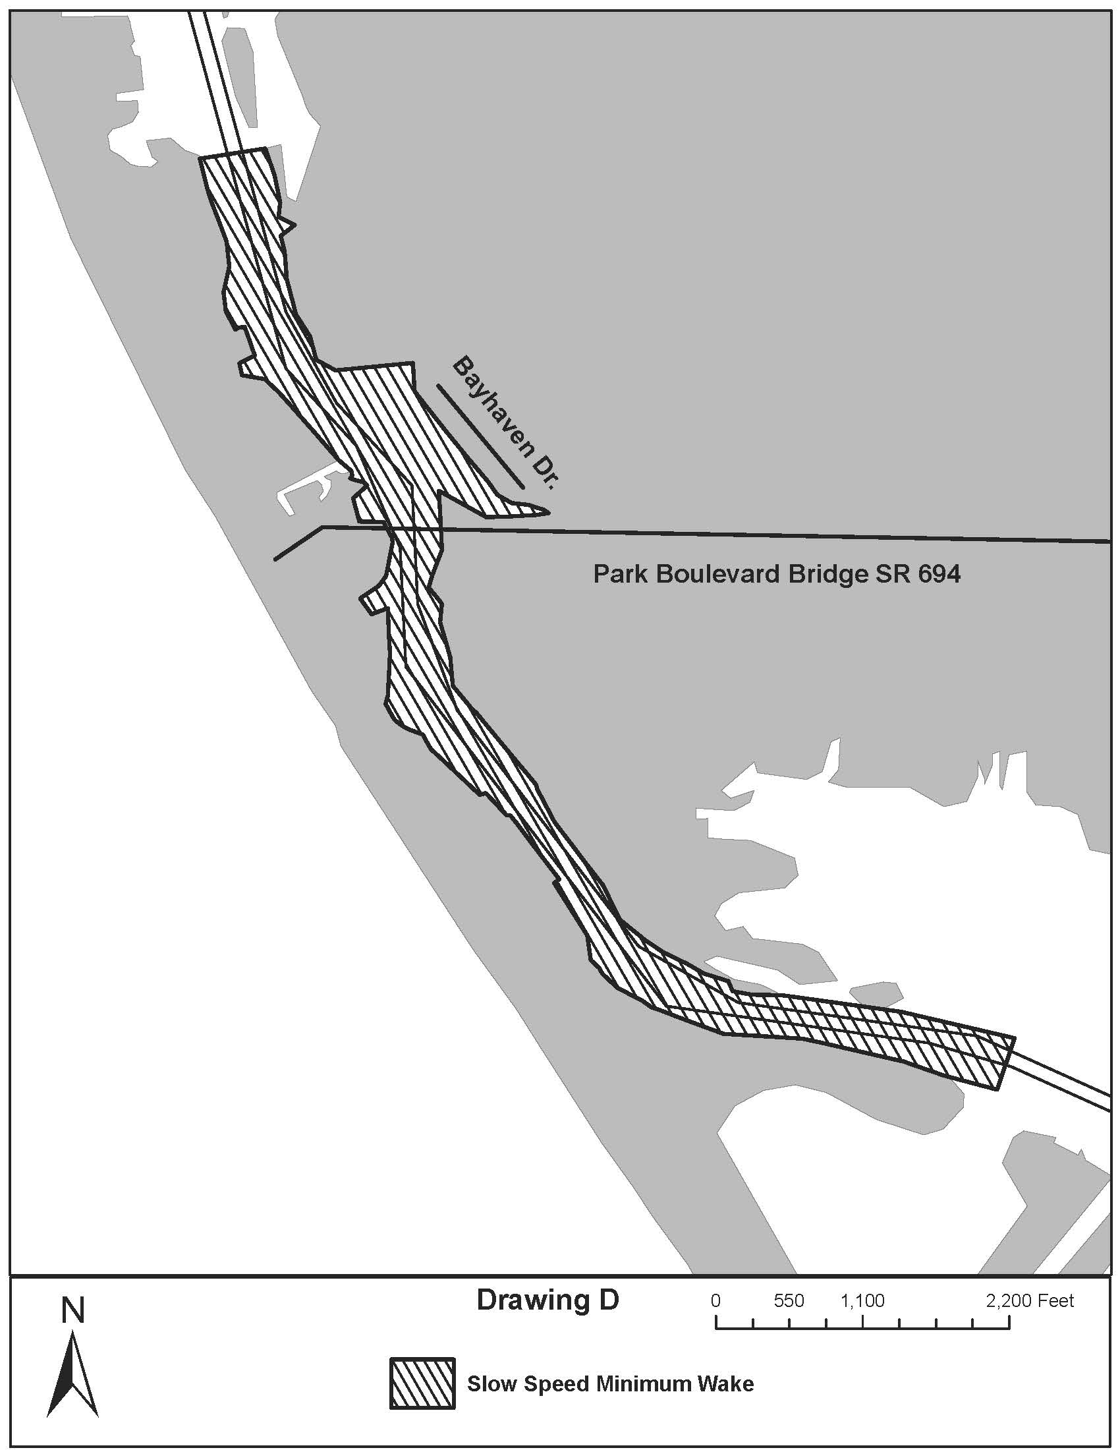
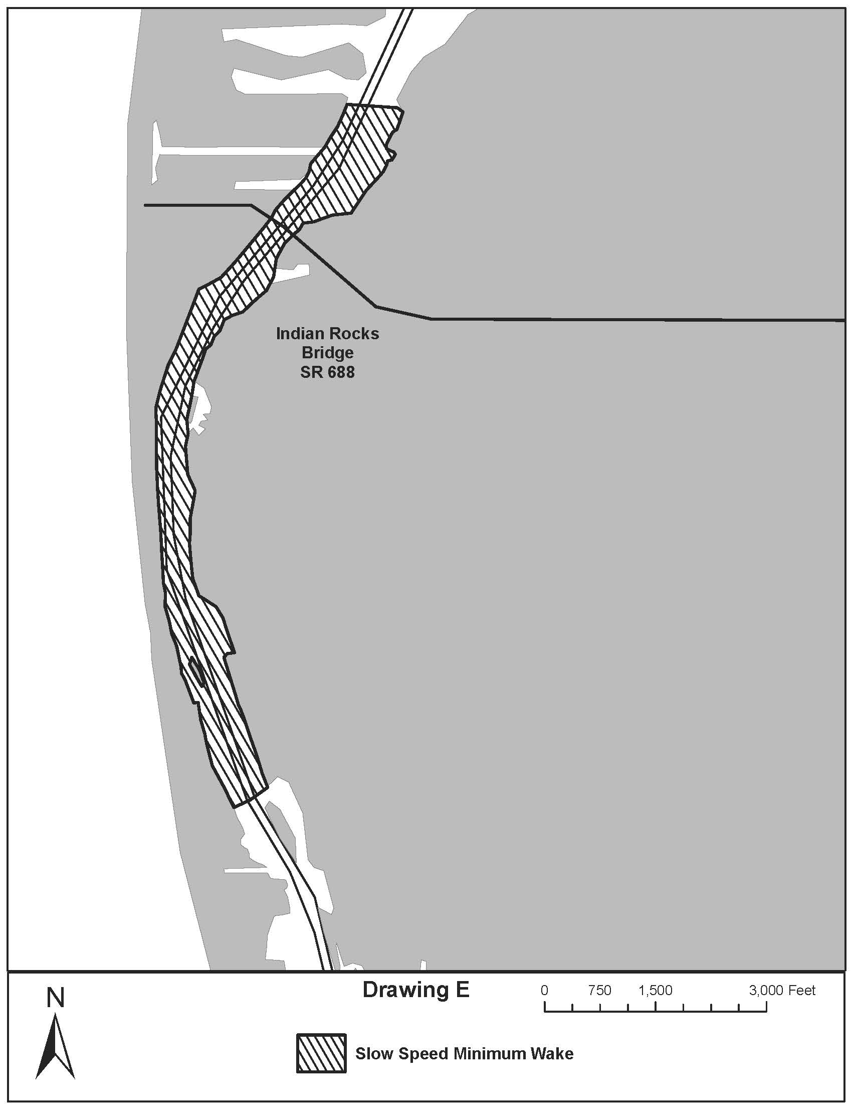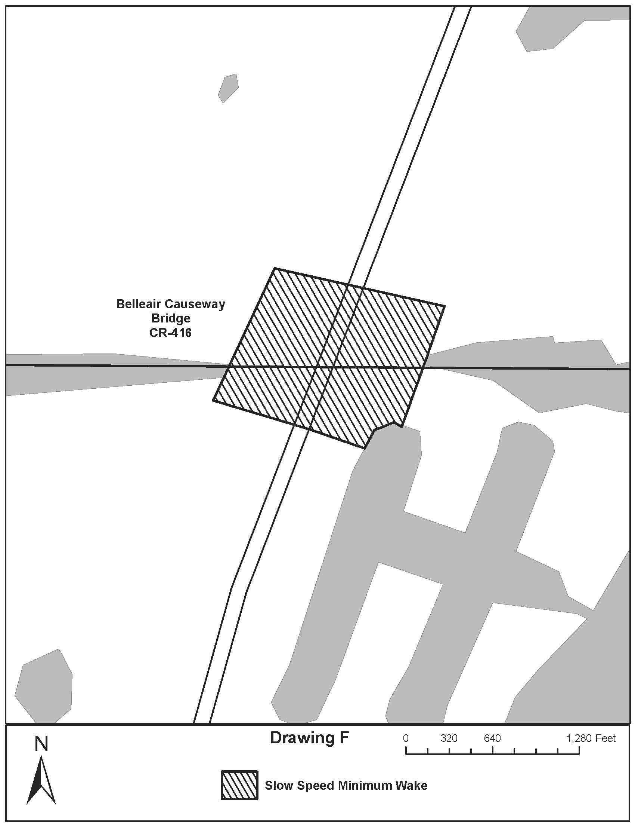
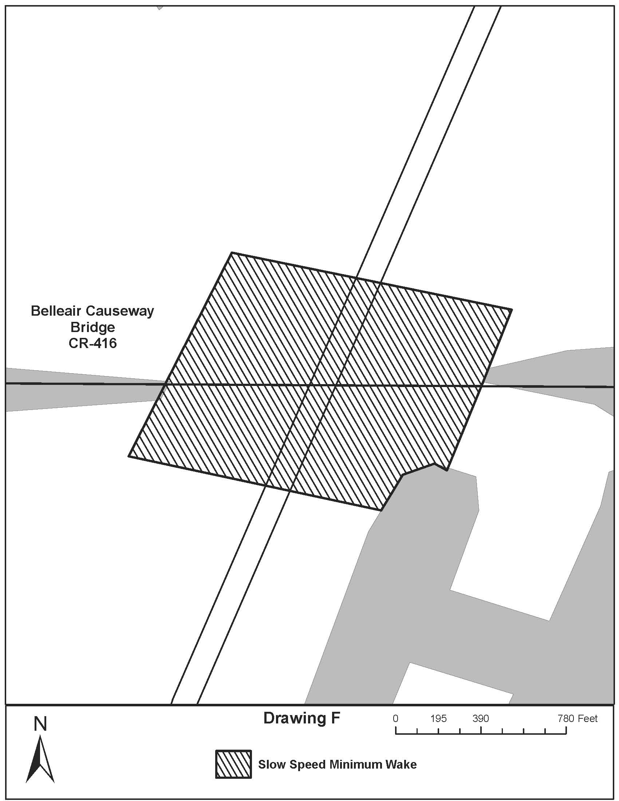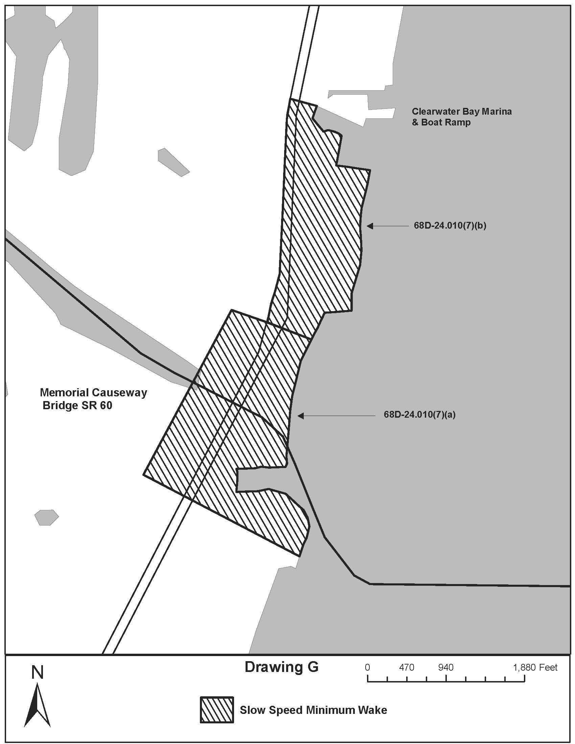
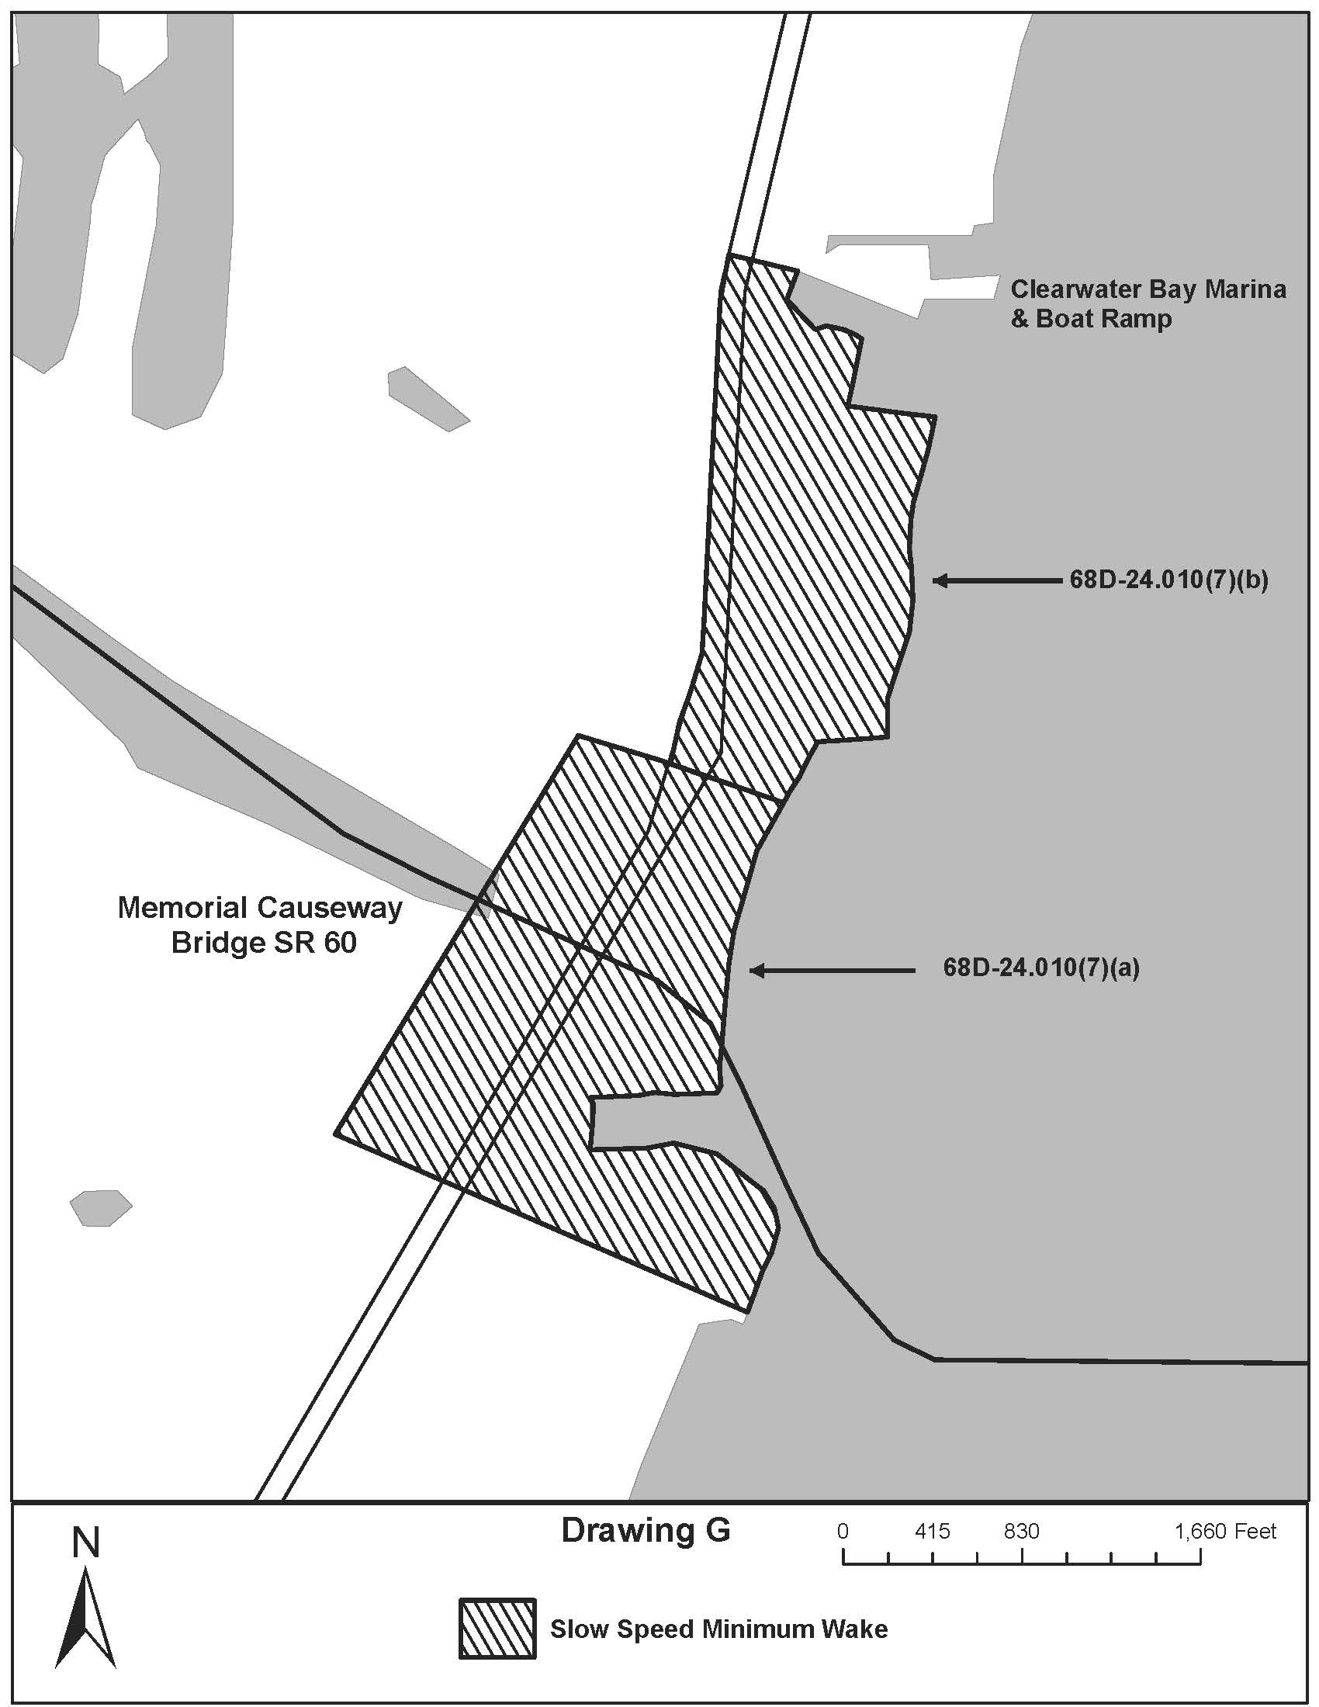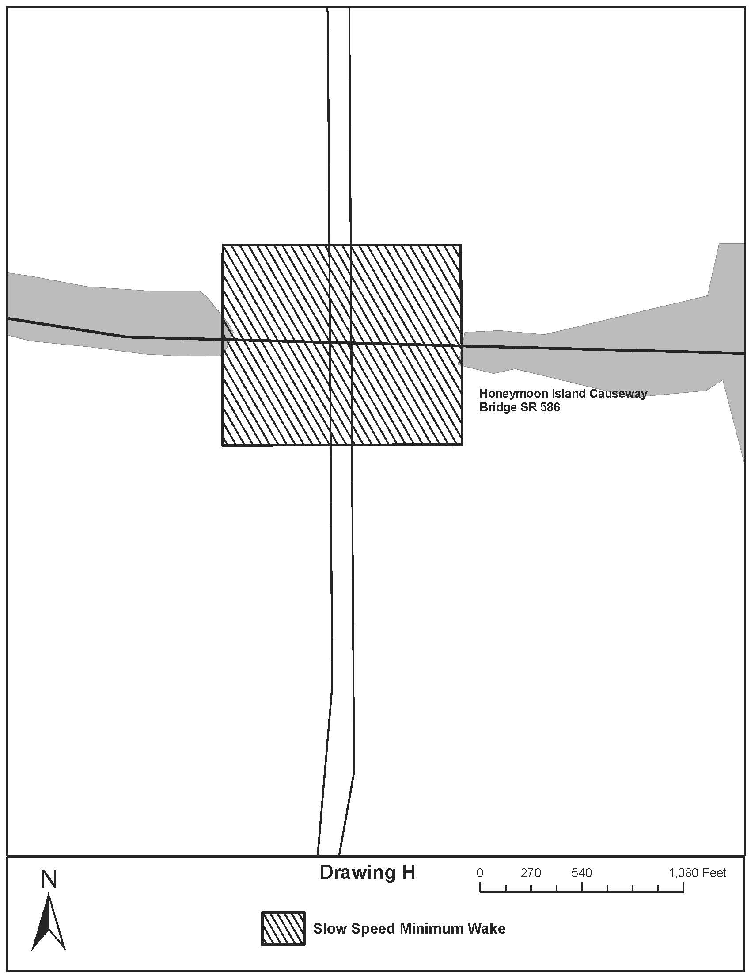
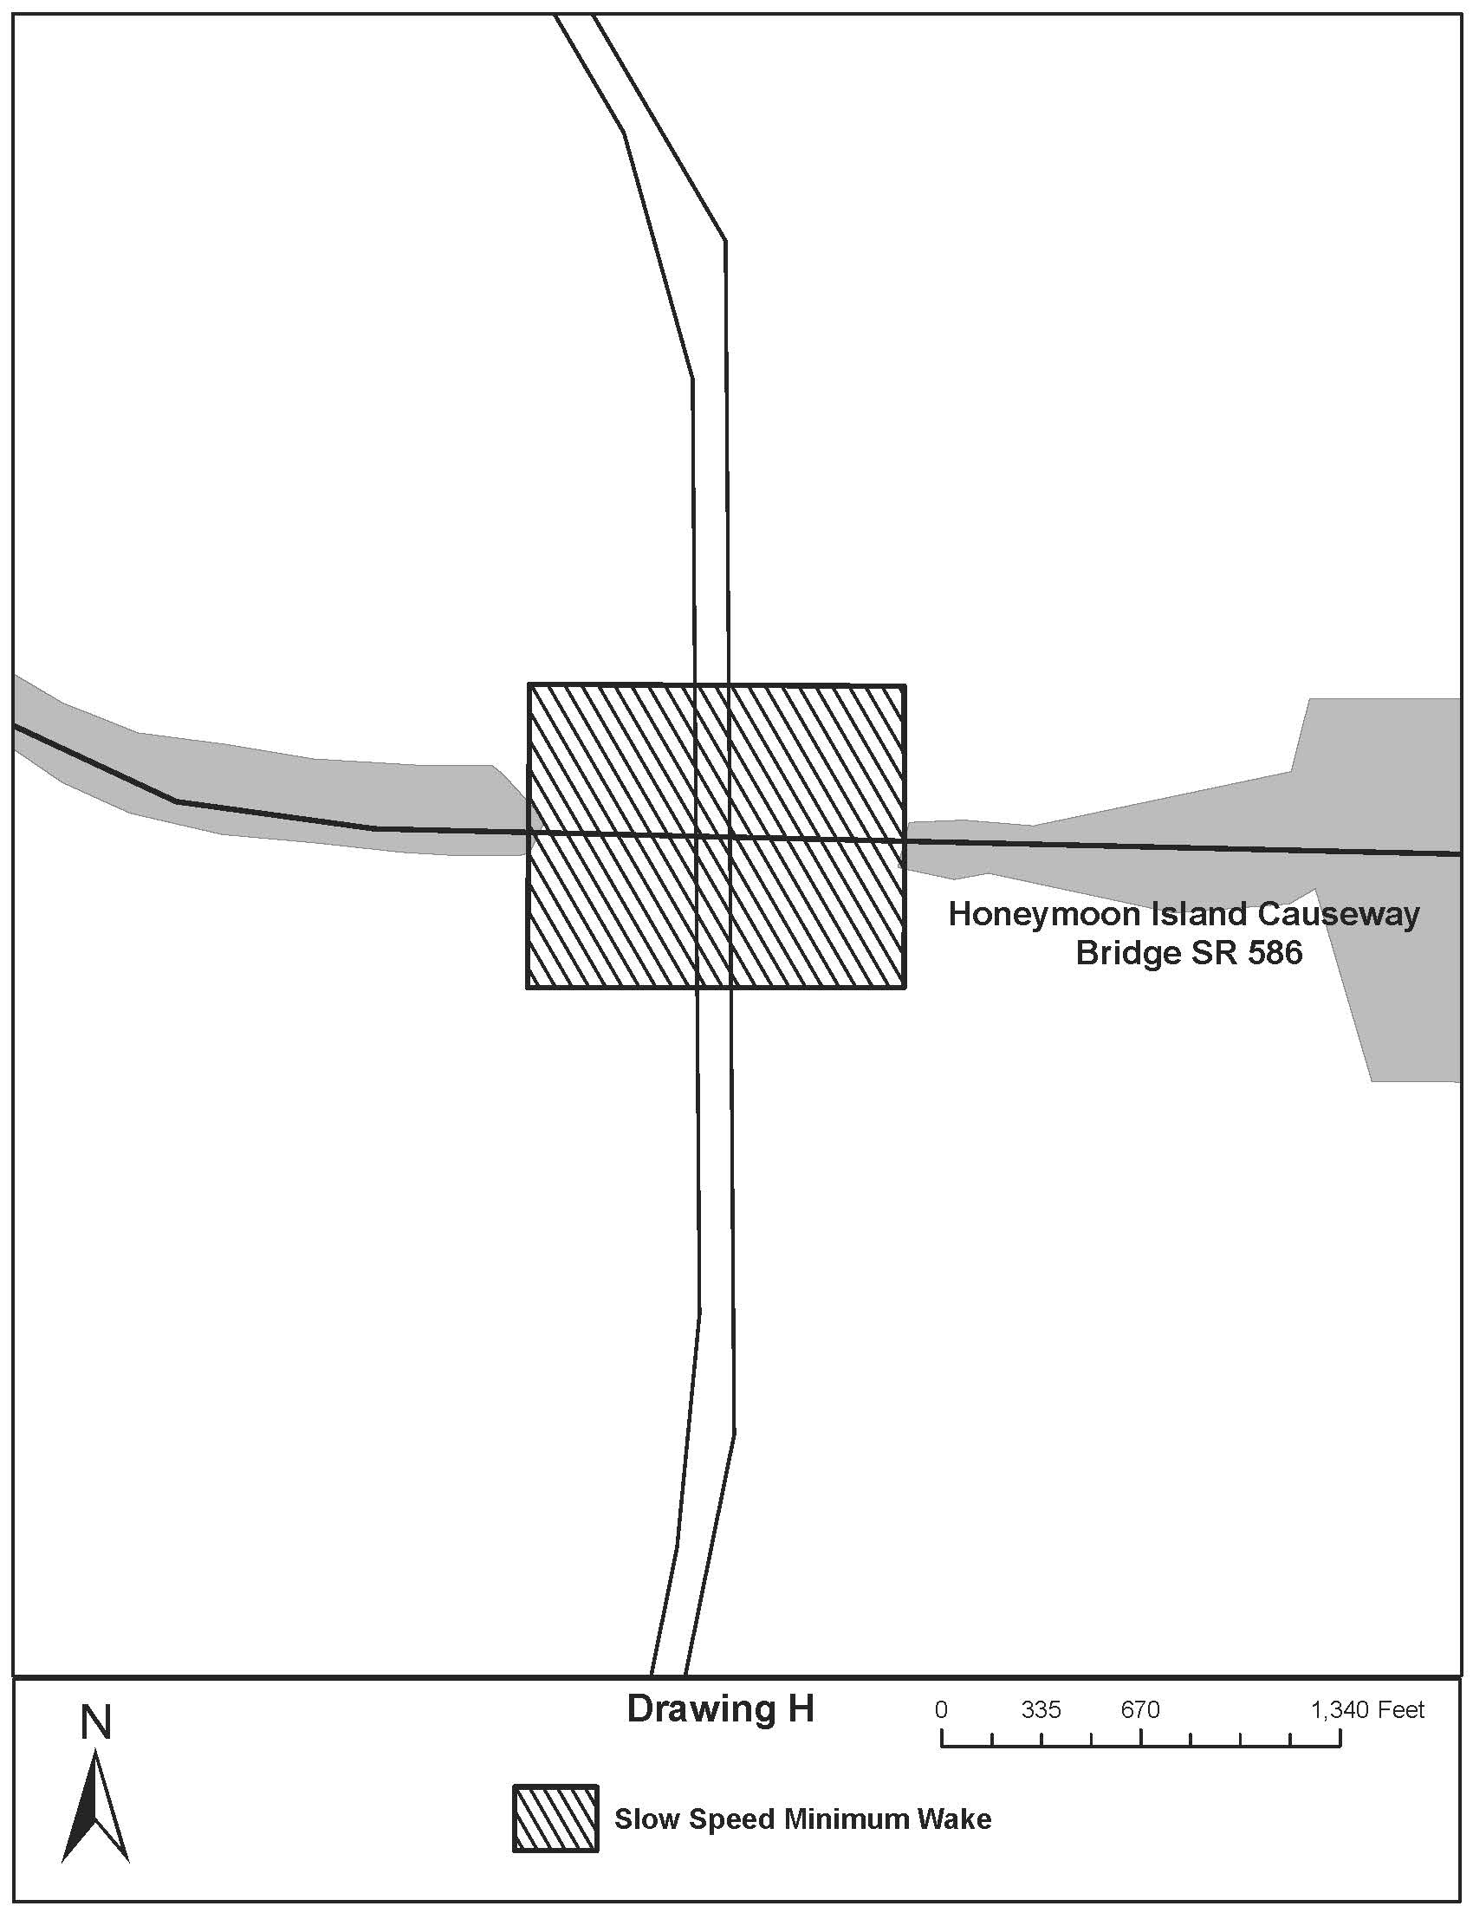

Rulemaking Specific Authority 327.46 FS. Law Implemented 327.46 FS. History–New 9-18-88, Amended 12-7-89, Formerly 16N-24.010, Amended 10-1-96, Formerly 62N-24.010, Amended 10-2-00,________.

