40E-41.063 Conditions for Issuance of Permits in the Western Canal 9 Basin.
(1) For design purposes the 100-year, 25-year and 10-year flood frequency elevations are established as 7.3 feet, 6.8 feet and 6.5 feet mean sea level, respectively.
(2) For systems designed to be pumped from fully diked areas, discharge shall be limited to three-fourths of an inch per twenty-four hours, or the criteria in Rules 62-330.301 and 62-330.302, F.A.C., whichever is more restrictive. In addition, no pumping shall be permitted when Canal 9 stages at pump tailwater exceed the 25-year peak elevation of 6.8 feet mean sea level.
(3) All direct connections to Canal 9 shall be designed to prevent lowering of the groundwater table below elevation 2.5 feet mean sea level. All indirect connections to Canal 9 shall be designed to prevent lowering of the groundwater table by installing the discharge facilities at a discharge elevation no lower than six inches below average existing ground elevation for the project. Nothing in this subsection shall be construed to preclude the construction and operation of discharge facilities designed to temporarily lower the groundwater table below these elevations immediately prior to the arrival of a major storm event.
(4) Fill encroachment criteria‒
(a) The volume encroached by development between average existing ground surface and elevation 7.0 feet mean sea level shall not exceed 2.0 feet times the total area of the property.
(b) For diked areas with on-site retention of runoff, the area diked shall not exceed the encroachment volume specified in paragraph (a) divided by the difference between average existing ground elevation within the dike and elevation 5.75 feet mean sea level. This will require all such projects on land of average elevation less than 3.75 feet mean sea level to preserve some area outside of the dikes with no fill. The preserved area shall be located so as to preserve natural basin flow patterns for lands outside the dikes.
(c) Typical development schemes using these criteria are depicted in Figure 41-2.

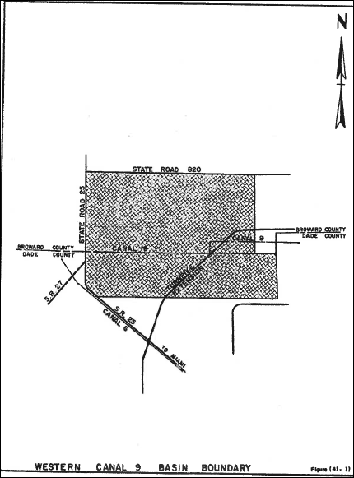

Rulemaking Authority 373.044, 373.113, 373.4131 FS. Law Implemented 373.413, 373.4131, 373.416 FS. History–New 9-3-81, Formerly 16K-34.06, Amended 4-20-94, 10-1-13.

