40E-41.363 Conditions for Issuance of Permits in the Water Preserve Area, Water Preserve Area Basin, or Adjacent to the Protective Levees.
(1) In order to obtain a permit under this part, an applicant must provide reasonable assurance that the proposed activities will meet the requirements of this section; not be harmful to the water resources; and be consistent with the purposes and objectives set forth in Rule 40E-41.320, F.A.C.
(2) Projects located within one mile of existing or proposed WPA components, or the Protective Levees, shall leave sufficient overburden in place to prevent seepage increases eastward into surface water bodies, such as surface water management lakes, canals, ditches or ponds, in accordance with the following design criteria:
(a) Proposed excavations located within one-quarter mile of the existing or proposed WPA components or the Protective Levees shall maintain an overburden thickness of at least three-quarters of the existing overburden.
(b) Proposed excavations located from one-quarter mile to one-half mile from existing or proposed WPA components or the Protective Levees shall maintain an overburden thickness of at least half of the existing overburden.
(c) Proposed excavations located from one-half mile to one mile from existing or proposed WPA components or the Protective Levees shall maintain an overburden thickness of at least one-quarter of the existing overburden.
(d) Figures 1, 2, 4, 5 and 6 show the thickness of existing overburden within the WPA, WPAB and adjacent to the Protective Levees.
(3) Notwithstanding paragraphs (2)(a)-(d) above, applicants can:
(a) Provide site-specific technical information documenting the presence of sufficient overburden above the production zone of the surficial aquifer system to demonstrate that a proposed excavation will not cause adverse seepage or hydrologic impacts to the WPA or Water Conservation Areas; or
(b) Propose an alternative engineering design, such as installation of a synthetic liner, muck back-filled trench or other seepage barrier, with site-specific technical information to demonstrate that a proposed excavation will not cause adverse seepage or hydrologic impacts to the WPA or Water Conservation Areas.
(4) Proposed projects within the WPA, WPAB or adjacent to the Protective Levees shall not lower existing water table elevations.
(5) In addition to the water quality treatment volumes required in section 4.2.1. of the Applicant’s Handbok Volume II, projects within the WPA or WPAB shall provide an additional fifty (50) percent retention/detention water quality treatment.
(6) No dredging or filling of wetlands shall be permitted in the WPA, except where necessary to provide access to upland sites; allow an economically viable use of private property; facilitate relocation or installation of essential public services such as electricity, transportation, telecommunications and water supply in locations compatible with the WPA objectives when it has been demonstrated that such services cannot be located outside the WPA; or to facilitate the objectives of the WPA or Comprehensive Everglades Restoration Plan.
(7) Mitigation for proposed impacts incurred in the WPA or WPAB must be provided within the WPAB, or at a mitigation bank or Regional Offsite Mitigation Area with an approved mitigation service area that includes the impact site, provided all other applicable criteria are met.
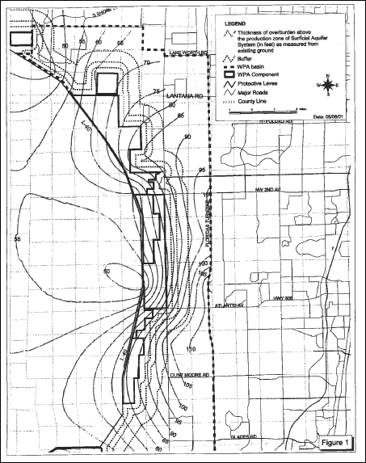
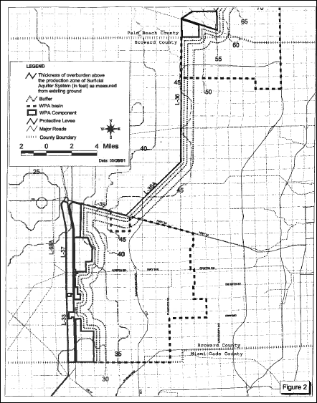
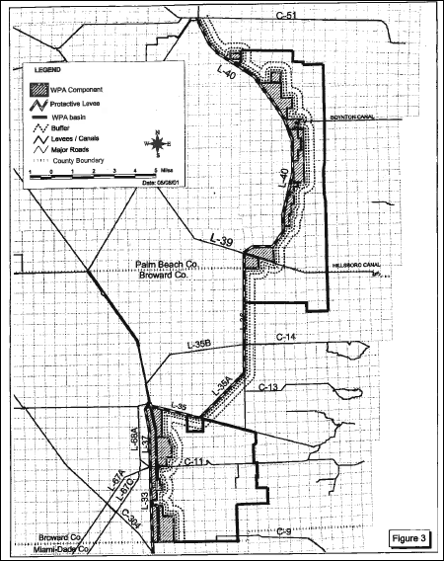

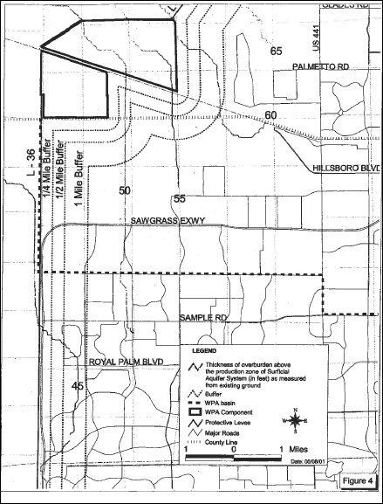

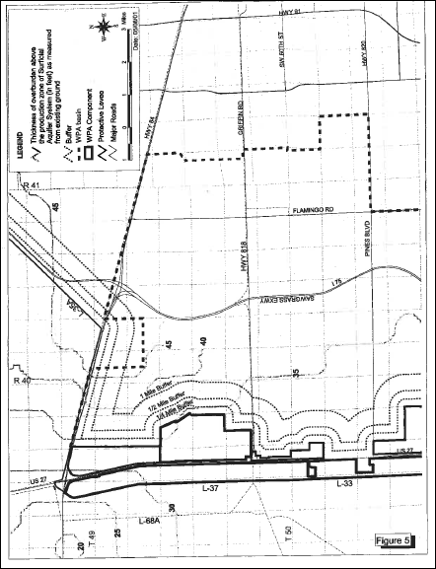

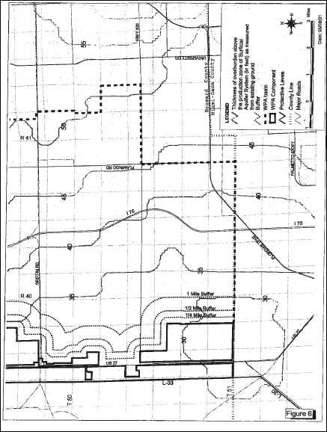
Rulemaking Authority 373.044, 373.113, 373.4131 FS. Law Implemented 373.413, 373.4131, 373.416 FS. History–New 10-21-01, Amended 12-1-11, 10-1-13.

