15C-1.0107 Strap Test Specifications.
(1) All tie-down straps shall be tested to American Society for Testing and Materials (ASTM) D 3953-91.
(2) All tie-down straps, etc., shall be Type 1, Finish B, Grade 1, Steel Strapping 109,000 minimum yield strength, .035'' minimum thickness (plus or minus .002 in. – 0.05MM), Finish B – hot-dipped galvanized zinc coating (ASTM Standard 123-89A); .60 ounces per square foot, per surface, 4750 pounds minimum break strength, marked every 12 to 15 inches (manufacturer’s name and ASTM Spec. D3953-91), 1 1/4'' width (plus or minus .005 in. – 0.13MM), 6.6 feet per pound of strap, elongation 6.5% to 12%.
(3) All straps shall be subjected to the following test procedures: (Refer to Example No. II for the proper format to use in reporting test results.)
(a) Bend Test (5 bends)
Strap shall be bent by hand over a radius of 1/8 inch plus or minus 1/64'' inch. One bend shall consist of a ninety (90) degree bend in one direction and return to the original position. Make successive bends in opposite directions.
(b) Breaking Test
The crosshead speed shall be two inches (2''). The test specimen shall be six inches (6'') in length between the clamps or jaws.
(c) Elongation Test
The elongation testing shall be conducted on the six inch (6'') length of strap exposed between the jaws. Two (2) measurements for elongation shall be recorded at four thousand seven hundred twenty-five (4,725) pounds then test shall be continued to strap failure and elongation recorded.
(d) Hardness Test or Military Specification listing the properties.
(4) Strap Splice or Connections
(a) Strap splice shall require at least twelve inches (12'') of strap overlap with two (2) seals evenly spaced. Each seal shall have two (2) crimps evenly spaced. All strap connections must be manufactured to meet minimum standards of Rule 15C-1.0105, F.A.C., and must be approved by the department.
(b) Factory installed sidewall and centerline bracket attachments shall require at least one (1) seal with two (2) crimps or equivalent welds evenly spaced and protected with a radius clip or manufactured bent or formed radius protective tab. (Note: Bracket lacing or field threading shall not be used.)
(c) Vertical and frame tie connections must be designed to swivel where attached to the mobile/manufactured home and must be connected to the home by means of grade #5 bolts with a minimum diameter of one-half inch (1/2'').
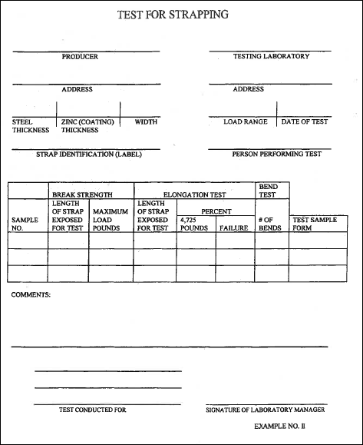
Rulemaking Authority 320.011, 320.8325(1) FS. Law Implemented 320.77(10), 320.822(12), 320.8285, 320.8325, 320.835(2) FS. History–New 1-10-94, Amended 10-2-95, 3-31-99.

