15C-1.0108 Anchor and Anchor Component Test Specifications.
(1) The anchor may be tested in one piece or cut in half. When the anchor is cut in half for test purposes, the top or head shall be tested with a sling around a bolt, pin, etc., or through the bolt or connection that the tie-down strap or cable is attached to when the system is installed on the mobile home. The force required shall be seven thousand one hundred twenty-five (7,125) pounds. The disc or helix shall be used in the certified test. Also, the shimming between the steel plate and the disc will assure that the hole (minimum 1 1/2'') through the plate and disc will be vertical with the shaft or rod. Other tests that are equivalent may be used. (Refer to Example Nos. III, IV and V for the proper format to use in reporting test results.)
(2) When the anchor is tested in one piece, the head and the disc will be tested together. The test block would have a slot cut in the plate for the anchor shaft or rod to pass through to position the test block with the disc. Connection on the head would be the same as required in subsection (1) of this rule.
(3) Anchor tensioning device test: Each different anchor model or type of tensioning device shall be tested with strap or cable connected to the anchor head connecting device. Force required shall be four thousand seven hundred twenty-five (4,725) pounds and continue to destruction or ten percent (10%) overload. (Refer to Example No. VI for the proper format to use in reporting test results.)
(4) Method of testing: The tensioning device (head) shall be tested with strap or cable inserted or connected to the device or head in the same manner as required to connect or attach when installed on the mobile/manufactured home or park trailer. Bolt(s) used in the test shall be identified and listed as a part of the approved anchor assembly. No devices shall be used in the test that are not regularly furnished and required to be used with the anchor and component field installation. (Examples: clips, wedges, pins or other required accessories.)
(5) All field tests shall be performed in the lower fifty percent (50%) of the soil class.
(6) Anchor and stabilizer holding power for Type 4(a) Soil shall require a minimum of four thousand seven hundred twenty-five (4,725) pounds in each direction. Anchor and stabilizer for Type 4(b) Soil shall require a minimum of six thousand (6,000) pounds in the vertical direction and four thousand seven hundred twenty-five (4,725) pounds in a forty-five (45) degree horizontal direction. Over two inches (2'') of uplift or three inches (3'') of side deflection shall be recorded as failure. (Refer to Example Nos. VII and VIII for the proper format to use in reporting test results.)
(7) Required Test Report: Each different type or model design must be field tested for holding power by an independent testing laboratory and certified by an engineer registered in the State of Florida. All field tests shall be conducted in the State of Florida. The lab report shall show the following:
(a) Model tested as described by engineering drawings.
(b) Method of installation.
(c) Date of installation.
(d) Date of pull-out test.
(e) Soil profile description for each type soil in which anchor is tested and listed to be installed according to the soil classification chart printed herein.
(f) Location of field test.
(g) Test equipment used.
(h) Pounds of force exerted and resultant vertical and horizontal movement in inches for the anchor and stabilizer.
(i) Description of stabilizer used in each auger anchor field test, including stabilizer manufacturer.
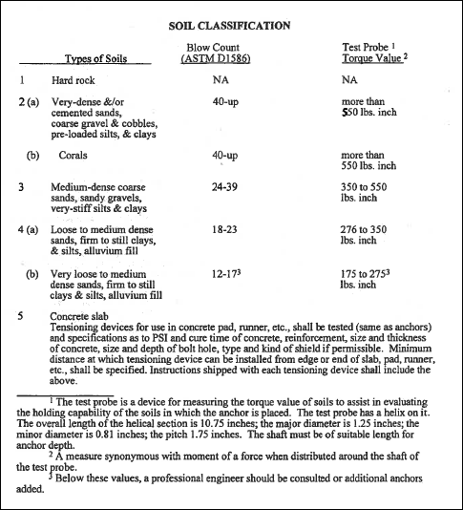

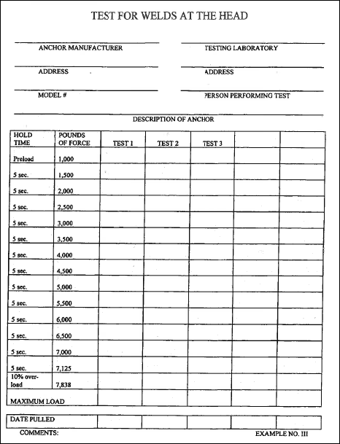

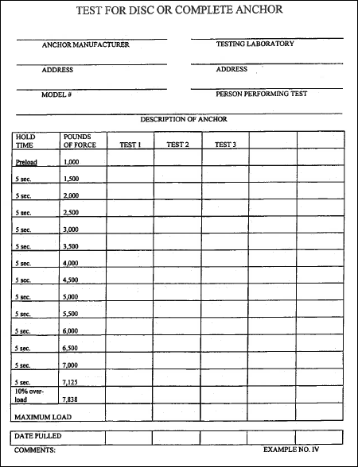

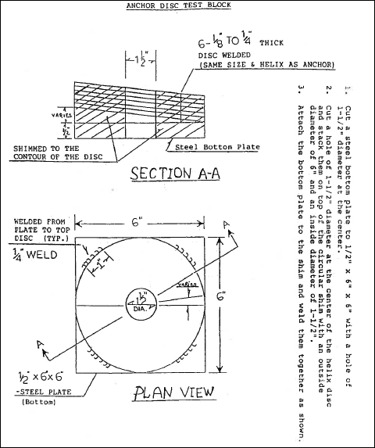

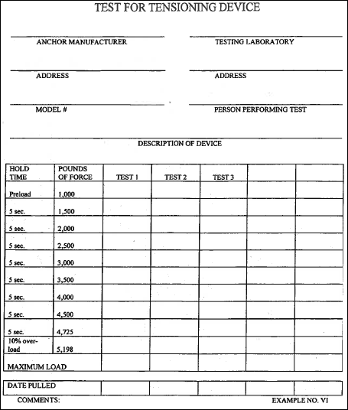

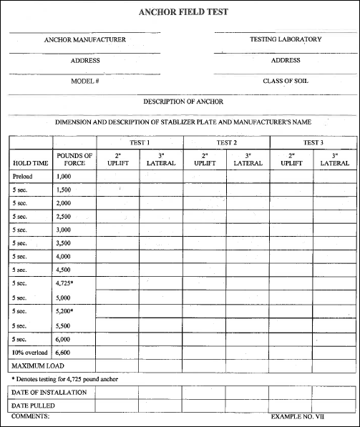
Rulemaking Authority 320.011, 320.8325(1) FS. Law Implemented 320.77(10), 320.822(12), 320.8285, 320.8325, 320.835(2) FS. History–New 1-10-94, Amended 10-2-95, 3-31-99.

