Notice of Proposed Rule
WATER MANAGEMENT DISTRICTS
South Florida Water Management District
RULE NOS.: RULE TITLES:
40E-2.011 Policy and Purpose
40E-2.041 Permits Required
40E-2.061 No-Notice General Permit by Rule
40E-2.071 Noticed General Permits and Individual Permits
40E-2.091 Publications Incorporated by Reference
40E-2.101 Content of Application
40E-2.301 Conditions for Issuance of Permits
40E-2.321 Duration of Permit
40E-2.331 Modification of Permits
40E-2.381 Limiting Conditions
PURPOSE AND EFFECT: The Florida Department of Environmental Protection (DEP) is leading a statewide effort (referred to as CUPCon) to improve consistency in the consumptive use permitting programs implemented by the water management districts (WMDs). The CUPCon goals include: 1) making the consumptive use permitting program less confusing for applicants; 2) treating applicants equitably statewide; 3) providing consistent protection of the environment; 4) streamlining the process; and 5) incentivizing behavior that protect water resources.
SUMMARY: Specifically, the proposed amendments: 1) require a single noticed general permit for contiguous properties unless served by separate withdrawal facilities; 2) grant a general permit by rule for the use of water for cooling/heating systems, a use that previously required a water use permit; 3) set forth circumstances under which the water use would likely qualify for such a general permit as well as specify those criteria under which an applicant must apply for an individual permit; 4) replace old water use forms with new ones; 5) incorporate provisions from Chapter 40E-20, F.A.C.; 5) conform to the water Resource Implementation Rule on minimum flows and levels; 6) provide for modifications of permits by letter for certain types of projects or activities; and 7) facilitate implementation of the recent amendments to Section 373.236(5), F.S.
In addition, the proposed amendments rename the “Basis of Review for Water Use Permit Applications Within the South Florida Water Management District” to “Water Use Permit Applicant’s Handbook For Use Within the South Florida Water Management District” and fulfill the goals of CUPCon to streamline the CUP application and compliance process as well as to make it easier for applicants/consultants that work in multiple WMD jurisdictions. The Applicant’s Handbook will contain a consistent order of appearance as well as contain consistent criteria on several topics, such as water conservation and 10-year compliance reports.
SUMMARY OF STATEMENT OF ESTIMATED REGULATORY COSTS AND LEGISLATIVE RATIFICATION:
The Agency has determined that this will not have an adverse impact on small business or likely increase directly or indirectly regulatory costs in excess of $200,000 in the aggregate within one year after the implementation of the rule. A SERC has been prepared by the agency.
Small businesses who are consumptive use permittees and applicants will benefit from the consistency and simplification of permit categories and experience cost savings.
The Agency has determined that the proposed rule is not expected to require legislative ratification based on the statement of estimated regulatory costs or if no SERC is required, the information expressly relied upon and described herein: The benefits to costs over a five year implementation period will result in a cumulative nominal savings of $862,740 and discounted cumulative savings of $825,139.
Any person who wishes to provide information regarding a statement of estimated regulatory costs, or provide a proposal for a lower cost regulatory alternative must do so in writing within 21 days of this notice.
RULEMAKING AUTHORITY: 373.044, 373.113, 373.118, 373.171 FS.
LAW IMPLEMENTED: 373.042, 373.0421, 373.079, 373.083, 373.103(1), 373.109, 373.118, 373.196, 373.1501, 373.1502, 373.203, 373.216, 373.219, 373.223, 373.224, 373.229, 373.2295, 373.232, 373.233, 373.236, 373.239, 373.244, 373.249, 373.250, 373.470 FS.
A HEARING WILL BE HELD AT THE DATE, TIME AND PLACE SHOWN BELOW:
DATE AND TIME: January 9, 2014, 9:00 a.m.
PLACE: South Florida Water Management District, B-1 Auditorium, 3301 Gun Club Road, West Palm Beach, FL 33406
Pursuant to the provisions of the Americans with Disabilities Act, any person requiring special accommodations to participate in this workshop/meeting is asked to advise the agency at least 5 days before the workshop/meeting by contacting: South Florida Water Management District Clerk's Office, (800)432-2045, ext. 2087 or (561)682-2087. If you are hearing or speech impaired, please contact the agency using the Florida Relay Service, 1(800)955-8771 (TDD) or 1(800)955-8770 (Voice).
THE PERSON TO BE CONTACTED REGARDING THE PROPOSED RULE IS: Steven Memberg, Water Use Policy Principal Scientist, South Florida Water Management District, 3301 Gun Club Road, West Palm Beach, FL 33406 (800)432-2045, ext. 2133 or (561)682-2133, email: smemberg@sfwmd.gov, or Jennifer Bokankowitz, Esq., South Florida Water Management District, 3301 Gun Club Road, West Palm Beach, FL 33406 (800)432-2045, ext. 2258 or (561)682-2258, email: jbokanko@sfwmd.gov. For procedural questions, contact Jan Sluth, CP, FRP, South Florida Water Management District, 3301 Gun Club Road, West Palm Beach, FL 33406 (800)432-2045, ext. 6299 or (561)682-6299, email: jsluth@sfwmd.gov

THE FULL TEXT OF THE PROPOSED RULE IS:

40E-2.011 Policy and Purpose.
(1) through (2) No change.
(3) The purpose of this chapter is to set forth the conditions for issuance for all water use permits and establish requirements for the various types of permits available under this chapter.
(4)(3) Additional rules relating to water use are found in Chapters 40E-5, F.A.C. (Artificial Recharge), Chapter 40E-8, F.A.C., (Minimum Flows and Levels (MFLs)), Chapter 40E-10, F.A.C. (Water Reservations), Chapters 40E-20, F.A.C. (General Water Use Permits), 40E-21, F.A.C. (The Water Shortage Plan), 40E-22, F.A.C., (Regional Water Shortage Plans), and 40E-24, F.A.C. (Mandatory Year-Round Landscape Irrigation Conservation Measures).
(5)(4) Standards for the construction, repair and abandonment of water wells are found in Chapters 40E-3, F.A.C. (Water Wells).
(6) If an application for any proposed water use does not meet the provisions of this chapter for a general permit or evidence indicates the potential for harm, the District will provide the permit applicant with the option to either withdraw the general permit application or supply the additional information and, if applicable, the fee required for an individual permit. In the event one of these options is not selected, staff will recommend that the Governing Board deny the general permit application. The criteria in the “Applicant’s Handbook for Water Use Permit Applications within the South Florida Water Management District,” incorporated by reference in Rule 40E-2.091, F.A.C., will be utilized to determine whether the conditions for issuance in Rule 40E-2.301, F.A.C., are satisfied.
Rulemaking Authority 373.044, 373.113, 373.171 FS. Law Implemented 373.103(1), 373.203, 373.216, 373.249 FS. History–New 9-3-81, Formerly 16K-2.01, Amended 7-4-82, 2-24-85, 11-18-91, 8-1-02, 8-31-03, 7-2-09, 10-23-12,_________

40E-2.041 Permits Required.
(1) No change.
(2) The District issues water use permits in two forms, individual water use permits and general water use permits. An individual water use permit may be obtained by meeting the requirements of this chapter. Chapter 40E-20, F.A.C., provides the requirements for qualifying for a general water use permit.
(3) No change.
(4) A water user seeking a noticed general permit shall obtain one permit for all withdrawals that are intended to serve contiguous property. Two or more properties represented as separate properties shall be aggregated and treated as a single property for permitting purposes when the District determines that the properties are physically proximate and either a) share the same irrigation infrastructure or b) are operated as a common enterprise. However, when multiple use classifications, as set forth in Rule 40E-21.651, F.A.C., are served by separate withdrawal facilities, the District is authorized to issue separate noticed general permits.
Rulemaking Authority 373.044, 373.113 FS. Law Implemented 373.079, 373.083, 373.103(1), 373.219, 373.244 FS. History–New 9-3-81, Formerly 16K-2.03(1), (2), Amended 10-23-12,_________.

40E-2.061 No-Notice General Permits by Rule.
Certain specified uses have been determined to be reasonable-beneficial, not interfering with existing legal uses and consistent with the public interest pursuant to Section 373.223, F.S. The Board hereby grants a Ggeneral water use Ppermit by Rrule for all non-exempt to each person that does not otherwise require a consumptive uses of water permit, within the District that satisfy the following criteria:
(1) General Permit by Rule for Landscape Irrigation to use, withdraw, or divert water at a Ssingle Ffamily Ddwelling or Dduplex –
(a) The Board hereby grants a general permit to each person for the use, withdrawal, or diversion of water at a single family dwelling or duplex including, but not limited to, home lawn and ornamental irrigation, car washing, and other incidental uses provided that water is obtained from a single on-site withdrawal facility, such as a private irrigation well or surface water diversion, for each single family dwelling or duplex, provided that landscape irrigation is conducted in accordance with Chapters 40E-21 and 40E-24, F.A.C., or with any approved variance, and that the amount of water used is limited to only that necessary for efficient utilization.
(b) When reclaimed water is available, the use of a private irrigation well or surface water diversion for home lawn and ornamental irrigation is not authorized under this section. Reclaimed water is deemed available when reclaimed water is provided by a utility through a point of connection at the property boundary.
(c) Persons using or proposing to use water in a manner that differs from the conditions imposed by Chapter 40E-24, F.A.C., shall apply for a modification of this permit pursuant to subsection 40E-2.331(4), F.A.C.
(2) General Permit by Rule for Short-Term Dewatering – The filing of an application for a permit under this rule is not required.
(a) The Board hereby grants a general permit for the use of water in conjunction with short-term dewatering operations, such as well pointing, utility construction, lake construction, exploratory testing, and other minor uses; or aquifer performance tests; or in conjunction with a short-term Remedial Action Plan approved by the state or local agency having legal jurisdiction over such activities, provided the following criteria are met:
1. Has a maximum daily pumpage of less than 5 million gallons (MG) and a maximum total project pumpage of less than 100 MG over a 180-day period.
2. Will retain all discharge on the project site unless associated with an aquifer performance test;
3. Will not dewater to a depth below 0.0 feet NGVD within 1,000 feet of saline water, except when dewatering water with a chloride concentration of greater than 1,000 milligrams per liter;
4. Will not occur within 100 feet of a wastewater treatment plant rapid-rate land application system permitted under Part IV of Chapter 62-610, F.A.C.;
5. Will not occur within 1,000 feet of a known landfill or contamination; and,
6. Will not occur within 1,000 feet of a freshwater wetland unless dewatering activities are completed within 60 days.
(b) In proceeding with general permit by rule for dewatering, the permittee acknowledges that the dewatering operation is subject to the Permit Conditions in Section 5.0 of the Applicant’s Handbook, including responsibility for mitigating any harm that may occur as a result of the dewatering to existing legal uses, off-site land uses, or natural resources.
(c) Linear projects, such as roads, utilities, or pipelines, may qualify for multiple general permits by rule. The dewatering activity for these projects may have a rolling 180-day duration, in which the dewatering operation at the end of each 180-day period occurs more than 1 mile from the location at the beginning of each 180-day period.
(3) General Permit by Rule for Closed-Loop Systems – When reclaimed water is available, the use of a private irrigation well or surface water diversion for home lawn and ornamental irrigation is not authorized under this section. Reclaimed water is deemed available when reclaimed water is provided by a utility through a point of connection at the property boundary.
(a) The Board hereby grants a general permit by rule for the use of water for cooling/heating systems for swimming pools and air conditioning units provided the following criteria are met:
1. The withdrawal and discharge points are on property legally controlled by the permittee;
2. The water is discharged to the same source, aquifer, or permeable zone from which it is withdrawn;
3. The discharge or injection has been permitted by the Department;
4. The water has no contact or mixing with other water sources, additives, and chemicals.
(b) In proceedings with a general permit by rule for closed-loop systems, the permittee acknowledges that the use is subject to the Permit Conditions in Section 5.0 of the Applicant’s Handbook, including responsibility for mitigating any harm that may occur as a result of the withdrawals to existing legal uses, off-site land uses, or natural resources.
(c) The permittee shall not utilize the withdrawal facility associated with this general permit by rule for any other type of consumptive use.
(4) Persons using or proposing to use water in a manner that differs from the conditions imposed by Chapter 40E-24, F.A.C., shall apply for a modification of this permit pursuant to subsection 40E-2.331(4), F.A.C.
(5) This no notice general permit by rule does not apply to domestic uses of water, such as water used for household purposes of drinking, bathing, cooking, sanitation, or other indoor uses, at single family dwellings and duplexes, which are addressed by subsection 40E-2.051(1), F.A.C.
Rulemaking Authority 373.044, 373.113, 373.118, 373.171 FS. Law Implemented 373.118, 373.219, 373.223 FS. History–New 3-15-10, Amended_________.

40E-2.071 Noticed General Permits and Individual Permits.
The use of water, which does not qualify for a general permit by rule, qualifies for a noticed general permit if the use:
(1) Does not withdraw from the following sources:
(a) Surface water from the C-23, C-24, or C-25 Canals;
(b) Surface water from the L-1, L-2, or L-3 Canals;
(c) Surface water within the Lake Istokpoga/Indian Prairie Canal System depicted in Figures 21-20 and 21-21, Chapter 40E-21, F.A.C.;
(d) Surface or groundwater within the Picayune Strand or Fakahatchee Estuary, groundwater indirectly from the Picayune Strand or Fakahatchee Estuary or any canal identified in Figure 3-6 of the Applicant’s Handbook, or surface water indirectly from any canal identified in Figure 3-6 of the Applicant’s Handbook;
(e) Surface water from the Lower East Coast Everglades Waterbodies, the North Palm Beach County/Loxahatchee River Watershed Waterbodies, or the integrated conveyance system identified in Figures 3-1 and 3-2 of the Applicant’s Handbook;
(f) Surface water from the protected canal reaches identified in Figure 3-1 in Chapter 40E-10, F.A.C.;
(2) Satisfies the following facility restrictions:
(a) Is from facilities having a cumulative withdrawal capacity of less than 1,000,000 GPD;
(b) Is from groundwater wells less than eight (8) inches in diameter; and,
(c) Is from surface water facilities which have a cumulative intake diameter less than six (6) inches;
(3) Has a cumulative average daily use of less than 100,000 GPD on an annual basis, unless the location and volume criteria in subsection (4), below, is applicable;
(4) Meets the following location and volume criteria, as applicable:
(a) Withdraws groundwater from the Lower Tamiami aquifer within the area depicted in Figure 2-1 and has an annual average allocation of less than 10,000 GPD;
(b) Withdraws groundwater from the Sandstone aquifer within the area depicted in Figure 2-2 and has an annual average allocation of less than 10,000 GPD;
(c) Withdraws groundwater from the Mid-Hawthorn aquifer within the area depicted in Figure 2-3 and has an annual average allocation of less than 10,000 GPD; or,
(d) Withdraws water for irrigation purposes within the South Dade County Water Use Basin depicted in Figure 21-11, Chapter 40E-21, F.A.C., and has an annual average allocation of less than 300,000 GPD, regardless of the facility restrictions in subsection (2), above; and,
(5) Is consistent with requirements of any applicable mandatory reuse zones.
An individual permit is required for all non-exempt uses that do not qualify for a general permit. Diversion and impoundment uses do not qualify for a general permits and must apply for an individual permit. Dewatering uses that do not qualify for a general permit by rule must apply for an individual permit.
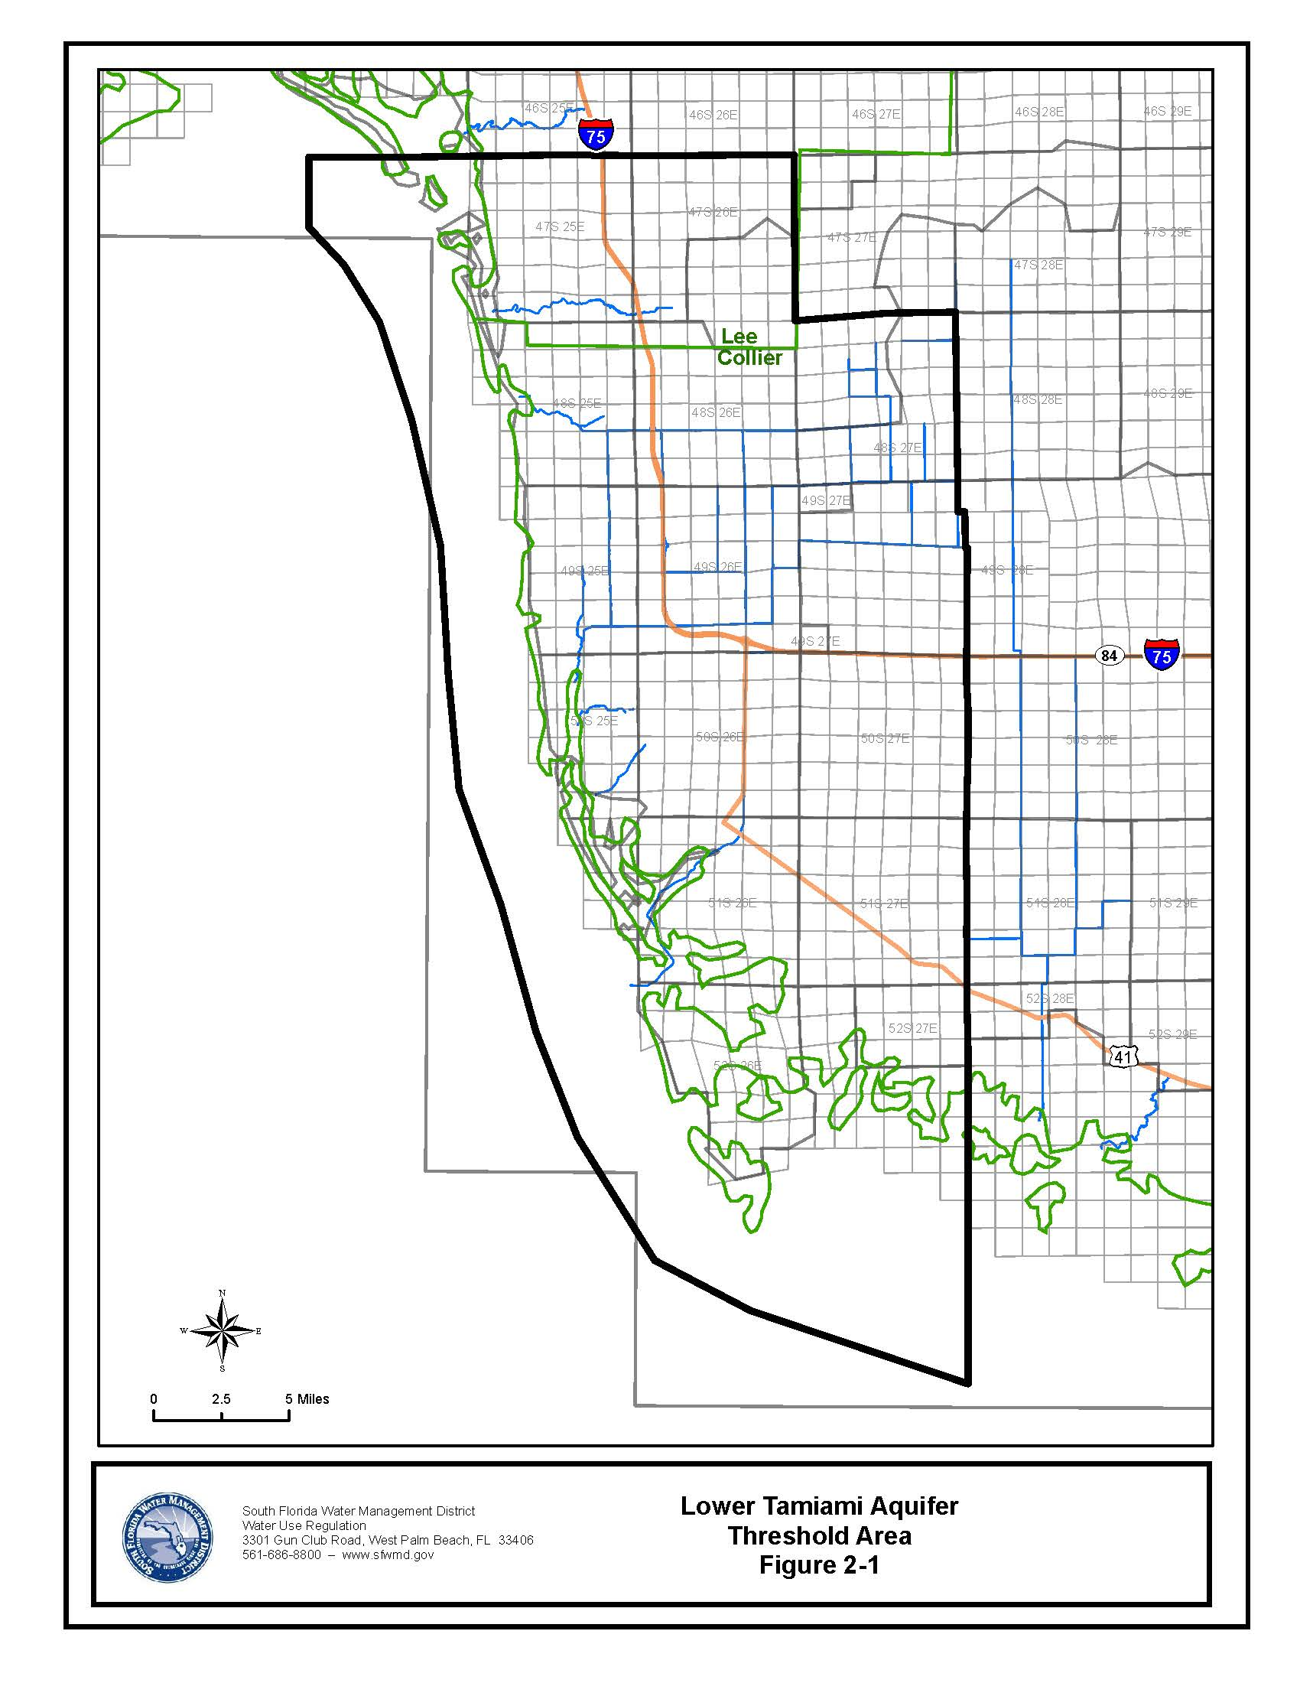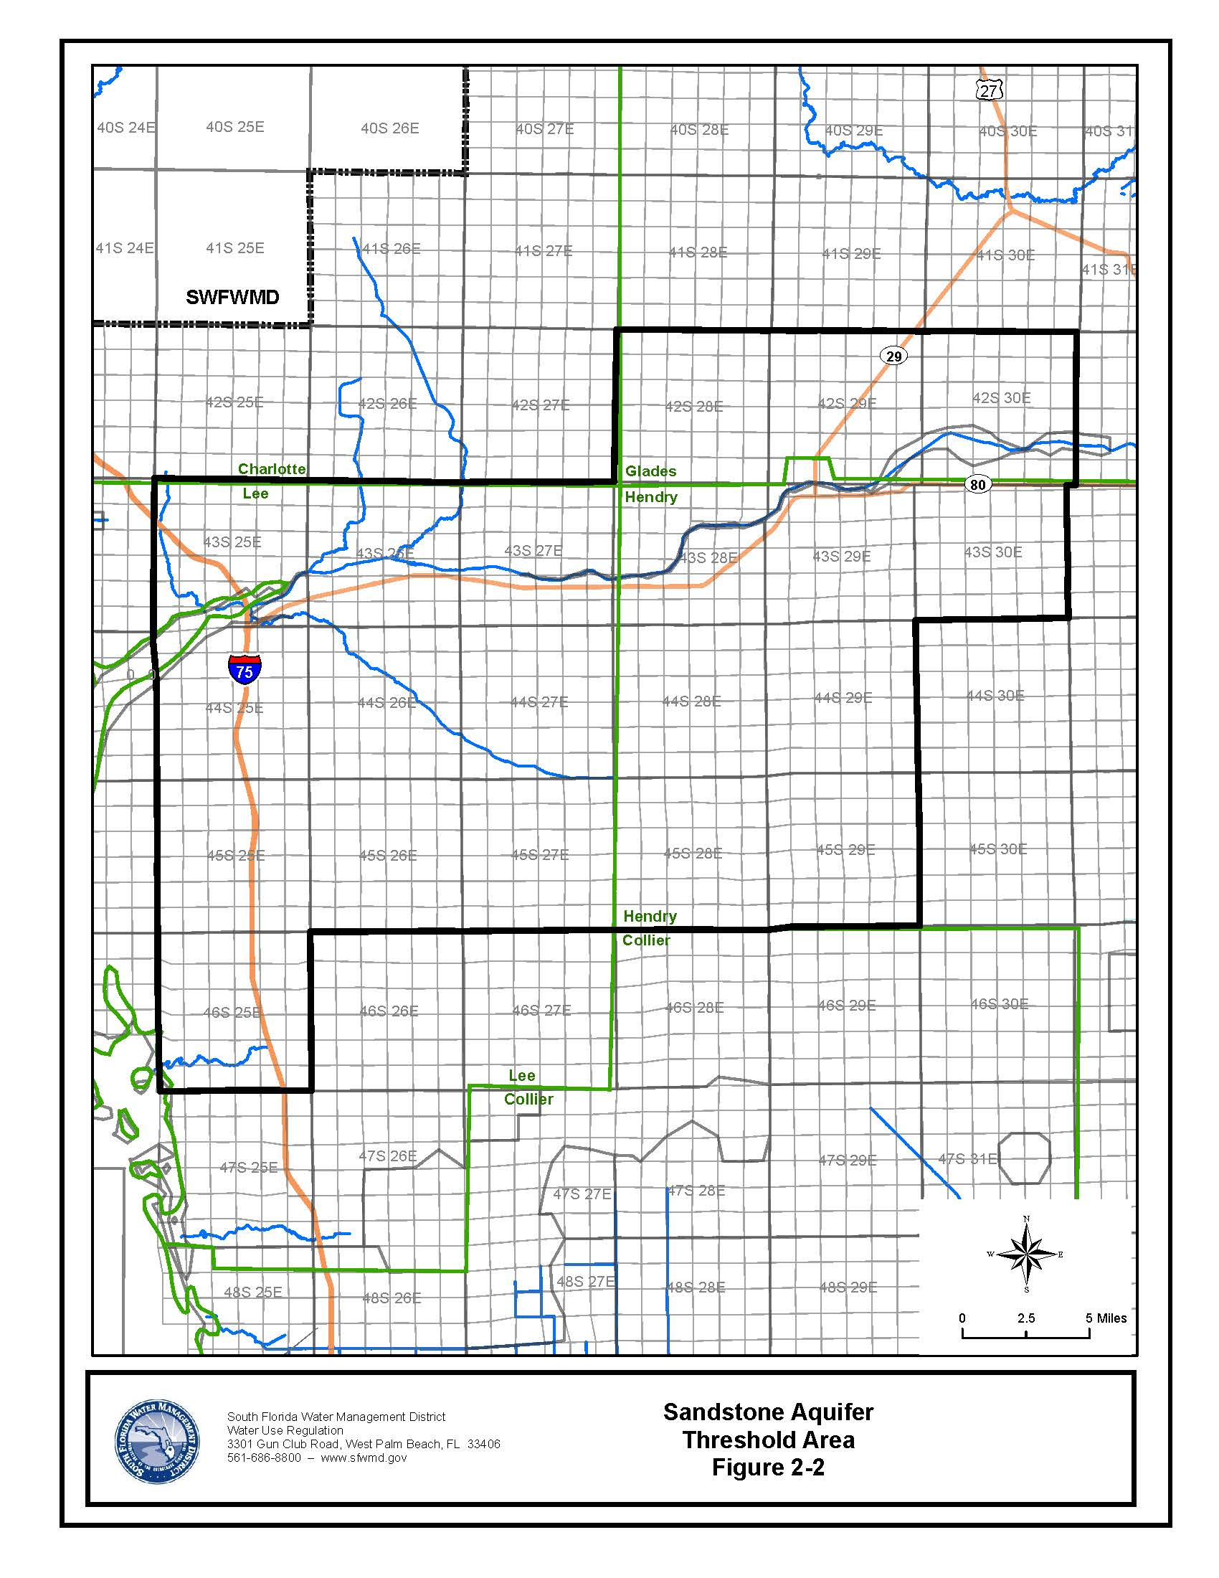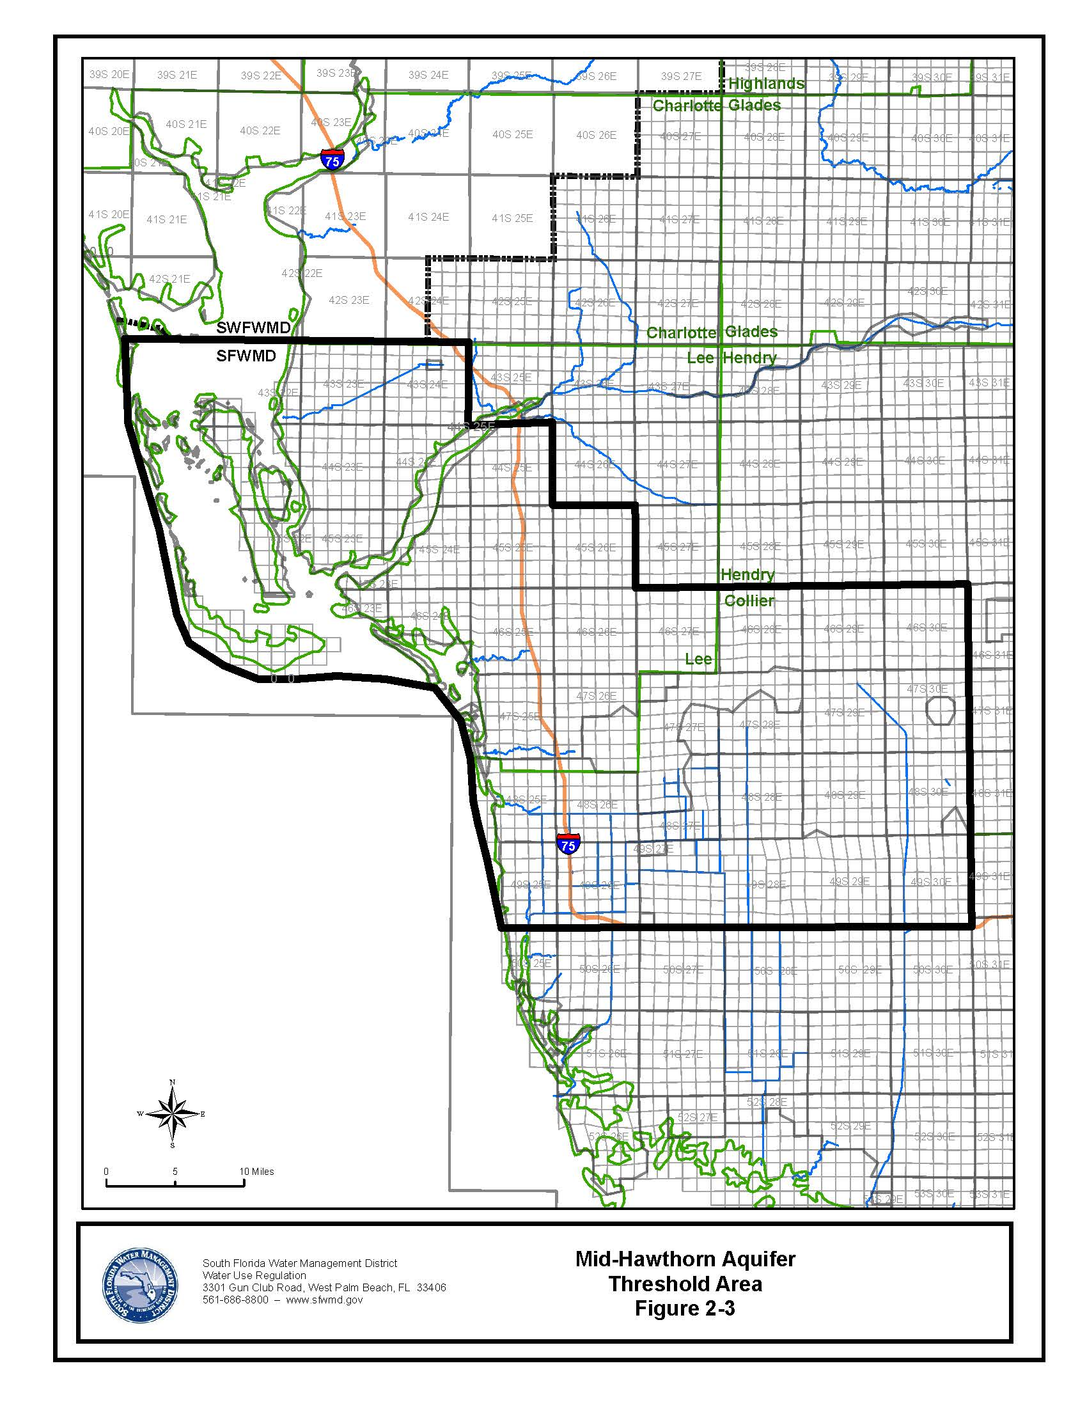

Rulemaking Authority 373.044, 373.113, 373.118, 373.171 FS. Law Implemented 373.118, 373.219, 373.223 FS. History–New _________.

40E-2.091 Publications Incorporated by Reference.
(1) The “Applicant’s Handbook Basis of Review for Water Use Permit Applications within the South Florida Water Management District – October 23, 2012,” http://www.flrules.org/Gateway/reference.asp?No=Ref-01630, is incorporated by reference herein. , and requires the use of the following forms, which are also incorporated by reference herein: Form 0188-QMQ, Quarterly Report of Withdrawals, October 2012, http://www.flrules.org/Gateway/reference.asp?No=Ref-01564, (referenced in Section 4.1);
(2) The Applicant’s Handbook requires the use of the following forms, which are hereby incorporated by reference: Form 0188-QASR, Quarterly Report of Injections and Withdrawals for Aquifer Storage and Recovery (ASR) Wells, October 2012, http://www.flrules.org/Gateway/reference.asp?No=Ref-01565, (referenced in Section 4.1);
(a) Form No. 0188-QBWDR, Quarterly Report of Bulk Water Delivered and Received, October 2012, http://www.flrules.org/Gateway/reference.asp?No=Ref-01567, referenced in Subsection 4.1; Form No. 1389, Crop (Freeze) Protection Form, hyperlink, referenced in Subsection XXXX;
(b) Form No. 1378, Water Use Pumpage Report Form, http://www.flrules.org/Gateway/reference.asp?No=Ref-01566, referenced in Subsection 4.1;
(c) Form No. 1377, Water Quality Report Form, http://www.flrules.org/Gateway/reference.asp?No=Ref-01568, referenced in Subsection 4.2;
(d) Form No. 1376, Report of Planting and Harvest of Seasonal Crops Form, http://www.flrules.org/Gateway/reference.asp?No=Ref-01569, referenced in Subsection 5.2.2; and,
(f) Form No. 1387, Flow Meter Accuracy Calibration Report Form, hyperlink, referenced in Subsection 5.2.2; and,
(g) Form No 1388, Alternative Method Calibration Report Form, referenced on Subsection 5.2.2.
(3) Subsections 62-40.416(7) and (8), F.A.C., need hyperlink, effective ______, are incorporated by reference. Form 0188-QMQF, Quarterly Report of Withdrawals from Wells and Surface Water Pumps, October 2012, http://www.flrules.org/Gateway/reference.asp?No=Ref-01566, (referenced in Section 4.1);
(4) Form 0188-QBWDR, Quarterly Report of Bulk Water Delivered and Received, October 2012, http://www.flrules.org/Gateway/reference.asp?No=Ref-01567, (referenced in Section 4.1)
(5) Form 0188-QMON, Quarterly Report of Monitoring Requirements, October 2012, http://www.flrules.org/Gateway/reference.asp?No=Ref-01568, (referenced in Section 4.2);
(6) Form 0188-QCROP, Report of Planting and Harvest of Seasonal Crops, October 2012, http://www.flrules.org/Gateway/reference.asp?No=Ref-01569, (referenced in Section 5.2.3);
(4) The “Applicant’s Handbook Basis of Review for Water Use Permit Applications within the South Florida Water Management District” and forms incorporated therein are available at no cost by contacting the South Florida Water Management District Clerk’s Office, 3301 Gun Club Road, West Palm Beach, FL 33406, 1(800)432-2045, ext. 6436 or (561) 682-6436.
Rulemaking Authority 373.044, 373.113, 373.118, 373.171 FS. Law Implemented 373.042, 373.0421, 373.109, 373.196, 373.219, 373.223, 373.224, 373.229, 373.232, 373.233, 373.236, 373.239, 373.250 FS. History–New 9-3-81, Formerly 16K-2.035(1), Amended 2-24-85, 11-21-89, 1-4-93, 4-20-94, 11-26-95, 7-11-96, 4-9-97, 12-10-97, 9-10-01, 12-19-01, 8-1-02, 6-9-03, 8-31-03, 4-23-07, 9-13-07, 2-13-08, 10-14-08, 7-2-09, 3-15-10, 3-18-10, 9-26-12, 10-23-12,_________.

NOTE: THE PROPOSED AMENDMENTS TO THE APPLICANT’S HANDBOOK ARE AVAILABLE FOR VIEWING AT www.sfwmd.gov/rules.

40E-2.101 Content of Application.
(1) Except in those circumstances detailed in subsection (5) below, aApplications for permits required by this chapter shall be filed electronically at www.sfwmd.gov/.ePermitting, or at the South Florida Water Management District Regulation Reception Desk, 3301 Gun Club Road, West Palm Beach, FL 33406, or at any of the District’s Service Centers. The addresses and phone numbers of the District’s Service Centers are online at www.sfwmd.gov, “Locations”.
(a) The application, Form No. 0645-W01, Water Use Permit Application, October 2012, http://www.flrules.org/Gateway/reference.asp?No=Ref-01570, shall include the following forms, if applicable:
(b) Form No. 0645-G60, Table A Description of Wells, October 2012, http://www.flrules.org/Gateway/reference.asp?No=Ref-01571, for permits with wells;
(c) Form No. 0645-G61-1, Table B Description of Surface Water Pumps, October 2012, http://www.flrules.org/Gateway/reference.asp?No=Ref-01572, for permits with pumps;
(d) Form No. 0645-G61-2, Table C Description of Culverts, October 2012, http://www.flrules.org/Gateway/reference.asp?No=Ref-01573, for permits with irrigation culverts;
(e) Form No. 0645-G65, Table D Crop Information, October 2012, http://www.flrules.org/Gateway/reference.asp?No=Ref-01574, for agricultural permits;
(f) Form No. 0645-G74, Table E Water Received From or Distributed to Other Entities, October 2012, http://www.flrules.org/Gateway/reference.asp?No=Ref-01575, for public water supply permits;
(g) Form No. 0645-G69, Table F Past Water Use & Table G Projected Water Use, October 2012, http://www.flrules.org/Gateway/reference.asp?No=Ref-01576, for public water supply permits;
(h) Form No. 0645-G70, Table H Projected Water Use, October 2012, http://www.flrules.org/Gateway/reference.asp?No=Ref-01577, for public water supply permits;
(i) Form No. 0645-G71, Table I Water Treatment Method and Losses, October 2012, http://www.flrules.org/Gateway/reference.asp?No=Ref-01578, for public water supply permits;
(j) Form No. 0645-G72, Table J Aquifer Storage and Recovery, October 2012, http://www.flrules.org/Gateway/reference.asp?No=Ref-01579, for public water supply permits; and
(k) Form No. 0645-G73, Table K Water Supply System Interconnections, October 2012, http://www.flrules.org/Gateway/reference.asp?No=Ref-01580, for public water supply permits.
(2) The application for all water use permits shall contain:
(a)(l) The appropriate permit application processing fee required by Rule 40E-1.607, F.A.C.;
(b)(m) The information required in Section 373.229(1), F.S.; and
(c)(n) Information sufficient to show that the use meets the criteria and conditions established in Rule 40E-2.301, F.A.C.; and
(d)(2) The application forms, as specified below, must be signed by the applicant or the authorized agent of the applicant.
(3) Application for an Individual Water Use Permit shall be made using Form No. 1379, Water Use Permit Application, Month year, hyperlink. Applicants shall also submit one or more of the following Supplemental Forms as appropriate for each type of water use proposed in the permit application:
(a) Form No. 1380, Water Use Permit Application Supplemental Form A – Agricultural Use, Month, year, hyperlink.
(b) Form No. 1381, Water Use Permit Application Supplemental Form B – Commercial/ Industrial Use, Month, year, hyperlink.
(c) Form No. 1382, Water Use Permit Application Supplemental Form C, Landscape/Recreation Use, Month, year, hyperlink.
(d) Form No. 1383, Water Use Permit Application Supplemental Form D, Dewatering Use, Month, year, hyperlink.
(e) Form No. 1384, Water Use Permit Application Supplemental Form E – Public Supply Use, Month, year, hyperlink.
(f) Form No. 1386, Water Use Permit Application Supplemental Form F – Diversion and Impoundment Use, Month, year, hyperlink.
(4) Application for a Noticed General Water Use Permit shall be made using Form No. 1391, Notice of Intent to Use a Water Use Noticed General Permit, Month year, hyperlink.
(5) The filing of an application is not required to qualify for a General Permit by Rule, provided the criteria in Rule 40E-2.061, F.A.C., are satisfied.
(6)(4) The forms identified in subsections (3)(1) and (4)(3) above are incorporated by reference herein and are available at no cost by contacting the South Florida Water Management District.
Rulemaking Authority 373.044, 373.113, 373.171 FS. Law Implemented 373.103(1), 373.219, 373.223, 373.229 FS. History–New 9-3-81, Amended 12-1-82, 2-24-85, 11-21-89, Repromulgated 1-4-93, Amended 4-20-94, 8-1-02, 10-23-12,_________.

40E-2.301 Conditions for Issuance of Permits.
(1) No change.
(a) through (g) No change.
(h) For uses with a recommended maximum allocation which exceeds 100,000 GPD or uses within a mandatory reuse zone, mMakes use of a reclaimed water source in accordance with the criteria contained in the “Applicant’s Handbook Basis of Review for Water Use Permit Applications within the South Florida Water Management District”, incorporated by reference in Rule 40E-2.091, F.A.C.
(i) Is in accordance with any the established minimum flows or and levels and implementation strategy established pursuant to Sections 373.042 and 373.0421, F.S. provisions in Chapter 373, F.S., this chapter and Chapter 40E-8, F.A.C.; and
(j) through (k) No change.
(2) In order to satisfy the conditions for permit issuance in subsection (1), the permit applicant must provide reasonable assurances that the criteria in the “Applicant’s Handbook Basis of Review for Water Use Permit Applications within the South Florida Water Management District”, incorporated by reference in Rule 40E-2.091, F.A.C., are met.
Rulemaking Authority 373.044, 373.113, 373.118 FS. Law Implemented 373.036, 373.042, 373.103(4), 373.1501, 373.1502, 373.223, 373.229, 373.2295, 373.470 FS. History–New 8-14-02, Amended 8-31-03, 4-23-07, 2-13-08, 7-2-09,_________.

40E-2.321 Duration of Permit.
General Duration Provision. When requested by an applicant, a consumptive use permit shall have a duration of 20 years provided the applicant provides sufficient data to demonstrate reasonable assurance that the proposed use meets the conditions for issuance for the requested 20 year permit duration; or otherwise, permits may be issued for a shorter duration that reflects the period for which such reasonable assurances can be provided. This determination will be made pursuant to requirements in Rule 40E-2.301, F.A.C., and the “Applicant’s Handbook Basis of Review for Water Use Permit Applications within the South Florida Water Management District”, incorporated by reference in Rule 40E-2.091, F.A.C.
Rulemaking Authority 373.044, 373.113, 373.171 FS. Law Implemented 373.236 FS. History–New 9-3-81, Amended 2-24-85, 4-20-94, 7-11-96, 8-31-03, 4-23-07, 2-13-08,_________.

40E-2.331 Modification of Permits.
(1) through (3) No change.
(4)(a) Modification of an existing water use permit shall be approved by letter, provided the permit is in compliance with all applicable limiting conditions and the modification request:
1. No change.
2. Does not modify the existing permit expiration date, except when: that
a. When Tthe permit duration is based upon the current lease expiration date, the permit duration shall be extended by letter modification to the new lease date, but shall not exceed the applicable permit duration pursuant to Rule 40E-2.321, F.A.C.; or,
b. A public water supply permittee achieves demonstrable savings attributable to implementation of its water conservation plan beyond that required by Subsection 2.3.2.F.1 of the Applicant’s Handbook; or,
c. A permittee complies with the extension provisions of Section 373.236(5), F.S.; or,
d. The permit duration is based upon a proposed “start” date for dewatering, the permit duration shall be extended by letter modification to one year from the new “start” date, but shall not exceed the applicable permit duration pursuant to Rule 40E-2.321, F.A.C.; or,
3. Does not potentially interfere with any presently existing legal use of water, cause environmental harm, saltwater intrusion, pollution of the water resources, harm to offsite land uses, does not withdraw water reserved under Chapter 40E-10, F.A.C., or does not otherwise raise issues requiring a Staff determination of whether such impacts would occur pursuant to the “Applicant’s Handook Basis of Review for Water Use Permit Applications within the South Florida Water Management District,”, incorporated by reference in Rule 40E-2.091, F.A.C.; and
4. through 6. No change.
(b) No change.
Rulemaking Authority 373.044, 373.113 FS. Law Implemented 373.079, 373.083, 373.223, 373.229, 373.239 FS. History–New 9-3-81, Formerly 16K-2.09(1), Amended 4-20-94, 7-11-96, 4-9-97, 12-10-97, 8-1-02, 4-23-07, 2-13-08, 7-2-09, 3-15-10, 10-23-12,_________.

40E-2.381 Permit Limiting Conditions.
The District shall impose on any permit granted under this chapter such reasonable standard and special permit conditions as are necessary to assure that the permitted use or withdrawal will be consistent with the overall objectives of the District, will not be harmful to the water resources of the District, is reasonable-beneficial, will not interfere with any presently existing legal uses, and is consistent with the public interest. Standard permit conditions in Section 5.1 of the “Applicant’s Handbook Basis of Review for Water Use Permit Applications within the South Florida Water Management District”, incorporated by reference in Rule 40E-2.091, F.A.C., shall be set forth in the permit. Special permit conditions, including those specified in Section 5.2 of the “Applicant’s Handbook Basis of Review for Water Use Permit Applications within the South Florida Water Management District”, incorporated by reference in Rule 40E-2.091, F.A.C., shall be set forth in the permit, as applicable.
Rulemaking Authority 373.044, 373.113, 373.171 FS. Law Implemented 373.042, 373.0421, 373.079, 373.083, 373.219(1) FS. History–New 9-3-81, Amended 2-24-85, 7-26-87, 4-20-94, 7-11-96, 4-9-97, 12-10-97, 9-10-01, 8-1-02, 4-23-07, 2-13-08, 10-23-12,_________

NAME OF PERSON ORIGINATING PROPOSED RULE: Maria C. Clemente, P.E., Water Use Bureau Chief, Regulation Division
NAME OF AGENCY HEAD WHO APPROVED THE PROPOSED RULE: South Florida Water Management District Governing Board
DATE PROPOSED RULE APPROVED BY AGENCY HEAD: November 14, 2013
DATE NOTICE OF PROPOSED RULE DEVELOPMENT PUBLISHED IN FAR: July 20, 2012 and Notice of Additional Workshops on April 30, 2013

