Notice of Proposed Rule

WATER MANAGEMENT DISTRICTS
South Florida Water Management District
RULE NOS.: RULE TITLES:
40E-10.021 Definitions
40E-10.031 Water Reservations Implementation
40E-10.041 Water Reservation Areas: Lower West Coast Planning Area
PURPOSE AND EFFECT: Section 601(h)(4)(B) of the Water Resources Development Act of 2000 requires the State of Florida to reserve or allocate water for the natural systems associated with the implementation of Comprehensive Everglades Restoration Plan (CERP) Projects. For the Caloosahatchee River West Basin Storage Reservoir (C-43 Reservoir) CERP Project, the District has elected to use its water reservation authority described in subsection 373.223(4), F.S.
SUMMARY: This rulemaking is prospective in nature in that the proposed amendments involve a future reservation of water when the C-43 Reservoir becomes operational. The proposed amendments include language relative to the water reservation. NOTE: The Basis of Review is proposed to be renamed and reorganized as the “Applicant’s Handbook for Water Use Permit Applications within the South Florida Water Management District” through the statewide water use permitting rulemaking referred to as “CUPCon.” The CUPcon amendments will become effective prior to the public hearing scheduled for this rule. Therefore, the Applicant’s Handbook is referenced herein rather than the Basis of Review.
SUMMARY OF STATEMENT OF ESTIMATED REGULATORY COSTS AND LEGISLATIVE RATIFICATION:
The Agency has determined that this will not have an adverse impact on small business or likely increase directly or indirectly regulatory costs in excess of $200,000 in the aggregate within one year after the implementation of the rule. A SERC has been prepared by the Agency.
The proposed rules do not impose new consumptive use permitting criteria, require new or additional permit analysis, or restrict the allocation of surface water.
The Agency has determined that the proposed rule is not expected to require legislative ratification based on the statement of estimated regulatory costs or if no SERC is required, the information expressly relied upon and described herein: As stated in the SERC, “it is uncertain when the construction of the C-43 Reservoir will be completed and operational. Therefore, it is premature to attempt to quantify all of the prospective impacts since not all of the possible specific impacts from implementation of the water reservation will be triggered or visible until the project becomes operational. Once the C-43 Reservoir becomes operational, the technical analysis and reservation rule will be revised and an additional SERC will be prepared.”
Any person who wishes to provide information regarding a statement of estimated regulatory costs, or provide a proposal for a lower cost regulatory alternative must do so in writing within 21 days of this notice.
RULEMAKING AUTHORITY: 373.044373.044, 373.113, 373.171 FS.
LAW IMPLEMENTED: 373.016373.016, 373.026, 373.036, 373.1501, 373.1502, 373.219, 373.223, 373.4592, 373.4595, 373.470 FS.
A HEARING WILL BE HELD AT THE DATE, TIME AND PLACE SHOWN BELOW:
DATE AND TIME: April 10, 2014, 9:00 a.m.
PLACE: South Florida Water Management District, B-1 Auditorium, 3301 Gun Club Road, West Palm Beach, FL 33406
Pursuant to the provisions of the Americans with Disabilities Act, any person requiring special accommodations to participate in this workshop/meeting is asked to advise the agency at least 5 days before the workshop/meeting by contacting: South Florida Water Management District Clerk’s Office, 1(800)432-2045, ext. 2087 or (561)682-2087. If you are hearing or speech impaired, please contact the agency using the Florida Relay Service, 1(800)955-8771 (TDD) or 1(800)955-8770 (Voice).
THE PERSON TO BE CONTACTED REGARDING THE PROPOSED RULE IS: Don Medellin, Principal Scientist, South Florida Water Management District, P. O. Box 24680, West Palm Beach, FL 33416-4680, 1(800)432-2045, ext. 6340 or (561)682-6340 or Jennifer Bokankowitz, Attorney, South Florida Water Management District, P. O. Box 24680, West Palm Beach, FL 33416-4680, 1(800)432-2045, ext. 2258 or (561)682-2258. For procedural issues, contact Jan Sluth, Senior Paralegal, South Florida Water Management District, P. O. Box 24680, West Palm Beach, FL 33416-4680, 1(800)432-2045, ext. 6299 or (561)682-6299

THE FULL TEXT OF THE PROPOSED RULE IS:

40E-10.021 Definitions.
(1) through (4) No change.
(5) Caloosahatchee River – The surface waters that flow through the S-79 structure, combined with tributary contributions below S-79 that collectively flow southwest to San Carlos Bay, as defined in subsection 40E-8.021(2), F.A.C.
(6) Caloosahatchee River (C-43) West Basin Storage Reservoir – A reservoir located in Hendry County, Florida, west of the City of LaBelle on the east side of the Townsend Canal and south of SR 80 as described in Appendix 1-12, and depicted in Figure 1-13 (also known as the ‘C-43 Reservoir’).
Rulemaking Authority 373.044, 373.113, 373.171 FS. Law Implemented 373.016, 373.026, 373.036, 373.1501, 373.1502, 373.219, 373.223, 373.4592, 373.4595, 373.470 FS. History–New 7-2-09, Amended 3-18-10, 7-21-13,________.

40E-10.031 Water Reservations Implementation.
(1) through (4) No change.
(5) Water reserved for the protection of fish and wildlife contained within and released, via operation, from the Caloosahatchee River (C-43) West Basin Storage Reservoir is defined in subsection 40E-10.041(3), F.A.C.
Rulemaking Authority 373.044, 373.113, 373.171 FS. Law Implemented 373.016, 373.026, 373.036, 373.1501, 373.1502, 373.219, 373.223, 373.4592, 373.4595, 373.470 FS. History–New 7-2-09, Amended 3-18-10, 7-21-13, ________.

40E-10.041 Water Reservation Areas: Lower West Coast Planning Area.
(1) through (2) No change.
(3) Caloosahatchee River (C-43) West Basin Storage Reservoir:
(a) All surface water contained within and released, via operation, from the Caloosahatchee River (C-43) West Basin Storage Reservoir is reserved from allocation.
(b) The water reserved under this paragraph will be available for fish and wildlife upon a formal determination of the Governing Board, pursuant to state and federal law, that the Caloosahatchee River (C-43) West Basin Storage Reservoir is operational.
(c) The reservation contained in this subsection and the criteria contained in Section 3.11.4 of the “Applicant’s Handbook for Water Use Permit Applications within the South Florida Water Management District,” incorporated by reference in Rule 40E-2.091, F.A.C., shall be revised pursuant to subsection 373.223(4), F.S., in light of changed conditions or new information and prior to the approval described in paragraph (3)(b) above.
(d) Pursuant to subsection 373.223(4), F.S., presently existing legal uses for the duration of a permit existing on RULE ADOPTION DATE are not contrary to the public interest.
Rulemaking Authority 373.044, 373.113, 373.171 FS. Law Implemented 373.016, 373.026, 373.036, 373.1501, 373.1502, 373.219, 373.223, 373.4592, 373.4595, 373.470 FS. History–New 7-2-09, Amended 3-18-10, 7-21-13,_________.

APPENDIX 1 LOWER WEST COAST PLANNING AREA: Figures 1-1 through 1-11 – NO CHANGE

1-12 LEGAL DESCRIPTION OF CALOOSAHATCHEE RIVER C-43 WEST
BASIN STORAGE RESERVOIR
Caloosahatchee River
C-43 West Basin Storage Reservoir
A parcel of land lying in Sections 31, 32, 33, 34, 35, and 36, Township 43 South, Range 28 East, Section 31, Township 43 South, Range 29 East, Section 6, Township 44 South, Range 29 East, and Sections 1, 2, 3, 4, 5, 6, 7, 8, 9, 10, 11, and 12, Township 44 South Range 28 East, Hendry County Florida, being more particularly described as follows:
Beginning at the Northwest corner of the East 1/2 of said Section 31, Township 43 South, Range 28 East; Thence, S89°51'14"E, along the North line of said East 1/2 , a distance of 2,635.83 feet to the Northwest corner of said Section 32;
Thence, N89°26'04"E, along the North line of the Northwest 1/4 of Section 32, a distance of 2,650.29 feet to the North quarter corner of section 32;
Thence, N89°27'01"E, along the North line of the Northeast 1/4 of Section 32 , a distance of 2,651.17 feet to the Northwest corner of said section 33;
Thence, N89°39'17"E, along the North line of the Northwest 1/4 of Section 33, a distance of 2,644.00 feet to the North 1/4 corner of Section 33;
Thence, N89°40'58"E, along the North line of the Northeast 1/4 of Section 33, a distance of 2,644.65 feet to the Northwest corner of said Section 34;
Thence, N89°24'50"E, along the North line of the Northwest 1/4 of Section 34, a distance of 2,644.35 feet to the North 1/4 corner of Section 34;
Thence, N89°25'57"E, along the North line of the Northeast 1/4 of Section 34, a distance of 2,644.21 feet to the Northwest corner of said Section 35;
Thence, N89°13'34"E, along the North line of the Northwest 1/4 of Section 35, a distance of 2,652.53 feet to the North 1/4 corner of Section 35;
Thence, N89°25'25"E, along the North line of Northeast 1/4 of Section 35, a distance of 2,650.20 feet to the Northwest corner of said Section 36;
Thence, N89°39'37"E, along the North line of the Northwest 1/4 of Section 36, a distance of 2,642.30 feet to the North 1/4 corner of Section 36;
Thence, N89°39'50"E, along the North line of the Northeast 1/4 of Section 36, a distance of 1,436.88 feet to an East corner of the Berry land as described in Official Record Book 605, page 1149, public records of Hendry County;
Thence , continue N 89°39'50"E, along said North line 1205.97 feet to the Northwest corner of said Section 31, Township 43 South, Range 29 East;
Thence, N89°39'59"E, along the North line of said Section 31, Township 43 South, Range 29 East for 1878.01 feet to an intersection with a line parallel with and 1,877.97 feet Easterly of, as measured perpendicular to the West line of said Section 31, Township 43 South, Range 29 East;
Thence, S00°09'39"E, along said parallel line for 5298.32 feet to an intersection with a line parallel with and 1877.97 feet Easterly of, as measured perpendicular to the West line of said Section 6, Township 44 South, Range 29 East;
Thence, S00°13'51"E, along said parallel line for 5241.63 feet to an intersection with the South line of the Southwest quarter of said Section 6, Township 44 South, Range 29 East;
Thence, N89°53'18”W, along said South line for 1878.00 feet to the Southwest corner of said Section 6 also being the Northeast corner of said Section 12, Township 44 South, Range 28 East;
Thence, S00°33'18"E, along the East line of Section 12, a distance of 5,310.64 feet to the Southeast corner of Section 12;
Thence, S89°30'12”W, along the South line of the Southeast 1/4 of Section 12, a distance of 2,634.72 feet to the South 1/4 corner;
Thence, S89°09'14”W, along the South line of the Southwest 1/4, a distance of 2,632.48 feet to the Southeast corner of said Section 11;
Thence, S87°42'48”W, along the South line of the Southeast 1/4 of Section 11, a distance of 2,640.48 feet to the South 1/4 corner of section 11;
Thence, S87°51'34”W, along the South line of the Southwest 1/4 of Section 11, a distance of 2,641.90 feet to the Southeast corner of said Section 10;
Thence, N89°40'57”W, along the South line of the Southeast 1/4 of Section 10 , a distance of 2,643.20 feet to the South 1/4 corner of Section 10;
Thence, N89°41'44”W, along the South line of the Southwest 1/4 of Section 10, a distance of 2,643.59 feet to the Southeast corner of said Section 9;
Thence, N89°47'36”W, along the South line of the Southeast 1/4 of Section 9, a distance of 2,654.46 feet to the South 1/4 corner of Section 9;
Thence, N89°47'39”W, along the South line of the Southwest 1/4 of Section 9, a distance of 2,201.47 feet to a point of curvature with the arc of a circular curve to the right having a radius of 459.30 feet and a central angle of 89°13'48"; thence Northwesterly along the arc of said curve, for 715.29 feet to a point of tangency on the West line of Section 9;
Thence, N00°34'21”W, along the West line of Section 9, a distance of 2,230.83 feet to an intersection with a line being 50 feet Northerly of, as measured at right angles and parallel with the South line of the North 1/2 of said Section 8;
Thence, N89°52'19”W, along said parallel line, a distance of 5,287.36 feet;
Thence, N44°21'33”W, a distance of 2,971.24 feet;
Thence, N32°48'36”W, a distance of 535.22 feet to an intersection with a line being 300 feet Easterly of, as measured at right angles and parallel to the West line of the East 1/2 of Section 6, Township 44 South, Range 28 East;
Thence, S89°40'57”W, along the South line of section 6, Township 44 South, Range 28 East, a distance of 300.00 feet to the West line of the East 1/2 ;
Thence, N00°21'09”W, along said West line, a distance of 5,287.40 feet to the South 1/4 corner of said Section 31;
Thence, N00°21'57”W, along the West line of the East 1/2 of Section 31, a distance of 5,275.89 feet to the Point of Beginning.

Figure 1-13. Caloosahatchee River (C-43) West Basin Storage Reservoir Project Location
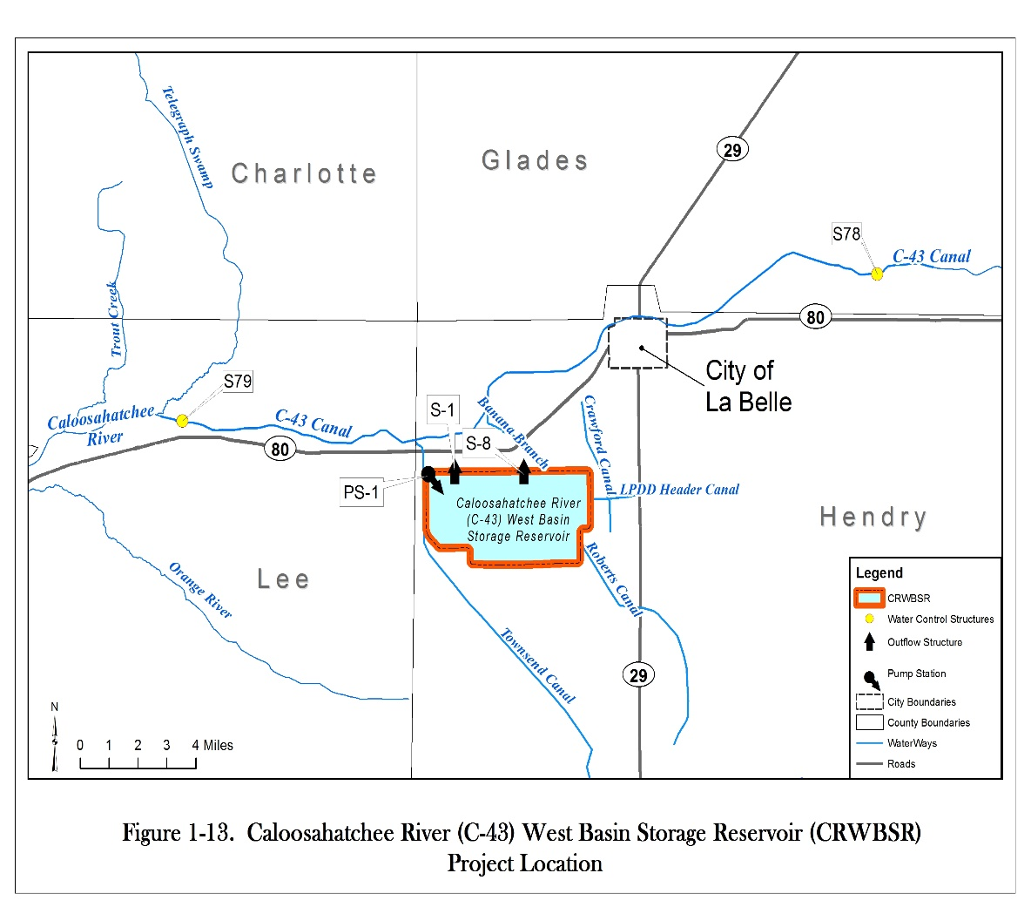

APPENDIX 2 NO CHANGE
APPENDIX 3 NO CHANGE

NAME OF PERSON ORIGINATING PROPOSED RULE: Don Medellin, Principal Scientist
NAME OF AGENCY HEAD WHO APPROVED THE PROPOSED RULE: South Florida Water Management District Governing Board
DATE PROPOSED RULE APPROVED BY AGENCY HEAD: February 13, 2014
DATE NOTICE OF PROPOSED RULE DEVELOPMENT PUBLISHED IN FAR: February 10, 2012, with Notice of Workshop for additional rule development workshop published on December 30, 2013

