Notice of Proposed Rule

FISH AND WILDLIFE CONSERVATION COMMISSION
Vessel Registration and Boating Safety
RULE NO.: RULE TITLE:
68D-24.018 St. Johns River Boating Restricted Areas
PURPOSE AND EFFECT: The purpose and effect of this rule amendment is to address needed changes to the boating restricted areas created by this rule. Additionally, the purpose is to address rule changes governing vessel speeds on the St. Johns River in Lake, Seminole and Volusia counties, where necessary, to manage this waterway and promote its use for safe boating. Staff has identified several needed changes, to include, but not limited to: repealing regulations in the tributaries of South Moon and Jungle Den Canals; making minor changes to the footprints of the State Road 40 (Astor) Bridge, State Road 44 (Whitehair) Bridge and Lake Monroe boating restricted areas; clarifying and modifying the geographic descriptions for seven zone boundaries; updating the rule maps, and removing the authority for Lake, Seminole and Volusia counties to mark the state-adopted year-round boating restricted areas.
SUMMARY: The rule amendment modifies seven zones in the Florida Intracoastal Waterway on the St. Johns River in a manner which maintains the existing footprint of each zone as currently marked. The amendment modifies the locations used to describe zone boundaries, increases the regulated vessel speed in the year-round zones from “Idle Speed No Wake” to “Slow Speed Minimum Wake,” repeals duplicative regulations in two tributaries, updates rule maps, removes the authority for Lake, Seminole and Volusia counties to mark the state-adopted year-round boating restricted areas and includes language to exclude water bodies such as canals and boat basins.
SUMMARY OF STATEMENT OF ESTIMATED REGULATORY COSTS AND LEGISLATIVE RATIFICATION:
The Agency has determined that this will not have an adverse impact on small business or likely increase directly or indirectly regulatory costs in excess of $200,000 in the aggregate within one year after the implementation of the rule. A SERC has not been prepared by the agency.
The Agency has determined that the proposed rule is not expected to require legislative ratification based on the statement of estimated regulatory costs or if no SERC is required, the information expressly relied upon and described herein: The proposed rule will match zone boundaries established in the rule to historical boundaries established by regulatory markers. The proposed rule will allow marginally faster vessel speeds through regulatory zones.
Any person who wishes to provide information regarding a statement of estimated regulatory costs, or provide a proposal for a lower cost regulatory alternative must do so in writing within 21 days of this notice.
RULEMAKING AUTHORITY: 327.04, 327.46 FS.
LAW IMPLEMENTED: 327.33(3), 327.46 FS.
IF REQUESTED WITHIN 21 DAYS OF THE DATE OF THIS NOTICE, A HEARING WILL BE SCHEDULED AND ANNOUNCED IN THE FAR.
THE PERSON TO BE CONTACTED REGARDING THE PROPOSED RULE IS: Major Richard Moore, Florida Fish and Wildlife Conservation Commission, Division of Law Enforcement, Boating and Waterways Section, 620 South Meridian Street, Tallahassee, Florida 32399-1600

THE FULL TEXT OF THE PROPOSED RULE IS:

68D-24.018 St. Johns River Boating Restricted Areas.
(1) For the purpose of regulating the speed and operation of vessel traffic on the St. Johns River in Lake, Seminole and Volusia Counties, Florida the following bBoating rRestricted aAreas are established. Coordinates used in the description of zone boundaries are referenced to the North American Datum of 1983 (NAD83). The boating restricted areas exclude all associated tributaries, creeks, canals, backwaters, channels, boat basins and other waterways unless otherwise designated or specifically described for inclusion:
(a) Year-Round Boating Restricted Areas –
1. Lake George Fender System: An Idle Slow Speed Minimum No Wake zone boating restricted area within the fender system and associated channel at the south end of Lake George, bounded on the north by from a line drawn perpendicular to the centerline of the channel at the north end of the fender system and bounded on the southeast by to a line drawn perpendicular to the centerline of the channel 1,500 feet south and southeast of the south end of the fender system, as depicted in Drawing A.
2. South Moon Canal:
a. An Idle Slow Speed Minimum No Wake zone boating restricted area from shoreline to shoreline in the St. Johns River, bounded on the northwest by and all waters of South Moon Canal, from a line drawn perpendicular to the centerline of the St. Johns River 50 feet north of the confluence of South Moon Canal and the St. Johns River and bounded on the south by to a line drawn perpendicular to the centerline of the St. Johns Rriver 850 feet south of said confluence, as depicted in Drawing B.
b. During flooding, an Idle Speed No Wake boating restricted area from shoreline to shoreline in the St. Johns River, from a line drawn perpendicular to the centerline of the St. Johns River 850 feet south of the confluence of South Moon Canal and the St. Johns River approximately 3,000 feet south to a line drawn perpendicular to the centerline of the St. Johns River 50 feet northwest of the confluence of the Jungle Den Canal, as depicted in Drawing B, to be in effect and enforceable when the St. Johns River level is 2.8 feet or higher as indicated by the St. Johns River Water Management District gauge at the S. R. 40 Bridge in Astor.
3. Jungle Den Canal:
a. An Idle Slow Speed Minimum No Wake zone boating restricted area from shoreline to shoreline in the St. Johns River, bounded on and all waters of the northwest by Jungle Den Canal, from a line drawn perpendicular to the centerline of the St. Johns River 50 feet northwest of the confluence of Jungle Den Canal and the St. Johns River and bounded on the south by to a line drawn perpendicular to the centerline of the St. Johns River 1,250 river 1,050 feet south of said confluence, as depicted in Drawing C.
b. During flooding an Idle Speed No Wake boating restricted area from shoreline to shoreline in the St. Johns River, from a line drawn perpendicular to the centerline of the river 1,050 feet south of the confluence of the Jungle Den Canal approximately 3,000 feet south to a line drawn perpendicular to the centerline of the St. Johns River 600 feet north of the centerline of the Astor Bridge (S. R. 40), as depicted in Drawing C, to be in effect and enforceable when the St. Johns River level is 2.8 feet or higher as indicated by the St. Johns River Water Management District gauge at the S. R. 40 Bridge in Astor.
4. SR 40 (Astor) Bridge: An Idle Slow Speed Minimum No Wake zone boating restricted area from shoreline to shoreline in the St. Johns River, bounded on the north by from a line drawn perpendicular to the centerline of the St. Johns River 875 600 feet north of the north end of the fender centerline of the SR 40 (Astor) Bridge (S. R. 40) and bounded on the south by to a line drawn perpendicular to the centerline of the St. Johns River 2,125 river 2,200 feet south of the south end of the fender centerline of said bridge, as depicted in Drawing D.
5. SR 44 (Whitehair) Bridge (Crows Bluff): An Idle Slow Speed Minimum No Wake zone boating restricted area from shoreline to shoreline in the St. Johns River, bounded on the north by from a line drawn perpendicular to the centerline of the St. Johns River 2,375 2,275 feet northwest of the northwest end of the fender centerline of the SR 44 (Whitehair) Bridge and bounded on the south by (S. R. 44) to a line drawn perpendicular to the centerline of the St. Johns River 1,025 river 1,150 feet south of the south end of the fender centerline of said bridge, as depicted in Drawing E.
6. Hontoon Island State Park: An Idle Slow Speed Minimum No Wake zone boating restricted area from shoreline to shoreline in the St. Johns River, bounded on the north by from a line drawn perpendicular to the centerline of the St. Johns River 4,025 3,600 feet northeast of the confluence of the Hontoon Dead River and the St. Johns River and bounded on the southeast by to a line drawn perpendicular to the centerline of the St. Johns River 1,950 feet southeast of said the confluence of the St. Johns River and the Hontoon Dead River, as depicted in Drawing F.
7. Highbanks Boat Ramp:
a. An Idle Slow Speed Minimum No Wake zone boating restricted area from shoreline to shoreline in the St. Johns River, bounded on the north by from a line drawn perpendicular to the centerline of the St. Johns River 450 river 400 feet north of the centerline of Highbanks Boat Ramp and bounded on the south by a line drawn perpendicular boat ramp at the foot of West Highbanks Road to a line drawn perpendicular and bounded on the south by a line drawn perpendicular to the centerline of the St. Johns River 350 river 300 feet south of the centerline of said boat ramp, as depicted in Drawing G.
b. During flooding, an Idle Speed No Wake boating restricted area from shoreline to shoreline in the St. Johns River, from a line drawn perpendicular to the centerline of the river 400 feet north of the boat ramp at the foot of the West Highbanks Road to a line drawn perpendicular to the centerline of the river 1,650 feet north of said boat ramp at marker #91 and from a line drawn perpendicular with the centerline of the river 300 feet south of said boat ramp to a line drawn perpendicular to the centerline of the river 1,800 feet south of said boat ramp as depicted in Drawing G, to be in effect and enforceable when the St. Johns River level is 5.6 feet or higher as indicated by the St. Johns River Water Management District gauge at the Sanford Station.
8. Lake Monroe: An Idle Slow Speed Minimum No Wake zone boating restricted area from shoreline to shoreline in the St. Johns River, bounded on the from a line drawn perpendicular to the centerline of the St. Johns River 3,000 feet west by of the centerline of the I-4 Bridge to a line drawn perpendicular parallel to the centerline of the St. Johns River 1,075 feet west of I-4 Bridge at the west east end of the of the CSX Railroad Bridge fender and bounded on the southeast by a line drawn perpendicular to the centerline of the St. Johns River 125 feet east of the east end system of the I-4 said Bbridge fender, to include the Lake Monroe Park Basin, as depicted in Drawing H.
9. Mullet Lake Park: During flooding, an Idle Speed No Wake boating restricted area from shoreline to shoreline in the St. Johns River, from a line drawn perpendicular to the centerline of the river at Mullet Lake Park boat ramp to a line drawn perpendicular to the centerline of the St. Johns River 3,000 feet west of Mullet Lake Park, as depicted in Drawing I, to be in effect and enforceable when the St. Johns River level is 6.3 feet or higher as indicated by the St. Johns River Water Management District gauge at the Jessup Station.
9.10. Lemon Bluff:
a. An Idle Slow Speed Minimum No Wake zone boating restricted area from shoreline to shoreline in the St. Johns River, bounded on the northeast by from a line drawn perpendicular to the centerline of the St. Johns River at the northeast tip of the unnamed island (located at approximate latitude 28º 48.394’ North, approximate longitude 81º 7.799’ West) southeast of Lemon Bluff Boat Ramp, and bounded on the south by 800 feet northeast of the southern terminus of Lemon Bluff Road to a line drawn perpendicular to the centerline of the St. Johns River 250 feet northwest of the southern tip of said unnamed island (located at approximate latitude 28º 48.282’ North, approximate longitude 81º 7.806’ West) at the southern terminus of Lemon Bluff Road, as depicted in Drawing IJ.
b. During flooding, an Idle Speed No Wake boating restricted area from shoreline to shoreline in the St. Johns River, from a line drawn perpendicular to the centerline of the river even with the southern terminus of the Lemon Bluff Road to a line drawn perpendicular to the centerline of the St. Johns River 3,800 feet southwest of the beginning line, as depicted in Drawing J, to be in effect and enforceable when the St. Johns River level is 6.3 feet or higher as indicated by the St. Johns River Water Management District gauge at the Jessup Station.
(b) Flood Zones –
1. Astor: During flooding, an Idle Speed No Wake zone from shoreline to shoreline in the St. Johns River, bounded on the northwest by a line drawn perpendicular to the centerline of the St. Johns River 50 feet north of the confluence of South Moon Canal and the St. Johns River and bounded on the south by a line drawn perpendicular to the centerline of the St. Johns River 2,125 feet south of the south end of the fender of the SR 40 (Astor) Bridge, as depicted in Drawing J, when the St. Johns River water level is 2.8 feet or higher as indicated by the St. Johns River Water Management District gauge at the SR 40 (Astor) Bridge.
2. Highbanks Boat Ramp: During flooding, an Idle Speed No Wake zone from shoreline to shoreline in the St. Johns River, bounded on the north by a line drawn perpendicular to the centerline of the St. Johns River 1,700 feet north of the centerline of Highbanks Road Boat Ramp and bounded on the southwest by a line perpendicular to the centerline of the St. Johns River 1,800 feet south of the centerline of the Highbanks Boat Ramp, as depicted in Drawing K, when the St. Johns River water level is 5.6 feet or higher as indicated by the St. Johns River Water Management District gauge at the Sanford Station.
3. Mullet Lake Park: During flooding, an Idle Speed No Wake zone from shoreline to shoreline in the St. Johns River, bounded on the east by a line drawn perpendicular to the centerline of the St. Johns River at Mullet Lake Park Boat Ramp and bounded on the west by a line drawn perpendicular to the centerline of the St. Johns River 3,000 feet west of Mullet Lake Park Boat Ramp, as depicted in Drawing L, when the St. Johns River water level is 6.3 feet or higher as indicated by the St. Johns River Water Management District gauge at the Jessup Station.
4. Lemon Bluff: During flooding, an Idle Speed No Wake zone from shoreline to shoreline in the St. Johns River, bounded on the northeast by a line drawn perpendicular to the centerline of the St. Johns River at the northeast tip of the unnamed (located at approximate latitude 28º 48.394’ North, approximate longitude 81º 7.799’ West) southeast of Lemon Bluff Boat Ramp and bounded on the southwest by a line drawn perpendicular to the centerline of the St. Johns River 3,675 feet southwest of the southern tip of said unnamed island (located at approximate latitude 28º 48.282’ North, approximate longitude 81º 7.806’ West), as depicted in Drawing M, when the St. Johns River water level is 6.3 feet or higher as indicated by the St. Johns River Water Management District gauge at the Jessup Station.
(c)(b) Lake, Seminole and Volusia cCounties are authorized to install and maintain appropriate regulatory markers demarcating the flood zones as directed by the Division of Law Enforcement within the boating restricted areas, or portions thereof, located within the respective counties. These counties may enter into agreements with public or private organizations or individuals to effect this purpose. Lake, Seminole and Volusia cCounties are authorized to make public service announcements to notify the public of the changes in speed zones before, during and after flooding.
(2) The boating restricted areas described in Rule 68D-24.018, F.A.C., are depicted on the following drawings:

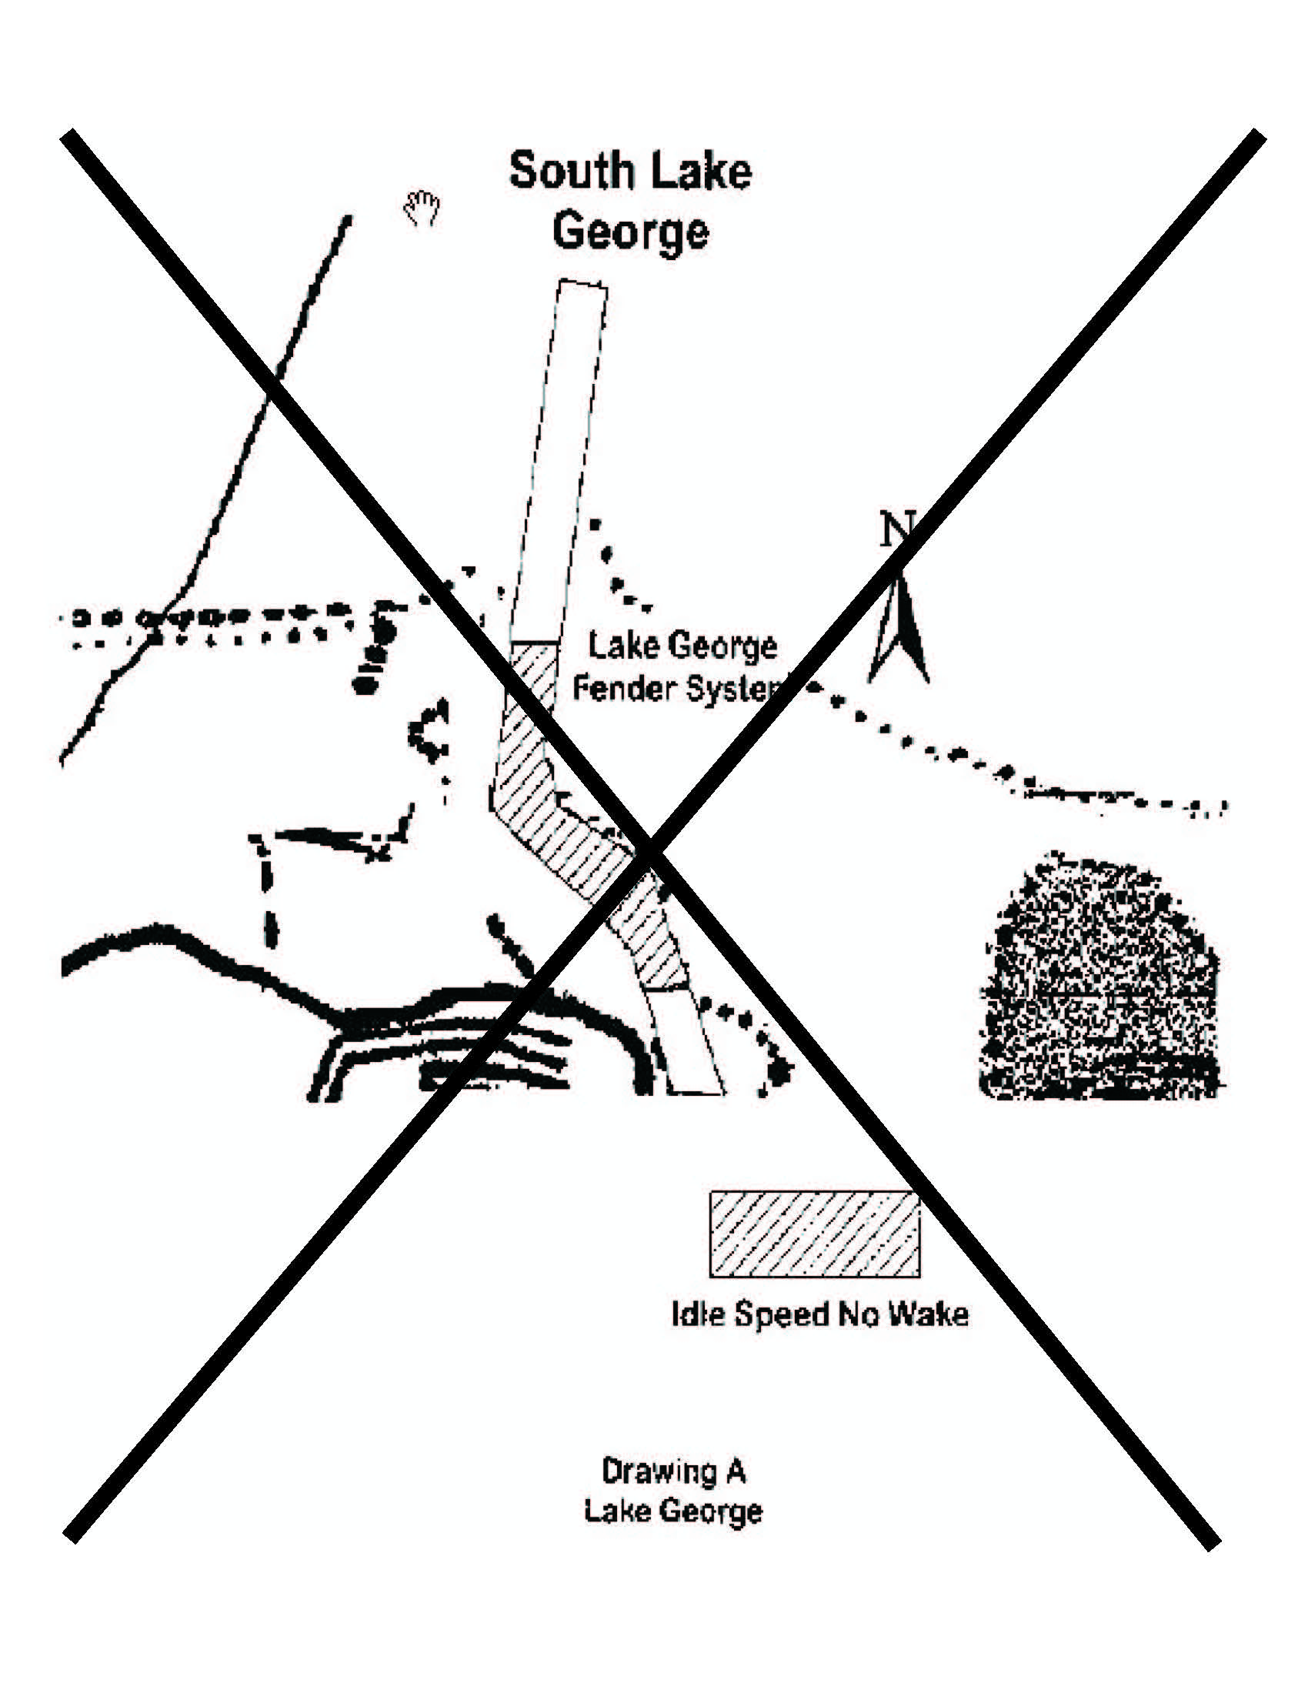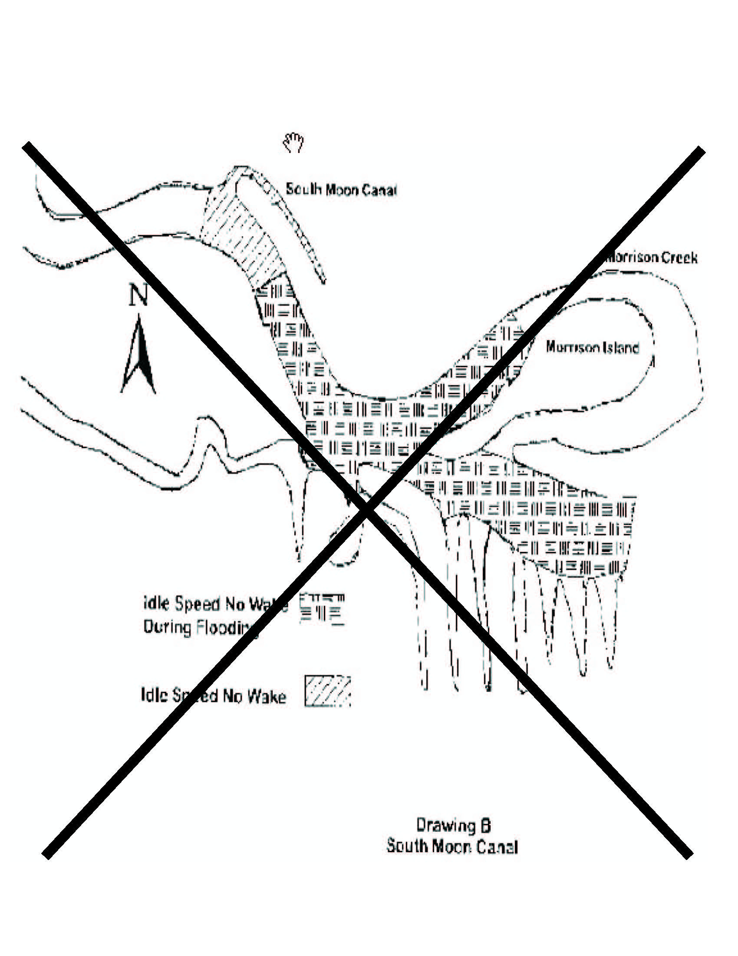
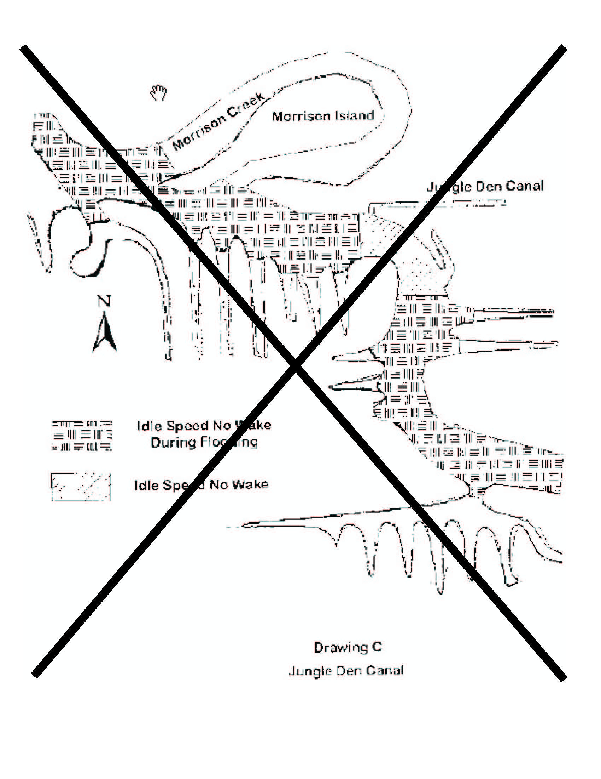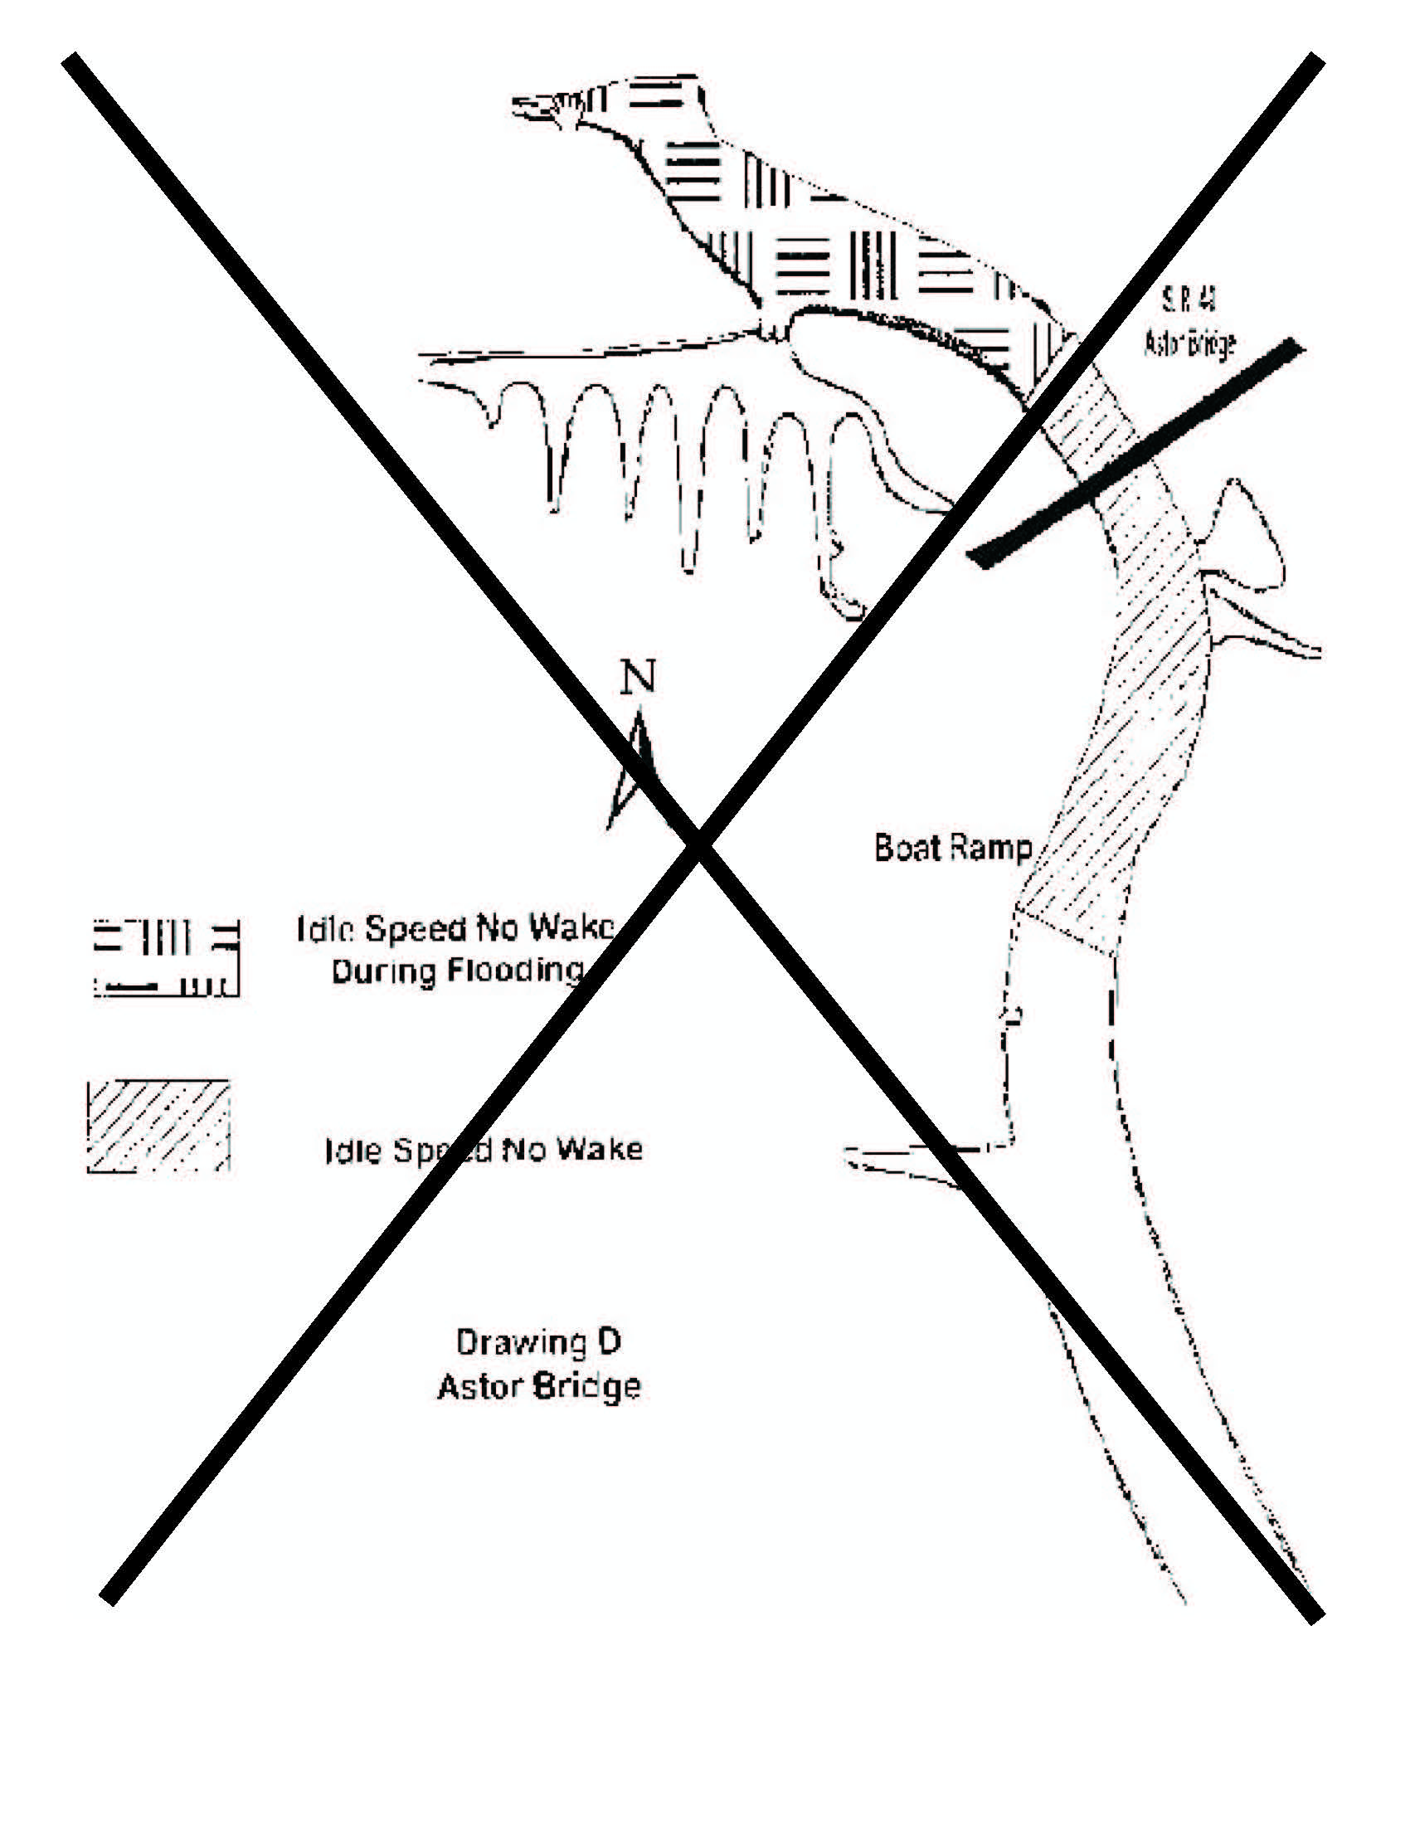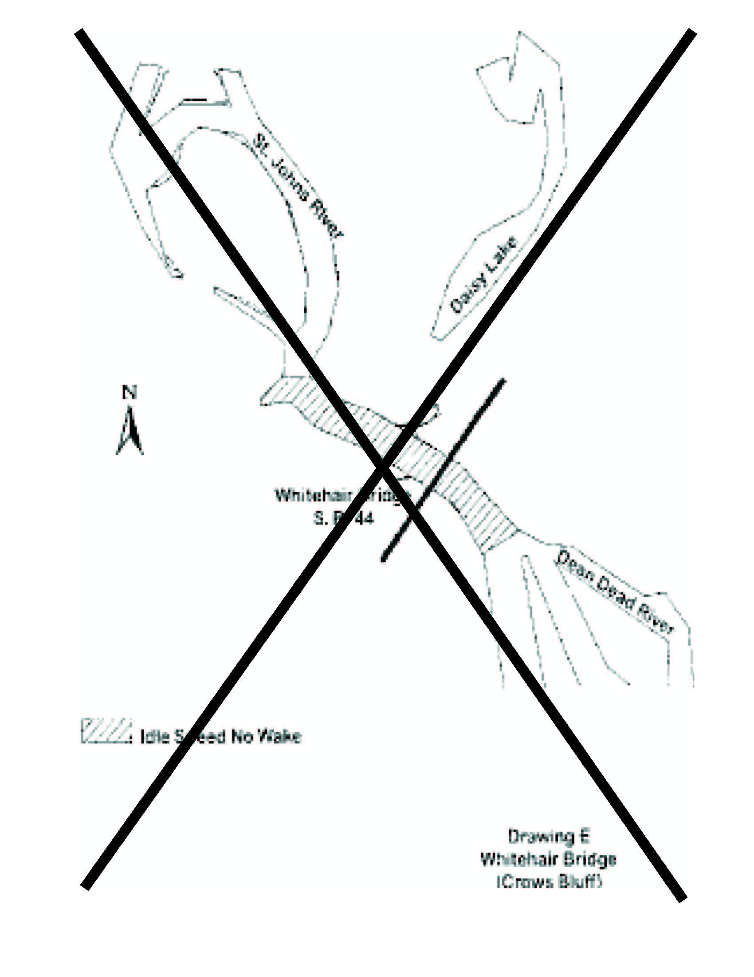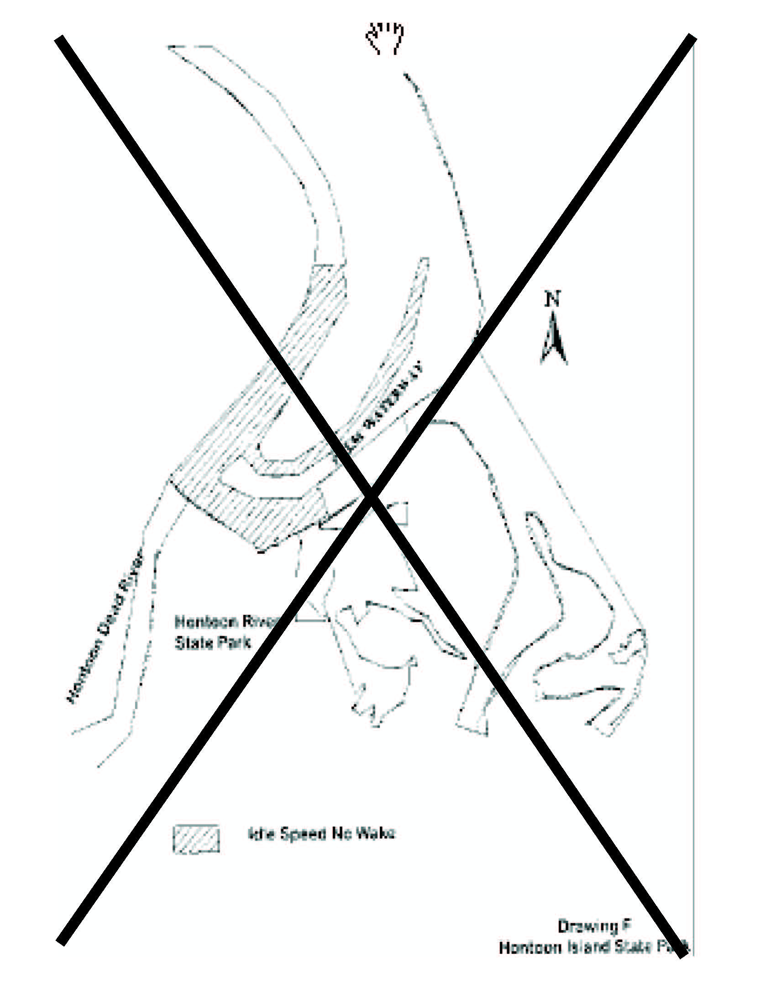

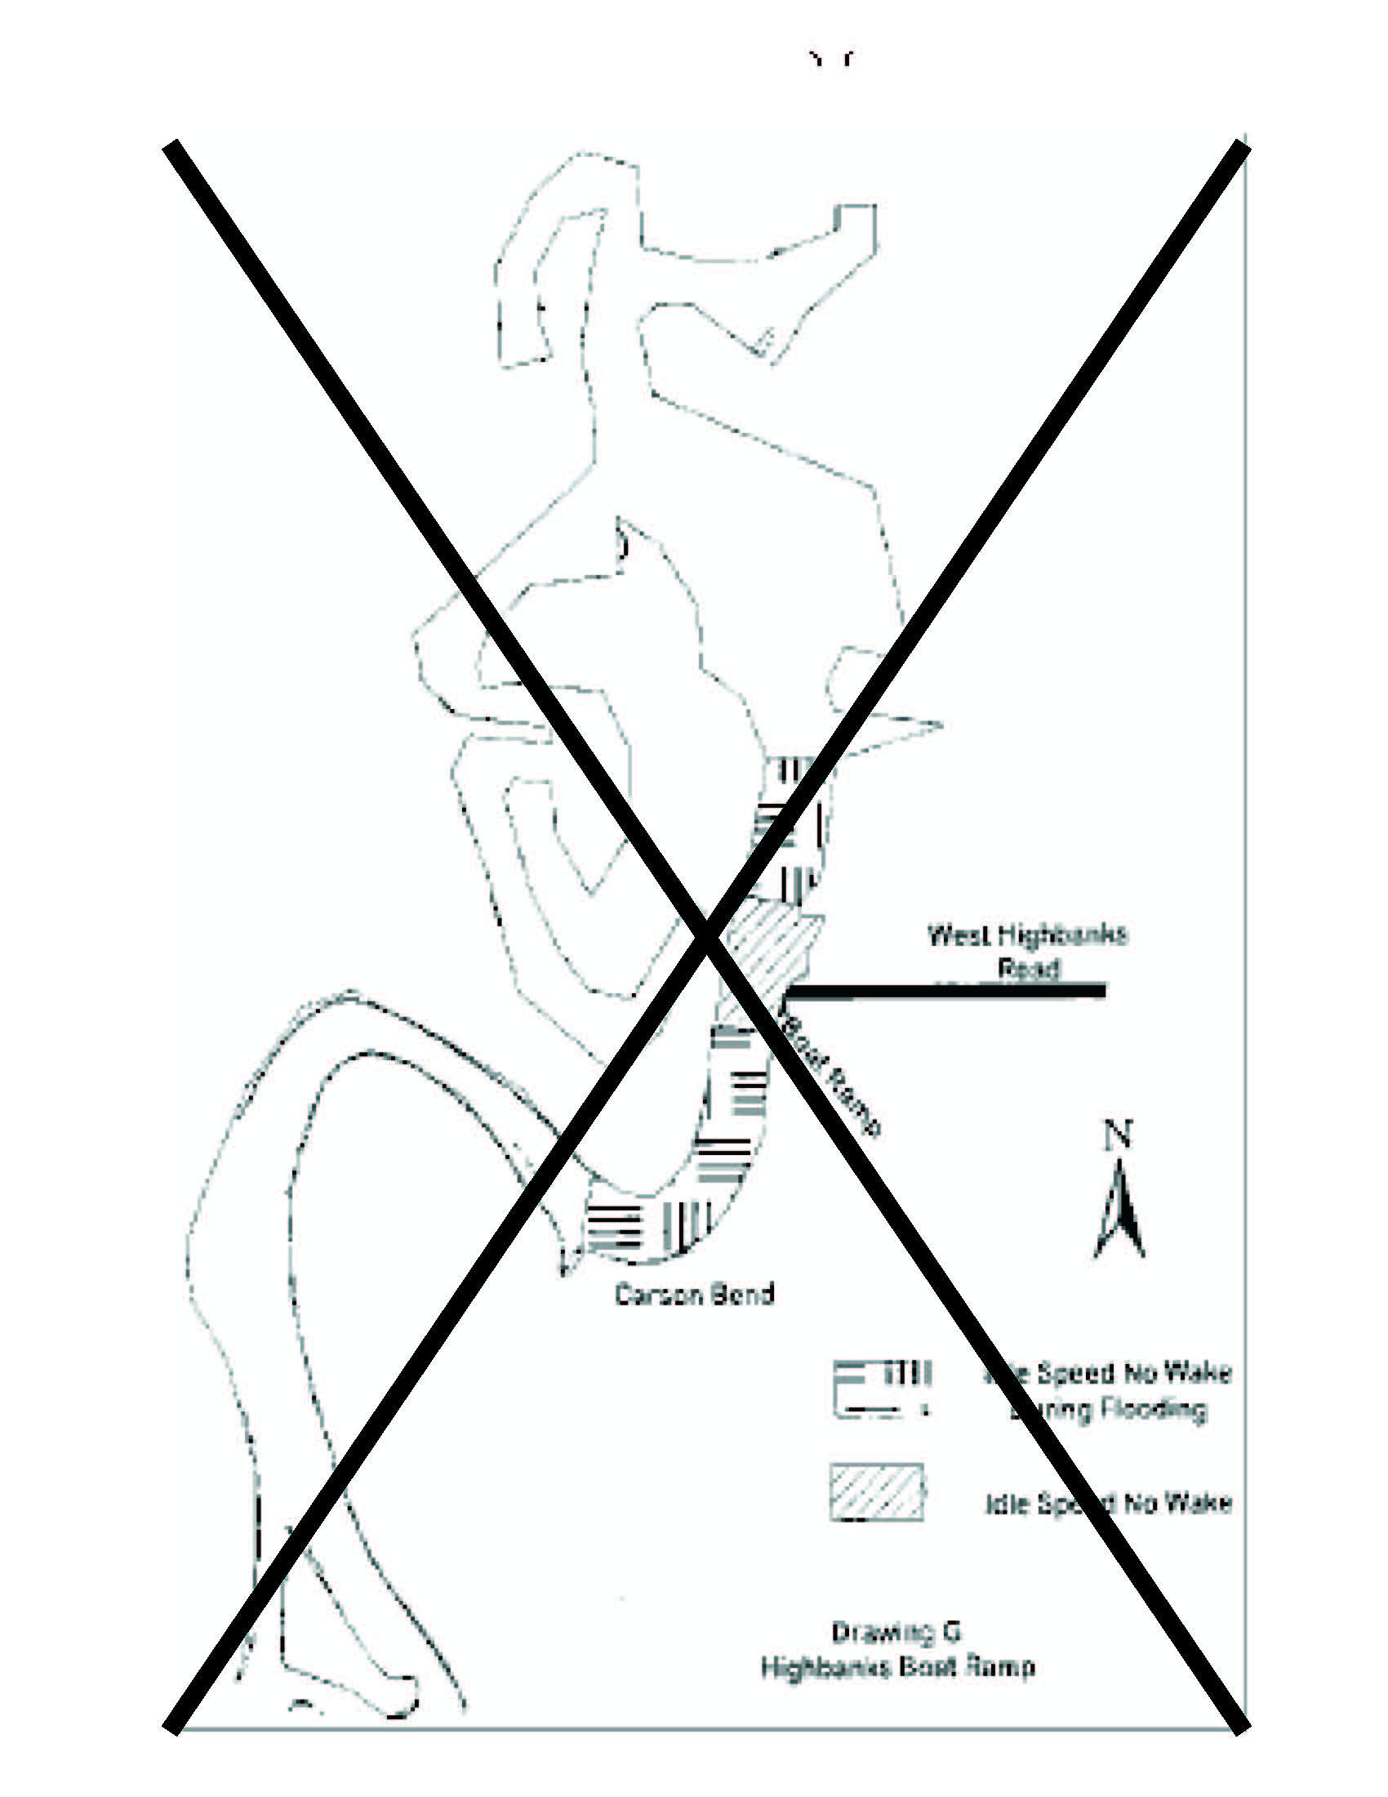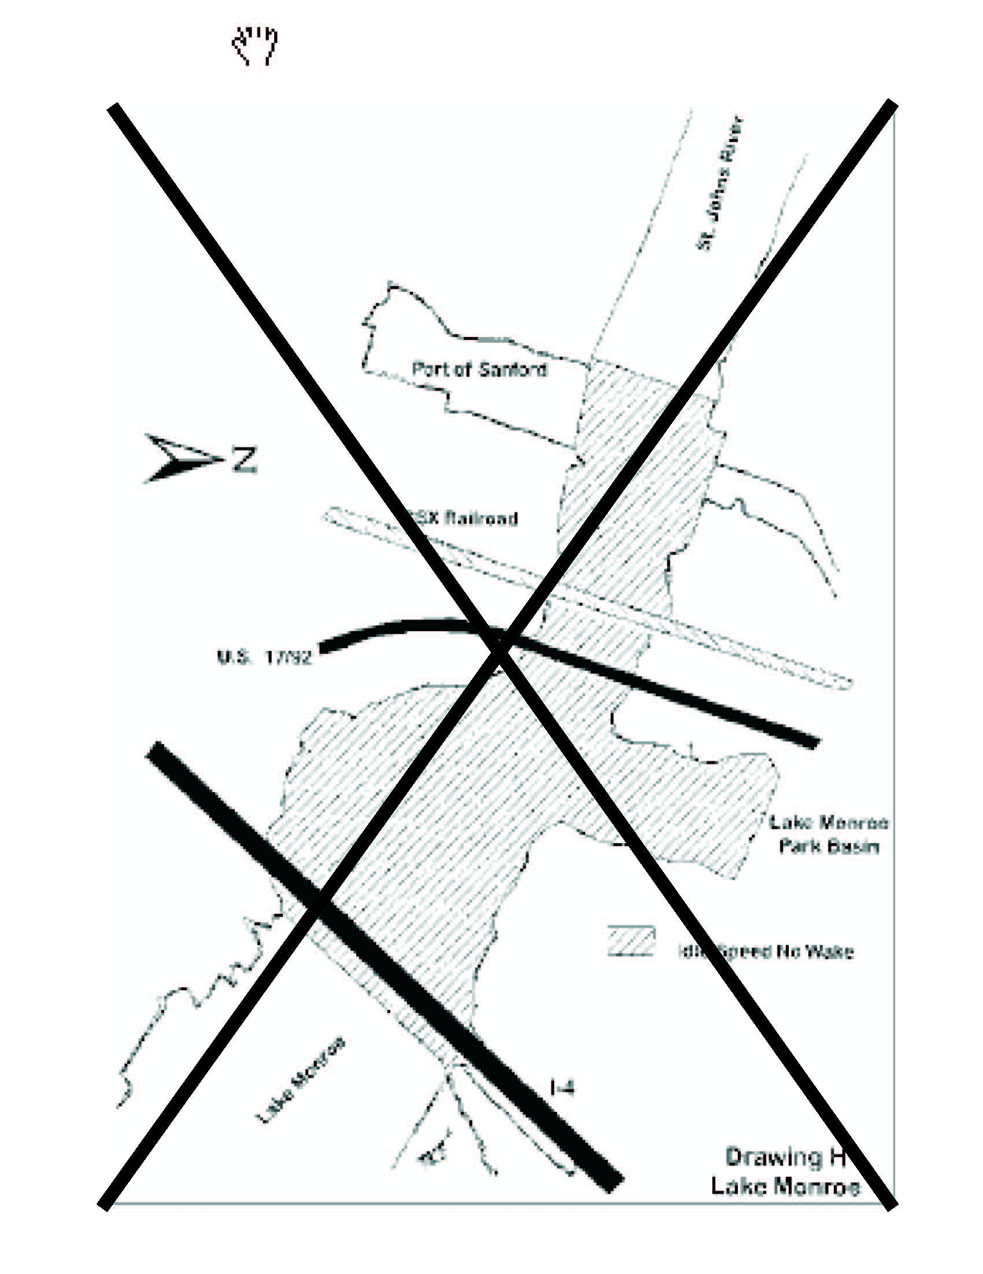
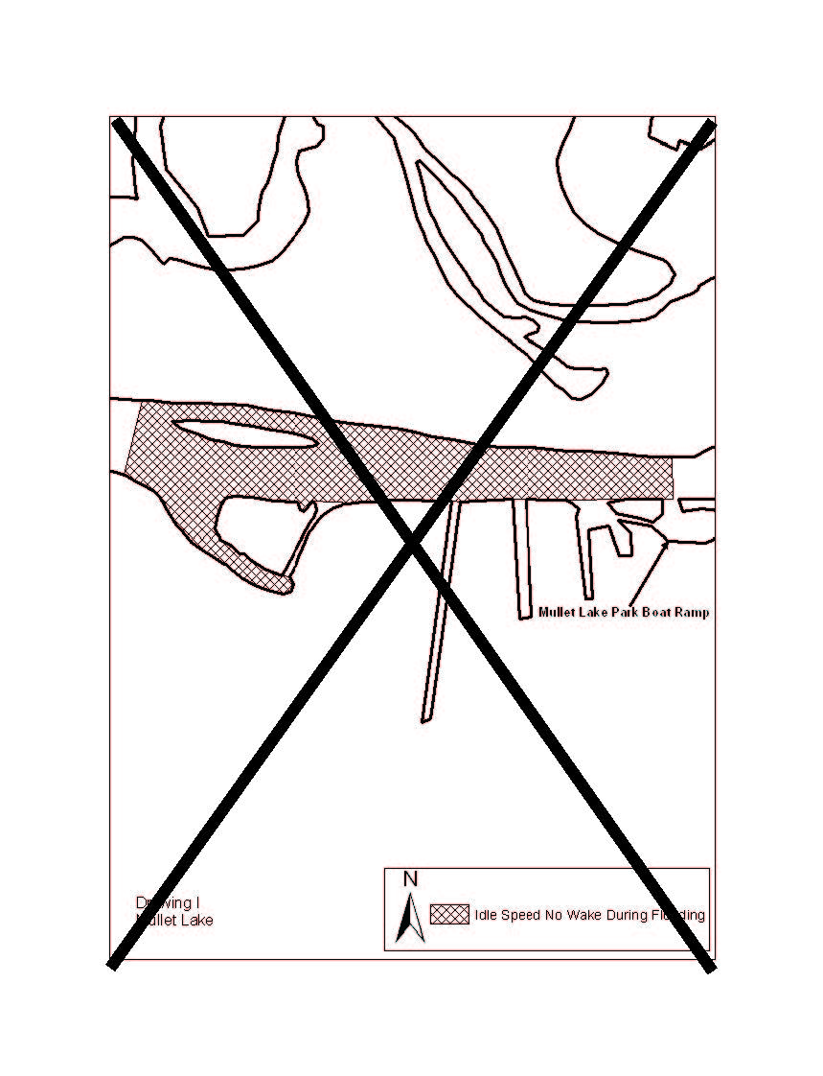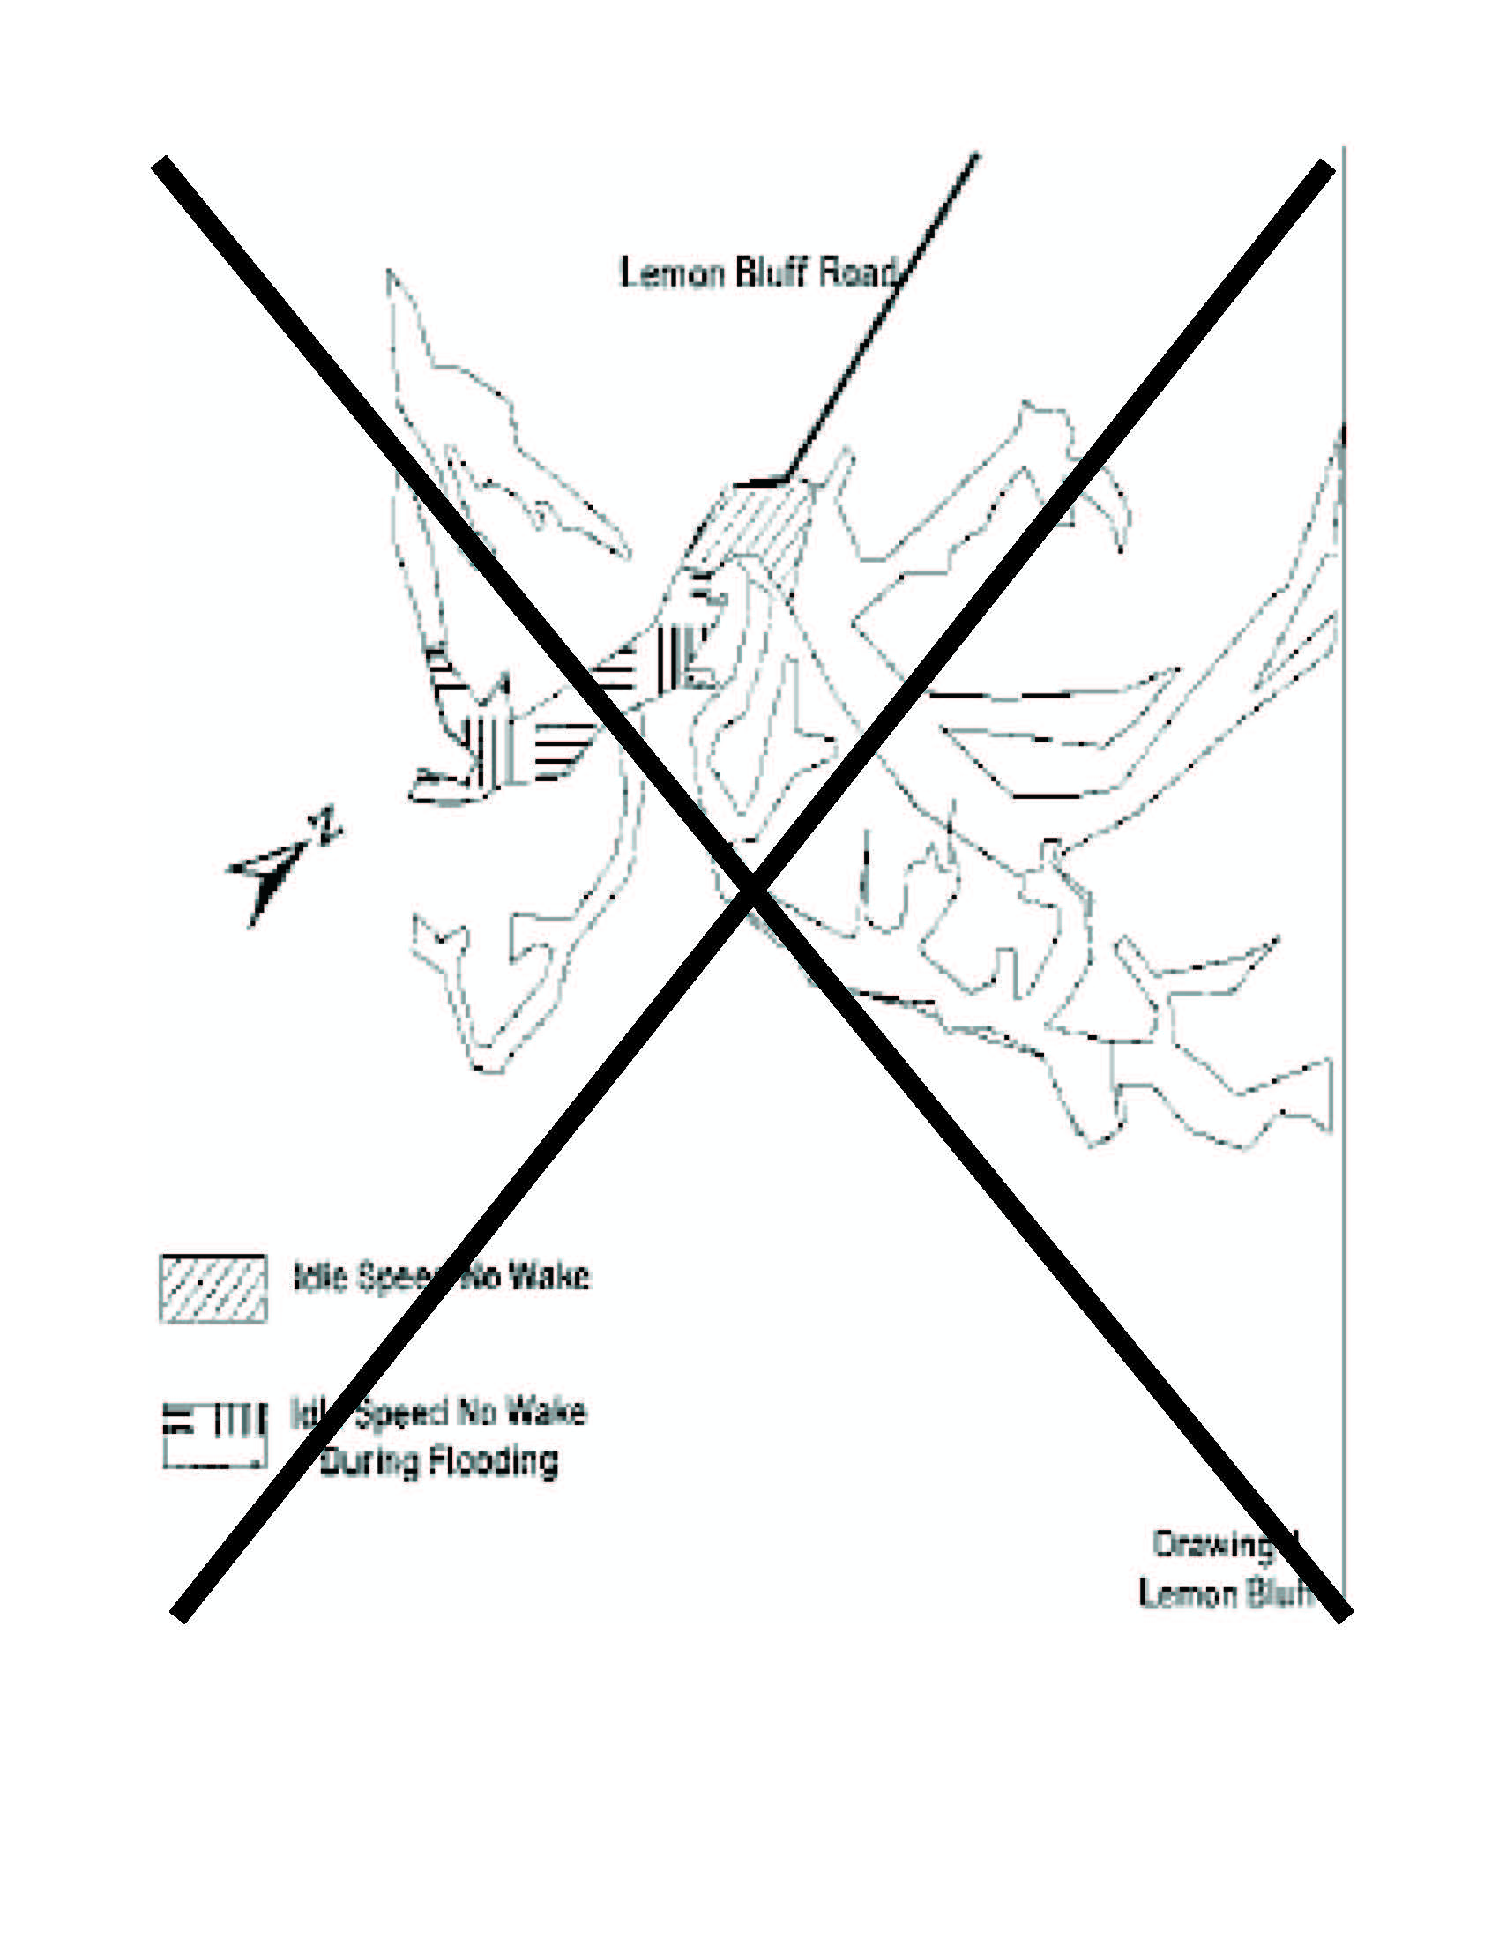
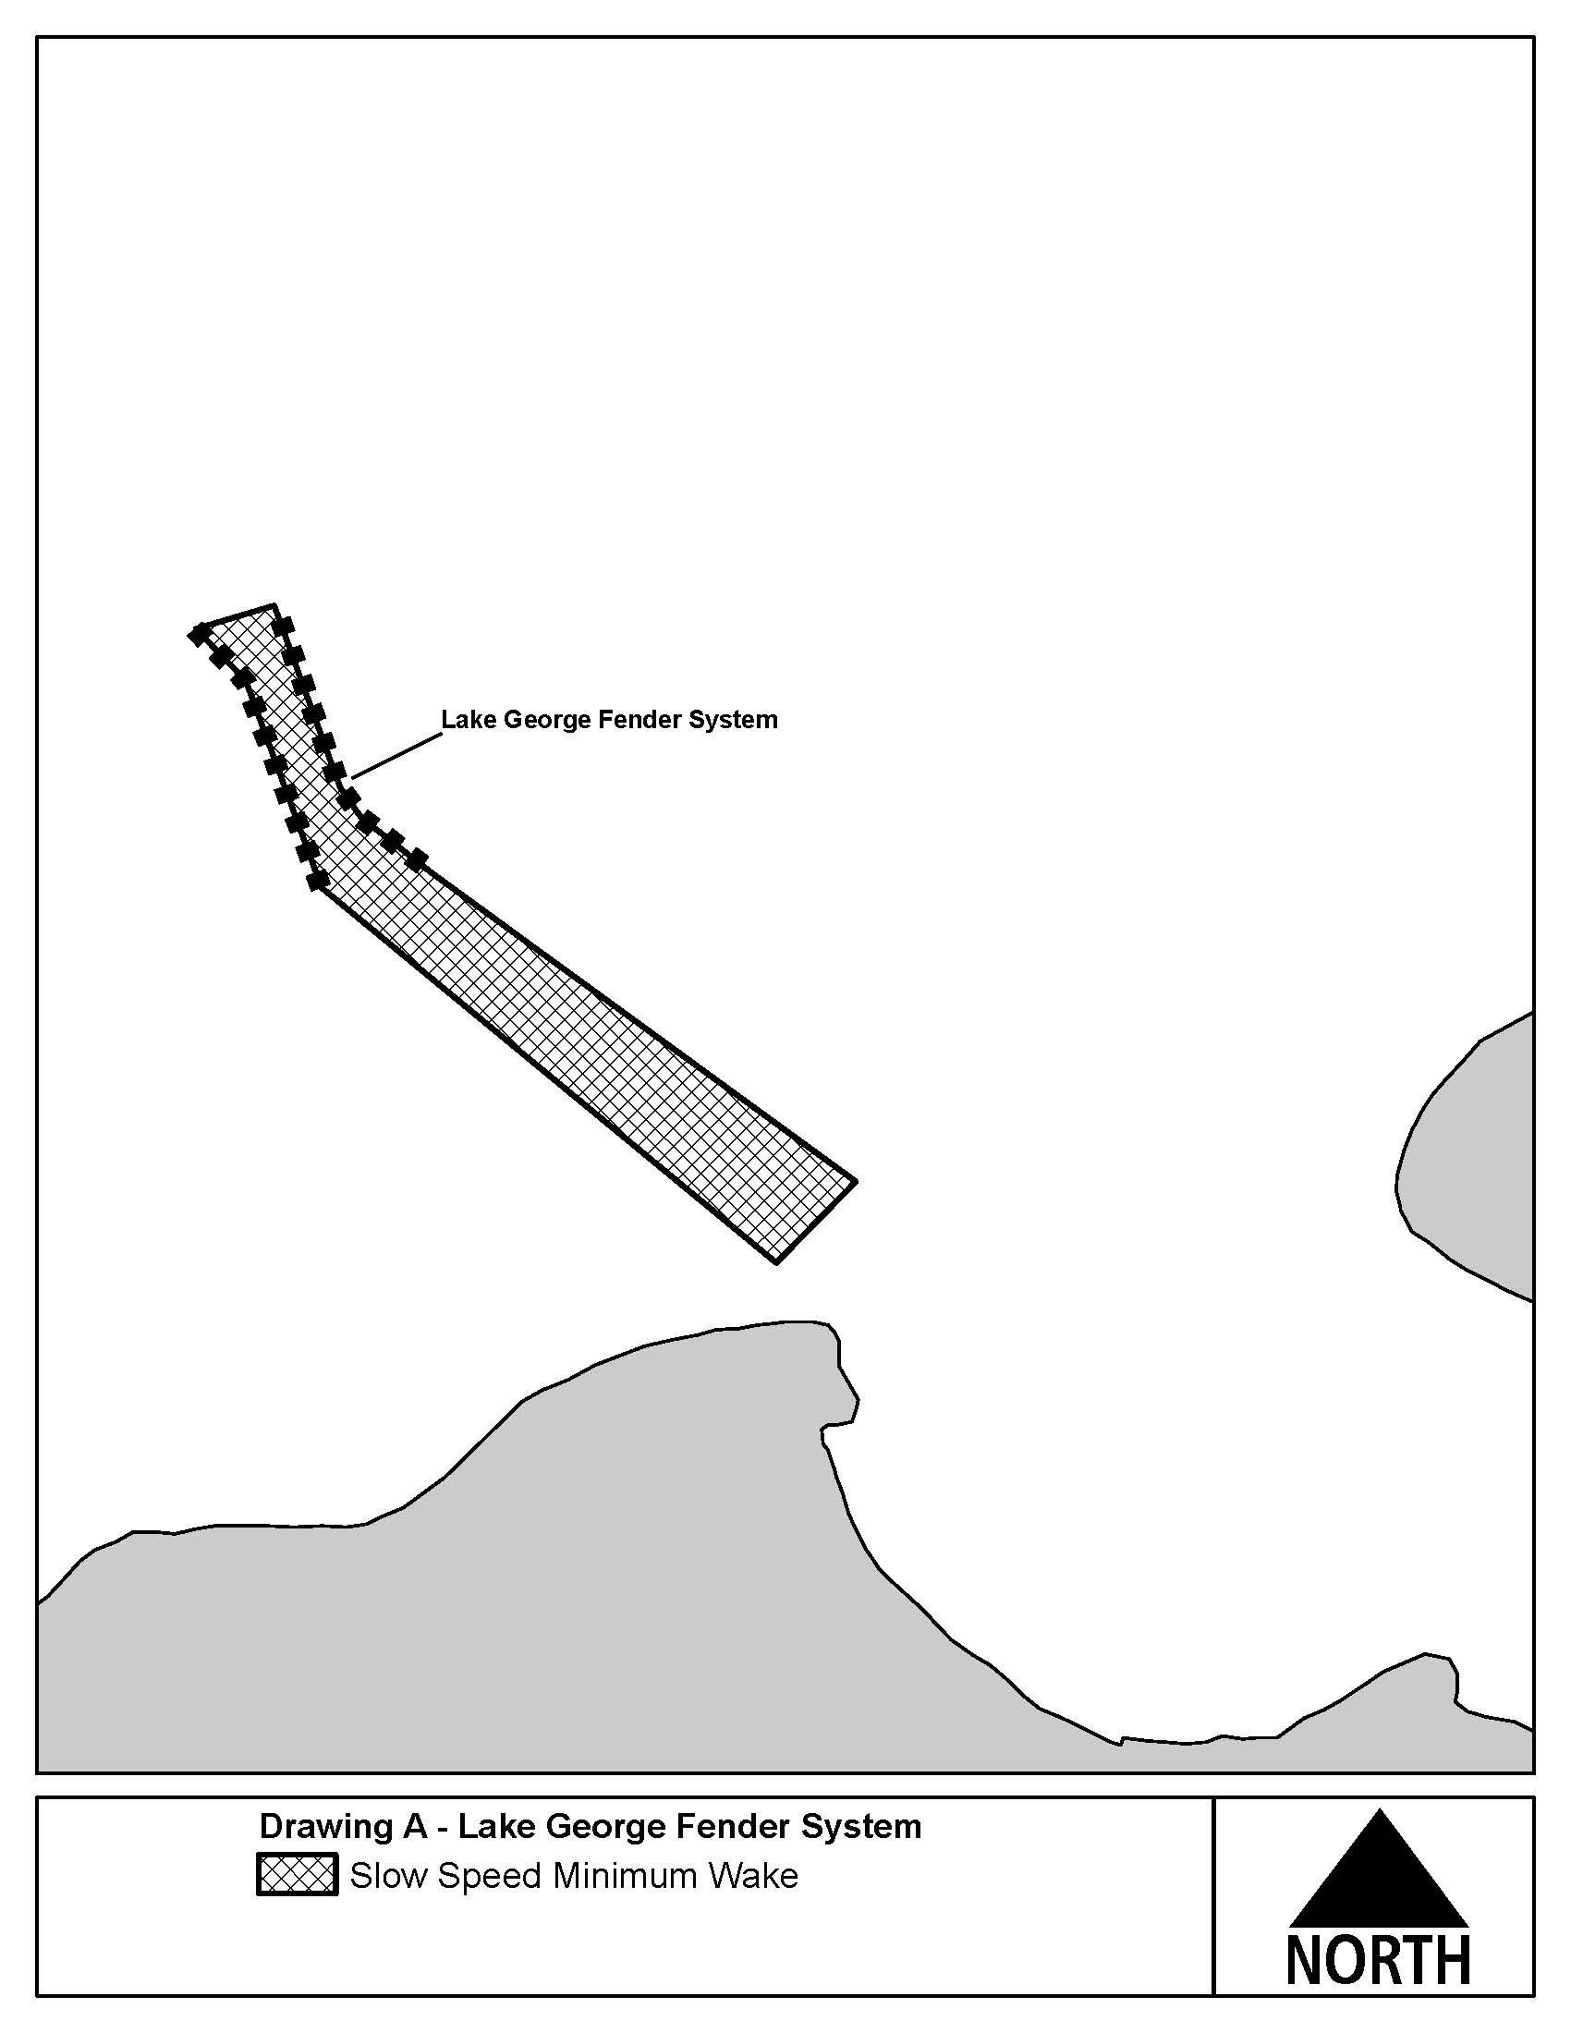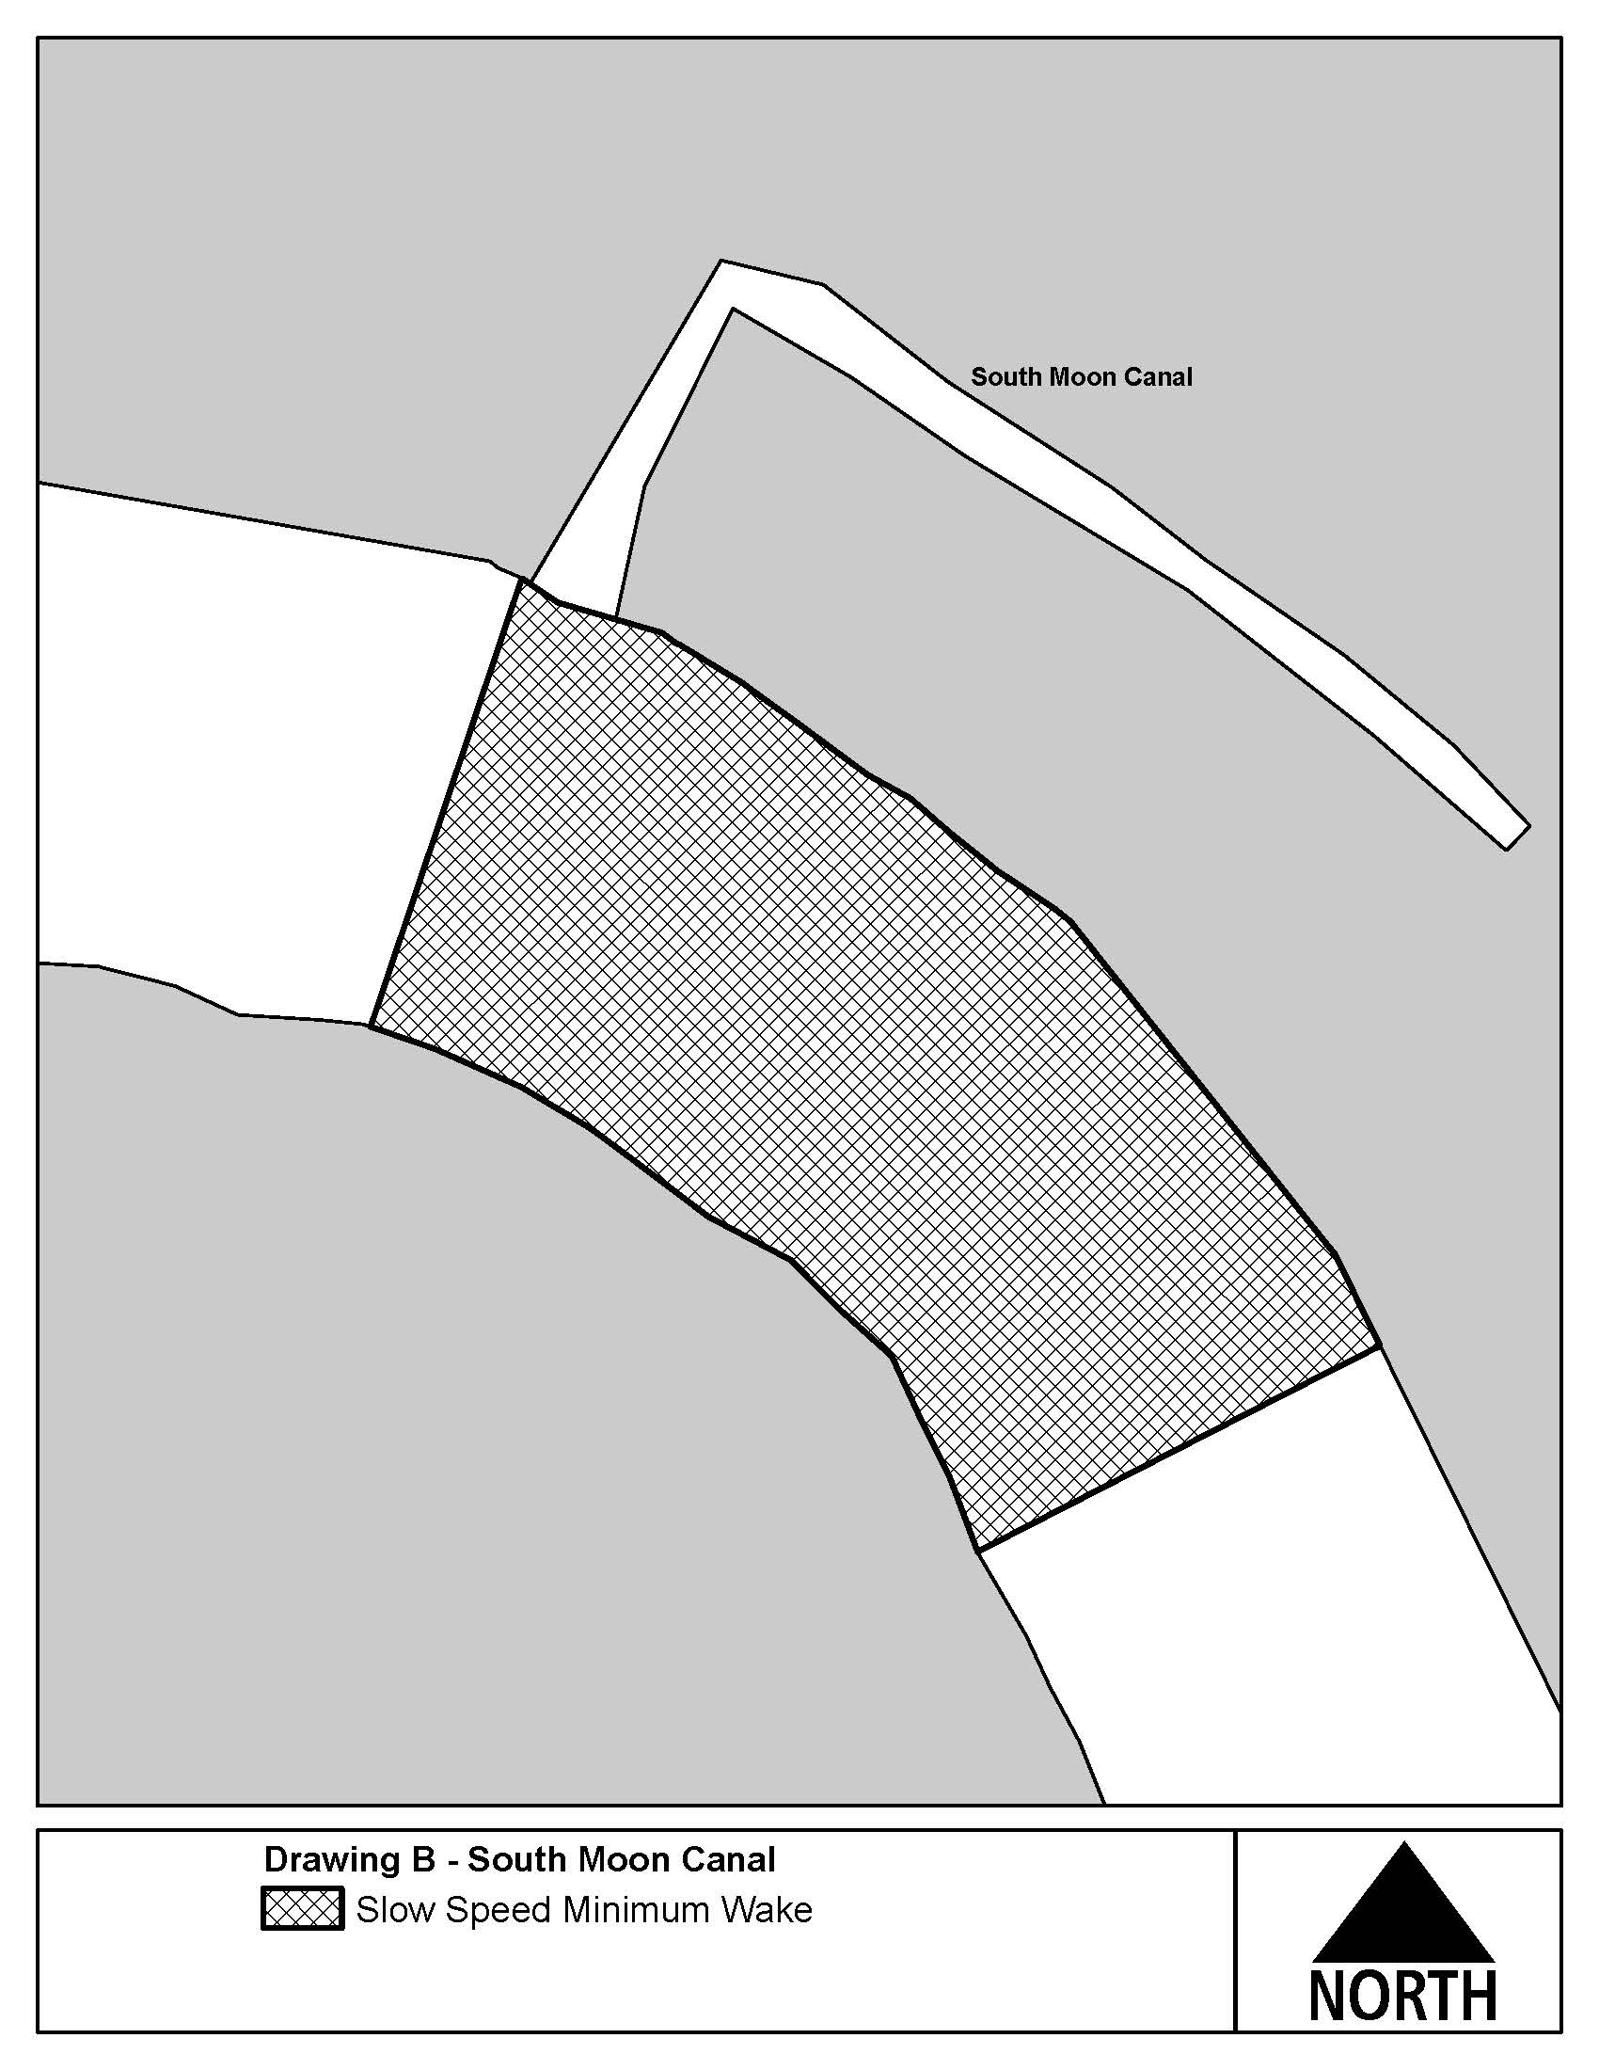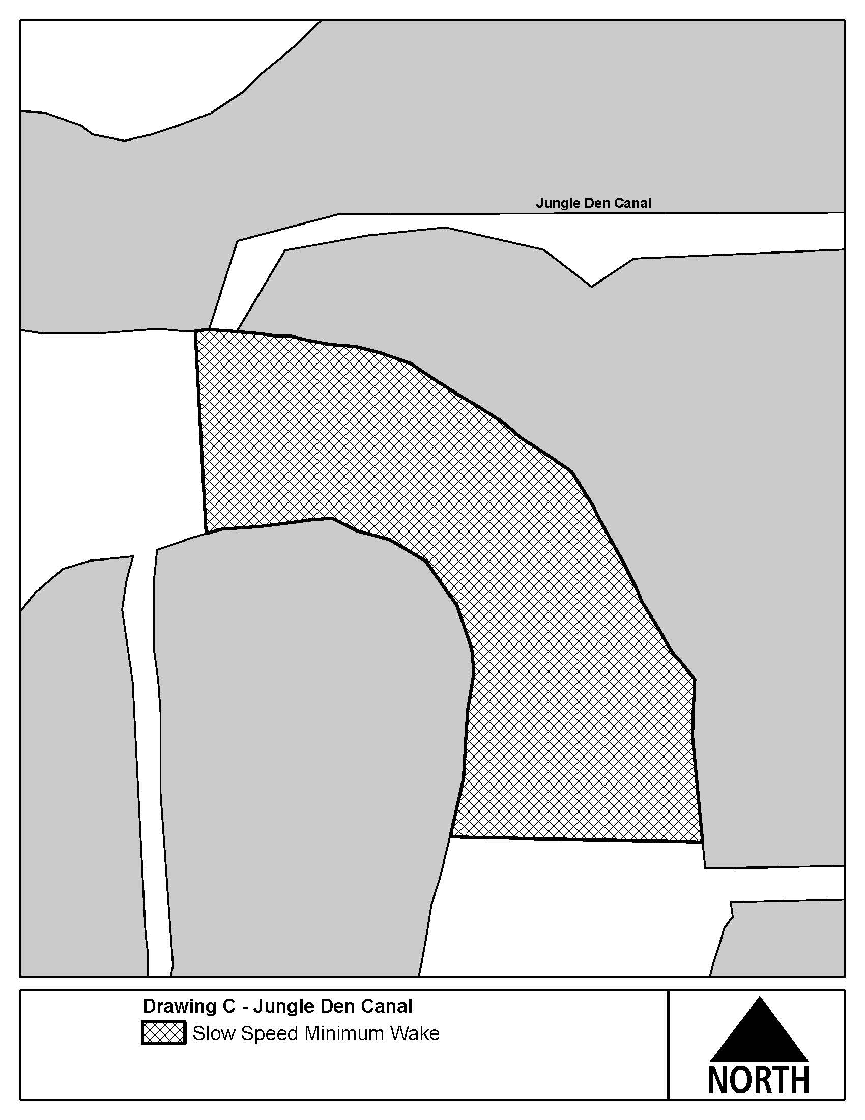
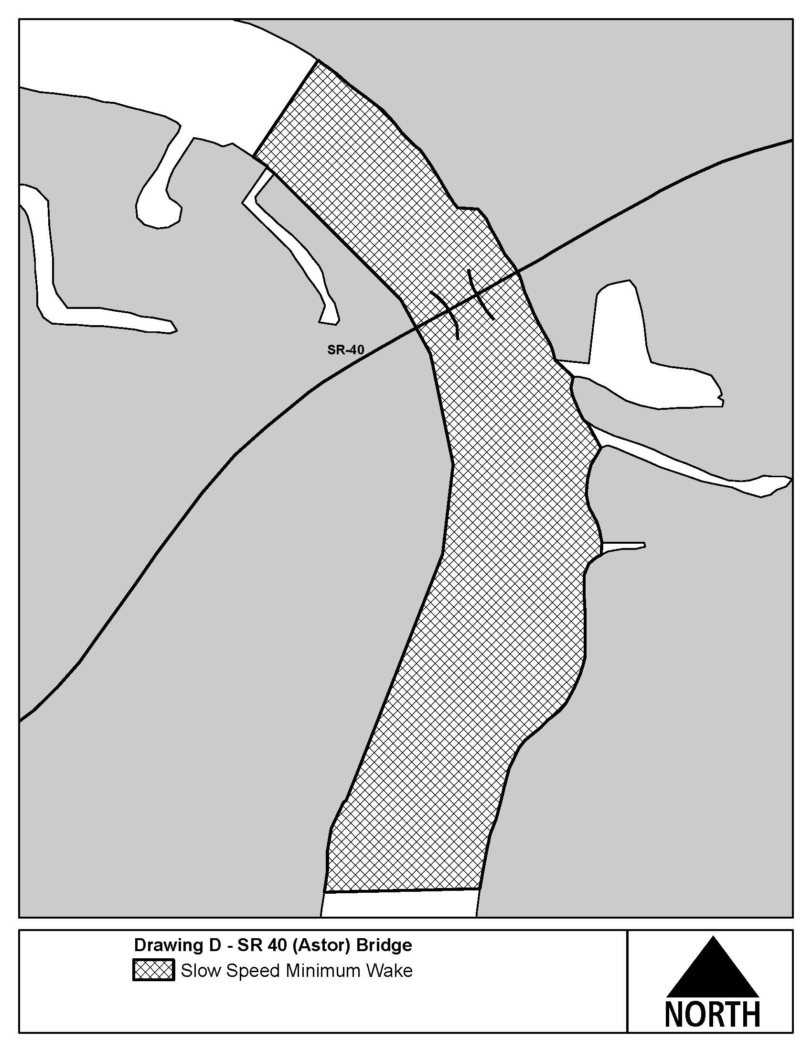
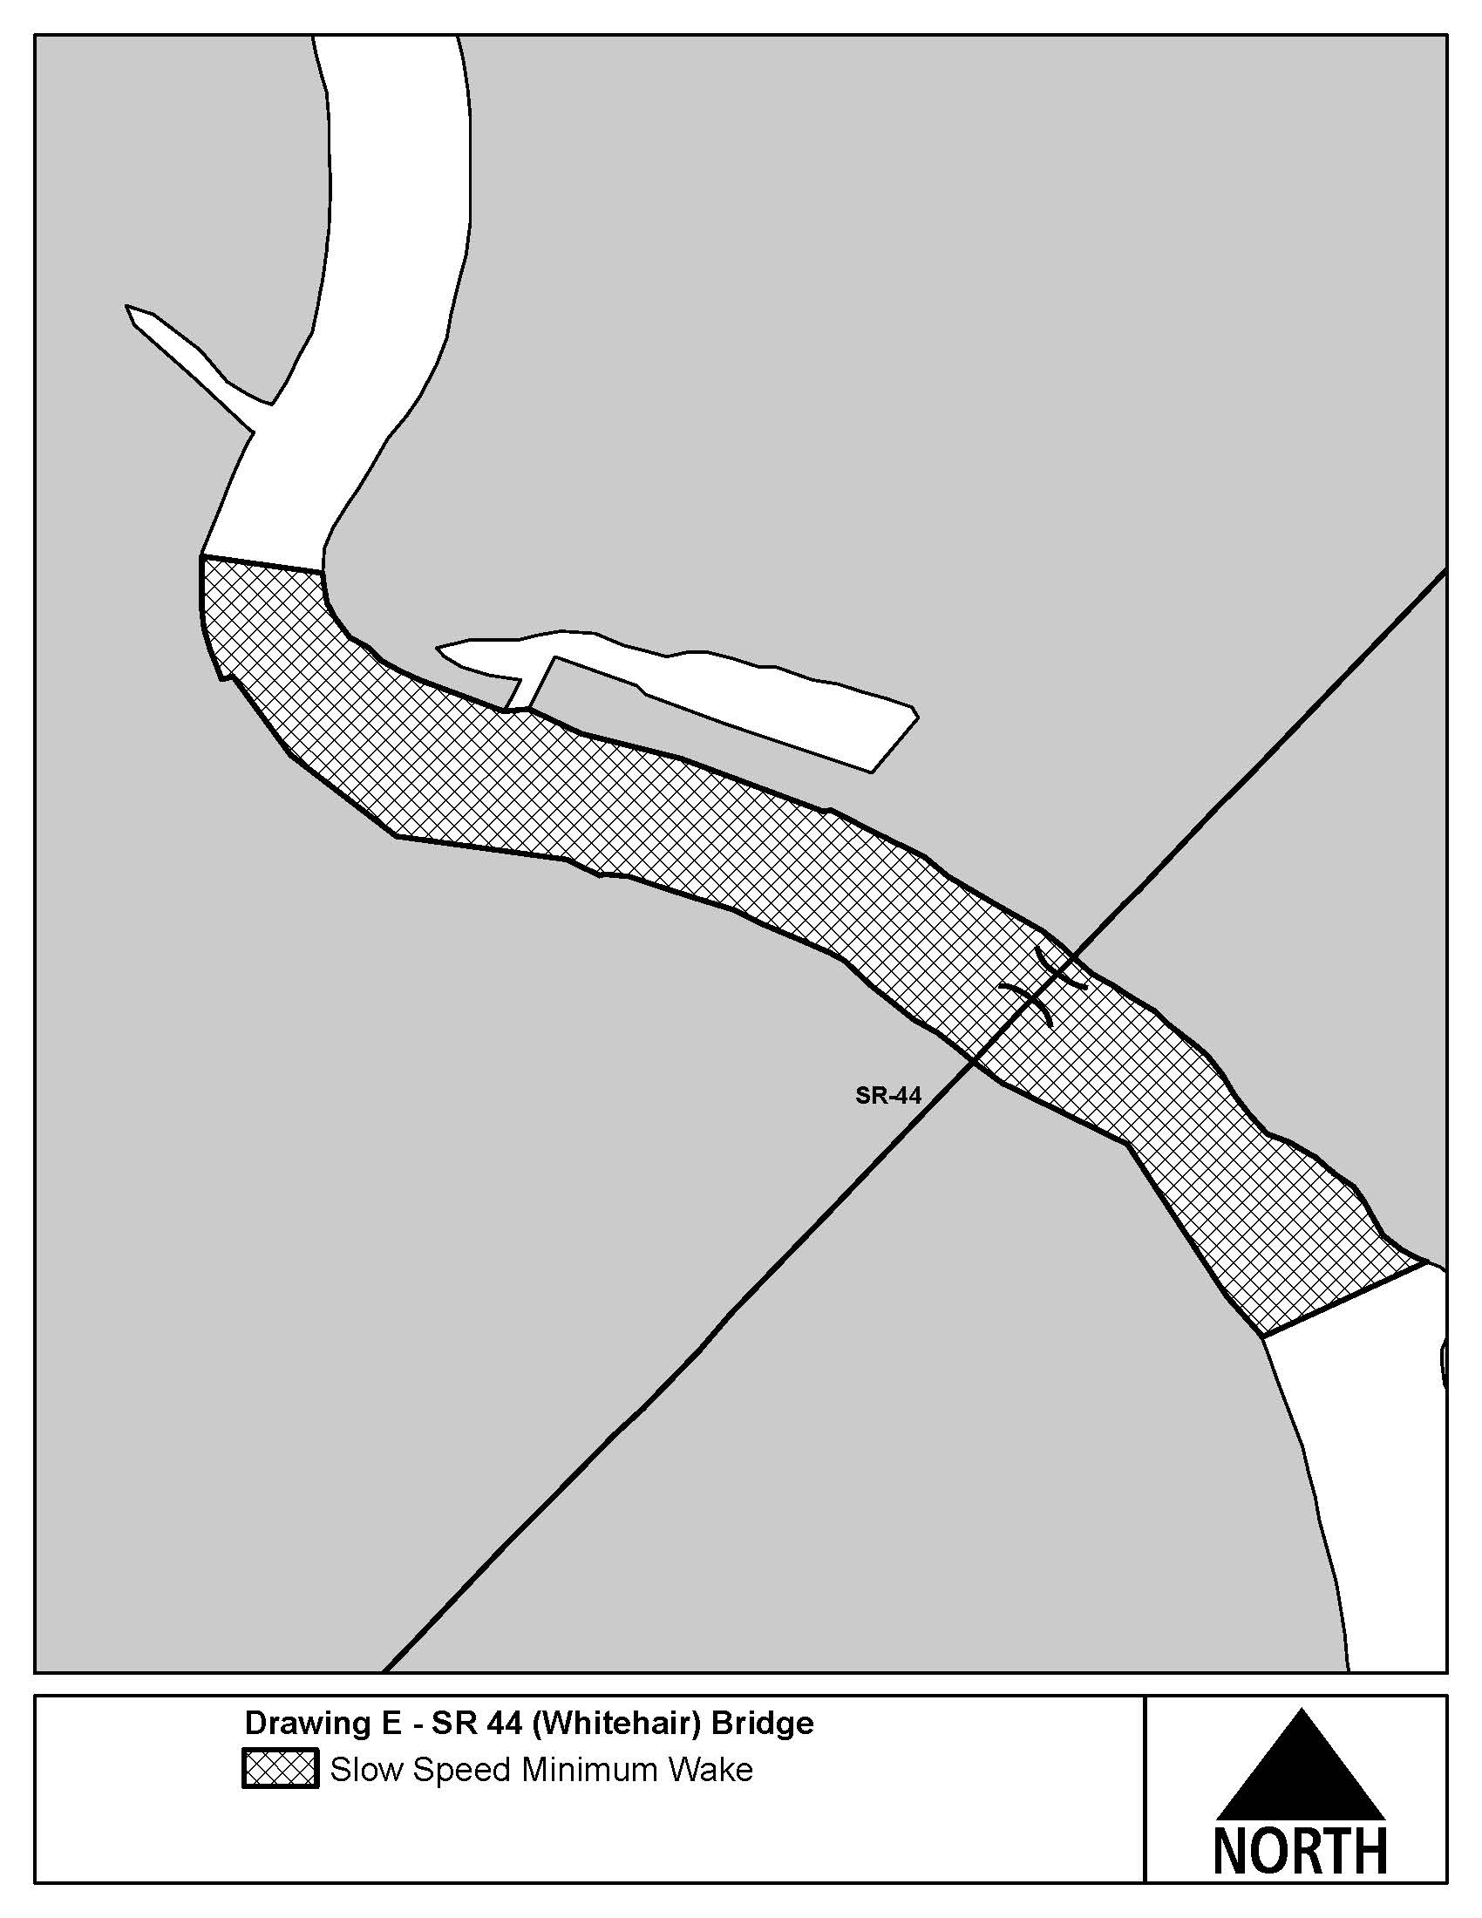
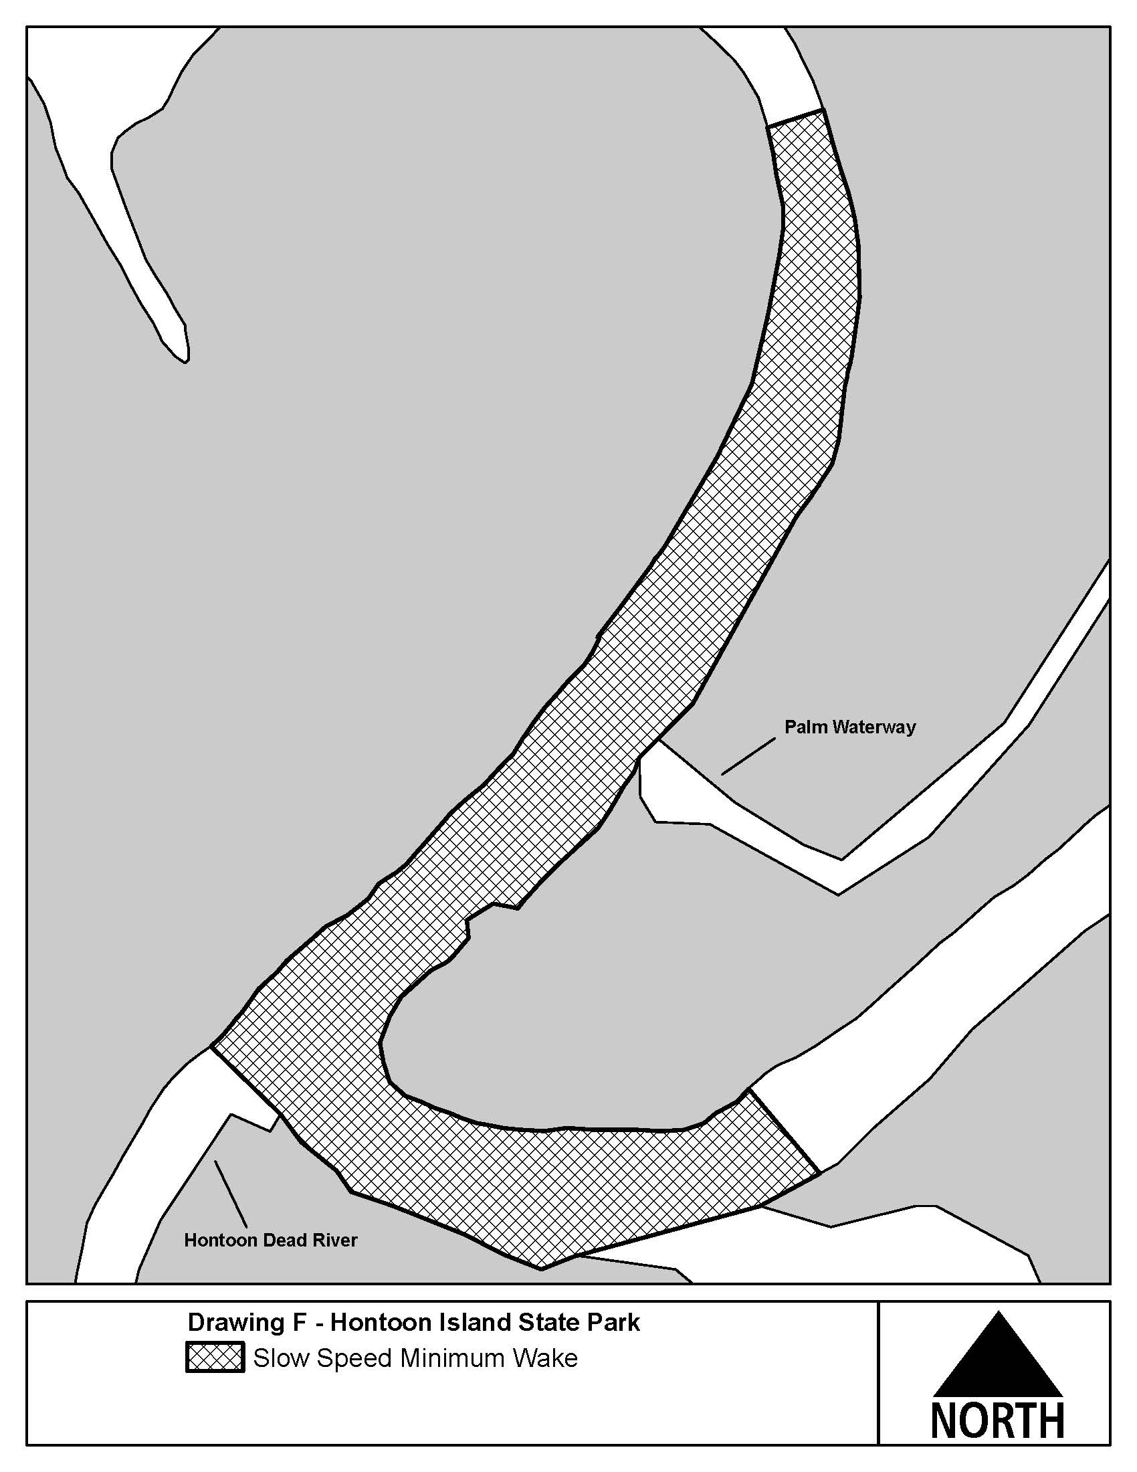
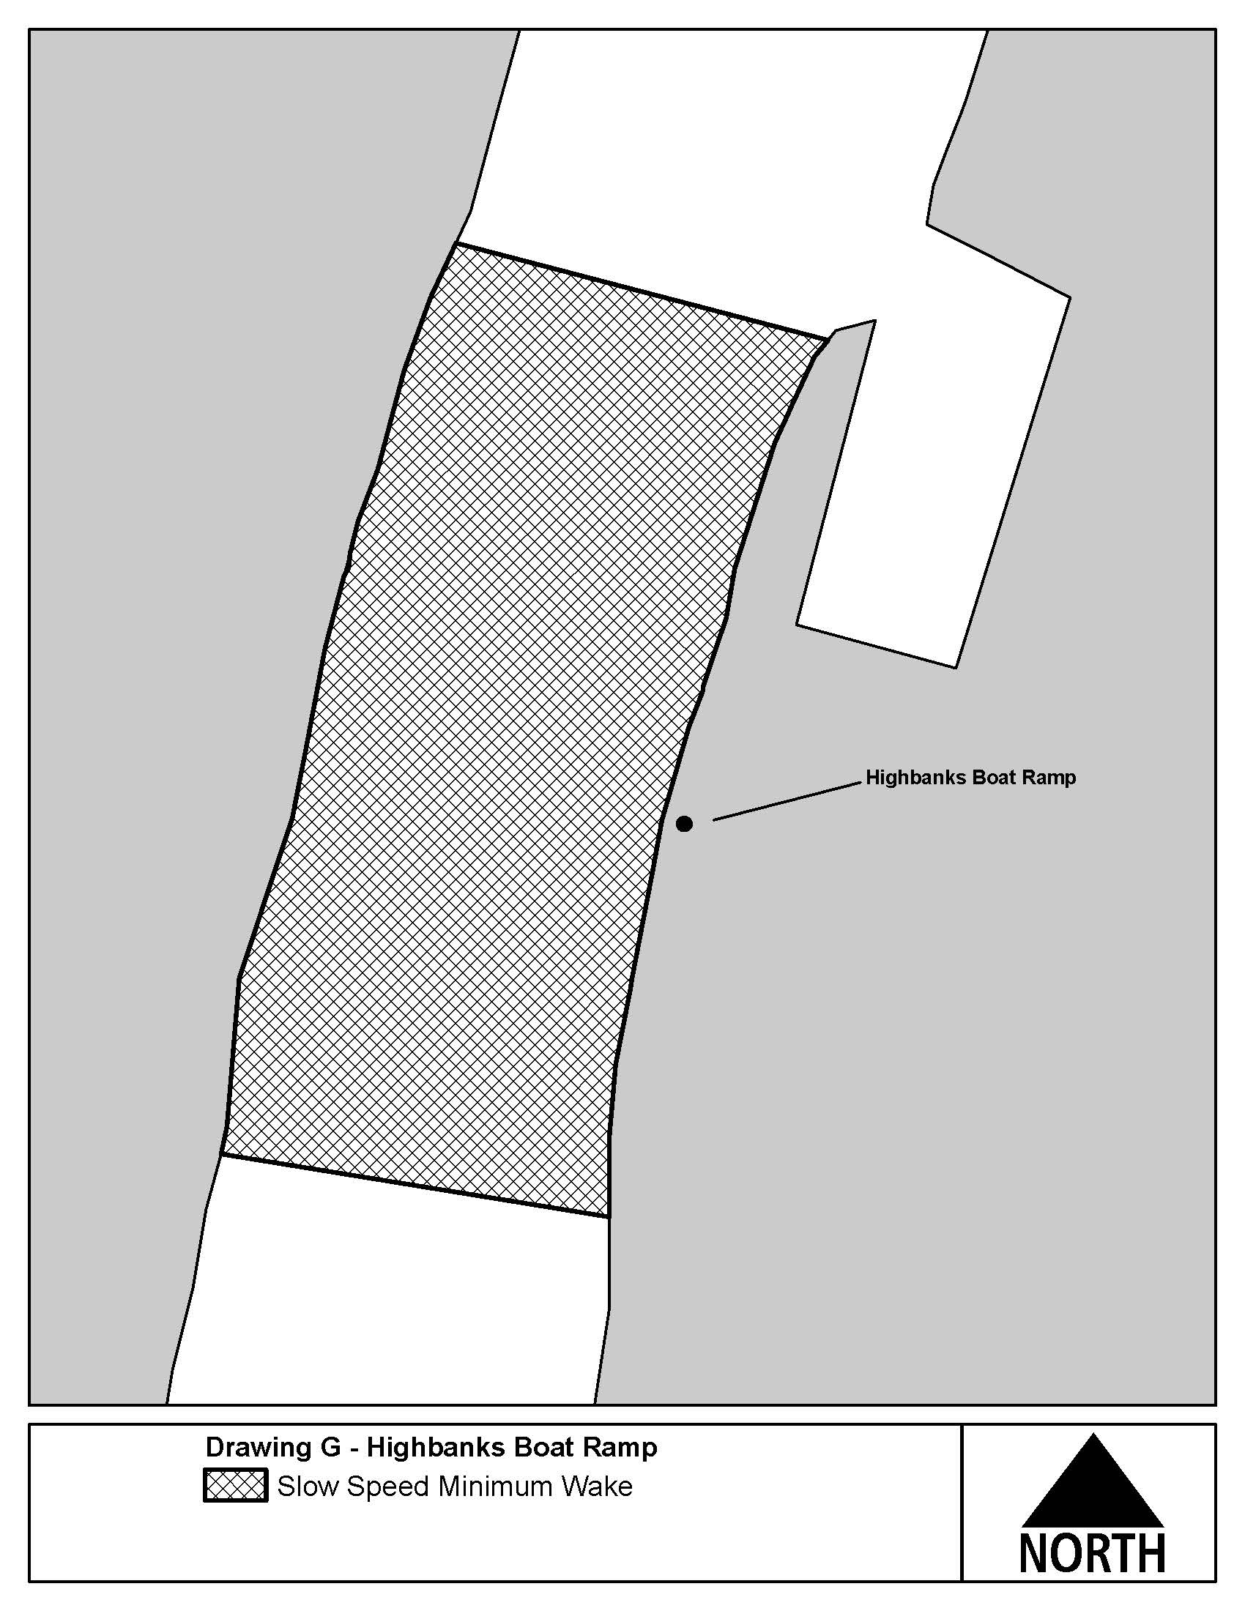
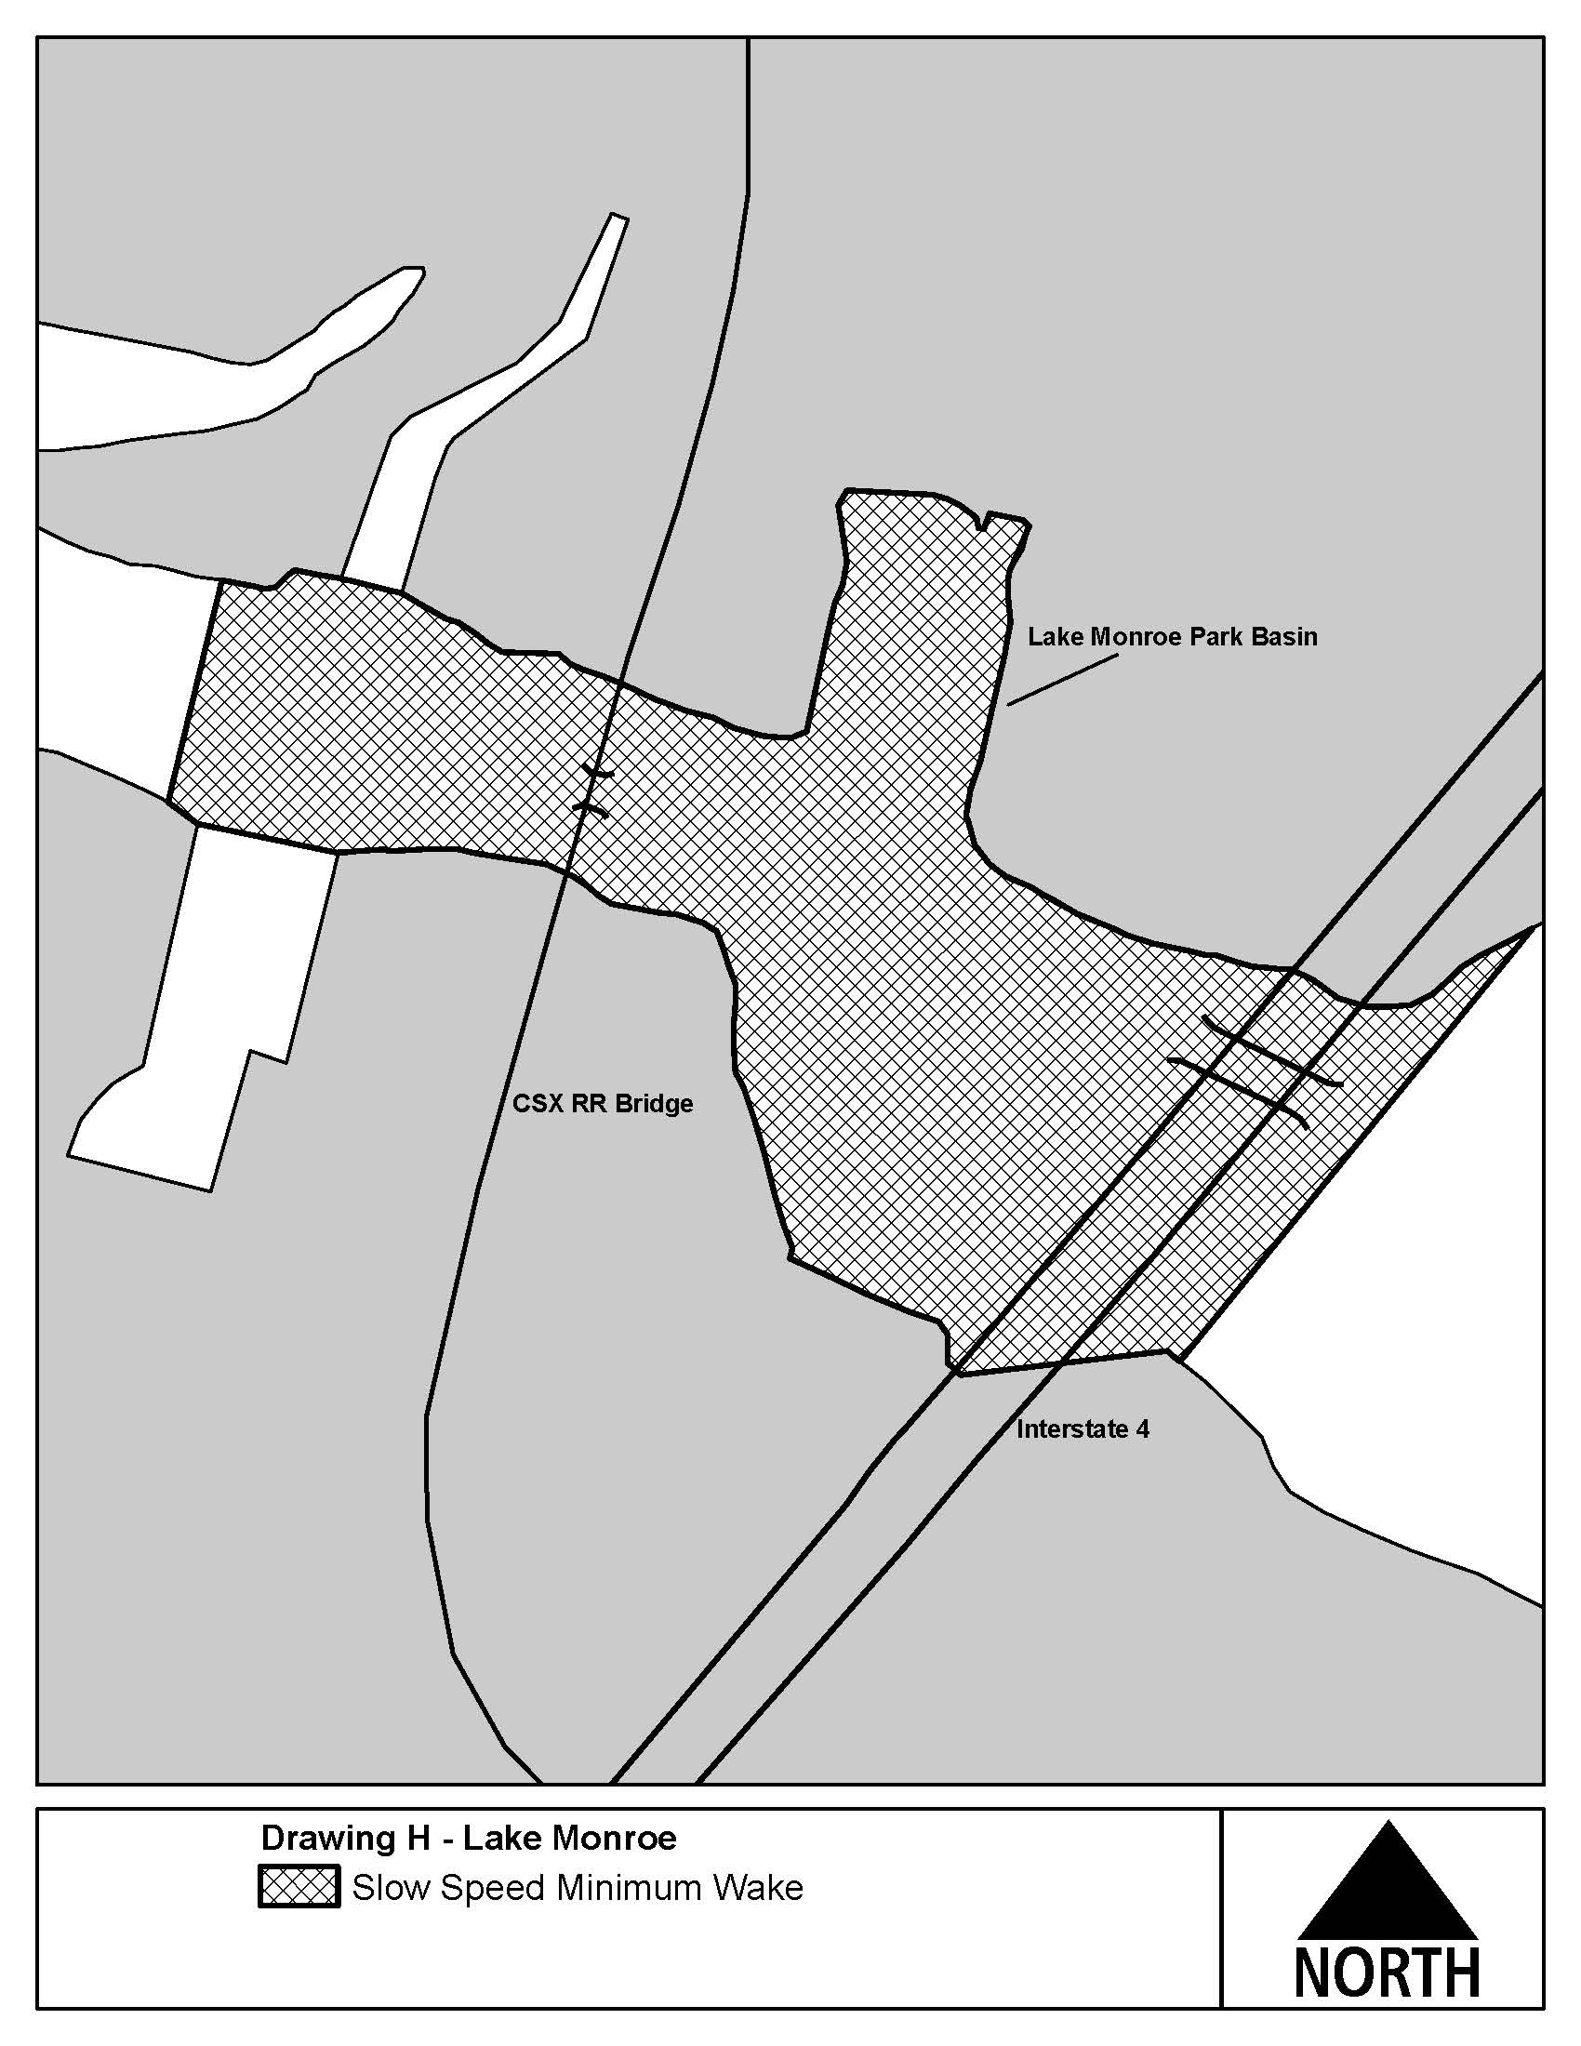
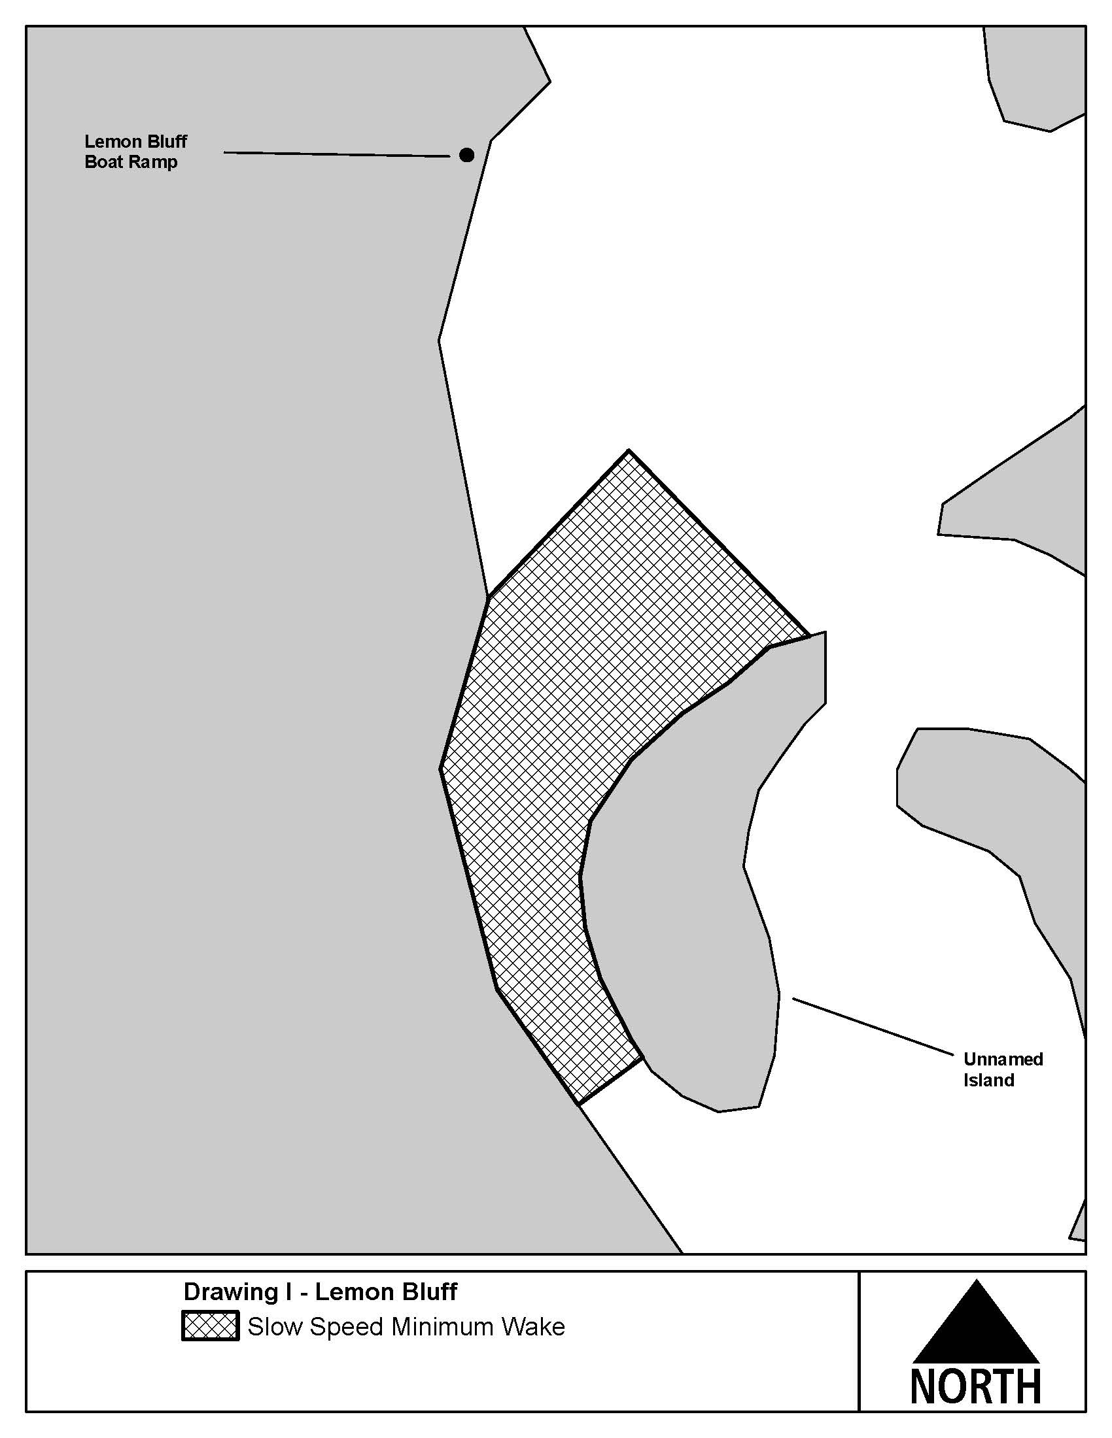
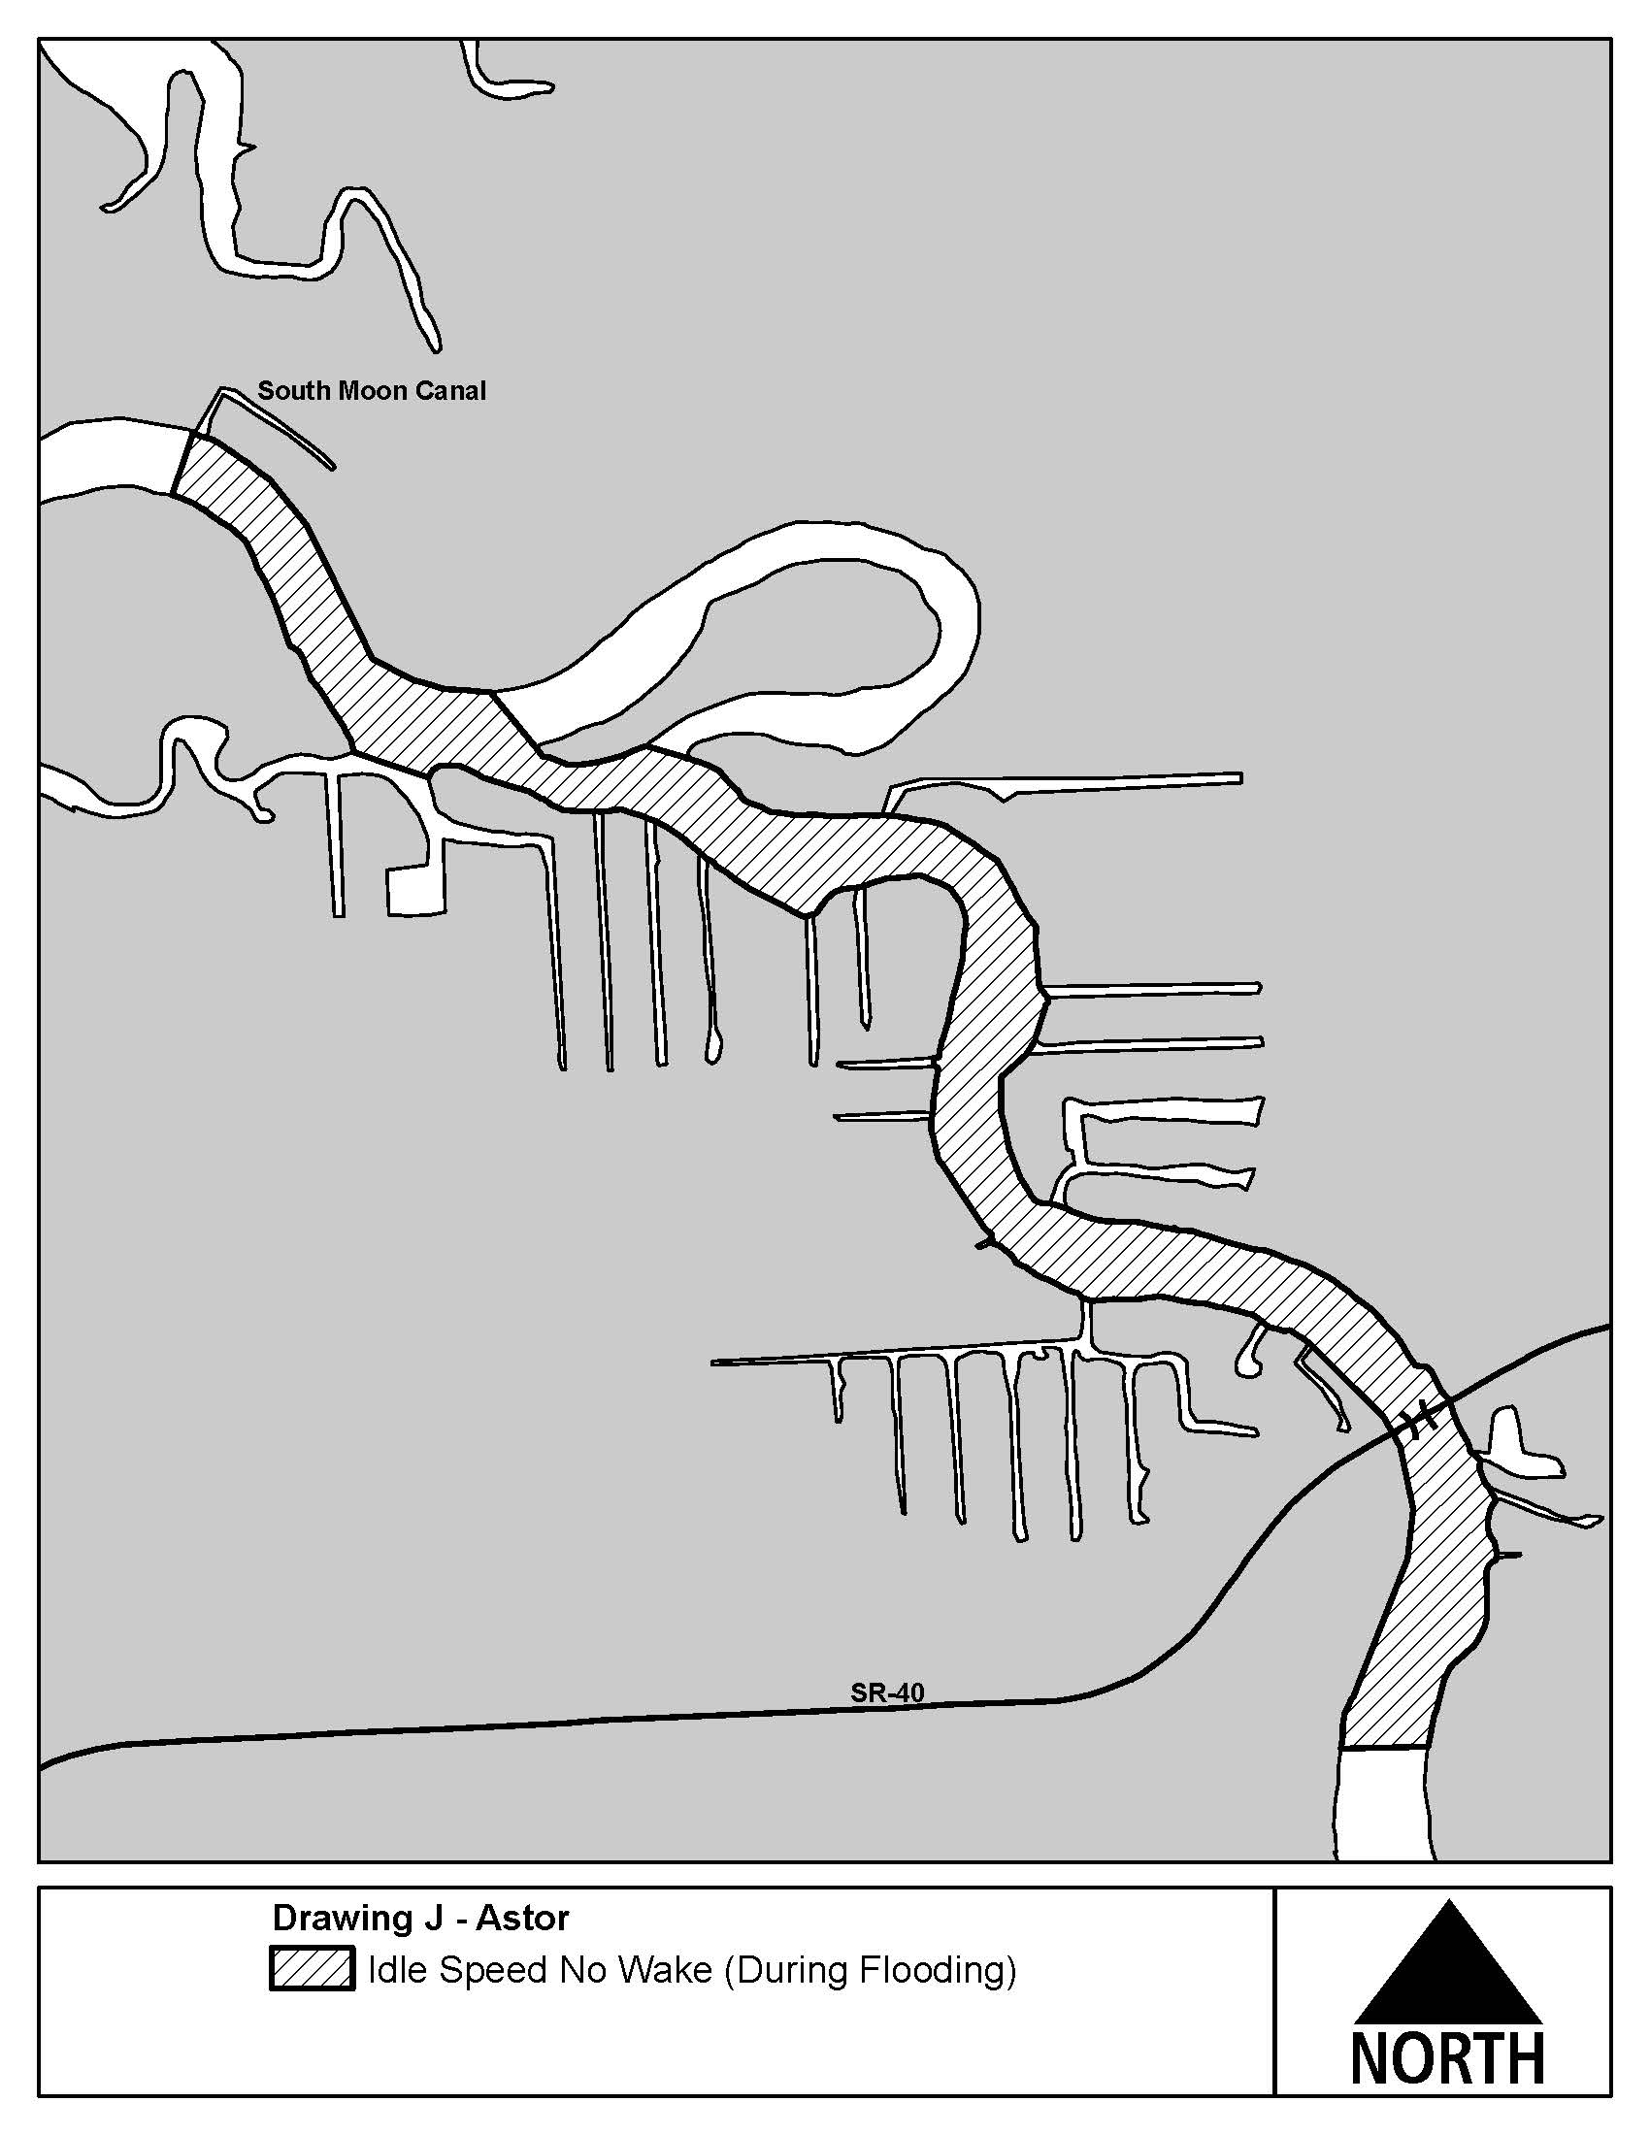
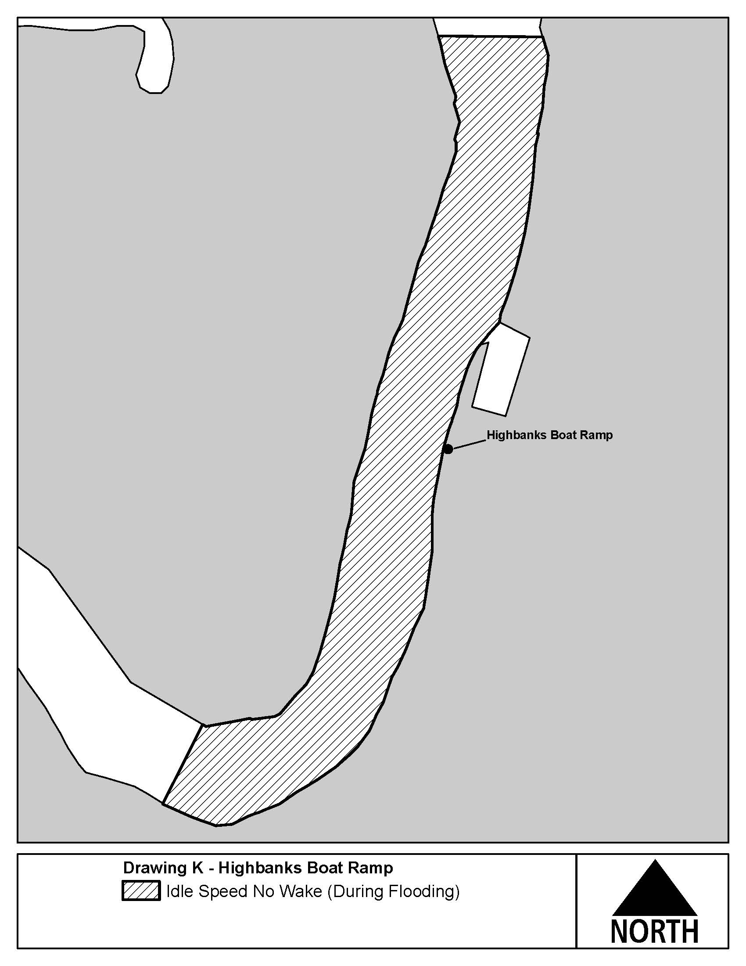
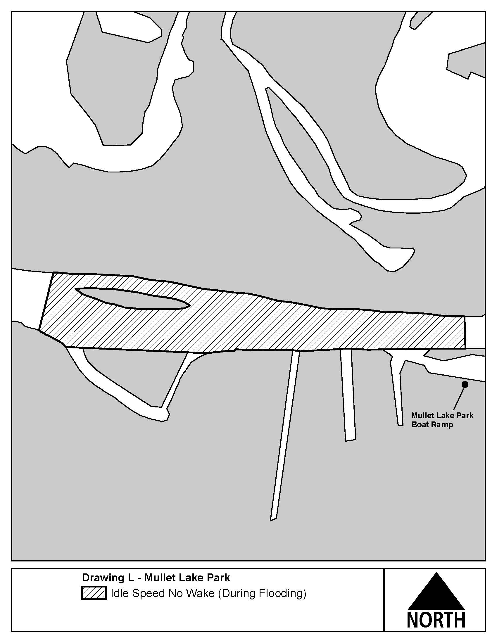
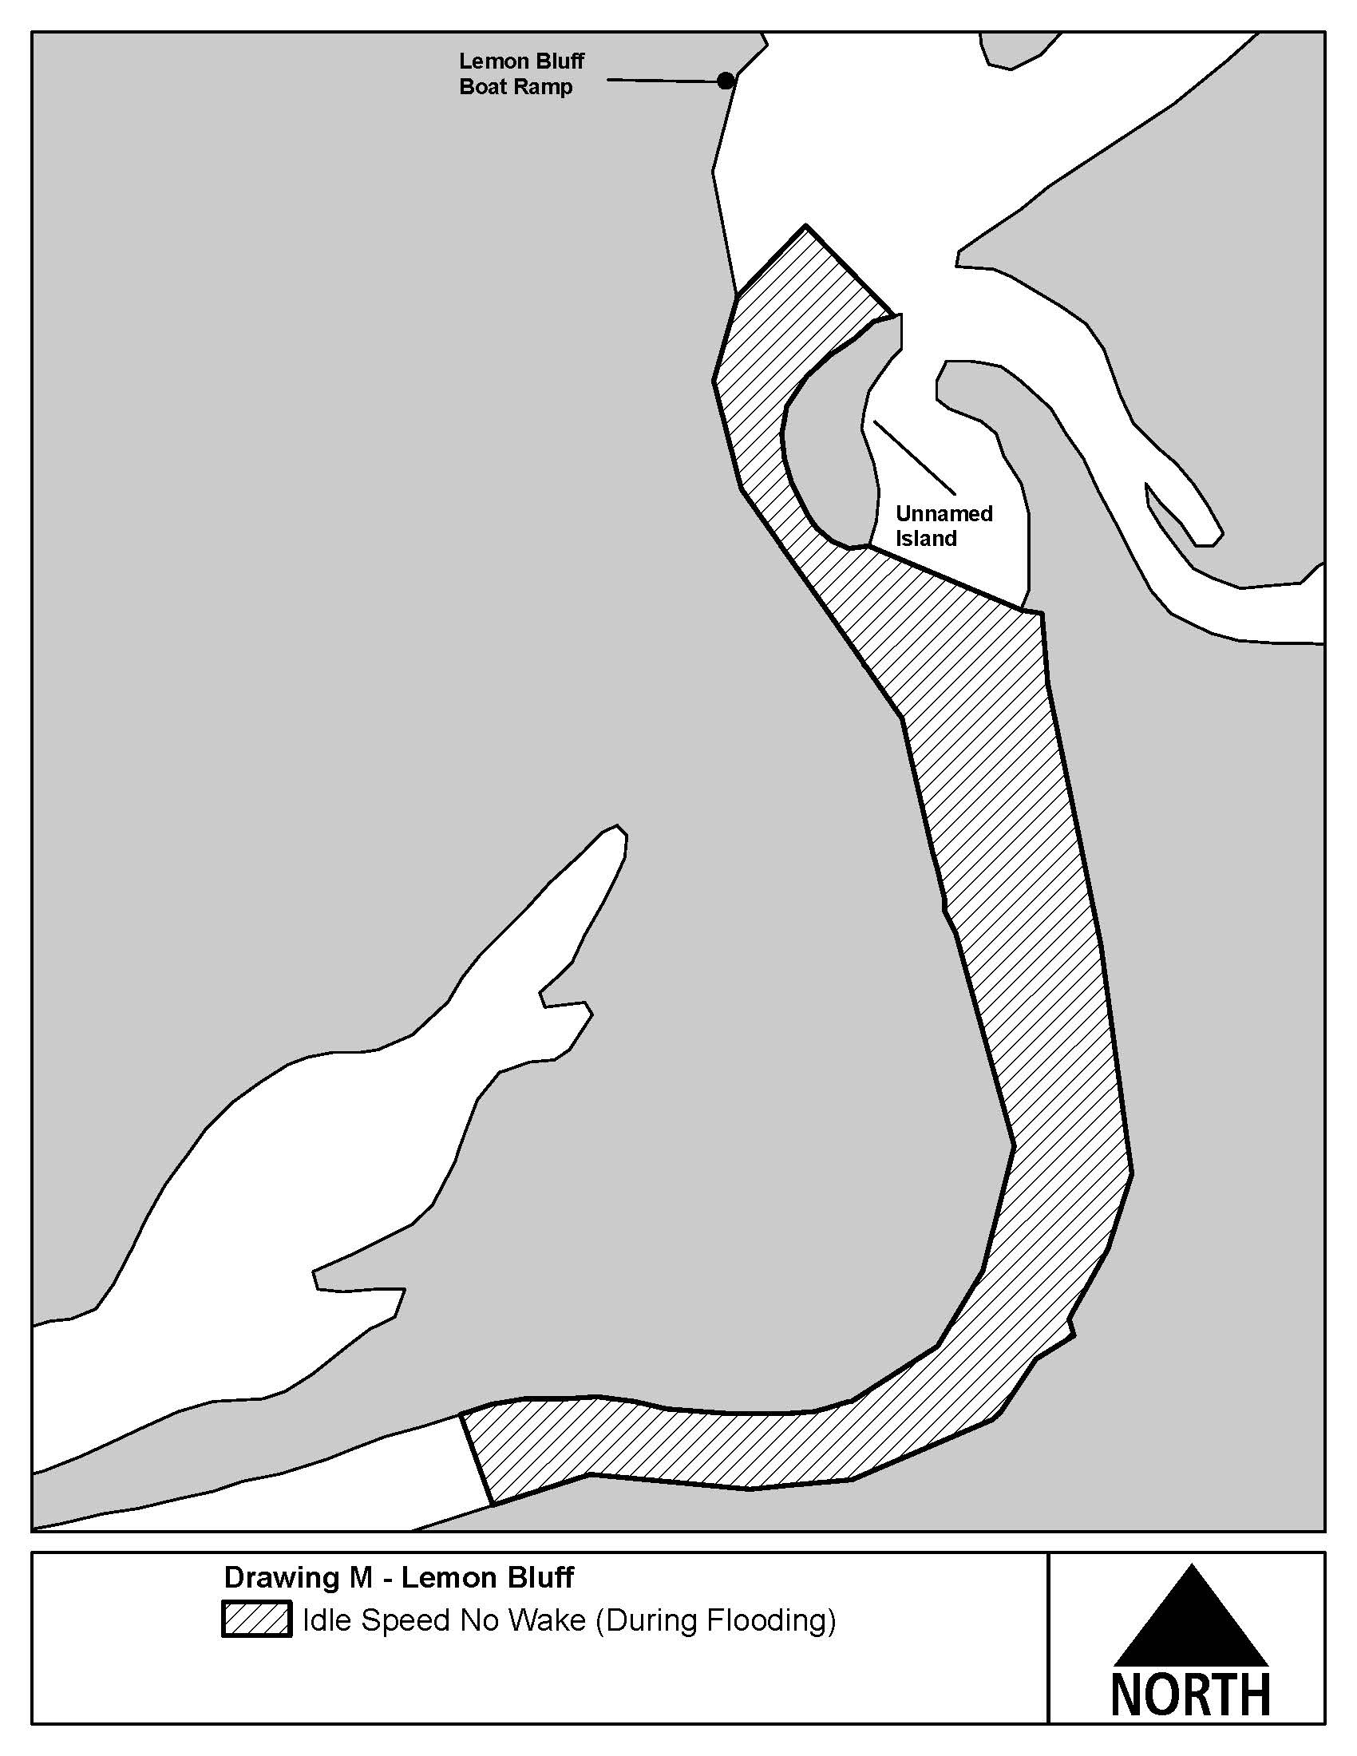

Rulemaking Authority 327.04, 327.46 FS. Law Implemented 327.33(3), 327.46 FS. History–New 6-3-92, Formerly 16N-24.018, Amended 10-3-95, 11-21-96, 2-4-98, Formerly 62N-24.018, Amended 4-22-13,________.

NAME OF PERSON ORIGINATING PROPOSED RULE: Major Richard Moore, Florida Fish and Wildlife Conservation Commission, Division of Law Enforcement, 620 South Meridian Street, Tallahassee, Florida 32399-1600
NAME OF AGENCY HEAD WHO APPROVED THE PROPOSED RULE: Florida Fish and Wildlife Conservation Commission
DATE PROPOSED RULE APPROVED BY AGENCY HEAD: February 12, 2014
DATE NOTICE OF PROPOSED RULE DEVELOPMENT PUBLISHED IN FAR: September 27, 2013

