20-94.001 Ownership.
The “Florida Sunshine Tree” symbol, as shown below,
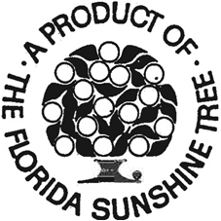
is a registered certification mark of the State of Florida, Department of Citrus, protected by U.S. Patent Office registration No. 941,773 and certain foreign registrations. All right, title and interest in and to said symbol, granted to and vested in the State of Florida, Department of Citrus, via State and Federal laws, is hereby noticed to all interested persons.
Rulemaking Authority 601.10(1), 601.11, 601.15(2)(b), (10)(a) FS. Law Implemented 601.101 FS. History–Formerly 105-1.46(1), Amended 1-1-75, Formerly 20-94.01.

