20-97.001 Ownership.
“Florida’s Seal of Approval” mark, as shown below,

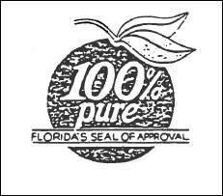

is a certification mark of the State of Florida, Department of Citrus, hereinafter referred to as “mark.” All right, title and interest in and to said mark, granted to and vested in the State of Florida, Department of Citrus, via State and Federal laws, is hereby noticed to all interested persons.
Rulemaking Authority 601.10(1), 601.11, 601.15(2)(b), (10)(a) FS. Law Implemented 601.101 FS. History–New 3-24-85, Formerly 20-97.01.

