20-98.001 Ownership.
The “Fresh Florida Sunshine Tree” mark, as shown below,

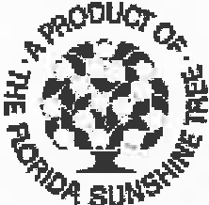

is a certification mark of the State of Florida, Department of Citrus. All right, title and interest in and to said mark, granted to and vested in the State of Florida, Department of Citrus, via State and Federal laws, is hereby noticed to all interested persons.
Rulemaking Authority 601.10(1), 601.11, 601.15 FS. Law Implemented 601.101 FS. History–New 2-5-87.

