20-111.001 Ownership and Purpose.
The purpose of this rule is to establish the guidelines for use of the “Made With Florida Citrus” mark. The “Made With Florida Citrus” mark, as shown below, is a registered trademark of the State of Florida, Department of Citrus.

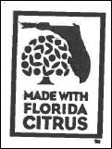

All right, title and interest in and to said mark, granted to and vested in the state of Florida, Department of Citrus, via State and Federal laws, is hereby noticed to all interested persons.
Rulemaking Authority 601.10(1), 601.11, 601.15(10)(a) FS. Law Implemented 601.101 FS. History–New 4-28-98, Amended 3-19-00, 5-23-01.

