40A-2.904 Areal Boundary Maps for Water Resource Caution Areas.
(1) Areal boundaries for the Santa Rosa, Okaloosa, and Walton County Water Resource Caution Area encompassing the area south of Eglin Air Force Base in Santa Rosa, (http://www.flrules.org/Gateway/reference.asp?No=Ref-03875), Okaloosa (http://www.flrules.org/Gateway/reference.asp?No=Ref-03874), and Walton County, (http://www.flrules.org/Gateway/reference.asp?No=Ref-03877), also the area extending south of SR-20 in Walton County to the Bay County, (http://www.flrules.org/Gateway/reference.asp?No=Ref-03876), Line are established for the implementation of water use permitting pursuant to this chapter and are indicated in Figure 2-2. These boundaries are depicted in specific detail for each of these counties on general county highway maps. These maps are hereby incorporated by reference and can be obtained from the District’s website (nwfwater.com) or from District offices.
(2) Areal boundaries for the Upper Telogia Creek Drainage Basin Water Resource Caution Area are established for the implementation of water use permitting pursuant to this Chapter and are indicated in Figure 2-3. These boundaries are depicted in detail on the Gadsden County, (http://www.flrules.org/Gateway/reference.asp?No=Ref-03873), general county highway map. This map is hereby incorporated by reference and can be obtained from the District’s website (nwfwater.com) or from District offices.

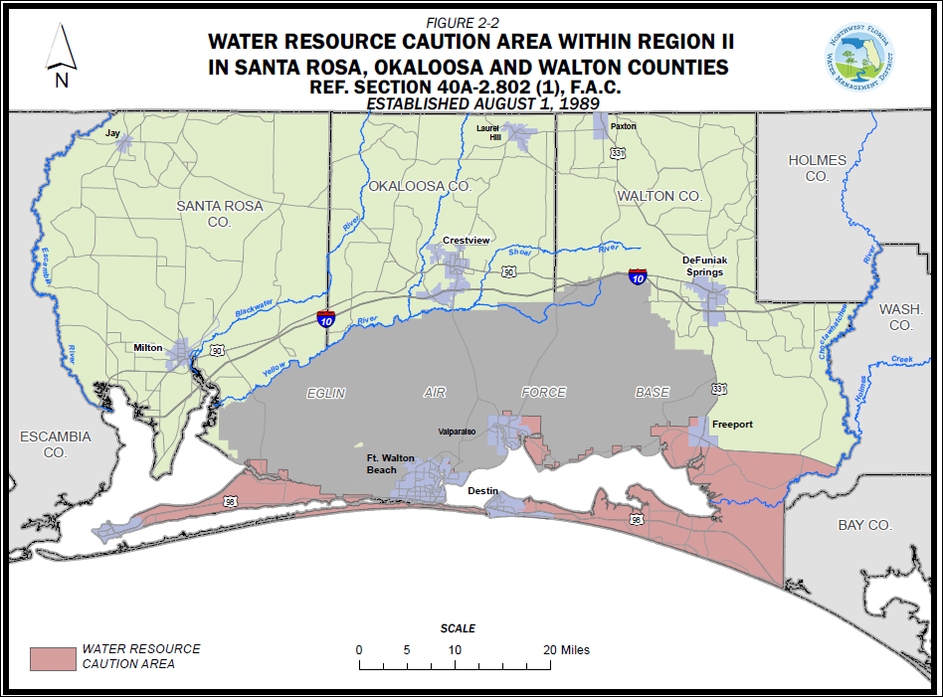

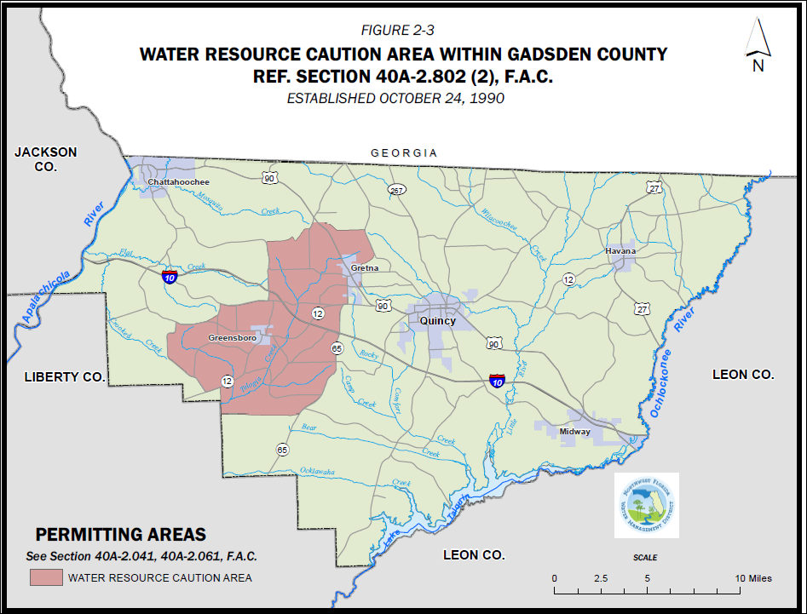
Rulemaking Authority 373.044, 373.171 FS. Law Implemented 373.216 FS. History–New 8-1-89, Amended 5-31-92, 11-1-93, 5-29-14.

