Notice of Proposed Rule

DEPARTMENT OF ENVIRONMENTAL PROTECTION
RULE NO.: RULE TITLE:
62-342.100 Intent
62-342.200 Definitions
62-342.450 Mitigation Bank Permit and Mitigation Bank Conceptual Approval Applications
62-342.470 Establishment of Mitigation Credits
62-342.650 Land Use Restrictions on Mitigation Banks
62-342.700 Financial Responsibility
62-342.750 Mitigation Bank Permit and Mitigation Bank Conceptual Approval
62-342.800 Surrender, Transfer, or Modification of Mitigation Bank Permits
62-342.850 Water Management District Mitigation Banks
62-342.900 Mitigation Banking Forms
PURPOSE AND EFFECT: The Department proposes to correct citations and references in Chapter 62-342, F.A.C., “Mitigation Banks,” resulting from adoption of the new Statewide Environmental Resource Permitting rule Chapter 62-330, F.A.C., effective October 1, 2013, and repeal of rules in Chapter 62-312, F.A.C., and repeal of Chapter 62-343, F.A.C., effective November 25, 2013.
Specifically, Rule 62-342.200 and paragraph 62-342.750(1)(c), refer to the success criteria in Rule 62-312.350, F.A.C., which is now repealed. The last effective date of Chapter 62-312, F.A.C., that existed prior to its repeal (March 15, 2007), needs to be added to the above provisions in Chapter 62-342, F.A.C., so that mitigation bankers can continue to rely on those criteria.
SUMMARY: Update and correct rule citations and references in Chapter 62-342, F.A.C., and in the forms.
OTHER RULES INCORPORATING THIS RULE: Sub-subparagraph 62-4.050(4)(e)4.a.; subsections 62-330.054(3), 62-330.056(3) and (4), 62-330.301(3), 62-330.320(5), and 62-330.340(1) and (2); and Applicant’s Handbook, Volume I, section 1.4.2; section 2.0(a) definitions 62. and 80.; section 3.3.2 ; section 5.5.3.1(d); section 10.3.1.3; and section 10.3.7.1(d).
EFFECT ON THOSE OTHER RULES: None. There are no changes proposed to the process or requirements of Chapter 62-342, F.A.C.
SUMMARY OF STATEMENT OF ESTIMATED REGULATORY COSTS AND LEGISLATIVE RATIFICATION: The Agency has determined that the proposed rule is not expected to require legislative ratification based on the statement of estimated regulatory costs or if no SERC is required, the information expressly relied upon and described herein: Not Applicable.
Any person who wishes to provide information regarding the statement of estimated regulatory costs, or provide a proposal for a lower cost regulatory alternative must do so in writing within 21 days of this notice.
RULEMAKING AUTHORITY: 373.4131, 373.4136(11) FS.
LAW IMPLEMENTED: 373.4131, 373.4135, 373.4136 FS.
IF REQUESTED WITHIN 21 DAYS OF THE DATE OF THIS NOTICE, A HEARING WILL BE SCHEDULED AND ANNOUNCED IN THE FAR.
THE PERSON TO BE CONTACTED REGARDING THE PROPOSED RULE IS: Alice Heathcock, Florida Department of Environmental Protection, Submerged Lands and Environmental Resources Coordination, 2600 Blair Stone Road, MS 2500, Tallahassee, FL 32399-2400, telephone: (850)245-8483, e-mail: Alice.Heathcock@dep.state.fl.us or facsimile (850)245-8499, (OGC NO. 14-0014)

THE FULL TEXT OF THE PROPOSED RULE IS:

62-342.100 Intent.
(1) No change.
(2) The responsibilities for implementing this chapter are described in Operating and Delegation Agreements between the Department of Environmental Protection (“Department”) and the water management districts (“Districts”). The Agreements are incorporated by reference in subsection 62-113.100(3), F.A.C. The term “Agency” applies to the Department or a District, as applicable, throughout this chapter.
(3) The Agency Department intends that Mitigation Banks be used to minimize mitigation uncertainty associated with traditional mitigation practices and provide greater assurance of mitigation success. It is anticipated that the consolidation of multiple mitigation projects into larger contiguous areas will provide greater assurance that the mitigation will yield long-term, sustainable, regional ecological benefits. Mitigation Banks shall be consistent with Agency Department endorsed watershed management objectives and emphasize restoration and enhancement of degraded ecosystems and the preservation of uplands and wetlands as intact ecosystems rather than alteration of landscapes to create wetlands. This is best accomplished through restoration of ecological communities that were historically present. The establishment and use of Mitigation Banks in or adjacent to areas of national, state, or regional ecological significance is encouraged, provided the area in which the Mitigation Bank is proposed to be located is determined appropriate for a Mitigation Bank and the Mitigation Bank meets all applicable permitting criteria.
(3) renumber (4) No change.
Rulemaking Authority 373.4131, 373.4136(11) FS. Law Implemented 373.4131, 373.4135, 373.4136 FS. History–New 2-2-94, Formerly 17-342.100, Amended 5-21-01,_________.

62-342.200 Definitions.
Terms used in this chapter shall have the meanings specified below.
(1) through (8) No change.
(9) “Regional Watershed” means a watershed as delineated in the following maps. (Figures 1, 2, 3, 4, and 5.)
Figure 1: Northwest Florida Water Management District ‒ “Regional Watersheds of the NWFWMD for Mitigation Banks, 7 Watersheds,” (May 21, 2001), which is incorporated by reference herein.
Figure 2: Suwannee River Water Management District – “Watersheds of the SRWMD Mitigation Banks, 7 Watersheds,” (May 21, 2001), which is incorporated by reference herein.
Figure 3: St. Johns River Water Management District – “SJRWMD, Regional Watersheds for Mitigation Banking (October 1, 2013)”, Appendix A, Figure 10.2.8-2, Applicants Handbook Volume II, which is incorporated by reference in subparagraph 62-330.010(4)(b)3, F.A.C., [October 1, 2013] (http://www.flrules.org/Gateway/reference.asp?No=Ref-03181), and in subsections 40C-4.091(1) [October 1, 2013] (https://www.flrules.org/Gateway/reference.asp?No=Ref-02524), 40C-42.091(1) [October 1, 2013] (https://www.flrules.org/Gateway/reference.asp?No=Ref-02525), and 40C-44.091(1), F.A.C., [October 1, 2013] (https://www.flrules.org/Gateway/reference.asp?No=Ref-02526).
Figure 4: Southwest Florida Water Management District – “Drainage Basins and Watersheds within the Southwest Florida Water Management District (October 1, 2013)”, Figure 2.6, Applicants Handbook Volume II, is incorporated by reference in subparagraph 62-330.010(4)(b)4, F.A.C., [October 1, 2013] (http://www.flrules.org/Gateway/reference.asp?No=Ref-03176), and in Rule 40D-4.091, F.A.C., [October 1, 2013] (https://www.flrules.org/Gateway/reference.asp?No=Ref-02527).
Figure 5: South Florida Water Management District – Appendix D: “SFWMD Basins for Cumulative Impact Assessments & Mitigation Bank Service Areas” (October 1, 2013), Applicants Handbook Volume II, including Appendices A through D, is incorporated by reference in subparagraph 62-330.010(4)(b)5, F.A.C., [October 1, 2013] (https://www.flrules.org/Gateway/reference.asp?No=Ref-02528) and in paragraph 40E-4.091(1)(a), F.A.C., [October 1, 2013] (https://www.flrules.org/Gateway/reference.asp?No=Ref-02529).
A copy of the incorporated material identified above also may be obtained from the Agency Internet site or by contacting staff in an Agency office identified in the “References and Design Aids, Volume I”, available at http://www.dep.state.fl.us/water/rulesprog.htm#erp.

[Substituting this same, but clearer, map for the one in current rule, which is missing the left margin. There are no changes to the basin boundaries, but the basin names are changed.]
Figure 1: Northwest Florida Water Management District ‒ “Regional Watersheds of the NWFWMD for Mitigation Banks, 7 Watersheds,” (May 21, 2001)
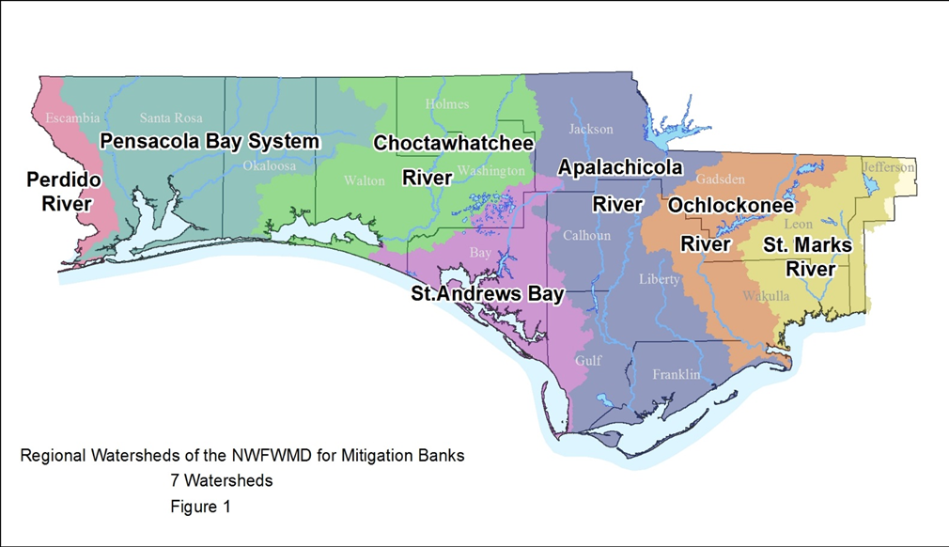

[Strike the following existing Figure 1:]
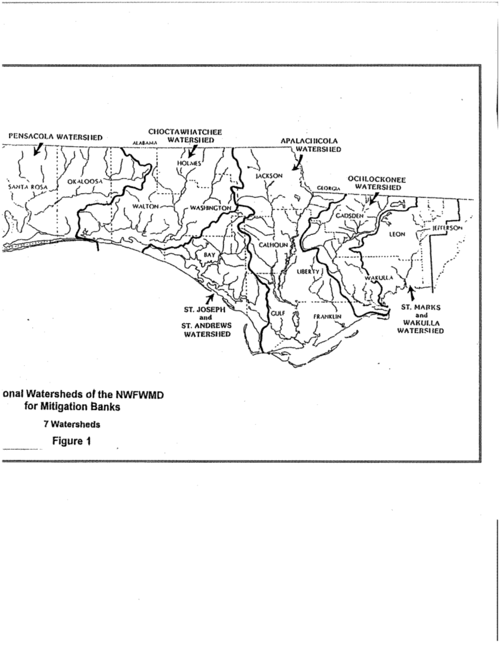
[Substitute the following clearer map for the one in current rule which is missing the left margin. There are no changes to the basin boundaries or names.]
Figure 2: Suwannee River Water Management District -- “Watersheds of the SRWMD Mitigation Banks, 7 Watersheds”, (May 21, 2001)
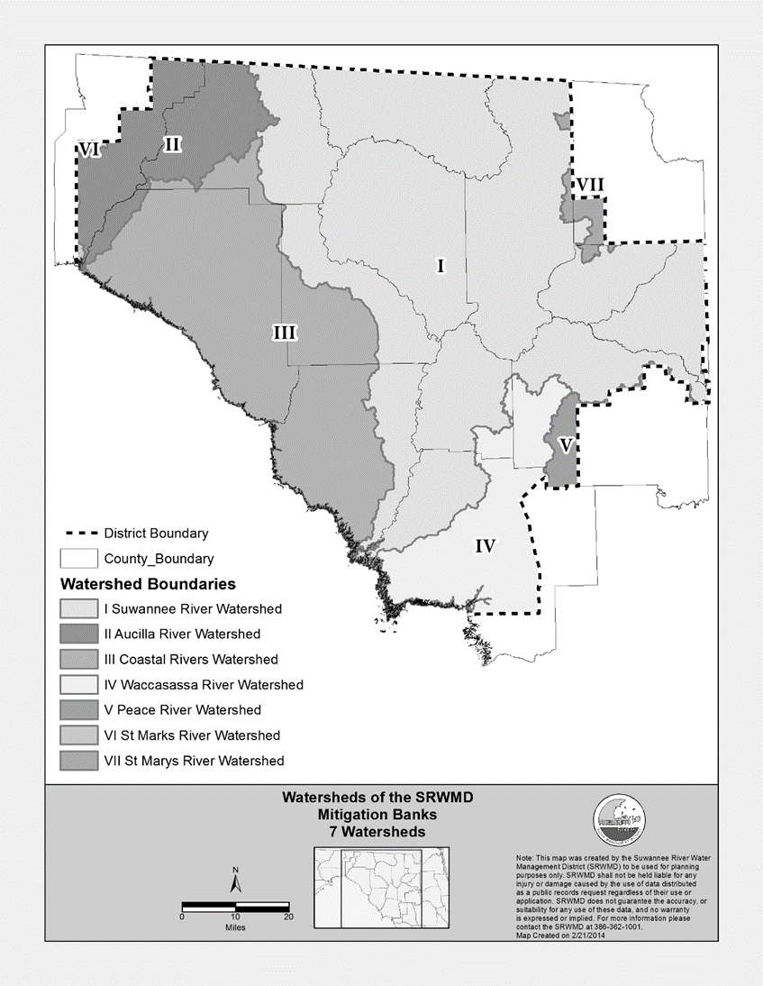

[Strike the following existing Figure 2:]
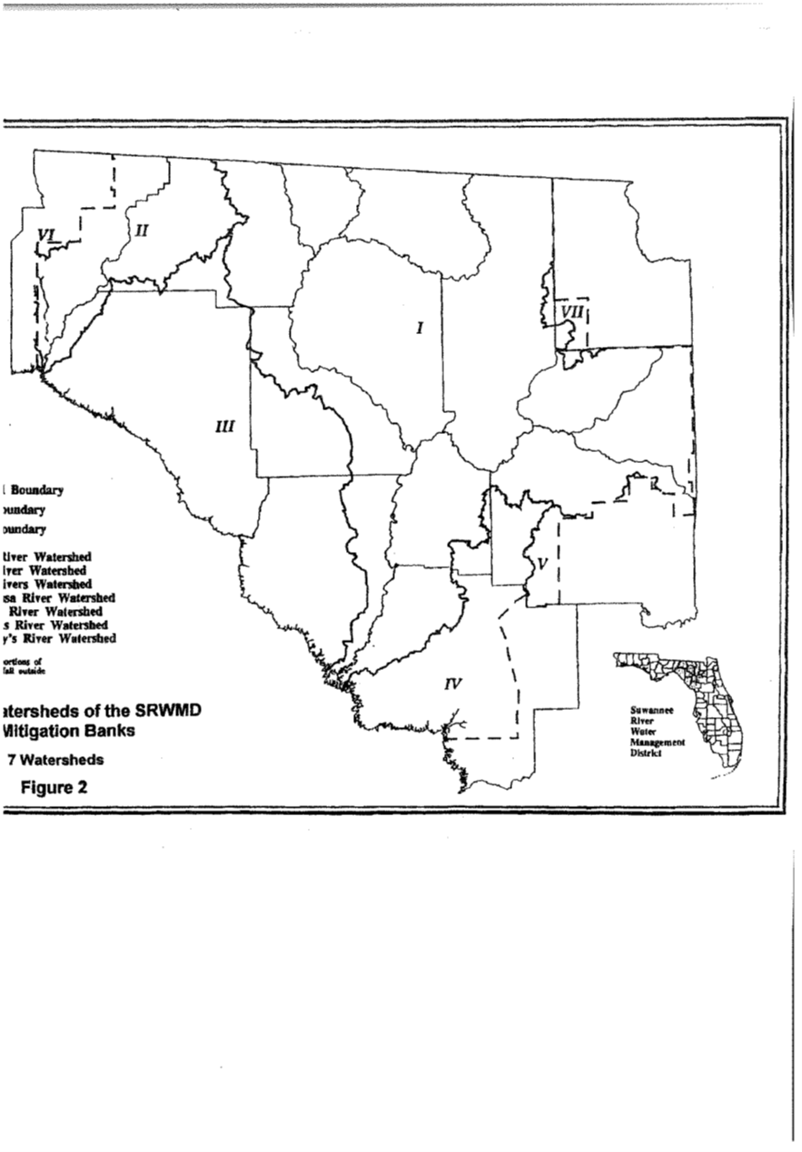
Figure 3: St. Johns River Water Management District -- “SJRWMD, Regional Watersheds for Mitigation Banking (October 1, 2013)
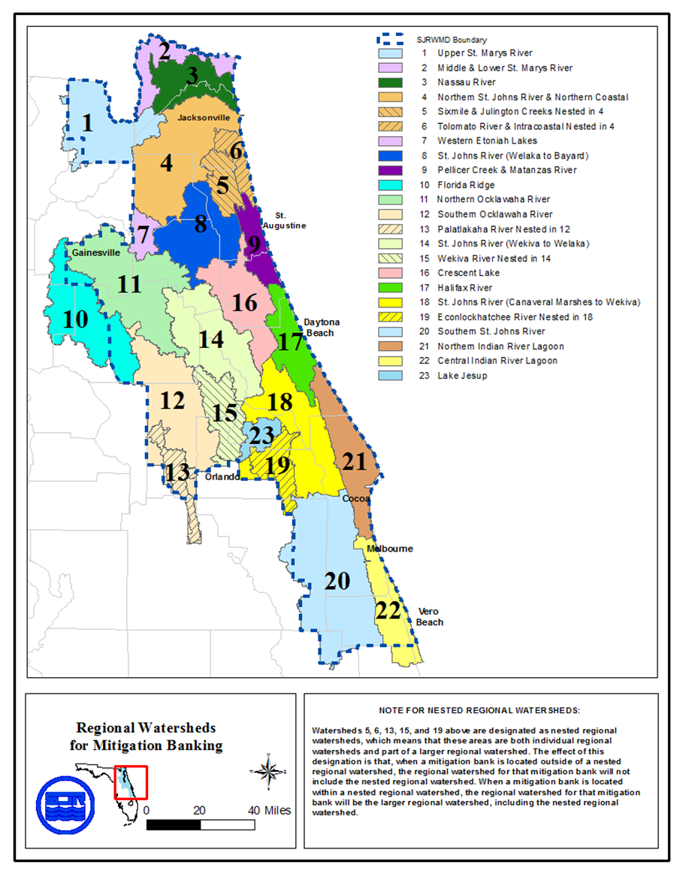
[Strike the following existing map, titled “Figure 3, Regional Watersheds for Mitigation Banking (11/09/1999)”:]
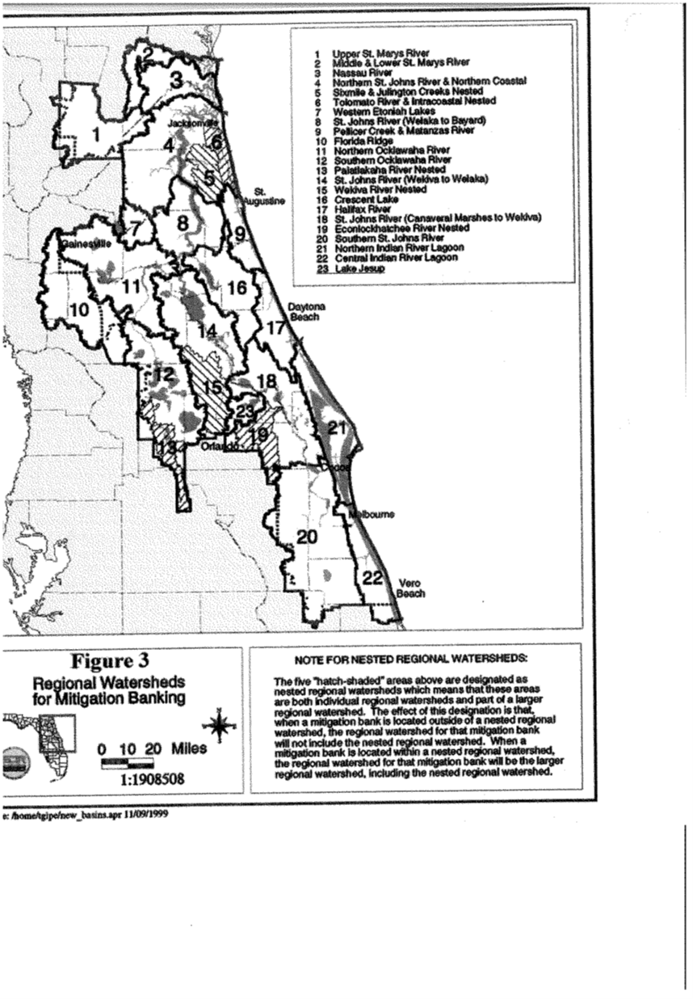
[Strike the following existing list of waterbodies, titled “SJRWMD REGIONAL WATERSHEDS FOR MITIGATION BANKS”:]
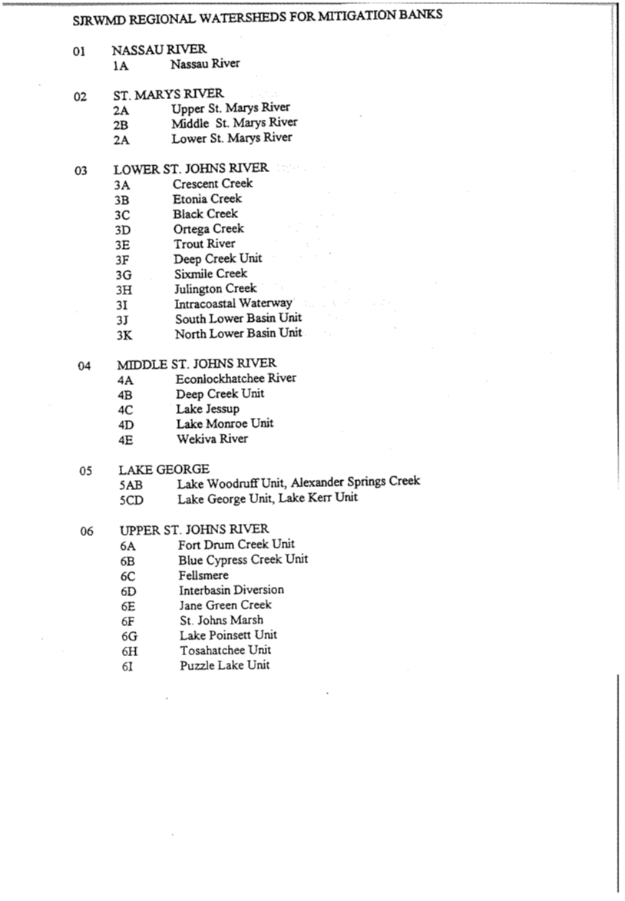

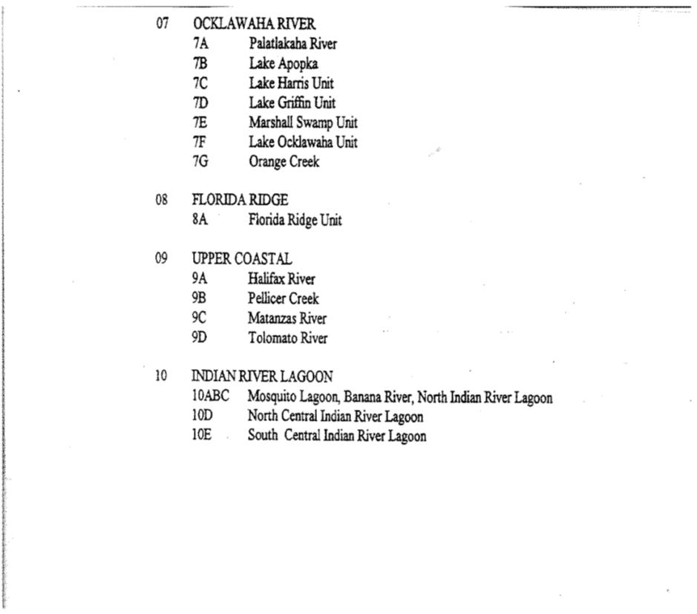
Figure 4: Southwest Florida Water Management District -- “Drainage Basins and Watersheds within the Southwest Florida Water Management District (October 1, 2013)”
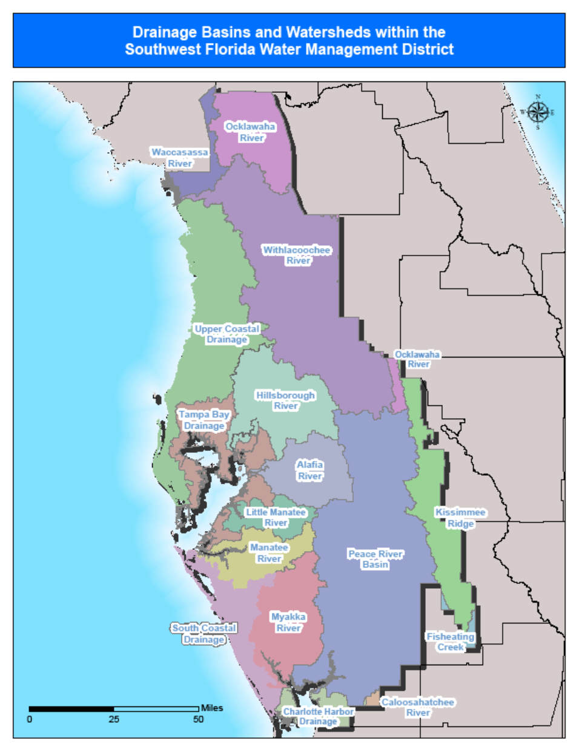
[Strike the following existing map, titled “Regional Watersheds of the SWFWMD for Mitigation Banks, 12 Watersheds, Figure 4”:]
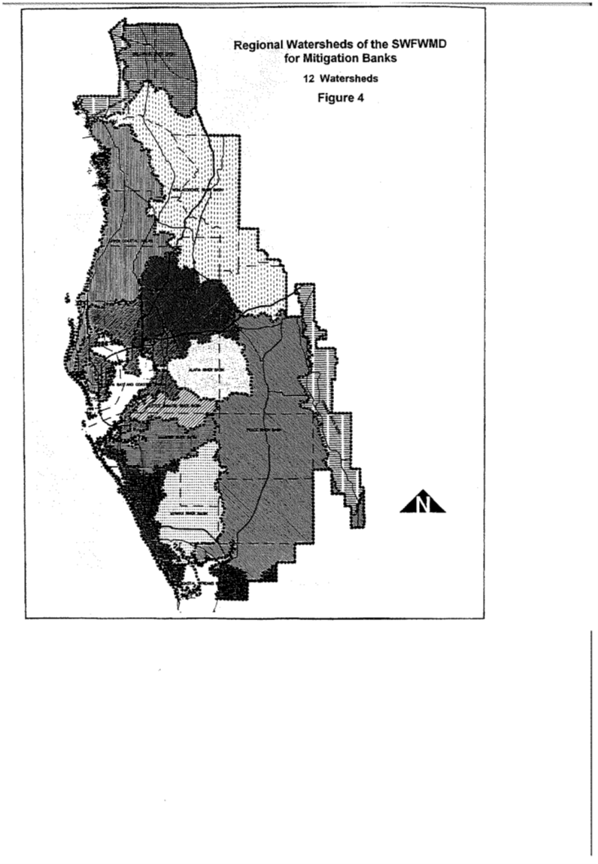
Figure 5: South Florida Water Management District – Appendix D: “SFWMD Basins for Cumulative Impact Assessments & Mitigation Bank Service Areas” (October 1, 2013)
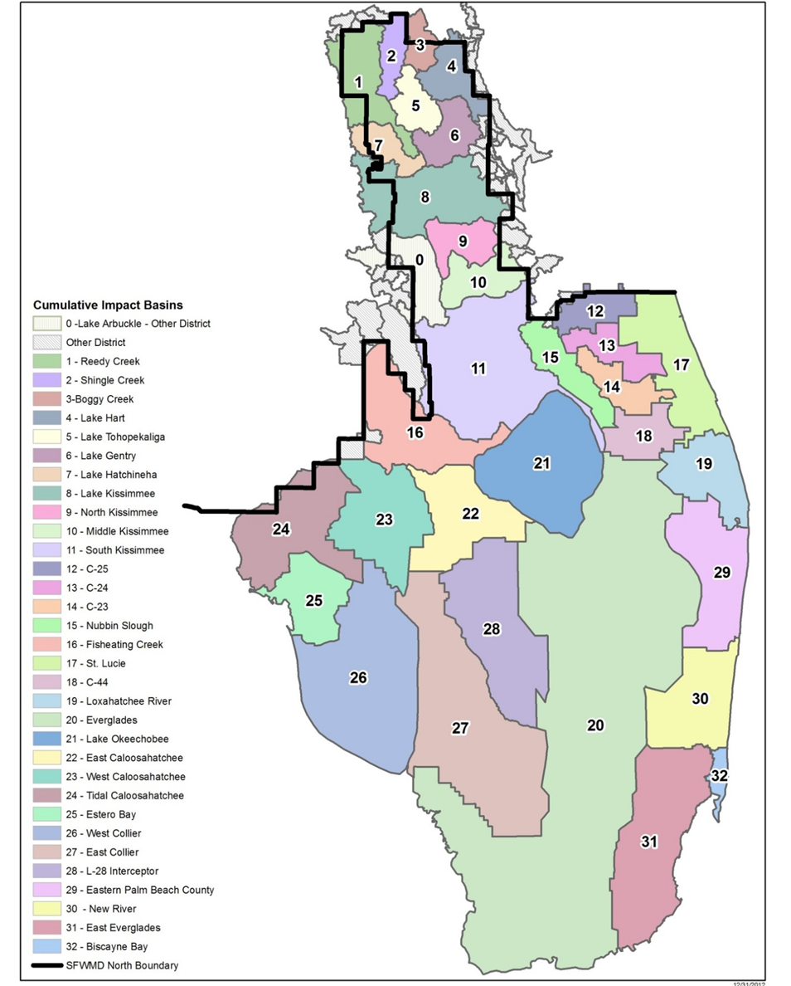

[Strike the following existing map, titled “Regional Watersheds of the SFWMD for Mitigation Banks, 35 Watersheds, Figure 5”:]
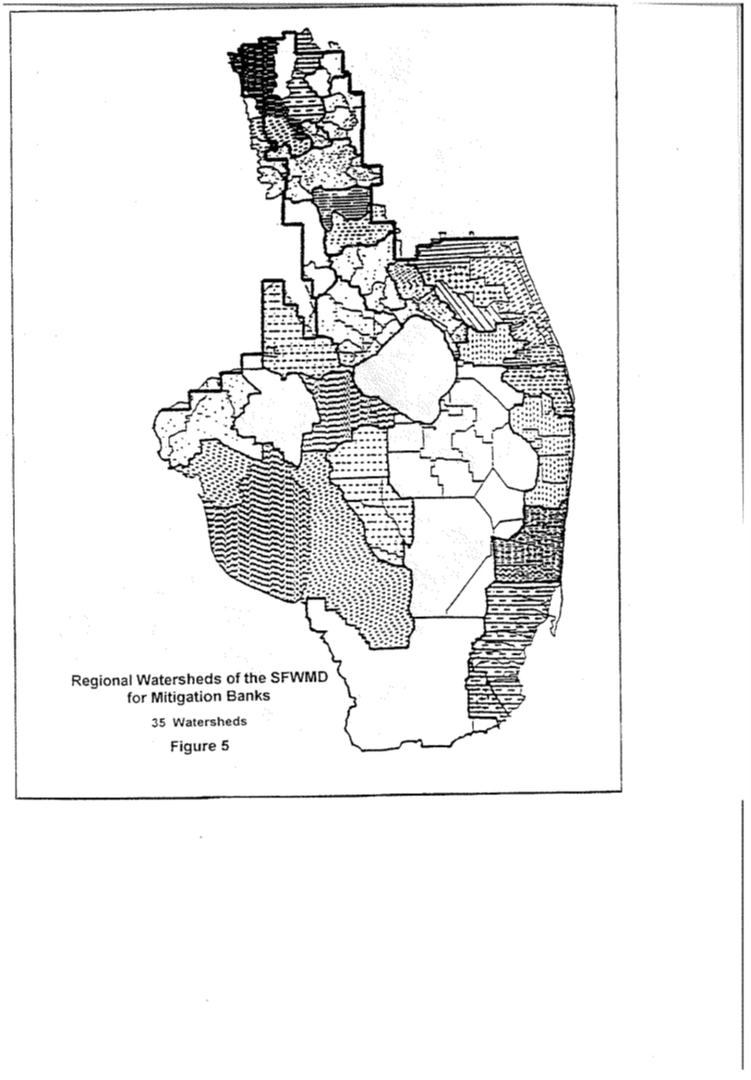
(10) “Success” means when a Mitigation Bank meets the success criteria provided in section 10.3.6 of Applicant’s Handbook, Volume I, incorporated by reference in Rule 62-330.010 62-312.350, F.A.C., and in the Mitigation Bank Permit. Prior to March 15, 2007, the success criteria was provided in Rule 62-312.350, F.A.C., and in the Mitigation Bank Permit.
Rulemaking Authority 373.4131, 373.4136(11) FS. Law Implemented 373.4131, 373.4135, 373.4136 FS. History–New 2-2-94, Formerly 17-342.200, Amended 12-12-94, 8-21-00, 5-21-01,___________.

62-342.450 Mitigation Bank Permit and Mitigation Bank Conceptual Approval Applications.
Any person or entity proposing to establish a Mitigation Bank must apply for a Mitigation Bank Permit. An application for a Mitigation Bank Permit shall also constitute an application for any required permit authorized under Part IV of Chapter 373, F.S. Mitigation Bank Permit applications shall be processed according to Chapter 120, F.S. The Agency Department will process and take action on all permit applications under Part IV of Chapter 373, F.S., necessary for the implementation of any Mitigation Bank for which it has permitting responsibility under the operating agreements between the Department and the Water Management Districts incorporated by reference in Rule 62-113.100, F.A.C. and the Department as authorized under Section 373.046, F.S. A person or entity who wishes to obtain an estimation of the legal and financial requirements necessary for a Mitigation Bank, information necessary for evaluation of a Mitigation Bank Permit application, and potential mitigation credits to be awarded under a Mitigation Bank Permit, may apply for a Mitigation Bank Conceptual Approval Permit. To provide the Agency Department with reasonable assurances that the proposed Mitigation Bank will meet the criteria in Section 373.4136, F.S., and in this chapter, and that any proposed system will meet the applicable criteria of Part IV of Chapter 373, F.S., each Mitigation Bank Permit application submitted to the Agency Department shall include the information required under Part IV of Chapter 373, F.S., as applicable, and the information specified below as appropriate for the proposed bank:
(1) through (7) No change.
(8) Any additional information which the Agency Department requests in order to evaluate whether the proposed Mitigation Bank meets the criteria of Section 373.4136, F.S., and this chapter.
Rulemaking Authority 373.4131, 373.4136(11) FS. Law Implemented 373.4131, 373.4135, 373.4136 FS. History–New 2-2-94, Formerly 17-342.450, Amended 12-12-94, 5-21-01,___________.

62-342.470 Establishment of Mitigation Credits.
(1) Based upon the information submitted by the applicant, and an assessment of the proposed Mitigation Bank under the criteria of Section 373.4136, F.S., the Agency Department will assign a number of Mitigation Credits to the proposed Mitigation Bank, or phases thereof.
(2) through (6) No change.
(7) The Agency Department shall maintain a ledger of the Mitigation Credits available in each Mitigation Bank. Mitigation Credits shall be withdrawn as a minor modification of the Mitigation Bank Permit. To use Mitigation Credits, the impact permit applicant must submit to the agency permitting the impact, documentation from the banker demonstrating that Mitigation Credits have been reserved, sold or transferred to the permit applicant, and that the banker has requested that the Mitigation Credits be withdrawn from the Mitigation Bank. If the agency permitting the impact determines that use of the Mitigation Credits proposed by the applicant is appropriate to offset the adverse impacts, it shall notify the Agency Department. Upon receipt of this notice, the Agency Department shall determine if a sufficient number and type of Mitigation Credits are available, withdraw the Mitigation Credits as a minor modification of the Mitigation Bank Permit, and notify the agency permitting the impact and the banker by letter of the withdrawal of the Mitigation Credits and the remaining balance of Mitigation Credits.
(8) When the Department or a the District is the banker, each Agency agency shall maintain its own ledger. The District or Department shall annually submit a report of the Mitigation Credits sold, transferred, or used from its Mitigation Bank to the permitting Agency Department.
Rulemaking Authority 373.4131, 373.4136(11) FS. Law Implemented 373.4131, 373.4135, 373.4136 FS. History–New 2-2-94, Formerly 17-342.470, Amended 5-21-01,__________.

62-342.650 Land Use Restrictions on Mitigation Banks.
(1) Before Mitigation Credits may be used from a Mitigation Bank or any phase of a Mitigation Bank, the banker shall either:
(a) Cause cause a fee interest to be conveyed to the Board of Trustees of the Internal Improvement Trust Fund (“Board of Trustees”);, or
(b) Cause cause a conservation easement to be conveyed to both the Department and the District. The grantor of a conservation easement may convey a conservation easement to additional grantees, but such conveyance shall be subordinate to the conservation easement granted to the Department and the District. Mitigation Banks on federal Federal, state, or water management district owned land shall be encumbered in perpetuity by conservation easements, or other mechanisms shall be employed to ensure preservation according to the Mitigation Bank permit.
(2) If the Mitigation Bank is located within an area identified in a Agency Department acquisition plan, and the Agency Department determines that the ecological value of the bank can be increased by incorporating the bank into the Agency’s Department’s land management programs, the Agency Department may award additional mitigation credits if the fee interest in the bank is conveyed to the Agency Department as opposed to a conservation easement.
(3) All conservation easements shall be granted in perpetuity without encumbrances, unless such encumbrances do not adversely affect the ecological viability of the Mitigation Bank. All conservation easements shall be of a form and content sufficient to ensure preservation of the Mitigation Bank according to the permit, and shall, at a minimum, meet requirements and restrictions of Section 704.06, F.S., except as provided in subsection 62-342.650(9), F.A.C. The conservation easement shall also provide that the banker shall have access to the property and the authority to perform all acts necessary to ensure compliance with the Mitigation Bank Permit (unless the banker is the fee owner of the property), and that the Agency Department shall have access and the authority to perform these acts if the banker fails to do so.
(4) No change.
(5) As part of providing reasonable assurance that the Mitigation Bank site will be preserved in perpetuity, the grantor of the property or conservation easement shall provide the following unless the Agency Department determines during the permit review process such items are not necessary to ensure preservation of the Mitigation Bank according to the permit:
(a) A boundary survey of the real property interest being conveyed. The survey must be certified, by a land surveyor and mapper, registered in the State of Florida, to meet the requirements of the Agency Department and the minimum technical standards set forth by the Florida Board of Professional Land Surveyors and Mappers mappers in Rules 5J-17.050 through 5J-17.052 Chapter 61G17-6, F.A.C., under Section 472.027, F.S.
(b) A certified appraisal or other documentation demonstrating the market value of the property or interest to be conveyed to determine the appropriate amount of title insurance.
(c) A marketable title commitment issued to the Agency Department as beneficiary in an amount at least equal to the fair market value, as established in paragraph 62-342.650(5)(b) 62-342.650(4)(b), F.A.C., of the interest being conveyed. An owner’s title insurance policy (ALTA Form B) naming the Agency Department as beneficiary shall be issued to the Agency Department within the time frames specified by the permit. The coverage, form and exceptions of the title insurance policy shall ensure that the Mitigation Bank will be preserved according to the Mitigation Bank Permit.
(d) A Phase I environmental audit identifying any environmental problems which may affect the liability of the Agency Department or Board of Trustees and any additional audits as are necessary to ensure that the Agency Department or the Board of Trustees is not subject to liability under federal Federal or state State laws relating to the treatment or disposal of hazardous substances or ownership of land upon which hazardous substances are located, or to ensure that there are not hazardous substances present on the property which would adversely affect construction, implementation, and perpetual management of the Mitigation Bank.
(6) The Agency Department shall require additional documentation or actions from the grantor of the conservation easement or fee interest if such additional documentation or actions are necessary to ensure that the Mitigation Bank will be preserved according to the Mitigation Bank permit.
(7) The banker shall pay the documentary revenue stamp tax and all other taxes or costs associated with the conveyance, including the cost of recording the deed or conservation easement and any other recordable instruments required by the Agency Department or Board of Trustees, unless prohibited or exempt by law, as a condition of the receipt of the conveyance.
(8) All real estate taxes and assessments which are or which may become a lien against the property shall be satisfied of record by the banker before recording the conservation easement. If necessary, the banker shall, in accordance with Section 196.295, F.S., place funds in escrow with the county tax collector. The mitigation banker shall also provide the Agency Department with annual documentation demonstrating that such taxes and assessments have been paid.
(9) As a condition of receipt of the conveyance the banker shall remove all abandoned personal property, solid waste, or hazardous substances from the property that: reduces the proposed ecological value of the property; will adversely affect the construction, implementation or management of the bank; will adversely affect the construction, alteration, operation, maintenance, abandonment or removal of any surface water management system to be constructed in the bank; or poses a risk of liability to the Board of Trustees or the Agency Department.
(10) The banker shall record the conservation easement or property deed required in the Mitigation Bank Permit. The banker shall submit to the Agency Department the original recorded conservation easement or property deed as soon as such document is returned from the public records office.
Rulemaking Authority 373.4131, 373.4136(11) FS. Law Implemented 373.4131, 373.4135, 373.4136 FS. History–New 2-2-94, Formerly 17-342.650, Amended 12-12-94, 5-21-01,__________.

62-342.700 Financial Responsibily
(1) No change.
(2) Submitting Financial Responsibility Documentation. The applicant shall provide draft documentation of the required financial responsibility mechanisms described below with the permit application, and shall submit to the Agency Department the executed or finalized documentation within the time frames specified in the permit. The provisions of this section shall also apply for any modifications to the Mitigation Bank Permit.
(3) General Terms for Financial Responsibility Mechanisms. In addition to the specific provisions regarding financial responsibility mechanisms for construction and implementation in subsection 62-342.700(4), F.A.C., and perpetual management in subsection 62-342.700(9), F.A.C., the following terms shall be complied with:
(a) The financial responsibility mechanisms shall be payable at the direction of the Agency Department to its designee or to a standby trust agreement. The financial responsibility mechanism shall be retained by the Agency Department if it is of a type which is retained by the beneficiary according to industry standards.
(b) Demonstration of financial responsibility shall be continuous until complete satisfaction of the applicable permit conditions and approved release of financial responsibility by the Agency Department.
(c) All financial mechanisms must guarantee that the banker will perform all of its obligations under the permit, provide alternative financial assurance of a type allowed by this section, and obtain the Agency’s Department’s written approval of the alternative assurance provided within 90 days after receipt by both the banker and the Agency Department of a notice of cancellation of a bond or intent not to extend the expiration date of a letter of credit.
(d) through (e) No change.
(f) A banker must notify the Agency Department by certified mail within 10 days after the commencement of a voluntary or involuntary proceeding:
1. through 3. No change.
4. A general assignment of its assets for the benefit of creditors under Chapter 727, F.S.
A banker may not assign its assets for the benefit of creditors. A banker will be without the required financial assurance in the event of a bankruptcy of the trustee of any trust provided under this rule, or the suspension or revocation of the authority of any trustee to act as trustee, or in the event of a bankruptcy of the issuing institution of any bond or letter of credit, or the revocation of the authority of such institution to issue such instruments. The banker must notify the Agency Department within 10 days, and establish other financial assurance within 60 days after such an event.
(4) No change.
(5) Surety or Performance Bond.
(a) No change.
(b) The surety or performance bond shall be worded in substantial conformance with Form 62-342.700(1) 62-342.900(1), “Mitigation Bank Performance Bond to Demonstrate Construction and Implementation Financial Assurance,” [May 21, 2001], which is incorporated by reference herein and available at http://www.flrules.org/Gateway/reference.asp?No=Ref-xxxxx. This form and all the forms incorporated in Rule 62-342.700, F.A.C., also are available from the Department of Environmental Protection’s Internet site, http://www.dep.state.fl.us/water/wetlands/erp/forms.htm; or by contacting the Submerged Lands and Environmental Resources Coordination Program, Department of Environmental Protection, 2600 Blair Stone Road—MS 2500, Tallahassee, Florida 32399, (850)245-8336. Deviations from the form shall be identified and submitted to the Agency Department for review and approval.
(c) No change.
(d) The mitigation banker who uses a surety or performance bond to satisfy the requirements of subsection 62-342.700(4), F.A.C., must establish a standby trust fund when the surety or performance bond is acquired. Under the terms of the bond, all amounts paid by the surety under the bond will be deposited directly into the standby trust fund for distribution by the trustee in accordance with the Agency’s Department’s instructions. The standby fund agreement must meet the requirements specified in subsection 62-342.700(7), F.A.C.
(e) The bonding company shall provide notice of cancellation of a bond by certified mail to the banker and to the Agency Department. Cancellation may not occur, however, during the 120 days beginning on the date of receipt of the notice of cancellation by both the banker and the Agency Department, as evidenced by the return receipt.
(f) A bond may be canceled by the banker if the Agency Department has given prior written consent. The Agency Department shall provide such consent when either the banker substitutes alternative financial assurance allowed under this rule and such alternate financial assurance is approved by the Agency Department and is effective or the Agency Department releases the banker from the requirements of this subsection.
(6) Irrevocable Letter of Credit.
(a) A mitigation banker may satisfy the requirements of subsection 62-342.700(4), F.A.C., by obtaining an irrevocable letter of credit that conforms to the requirements of this subsection. The irrevocable letter of credit shall be provided by a federally insured depository that is “well capitalized” or “adequately capitalized” as defined in Section 38 of the Federal Deposit Insurance Act [12 USC 1831o(b)] (12 USC 1831(o)). The banker shall submit proof of such capitalization to the Agency Department.
(b) The irrevocable letter of credit shall be worded in substantial conformance with Form 62-342.700(2) 62-342.900(2), “Mitigation Bank Irrevocable Letter of Credit to Demonstrate Construction/Implementation Financial Assurance,” (May 21, 2001) (http://www.flrules.org/Gateway/reference.asp?No=Ref-xxxxx), incorporated by reference herein. Deviations from the form shall be identified and submitted to the Agency Department for review and approval.
(c) A mitigation banker who uses an irrevocable letter of credit to satisfy the requirements of subsection 62-342.700(4), F.A.C., must also establish a standby trust fund when the irrevocable letter of credit is acquired. Under the terms of the irrevocable letter of credit, all amounts paid pursuant to a sight draft by the Agency Department will be deposited by the issuing institution directly into the standby trust fund to be distributed by the trustee in accordance with instructions from the Agency Department. This standby trust fund must meet the requirements specified in subsection 62-342.700(7), F.A.C.
(d) Letters of credit must be irrevocable and issued for a period of at least one year, and the expiration date must be automatically extended for a period of at least one year unless, at least 120 days prior to the expiration date, the issuing institution notifies both the banker and the Agency Department by certified mail of a decision not to extend the expiration date. The terms of the irrevocable letter of credit must provide that the 120 days begins on the date when both the banker and the Agency Department have received the notice, as evidenced by the return receipts.
(7) Standby Trust Fund.
(a) A mitigation banker using a surety or performance bond or irrevocable letter of credit shall contemporaneously establish a standby trust fund. The trustee of the standby trust shall be an entity that has the authority to act as a trustee and whose trust operations are regulated and examined by a federal Federal agency or an agency of the state in which the fund is established. The banker shall provide proof of such regulation and examination to the Agency Department.
(b) The standby trust agreement shall be worded in substantial conformance with Form 62-342.700(3) 62-342.900(3), “Mitigation Bank Standby Trust Fund Agreement to Demonstrate Construction/Implementation Financial Assurance,” (May 21, 2001) (http://www.flrules.org/Gateway/reference.asp?No=Ref-xxxxx), incorporated by reference herein. Deviations from the form shall be identified and submitted to the Agency Department for review and approval.
(8) Trust Fund.
(a) A mitigation banker may satisfy the requirements of subsection 62-342.700(4), F.A.C., by establishing a trust fund that conforms to the requirements of this section. The trustee of the trust fund shall be an entity that has the authority to act as a trustee and whose trust operations are regulated and examined by a federal Federal agency or an agency of the state in which the fund is established. The banker shall provide proof of such regulation and examination to the Agency Department.
(b) The trust agreement must be worded in substantial conformance to Form 62-342.700(4) 62-342.900(4), “Mitigation Bank Trust Fund Agreement to Demonstrate Construction/Implementation Financial Assurance,” (May 21, 2001) (http://www.flrules.org/Gateway/reference.asp?No=Ref-xxxxx), incorporated by reference herein. Deviations from the form shall be identified and submitted to the Agency Department for review and approval.
(9) Financial Responsibility for Perpetual Management.
(a) A banker shall establish either a trust fund or an irrevocable letter of credit or surety or performance bond with a corresponding standby trust fund to provide financial responsibility for the perpetual management of the Mitigation Bank, or phase thereof. When a trust fund is used, the requirements of subsection 62-342.700(8), F.A.C., must be met. When a surety or performance bond or irrevocable letter of credit is used with a standby trust fund, the requirements of subsections 62-345.700(5), 62-342.700(6), 62-342.700(5), and 62-342.700(7), F.A.C., respectively, must be met, except all references to construction and implementation shall be changed to perpetual management. Trust fund agreements for perpetual management shall be worded in substantial conformance with Form 62-342.700(5) 62-342.900(5), “Mitigation Bank Trust Fund Agreement to Demonstrate Perpetual Management Financial Assurance,” (May 21, 2001) (http://www.flrules.org/Gateway/reference.asp?No=Ref-xxxxx), incorporated by reference herein. Standby trust fund agreements for perpetual management shall be worded in substantial conformance with Form 62-342.700(6) “Mitigation Bank Standby Trust Fund Agreement to Demonstrate Perpetual Management Financial Assurance” (May 21, 2001) (http://www.flrules.org/Gateway/reference.asp?No=Ref-xxxxx), incorporated by reference herein. Deviations from the form shall be identified and submitted to the Agency Department for review and approval.
(b) through (c) No change.
(10) Cost estimates.
(a) through (c) No change.
(d) The banker shall submit written cost estimates, together with verifiable basis for the estimates to the Agency Department along with the financial responsibility mechanism.
(e) No change.
(11) Cost adjustments.
(a) Every two years, the banker shall undertake an estimate of the costs of the remaining construction, implementation, and perpetual management. The banker shall submit the estimate to the Agency Department in writing certified by a licensed professional whose license authority in the State of Florida includes the ability to provide such certified written estimates accompanied by supporting documentation. Construction, implementation, and perpetual management costs shall be listed separately. The Agency Department shall review the cost adjustment statement and supporting documentation to determine if they reflect all construction, implementation, and perpetual management costs. If the cost adjustment statement and supporting documentation accurately reflects a good faith estimate of all construction, implementation and perpetual management costs, the Agency Department shall approve the cost adjustment statement.
(b) No change.
(c) Revised cost estimates shall be used as the basis for modifying the financial mechanism. If the value of the financial mechanism is less than the total amount of the current construction and implementation and perpetual management cost estimates, the banker shall, upon Agency Department approval of the cost adjustment statement, increase the value of the financial mechanism to reflect the new estimate within 60 days. If the value of the funding mechanism is greater than the total amount of the current cost estimate, the banker may reduce the value of the funding mechanism to reflect the new estimate upon receiving Agency Department approval of the cost adjustment statement.
(d) The Agency Department shall require adjustment of the amount of financial responsibility provided for construction, implementation or perpetual management at times other than the cost adjustment period when the estimated costs associated with compliance with the permit conditions exceed the current amount of financial responsibility and such financial assurances are deemed necessary to ensure compliance with the permit conditions.
(e) No change.
(12) No change.
Rulemaking Authority 373.4131, 373.4136(11) FS. Law Implemented 373.4131, 373.4135, 373.4136 FS. History–New 2-2-94, Formerly 17-342.700, Amended 12-12-94, 9-12-95, 5-21-01,___________.

62-342.750 Mitigation Bank Permit and Mitigation Bank Conceptual Approval.
If the Mitigation Bank proposal meets the criteria of Section 373.4136, F.S., Chapter Chapters 62-330, 62-341, and 62-343, F.A.C., and this chapter, the Agency Department shall issue a Mitigation Bank Permit to the banker. An authorization under this section may be issued in two forms: a Mitigation Bank Permit or a Mitigation Bank Conceptual Approval.
(1) The Mitigation Bank Permit authorizes the establishment, implementation and operation of the Mitigation Bank, authorizes the construction, alteration, operation, maintenance, abandonment or removal of any surface water management system proposed within the Mitigation Bank, and sets forth the rights and responsibilities of the banker and the Department for the implementation, management, maintenance and operation of the Mitigation Bank. The Mitigation Bank Permit shall include the following:
(a) through (b) No change.
(c) The success criteria by which the Mitigation Bank will be evaluated. “Success” means when a Mitigation Bank meets the success criteria provided in Rule 62-312.350, F.A.C., and in the Mitigation Bank Permit.
(d) through (h) No change.
(i) The conditions required under Chapter Chapters 62-330, 62-341, and 62-343, F.A.C., as applicable, for construction, alteration, operation, maintenance, abandonment or removal of any surface water management system proposed within the Mitigation Bank.
(2) through (3) No change.
Rulemaking Authority 373.4131, 373.4136(11) FS. Law Implemented 373.4131, 373.4135, 373.4136 FS. History–New 2-2-94, Formerly 17-342.750, Amended 5-21-01,__________.

62-342.800 Surrender, Transfer, or Modification of Mitigation Bank Permits.
(1) If no credits have been used or sold, a banker may apply to surrender a Mitigation Bank permit, or permitted phase thereof, by submitting a written request to the Agency Department. The written request must identify which phase of the Mitigation Bank will be surrendered, indicate the extent of mitigation work performed in that phase, and describe the conservation property interest encumbering that phase. The Agency Department shall authorize release from a Mitigation Bank permit when no credits have been used, and relinquishment of the phase would not compromise the ecological value of the remaining portions of the Mitigation Bank. A surrender and release of a geographic phase of a Mitigation Bank shall be made by modification of the Mitigation Bank Permit.
(2) If a property interest has been conveyed as provided in Rule 62-342.650, F.A.C., for a Mitigation Bank permit which is surrendered as provided above, the Agency Department shall convey the property interest back to the grantor of that interest.
(3) If a surface water management system has been constructed or altered within the Mitigation Bank, the banker shall obtain any permits required under Part IV of Chapter 373, F.S., Sections 373.413, 373.414, and 373.426, F.S., and Chapter Chapters 62-330, 62-341, and 62-343, F.A.C., to operate or abandon the surface water management system.
(4) To transfer a Mitigation Bank Permit, the banker shall meet the requirements of Chapter 62-330 62-343, F.A.C., and the entity to whom the permit will be transferred must provide reasonable assurances that it can meet the requirements of the permit. If the transfer to the Agency Department is proposed, the current banker shall provide an updated cost estimate and adjust the final responsibility mechanism, as appropriate, prior to transfer of the permit.
(5) No change.
Rulemaking Authority 373.4131, 373.4136(11) FS. Law Implemented 373.4131, 373.4135, 373.4136 FS. History–New 2-2-94, Formerly 17-342.800, Amended 12-12-94, 5-21-01,___________.

62-342.850 Department or Water Management District Mitigation Banks.
The Department or a District may construct, operate, manage, and maintain a Mitigation Bank under this section after obtaining a Mitigation Bank Permit from the appropriate reviewing Agency Department.
(1) The Department or A District may apply to establish a Mitigation Bank by submitting a Mitigation Bank plan, meeting the applicable permitting criteria of this section, in one of the following formats:
(a) No change.
(b) A Mitigation Bank plan identifying one or more parcels of land in which the Department or District has a legal or equitable interest.
(2) Land Use Restrictions on Department or District Mitigation Banks. The Department or District shall maintain the land within the Regional Mitigation Bank pursuant to the terms of the Mitigation Bank Permit. Any change in the land use shall require a modification of the Mitigation Bank Permit.
(3) Notwithstanding any other provision of this chapter, the Department or District may sell, transfer, or use Mitigation Credits prior to acquiring the proposed mitigation site as set forth in its Mitigation Bank Permit.
(4) District Financial Responsibility. A portion of the funds contributed to a Department or District Mitigation Bank from the sale of credits shall be dedicated for the construction and implementation of the Mitigation Bank, and a portion of the funds shall be dedicated for the long-term management of the bank as set forth in the Mitigation Bank Permit. Funds derived from the sale of Mitigation Credits which are not necessary for the construction, implementation, and long-term management of a Department or District Regional Mitigation Bank shall be dedicated for the initiation of other Department or District Mitigation Banks, or expansion of other Department or District land acquisition or restoration projects which improve regional ecological conditions.
(5) Procedures for Establishment of Mitigation Banks. Mitigation Banks established by the Department or Districts shall be permitted, as applicable, under the procedures in the Operating Agreements Concerning Environmental Resource Permitting, Management and Storage of Surface Waters Regulation, and Wetland Resource Regulation, as adopted by the Department in paragraphs 62-113.100(3)(f), (m), (s), (x), and (aa) subsections 62-113.100(3)(e), (k), (p), and (t), F.A.C.
(6) No change.
Rulemaking Authority 373.4131, 373.4136(11) FS. Law Implemented 373.4131, 373.4135, 373.4136 FS. History–New 2-2-94, Formerly 17-342.850, Amended 12-12-94, 5-21-01,___________.

62-342.900 Mitigation Banking Forms.
The forms and instructions used by the Department in the Mitigation Banking program are adopted and incorporated by reference in this section. The forms are listed by rule number, which is also the form number, and with the subject title and effective date. Copies of forms may be obtained by telephoning or writing to the Bureau of Submerged Lands and Environmental Resources, MS 2500, Department of Environmental Protection, 2600 Blair Stone Road, Tallahassee, Florida 32399, (850)488-6579.
(1) Mitigation Bank Performance Bond to Demonstrate Construction and Implementation Financial Assurance.
(2) Mitigation Bank Irrevocable Letter of Credit to Demonstrate Construction/Implementation Financial Assurance.
(3) Mitigation Bank Standby Trust Fund Agreement to Demonstrate Construction/Implementation Financial Assurance.
(4) Mitigation Bank Trust Fund Agreement to Demonstrate Construction/Implementation Financial Assurance.
(5) Mitigation Bank Trust Fund Agreement to Demonstrate Perpetual Management Financial Assurance.
(6) Mitigation Bank Standby Trust Fund Agreement to Demonstrate Perpetual Management Financial Assurance.
Rulemaking Authority 373.4136(11) FS. Law Implemented 373.4135, 373.4136 FS. History–New 5-21-01, Repealed___________.

NAME OF PERSON ORIGINATING PROPOSED RULE: Mark Thomasson, Director

NAME OF AGENCY HEAD WHO APPROVED THE PROPOSED RULE: Herschel T. Vinyard Jr., Secretary

DATE PROPOSED RULE APPROVED BY AGENCY HEAD: June 3, 2014

DATE NOTICE OF PROPOSED RULE DEVELOPMENT PUBLISHED IN FAR: March 31, 2014

