40E-2.071 Noticed General Permits and Individual Permits.
(1) The use of water, which does not qualify for a general permit by rule, qualifies for a noticed general permit if the use:
(a) Does not withdraw from the following sources:
1. Surface water from the C-23, C-24 or C-25 Canals;
2. Surface water from the L-1, L-2 or L-3 Canals;
3. Surface water within the Lake Istokpoga/Indian Prairie Canal System depicted in Figures 21-20 and 21-21, Chapter 40E-21, F.A.C.;
4. Surface or groundwater within the Picayune Strand or Fakahatchee Estuary, groundwater indirectly from the Picayune Strand or Fakahatchee Estuary or any canal identified in Figure 3-4 of the Applicant’s Handbook, or surface water indirectly from any canal identified in Figure 3-4 of the Applicant’s Handbook;
5. Surface water from the Lower East Coast Everglades Waterbodies, the North Palm Beach County/Loxahatchee River Watershed Waterbodies, or the integrated conveyance system identified in Figures 3-1 and 3-2 of the Applicant’s Handbook;
6. Surface water from the protected canal reaches identified in Figure 3-1 in Chapter 40E-10, F.A.C.;
(b) Satisfies the following facility restrictions:
1. Is from facilities having a cumulative withdrawal capacity of less than 1,000,000 GPD;
2. Is from groundwater wells less than eight (8) inches in diameter; and,
3. Is from surface water facilities which have a cumulative intake diameter less than six (6) inches;
(c) Has a cumulative average daily use of less than 100,000 GPD on an annual basis, unless the location and volume criteria in subparagraph (d)4., below, is applicable;
(d) Meets the following location and volume criteria, as applicable:
1. Withdraws groundwater from the Lower Tamiami aquifer within the area depicted in Figure 2-1 and has an annual average allocation of less than 10,000 GPD;
2. Withdraws groundwater from the Sandstone aquifer within the area depicted in Figure 2-2 and has an annual average allocation of less than 10,000 GPD;
3. Withdraws groundwater from the Mid-Hawthorn aquifer within the area depicted in Figure 2-3 and has an annual average allocation of less than 10,000 GPD; or,
4. Withdraws water for irrigation purposes within the South Dade County Water Use Basin depicted in Figure 21-11, Chapter 40E-21, F.A.C., and has an annual average allocation of less than 300,000 GPD, regardless of the facility restrictions in paragraph (1)(b), above; and,
(e) Is consistent with requirements of any applicable mandatory reuse zones.
(2) An individual permit is required for all non-exempt uses that do not qualify for a general permit. Diversion and impoundment uses do not qualify for a general permit and must apply for an individual permit. Dewatering uses that do not qualify for a general permit by rule must apply for an individual permit.
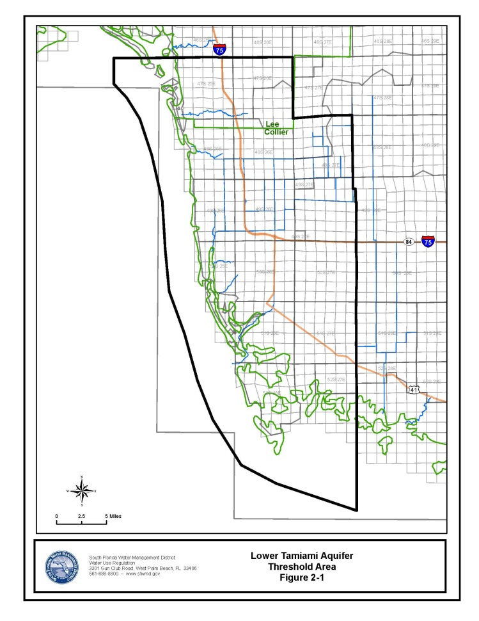
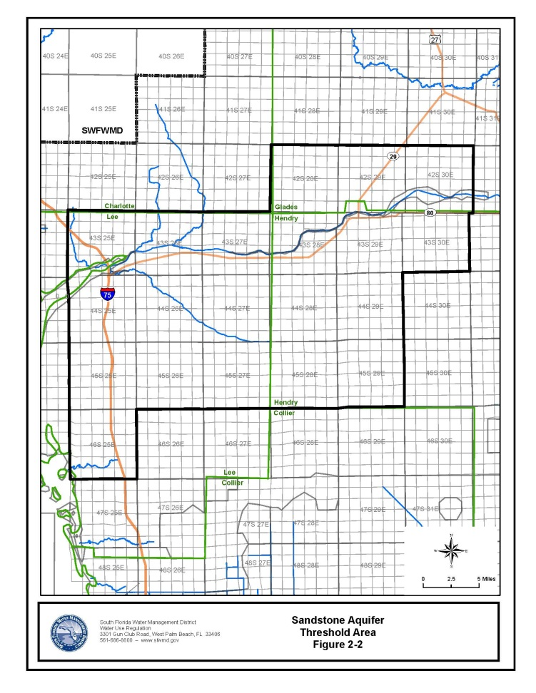
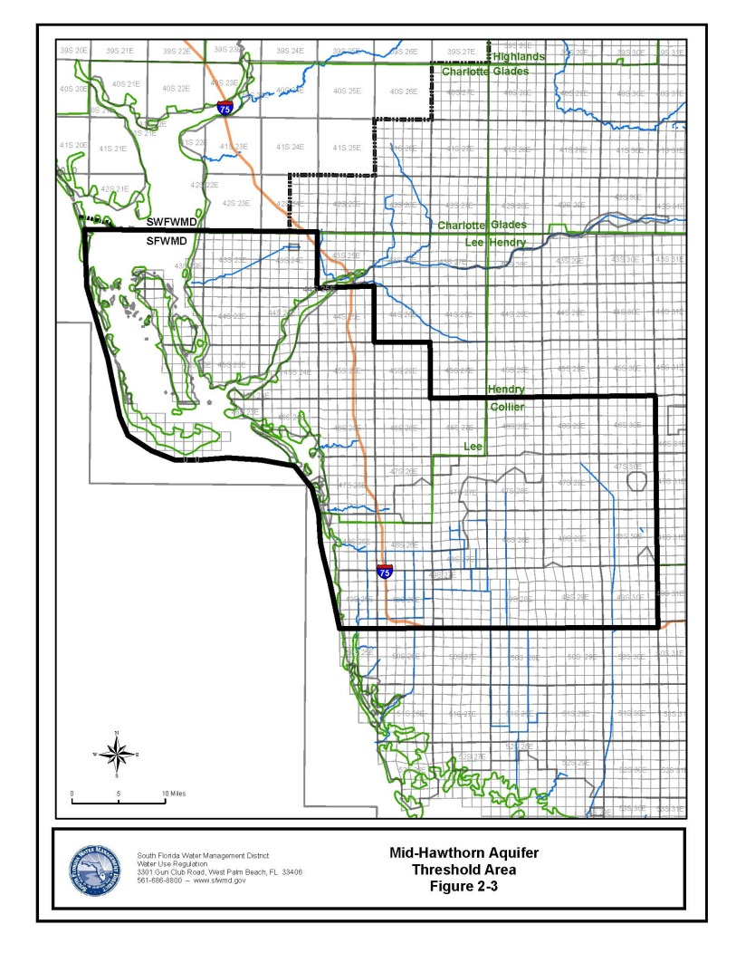
Rulemaking Authority 373.044, 373.113, 373.118, 373.171, 373.216 FS. Law Implemented 373.083, 373.118, 373.219, 373.223 FS. History–New 7-14-14.

