Notice of Emergency Rule

DEPARTMENT OF THE LOTTERY
RULE NO.: RULE TITLE:
53ER14-43 Instant Game Number 1243, MATCH & WIN™
SUMMARY: This emergency rule describes Instant Game Number 1243, “MATCH & WIN™” for which the Department of the Lottery will start selling tickets on a date to be determined by the Secretary of the Department. The rule sets forth the specifics of the game; determination of prizewinners; estimated odds of winning, value and number of prizes in the game.
THE PERSON TO BE CONTACTED REGARDING THE EMERGENCY RULE IS: Diane D. Schmidt, Legal Analyst, Department of the Lottery, 250 Marriott Drive, Tallahassee, Florida 32399-4011

THE FULL TEXT OF THE EMERGENCY RULE IS:

53ER14-43 Instant Game Number 1243, MATCH & WIN™.
(1) Name of Game. Instant Game Number 1243, “MATCH & WIN™.”
(2) Price. MATCH & WIN™ lottery tickets sell for $3.00 per ticket.
(3) MATCH & WIN™ lottery tickets shall have a series of numbers in machine readable code (or bar code) on the back of the ticket, along with a validation number under the latex area on the ticket. To be a valid winning MATCH & WIN™ lottery ticket, the ticket must meet the applicable requirements of Rule 53ER13-31, F.A.C.
(4) The “YOUR 15 RED NUMBERS” play symbols are as follows:
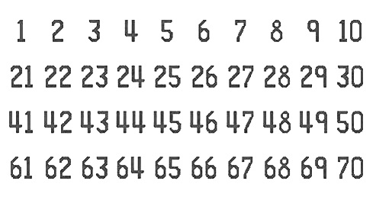
(5) The “YOUR 15 BLACK NUMBERS” play symbols are as follows:
(6) The red column/row play symbols are as follows:
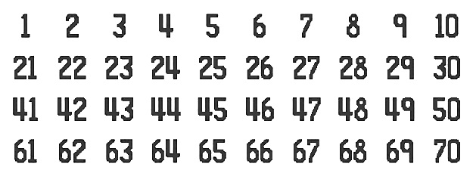
(7) The black column/row play symbols are as follows:
(8) The “RED PRIZE” row and column prize symbols and prize symbol captions are as follows:
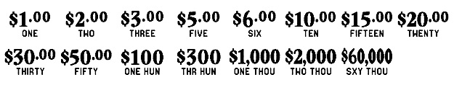
(9) The “BLACK PRIZE” row and column prize symbols and prize symbol captions are as follows:
(10) The legends are as follows:
(11) Determination of Prizewinners.
(a) There are three rows and eight columns that comprise the Game Play Grid of each MATCH & WIN™ ticket. Each row and each column is played separately.
1. A ticket having four red numbers in a single row that match four numbers in the “YOUR 15 RED NUMBERS” shall entitle the claimant to the corresponding “RED PRIZE” shown for that row.
2. A ticket having four black numbers in a single row that match four numbers in the “YOUR 15 BLACK NUMBERS” shall entitle the claimant to the corresponding “BLACK PRIZE” shown for that row.
3. A ticket having three red numbers in a single column that match three numbers in the “YOUR 15 RED NUMBERS” shall entitle the claimant to the corresponding “YOUR COLUMN PRIZE” shown for that column.
4. A ticket having three black numbers in a single column that match three numbers in the “YOUR BLACK NUMBERS” shall entitle the claimant to the corresponding “YOUR COLUMN PRIZE” prize shown for that column.
(b) The prizes are: $1.00, $2.00, $3.00, $5.00, $6.00, $10.00, $15.00, $20.00, $30.00, $50.00, $100, $300, $1,000, $2,000 and $60,000.
(12) The estimated odds of winning, value, and number of prizes in Instant Game Number 1243 are as follows:

NUMBER OF
WINNERS IN
 |  | ESTIMATED | 84 POOLS OF
 |  | ODDS OF | 180,000 TICKETS
GAME PLAY | WIN | 1 IN | PER POOL
$1 x 3 | $3 | 20.00 | 756,000
$3 | $3 | 20.00 | 756,000
$1 x 5 | $5 | 50.00 | 302,400
($1 x 2) + $3 | $5 | 100.00 | 151,200
$2 + $3 | $5 | 50.00 | 302,400
$5 | $5 | 100.00 | 151,200
($1 x 4) + $2 | $6 | 125.00 | 120,960
($1 x 3) + $3 | $6 | 250.00 | 60,480
$2 x 3 | $6 | 250.00 | 60,480
$3 x 2 | $6 | 250.00 | 60,480
$6 | $6 | 100.00 | 151,200
$1 x 10 | $10 | 250.00 | 60,480
$2 x 5 | $10 | 125.00 | 120,960
$1 + $3 + $6 | $10 | 250.00 | 60,480
$5 x 2 | $10 | 100.00 | 151,200
$10 | $10 | 250.00 | 60,480
($1 x 5) + ($2 x 5) | $15 | 500.00 | 30,240
$3 x 5 | $15 | 500.00 | 30,240
$5 x 3 | $15 | 500.00 | 30,240
$5 + $10 | $15 | 500.00 | 30,240
$15 | $15 | 500.00 | 30,240
$2 x 10 | $20 | 500.00 | 30,240
($3 x 3) + $5 + $6 | $20 | 500.00 | 30,240
($5 x 2) + $10 | $20 | 500.00 | 30,240
$10 x 2 | $20 | 500.00 | 30,240
$20 | $20 | 500.00 | 30,240
($2 x 6) + ($3 x 6) | $30 | 849.06 | 17,808
($5 x 4) + $10 | $30 | 900.00 | 16,800
$10 x 3 | $30 | 900.00 | 16,800
$15 x 2 | $30 | 900.00 | 16,800
$30 | $30 | 900.00 | 16,800
($3 x 10) + ($5 x 4) | $50 | 1,440.00 | 10,500
$5 x 10 | $50 | 1,440.00 | 10,500
$10 + ($20 x 2) | $50 | 1,440.00 | 10,500
$20 + $30 | $50 | 1,440.00 | 10,500
$50 | $50 | 1,440.00 | 10,500
($6 x 10) + ($10 x 4) | $100 | 3,600.00 | 4,200
$10 x 10 | $100 | 3,600.00 | 4,200
($10 x 5) + $20 + $30 | $100 | 3,600.00 | 4,200
$20 x 5 | $100 | 3,600.00 | 4,200
$50 x 2 | $100 | 3,600.00 | 4,200
$100 | $100 | 3,600.00 | 4,200
($10 x 10) + ($50 x 4) | $300 | 90,000.00 | 168
$30 x 10 | $300 | 90,000.00 | 168
$50 x 6 | $300 | 90,000.00 | 168
$100 x 3 | $300 | 90,000.00 | 168
$300 | $300 | 90,000.00 | 168
($50 x 8) + ($100 x 6) | $1,000 | 180,000.00 | 84
$100 x 10 | $1,000 | 180,000.00 | 84
($100 x 4) + ($300 x 2) | $1,000 | 180,000.00 | 84
$100 + ($300 x 3) | $1,000 | 180,000.00 | 84
$1,000 | $1,000 | 180,000.00 | 84
($50 x 4) + ($100 x 6) + ($300 x 4) | $2,000 | 180,000.00 | 84
$2,000 | $2,000 | 180,000.00 | 84
$60,000 | $60,000 | 756,000.00 | 20

(13) The estimated overall odds of winning some prize in Instant Game Number 1243 are 1 in 3.99. Prizes, including the top prizes, are subject to availability at the time of ticket purchase. Prizes may be unavailable due to prior sale or other causes occurring in the normal course of business including, but not limited to, ticket damage, defect, theft, or loss.
(14) For reorders of Instant Game Number 1243, the estimated odds of winning, value, and number of prizes shall be proportionate to the number of tickets reordered.
(15) Payment of prizes for MATCH & WIN™ lottery tickets shall be made in accordance with the rule of the Florida Lottery governing payment of prizes.
A copy of the current rule can be obtained from the Florida Lottery, Office of the General Counsel, 250 Marriott Drive, Tallahassee, Florida 32399-4011.
Rulemaking Authority 24.105(9)(a), (b), (c), 24.109(1), 24.115(1) FS. Law Implemented 24.105(9)(a), (b), (c), 24.115(1) FS. History–New 8-8-14.

THIS RULE TAKES EFFECT UPON BEING FILED WITH THE DEPARTMENT OF STATE UNLESS A LATER TIME AND DATE IS SPECIFIED IN THE RULE.
EFFECTIVE DATE: August 8, 2014

