Notice of Proposed Rule

FISH AND WILDLIFE CONSERVATION COMMISSION
Vessel Registration and Boating Safety
RULE NO.: RULE TITLE:
68D-24.017 Palm Beach County Boating Restricted Areas.
PURPOSE AND EFFECT: The purpose and effect of this rule development notice is to address possible rule changes affecting vessel speeds on the Florida Intracoastal Waterway within Palm Beach County, updating rule maps and making other changes to rule language where necessary to manage and promote the use of this state waterway for safe and enjoyable boating.
SUMMARY: This rule amendment extends one (1) zone in the Florida Intracoastal Waterway in Palm Beach County, specifically the expansion of the zone surrounding the SR 806 (East Atlantic Ave.) Bridge to provide safety to those utilizing a landing facility available for use by the general boating public. The amendment also updates the rule maps.
SUMMARY OF STATEMENT OF ESTIMATED REGULATORY COSTS AND LEGISLATIVE RATIFICATION: The Agency has determined that this will not have an adverse impact on small business or likely increase directly or indirectly regulatory costs in excess of $200,000 in the aggregate within one year after the implementation of the rule. A SERC has not been prepared by the agency.
The Agency has determined that the proposed rule is not expected to require legislative ratification based on the statement of estimated regulatory costs or if no SERC is required, the information expressly relied upon and described herein: the nature of the rule and the preliminary analysis conducted to determine whether a SERC was required. Any person who wishes to provide information regarding a statement of estimated regulatory costs, or provide a proposal for a lower cost regulatory alternative must do so in writing within 21 days of this notice.
RULEMAKING AUTHORITY: 327.04, 327.46 FS.
LAW IMPLEMENTED: 327.46 FS.
IF REQUESTED WITHIN 21 DAYS OF THE DATE OF THIS NOTICE, A HEARING WILL BE SCHEDULED AND ANNOUNCED IN THE FAR.
THE PERSON TO BE CONTACTED REGARDING THE PROPOSED RULE IS: Major Richard Moore, Florida Fish and Wildlife Conservation Commission, Division of Law Enforcement, Boating and Waterways Section, 620 South Meridian Street, Tallahassee, Florida 32399-1600

THE FULL TEXT OF THE PROPOSED RULE IS:

68D-24.017 Palm Beach County Boating Restricted Areas.
(1) For the purpose of regulating speed and operation of vessel traffic on the Intracoastal Waterway within Palm Beach County, Florida, the following boating restricted areas are established:
(a) through (k) No Change.
(l) SR 806 (East Atlantic Ave.) Bridge – A Slow Speed Minimum Wake zone from shoreline to shoreline, in and adjacent to the Florida Intracoastal Waterway, bounded on the north by a line drawn perpendicular to the centerline of the Florida Intracoastal Waterway 300 675 feet north of the north end of the fender of the SR 806 (East Atlantic Ave.) Bridge, and bounded on the south by a line drawn perpendicular to the centerline of the Florida Intracoastal Waterway, 500 feet north of the centerline of the Knowles Park boat ramp, as depicted in drawing L.
(m) through (r) No Change.
(2) The boating restricted areas described in Rule 68D-24.017, F.A.C., are depicted on the following drawings:
Drawings A through K, No Change.
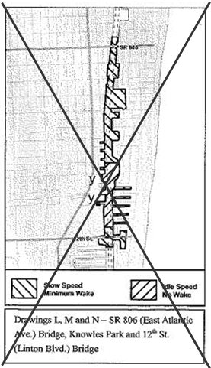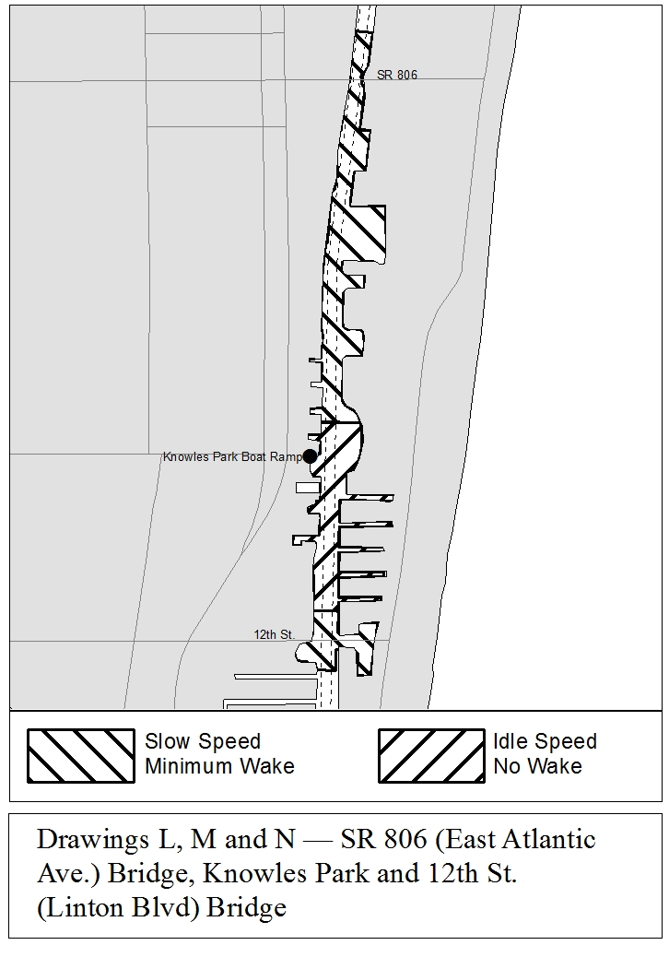
Drawings O through R, No Change.
Rulemaking Authority 327.04, 327.46 FS. Law Implemented 327.46 FS. History–New 2-28-91, Amended 8-6-92, 6-14-93, Formerly 16N-24.017, Amended 10-27-97, 3-3-99, Formerly 62N-24.017, Amended 5-20-10, .

NAME OF PERSON ORIGINATING PROPOSED RULE: Major Richard Moore, Florida Fish and Wildlife Conservation Commission, Division of Law Enforcement, 620 South Meridian Street, Tallahassee, Florida 32399-1600
NAME OF AGENCY HEAD WHO APPROVED THE PROPOSED RULE: Florida Fish and Wildlife Conservation Commission
DATE PROPOSED RULE APPROVED BY AGENCY HEAD: February 4, 2015
DATE NOTICE OF PROPOSED RULE DEVELOPMENT PUBLISHED IN FAR: January 21, 2015

