29L-2.004 DRI Review Process ‒ Graphic.
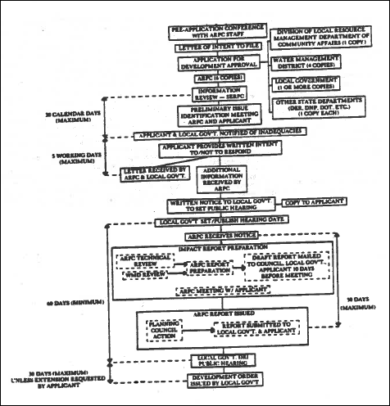
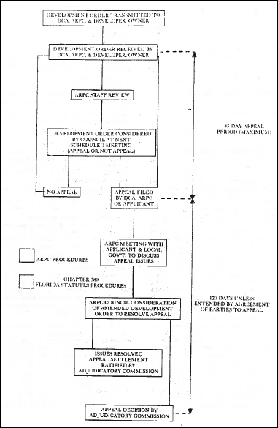
Rulemaking Authority 120.53(1), 163.01, 380.06, 380.07 FS. Law Implemented 120.53(1), 163.01, 380.06, 380.07 FS. History–New 4-4-78, Formerly 29L-2.04.

