40A-2.902 Areal Boundary Maps for Water Use Permitting.
General areal boundaries for Water Resource Caution Areas and Areas of Resource Concern are established for the implementation of water use permitting pursuant to this chapter and are indicated in Figures 2-1, 2-2, and 2-3. These boundaries are depicted in detail on the following maps: Water Resource Caution Area Map for Santa Rosa County (http://www.flrules.org/Gateway/reference.asp?No=Ref-05287); Water Resource Caution Area Map for Okaloosa County (http://www.flrules.org/Gateway/reference.asp?No=Ref-05286); Water Resource Caution Area Map for Walton County (http://www.flrules.org/Gateway/reference.asp?No=Ref-05288); Upper Telogia Creek Drainage Basin Water Resource Caution Area and Area of Resource Concern Map for Gadsden County (http://www.flrules.org/Gateway/reference.asp?No=Ref-05285); and Area of Resource Concern Map for Bay County (http://www.flrules.org/Gateway/reference.asp?No=Ref-05284), and are hereby incorporated by reference (effective April 29, 2015). Copies of these maps can be obtained from the District’s website (nwfwater.com) or from the Northwest Florida Water Management District, 81 Water Management Drive, Havana, Florida 32333-4712.

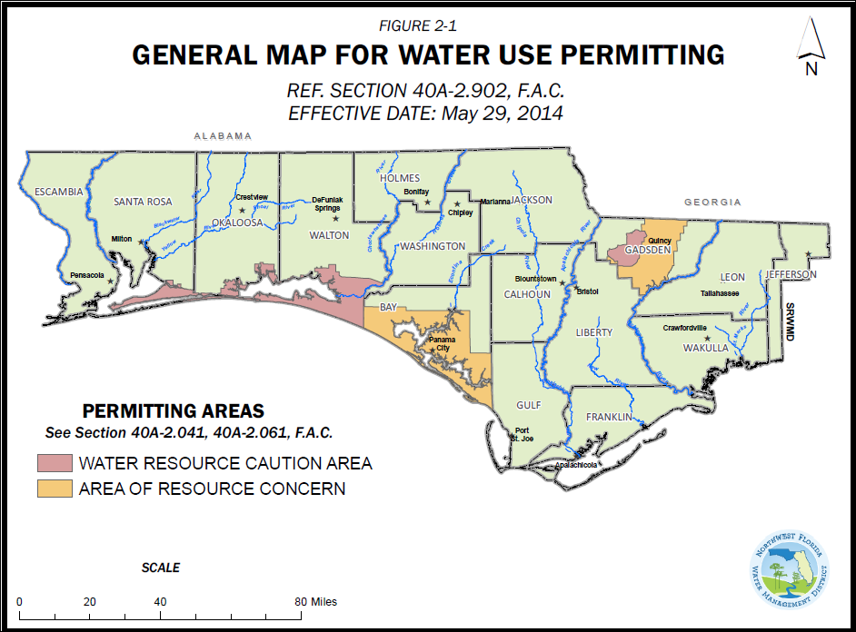

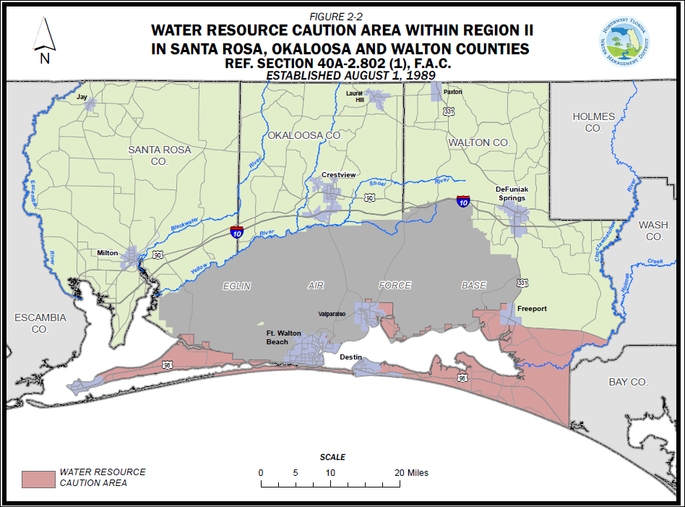

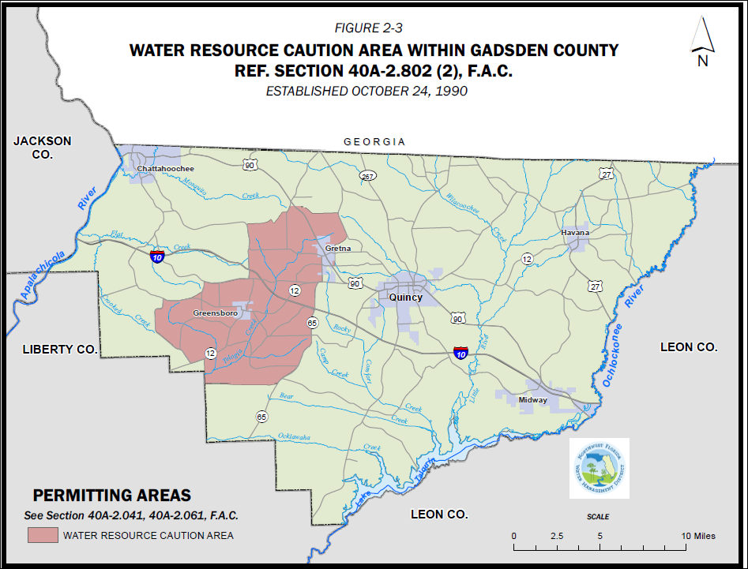
Rulemaking Authority 373.044, 373.171 FS. Law Implemented 373.216 FS. History–New 10-1-82, Amended 1-5-86, 5-4-87, 8-1-89, 5-31-92, 7-1-98, 1-1-05, 5-29-14, 4-29-15.

