62-42.300 Minimum Flows and Levels and Recovery and Prevention Strategies
The Department hereby establishes the following minimum flows and levels in accordance with Section 373.042, F.S.
(1) Lower Santa Fe and Ichetucknee Rivers and Associated Priority Springs: The minimum surface water flows for the Lower Santa Fe and Ichetucknee River and Associated Priority Springs are provided below:
(a) The minimum surface water flows for the Lower Santa Fe at the Santa Fe River near Ft. White, FL (USGS Gage No. 02322500) are:
1. 3,101 cubic feet per second (cfs) for a flow duration frequency of five percent,
2. 2,523 cubic feet per second (cfs) for a flow duration frequency of 10 percent,
3. 1,768 cubic feet per second (cfs) for a flow duration frequency of 25 percent,
4. 1,214 cubic feet per second (cfs) for a flow duration frequency of 50 percent,
5. 920 cubic feet per second (cfs) for a flow duration frequency of 75 percent,
6. 749 cubic feet per second (cfs) for a flow duration frequency of 90 percent,
7. 672 cubic feet per second (cfs) for a flow duration frequency of 95 percent,
The minimum flows expressed above were derived from baseline and minimum flow duration curves, shown on Figure 1a below, which were based on a period of record of daily mean flows from October 1, 1932 to September 30, 1990 at the Santa Fe River near Ft. White, FL (USGS Gage No. 02322500). Only the flows and associated frequencies listed in subparagraphs (1)(a)1.-7., above, are the established minimum flows.
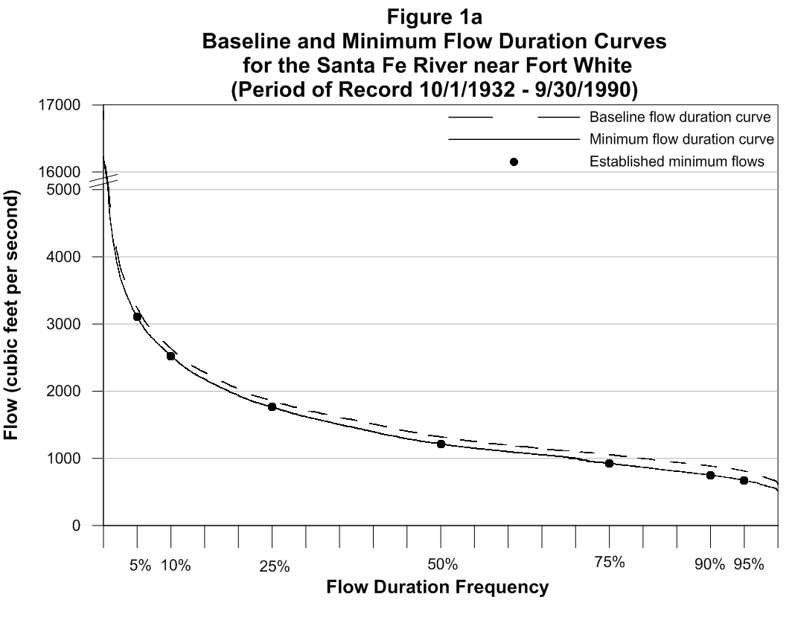
(b) The minimum surface water flows for the Ichetucknee River at U.S. Highway 27 (USGS Gage No. 02322700) are:
1. 473 cubic feet per second (cfs) for a flow duration frequency of five percent,
2. 448 cubic feet per second (cfs) for a flow duration frequency of 10 percent,
3. 386 cubic feet per second (cfs) for a flow duration frequency of 25 percent,
4. 343 cubic feet per second (cfs) for a flow duration frequency of 50 percent,
5. 318 cubic feet per second (cfs) for a flow duration frequency of 75 percent,
6. 282 cubic feet per second (cfs) for a flow duration frequency of 90 percent,
7. 246 cubic feet per second (cfs) for a flow duration frequency of 95 percent,
The minimum flows expressed above were derived from baseline and minimum flow duration curves, shown on Figure 1b below, which were based on a period of record of daily mean flows from October 1, 1932 to September 30, 1990 at the Ichetucknee River at U.S. Highway 27 (USGS Gage No. 02322700). Gaps in the flow record prior to 1975 were filled using linear interpolation. Gaps in the flow record from 1975 through 1990 were filled using a simple linear regression where flow was a function of groundwater levels at SRWMD well ID No. S041705001. Only the flows and associated frequencies listed in subparagraphs (1)(b)1.-7., above, are the established minimum flows.
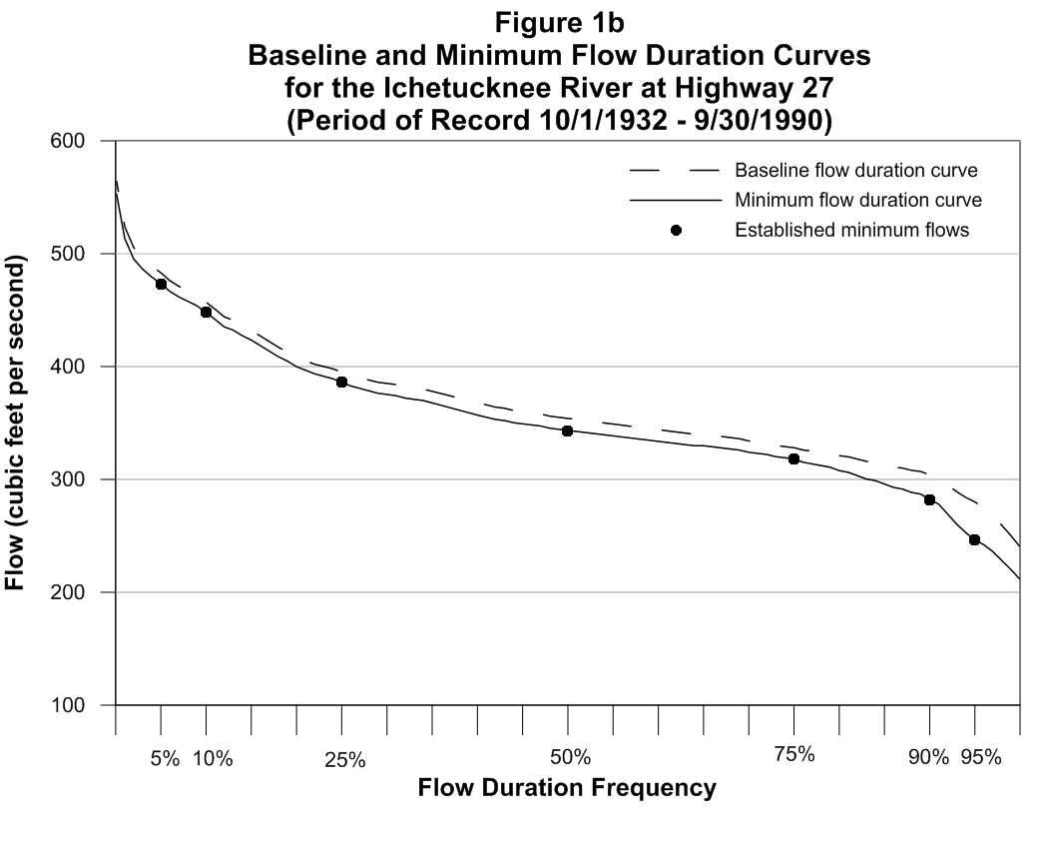
(c) The minimum surface water flows for the Priority Springs are established as a percent reduction from the median baseline flow contribution of each spring to the flow at the respective river gages listed in paragraphs 62-42.300(1)(a) and (b), F.A.C.:
1. Lower Santa Fe River Priority Springs:
a. Santa Fe Rise: Eight percent,
b. ALA112971 (Treehouse): Eight percent,
c. Hornsby: Eight percent,
d. Columbia: Eight percent,
e. Poe: Eight percent,
f. COL 101974 (Unnamed): Eight percent,
g. Rum Island: Eight percent,
h. July: Eight percent,
i. Devil’s Ear (Ginnie Group): Eight percent,
j. GIL.1012973 (Siphon Creek Rise): Eight percent.
2. Ichetucknee River Priority Springs:
a. Ichetucknee Head: Three percent,
b. Blue Hole: Three percent,
c. Mission: Three percent,
d. Devil’s Eye: Three percent,
e. Grassy Hole: Three percent,
f. Mill Pond: Three percent.
(d) Pursuant to Section 373.0421, F.S., the Department hereby adopts and incorporates by reference Section 6.0, entitled Supplemental Regulatory Measures, effective date June 10, 2015. Copies of Section 6.0 entitled Supplemental Regulatory Measures are available at http://www.flrules.org/Gateway/reference.asp?No=Ref-05105, or on the Department’s website at http://www.dep.state.fl.us/water/waterpolicy/pubs.htm. The Minimum Flows and Levels adopted in paragraphs 62-42.300(1)(a) through (c), F.A.C., above, and the Section 6.0 Supplemental Regulatory Measures adopted herein are inseverable, shall be construed as a whole, and are adopted simultaneously pursuant to subsection 62-40.473(5), F.A.C.
(e) Upon completion of the North Florida Southeast Georgia Regional Groundwater Flow Model currently under development, the Department, in coordination with the Suwannee River Water Management District and the St. Johns River Water Management District, shall re-evaluate the Minimum Flows and Levels and the present status of the Lower Santa Fe and Ichetucknee Rivers and Associated Priority Springs pursuant to Section 373.0421(3), F.S., using the best available scientific or technical data, methodologies, and models. No later than three years from the publication of the final peer review report on the North Florida Southeast Georgia Regional Groundwater Flow Model, or by December 31, 2019, whichever is earlier, the Department shall:
1. Publish a Notice of Proposed Rule to strike paragraphs 62-42.300(1)(a) through (d), F.A.C., and re-propose for adoption Minimum Flows and Levels for the Lower Santa Fe and Ichetucknee Rivers and Associated Priority Springs and any associated recovery or prevention strategies; and,
2. Adopt the proposed rule in accordance with the timeframes provided in section 120.54(3), F.S.
Rulemaking Authority 373.026(7), 373.036(1)(d), 373.043, 373.171 FS. Law Implemented 373.023, 373.026, 373.033, 373.036(1)(d), 373.0391, 373.0395, 373.042, 373.046, 373.0831, 373.086, 373.103, 373.106, 373.171, 373.175, 373.185, 373.1961, 373.223, 373.246, 373.250, 373.418, 373.451, 373.453, 403.0615(3), 403.064, 403.0891 FS., Section 38, Chapter 2002-296, Laws of Florida. History–New 6-10-15.

