Notice of Proposed Rule

FISH AND WILDLIFE CONSERVATION COMMISSION
Vessel Registration and Boating Safety
RULE NO.: RULE TITLE:
68D-24.109 Withlacoochee River Boating Restricted Areas
PURPOSE AND EFFECT: The purpose and effect of this rule amendment is to address changes affecting vessel speeds during flood conditions on the Withlacoochee River within Citrus, Hernando, Marion, and Sumter Counties, updating maps and making other changes to rule language where necessary to manage and promote the use of this state waterway for safe and enjoyable boating.
SUMMARY: This rule amendment proposes to reduce the zone boundaries of the following sections of the river; North Hooty Point to south of East Newman Drive, East Squire Court to south of East Shawnee Trail, and Citrus/Hernando County Line to south of Riverside RV Park. Another section, Iron Bridge Primitive Boat Launch to CSX Railroad Trestle, the zone boundaries would be slightly increased. There is no proposed change to the current water level which triggers the restricted areas during a flood. The revisions would also update maps for consistency and to reflect changes in the restricted areas.
SUMMARY OF STATEMENT OF ESTIMATED REGULATORY COSTS AND LEGISLATIVE RATIFICATION: The Agency has determined that this will not have an adverse impact on small business or likely increase directly or indirectly regulatory costs in excess of $200,000 in the aggregate within one year after the implementation of the rule. A SERC has not been prepared by the agency.
The Agency has determined that the proposed rule is not expected to require legislative ratification based on the statement of estimated regulatory costs or if no SERC is required, the information expressly relied upon and described herein: the nature of the rule and the preliminary analysis conducted to determine whether a SERC was required.
Any person who wishes to provide information regarding a statement of estimated regulatory costs, or provide a proposal for a lower cost regulatory alternative must do so in writing within 21 days of this notice.
RULEMAKING AUTHORITY: 327.04, 327.40, 327.46 FS.
LAW IMPLEMENTED: 327.46 FS.
IF REQUESTED WITHIN 21 DAYS OF THE DATE OF THIS NOTICE, A HEARING WILL BE SCHEDULED AND ANNOUNCED IN THE FAR.
THE PERSON TO BE CONTACTED REGARDING THE PROPOSED RULE IS: Captain Gary Klein, Boating and Waterways Section, Division of Law Enforcement, 620 South Meridian St., Tallahassee, Florida 32399-1600, waterway.mangement@myfwc.com

THE FULL TEXT OF THE PROPOSED RULE IS:

68D-24.109 Withlacoochee River Boating Restricted Areas.
For the purpose of regulating the speed and operation of vessel traffic during flood conditions on and adjacent to the Withlacoochee River within Citrus, Hernando, Marion, and Sumter Counties, the following Boating Restricted Areas are established, which shall include all associated and navigable tributaries, creeks, coves bends, and backwaters unless otherwise designated or excluded:
(1) Idle Speed No Wake and River Closure Restrictions Segments.
(a) Big Flat Rock at Mile Marker 9 to Camp Izzard Boat Ramp Segment at Mile Marker 24.
1. All waters of in and adjacent to the Withlacoochee River from shoreline to shoreline, from the Big Flat Rock (29.00.920N/082.24.658W29 00.920N, 82 24.658W) south to Mile Marker 24, located at Camp Izzard Boat Ramp (29 0.036N, 82 22.030W) for a distance of 4.5 miles. This Idle Speed No Wake restriction shall be active and enforceable only when the water level of the Withlacoochee rRiver is measured at the USGS Holder gauge (02313000) at 7.0’ feet or higher and will remain in effect until the river recedes below 7.0’ feet.
2. When the Withlacoochee rRiver is measured at the USGS Holder gauge (02313000) at 10.0’ feet or higher, the river in this area will be closed to all vessel traffic except emergency, law enforcement, firefighting, or rescue vessels owned or operated by a governmental entity, as depicted in Drawing A. As river levels recede below 10.0’, the river will reopen to all vessel traffic at Idle Speed No Wake.
3.(a) As river levels recede below 10.0 feet, the river will reopen to all vessel traffic at Idle Speed No Wake. When the river recedes below 7.0 feet, the speed will be Resume Normal Safe Operation.
(b) Camp Izzard Boat Ramp at Mile Marker 24 to the Marion/Sumter County Line Mile Marker 30 Segment.
1. All waters of in and adjacent to the Withlacoochee River, from shoreline to shoreline, from Mile Marker 24 located at Camp Izzard Boat Ramp (29 0.036N, 82 22.030W) south to the Marion/Sumter county line (28 57.622N, 82 18.703W) Mile Marker 30 for a distance of 6.0 miles. This Idle Speed No Wake restriction shall be active and enforceable only when the water level of the Withlacoochee rRiver is measured at the USGS Holder gauge (02313000) at 6.0’ feet or higher and will remain in effect until the river recedes below 6’.0 feet.
2. When the Withlacoochee rRiver is measured at the USGS Holder gauge (02313000) at 9.0’ feet or higher, the river in this area will be closed to all vessel traffic except emergency, law enforcement, firefighting, or rescue vessels owned or operated by a governmental entity, as depicted in Drawing B. As the river levels recede below 9.0’, the river will reopen to all vessel traffic at Idle Speed No Wake.
3. As river levels recede below 9.0 feet, the river will reopen to all vessel traffic at Idle Speed No Wake. When the river recedes below 6.0 feet, vessel speed will be Resume Normal Safe Operation.
(c) North Hooty Point Turner Camp at Mile Marker 34 to south of East Newman Drive Mile Marker 35A Segment.
1. All waters of in and adjacent to the Withlacoochee River shoreline to shoreline, from North Hooty Point (28 54.527N, 82 16.603W) Mile Marker 34 to south of East Newman Drive Mile Marker 35A (28.53.722N / 082.16.231W 28 53.630N, 82 16.110W) for a distance of 1.35 miles. This Idle Speed No Wake restriction shall be active and enforceable only when the water level of the Withlacoochee rRiver is measured at the USGS SR 44 gauge (02312722) at 38.0’ feet or higher and will remain in effect until the river recedes to below 38.0’ feet.
2. When the Withlacoochee rRiver is measured at the USGS SR 44 gauge (02312722) at 41.0’ feet or higher, the river in this area will be closed to all vessel traffic except emergency, law enforcement, firefighting, or rescue vessels owned or operated by a governmental entity, as depicted in dDrawing C and D.
3. As river levels recede below 41 feet, the river will reopen to all vessel traffic at Idle Speed No Wake. When the river recedes to below 38 feet, the speed will be Resume Normal Safe Operation.
(d) East Squire Court at Mile Marker 38 to south of East Mile Marker 41 at Shawnee Trail Segment.
1. All waters of in and adjacent to the Withlacoochee River from shoreline to shoreline, from East Mile Marker 38 at Squire Court (28 52.384N, 82 14.484W), south to south of East Mile Marker 41 at Shawnee Trail (28 50.117N, 82 12.280W) for a distance of 3.4 miles. This Idle Speed No Wake restriction shall be active and enforceable only when the water level of the Withlacoochee rRiver is measured at the USGS SR 44 gauge (02312722) at 38.0’ or higher feet and will remain in effect until the river recedes to below 38.0’ feet.
2. When the Withlacoochee rRiver is measured at the USGS SR 44 gauge (02312722) at 41.0’or higher feet, the river in this area will be closed to all vessel traffic except emergency, law enforcement, firefighting, or rescue vessels owned or operated by a governmental entity, as depicted in Drawing C and D. As river levels recede below 41.0’ feet, the river will reopen to all vessel traffic at Idle Speed No Wake.
3. As river levels recede below 41 feet, the river will reopen to all vessel traffic at Idle Speed No Wake. When the river recedes to below 38 feet, the speed will be Resume Normal Safe Operation.
(e) Citrus/Hernando County Line to south of the Riverside RV Park Mile Marker 61 Segment.
1. All waters of in and adjacent to the Withlacoochee River, from shoreline to shoreline, from the Citrus/Hernando County line (28 40.060N, 82 15.786W) south to south of the Riverside RV Park (28 38.342N, 82 15.606W) Mile Marker 61. This Idle Speed No Wake restriction shall be active and enforceable only when the water level of the Withlacoochee rRiver is measured at the USGS Croom gauge (02312500) at 9.0’ or higher and will remain in effect until the river recedes to below 9.0’ feet.
2. When the Withlacoochee rRiver is measured at the USGS Croom gauge (02312500) at 11.0’or higher feet, the river in this area will be closed to all vessel traffic except emergency, law enforcement, firefighting, or rescue vessels owned or operated by a governmental entity, as depicted in Drawing E. As river levels recede below 11.0’ feet, the river will reopen to all vessel traffic at Idle Speed No Wake.
3. When the river recedes to below 9.0 feet, vessel speed will be Resume Normal Safe Operation.
(f) Iron Bridge Primitive Boat Launch Silver Lake at Mile Marker 64 to CSX Railway Trestle at Mile Marker 70 Segment.
1. All waters of in and adjacent to the Withlacoochee River, from shoreline to shoreline, from the Iron Bridge Primitive Boat Launch (28 35.600N, 82 13.300W) Silver Lake Park boundary line, at Mile Marker 64, south to 500 feet north of the fender system of the CSX Rrailway Ttrestle (28 34.323N, 82 9.240W) at Mile Marker 70, for a distance of 7.0 miles. This Idle Speed No Wake restriction shall be active and enforceable only when the water level of the Withlacoochee rRiver is measured at the USGS Trilby gauge (02312000) at 12.0’ feet or higher and will remain in effect until the river recedes to below 12.0’ feet.
2. When the Withlacoochee rRiver is measured at the USGS Trilby gauge (02312000) at 15.0’ feet or higher, the River in this area will be closed to all vessel traffic except emergency, law enforcement, firefighting, or rescue vessels owned or operated by a governmental entity, as depicted in Drawing F. As river levels recede below 15.0’ feet, the river will reopen to all vessel traffic at Idle Speed No Wake.
3. When the river recedes below 12.0 feet, vessel speed will be Resume Normal Safe Operation.
(2) The boating restricted areas are depicted in the following drawings:

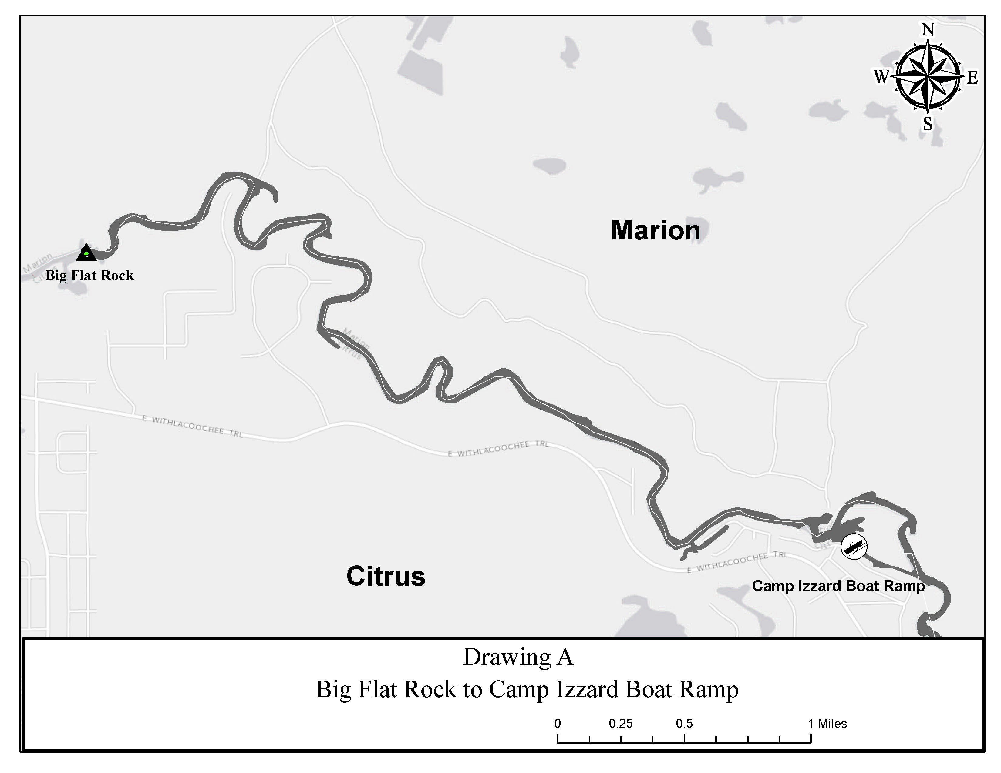
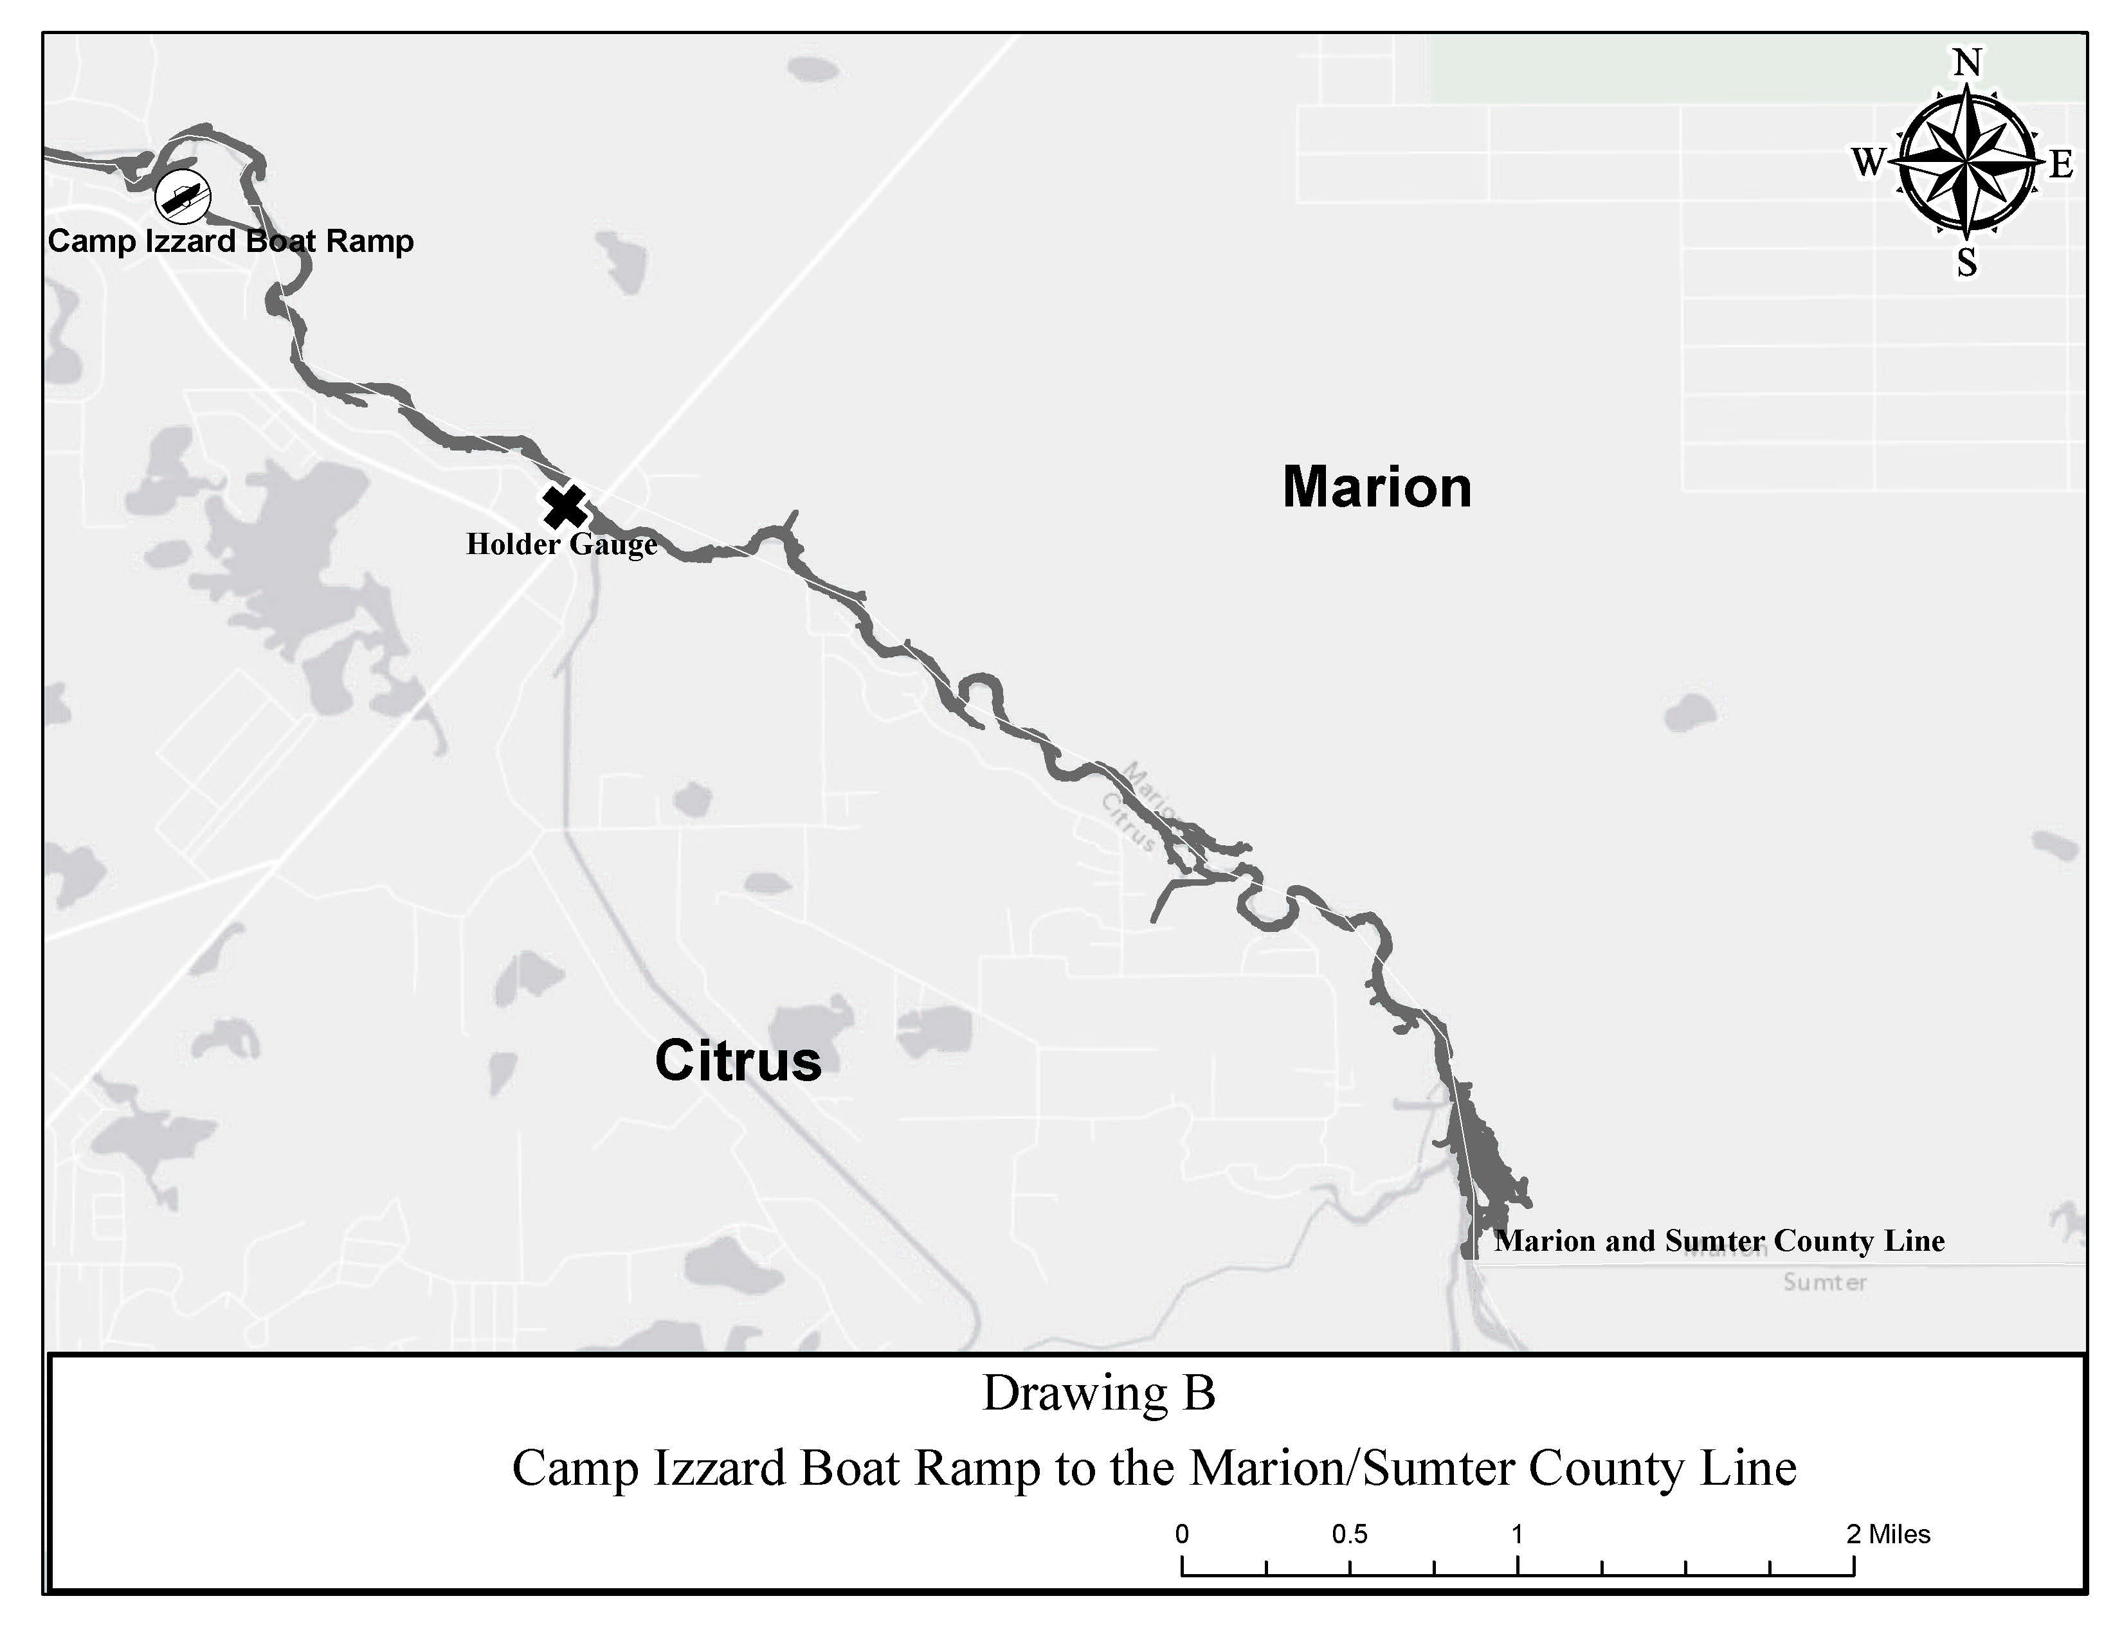

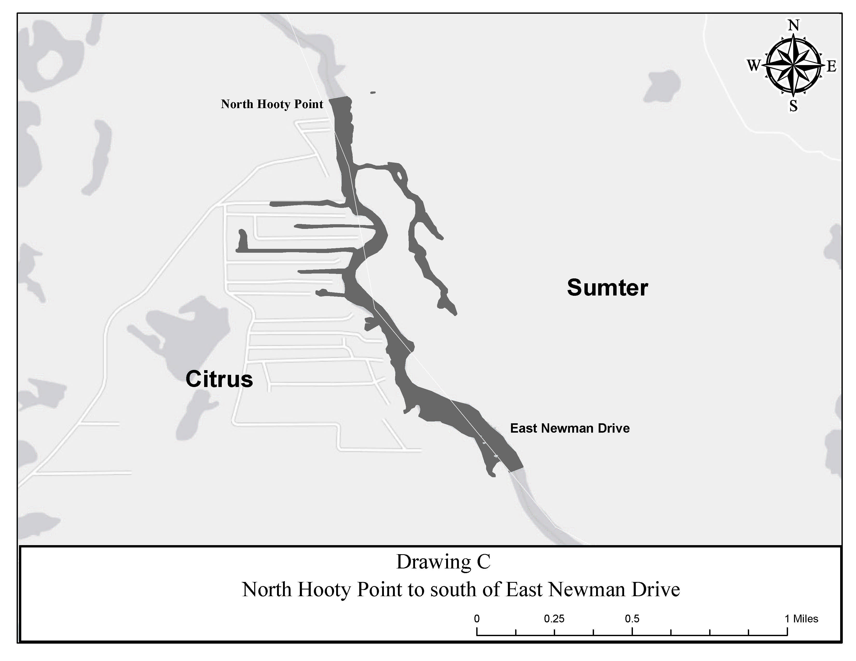
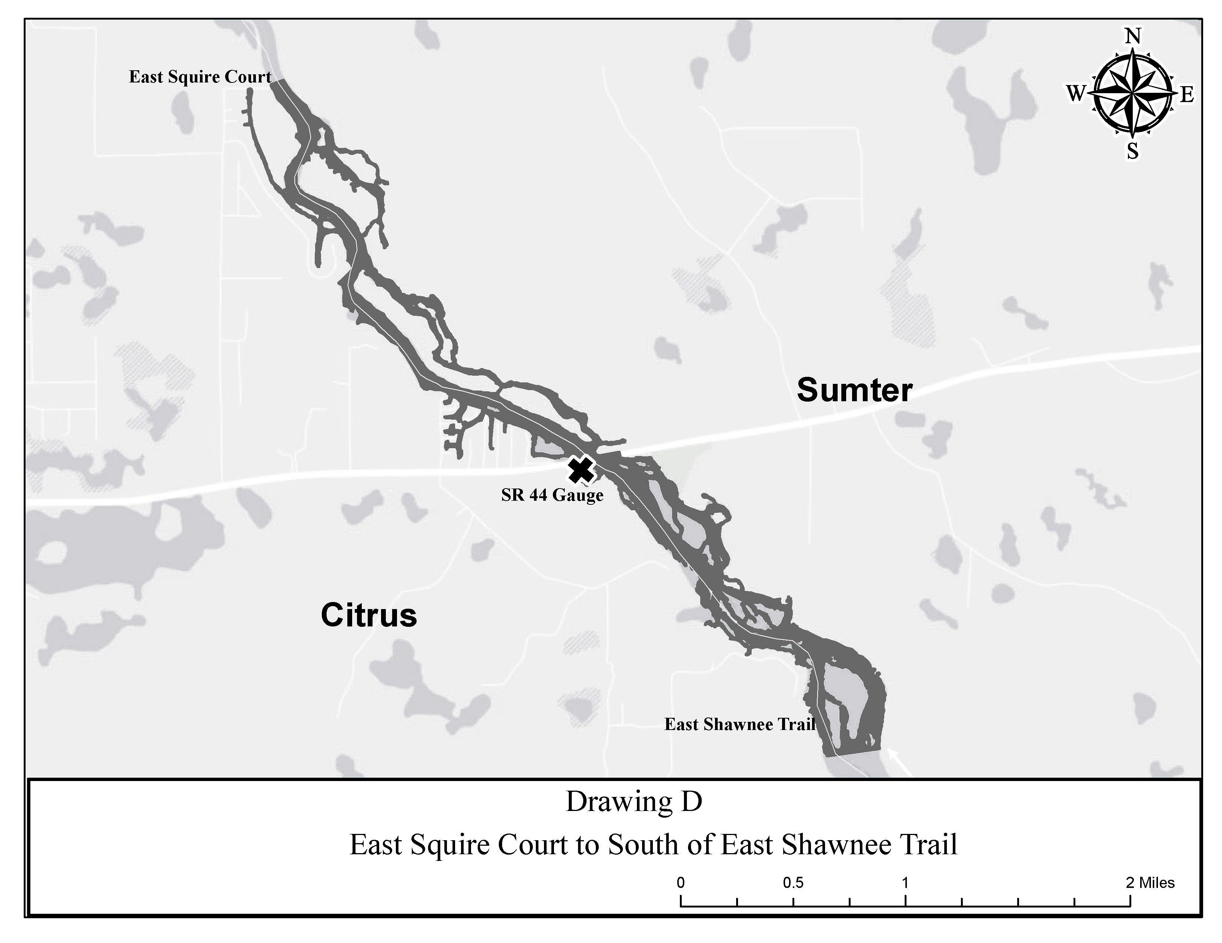
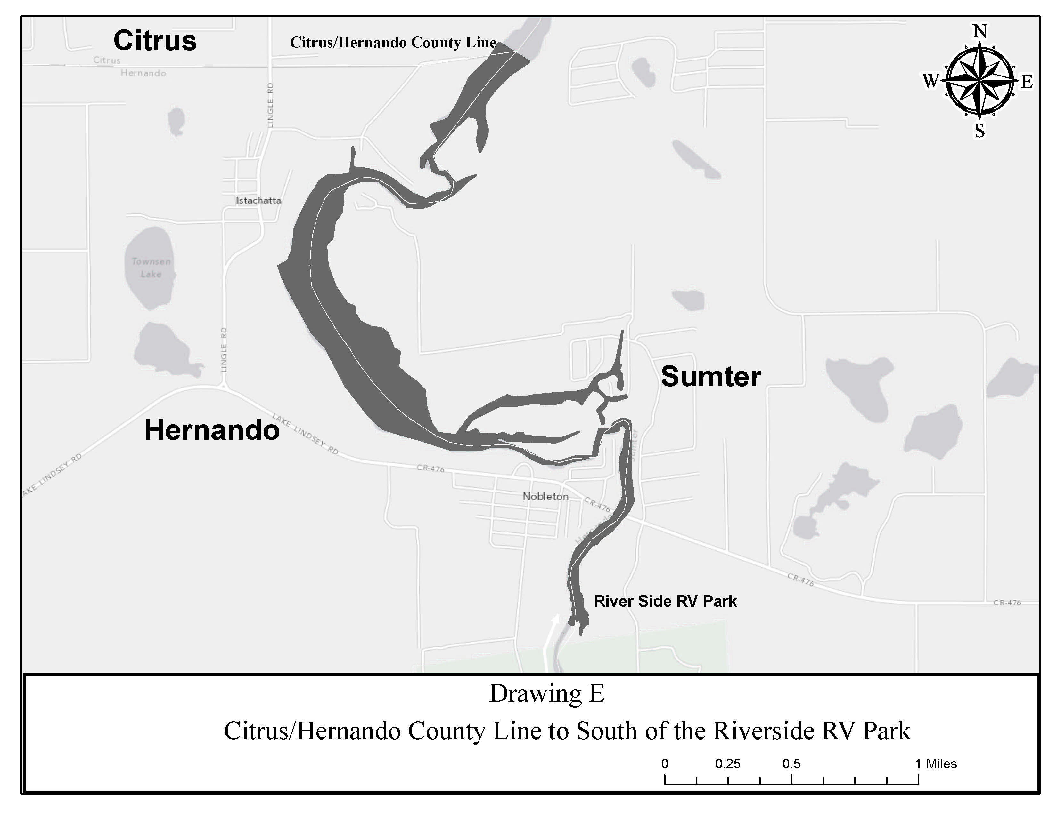
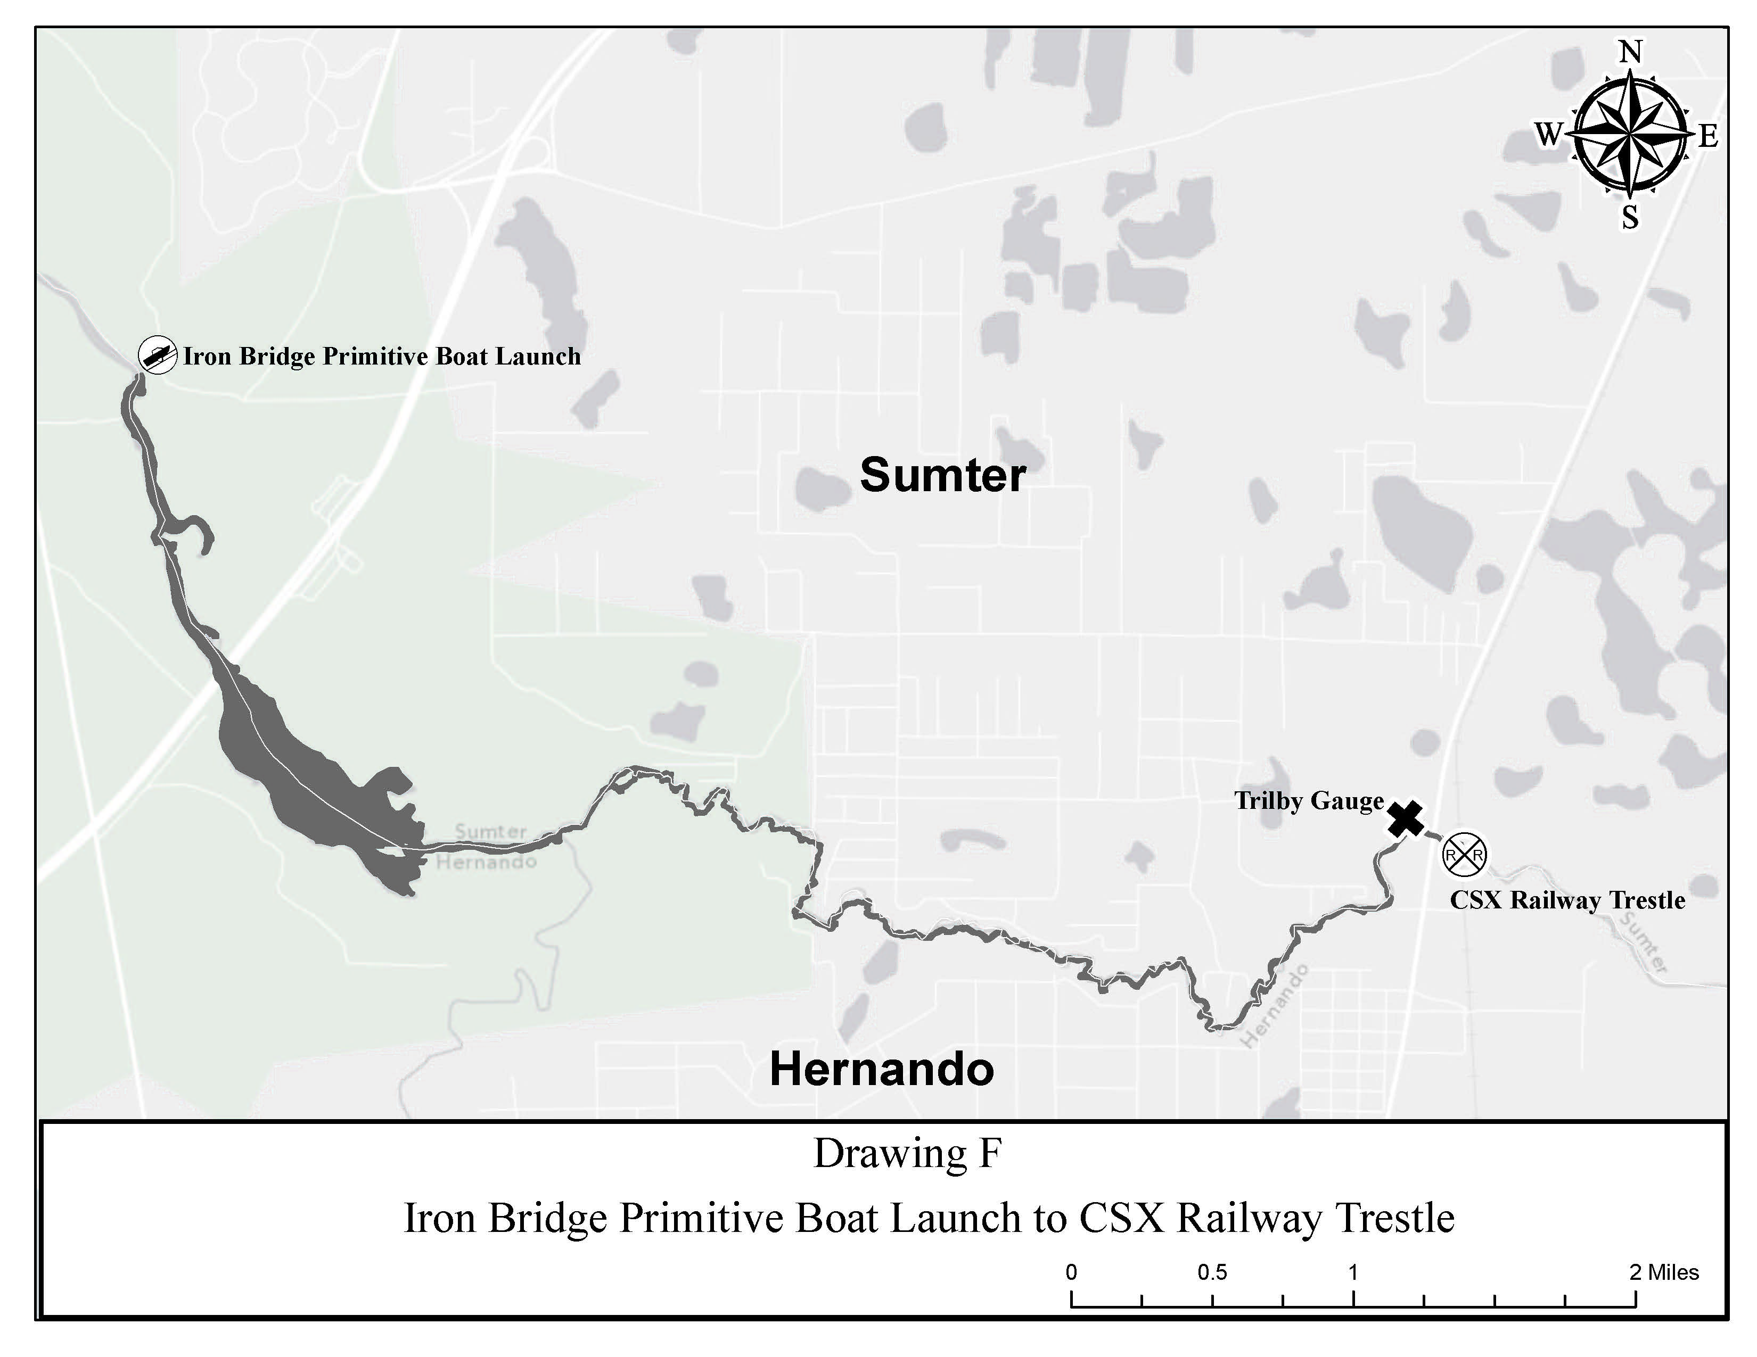
Rulemaking Authority 327.04, 327.40, 327.46 FS. Law Implemented 327.46 FS. History–New 2-10-97, Formerly 62N-24.109, Amended 11-5-07, .

NAME OF PERSON ORIGINATING PROPOSED RULE: Captain Gary Klein, Florida Fish and Wildlife Conservation Commission, Division of Law Enforcement, 620 South Meridian Street, Tallahassee, Florida 32399-1600, waterway.management@myfwc.com, (850)488-5600
NAME OF AGENCY HEAD WHO APPROVED THE PROPOSED RULE: Florida Fish and Wildlife Conservation Commission
DATE PROPOSED RULE APPROVED BY AGENCY HEAD: June 24, 2015
DATE NOTICE OF PROPOSED RULE DEVELOPMENT PUBLISHED IN FAR: March 24, 2015

