68D-24.109 Withlacoochee River Boating Restricted Areas.
For the purpose of regulating the speed and operation of vessel traffic during flood conditions on the Withlacoochee River within Citrus, Hernando, Marion, and Sumter Counties, the following Boating Restricted Areas are established, which shall include all associated and navigable tributaries, creeks, coves bends, and backwaters unless otherwise designated or excluded:
(1) Idle Speed No Wake and River Closure Restrictions.
(a) Big Flat Rock to Camp Izzard Boat Ramp.
1. All waters of the Withlacoochee River, from the Big Flat Rock (29 00.920N, 82 24.658W) south to Camp Izzard Boat Ramp (29 0.036N, 82 22.030W). This Idle Speed No Wake restriction shall be active and enforceable only when the water level of the river is measured at the USGS Holder gauge (02313000) at 7.0' or higher and will remain in effect until the river recedes below 7.0'.
2. When the river is measured at the USGS Holder gauge (02313000) at 10.0' or higher, this area will be closed to all vessel traffic except emergency, law enforcement, firefighting, or rescue vessels owned or operated by a governmental entity, as depicted in Drawing A. As river levels recede below 10.0', the river will reopen to all vessel traffic at Idle Speed No Wake.
(b) Camp Izzard Boat Ramp to the Marion/Sumter County Line.
1. All waters of the Withlacoochee River, from Camp Izzard Boat Ramp (29 0.036N, 82 22.030W) south to the Marion/Sumter county line (28 57.622N, 82 18.703W). This Idle Speed No Wake restriction shall be active and enforceable only when the water level of the river is measured at the USGS Holder gauge (02313000) at 6.0' or higher and will remain in effect until the river recedes below 6.0'.
2. When the river is measured at the USGS Holder gauge (02313000) at 9.0' or higher, this area will be closed to all vessel traffic except emergency, law enforcement, firefighting, or rescue vessels owned or operated by a governmental entity, as depicted in Drawing B. As the river levels recede below 9.0', the river will reopen to all vessel traffic at Idle Speed No Wake.
(c) North Hooty Point to south of East Newman Drive.
1. All waters of the Withlacoochee River, from North Hooty Point (28 54.527N, 82 16.603W) to south of East Newman Drive (28 53.630N, 82 16.110W). This Idle Speed No Wake restriction shall be active and enforceable only when the water level of the river is measured at the USGS SR 44 gauge (02312722) at 38.0' or higher and will remain in effect until the river recedes to below 38.0'.
2. When the river is measured at the USGS SR 44 gauge (02312722) at 41.0' or higher, this area will be closed to all vessel traffic except emergency, law enforcement, firefighting, or rescue vessels owned or operated by a governmental entity, as depicted in Drawing C.
(d) East Squire Court to south of East Shawnee Trail.
1. All waters of the Withlacoochee River, from East Squire Court (28 52.384N, 82 14.484W), to south of East Shawnee Trail (28 50.117N, 82 12.280W). This Idle Speed No Wake restriction shall be active and enforceable only when the water level of the river is measured at the USGS SR 44 gauge (02312722) at 38.0' or higher and will remain in effect until the river recedes to below 38.0'.
2. When the river is measured at the USGS SR 44 gauge (02312722) at 41.0' or higher, this area will be closed to all vessel traffic except emergency, law enforcement, firefighting, or rescue vessels owned or operated by a governmental entity, as depicted in Drawing D. As river levels recede below 41.0', the river will reopen to all vessel traffic at Idle Speed No Wake.
(e) Citrus/Hernando County Line to south of the Riverside RV Park.
1. All waters of the Withlacoochee River, from the Citrus/Hernando County line (28 40.060N, 82 15.786W) south to south of the Riverside RV Park (28 38.342N, 82 15.606W). This Idle Speed No Wake restriction shall be active and enforceable only when the water level of the river is measured at the USGS Croom gauge (02312500) at 9.0' or higher and will remain in effect until the river recedes to below 9.0'.
2. When the river is measured at the USGS Croom gauge (02312500) at 11.0' or higher, this area will be closed to all vessel traffic except emergency, law enforcement, firefighting, or rescue vessels owned or operated by a governmental entity, as depicted in Drawing E. As river levels recede below 11.0', the river will reopen to all vessel traffic at Idle Speed No Wake.
(f) Iron Bridge Primitive Boat Launch to CSX Railway Trestle.
1. All waters of the Withlacoochee River, from the Iron Bridge Primitive Boat Launch (28 35.600N, 82 13.300W), south to the CSX Railway Trestle (28 34.323N, 82 9.240W). This Idle Speed No Wake restriction shall be active and enforceable only when the water level of the river is measured at the USGS Trilby gauge (02312000) at 12.0' or higher and will remain in effect until the river recedes to below 12.0'.
2. When the river is measured at the USGS Trilby gauge (02312000) at 15.0' or higher, this area will be closed to all vessel traffic except emergency, law enforcement, firefighting, or rescue vessels owned or operated by a governmental entity, as depicted in Drawing F. As river levels recede below 15.0', the river will reopen to all vessel traffic at Idle Speed No Wake.
(2) The boating restricted areas are depicted in the following drawings:
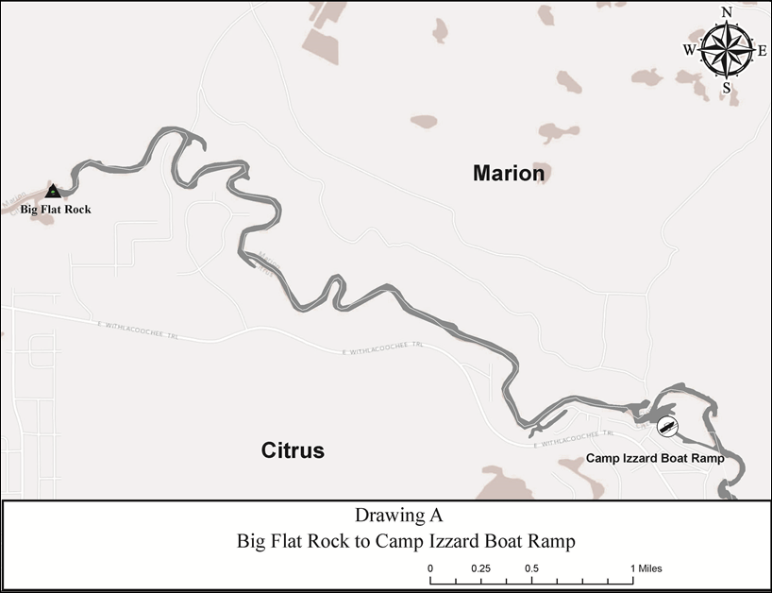
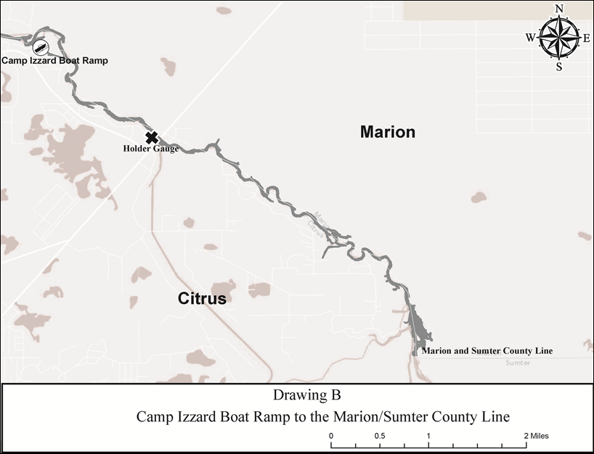
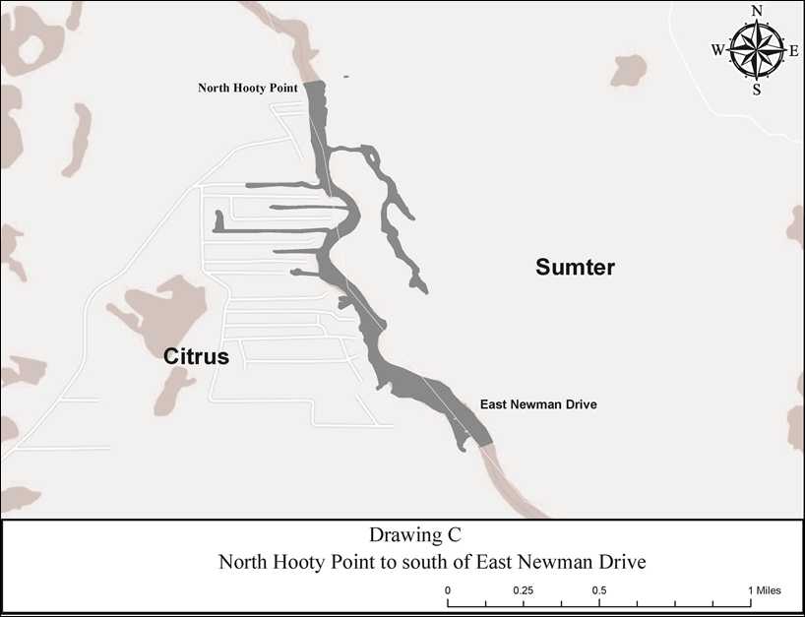
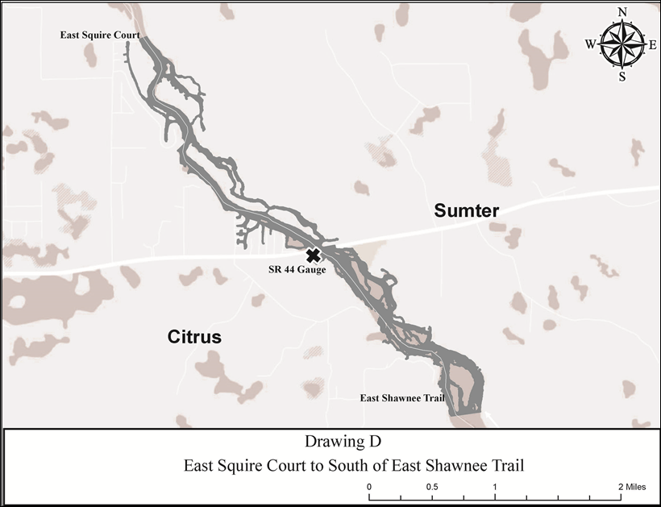
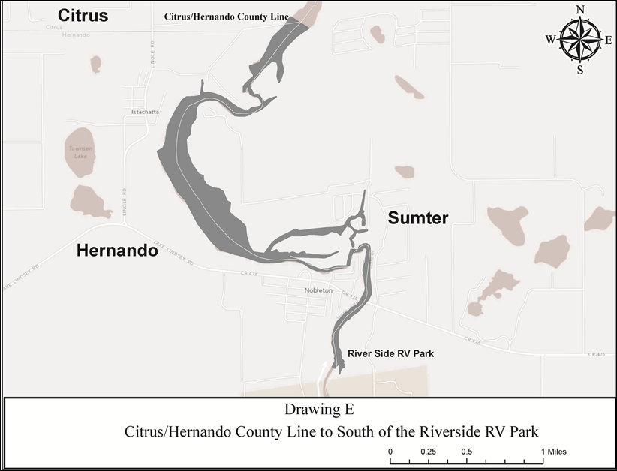

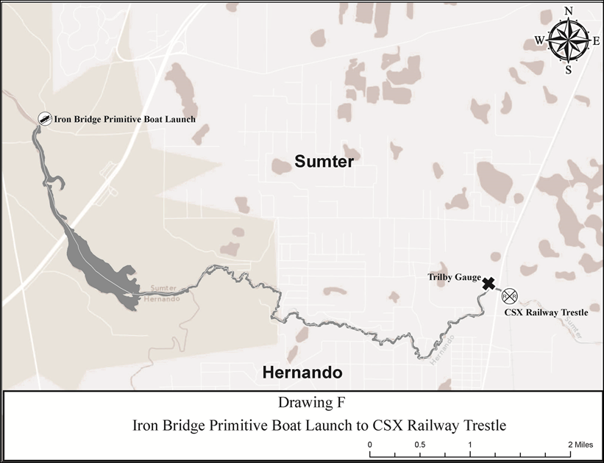
Rulemaking Authority 327.04, 327.40, 327.46 FS. Law Implemented 327.46 FS. History–New 2-10-97, Formerly 62N-24.109, Amended 11-5-07, 9-13-15.

