Notice of Proposed Rule

FISH AND WILDLIFE CONSERVATION COMMISSION
Vessel Registration and Boating Safety
RULE NO: RULE TITLE
68D-24.020 Suwannee and Santa Fe River Boating Restricted Areas.
PURPOSE AND EFFECT: To address possible rule changes affecting vessel speed during flood conditions within the Santa Fe River and the southern portion of the Suwannee River updating maps and making other changes to rule language where necessary to manage and promote the use of this state waterway for safe and enjoyable boating.
SUMMARY: The rule amendment proposes deregulating approximately 10 miles of remote, uninhabited stretches of the Suwannee River from the boating restricted area which activates during high water events. The affected section of the river is Zone 4, which extends from CR 340 downstream to Fowlers Bluff. There are no other proposed changes to Zone 4.
The proposed rule amendment would also revise the boating restricted area within the Santa Fe River which activates during high water events. Instead of the current 36-mile zone from River Rise to its confluence with the Suwannee River, the Santa Fe River would be divided into four zones. Each zone would activate and deactivate independently, which would more accurately reflect the public safety needs during various high water events occurring within the basin.
The revisions would also incorporate federally adopted gauge datum, resolve an incorrect reference to mean sea level in the current rule and update maps for consistency and to reflect changes in the restricted areas.
SUMMARY OF STATEMENT OF ESTIMATED REGULATORY COSTS AND LEGISLATIVE RATIFICATION: The Agency has determined that this will not have an adverse impact on small business or likely increase directly or indirectly regulatory costs in excess of $200,000 in the aggregate within one year after the implementation of the rule. A SERC has not been prepared by the agency.
The Agency has determined that the proposed rule is not expected to require legislative ratification based on the statement of estimated regulatory costs or if no SERC is required, the information expressly relied upon and described herein: the nature of the rule and the preliminary analysis conducted to determine whether a SERC was required. Any person who wishes to provide information regarding a statement of estimated regulatory costs, or provide a proposal for a lower cost regulatory alternative must do so in writing within 21 days of this notice.
RULEMAKING AUTHORITY: 327.04, 327.46, FS.
LAW IMPLEMENTED: 327.46, FS.
IF REQUESTED WITHIN 21 DAYS OF THE DATE OF THIS NOTICE, A HEARING WILL BE SCHEDULED AND ANNOUNCED IN THE FAR.
THE PERSON TO BE CONTACTED REGARDING THE PROPOSED RULE IS: Captain Gary Klein, Boating and Waterways Section, Division of Law Enforcement, 620 South Meridian St., Tallahassee, Florida 32399-1600 (waterway.mangement@myfwc.com).

THE FULL TEXT OF THE PROPOSED RULE IS:

68D-24.020 Suwannee and Santa Fe River Boating Restricted Areas.
(1) For the purpose of regulating the speed and operation of vessel traffic during flood events, the Suwannee and Santa Fe River Boating Restricted Areas are established, which shall include all associated and navigable tributaries, creeks, coves, bends, and backwaters unless otherwise designated or excluded. as follows:
Suwannee River Idle Speed No Wake Zones –
(a) Zone 1: All waters in and adjacent to the Suwannee rRiver from the centerline of the U.S. 90 Bridge at Ellaville south to the centerline of the S.R. 51 Bridge at Luraville, in effect and enforceable when the Suwannee rRiver level is forty-seven feet (47') (MSL) or higher (NGVD 29) or 46.25' or higher (NAVD 88) as indicated by on the Ellaville gauge (USGS 02319500), as depicted in Drawing A.
(b) Zone 2: All waters in and adjacent to the Suwannee rRiver from the centerline of the S.R. 51 Bridge at Luraville to a line drawn perpendicular to the centerline of the Suwannee rRiver at Little River Spring, in effect and enforceable when the Suwannee rRiver level is twenty-six feet (26') (MSL) or higher (NGVD 29) or 25.25' or higher (NAVD 88) as indicated by on the Branford gauge (USGS 02320500), as depicted in Drawing B.
(c) Zone 3: All waters in and adjacent to the Suwannee rRiver from a line drawn perpendicular to the centerline of the Suwannee rRiver at Little River Spring to the centerline of the C.R. 340 Bridge at Rock Bluff, in effect and enforceable when the Suwannee rRiver level is twenty-four feet (24') (MSL) or higher (NGVD 29) or 23.25' or higher (NAVD 88) as indicated by on the Branford gauge (USGS 02320500), as depicted in Drawing C.
(d) Zone 4: All waters in and adjacent to the Suwannee rRiver from the centerline of the C.R. 340 Bridge at Rock Bluff to a line drawn perpendicular to the centerline of the Suwannee rRiver approximately one mile 300' southwest of the Fowler Bluff New Clay Landing Boat Ramp, from a line drawn perpendicular to the centerline of the river approximately 6,000' north of the Camp Azalea Boat Ramp to a line drawn perpendicular to the centerline of the river approximately 1,300' south of the Yellow Jacket Landing, and from a line drawn perpendicular to the centerline of the river approximately 2,000' northeast of the Fowler’s Bluff Boat Ramp to a line drawn perpendicular to the centerline of the river approximately one mile southwest of the Fowler’s Bluff Boat Ramp, in effect and enforceable when the Suwannee rRiver level is nine feet (9') (MSL) or higher (NGVD 29) or 8.35' or higher (NAVD 88) as indicated by on the Wilcox gauge (USGS 02323500), as depicted in Drawing D.

Santa Fe River Idle Speed No Wake Zones –
(e) Zone 5: All waters in and adjacent to the Santa Fe rRiver from a line drawn perpendicular to the centerline of the Santa Fe River at the River Rise in O’Leno State Park downstream westerly to the centerline of the U.S. 27 Bridge confluence of the Suwannee and Santa Fe Rivers, in effect and enforceable when the Santa Fe rRiver is 35' seventeen feet (17') (MSL) or higher (NGVD 29) or 34.20' or higher (NAVD 88) as indicated by on the High Springs Three Rivers Estates gauge (USGS 02321975), as depicted in Drawing E.
(f) Zone 6: All waters from the centerline of the U.S. 27 Bridge downstream to a line drawn perpendicular to the centerline of the river, shoreline to shoreline, one-half mile upstream from the S.R. 47 Bridge, in effect and enforceable when the river is 24' or higher (NGVD 29) or 23.25' or higher (NAVD 88) as indicated by the Fort White gauge (USGS 02322500), as depicted in Drawing F.
(g) Zone 7: All waters in and adjacent to the river from a line drawn perpendicular to the centerline of the river, shoreline to shoreline, one-half mile upstream from the S.R. 47 Bridge, downstream to a line drawn perpendicular to the centerline of the river, shoreline to shoreline, from the westernmost point of the unnamed island located at 29° 54.527’ N, 82° 46.074’ W, in effect and enforceable when the river is 19.5' or higher (NGVD 29) or 18.75' or higher (NAVD 88) as indicated by the Three Rivers Estates gauge (USGS 02322703), as depicted in Drawing G.
(h) Zone 8: All waters in and adjacent to the river from a line drawn perpendicular to the centerline of the river, shoreline to shoreline, from the westernmost point of the unnamed island located at 29° 54.527’ N, 82° 46.074’ W downstream to the confluence of the Suwannee and Santa Fe Rivers, to include the Ichetucknee River upstream to the U.S. 27 Bridge, in effect and enforceable when the river is 17' or higher (NGVD 29) or 16.25' or higher (NAVD 88) as indicated by the Three Rivers Estates gauge (USGS 02322703), as depicted in Drawing H.
(2) When in Effect – The boating restricted areas established in subsection (1) shall be active and enforceable only when the water levels are as specified in each paragraph. For purposes of this rule, all referenced river levels are provided in both the North American Vertical Datum of 1988 (NAVD 88) feet above mean sea level (MSL), and the National Geodetic Vertical Datum of 1929 (NGVD 29).
(1) The boating restricted areas described in Rule 68D-24.020, F.A.C., are depicted in the following drawings:
Drawings A through C; No change.
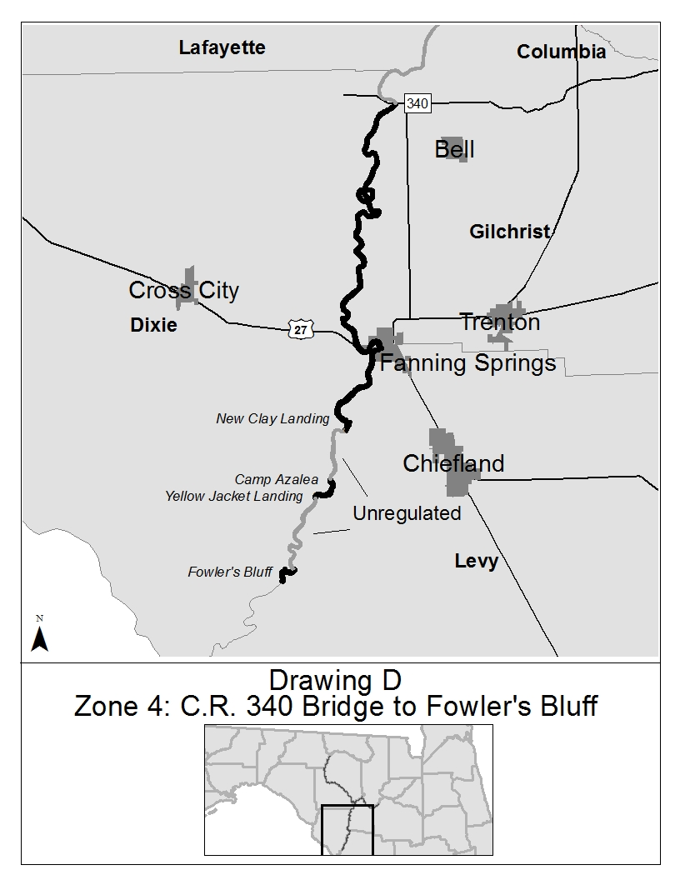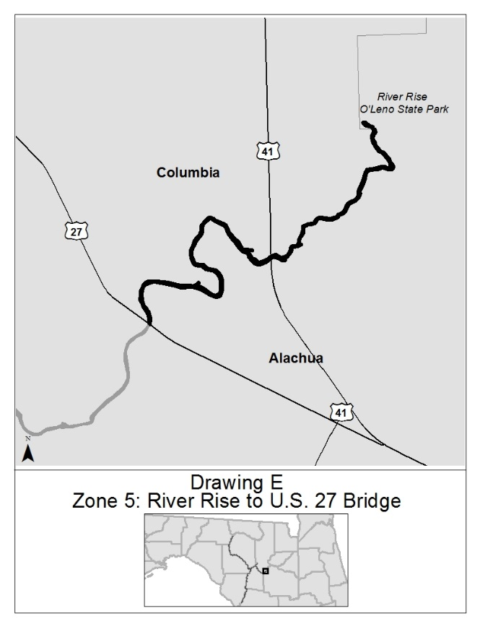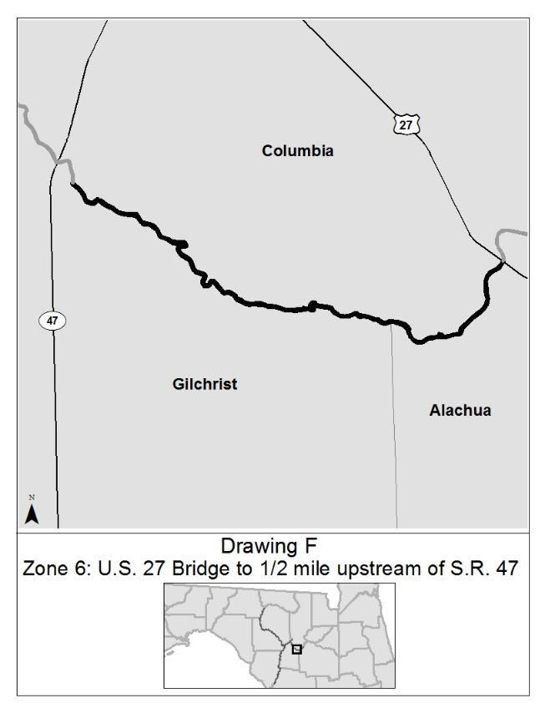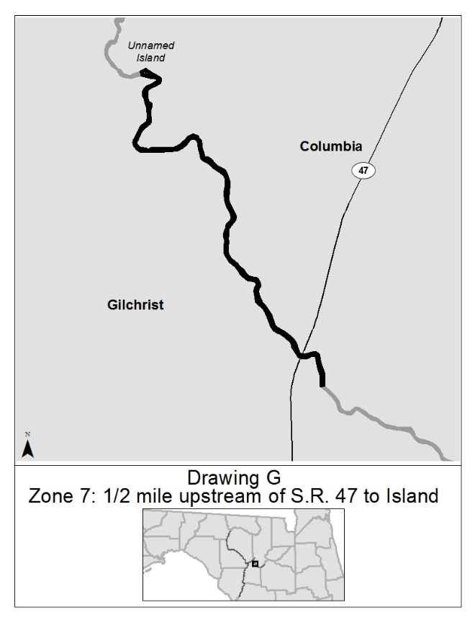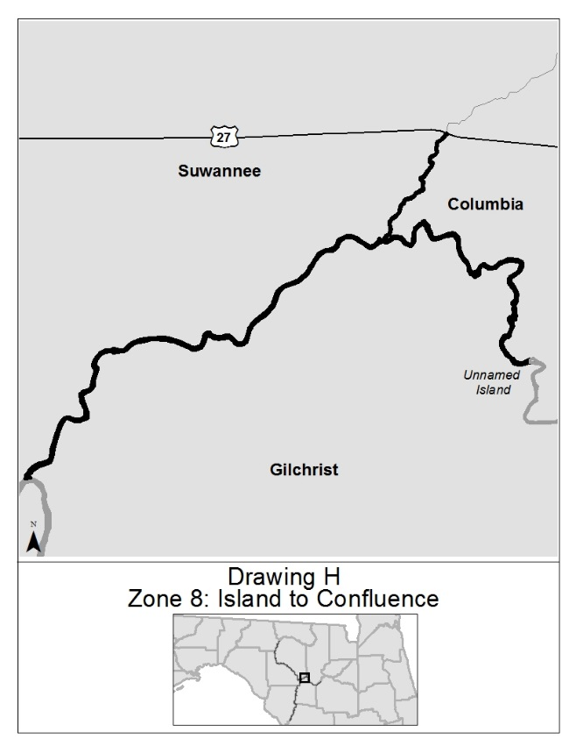
Rulemaking Authority 327.04, 327.46 FS. Law Implemented 327.46 FS. History–New 5-3-94, Formerly 16N-24.020, 62N-24.020, Amended 3-16-06, ______.

NAME OF PERSON ORIGINATING PROPOSED RULE: Major Richard Moore, Florida Fish and Wildlife Conservation Commission, Division of Law Enforcement, 620 South Meridian Street, Tallahassee, Florida 32399-1600 waterway.management@myfwc.com (850)488-5600.
NAME OF AGENCY HEAD WHO APPROVED THE PROPOSED RULE: Florida Fish and Wildlife Conservation Commission
DATE PROPOSED RULE APPROVED BY AGENCY HEAD: September 3, 2015
DATE NOTICE OF PROPOSED RULE DEVELOPMENT PUBLISHED IN FAR: April 7, 2015

