Notice of Proposed Rule

DEPARTMENT OF STATE
Division of Elections
RULE NO.: RULE TITLE:
1S-2.032 Uniform Primary and General Election Ballot
PURPOSE AND EFFECT: To clarify and simplify appropriate requirements for uniform ballot content and layout applicable to existing and future certified voting systems, provide standards for new technology of “hybrid” voting system, and provide updated ballot forms.
SUMMARY: To clarify and simplify appropriate requirements applicable to existing and future certified voting systems, provide standards for new technology, and provide updated ballot forms.
SUMMARY OF STATEMENT OF ESTIMATED REGULATORY COSTS AND LEGISLATIVE RATIFICATION:
The Agency has determined that this will not have an adverse impact on small business or likely increase directly or indirectly regulatory costs in excess of $200,000 in the aggregate within one year after the implementation of the rule. A SERC has not been prepared by the Agency.
The Agency has determined that the proposed rule is not expected to require legislative ratification based on the statement of estimated regulatory costs or if no SERC is required, the information expressly relied upon and described herein: Legislative ratification will not be required pursuant to Section 120.541(3), F.S. Based on a SERC checklist prepared by the agency, this rule will not have an adverse effect on businesses or private-sector economic growth, job-creation, employment or investment; nor will it increase regulatory costs in excess of the threshold mandating legislative ratification. No other statute requires legislative ratification for this rule.
Any person who wishes to provide information regarding a statement of estimated regulatory costs, or provide a proposal for a lower cost regulatory alternative must do so in writing within 21 days of this notice.
RULEMAKING AUTHORITY: 20.10, 97.012, 101.151
LAW IMPLEMENTED: 101.151, 103.021, 105.041
IF REQUESTED WITHIN 21 DAYS OF THE DATE OF THIS NOTICE, A HEARING WILL BE HELD AT THE DATE,TIME AND PLACE SHOWN BELOW(IF NOT REQUESTED, THIS HEARING WILL NOT BE HELD):
DATE AND TIME: Friday, October 30, 2015
PLACE: Room 307, R.A. Gray Building, 500 S. Bronough St., Tallahassee, FL 32399
Pursuant to the provisions of the Americans with Disabilities Act, any person requiring special accommodations to participate in this workshop/meeting is asked to advise the agency at least 3 days before the workshop/meeting by contacting: Brandy Hedges, at (850)245-6536, or Brandy.Hedges@dos.myflorida.com. If you are hearing or speech impaired, please contact the agency using the Florida Relay Service, 1(800)955-8771 (TDD) or 1(800)955-8770 (Voice).
THE PERSON TO BE CONTACTED REGARDING THE PROPOSED RULE IS: Lydia Strom, Assistant General Counsel, at Lydia.Strom@dos.myflorida.com or (850)245-6536.

Substantial rewording of Rule 1S-2.032 follows. See Florida Administrative Code for present text.

1S-2.032 Uniform Design for Primary and General Election Ballots.
(1) Purpose. This rule prescribes a uniform ballot design for primary and general elections for each type of certified voting system.
(2) Definitions. For purposes of this rule:
(a) “Audio ballot” means an electronic voting device which audibly reads a ballot and permits the voter to select choices.
(b) “Coded text” means the text of a proposed constitutional amendment or revision that has underlined and stricken text to represent additions and deletions, respectively, within the amendment or revision.
(c) “Contest title” means the office title for a race on the ballot in which candidates are seeking an elected office, e.g., “Attorney General” or “County Commissioner, District 2.” It also includes the title for a public measure on the ballot, e.g., “Constitutional Amendment,” “County Referendum,” or “City Referendum.”
(d) “Font size” means the size of the printed characters on the ballot. Font size is measured in millimeters (mm) and points. A point equals 0.353mm.
(e) “General election” refers to a general election as defined in Section 97.021, F.S.
(f) “Hybrid voting system” means an electronic or electromechanical device by which a voter with disabilities interacts with an electronic visual display to produce a paper output that contains the contest titles and the voter’s selections, and may also contain, but not be limited to, a barcode or other machine-readable optical label containing the voter’s selections. A hybrid voting system may be designed to read the vote targets or selections or the machine-readable optical label on the paper output.
(g) “Manual marking device” means a roller-ball pen, felt pen, or pencil which leaves an identifiable ink or pencil mark, as applicable, when used on a paper ballot.
(h) “Paper ballot” means an election ballot made of paper to be tabulated by optical scan and for use by a voter to select choices on a vote target by using a manual marking device.
(i) “Primary election” refers to a primary election as defined in Section 97.021, F.S.
(j) “Presidential Preference Primary” refers to a presidential preference primary election in Section 103.101, F.S.
(k) “Visual display ballot” means an electronic display for a voter to select choices as shown on the display, which may be on a touchscreen device or a personal computer display.
(l) “Vote target” means an area on the ballot where the voter indicates his or her vote. The vote target may be an oval, square, rectangle, or broken arrow.
(m) “Universal Primary Contest” refers to a contest in a primary election in which all candidates for an office have the same party affiliation and the winner of that contest will have no opposition in the general election. In a universal primary contest, all qualified electors may vote in the primary for that office, regardless of party affiliation.
(3) Ballot language.
(a) The official language for a ballot is English.
(b) Ballots shall be translated into other languages that are required by law or court order. This does not prohibit a supervisor of elections from including one or more other languages as he or she determines is necessary to accommodate the respective electorate.
(c) When more than one language appears on the ballot, the English version of the ballot shall appear first on the ballot, followed by the required other language or languages.
(d) Subject to paragraph (c), ballots that include more than one language may have:
1. All languages appear entirely on one ballot.
2. English and one translated language (one of many applicable to the election) combined on a separate ballot, with English and another or other translated language(s) combined on separate ballot(s).
3. Each language appears on separate ballots only after compliance with Section 101.151(8), F.S.
(4) Ballot font, alignment, and columns.
(a) Font. The minimum and maximum font sizes for the different ballots are:
1. Paper ballots: The minimum font size is 10-point type (3.5mm), except the minimum font size for the ballot title is bold, 12-point type (4.2mm). The maximum font size for a paper ballot is 12-point type (4.2mm), except the maximum font size for the ballot title is bold, 14-point type (5 mm).
2. Visual display ballot: The minimum font size is 14-point type (5 mm) and the maximum font size is 24-point type (8.5 mm).
3. All fonts on a ballot shall be the same sans-serif font. Sans-serif font means a typeface that does not have small projecting features (serifs) at the end of characters. Recommended fonts are: Arial, Helvetica, Tahoma or Univers. All fonts shall be black. Colored text, however, may be used on the ballot to differentiate between precincts or ballot type (e.g., early voting, absentee ballot, or election day ballot); in the ballot footer to direct the voter to vote both sides of the ballot page as specified in paragraph (10)(g), below; and on a visual display ballot as specified in paragraph (11)(a), below.
4. Each category on a ballot shall have consistent font sizes; for example, if one candidate’s name is in 10-point type, the names of all candidates on that ballot shall be in 10 point type.
5. Unless specified by this rule, the font shall not be in bold type.
6. A ballot shall not contain an ampersand, “&”, in any of its titles or text.
7. The contest titles and ballot title for issues shall be in bold and in upper and lower case font. The ballot summary or, when applicable for a proposed constitutional amendment or revision, the financial impact statement, shall be in upper and lower case font followed by the choices of Yes and No.
8. The appropriate three-letter party affiliation or no party affiliation (NPA) for candidates shall be in all capital letters.
(b) Alignment. Unless otherwise indicated herein, all type on a ballot shall be aligned to the left of the page or column, as applicable. The ballot title may be centered on the page or column while the ballot instructions shall be aligned to the left on the page or column.
(c) Columns.
1. A paper ballot page shall contain no more than three columns.
2. A visual display ballot shall contain no more than two columns.
3. All candidates for the same race shall appear on the same page and in the same column on a paper ballot or entirely on one screen page of the default setting for a visual display ballot, except as otherwise specified within this rule. A voter may magnify the default setting of a visual display ballot so that all candidates in the same race may not appear on one screen page.
4. No issue or public measure choices of Yes and No shall be split between columns or pages.
5. No judicial merit selection and retention question on the ballot shall appear in more than one column, span more than one column, or extend onto another side or page of the ballot. However, each separate retention question relating to the same or different category of judicial retention may be split.
(5) Ballot Title. The ballot title shall be printed single-spaced, flush left or centered across the top of the first page of a paper ballot and on the first ballot screen of a visual display ballot. The date of the election within the ballot title shall list the full name of the month, the numeric day, and full numeric year (for example, November 8, 2016). The ballot title, in bold upper and lower case letters, shall be printed on the ballot for each election in no less than two and not more than four lines, for example:
Official Presidential Preference Primary Election Ballot
(date of election)
(name) __ Party
[Insert county name], Florida
Official Primary Election Ballot, (date of election)
(Insert name of Party or insert Nonpartisan, as applicable), [Insert county name], Florida

Official General Election Ballot
(date of election)
[Insert county name], Florida
Official Special Election Ballot
(date of election)
[Insert county name], Florida
Official Special Primary Election Ballot
(date of election)
(Insert name of Party or insert Nonpartisan, as applicable)
[Insert county name], Florida

(6) Contest title. After the instructions, the title of each contest on the ballot shall appear either against no background or a lightly shaded background in bold, upper and lower case font. The contest title involving a public office shall appear as prescribed for office titles in Sections 101.151, F.S., e.g., State Senator. Additionally, the contest title for a constitutional amendment shall read: No. ___ Constitutional Amendment, Article ____, Section ____.
(7) Listing of election contests. Under each ballot title, the ballot shall list the contests in the order specified in Sections 101.151 and 105.041, F.S., and as further specified herein as follows:
(a) Partisan offices.
1. Federal office.
2. State office.
3. County office.
4. Municipal office.
5. Special district office. The order of special district offices on a ballot shall be: multi-county, county, municipal, and districts covering a geographical area less than municipal. The special districts within each listing shall be listed alphabetically.
(b) Nonpartisan offices.
1. Justice of the Supreme Court (judicial merit selection and retention).
2. Judge of a District Court of Appeal (judicial merit selection and retention).
3. Circuit Judge (election or merit selection and retention).
4. County Judge (election or merit selection and retention).
5. School Board Member.
6. Nonpartisan county office. If a county elects other county officers on a nonpartisan basis, the order of those offices shall be the same as the order in s. 101.151, F.S. for partisan offices and shall appear after the contest for school board member.
7. Nonpartisan municipal office.
8. Nonpartisan special district office. The order of special district offices on a ballot shall be: multi-county, county, municipal, and districts covering a geographical area less than municipal. The special districts within each listing shall be listed alphabetically.
(c) Candidate names. Names of candidates shall be in upper and lower case font. The space between candidate names in the same contest may be single-spaced or double-spaced.
(d) Issue or public measure.
1. Statewide constitutional amendment or other statewide public measure.
2. County public measure including local option for merit selection and retention or election for circuit or county judge.
3. Municipal public measure.
4. Special district public measure. Special district public measures shall be listed in the same order as special district offices.
(8) Contest instructions. Immediately below the contest title for public office, the ballot shall instruct the voter about his or her choices as follows:
(a) In contests for office in which the voter may make only one choice, including offices with paired or joint candidates, the instruction shall read: (Vote for 1).
(b) In contests for office in which the voter may make more than one choice, the instruction shall read: (Vote for up to [enter number to be elected]).
(c) When a primary election includes one or more Universal Primary Contests, the phrase, Universal Primary Contest, shall appear in bold beneath the office title of the Universal Primary Contest and before the contest instruction.
(9) Contest choices.
(a) Candidate names other than write-in candidates.
1. The list of names of nominees or candidates shall follow the instructions for contest choices as set forth in subsection (7).
2. Each nominee or candidate’s name shall be displayed in the following order notwithstanding any other order or designation as indicated on the candidate oath per Section 99.021, F.S.
a. First name or a shortened form as provided by the candidate or nominee (e.g., Rob, instead of Robert, or J. instead of James).
b. Middle initial or middle name, and if applicable, a bona fide nickname by which the candidate or nominee is commonly or customarily known. If the oath includes both the first and last names and the nickname of a candidate, the nickname shall be enclosed in quotation marks (e.g., Garrett R. “Gator” Cane) on the ballot. If the candidate does not indicate on the oath that the nickname should be included with the candidate's first name (e.g., Ted Davis printed on the oath for a candidate named Thomas Eugene Davis; or Dottie Smith printed on the oath for a candidate named Doris Smith), the nickname shall not be in quotation marks on the ballot (e.g., Ted Davis, not "Ted" Davis; or Dottie Smith, not "Dottie" Smith).
c. Surname (last name).
d. Suffix such as Sr. or Jr., or II or sequential numbers.
3. The name of each nominee or candidate shall be in upper and lower case letters.
4. Each name of a nominee or candidate shall be associated with a corresponding vote target.
a. For oval, square, and rectangle vote targets, the name shall appear after the vote target.
b. For a broken arrow vote target, the name shall be in front of the party designation, if applicable, and before the broken arrow.
c. The name of the second candidate or nominee in a paired or joined candidacy shall appear indented under the name of the principal candidate. Only the principal candidate’s name shall have the party designation and vote target associated with it.
(b) Write-in candidates.
1. In a contest in which one or more write-in candidates have qualified, the phrase “Write-in” shall appear directly after the end of the list of candidate names printed or displayed on the ballot for that contest. A blank line shall be placed after or immediately over Write-in, and a corresponding vote target shall be associated with the blank line. In a contest with joint candidacies, no second write-in line is required.
2. In a contest in which multiple candidates may be selected and more than one write-in candidate has qualified, the phrase “Write-in” shall be added and a blank line for each number of selections, or for each number of qualified write-in candidates, whichever is less, shall appear on the ballot. The write-in option shall be added directly below the list of candidate names printed on the ballot for that contest and a corresponding vote target shall be associated with each blank line with the word Write-in immediately preceding the blank line or over it. For example, when a contest is “Vote for up to 2,” and three write-in candidates have qualified, the contest would reflect the phrase “Write-in” and have two blank lines placed after or immediately over the word Write-in with a corresponding vote target associated with each blank line to ensure that voters could write in the names of two of the three qualified write-in candidates if they so choose.
3. To familiarize a voter with the location of write-in positions on the ballot, all sample ballots produced or distributed pursuant to Section 101.20, F.S., shall show the location where a voter will write in or input the name of a write-in candidate in any race in which a write-in candidate has qualified.
(c) Party Affiliation.
1. In a general election, the appropriate three-letter abbreviation of a political party name or no party affiliation (NPA) in capital letters shall be included for each candidate or pair of candidates in a partisan contest. The party abbreviation shall appear on the same line to the right of the candidate’s name or the first candidate’s name of a paired or joint candidacy.
2. The party abbreviation placed on the ballot shall be the same abbreviation the Division of Elections assigns to the registered political party or as appears on the Division’s official certification of candidates for the election. The party abbreviation shall not be enclosed in parentheses.
3. The party abbreviation shall not be included on primary election ballots, unless there is a Universal Primary Contest on one or more ballot styles in the county. In a Universal Primary Contest, the names of all candidates for all partisan offices, including candidates for the Universal Primary Contest, shall be displayed with an appropriate abbreviation of the party name.
(d) Incumbent designation. When the law permits the ballot to designate the incumbent on the ballot, the word incumbent shall appear in lower case letters to the right of the incumbent’s name.
(e) Multiple contests under one contest title. When there are multiple contests under one contest title, the contests shall be separated by a solid line across the column in which the contest appears.
(10) Paper ballots.
(a) Paper stock. Paper ballots shall be on applicable paper stock so they may be properly read by the optical scan voting equipment. The paper ballot’s size shall be a minimum of 8 ½” x 11” to a maximum of 11” x 22”, not including optional ballot stubs that may be included on the ballot.
(b) Paper color. The ballot color shall be white.
(c) Ballot layout.
1. Ballot stub. An optional ballot stub of a minimum length of one inch to a maximum length of three inches may be located at the top or bottom of the paper ballot with the bottom being the preferred location. The stub should have a control number that may be used for later reconciliation of ballots.
2. Barcode. A paper ballot may contain an optional barcode to identify:
a. The ballot, which barcode may be on the ballot, the ballot stub, or both. This barcode shall only identify the party, precinct, ballot style, page number, or type of ballot. The barcode may not be used in any manner to identify the voter.
b. The voter’s voted choices on the ballot, which barcode may be located in any area of the ballot, except within the area containing the contests. This barcode shall only contain the voter’s selections and may not be used in any manner to identify the voter.
(d) Ballot Instructions.
1. Ballot instructions shall appear flush left in normal or bold font with a minimum size of 10-point type (3.5mm) immediately below the ballot title either across the page or in the first column. The following instructions shall appear:
a. If the vote target is an oval, square, or rectangle:
- Instructions: To vote, fill in the (oval) (square) (rectangle) completely (insert picture of either filled oval, filled square or filled rectangle) next to your choice. Use (insert type(s) of appropriate marking device).
- If you make a mistake, ask for a new ballot. Do not cross out or your vote may not count.
Where a write-in candidate has qualified, add an additional instruction to read:
- To vote for a write-in candidate, fill in the (oval) (square) (rectangle) and print the name clearly on the blank line provided for the write-in candidate.
b. If the vote target is a broken arrow:
- Instructions: To vote, connect the head and tail of the arrow pointing to your choice (insert picture of a completed arrow) next to your choice. Use (insert type(s) of appropriate marking device) black roller-ball pen or felt pen.
- If you make a mistake, ask for a new ballot. Do not cross out or your vote may not count.
Where a write-in candidate has qualified, add an additional instruction to read:
- To vote for a write-in candidate, complete the arrow and print the name clearly on the blank line provided for the write-in candidate.
2. The space for marking the vote target shall comply with the voting system’s specifications. In contests for retention, constitutional amendments or other public measures, the choices Yes and No shall appear beneath the ballot question, upper and lower case letters on separate lines.
3. Additional instructions for absentee ballots. The following instructions or substantially similar instructions, along with other instructions as deemed necessary by the supervisor of elections, shall be printed on the secrecy sleeve or on a separate sheet as follows:
a. An applicable illustration depending on whether the system uses ovals, squares, rectangles, or broken arrows as vote targets. For example, the following represent depictions for oval and broken arrow vote targets:

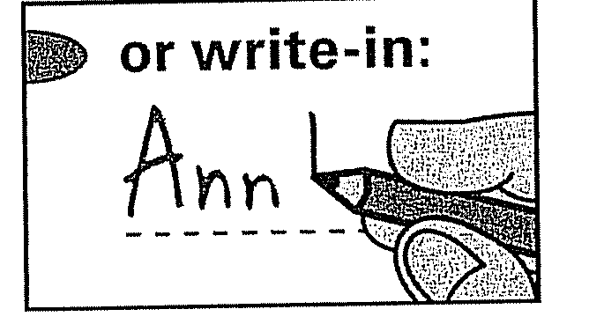
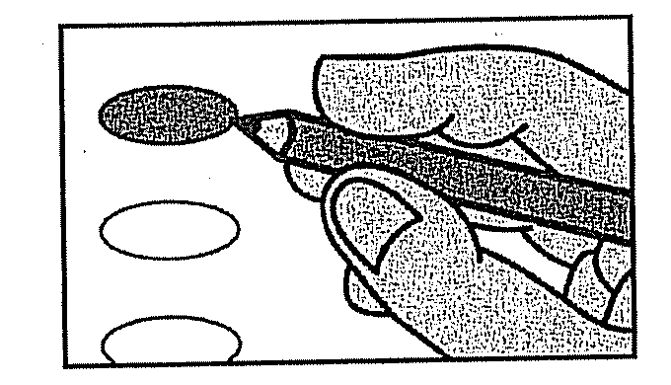

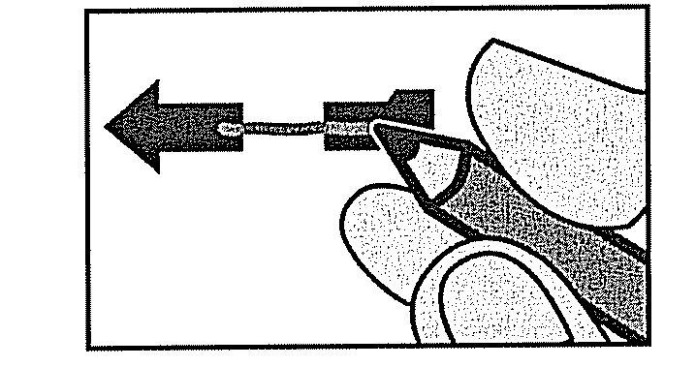
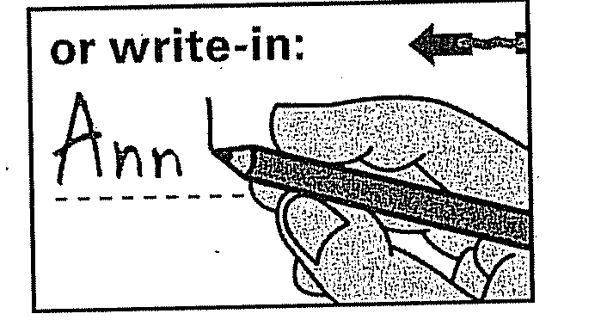

b. The statement: IMPORTANT: If you make a mistake on your ballot, contact the Supervisor of Elections’ office for instructions.
(e) Vote target. The vote target may be an oval, square, rectangle, or broken arrow icon. The oval, square, and rectangle shall be in dark black outline. The broken arrow’s head and tail shall be black and the broken area of the arrow shall have a narrow gray or black line between the arrow’s head and tail. The alignment of the vote target shall be at an available location that allows it to be flush or indented from the left margin for an oval, square, or rectangle and from the right margin for a broken arrow.
(f) Ballot front page. The front page of the paper ballot shall conform to the following requirements:
1. The ballot title shall appear as set forth in subsection (5).
2. The election contest(s) shall appear as set forth in subsections (6), (7), (8), and (9).
(g) Ballot footer. A ballot footer shall appear on the bottom of the front page and the bottom of the reverse page if one or more contests appear on the reverse page of the ballot. The text shall be in bold, upper and lower case text, with a minimum font of 10-point (3.5mm) type, and read: Vote Both Sides of Page.
(h) Reverse side of ballot front page. The reverse side of the first page of the paper ballot, if a reverse side is required, shall conform to the requirements for the front page of the ballot, except the ballot title and ballot instructions need not be included.
(i) Multiple ballot sheets. A second ballot sheet of paper and any additional ballot sheets of a paper ballot, if applicable, shall conform to the requirements of the reverse side of the first page of a paper ballot. When multiple ballot sheets exist, page numbers for each ballot page may be inserted for clarification. If page numbers are used, both the current page number and the total page count shall be provided and be located in the same place on each page; for example, Page 1 of 4, Page 3/4, 3 of 5, or similar notations.
(j) Contest designation. Each contest on the paper ballot shall be in a box outlined in black type or, in the absence of an outline box, each contest shall have a straight black line above the top of the contest.
(11) Visual display ballots.
(a) Display.
1. The initial or welcome screen shall contain the ballot title set forth in subsection (5) and may have an icon for the county’s seal. The start of the visual introduction or welcome screen can be manual or automatic and may continue on more than one screen.
2. The visual display may have accompanying audio which reads the text on the visual display ballot.
3. The visual display ballot may have color background and color text.
4. The visual display may have contrast and magnification capabilities.
(b) Choice selection. The voter must be able to make selections using a keyboard, number keypad, tactile device, assistive device, mouse, or finger touch.
(c) Ballot instructions. The visual display ballot instructions may appear at any point before the contest choices or may be posted separately and prominently in each voting booth. The instructions on a visual display ballot shall inform the voter how to:
1. Select a language other than English for the ballot and have the remainder of the visual display ballot displayed in the selected language. This instruction is only required if two or more language choices are offered or required in the county for its voting system.
2. Start voting the ballot.
3. Mark a choice and how that choice will be reflected or appear on the screen, to include how to vote for a write-in candidate.
4. Vote for a qualified write-in candidate whose name is not printed on the ballot. This instruction is to be added in which one or more write-in candidates have qualified for an office.
5. Change or undo a choice if the voter changes his or her mind on a particular candidate or issue.
6. Proceed to the next ballot page.
7. Go back a screen.
8. Review his or her choices before casting the ballot.
9. Cast the ballot in order for his or her vote to be recorded.
(d) Contest title. Before the listing of the election contests on a visual display ballot, the contest title shall appear as specified in subsection (6).
(e) Contest order. The visual display ballot shall list the contests in the order specified in subsection (7).
(f) Contest choices.
1. Below the contest title, the ballot shall direct the voter about the choices in each contest as specified in subsection (8).
2. Each screen of a visual display ballot may have one or more contests on the screen.
3. Each screen of the visual display ballot shall display all candidates in a contest, but if not all candidates can be displayed at the minimum font size on one screen, the visual display shall indicate that additional candidates are on a following display or on a scroll display.
4. The vote target shall be flush or indented on either the left or right side.
5. The selection of choice may be made at the vote target or anywhere on the line containing the vote target.
6. For any public measures, the text may be displayed on as many screens as necessary to accommodate the text. Any coding of the text shall be displayed in the same manner as on paper ballots.
(g) Undervoted contest. The visual display ballot shall have a method to indicate to the voter when the voter did not select all allowable vote(s) in a contest and the consequence for not fully selecting votes within a contest.
(h) Final instructions before casting the ballot.
1. The visual display shall indicate to the voter if the voter is about to cast a blank ballot and the consequences of casting a blank ballot.
2. The visual display shall allow the voter to review the ballot and make any desired changes.
3. The visual display shall provide a clear instruction how to cast the ballot and confirm whether the voter desires to cast the ballot.
4. The visual display shall visually display that the ballot was cast and voting is complete.
(12) Hybrid voting system.
(a) Electronic display requirements. The electronic display for a hybrid voting system shall comply with the requirements for a visual display ballot contained in this rule.
(b) Paper output requirements. The font of the paper output must be no less than 9-point type and the paper output itself may be of any size and format so long as it includes all contests and selections and the output can be properly tabulated. The paper output must contain:
1. Human readable text without abbreviations or shortened text for the ballot title, except dates may be in all numeric text, for example, 08/26/2014;
2. Human readable text identical in content as displayed on the visual display ballot for each contest title for which the voter made a selection;
3. Human readable text identical in content as displayed on the visual display ballot for the voter’s selections in each contest; and
4. If the paper output is designed for the tabulator to read the barcode or optical label, a corresponding barcode or other machine-readable optical label for each of the voter’s selections.
(13) Audio ballot.
(a) Audio format.
1. The audio system shall allow the voter to change the volume at any point in the balloting process.
2. An audio voting device may have both a visual display ballot and an audio ballot separately or in combination.
3. Audio can be synthesized voice or recorded human speech, which speech may be a male or female voice.
4. The audio ballot shall have the capability for a voter to use either a headphone or handset to listen to the audio.
5. The audio ballot must produce auditory feedback tones for providing important and necessary information to the voter.
6. All instructions, information, text, and candidate names shall be given without voice inflection so as to favor or disfavor any potential selection
7. The order of election contests on the audio ballot shall be the same as the requirements in subsection (7).
(b) Audio introduction. The start of the audio introduction can be manual, automatic, or continual repetition. The default language for the audio ballot is English. The introduction shall repeat itself in all applicable languages until the voter confirms to continue with the ballot in English or makes a change to a different language. The introduction must have instructions regarding how the voter may select an additional language. If the voter chooses another language, the remainder of the audio shall be in the selected language.
(c) At the beginning, the audio ballot shall instruct the voter as to:
1. The ballot title, party identification for a primary election, and the number of contests on the ballot.
2. How to have an instruction repeated.
3. How each contest is indicated on the ballot, and if applicable, the number associated with the contest to facilitate the voter’s ability to locate the contest on the ballot.
4. How to return to a previous contest on the ballot,
5. How to proceed from one contest to another or from one candidate to another.
6. How to make and change a selection in a contest.
7. How to repeat the selections made.
8. How to confirm a choice that has been made.
9. How to enter a write-in candidate’s name and vote for the write-candidate.
(d) During the voting session, the audio ballot shall inform the voter of:
1. The contest title and optional contest number of the contest, the number of available votes which can be cast in the contest, the number of candidates for the office, the candidates' names and their corresponding party designation, if included on the ballot, and whether a candidate is an incumbent if authorized by s. 101.151, F.S..
2. Any constitutional amendment as specified in the following order:
a. No. ____ Constitutional Amendment, Article ____, Section ____.
b. The ballot title for the proposed amendment.
c. The ballot summary for the proposed amendment, or when applicable, the full text of the proposed constitutional amendment or revision, followed by the financial impact statement, if provided.
d. The choices of Yes and No.
3. Any other public measure in the following order: the ballot title, ballot summary, and the choices of Yes and No.
4. When the voter has not made a selection in a contest or has selected less than the allowable number of choices for the contest and the consequences for not fully selecting the available choices within a contest.
5. How the voter can change or undo a selection for a candidate or choice.
6. How the voter can continue to the next contest on the ballot.
7. That the voter has reached the end of the ballot.
8. Review his or her choices before casting the ballot and to make any desired changes.
9. How to cast the ballot.
10. A confirmation that the ballot was cast and that voting has been completed.
(14) Deviation from the rule.
(a) A supervisor of elections may seek approval to deviate from the requirements of this rule for the following reasons:
1. There are more candidates for a contest than will fit in one column or screen.
2. The candidate’s name is longer than will allow the party abbreviation to fit to the right of the candidate’s name.
3. A candidate’s name is too long to fit on one line in the minimum font size.
4. The party abbreviation cannot be printed in the minimum font size without going onto a second line.
5. Printing the (Vote for 1) or (Vote for up to [enter number to be elected]) designations in the minimum font size will require an additional ballot card.
6. The voting system will not permit the suppression of party abbreviations on ballots when a universal primary contest exists.
7. Any other circumstances that dictate deviation.
(b) A supervisor must certify the basis for the request, and submit the request and copy of the proposed ballot for approval to the Division of Elections. Approval must be obtained prior to printing or distributing the ballot.
(c) The Division shall verify the facts and circumstances that justify deviation from the rule prior to giving its approval.
(15) Graphic depiction of ballots.
(a) The forms in this paragraph represent illustrations of uniform presidential preference primary, primary, and general election ballots which may be adapted to each type of voting system certified in Florida based upon the requirements of each voting system and this rule (e.g., font size, flush left or centering of the ballot title, and placement of ballot instructions in the first column or centered across the page). Common examples of adaptations may include, but not be limited to, the insertion of timing marks and barcodes on the ballot, precinct designations, vote targets being of a different type, or vote targets being at a different location on the ballot; otherwise, the ballot used in an election shall be substantially in accordance with one of the following applicable forms:
1. DS-DE 200 (eff. /2015), Presidential Preference Primary ballot (hyperlink to be inserted here);
2. DS-DE 201 (eff. /2015), Democratic Primary ballot, not containing a universal primary contest (hyperlink to be inserted here);
3. DS-DE 202 (eff. /2015), Republican Primary ballot, not containing a universal primary contest (hyperlink to be inserted here);
4. DS-DE 203 (eff. /2015), Nonpartisan Primary ballot, not containing a universal primary contest (hyperlink to be inserted here);
5. DS-DE 204 (eff. /2015), Democratic Primary ballot, containing a universal primary contest (hyperlink to be inserted here);
6. DS-DE 205 (eff. /2015), Republican Primary ballot, containing a universal primary contest (hyperlink to be inserted here);
7. DS-DE 206 (eff. /2015), Nonpartisan Primary ballot, containing a universal primary contest (hyperlink to be inserted here);
8. DS-DE 207 (eff. /2015), General Election ballot (hyperlink to be inserted here); and
9. DS-DE 208 (eff. /2015), Hybrid Voting System Primary Election Paper Output Receipt (hyperlink to be inserted here).
(b) The forms in paragraph (a) are hereby incorporated by reference and may be obtained from the Division of Elections, R.A. Gray Building, 500 S. Bronough Street, Tallahassee, Florida 32399-0250, (850) 245-6200, or may be printed directly from the Division of Elections’ website.
(16) Effective date. This rule applies to any election scheduled to be held on or after January 1, 2016.
Rulemaking Specific Authority 20.10(3), 97.012(1), 101.151(8), 101.151(9), 103.101(6)(5), 105.041(2), FS. Law Implemented 103.021, 101.151(8), 101.161, 101.5608(3),(4), 105.041, FS. History–New 6-6-02, Amended 9-8-02, 07-13-04, __________.
NAME OF PERSON ORIGINATING PROPOSED RULE: Lydia Strom
NAME OF AGENCY HEAD WHO APPROVED THE PROPOSED RULE: Kenneth W. Detzner
DATE PROPOSED RULE APPROVED BY AGENCY HEAD: September 29, 2015
DATE NOTICE OF PROPOSED RULE DEVELOPMENT PUBLISHED IN FAR: July 24, 2015

