68D-24.020 Suwannee and Santa Fe River Boating Restricted Areas.
(1) For the purpose of regulating the speed and operation of vessel traffic during flood events, the Suwannee and Santa Fe River Boating Restricted Areas are established, which shall include all associated and navigable tributaries, creeks, coves, bends, and backwaters unless otherwise designated or excluded.
Suwannee River Idle Speed No Wake Zones‒
(a) Zone 1: All waters in and adjacent to the river from the centerline of the U.S. 90 Bridge at Ellaville south to the centerline of the S.R. 51 Bridge at Luraville, in effect and enforceable when the river is 47' or higher (NGVD 29) or 46.25' or higher (NAVD 88) as indicated by the Ellaville gauge (USGS 02319500), as depicted in Drawing A.
(b) Zone 2: All waters in and adjacent to the river from the centerline of the S.R. 51 Bridge at Luraville to a line drawn perpendicular to the centerline of the river at Little River Spring, in effect and enforceable when the river is 26' or higher (NGVD 29) or 25.25' or higher (NAVD 88) as indicated by the Branford gauge (USGS 02320500), as depicted in Drawing B.
(c) Zone 3: All waters in and adjacent to the river from a line drawn perpendicular to the centerline of the river at Little River Spring to the centerline of the C.R. 340 Bridge at Rock Bluff, in effect and enforceable when the river is 24' or higher (NGVD 29) or 23.25' or higher (NAVD 88) as indicated by the Branford gauge (USGS 02320500), as depicted in Drawing C.
(d) Zone 4: All waters in and adjacent to the river from the centerline of the C.R. 340 Bridge at Rock Bluff to a line drawn perpendicular to the centerline of the river approximately 300' southwest of the New Clay Landing Boat Ramp, from a line drawn perpendicular to the centerline of the river approximately 6,000' north of the Camp Azalea Boat Ramp to a line drawn perpendicular to the centerline of the river approximately 1,300' south of the Yellow Jacket Landing, and from a line drawn perpendicular to the centerline of the river approximately 2,000' northeast of the Fowler’s Bluff Boat Ramp to a line drawn perpendicular to the centerline of the river approximately one mile southwest of the Fowler’s Bluff Boat Ramp, in effect and enforceable when the river is 9' or higher (NGVD 29) or 8.35' or higher (NAVD 88) as indicated by the Wilcox gauge (USGS 02323500), as depicted in Drawing D.
Santa Fe River Idle Speed No Wake Zones –
(e) Zone 5: All waters in and adjacent to the river from the River Rise in O’Leno State Park downstream to the centerline of the US 27 Bridge, in effect and enforceable when the river is 35' or higher (NGVD 29) or 34.20' or higher (NAVD 88) as indicated by the High Springs gauge (USGS 02321975), as depicted in Drawing E.
(f) Zone 6: All waters from the centerline of the US 27 Bridge downstream to a line drawn perpendicular to the centerline of the river, shoreline to shoreline, one-half mile upstream from the S.R. 47 Bridge, in effect and enforceable when the river is 24' or higher (NGVD 29) or 23.25' or higher (NAVD 88) as indicated by the Fort White gauge (USGS 02322500), as depicted in Drawing F.
(g) Zone 7: All waters in and adjacent to the river from a line drawn perpendicular to the centerline of the river, shoreline to shoreline, one-half mile upstream from the S.R. 47 Bridge, downstream to a line drawn perpendicular to the centerline of the river, shoreline to shoreline, from the westernmost point of the unnamed island located at 29° 54.527' N, 82° 46.074' W, in effect and enforceable when the river is 19.5' or higher (NGVD 29) or 18.75' or higher (NAVD 88) as indicated by the Three Rivers Estates gauge (USGS 02322703), as depicted in Drawing G.
(h) Zone 8: All waters in and adjacent to the river from a line drawn perpendicular to the centerline of the river, shoreline to shoreline, from the westernmost point of the unnamed island located at 29° 54.527' N, 82° 46.074' W downstream to the confluence of the Suwannee and Santa Fe Rivers, to include the Ichetucknee River upstream to the US 27 Bridge, in effect and enforceable when the river is 17' or higher (NGVD 29) or 16.25' or higher (NAVD 88) as indicated by the Three Rivers Estates gauge (USGS 02322703), as depicted in Drawing H.
(2) When in Effect – The boating restricted areas established in subsection (1) shall be active and enforceable only when the water levels are as specified in each paragraph. For purposes of this rule, all referenced river levels are provided in both the North American Vertical Datum of 1988 (NAVD 88) and the National Geodetic Vertical Datum of 1929 (NGVD 29).
(3) The boating restricted areas described in Rule 68D-24.020, F.A.C., are depicted in the following drawings:
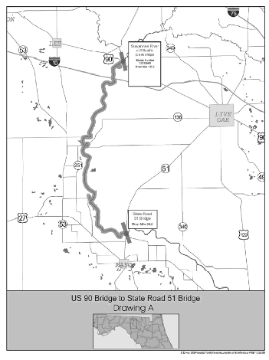
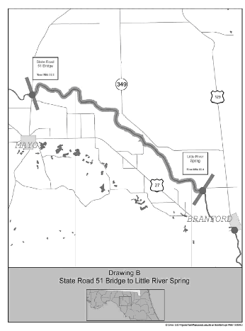
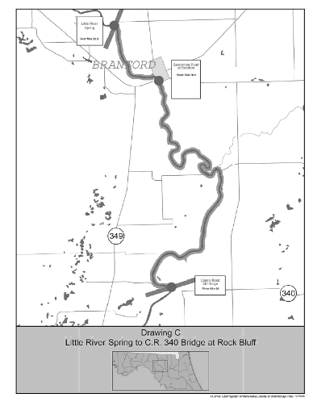
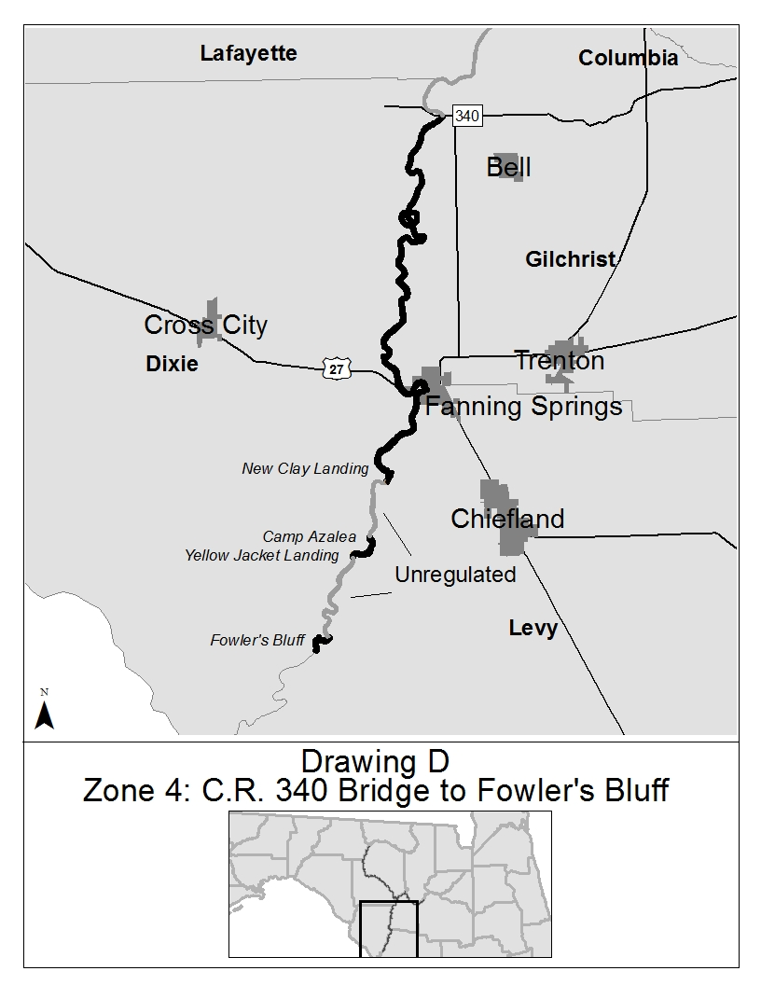
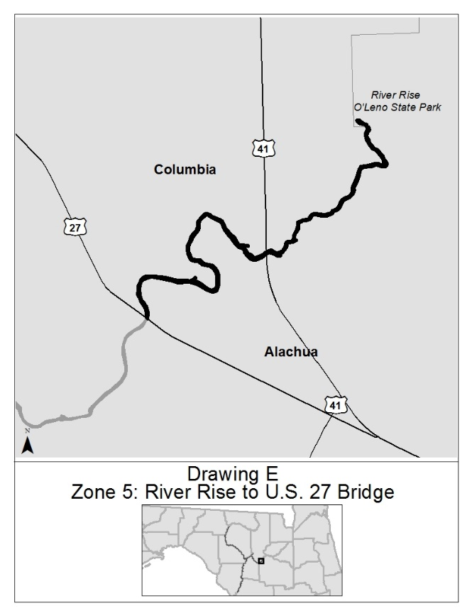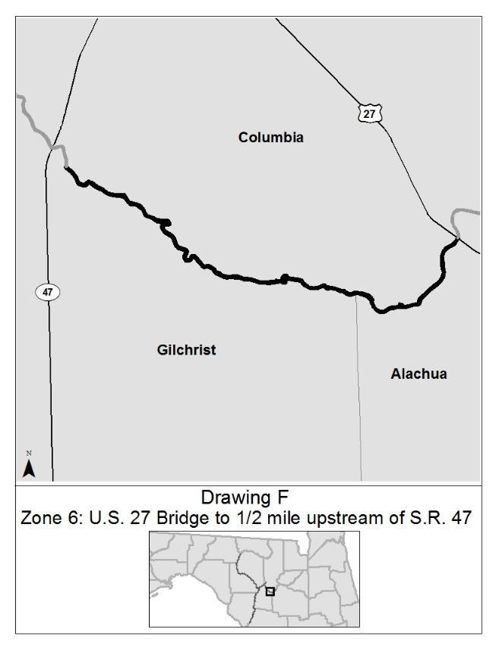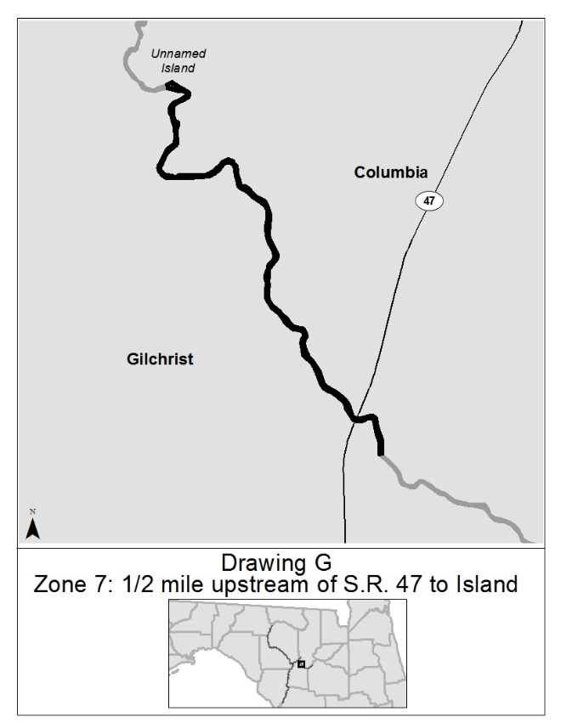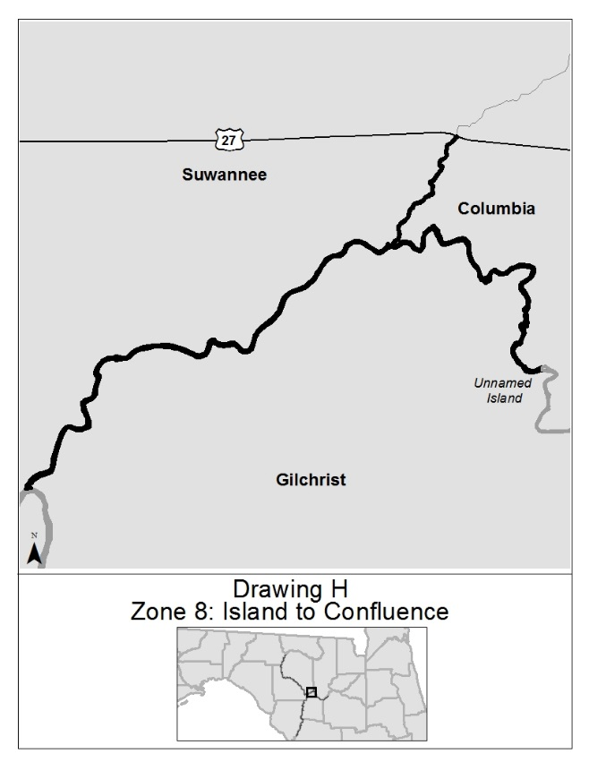
Rulemaking Authority 327.04, 327.46 FS. Law Implemented 327.46 FS. History–New 5-3-94, Formerly 16N-24.020, 62N-24.020, Amended 3-16-06, 11-4-15.

