Notice of Proposed Rule

WATER MANAGEMENT DISTRICTS
St. Johns River Water Management District
RULE NO.: RULE TITLE:
40C-41.023 Basin Boundaries
PURPOSE AND EFFECT: Management District (SJRWMD) initiated rulemaking to amend its rules consistent with notice published in the Florida Administrative Register on February 12, 2015, the St. Johns River Water Section 373.4131, F.S. These rules were last amended on October 1, 2013, to make them consistent with section 373.4131, F.S., which required the Department of Environmental Protection (“DEP”) in coordination with the five water management districts (“WMDs”) to develop statewide environmental resource permitting (“ERP”) rules. The purpose and effect of this rulemaking will be to make corrections and provide clarifications that have been identified as necessary since October 1, 2013. More specifically, the rulemaking will: (1) delete the reference to standard and general (stormwater) permits in subsection 40C-41.063(4), F.A.C., since the statewide ERP rules only provide for issuance of conceptual approval and individual permits; (2) reflect the movement of Rule 40C-42.091, F.A.C. into 40C-4.091, F.A.C.; (3) replace, with better graphics, the figures depicting special basins (identified as Figures 41-1 through 41-4 in 40C-41.023, and as Figures 13.0-1 through 13.0-4 in the “Environmental Resource Permit Applicant’s Handbook, Volume II: For Use within the Geographic Limits of the St. Johns River Water Management District” (Volume II) which is incorporated by reference in subsection 40C-41.043(5), F.A.C.); and (4) update the effective date for Part VI of Volume II as SJRWMD also will correct wording glitches in Volume II. These corrections include deleting language in 13.4.4.(d) (Off-site Land Preservation) that SJRWMD had intended to delete in the previous rulemaking to reflect the adoption of the Uniform Mitigation Assessment Method (UMAM), inserting language in 13.4.2 (Floodplain Storage Criteria) that it had intended to carry over from the rule as it existed before October 1, 2013, and amending Appendix B of Volume II to reflect that lands within Polk County were transferred to the Southwest Florida Water Management District, effective at 12:01 a.m. on July 1, 2003, per subsection 373.0691(2), Florida Statutes (2015).
SUMMARY: The proposed rule revisions will correct and clarify text in light of provisions in Chapter 62-330, F.A.C., and movement of Rule 40C-42.091, F.A.C. into Rule 40C-4.091, F.A.C., correct wording glitches in Volume II (including minor changes to provisions regarding off-site land preservation and floodplain storage criteria) that resulted from the initial rulemaking for the statewide ERP rules, and amend the boundaries of the Ocklawaha River Basin to reflect that lands within Polk County were transferred by operation of law to the Southwest Florida Water Management District.
SUMMARY OF STATEMENT OF ESTIMATED REGULATORY COSTS AND LEGISLATIVE RATIFICATION: The Agency has determined that this will not have an adverse impact on small business or likely increase directly or indirectly regulatory costs in excess of $200,000 in the aggregate within one year after the implementation of the rule. A SERC has not been prepared by the Agency.
The Agency has determined that the proposed rule is not expected to require legislative ratification based on the statement of estimated regulatory costs or if no SERC is required, the information expressly relied upon and described herein: The District has completed for the Governor’s Office of Fiscal Accountability and Regulatory Reform (OFARR) the “Is a SERC Required?” form and prepared a summary of the proposed rule amendments, which are both available upon request. Based on the completed “Is a SERC Required?” form and summary and the analysis performed by District staff in preparing and completing those documents, the proposed rule amendments are not expected to require legislative ratification pursuant to subsection 120.541(3), F.S.
Any person who wishes to provide information regarding a statement of estimated regulatory costs, or provide a proposal for a lower cost regulatory alternative must do so in writing within 21 days of this notice.
RULEMAKING AUTHORITY: 369.318, 373.044, 373.113, 373.4131, 373.415, 373.418 FS.
LAW IMPLEMENTED: 369.318, 373.413, 373.4131, 373.414, 373.415, 373.416, 373.418, 373.426, 373.461 FS.
IF REQUESTED WITHIN 21 DAYS OF THE DATE OF THIS NOTICE, A HEARING WILL BE SCHEDULED AND ANNOUNCED IN THE FAR.
Pursuant to the provisions of the Americans with Disabilities Act, any person requiring special accommodations to participate in this workshop/meeting is asked to advise the agency at least 48 hours before the workshop/meeting by contacting: District Clerk, (386)329-4127. If you are hearing or speech impaired, please contact the agency using the Florida Relay Service, 1(800)955-8771 (TDD) or 1(800)955-8770 (Voice).
THE PERSON TO BE CONTACTED REGARDING THE PROPOSED RULE IS: Veronika Thiebach, Sr. Assistant General Counsel, Office of General Counsel, St. Johns River Water Management District, 4049 Reid Street, Palatka, Florida 32177-2529, (386)326-3026, email vthiebach@sjrwmd.com

THE FULL TEXT OF THE PROPOSED RULE IS:

40C-41.023 Basin Boundaries.
(1) The Upper St. Johns River Hydrologic Basin is that area generally depicted in Figure 41-1 and defined in “Environmental Resource Permit Applicant’s Handbook Volume II: For Use Within the Geographic Limits of the St. Johns River Water Management District”, (effective date 10-1-13), Appendix B which is hereby incorporated by reference available at [https://www.flrules.org/Gateway/reference.asp?No=Ref-06353 http://www.flrules.org/Gateway/reference.asp?No=Ref-02999] and upon request from the St. Johns River Water Management District, 4049 Reid Street, Palatka, FL 32177-2529.
(2) through (6) No change.
(7) The Sensitive Karst Areas Basin is that area generally depicted in Figures 41-2, 41-3, and 41-4 and defined in “Environmental Resource Permit Applicant’s Handbook Volume II: For Use Within the Geographic Limits of the St. Johns River Water Management District”, Appendix B.
(8) No change.
Substantial revisions to Figures 41-1 through 41-4 in rule 40C-41.023, F.A.C., follow. See Florida Administrative Code for present Figures.

Figure 41-1 Basin Criteria Map

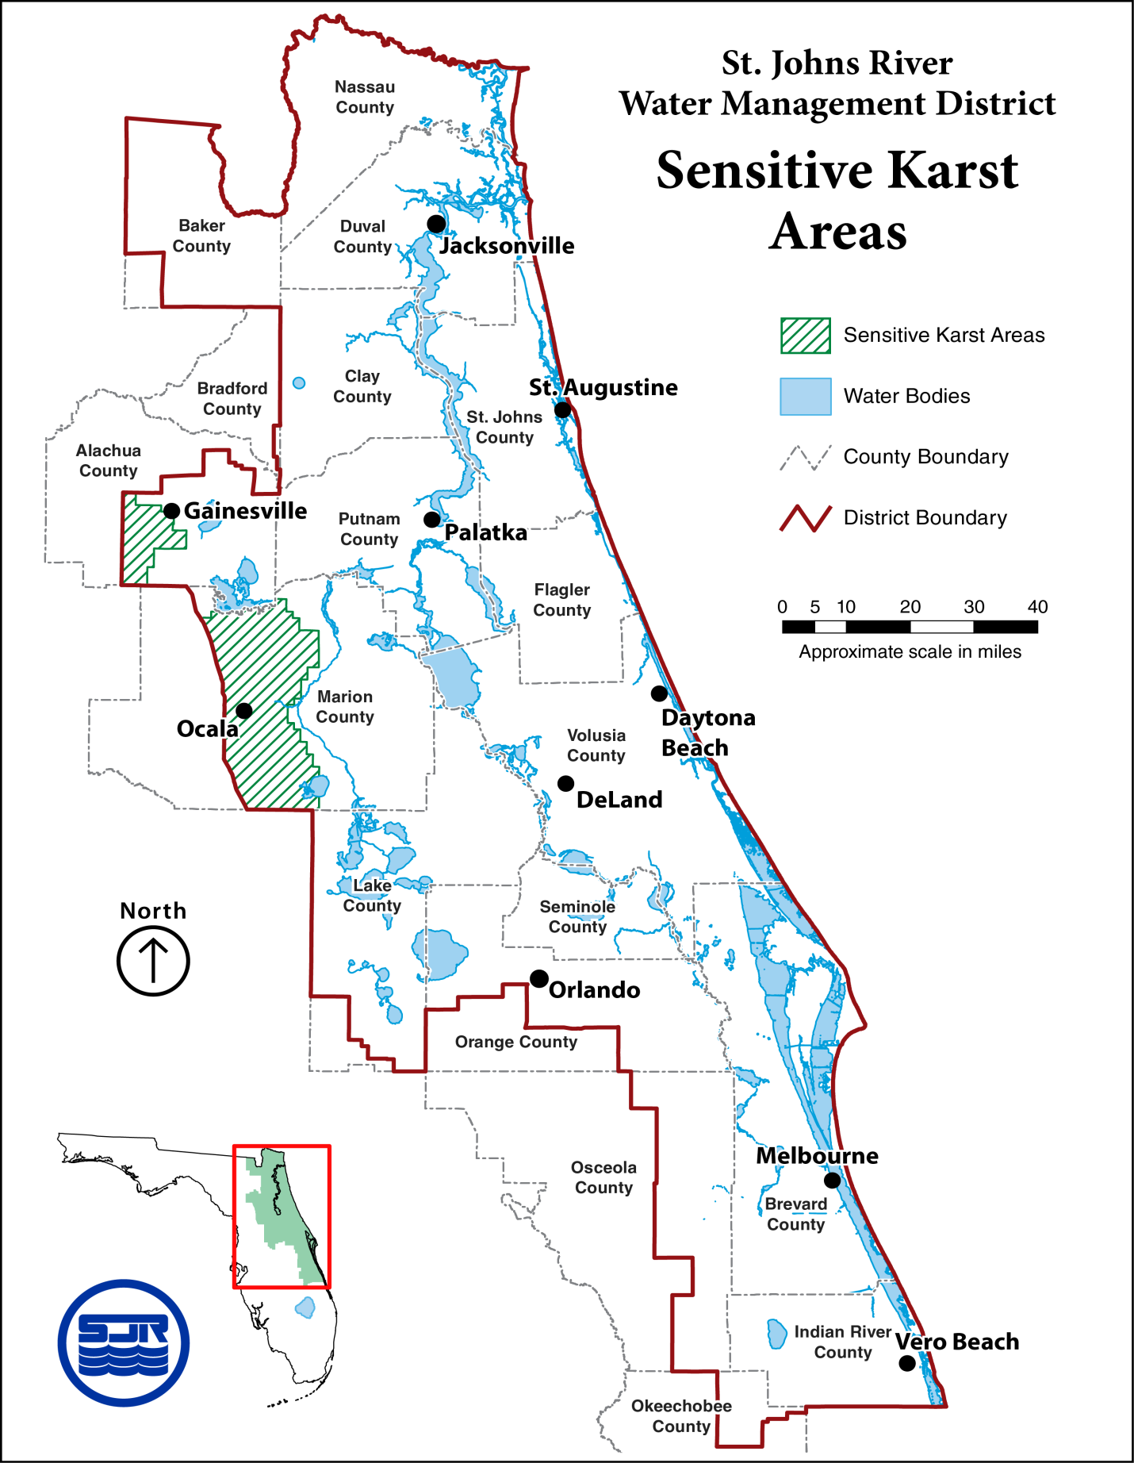
Figure 41-2 Sensitive Karst Areas in the St. Johns River Water Management District
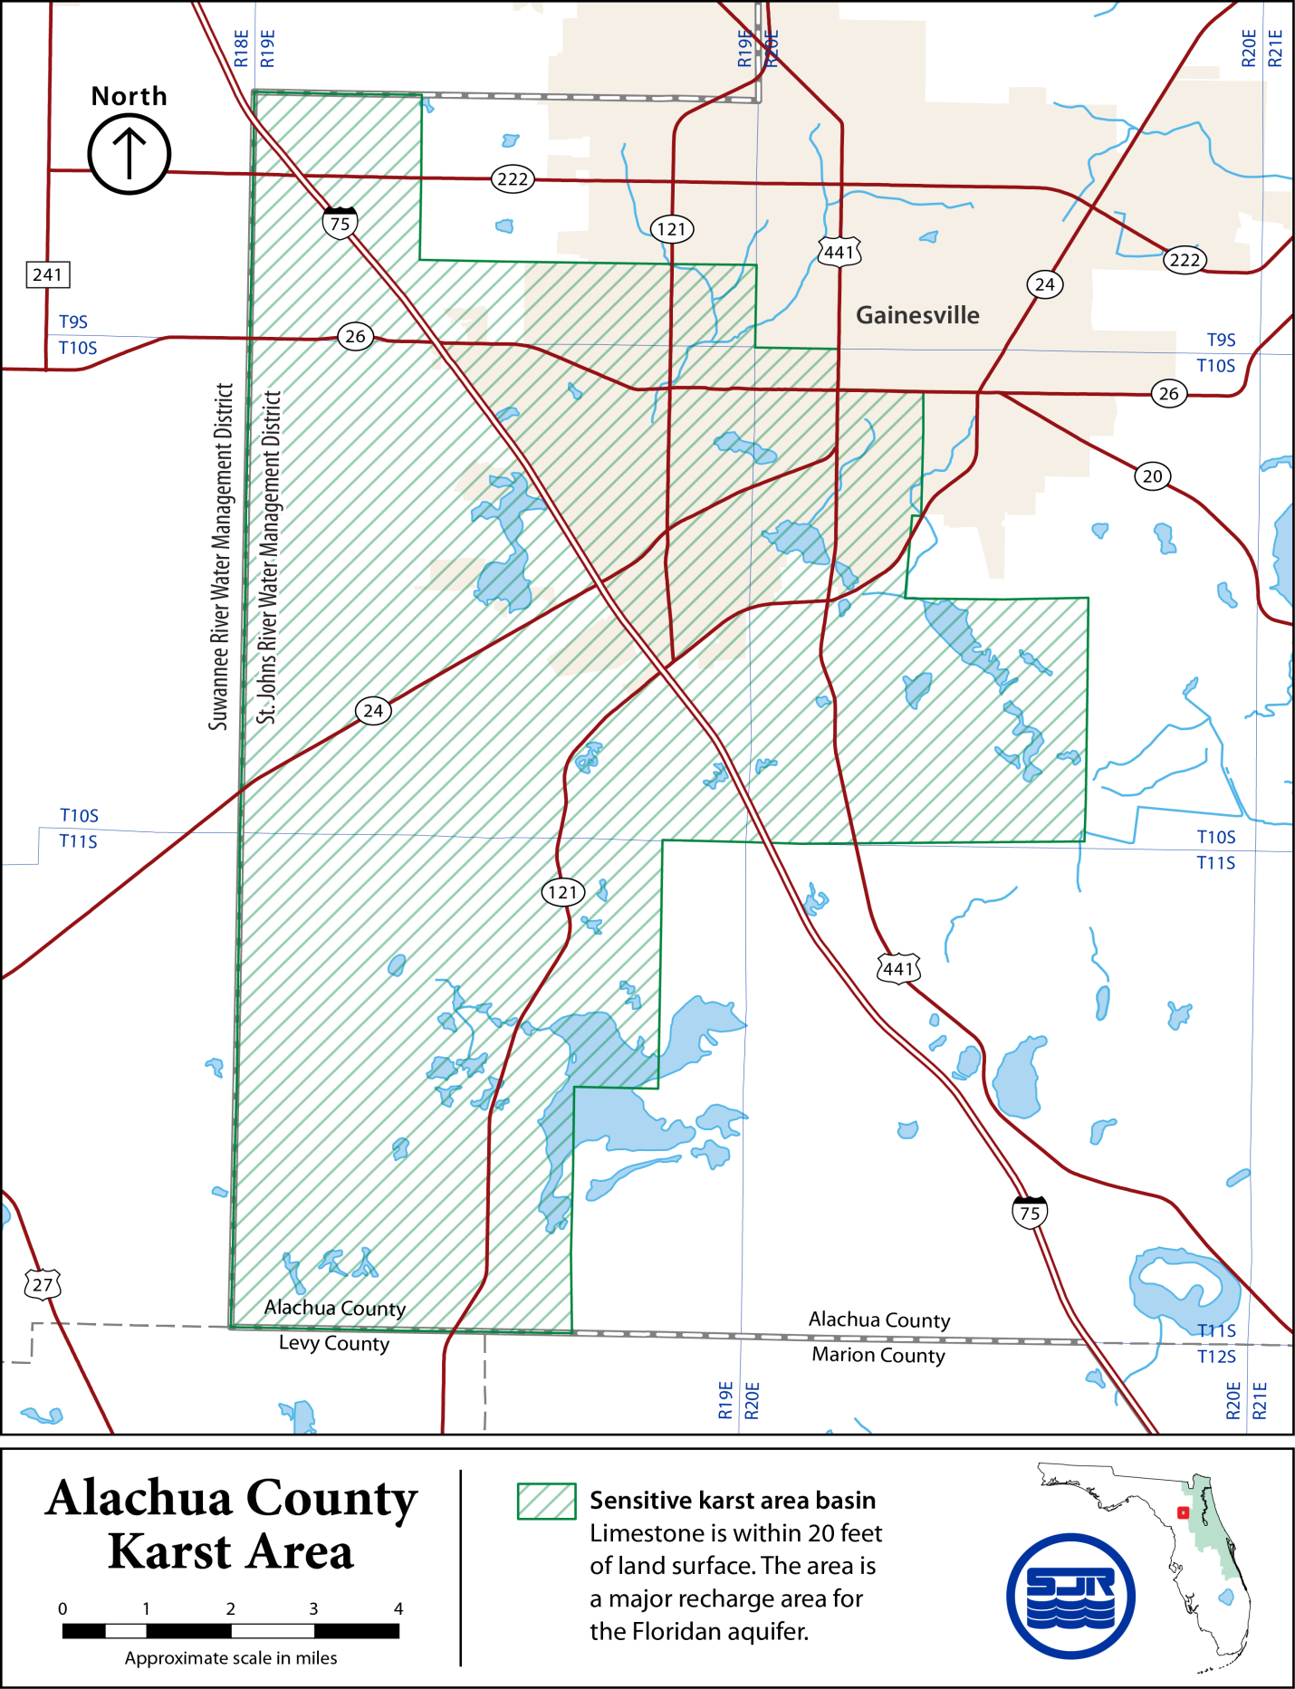
Figure 41-3 Alachua County Karst Area

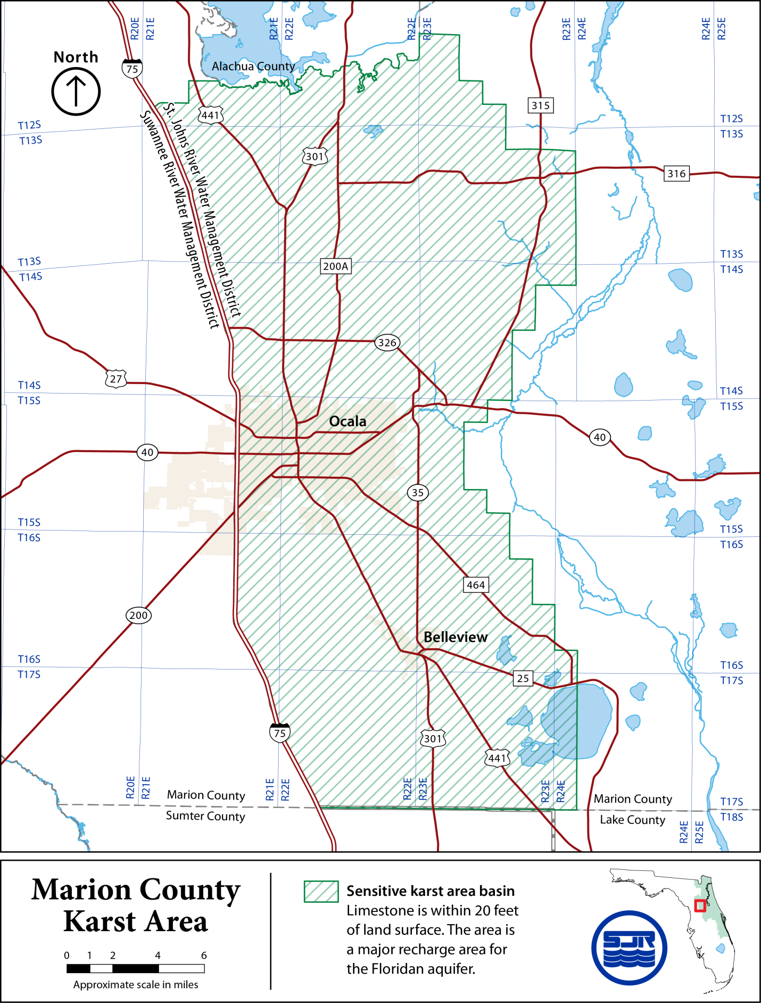
Figure 41-4 Marion County Karst Area
This rule will become effective on January 1, 2016, or upon the date that any related amendments to Chapter 62-330, F.A.C., proposed by the Department of Environmental Protection in the Notice of Rule Development published in the Florida Administrative Register on September 3, 2014 (Vol. 40, No. 17) take effect, whichever is later.
Rulemaking Authority 369.318, 373.044, 373.113, 373.4131, 373.414, 373.415, 373.418 FS. Law Implemented 369.318, 373.413, 373.4131, 373.414, 373.415, 373.416, 373.418, 373.426, 373.461 FS. History–New 12-7-83, Amended 5-17-87, 8-30-88, 4-3-91, 9-25-91, 7-14-92, 10-3-95, 11-25-98, 10-11-01, 3-7-03, 2-10-05, 12-3-06, 10-1-13, .

NAME OF PERSON ORIGINATING PROPOSED RULE: Veronika Thiebach, Sr. Assistant General Counsel, St. Johns River Water Management District, 4049 Reid Street, Palatka, Florida 32177-2529, 386-329-4488 and Thomas Mayton Jr., Sr. Assistant General Counsel, St. Johns River Water Management District, 4049 Reid Street, Palatka, Florida 32177-2529, 386-329-4108
NAME OF AGENCY HEAD WHO APPROVED THE PROPOSED RULE: Governing Board of the St. Johns River Water Management District.
DATE PROPOSED RULE APPROVED BY AGENCY HEAD: November 10, 2015
DATE NOTICE OF PROPOSED RULE DEVELOPMENT PUBLISHED IN FAR: February 12, 2015

