40E-21.671 Method of Withdrawal Classes.
Each water user may be identified by one or more of the following method of withdrawal classes:
(1) Surface waters:
(a) Pump.
(b) Gravity flow.
(2) Ground waters:
(a) Artesian well.
(b) Pumped well.
(c) Infiltration gallery.
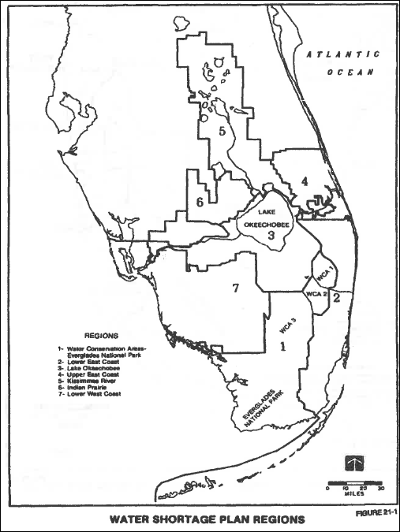

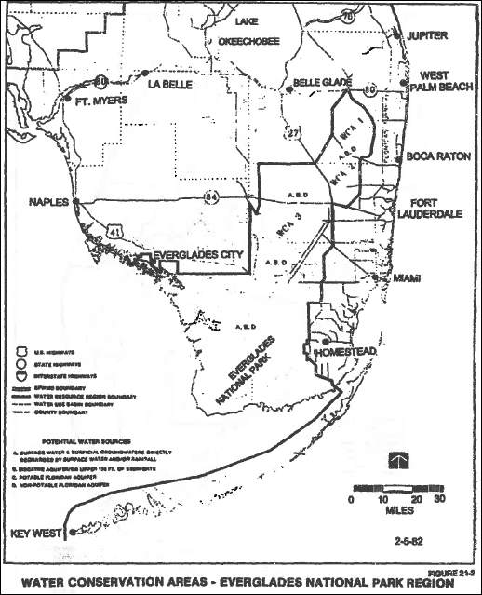

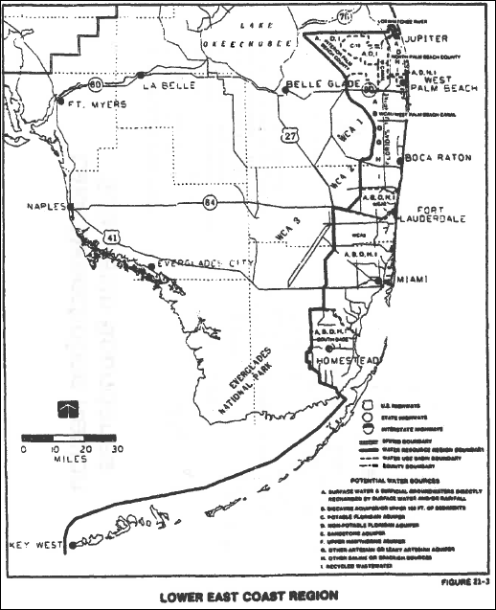

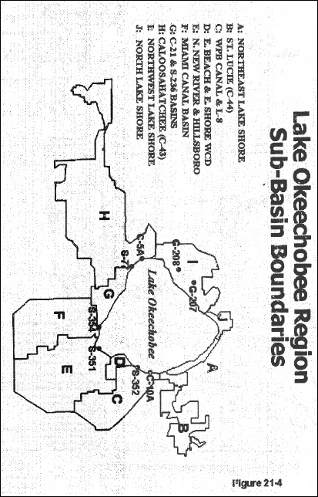

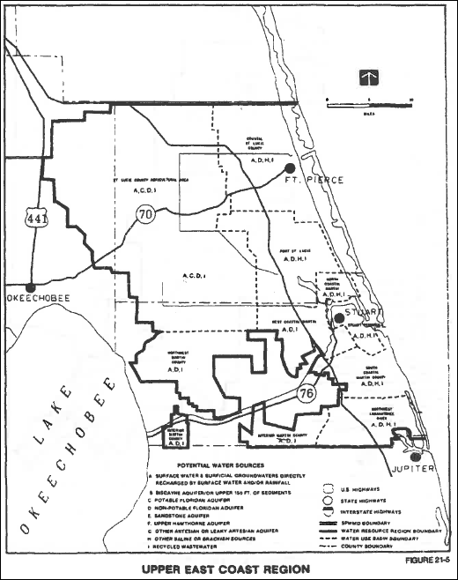

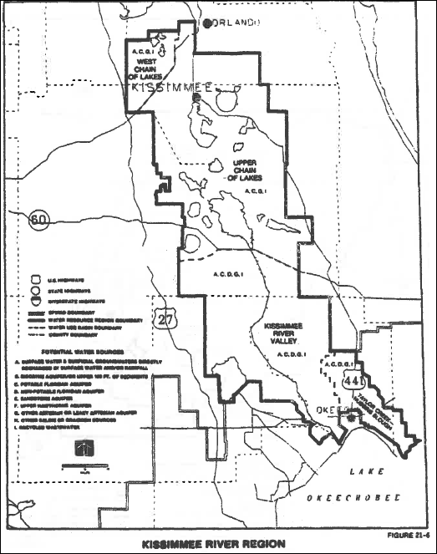

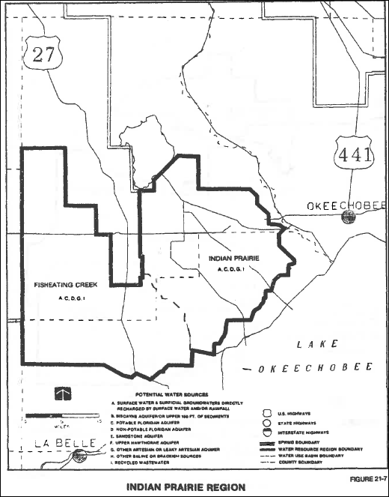

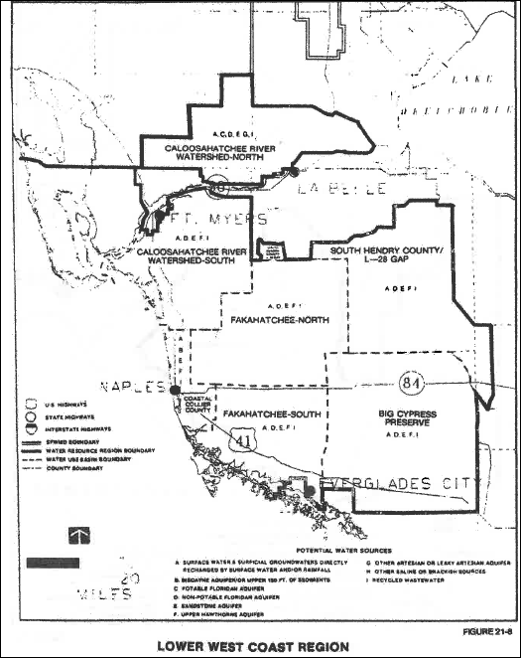

Rulemaking Authority 373.044, 373.113 FS. Law Implemented 373.175, 373.246 FS. History–New 5-31-82.

