40E-21.691 Surface Water Use Basin Descriptions.
This rule contains descriptions of the boundaries of the surface water use basins listed in Rule 40E-21.631, F.A.C.
(1) Water Conservation Areas/Everglades National Park Water Conservation Areas/Everglades National Park Water Use Basin, described as:
Palm Beach County (See Figure 21-13)
A parcel of land in Palm Beach County bounded as follows:
On the East by the centerlines of South Florida Water Management District’s Levee 40 and South Florida Water Management District’s Levee 36; On the South by the Palm Beach-Broward County line; On the West by the centerlines of South Florida Water Management District’s Levee 6 and South Florida Water Management District’s Levee 7; And, on the North by the centerline of South Florida Water Management District’s Levee 7 Extension.
Broward County (See Figure 21-12)
Beginning at the intersection of the centerline of South Florida Water Management District’s Levee 28 and the Broward-Palm Beach County line; Thence, Easterly along said Broward-Palm Beach County line to the centerline of South Florida Water Management District’s Levee 36; Thence, Southerly, Southwesterly, Northwesterly, Southwesterly and Southerly along said centerline of Levee 36 and South Florida Water Management District’s Levees 35A, 35, 37 and 33 to the Broward-Dade County line; Thence, Westerly, Northerly and Westerly along said Broward-Dade County line to the Broward-Collier County line; Thence, Northerly along said Broward-Collier County line to the centerline of South Florida Water Management District’s Levee 28 Interceptor; Thence, Southeasterly along said centerline of Levee 28 Interceptor to the centerline of South Florida Water Management District’s Levee 28; Thence, Northeasterly and Northerly along said centerline of Levee 28 to the Point of Beginning.
Dade County (See Figure 21-11)
All that part of Dade County lying Westerly of the following specifically described line:
Beginning at the intersection of the centerline of South Florida Water Management District’s Levee 37 and the Dade-Broward County line; Thence, Southerly and Southwesterly along said centerline of Levee 37 and the centerline of South Florida Water Management District’s Levees 30 and 31 North to the North line of Section 2, Township 55 South, Range 38 East; Thence, Westerly along the section lines to the Northwest corner of Section 6, Township 55 South, Range 37 East; Thence, Southerly along the section lines to the Northeast corner of Section 24, Township 57 South, Range 37 East; Thence, Westerly to the Northwest corner of said Section 24; Thence, Southerly along the section lines to the Southwest corner of Section 36, Township 57 South, Range 37 East; Thence, Easterly to the Southeast corner of said Section 36; Thence, Southerly along the section lines to the Southwest corner of Section 7, Township 58 South, Range 38 East; Thence, Easterly along the South line of said Section 7 to the centerline of South Florida Water Management District’s Canal 111; Thence, Southeasterly, Southerly and Southeasterly along said centerline of Canal 111 to the centerline of State Road 5 (U. S. Highway 1); Thence, Southerly along said centerline of State Road 5 (U. S. Highway 1) to Florida Bay, the Dade County line and the end of the specifically described line.
Monroe County (See Figure 21-10)
Beginning at the Northeast corner of Monroe County; Thence, Westerly along the Monroe-Collier County line to the Easterly shore of the Gulf of Mexico; Thence, Southerly along said shore to the Monroe-Dade County line; Thence, Northerly along said County line to the Point of Beginning.
Collier County (See Figure 21-25)
All that part of the Everglades National Park lying within Collier County.
(2) Lower East Coast.
(a) Interior Palm Beach County Water Use Basin, described as:
Palm Beach County (See Figure 21-13)
Beginning at the intersection of the centerline of South Florida Water Management District’s Levee 8 North Tieback with the Palm Beach-Martin County line; Thence, Easterly along said County line to the centerline of County Road 711; Thence, Southerly along said centerline of County Road 711 to the centerline of State Road 706; Thence, Westerly along said centerline of State Road 706 and its Westerly extension to the West line of Section 33, Township 40 South, Range 40 East; Thence, Southwesterly to the Southwest corner of Section 5, Township 41 South, Range 40 East; Thence, Southwesterly to the Northeast corner of Section 13, Township 41 South, Range 39 East; Thence, Westerly along the section line to the north-south one-quarter section line of said Section 13; Thence, Southerly along said north-south one-quarter section line to the South line of said Section 13; Thence, Southeasterly to the Southwest corner of Section 2, Township 42 South, Range 40 East; Thence, Easterly along the section lines to the Northeast corner of Section 12, Township 42 South, Range 40 East; Thence, Southerly along the section line to the Southeast corner of said Section 12; Thence, Easterly along the section lines to the north-south one-quarter section line of Section 17, Township 42 South, Range 41 East; Thence, Southerly along said north-south one-quarter section line to the South line of said Section 17; Thence, Easterly along the section lines to the Northeast corner of Section 24, Township 42 South, Range 41 East; Thence, Southerly along the section lines to the centerline of State Road 80; Thence, Westerly along said centerline of State Road 80 to the centerline of Folsom Road; Thence, Northerly along said centerline of Folsom Road to the South line of the Northwest one-quarter of Section 22, Township 43 South, Range 41 East; Thence, Easterly along said south line to the Southeast corner of the Northwest one-quarter of said Section 22; Thence, Northerly along the East line of said Northwest one-quarter of Section 22 to the Northeast corner of said Northwest one-quarter of Section 22; Thence, Westerly along the North line of said Section 22 to the Southeast corner of Section 16, Township 43 South, Range 41 East; Thence, Northerly along the section line to the Northeast corner of said Section 16; Thence, Westerly along the section line to the Southeast corner of Section 8, Township 43 South, Range 41 East; Thence, Northerly along the section lines to the centerline of the “M” Canal; Thence, Westerly and Southwesterly along said centerline of the “M” Canal and the centerline of South Florida Water Management District’s Levee 8 Tieback Borrow Canal and its Southerly extension to the centerline of South Florida Water Management District’s Levee 8; Thence, Northwesterly, Westerly and Northerly along said centerline of Levee 8 and the centerline of Levee 8 North Tieback to the Point of Beginning.
(b) Loxahatchee River Water Use Basin, described as:
Palm Beach County (See Figure 21-13)
Beginning at the intersection of the centerline of County Road 711 and the Palm Beach-Martin County line; Thence, Easterly, Northerly and Easterly along said County line to the centerline of the Loxahatchee River; Thence, Southeasterly along said centerline of the Loxahatchee River to the centerline of the Southwest Fork of the Loxahatchee River; Thence, Southwesterly along said centerline of the Southwest Fork of the Loxahatchee River to the Easterly right of way line of South Florida Water Management District’s Canal 18; Thence, Northwesterly along said right of way line to the Northwesterly right of way line of said Canal 18; Thence, Southwesterly along the Northwesterly and Westerly right of way line of said Canal 18 to the North line of Section 19, Township 41 South, Range 42 East; Thence, Westerly along the section lines to the Northwest corner of Section 21, Township 41 South, Range 41 East; Thence, Northerly along the section line to the Southwest corner of Section 9, Township 41 South, Range 41 East; Thence, Easterly along the section line to the north-south one-quarter section line of said Section 9; Thence, Northerly along the north-south one-quarter section lines to the centerline of State Road 706; Thence, Westerly along said centerline of State Road 706 to the centerline of County Road 711; Thence, Northerly along said centerline of County Road 711 to the Point of Beginning.
(c) C-18 Water Use Basin, described as:
Palm Beach County (See Figure 21-13)
Beginning at the intersection of the centerline of County Road 711 and the centerline of State Road 706; Thence, Easterly along said centerline of State Road 706 to the north-south one-quarter section line of Section 4, Township 41 South, Range 41 East; Thence, Southerly along the north-south one-quarter section line to the South line of Section 9, Township 41 South, Range 41 East; Thence, Westerly along the section line to the Northeast corner of Section 17, Township 41 South, Range 41 East; Thence, Southerly along the section line to the Southeast corner of said Section 17; Thence, Easterly along the section lines to the Westerly right of way line of South Florida Water Management District’s Canal 18; Thence, Northerly and Northeasterly along said right of way line to the Southwest Fork of the Loxahatchee River; Thence, Southeasterly along said Canal 18 right of way line to the Southeasterly right of way line of said Canal 18; Thence, Southwesterly along said right of way line to the centerline of Florida’s Turnpike; Thence, Southeasterly along said centerline of Florida’s Turnpike to the West line of Section 15, Township 41 South, Range 42 East; Thence, Southerly along the section lines to the Southeast corner of Section 21, Township 41 South, Range 42 East; Thence, Westerly along the section line to the Southwest corner of said Section 21; Thence, Southerly along the section lines to the centerline of South Florida Water Management District’s Canal 18; Thence, Southeasterly along said centerline to the Northeast one-quarter right of way line of the Seaboard Coastline Railroad; Thence, Northwesterly along said Northeasterly right of way line to the West line of Section 7, Township 42 South, Range 42 East; Thence, Southerly along the section lines to the Southeast corner of Section 13, Township 42 South, Range 41 East; Thence, Westerly along the section lines to the north-south one-quarter section line of Section 17, Township 42 South, Range 41 East; Thence, Northerly along said north-south one-quarter section line to the North line of said Section 17; Thence, Westerly along the section lines to the Southeast corner of Section 12, Township 42 South, Range 40 East; Thence, Northerly along the section line to the Northeast corner of said Section 12; Thence, Westerly along the section lines to the Southwest corner of Section 2, Township 42 South, Range 40 East; Thence, Northwesterly to the Southwest corner of the East one-half of Section 13, Township 41 South, Range 39 East; Thence, Northerly along the West line of the East one-half of said section 13 to the Northwest corner of the East one-half of said Section 13; Thence, Easterly along the section line to the Northeast corner of said Section 13; Thence, Northeasterly to the Northeast corner of Section 7, Township 41 South, Range 40 East; Thence, Northeasterly to the intersection of the West line of Section 33, Township 40 South, Range 40 East with the centerline of State Road 706; Thence Easterly along said centerline of State Road 706 to the Point of Beginning.
(d) North Palm Beach County Water Use Basin, described as:
Palm Beach County (See Figure 21-13)
All that part of Palm Beach County lying Easterly and Northerly of the following specifically described line:
From the Northwest corner of Section 27, Township 40 South, Range 42 East on the Palm Beach-Martin County line bear Easterly along said County line to the centerline of the Loxahatchee River and the Point of Beginning. Thence, Southeasterly along said centerline of the Loxahatchee River to the centerline of the Southwest Fork of the Loxahatchee River; Thence, Southwesterly along said centerline of the Southwest Fork of the Loxahatchee River to the Easterly right of way line of South Florida Water Management District’s Canal 18; Thence, Southeasterly along said right of way line to the Southeasterly right of way line of said Canal 18; Thence, Southwesterly along said right of way line to the centerline of Florida’s Turnpike; Thence, Southeasterly along said centerline of Florida’s Turnpike to the West line of Section 15, Township 41 South, Range 42 East; Thence, Southerly along the section lines to the Southeast corner of Section 21, Township 41 South, Range 42 East; Thence, Westerly along the section line to the Southwest corner of said Section 21; Thence, Southerly along the section lines to the centerline of South Florida Water Management District’s Canal 18; Thence, Southeasterly along said centerline to the Northeasterly right of way line of the Seaboard Coastline Railroad; Thence, Southeasterly along said right of way line to the West line of Section 22, Township 42 South, Range 42 East; Thence, Southerly along the section lines to the Northeast corner of the Southeast one-quarter of Section 4, Township 43 South, Range 42 East and the Corporate City Limit Line of the City of West Palm Beach; Thence, Easterly along said Corporate City Limit Line and along the Northerly Corporate City Limit Line of the Town of Palm Beach to the Westerly shore of the Atlantic Ocean, and the end of the specifically described line.
Martin County (See Figure 21-14)
Beginning at the intersection of the centerline of Country Club Drive with the Martin-Palm Beach County line; Thence, Northwesterly along said centerline to the North line of the South one-half of the Northwest one-quarter of the Southwest one-quarter of the Southwest one-quarter of Section 23, Township 40 South, Range 42 East; Thence, Westerly along said line and along the North line of the South one-half of the North one-half of the South one-half of the Southeast one-quarter of Section 22, Township 40 South, Range 42 East, to the centerline of the Loxahatchee River; Thence, Northwesterly along said centerline to the north line of the South one-half of the North one-half of the Southeast one-quarter of said Section 22; Thence, Easterly along said line to the centerline of said Country Club Drive; Thence, Northwesterly along said centerline to the West line of the East one-quarter of the Northeast one-quarter of said Section 22; Thence, Northerly along said West line to the Northwest corner of the Southeast one-quarter of the Northeast one-quarter of said Section 22; Thence, Easterly along the one-quarter one-quarter section lines to the Northeast corner of the Southwest one-quarter of the Northwest one-quarter of Section 23, Township 40 South, Range 42 East; Thence, Southerly along the East line of said Southwest one-quarter of the Northwest one-quarter of Section 23 to the South line of the North one-half of said Section 23; Thence, Easterly along said line to the centerline of the North Fork of the Loxahatchee River; Thence, Southeasterly along said centerline to the Martin-Palm Beach County line; Thence, Westerly along said County line to the Point of Beginning.
And also;
All the South one-half of the Southeast one-quarter of Section 24, Township 40 South, Range 42 East; And the Southeast one-quarter of the Southwest one-quarter of said Section 24; And the West three-quarters of the Southwest one-quarter of the Southwest one-quarter of Section 19, Township 40 South, Range 43 East.
(e) M Canal Water Use Basin, described as:
Palm Beach County (See Figure 21-13)
All the lands lying within the Corporate Limits of the Town of Palm Beach and the City of West Palm Beach.
(f) Water Conservation Area 1/West Palm Beach Canal Water Use Basin, described as:
Broward County (See Figure 21-12)
All that part of Broward County lying Easterly and Northerly of the following specifically described line:
Beginning at the intersection of the Broward-Palm Beach County line and the centerline of South Florida Water Management District’s Levee 36; Thence, Southerly along said centerline of Levee 36 to the centerline of South Florida Water Management District’s Canal 14 (Cypress Creek); Thence, Easterly, Southerly, Southeasterly and Northeasterly along said centerline of Canal 14 (Cypress Creek) to the centerline of the Intracoastal Waterway; Thence, East to the Atlantic Ocean and the end of the specifically described line.
Palm Beach County (See Figure 21-13)
Beginning at the intersection of the centerline of South Florida Water Management District’s Levee 36 and the Palm Beach-Broward County line; Thence, Easterly along said County line to the Westerly shore of the Atlantic Ocean; Thence, Northerly along said shoreline to the South Palm Beach-Town of Palm Beach Corporate Limits; Thence, Westerly and Northerly along said Town of Palm Beach Corporate Limits to the Corporate Limits of the City of Lake Worth; Thence, Easterly and Northerly along said Corporate Limits of the City of Lake Worth to the Corporate Limits of the Town of Palm Beach; Thence, Westerly and Northerly along the Corporate Limits of the Town of Palm Beach to the Corporate Limits of the City of West Palm Beach; Thence, Westerly, Northerly and Westerly along said Corporate Limits to the Northwest corner of Section 19, Township 43 South, Range 42 East; Thence, Southerly along the section lines to the centerline of State Road 80; Thence, Westerly along said centerline of State Road 80 to the centerline of Folsom Road; Thence, Northerly along said centerline of Folsom Road to the South line of the Northwest one-quarter of Section 22, Township 43 South, Range 41 East; Thence, Easterly along said South line to the Southeast corner of the Northwest one-quarter of said Section 22; Thence, Northerly along the East line of said Northwest one-quarter of Section 22 to the Northeast corner of said Northwest one-quarter of Section 22; Thence, Westerly along the North line of said Section 22 to the Southeast corner of Section 16, Township 43 South, Range 41 East; Thence, Northerly along the section line to the Northeast corner of said Section 16; Thence, Westerly along the section line to the Southeast corner of Section 8, Township 43 South, Range 41 East; Thence, Northerly along the section lines to the centerline of the “M” Canal; Thence, Westerly and Southwesterly along said centerline of the “M” Canal and the centerline of South Florida Water Management District’s Levee 8 Tieback Borrow Canal and its Southerly extension to the centerline of South Florida Water Management District’s Levee 8; Thence, Southerly, Southeasterly and Southerly along said centerline of Levee 8 and the centerlines of South Florida Water Management District’s Levees 40 and 36 to the Point of Beginning.
(g) Water Conservation Area 2 Water Use Basin, described as:
Broward County (See Figure 21-12)
Beginning at the intersection of the centerline of South Florida Water Management District’s Canal 14 (Cypress Creek) and the centerline of South Florida Water Management District’s Levee 36; Thence, Easterly, Southerly, Southeasterly and Northeasterly along said centerline of Canal 14 (Cypress Creek) to the centerline of the Intracoastal Waterway; Thence, East to the Atlantic Ocean; Thence, Southerly along the Atlantic Ocean to the Fort Lauderdale-Hollywood Corporate Boundary line; Thence, Westerly along said Corporate Boundary line to the centerline of the Intracoastal Waterway; Thence, Northerly along said centerline of the Intracoastal Waterway to the centerline of the New River; Thence, Westerly and Southwesterly along said centerline of the New River and the centerline of the South Fork of the New River to the centerline of the North New River Canal; Thence, Northwesterly along said centerline of the North New River Canal to the Southerly extension of the centerline of South Florida Water Management District’s Levee 35A; Thence, Northeasterly and Northerly along said centerline of said Southerly extension and the centerline of South Florida Water Management District’s Levees 35A and 36 to the Point of Beginning.
(h) Water Conservation Area 3 Water Use Basin, described as:
Broward County (See Figure 21-12)
All that part of Broward County lying Easterly and Southerly of the following specifically described line:
Beginning at the intersection of the Broward-Dade County line and the centerline of South Florida Water Management District’s Levee 33; Thence, Northerly, Northeasterly and Southeasterly along said centerline of Levee 33 and the centerline of South Florida Water Management District’s Levees 37 and 35 to the centerline of South Florida Water Management District’s Levee 35A; Thence, Southerly along the Southerly extension of said Levee 35A to the centerline of South Florida Water Management District’s North New River Canal; Thence, Southeasterly along said centerline of the North New River Canal to the centerline of the South Fork of the New River; Thence, Northeasterly and Easterly along said centerline of the South Fork of the New River and the New River to the centerline of the Intracoastal Waterway; Thence, Southerly along said centerline of the Intracoastal Waterway to the Fort Lauderdale-Hollywood Corporate Boundary line; Thence, Easterly along said Corporate Boundary line to the Atlantic Ocean and the end of the specifically described line.
Dade County (See Figure 21-11)
All that part of Dade County lying Easterly of the following specifically described line:
Beginning at the intersection of the centerline of South Florida Water Management District’s Levee 37 and the Dade-Broward County line; Thence, Southerly along said centerline of Levee 37 and the centerline of South Florida Water Management District’s Levees 30 and 31 North to the centerline of South Florida Water Management District’s Canal 1 West; Thence, Easterly and Southeasterly along said centerline of Canal 1 West to the East line of Section 11, Township 56 South, Range 39 East; Thence, Southerly along said line to the Southwest corner of Section 12, Township 56 South, Range 39 East; Thence, Easterly to the Southeast corner of said Section 12; Thence, Southerly along the West line of Section 18, Township 56 South, Range 40 East to the South line of the North one-half of said Section 18; Thence, Easterly along the one-quarter section lines to the centerline of State Road 821; Thence, Southerly along said centerline of State Road 821 to the South line of Section 17, Township 56 South, Range 40 East; Thence, Easterly along said section lines to the waters of Biscayne Bay and the end of the specifically described line.
Broward County (See Figure 21-12)
All that part of Broward County lying Easterly and Southerly of the following specifically described line:
Beginning at the intersection of the Broward-Dade County line and the centerline of South Florida Water Management District’s Levee 33; Thence, Northerly, Northeasterly and Southeasterly along said centerline of Levee 33 and the centerline of South Florida Water Management District’s Levees 37 and 35 to the centerline of South Florida Water Management District’s Levee 35A; Thence, Southerly along the Southerly extension of said Levee 35A to the centerline of South Florida Water Management District’s North New River Canal; Thence, Southeasterly along said centerline of the North New River Canal to the centerline of the South Fork of the New River; Thence, Northeasterly and Easterly along said centerline of the South Fork of the New River and the New River to the centerline of the Intracoastal Waterway; Thence, Southerly along said centerline of the Intracoastal Waterway to the Fort Lauderdale-Hollywood Corporate Boundary line; Thence, Easterly along said Corporate Boundary line to the Atlantic Ocean and the end of the specifically described line.
(i) South Dade Water Use Basin, described as:
Dade County (See Figure 21-11)
Beginning at the Northwest corner of Section 6, Township 55 South, Range 38 East; Thence, Southerly along the section lines to the Northeast corner of Section 24, Township 58 South, Range 37 East; Thence, Westerly to the Northwest corner of said Section 24; Thence, Southerly along the section lines to the Southwest corner of Section 36, Township 58 South, Range 37 East; Thence, Easterly to the Southeast corner of said Section 36; Thence, Southerly along the section lines to the Southwest corner of Section 7, Township 58 South, Range 38 East; Thence, Easterly along the section lines to the centerline of South Florida Water Management District’s Canal 111; Thence, Southeasterly, Southerly and Southeasterly along said centerline of Canal 111 to the centerline of State Road 5 (U.S. Highway 1); Thence, Southerly along said centerline of State Road 5 (U.S. Highway 1) to the Dade-Monroe County line and Florida Bay; Thence, Northeasterly along the Dade-Monroe County line to the Western shore of Little Card Sound; Thence, Northeasterly and Northerly along the Western shore of Little Card Sound and Biscayne Bay to the south line of Section 14, Township 56 South, Range 40 East; Thence, Westerly along the section lines to the centerline of State Road 821; Thence, Northerly along said centerline of State Road 821 to the South line of the North one-half of Section 17, Township 56 South, Range 40 East; Thence, Westerly along the one-quarter section lines to the Southwest corner of the Northwest one-quarter of said Section 18; Thence, Northerly to the Southeast corner of Section 12, Township 56 South, Range 39 East; Thence, Westerly along the South line of said Section 12 to the Southwest corner of said Section 12; Thence, Northerly along the West line of said Section 12 to the centerline of South Florida Water Management District’s Canal 1 West; Thence, Northwesterly and Westerly along said centerline of Canal 1 West to the centerline of South Florida Water Management District’s Levee 31 North; Thence, Northerly along said centerline of Levee 31 North to the North line of Section 2, Township 55 South, Range 38 East; Thence, Westerly along the section lines to the Point of Beginning.
Monroe County (See Figure 21-10)
All of the Florida Keys lying within Monroe County.
(3) Lake Okeechobee.
(a) Everglades Agricultural Area Water Use Basin, described as:
Palm Beach County (See Figure 21-13)
Beginning at the intersection of the Palm Beach-Martin County line and the centerline of South Florida Water Management District’s Levee D-9; Thence, Easterly along said County line to the centerline of South Florida Water Management District’s Levee 8 Tieback; Thence, Southerly along said centerline of Levee 8 Tieback to the centerline of Levee 8; Thence, Easterly, Southeasterly and Southerly along said centerline of Levee 8 to the Easterly extension of the centerline of South Florida Water Management District’s Levee 7; Thence, Westerly and Southwesterly along said centerline of Levee 7 and the centerline of South Florida Water Management District’s Levee 6 and its Southerly extension to the intersection thereof with the Palm Beach-Broward County line; Thence, Easterly along said Palm Beach-Broward County line to the Palm Beach-Hendry County line; Thence, Northerly along said Palm Beach-Hendry County line to the intersection thereof with the centerline of South Florida Water Management District’s Levee D-2; Thence, Southeasterly, Northeasterly and Northerly along said Centerline of Levee D-2 and the centerline of South Florida Water Management District’s Levee D-9 to the Point of Beginning.
Glades County (See Figure 21-21)
Beginning at the intersection of the centerline of State Road 25 (U.S. Highway 27) and the Glades-Hendry County line; Thence, Northerly along said centerline of State Road 25 and the Northerly extension thereof to the intersection thereof with the centerline of South Florida Water Management District’s Levee D-3; Thence, southeasterly along said centerline of Levee D-3 and the centerline of South Florida Water Management District’s Levee D-1 to the intersection thereof with the Glades-Hendry County line; Thence, Southeasterly and Westerly along said county line to the Point of Beginning.
Hendry County (See Figure 21-24)
Beginning at the intersection of the Easterly right of way line of State Road 25 (U.S. Highway 27) and the Hendry-Glades County line; Thence, Southerly and Easterly along the Easterly and Northerly right of way line of said State Road 25 to the intersection thereof with the Westerly line of Section 12, Township 43 South, Range 33 East; Thence, Southerly along the section lines to the intersection thereof with the Northerly right of way line of South Florida Water Management District’s Levee 1; Thence, Easterly and Southerly along said Northerly right of way line and the Easterly right of way line of South Florida Water Management District’s Levee 2 and Levee 3 to the Hendry-Palm Beach County line; Thence, Northerly along the Hendry-Palm Beach County line to the intersection thereof with the Southerly right of way line of South Florida Water Management District’s Levee D-2; Thence, Northwesterly along said Southerly right of way line of Levee D-2 and along the Southerly right of way line of South Florida Water Management District’s Levee D-1 to the intersection thereof with the Hendry-Glades County line; Thence, Southerly and Westerly along said Hendry-Glades County line to the Point of Beginning.
(b) Caloosahatchee River Water Use Basin, described as:
Glades County (See Figure 21-21)
Beginning at the intersection of the centerline of State Road 25 (U.S. Highway 27) and the Glades-Hendry County line; Thence, Westerly, Northerly and Westerly along said county line to the intersection thereof with the centerline of State Road 29; Thence, Northeasterly along said centerline of State Road 29 to the intersection thereof with the centerline of State Road 78; Thence, Easterly and Northeasterly along said centerline of State Road 78 to the intersection thereof with the centerline of State Road 25 (U.S. Highway 27); Thence, Easterly along said centerline of State Road 25 to the intersection thereof with the centerline of South Florida Water Management District’s Canal 43; Thence, Northeasterly along said centerline of Canal 43 to Structure 77; Thence, southeasterly along the centerline of South Florida Water Management District’s Levee D-3 to the intersection thereof with the Northerly extension of the centerline of State Road 25 (U.S. Highway 27); Thence, Southerly along said centerline of State Road 25 to the Point of Beginning.
Hendry County (See Figure 21-24)
Beginning at the intersection of the Westerly right of way line of State Road 25 (U.S. Highway 27) and the Hendry-Glades County line; Thence, Southerly and Easterly along the Westerly and Southerly right of way line of said State Road 25 to the intersection thereof with the Westerly line of Section 12, Township 43 South, Range 33 East; Thence, Southerly along the section lines to the intersection thereof with the Northeast corner of Section 11, Township 44 South, Range 33 East; Thence, Westerly along the section lines to the Northwest corner of Section 7, Township 44 South, Range 33 East; Thence, Southwesterly to the Southwest corner of Section 12, Township 44 South, Range 32 East; Thence, Westerly along the section lines to the Easterly right of way line of State Road 833; Thence, Southerly along said line to the intersection thereof with the Northerly right of way line of State Road 832; Thence, Westerly along said line to the intersection thereof with the centerline of the Keri Grade; Thence, Southwesterly along said Keri Grade to the intersection thereof with the West line of Section 11, Township 45 South, Range 31 East; Thence, Southerly along the section lines to the Northeast corner of the South one-half of Section 15, Township 45 South, Range 31 East; Thence, Southwesterly to the Southwest corner of said Section 15; Thence, Westerly along the section lines to the intersection thereof with the centerline of the Seaboard Coastline Railroad; Thence, Southerly along said line to the Hendry-Collier County line; Thence; Westerly along said Countyline to the Southeast corner of Section 36, Township 45 South, Range 28 East; Thence, Northerly along the section lines to the Southeast corner of Section 24, Township 45 South, Range 28 East; Thence Northwesterly to the Northwest corner of the East one-half of Section 24, Township 45 South, Range 28 East; Thence, Westerly along the centerline of Church Road to the Southeast corner of Section 17, Township 45 South, Range 28 East; Thence, Northwesterly to the Northeast corner of the Southwest one-quarter of said Section 17; Thence, Southerly along the section lines to the Northwest corner of the south one-half of Section 29, Township 45 South, Range 28 East; Thence, Southeasterly to the Southeast corner of Section 32, Township 45 South, Range 28 East and the Hendry-Collier County line; Thence, Westerly along said Hendry-Collier County line to the Hendry-Lee County line; Thence, Northerly along said County line to the centerline of State Road 78; Thence, Easterly, Northerly, Easterly and Northerly along said line to the intersection thereof with the Hendry-Glades County line; Thence, Easterly along said line to the Point of Beginning.
Lee County (See Figure 21-23)
Beginning at the intersection of the centerline of U.S. Highway 41 (Cleveland Avenue) with the centerline of North Airport Road; Thence, Southerly along the centerline of U.S. Highway 41 to the South line of Section 2, Township 45 South, Range 24 East; Thence, Westerly along said line to the Southwest corner of the Southeast one-quarter of said Section 2; Thence, Northerly to the center of said Section 2; Thence, Westerly along the East-West 1/4 line to the centerline of Sunrise Drive; Thence, Northerly along said centerline to the centerline of Davis Drive; Thence, Westerly along said centerline to the centerline of State Road 867 (McGregor Boulevard); Thence, Northeasterly along said centerline to the centerline of Vesper Drive; Thence, Westerly along said centerline and its Westerly extension to the centerline of the Okeechobee Waterway; Thence, Northeasterly along said centerline to the centerline of State Road 45 (U.S. 41); Thence, Northwesterly along said centerline to the centerline of State Road 78A; Thence, Westerly along said centerline to the centerline of Yellow Fever Creek; Thence, Northwesterly along said centerline to the intersection thereof with the West line of Section 3, Township 44 South, Range 24 East; Thence, Northerly along the section lines to the Southeast corner of Section 16, Township 43 South, Range 24 East; Thence, Westerly along the section line to the Southwest corner of said Section 16; Thence, Northerly along the section lines to the Northwest corner of Section 9, Township 43 South, Range 24 East; Thence, Easterly along the section lines to the Northeast corner of Section 8, Township 43 South, Range 26 East; Thence, Southerly along the section line to the intersection thereof with the centerline of State Road 78; Thence, Easterly along said centerline to the Lee-Hendry County line; Thence, Southerly along said County line to the Southeast corner of Section 36, Township 43 South, Range 27 East; Thence, Westerly along the section lines to the Southwest corner of Section 32, Township 43 South, Range 27 East; Thence, Northwesterly in a straight line to the Southwest corner of Section 26, Township 43 South, Range 26 East; Thence, Northerly along the section lines to the centerline of the Okeechobee Waterway; Thence, Southwesterly along said centerline to the Northerly extension of the centerline of Prospect Avenue; Thence, Southerly along said centerline to the centerline of Glenwood Avenue; Thence, Easterly along said centerline to the Centerline of State Road 80 B (Ortiz Avenue); Thence, Southerly along said centerline to the centerline of Ballard Road; Thence, Westerly along said centerline to the West line of Section 16, Township 44 South, Range 25 East; Thence, Southerly along said line to the centerline of State Road 82 (Anderson Avenue); Thence, Westerly along said centerline to the center of Ford Street; Thence, Southerly along said centerline to the centerline of Hanson Street; Thence, Westerly along said centerline to the centerline of the Seaboard Coastline Railroad; Thence, Southerly along said centerline to the centerline of North Airport Road; Thence, Westerly along said centerline to the Point of Beginning.
Collier County (See Figure 21-25)
Beginning at the Northwest corner of Section 5, Township 46 South, Range 29 East on the Collier-Hendry County line; Thence, Southerly along the section line to the Southwest corner of said Section 5; Thence, Easterly along the section line to the Southeast corner of said Section 5; Thence, Northerly along the section line to the Northwest corner of the Southwest one-quarter of Section 4, Township 46 South, Range 29 East; Thence, Easterly along the one-quarter section line to the Northeast corner of the Southwest one-quarter of said Section 4; Thence, Southeasterly to the Southeast corner of said Section 4; Thence, Southeasterly to the Southeast corner of Section 10, Township 46 South, Range 29 East; Thence, continue Southeasterly along the extension of said line to the centerline of the Seaboard Coastline Railroad; Thence, Northerly along said centerline of the Seaboard Coastline Railroad to the Collier-Hendry County line; Thence, Westerly along said County line to the Point of Beginning.
(c) St. Lucie River Water Use Basin, described as:
Martin County (See Figure 21-14)
Beginning at the Southeast corner of Section 25, Township 40 South, Range 37 East on the Martin-Palm Beach County line; Thence, Westerly along said County line to the centerline of South Florida Water Management District’s Levee D-9; Thence, Northerly along said centerline to the centerline of the Okeechobee Waterway (Canal 44); Thence, Easterly along said centerline to the centerline of South Florida Water Management District’s Levee 65; Thence, Northwesterly along said centerline to the South line of the North one-half of Section 22, Township 39 South, Range 37 East; Thence, Easterly along said line to the Southeast corner of the Northeast one-quarter of said Section 22; Thence, Northerly along the section line to the Northwest corner of Section 23, Township 39 South, Range 37 East; Thence, Easterly along the section lines to the Northeast corner of the Northwest one-quarter of Section 20, Township 39 South, Range 38 East; Thence, Southerly along the one-quarter section lines to the center of Section 29, Township 39 South, Range 38 East; Thence, Easterly to the Southeast corner of the Northeast one-quarter of said Section 29; Thence, Southerly along the section line to the Southeast corner of said Section 29; Thence, Westerly along the section line to the Northwest corner of the Northeast one-quarter of the Northeast one-quarter of Section 32, Township 39 South, Range 38 East; Thence, Southerly along the one-quarter one-quarter section line to the Southwest corner of the Northeast one-quarter of the Northeast one-quarter of said Section 32; Thence, Easterly along the one-quarter one-quarter section line to the Southeast corner of the Northeast one-quarter of the Northeast one-quarter of said Section 32; Thence, Southerly along the section line to the Northeast corner of the Northeast one-quarter of the Southeast one-quarter of said Section 32; Thence, Easterly along the one-quarter section line to the Southeast corner of the Southwest one-quarter of the Northwest one-quarter of Section 33, Township 39 South, Range 38 East; Thence, Northerly along the one-quarter one-quarter section line to the Northeast corner of the Northwest one-quarter of the Northwest one-quarter of said Section 33; Thence, Easterly along the section line to the Northeast corner of said Section 33; Thence, Southerly along the section line to the North line of the South one-half of the Southwest one-quarter of Section 34, Township 39 South, Range 38 East; Thence, Easterly along said line to the Northeast corner of the South one-half of the Southwest one-quarter of said Section 34; Thence, Southerly along the one-quarter section line to the South line of said Section 34; Thence, Easterly along said line to the Southeast corner of said Section 34; Thence, Southerly along the section line to the Southwest corner of the North one-half of the Northwest one-quarter of the Northwest one-quarter of Section 2, Township 40 South, Range 38 East; Thence, Easterly along said line to the Southeast corner of the North one-half of the Northwest one-quarter of the Northwest one-quarter of said Section 2; Thence, Southerly along the one-quarter one-quarter section line to the Northwest corner of the Southeast one-quarter of the Northwest one-quarter of said Section 2; Thence, Easterly along the one-quarter one-quarter section line to the Northeast corner of the Southeast one-quarter of the Northwest one-quarter of said Section 2; Thence, Southerly along the one-quarter section line to the center of said Section 2; Thence, Easterly along the one-quarter section lines to the East one-quarter corner of Section 1, Township 40 South, Range 38 East; Thence, Southerly along the section lines to the North right of way line of the Okeechobee Waterway (Canal 44); Thence, Easterly and Northeasterly along said right of way line to the East line of Section 4, Township 39 South, Range 40 East; Thence, Northerly along the section lines to the Northeast corner of Section 33, Township 39 South, Range 39 East; Thence, Westerly approximately 1.8 miles along the section lines to the centerline of a canal running to the Northwest; Thence, Northwesterly along said centerline to its intersection with the West line of Section 18, Township 39 South, Range 39 East; Thence, Northerly along the section lines to the Northwest corner of Section 6, Township 39 South, Range 39 East; Thence, Easterly along the section lines to the Northwest corner of the Northeast one-quarter of Section 2, Township 39 South, Range 39 East; Thence, Southerly along the one-quarter section line to the Southwest corner of the Southeast one-quarter of Section 11, Township 39 South, Range 39 East; Thence, Easterly along the section lines to the Southeast corner of Section 12, Township 39 South, Range 39 East; Thence, Northerly along the section lines to the Northeast corner of Section 25, Township 38 South, Range 39 East; Thence, Westerly along the section lines to the Southwest corner of Section 23, Township 38 South, Range 39 East; Thence, Northerly along the section line to the Northwest corner of said Section 23; Thence, Easterly along the section lines to the Southeast corner of the Southwest one-quarter of Section 17, Township 38 South, Range 40 East; Thence, Southerly along the one-quarter Section line to the Southwest corner of the Southeast one-quarter of Section 20, Township 38 South, Range 40 East; Thence, Easterly along the section line to the Southeast corner of said Section 20; Thence, Southerly along the section line approximately 2.5 miles to a canal running to the Southeast; Thence, Southeasterly along the centerline of said canal to the intersection with the North line of the South one-half of Section 15, Township 39 South, Range 40 East; Thence, Easterly along said line approximately 0.6 mile to the centerline of the canal running to the North; Thence, Northerly along said centerline to the North line of the South one-half of Section 10, Township 39 South, Range 40 East; Thence, Easterly along said line to the Southeast corner of the Northeast one-quarter of said Section 10; Thence, Northerly along said section line to the Northwest corner of Section 11, Township 39 South, Range 40 East; Thence, Easterly along the section line to the Southeast corner of Tract 61, Section 2, Township 39 South, Range 40 East, Palm City Farms, as recorded in Plat Book 1, Page 42, Palm Beach County, Florida, Public Records; Thence, Northerly along the East line of said Tract 61 to the Northeast corner thereof; Thence, Westerly along the Tract lines to the centerline of Hog Creek; Thence, Northeasterly along said centerline to the East line of Tract 51, of said Plat; Thence, Northerly along said Tract line to the Southeast corner of Tract 46; Thence, Westerly along the South line of said Tract to the Southwest corner thereof; Thence, Northerly along the West line of said Tract to the Northwest corner thereof; Thence, Easterly along the North line of Tracts 46 and 47 to the Westerly line of St. Lucie Inlet Farms, as recorded in Plat Book 1, page 98, Palm Beach County, Florida, Public Records; Thence, Northerly along said Westerly line to the North line of said Plat; Thence, Northeasterly along said Northerly line to the West line of Tract 11, Commissioners Plat of the Miles or Hanson Grant, as recorded in Plat Book 1, Page 11, Palm Beach County, Florida, Public Records; Thence, Northwesterly along said Tract line to the North line of said Plat; Thence, Northeasterly along said North line to the Westerly right of way line of Florida’s Turnpike; Thence, Southeasterly along said right of way line to the Northwesterly right of way line of the Okeechobee Waterway (Canal 44); Thence, Southwesterly along said right of way line to the South line of Section 12, Township 39 South, Range 40 East; Thence, Westerly along the section lines to the Northwest corner of Section 14, Township 39 South, Range 40 East; Thence, Southerly along the West line of said Section 14, to the South line of the North one-half of the North one-half of said Section 14; Thence, Easterly along said line to the Southeasterly right of way line of the Okeechobee Waterway (C-44); Thence, Northeasterly along said right of way line to the North line of Section 13, Township 39 South, Range 40 East; Thence, Easterly along said line to the Northeast corner of the Northwest one-quarter of said Section 13; Thence, Southerly along the one-quarter section line to the center of said Section 13; Thence, Easterly along the one-quarter section lines to the West line of the East one-half of the Northeast one-quarter of Section 18, Township 39 South, Range 41 East; Thence, Northerly along said West line to the North line of the South one-half of the Northeast one-quarter of the Northeast one-quarter of said Section 18; Thence, Easterly along said line and along the North line of the South one-half of the North one-half of the Northwest one-quarter of Section 17, Township 39 South, Range 41 East; to the East line of said Northwest one-quarter; Thence, Southerly along said East line to the center of said Section 17; Thence, Westerly along the South line of the Northwest one-quarter of said Section 17 to the Southwest corner of said Northwest one-quarter; Thence, Southerly along the section line to the Southwest corner of said Section 17; Thence, Easterly along the South line of said Section 17 to the Northeast corner of the Northwest one-quarter of Section 20, Township 39 South, Range 41 East; Thence, Southerly along the one-quarter section line to the center of said Section 20; Thence, Easterly along the one-quarter section lines to the East line of the West one-half of the Southwest one-quarter of Section 22, Township 39 South, Range 41 East; Thence, Southerly along said line to the South line of said Section 22; Thence, Westerly along the section lines to the Northwest corner of the Northeast one-quarter of Section 28, Township 39 South, Range 41 East; Thence, Southerly along the one-quarter section lines to the Southeast corner of the Southwest one-quarter of Section 33, Township 39 South, Range 41 East; Thence, Westerly along the section lines to the Northeast corner of the Northwest one-quarter of Section 6, Township 40 South, Range 41 East; Thence, Southerly along the one-quarter section line to the Northeast corner of the Northwest one-quarter of Section 7, Township 40 South, Range 41 East; Thence, Westerly along the section lines to the Northeast corner of the Northwest one-quarter of Section 10, Township 40 South, Range 40 East; Thence, Southerly along the one-quarter section lines approximately 2.0 miles to the centerline of a levee running to the Northwest; Thence, Northwesterly along said centerline to the West line of Section 18, Township 40 South, Range 40 East; Thence, Northerly along the section lines to the centerline of State Road 76; Thence, Southwesterly along said centerline approximately 1.9 miles to a drainage canal running to the Southeast; Thence, Southeasterly along the centerline of said canal to the north-south one-quarter section line of Section 2, Township 40 South, Range 39 East; Thence, Southerly along the one-quarter section lines to the centerline of State Road 710; Thence, Northwesterly along said centerline to the East line of Section 16, Township 40 South, Range 39 East; Thence, Southerly along the section lines to the Southwest corner of the Northwest one-quarter of Section 27, Township 40 South, Range 39 East; Thence, Easterly along the one-quarter section line to the Northwest corner of the Southwest one-quarter of Section 26, Township 40 South, Range 39 East; Thence, Southerly along the section line to the Martin-Palm Beach County line; Thence, Westerly along said County line to the Southeast corner of Section 28, Township 40 South, Range 38 East; Thence, Northerly along the section lines to the Northeast corner of Section 9, Township 40 South, Range 38 East; Thence, Westerly along the section lines to the East line of the West one-half of the East one-half of Section 5, Township 40 South, Range 38 East; Thence, Northerly along said line to the Northwest corner of the Northeast one-quarter of the Northeast one-quarter of said Section 5; Thence, Westerly along the section line to the Northeast corner of the Northwest one-quarter of said Section 5; Thence, Southerly along the one-quarter section line to the Northeast corner of the Northwest one-quarter of Section 8, Township 40 South, Range 38 East; Thence, Westerly to the Northwest corner of said Section 8; Thence, Southerly along the section lines to the Southeast corner of the Northeast one-quarter of Section 18, Township 40 South, Range 38 East; Thence, Westerly along the one-quarter section line to the Northwest corner of the Southwest one-quarter of said section 18; Thence, Southerly along the section lines to the Martin-Palm Beach County line and the Point of Beginning.
(d) Lakeshore Perimeter Water Use Basin, described as:
Glades County (See Figure 21-21)
Beginning at the Northeast corner of Section 1, Township 38 South, Range 33 East in the North boundary line of Glades County; Thence, Southwesterly to the Southwest corner of the Northwest one-quarter of said Section 1; Thence, Southerly along the West line of Sections 1 and 12, Township 38 South, Range 33 East to the Northwest corner of Section 13, Township 38 South, Range 33 East; Thence, Southeasterly to the Southeast corner of said Section 13; Thence, Southeasterly to the southeast corner of Section 19, Township 38 South, Range 34 East; Thence, Southerly to the intersection thereof with the Southerly right of way line of South Florida Water Management District’s Levee 59; Thence, Southwesterly along the Southeasterly right of way lines of South Florida Water Management District’s Levees 59, 60 and 61 to the intersection thereof with the Southerly right of way line of South Florida Water Management District’s Levee 50; Thence, Westerly along said right of way line to the intersection thereof with the East line of Section 26, Township 40 South, Range 31 East; Thence, Southerly along the section lines to the intersection thereof with the North right of way line of South Florida Water Management District’s Levee D-3; Thence, Westerly and Southwesterly along said right of way line of Levee D-3 and the Northwesterly right of way line of South Florida Water Management District’s Levee 43 and its Southerly extension to the intersection thereof with the centerline of State Road 25 (U.S. Highway 27); Thence, Southeasterly and Easterly along said centerline of State Road 25 to the intersection thereof with the centerline of South Florida Water Management District’s Canal 43; Thence, Northeasterly along said centerline of Canal 43 to Structure 77; Thence, Northwesterly and Northerly along the centerline of Levee D-3 to the intersection thereof with the centerline of State Road 78; Thence, Northerly along said centerline of State Road 78 to the intersection thereof with the centerline of South Florida Water Management District’s Levee 50; Thence, Northeasterly along the centerline of said Levee 50 and South Florida Water Management District’s Levees 49 and 48 and the Northerly extension thereof to the intersection thereof with the Glades-Okeechobee County line; Thence, Northwesterly along said County line to the Glades-Highlands County line; Thence Westerly along said Glades-Highlands County line to the Point of Beginning.
Okeechobee County (See Figure 21-16)
All that part of Okeechobee County lying Northerly of South Florida Water Management District’s Levee D-4 and Southerly of the following specifically described line:
Beginning at the intersection of the Okeechobee-St. Lucie County line and the centerline of South Florida Water Management District’s Levee 64 Remainder; Thence, Northwesterly along the centerline of said Levee 64 Remainder and the centerline of South Florida Water Management District’s Levee 63 South and South Florida Water Management District’s Levee 63 North to the West line of Section 32, Township 37 South, Range 36 East; Thence, Southerly along said line to the Southeast corner of the Northeast one-quarter of Section 31, Township 37 South, Range 36 East; Thence, Westerly to the center of said Section 31; Thence, Northerly to the Northeast corner of the Northwest one-quarter of said Section 31; Thence, Westerly to the Northwest corner of said Section 31; Thence, Northerly to the Northeast corner of the Southeast one-quarter of Section 25, Township 37 South, Range 35 East; Thence, Westerly to the Northwest corner of the Southwest one-quarter of said section 25; Thence Northerly along the section lines to the Northwest corner of section 13, Township 37 South, Range 35 East; Thence, Westerly to the centerline of Hamrick Road; Thence, Northerly along said centerline to the North line of the South one-half of Section 11, Township 37 South, Range 35 East; Thence, Westerly along the one-quarter section lines to the Southwest corner of the Northwest one-quarter of Section 9, Township 37 South, Range 35 East; Thence, Southerly to the Southwest corner of said Section 9; Thence, Westerly along the section lines to the Southwest corner of Section 7, Township 37 South, Range 35 East; Thence, Southerly along the section lines to the Southwest corner of Section 30, Township 37 South, Range 35 East; Thence, Southeasterly to the Southwest corner of Section 32, Township 37 South, Range 35 East; Thence, Southwesterly to the Northwest corner of Section 18, Township 38 South, Range 35 East; Thence, Southerly along the section line to the Okeechobee-Glades County line and the end of the specifically described line.
Palm Beach County (See Figure 21-13)
All that part of Palm Beach County lying lakeward of the centerlines of South Florida Water Management District’s Levees D-2 and D-9; Less, however, the waters of Lake Okeechobee.
Martin County (See Figure 21-14)
All that part of Martin County lying Northeasterly of South Florida Water Management District’s Levee 47 and Southwesterly of the following specifically described line:
Beginning at the intersection of the centerline of South Florida Water Management District’s Levee 64 and the West line of Section 19, Township 38 South, Range 37 East on the Martin-Okeechobee County line; Thence, Southeasterly along said centerline of Levee 64 and the centerline of South Florida Water Management District’s Levee 65 and its extension to the centerline of the Okeechobee Waterway (Canal 44); Thence, Westerly along said centerline to Lake Okeechobee and the end of the specifically described line.
(4) Upper East Coast.
(a) St. Lucie County Agricultural Area Water Use Basin, described as:
St. Lucie County (See Figure 21-15)
Beginning at the Northeast corner of Section 1, Township 34 South, Range 38 East on the St. Lucie-Indian River County line; Thence, Southerly along the section lines to the Northwest corner of Section 19, Township 34 South, Range 39 East; Thence, Easterly along the section lines to the north-south one-quarter section line of said Section 19; Thence, Southerly along the north-south one-quarter section lines to the centerline of State Road 68; Thence, Easterly along said centerline of State Road 68 to the East section line of Section 7, Township 35 South, Range 39 East; Thence, Southerly along the section line to the Northwest corner of Section 17, Township 35 South, Range 39 East; Thence, Easterly along the section line to the north-south one-quarter section line of said Section 17; Thence, Southerly along the north-south one-quarter section lines to the Northwest corner of the Southeast one-quarter of said Section 29; Township 35 South, Range 39 East; Thence, Easterly to the Northeast corner of the Southeast one-quarter of said section 29; Thence, Southerly along the section lines to the Southeast corner of Section 5, Township 36 South, Range 39 East; Thence, Westerly along the section lines to the north-south one-quarter section line of Section 7, Township 36 South, Range 39 East; Thence, Southerly along the north-south one-quarter section lines to the South line of Section 18, Township 36 South, Range 39 East; Thence, Easterly along the section lines to the Northeast corner of Section 22, Township 36 South, Range 39 East; Thence, Southerly along the section lines to the Northwest corner of Section 25, Township 36 South, Range 39 East; Thence, Southeasterly to the Southeast corner of said Section 25; Thence, Southerly along the section lines to the Southeast corner of Section 35, Township 37 South, Range 39 East on the St. Lucie-Martin County line; Thence, Westerly along said St. Lucie-Martin County line to the Southeast corner of Section 33, Township 37 South, Range 37 East; Thence, Northerly along the section line to the Northeast corner of said Section 33; Thence, Westerly along the section line to the Northwest corner of said Section 33; Thence, Northerly along the section lines to the Northeast corner of Section 17, Township 37 South, Range 37 East; Thence, Westerly along the section lines to the Northwest corner of Section 18, Township 37 South, Range 37 East on the St. Lucie-Okeechobee County line; Thence, Northerly along said St. Lucie-Okeechobee County line to the St. Lucie-Indian River County line; Thence, Easterly along said St. Lucie-Indian River County line to the Point of Beginning.
Okeechobee County (See Figure 21-16) All that part of Okeechobee County lying Easterly of the following specifically described line:
Beginning at the Southeast corner of Section 1, Township 34 South, Range 36 East and the Okeechobee-St. Lucie County line; Thence, Westerly along the section lines to the Northwest corner of Section 10, Township 34 South, Range 36 East; Thence, Southerly to the Northeast corner of Section 16, Township 34 South, Range 36 East; Thence, Westerly along the section lines to the Northwest corner of Section 18, Township 34 South, Range 36 East; Thence, Southerly to the Northeast corner of Section 13, Township 34 South, Range 35 East; Thence, Westerly to the Northwest corner of said Section 13; Thence, Southerly along the section lines to the Southwest corner of Section 36, Township 34 South, Range 35 East; Thence, Westerly along the section lines to the centerline of State Road 15 (U. S. Highway 441); Thence, Southerly along said centerline to the North line of the South one-half of Section 15; Township 35 South, Range 35 East; Thence, Easterly along the one-quarter section lines to the center of Section 13, Township 35 South, Range 35 East; Thence, Southerly to the Southwest corner of the Southeast one-quarter of Section 25, Township 35 South, Range 35 East; Thence, Easterly to the Southeast corner of said Section 25; Thence, Southeasterly to the Northeast corner of Section 6, Township 36 South, Range 36 East; Thence, Southerly along the section lines to the Southwest corner of Section 8, Township 36 South, Range 36 East; Thence, Easterly to the Southeast corner of said Section 8; Thence, Southeasterly to the Southeast corner of Section 16, Township 36 South, Range 36 East; Thence, Southerly to the Southwest corner of Section 22, Township 36 South, Range 36 East; Thence, Southeasterly to the Southeast corner of Section 27, Township 36 South, Range 36 East; Thence, Southerly along the section lines to the Southwest corner of Section 2, Township 37 South, Range 36 East; Thence, Easterly along the section lines to the Okeechobee-St. Lucie County line and the end of the specifically described line.
Martin County (See Figure 21-14) Beginning at the Northwest corner of Section 3, Township 38 South, Range 37 East on the Martin-St. Lucie County line; Thence, Southerly along the section lines to the Southwest corner of Section 10, Township 38 South, Range 37 East; Thence, Easterly along the section lines to the Southeast corner of Section 11, Township 38 South, Range 37 East; Thence, Southerly along the section lines to the Southwest corner of Section 13, Township 38 South, Range 37 East; Thence, Easterly along the section lines to the Southeast corner of Section 14, Township 38 South, Range 39 East; Thence, Northerly along the section lines to the Martin-St. Lucie County line; Thence, Westerly along the said County line to the Point of Beginning.
(b) Coastal St. Lucie County Water Use Basin, described as:
St. Lucie County (See Figure 21-15)
All that part of St. Lucie County lying Easterly and Northerly of the following specifically described line:
Beginning at the Northeast corner of Section 1, Township 34 South, Range 38 East on the St. Lucie-Indian River County line; Thence, Southerly along the section lines to the Northwest corner of Section 19, Township 34 South, Range 39 East; Thence, Easterly along the section line to the north-south one-quarter section line of said Section 19; Thence, Southerly along the north-south one-quarter section lines to the centerline of State Road 68; Thence, Easterly along said centerline of State Road 68 to the East section line of Section 7, Township 35 South, Range 39 East; Thence, Southerly along the section line to the Northwest corner of Section 17, Township 35 South, Range 39 East; Thence, Easterly along the section line to the north-south one-quarter section line of said Section 17; Thence, Southerly along the north-south one-quarter section lines to the Northwest corner of the Southeast one-quarter of Section 29, Township 35 South, Range 39 East; Thence, Easterly to the Northeast corner of the Southeast one-quarter of said Section 29; Thence, Southerly along the section lines to the centerline of State Road 712; Thence, Easterly along said centerline of State Road 712 to the centerline of State Road 5 (U.S. Highway 1); Thence, Southerly along said centerline of State Road 5 (U.S. Highway 1) to the South line of Section 10, Township 36 South, Range 40 East; Thence, Easterly along the section lines and its Easterly extension to the centerline of the Intracoastal Waterway; Thence, Southeasterly along said centerline of the Intracoastal Waterway to the St. Lucie-Martin County line; Thence, Easterly along said St. Lucie-Martin County line to the Atlantic Ocean and the end of the specifically described line.
(c) Port St. Lucie Water Use Basin, described as:
St. Lucie County (See Figure 21-15)
Beginning at the Southeast corner of Section 35, Township 37 South, Range 39 East on the St. Lucie-Martin County line; Thence, Northerly along the section lines to the Southeast corner of Section 25, Township 36 South, Range 39 East; Thence, Northwesterly to the Northwest corner of said Section 25; Thence, Northerly along the section lines to the Northeast corner of Section 22, Township 36 South, Range 39 East; Thence, Westerly along the section lines to the north-south one-quarter section line of Section 18, Township 36 South, Range 39 East; Thence, Northerly along the north-south one-quarter section lines to the North line of Section 7, Township 36 South, Range 39 East; Thence, Easterly along the section lines to the Southeast corner of Section 5, Township 36 South, Range 39 East; Thence, Northerly along the section line to the center line of State Road 712; Thence, Easterly along said centerline of State Road 712 to the centerline of State Road 5 (U.S. Highway 1); Thence, Southerly along said centerline of State Road 5 (U.S. Highway 1) to the South line of Section 10, Township 36 South, Range 40 East; Thence, Easterly along the section lines and its Easterly extension to the centerline of the Intracoastal Waterway; Thence, Southeasterly along said centerline of the Intracoastal Waterway to the St. Lucie-Martin County line; Thence, Westerly, Southerly and Westerly along said County line to the Point of Beginning.
(d) Northwest Martin County Water Use Basin, described as:
Martin County (See Figure 21-14)
Beginning at the Northeast corner of Section 24, Township 38 South, Range 37 East; Thence, Southwesterly to the Southwest corner of Section 34, Township 38 South, Range 37 East; Thence, Southerly along the section line to the Southeast corner of Section 4, Township 39 South, Range 37 East; Thence, Westerly along the section line to the centerline of South Florida Water Management District’s Levee 65; Thence, Southeasterly along said centerline to the South line of the North one-half of Section 22, Township 39 South, Range 37 East; Thence, Easterly along said line to the Southeast corner of the Northeast one-quarter of said Section 22; Thence, Northerly to the Northwest corner of Section 23, Township 39 South, Range 37 East; Thence, Easterly along the section lines to the Northeast corner of the Northwest one-quarter of Section 20, Township 39 South, Range 38 East; Thence, Southerly along the one-quarter section lines to the center of Section 29, Township 39 South, Range 38 East; Thence, Easterly to the Southeast corner of the Northeast one-quarter of said Section 29; Thence, Southerly along the section line to the Southeast corner of said Section 29; Thence Westerly along the section line to the Northwest corner of the Northeast one-quarter of the Northeast one-quarter of Section 32, Township 39 South, Range 38 East; Thence, Southerly along the one-quarter one-quarter section line to the Southwest corner of the Northeast one-quarter of the Northeast one-quarter of said Section 32; Thence, Easterly along the one-quarter one-quarter section line to the Southeast corner of the Northeast one-quarter of the Northeast one-quarter of said Section 32; Thence, Easterly along the one-quarter section line to the Southeast corner of the Southwest one-quarter of the Northwest one-quarter of Section 33, Township 39 South, Range 38 East; Thence, Northerly along the one-quarter one-quarter section line to the Northeast corner of the Northwest one-quarter of the Northwest one-quarter of said Section 33; Thence, Easterly along the section line to the Northeast corner of said Section 33; Thence, Southerly along the section line to the North line of the South one-half of the Southwest one-quarter of Section 34, Township 39 South, Range 38 East; Thence, Easterly along said line to the Northeast corner of the South one-half of the Southwest one-quarter of said Section 34; Thence, Southerly along the one-quarter section line to the South line of said Section 34; Thence, Easterly along said line to the Southeast corner of said Section 34; Thence, Southerly along the section line to the Southwest corner of the North one-half of the Northwest one-quarter of the Northwest one-quarter of Section 2, Township 40 South, Range 38 East; Thence, Easterly along said line to the Southeast corner of the North one-half of the Northwest one-quarter of the Northwest one-quarter of said Section 2; Thence, Southerly along the one-quarter one-quarter section line to the Northwest corner of the Southeast one-quarter of the Northwest one-quarter of said Section 2; Thence, Easterly along the one-quarter one-quarter section line to the Northeast corner of the Southeast one-quarter of the Northwest one-quarter of said Section 2; Thence, Southerly along the one-quarter section line to the center of said Section 2; Thence, Easterly along the one-quarter section lines to the East one-quarter corner of Section 1, Township 40 South, Range 38 East; Thence, Southerly along the section lines to the North right of way line of Okeechobee Waterway (Canal 44); Thence, Easterly and Northeasterly along said right of way line to the East line of Section 4, Township 39 South, Range 40 East; Thence, Northerly along the section lines to the Northeast corner of Section 33, Township 39 South, Range 39 East; Thence, Westerly approximately 1.8 miles along the section lines to the centerline of a canal running to the Northwest; Thence, Northwesterly along said centerline to its intersection with the West line of Section 18, Township 39 South, Range 39 East; Thence, Northerly along the section lines to the Northwest corner of Section 6, Township 39 South, Range 39 East; Thence, Easterly along the section lines to the Northwest corner of the Northeast one-quarter of Section 2, Township 39 South, Range 39 East; Thence, Southerly along the one-quarter section line to the Southwest corner of the Southeast one-quarter of Section 11, Township 39 South, Range 39 East; Thence, Easterly along the section lines to the Southeast corner of Section 12, Township 39 South, Range 39 East; Thence, Northerly along the section lines to the Northeast corner of Section 25, Township 38 South, Range 39 East; Thence, Westerly along the section lines to the Southwest corner of Section 23, Township 38 South, Range 39 East; Thence, Northerly along the section line to the Northwest corner of said Section 23; Thence, Westerly along the section lines to the Point of Beginning.
(e) South Coastal Martin County Water Use Basin, described as:
Martin County (See Figure 21-14)
Beginning at the intersection of the centerline of State Road 5 (U.S. Highway 1) with the centerline of Cove Road; Thence, Southwesterly along the centerline of Cove Road to the centerline of Florida’s Turnpike; Thence, Northwesterly along said centerline to the Southeasterly right of way line of the Okeechobee Waterway (C-44); Thence, Southwesterly along said right of way line to the South line of Section 12, Township 39 South, Range 40 East; Thence, Westerly along the section lines to the Northwest corner of Section 14, Township 39 South, Range 40 East; Thence, Southerly along the West line of said Section 14, to the South line of the North one-half of the North one-half of said Section 14; Thence, Easterly along said line to the Southeasterly right of way line of the Okeechobee Waterway (C-44); Thence, Northeasterly along said right of way line to the South line of the North one-half of the Northwest one-quarter of the Northwest one-quarter of Section 13, Township 39 South, Range 40 East; Thence, Easterly along said line to the West line of the Northeast one-quarter of the Northwest one-quarter of said Section 13; Thence, Northerly along said line to the Northwest corner of said Northeast one-quarter of the Northwest one-quarter of said Section 13; Thence, Easterly along the section line to the Northeast corner of the Northwest one-quarter of said Section 13; Thence, Southerly along the one-quarter section line to the center of said Section 13; Thence, Easterly along the one-quarter section lines to the West line of the East one-half of the Northeast one-quarter of Section 18, Township 39 South, Range 41 East; Thence, Northerly along said line to the North line of the South one-half of the Northeast one-quarter of the Northeast one-quarter of said Section 18; Thence, Easterly along said line and along the North line of the South one-half of the North one-half of the Northwest one-quarter of Section 17, Township 39 South, Range 41 East to the East line of said Northwest one-quarter; Thence, Southerly along said East line to the center of said Section 17; Thence, Westerly along the South line of the Northwest one-quarter of said Section 17 to the Southwest corner of said Northwest one-quarter; Thence, Southerly along the section line to the Southwest corner of said Section 17; Thence, Easterly along the South line of said Section 17 to the intersection with the centerline of State Road 711; Thence, Southerly along said centerline to the South line of the Northeast one-quarter of Section 20, Township 39 South, Range 41 East; Thence, Easterly along the one-quarter section lines to the East line of the West one-half of the Southwest one-quarter of Section 22, Township 39 South, Range 41 East; Thence, Southerly along said line to the South line of said Section 22; Thence, Westerly along the section lines to the Northwest corner of the Northeast one-quarter of Section 28, Township 39 South, Range 41 East; Thence, Southerly along the one-quarter section line to the intersection with the centerline of State Road 708; Thence, Easterly along said centerline to the centerline of Powerline Avenue; Thence, Southerly along said centerline to the South line of the North one-half of Section 32, Township 39 South, Range 42 East; Thence, Easterly along said line to the centerline of Flora Avenue; Thence, Northerly along said centerline to the North line of Section 33, Township 39 South, Range 42 East; Thence, Easterly along the section lines to the centerline of the Intracoastal Waterway; Thence, Southerly along said centerline to an Easterly prolongation of the east-west one-quarter section line of Section 1, Township 40 South, Range 42 East; Thence, Easterly along said prolongation to the Westerly shore of the Atlantic Ocean; Thence, Northerly along said shoreline to the centerline of the St. Lucie Inlet; Thence, Westerly along said line to the intersection with the centerline of the Intracoastal Waterway; Thence, Southeasterly along said centerline to the North Boundary line of Gomez Grant; Thence, Southwesterly along said line to the centerline of State Road 5 (U. S. Highway 1); Thence, Northwesterly along said centerline to the Point of Beginning.
(f) North Coastal Martin County Water Use Basin, described as:
Martin County (See Figure 21-14)
Beginning at the Northwest corner of Section 18, Township 37 South, Range 41 East on the Martin-St. Lucie County line; Thence, Southerly along the Martin-St. Lucie County line to the Northwest corner of Section 6, Township 38 South, Range 41 East; Thence, Easterly along the section lines to the centerline of State Road 5 (U.S. Highway 1); Thence, Northerly along said centerline to the North line of Section 32, Township 37 South, Range 41 East; Thence, Easterly along the section lines to the centerline of the Florida East Coast Railway; Thence, Southerly along said centerline to the centerline of the St. Lucie River; Thence, Easterly along said centerline to the Southerly extension of the East line of Section 34, Township 37 South, Range 41 East; Thence, Northerly along the section lines to the centerline of Palmer Street; Thence, Easterly along said centerline and its Easterly extension to the centerline of the Intracoastal Waterway; Thence, Northwesterly along said centerline to the Martin-St. Lucie County Line; Thence, Westerly along said line to the Point of Beginning.
(g) West Coastal Martin County Water Use Basin, described as:
Martin County (See Figure 21-14)
Beginning at the Northeast corner of Section 1, Township 38 South, Range 40 East, on the Martin-St. Lucie County line; Thence, Westerly along the section lines to the Northwest corner of Section 1, Township 38 South, Range 39 East; Thence, Southerly along the section lines to the Southwest corner of Section 13, Township 39 South, Range 38 East; Thence, Easterly along the section lines to the Southeast corner of the Southwest one-quarter of Section 17, Township 38 South, Range 40 East; Thence, Southerly along the one-quarter section lines to the Southwest corner of the Southeast one-quarter of Section 20, Township 38 South, Range 40 East; Thence, Easterly along the section line to the Southeast corner of said Section 20, Thence, Southerly along the section lines approximately 2.5 miles to a canal running to the Southeast; Thence, Southeasterly along the centerline of said canal to the intersection with the North line of the South one-half of Section 15, Township 39 South, Range 40 East; Thence, Easterly along said line approximately 0.6 mile to the centerline of a canal running to the North; Thence, Northerly along said centerline to the North line of the South one-half of Section 10, Township 39 South, Range 40 East; Thence, Easterly along said line to the Southeast corner of the Northeast one-quarter of said Section 10; Thence, Northerly along the section line to the Northwest corner of Section 11, Township 39 South, Range 40 East; Thence, Easterly along the section line to the Southeast corner of Tract 61, Section 2, Township 39 South, Range 40 East, Palm City Farms, as recorded in Plat Book 6, Page 42 of Palm Beach County, Florida, Public Records; Thence, Northerly along the East line of said Tract 61 to the Northeast corner of said Tract 61; Thence, Westerly along the Tract lines to the centerline of Hog Creek; Thence, Northeasterly along said centerline to the East line of Tract 51 of said Plat; Thence, Northerly along said Tract line to the Southeast corner of Tract 46; Thence, Westerly along the South line of said Tract to the Southwest corner of said Tract 46; Thence, Northerly along the West line of said Tract to the Northwest corner of said Tract 46; Thence, Easterly along the North line of Tracts 46 and 47 to the Westerly line of St. Lucie Inlet Farms, as recorded in Plat Book 1, Page 98, Palm Beach County, Florida, Public Records; Thence Northwesterly along said Westerly line to the North line of said Plat; Thence, Northeasterly along said Northerly line to the West line of Tract 11, Commissioners Plat of the Miles or Hanson Grant, as recorded in Plat Book 1, Page 11, Palm Beach County, Florida, Public Records; Thence, Northwesterly along said Tract line to the North line of said Plat; Thence, Northeasterly along said North line to the Westerly right of way line of Florida’s Turnpike; Thence, Southeasterly along said right of way line to the centerline of Cove Road; Thence, Northeasterly along said centerline to the centerline of State Road 5, (U.S. Highway 1); Thence Northwesterly along said centerline to the centerline of Indian Street; Thence, Southwesterly along said centerline to the centerline of State Road 76; Thence, Northerly along said centerline to the North boundary line of Hanson Grant; Thence, Westerly along said line to the centerline of the South Fork of the St. Lucie River; Thence, Northerly along said centerline to the centerline of State Road 5 (U.S. Highway 1); Thence, Northerly along said centerline to the North line of Section 5, Township 38 South, Range 41 East; Thence, Westerly along the section lines to the Point of Beginning.
(h) Stuart Peninsula Water Use Basin, described as:
Martin County (See Figure 21-14)
Beginning at the intersection of the centerline of State Road 5 (U.S. Highway 1) with the centerline of Cove Road; Thence, Northwesterly along the centerline of State Road 5 (U.S. Highway 1) to the centerline of Indian Street; Thence, Southwesterly along said centerline to the centerline of State Road 76; Thence, Northerly along said centerline to the North Boundary Line of Hanson Grant; Thence, Westerly along said line to the centerline of the South Fork of the St. Lucie River; Thence, Northerly along said centerline to the centerline of State Road 5 (U.S. Highway 1); Thence, Northerly along said centerline to the North line of Section 32, Township 37 South, Range 41 East; Thence, Easterly along the section lines to the centerline of the Florida East Coast Railway; Thence, Southerly along said centerline to the centerline of the St. Lucie River; Thence, Easterly along said centerline to the Southerly extension of the centerline of Section 34, Township 37 South, Range 41 East; Thence, Northerly along the section lines to the centerline of Palmer Street; Thence, Easterly along said centerline and its Easterly extension to the centerline of the Intracoastal Waterway; Thence, Northwesterly along said centerline to the Martin-St. Lucie County line; Thence, Easterly along said County line to the Western Shoreline of the Atlantic Ocean; Thence, Southeasterly along said shoreline to the centerline of the St. Lucie Inlet; Thence, Westerly along said line to the intersection with the centerline of the Intracoastal Waterway; Thence, Southeasterly along said centerline to the North Boundary line of Gomez Grant; Thence, Southwesterly along said line to the centerline of State Road 5 (U.S. Highway 1); Thence, Northwesterly along said centerline to the Point of Beginning.
(i) Interior Martin County Water Use Basin, described as:
Martin County (See Figure 21-14)
Beginning at the Southwest corner of Section 26, Township 40 South, Range 39 East on the Martin-Palm Beach County line; Thence, Northerly along the West line of said Section 26 to the Northwest corner of the Southwest one-quarter of said Section 26; Thence, Westerly along the one-quarter section line to the Southwest corner of the Northwest one-quarter of Section 27, Township 40 South, Range 39 East; Thence, Northerly along the section lines to the centerline of State Road 710; Thence, Southeasterly along said centerline to the East line of the West one-half of Section 23, Township 40 South, Range 39 East; Thence, Northerly along the one-quarter section lines to the center of Section 2, Township 40 South, Range 39 East and a canal running to the Northwest; Thence, Northwesterly along the centerline of said canal to the centerline of State Road 76; Thence, Northeasterly along said centerline to the West line of Section 31, Township 39 South, Range 40 East; Thence, Southerly along the section lines to the Northwest corner of Section 18, Township 40 South, Range 40 East; Thence, continue Southerly along the West line of said Section 18 approximately 0.2 mile to the centerline of a levee; Thence, Southeasterly along said centerline to the East line of the West one-half of Section 22, Township 40 South, Range 40 East; Thence, Northerly along the one-quarter section lines to the Northeast corner of the Northwest one-quarter of Section 10, Township 40 South, Range 40 East; Thence, Easterly along the section lines to the Northeast corner of the Northwest one-quarter of Section 7, Township 40 South, Range 41 East; Thence, Northerly along the one-quarter section line to the Northeast corner of the Northwest one-quarter of Section 6, Township 40 South, Range 41 East; Thence, Easterly along the Section lines to the centerline of County Highway 711; Thence, Southerly along said centerline to Martin-Palm Beach County line; Thence, Westerly along said County line to the Point of Beginning.
Also, begin at the Southwest corner of Section 30, Township 40 South, Range 38 East on the Martin-Palm Beach County line; Thence, Northerly along the section lines to the North line of the South one-half of Section 18, Township 40 South, Range 38 East; Thence, Easterly along the one-quarter section line to the Southeast corner of the Northeast one-quarter of said Section 18; Thence, Northerly along the section lines to the Northwest corner of Section 8, Township 40 South, Range 38 East; Thence, Easterly along the section line to the Northeast corner of the Northwest one-quarter of said Section 8; Thence, Northerly along the one-quarter section lines to the Northeast corner of the Northwest one-quarter of Section 5, Township 40 South, Range 38 East; Thence, Easterly along the section line to the East line of the West one-half of the East one-half of said Section 5; Thence, Southerly along said line to the South line of said Section 5; Thence, Easterly along the section lines to the Northeast corner of Section 9, Township 40 South, Range 38 East; Thence, Southerly along the section lines to the Southeast corner of Section 28; Township 40 South, Range 38 East to the Martin-Palm Beach County line; Thence, Westerly along said County line to the Point of Beginning.
(j) Northwest Loxahatchee River Water Use Basin, described as:
Martin County (See Figure 21-14)
All that part of Martin County lying Southerly and Easterly of the following specifically described line:
Beginning at the centerline of County Highway 711 on the Martin-Palm Beach County line; Thence, Northerly along said centerline to the North line of Section 5, Township 40 South, Range 41 East; Thence, Easterly along the section lines to the Southeast corner of the Southwest one-quarter of Section 33, Township 39 South, Range 41 East; Thence, Northerly along the one-quarter section lines to the centerline of County Highway 708; Thence, Easterly along said centerline to the centerline of Powerline Avenue; Thence, Southerly along said centerline to the South line of the North one-half of Section 32, Township 39 South, Range 42 East; Thence, Easterly along said line to the Centerline of Flora Avenue; Thence, Northerly along said centerline to the North line of Section 33, Township 39 South, Range 42 East; Thence, Easterly along the section lines to the centerline of the Intracoastal Waterway in Hobe Sound; Thence, Southerly along said centerline to an Easterly prolongation of the East-West one-quarter section line of Section 1, Township 40 South, Range 42 East; Thence, Easterly along said Easterly prolongation to the waters of the Atlantic Ocean and the end of the specifically described line.
Less, however, Beginning at the intersection of the centerline of Country Club Drive with the Martin-Palm Beach County line; Thence, Northwesterly along said centerline to the North line of the South one-half of the Northwest one-quarter of the Southwest one-quarter of the Southwest one-quarter of Section 23, Township 40 South, Range 42 East; Thence, Westerly along said line and along the North line of the South one-half of the North one-half of the South one-half of the Southwest one-quarter of Section 22, Township 40 South, Range 42 East to the centerline of the Loxahatchee River; Thence, Northwesterly along said centerline to the North line of the South one-half of the North one-half of the Southeast one-quarter of said Section 22; Thence, Easterly along said line to the centerline of said Country Club Drive; Thence, Northwesterly along said centerline to the West line of the East one-quarter of the Northeast one-quarter of said Section 22; Thence, Northerly along said West line to the Northwest corner of the Southeast one-quarter of the Northeast one-quarter of said Section 22; Thence, Easterly along the one-quarter one-quarter section lines to the Northeast corner of the Southwest one-quarter of the Northwest one-quarter of Section 23, Township 40 South, Range 42 East; Thence, Southerly along the East line of said Southwest one-quarter of the Northwest one-quarter of Section 23 to the South line of the North one-half of said Section 23; Thence, Easterly along said line to the centerline of the North Fork of the Loxahatchee River; Thence, Southeasterly along said centerline to the Martin-Palm Beach County line; Thence, Westerly along said County line to the Point of Beginning.
And also;
All the South one-half of the Southeast one-quarter of Section 24, Township 40 South, Range 42 East; And the Southeast one-quarter of the Southwest one-quarter of said Section 24; And the West three-quarters of the Southwest one-quarter of the Southwest one-quarter of Section 19, Township 40 South, Range 43 East.
(5) Kissimmee.
(a) West Chain of Lakes Water Use Basin, described as:
Orange County (See Figure 21-17)
Beginning at the intersection of the centerline of Interstate 4 (State Road 400) with the Orange-Osceola County line; Thence, Westerly along said County line to the Southwest corner of Orange County; Thence Northerly along the Lake-Orange County line, also being the Range line between Ranges 26 and 27 East, to the Northwest corner of Section 18, Township 23 South, Range 27 East; Thence, Easterly along the section lines to the Southwest corner of Section 12, Township 23 South, Range 27 East; Thence, Northerly along the section lines to the Northwest corner of Section 1, Township 23 South, Range 27 East; Thence, Easterly along the Township line between Townships 22 and 23 South to the intersection with the centerline of State Road 435; Thence, Southerly along said centerline to the centerline of Conroy Road; Thence, Westerly along said centerline to the centerline of State Road 439 (Turkey Lake Road); Thence, Southerly along said centerline to the intersection with the centerline of Interstate 4 (State Road 400) in Section 11, Township 24 South, Range 28 East; Thence, Southwesterly along said centerline to the Point of Beginning.
Osceola County (See Figure 21-18) Beginning at the intersection of the centerline of Interstate 4 (State Road 400) with the Osceola-Orange County line; Thence, Southwesterly along said centerline to the Osceola-Polk County line; Thence, Westerly and Northerly along said County line to the Osceola-Orange County line; Thence, Easterly along said County line to the Point of Beginning.
(b) Upper Chain of Lakes Water Use Basin, described as:
Orange County (See Figure 21-17)
Beginning at the intersection of the centerline of Interstate 4 (State Road 400) with the Orange-Osceola County line; Thence, Northeasterly along said centerline to the intersection with the centerline of State Road 439 (Turkey Lake Road) in Section 11, Township 24 South, Range 28 East; Thence, Northerly along said centerline to the centerline of Conroy Road; Thence, Easterly along said centerline to the intersection with the centerline of State Road 435; Thence, Northerly along said centerline to the Northwest corner of Section 6, Township 23 South, Range 28 East; Thence, Northerly along the section lines to the Northwest corner of Section 30, Township 22 South, Range 29 East; Thence, Easterly along the section lines to the Westerly right of way line of U. S. Highway 441; Thence, Southerly along the Westerly right of way line to the intersection with the Northerly right of way line of State Road 528A; Thence, Easterly along the Northerly right of way line to the intersection with the Northerly right of way line of State Road 528, also known as the Bee Line Expressway; Thence, Easterly along the Northerly right of way line of State Road 528 to the intersection with the Range line between Ranges 31 and 32 East; Thence, Southerly along said Range line to the Orange-Osceola County line; Thence, Westerly along the Orange-Osceola County line to the Point of Beginning.
Polk County (See Figure 21-19)
Beginning at the intersection of the West line of Section 30, Township 31 South, Range 29 East with the centerline of State Road 630; Thence, North along the Range line between Ranges 28 and 29 East; in Townships 32 and 31 South, to the Northwest corner of Section 7, Township 31 South, Range 29 East; Thence, East along the section line to the Northeast corner of Section 7, Township 31 South, Range 29 East; Thence, North along the section lines to the Northwest corner of Section 17, Township 30 South, Range 29 East; Thence, East along the section line to the Northeast corner of the West one-half of Section 17, Township 30 South, Range 29 East; Thence, North along the 1/2-section lines to the Northeast corner of the West one-half of Section 5, Township 30 South, Range 29 East; Thence, West along the section line to the Southwest corner of Section 32, Township 29 South, Range 29 East; Thence, North along the section lines to the Northeast corner of Section 19, Township 29 South, Range 29 East; Thence, West along the South boundaries of Section 18, Township 29 South, Range 29 East and Sections 13, 14, 15, 16 and 17 in Township 29 South, Range 28 East, to the Southwest corner of said Section 17; Thence, North along the section lines to the intersection with the West shoreline of Lake Pierce in Township 29 South, Range 28 East; Thence, Following the West shore of Lake Pierce to its intersection with the West line of Section 5, Township 29 South, Range 28 East; Thence, North along the section line to the Northwest corner of Section 5, Township 29 South, Range 28 East; Thence, East along the Township line to the Southwest corner of Section 33, Township 28 South, Range 28 East; Thence, North along the section line to the Northwest corner of the Southwest one-quarter of the Southwest one-quarter of Section 28, Township 28 South, Range 28 East; Thence, East along the 1/4-section line to the intersection of said 1/4-section line with Lake Pierce; Thence, follow the shoreline Northeasterly to its intersection with the 1/2-section line of Section 28, Township 28 South, Range 28 East; Thence, North on the 1/2-section line to the Northwest corner of the Southeast one-quarter of Section 28, Township 28 South, Range 28 East; Thence, East along the 1/ 2-section line to the Northeast corner of the Southeast one-quarter of Section 28, Township 28 South, Range 28 East; Thence, South along the section line to the Northwest corner of Section 3, Township 29 South, Range 28 East; Thence, East along the section line to the Northeast corner of Section 3, Township 29 South, Range 28 East; Thence, North along the section line to the Northwest corner of Section 23, Township 28 South, Range 28 East; Thence, West along the section line to the Southwest corner of Section 16, Township 28 South, Range 28 East; Thence, North along the section line to the Northwest corner of Section 16, Township 28 South, Range 28 East; Thence, West along the section line to the Southwest corner of Section 8, Township 28 South, Range 28 East; Thence, North along the section line to the Northwest corner of Section 5, Township 28 South, Range 28 East; Thence, West along the Township line to the intersection of said Township line with Lake Marion; Thence, following the South shoreline of Lake Marion to its intersection again with said Township line; Thence, West along the Township line to the Southeast corner of Section 36, Township 27 South, Range 27 East; Thence, North along the Range line between Ranges 27 and 28 East to the intersection of said Range line with Lake Marion; Thence, following the West shore of Lake Marion to its intersection again with the Range line between Ranges 27 and 28 East; Thence, North along said Range line, in Townships 27 and 26 South, to the Northwest corner of Township 26 South, Range 28 East; being on the Polk-Osceola County line; Thence, Southeasterly along the Polk-Osceola County line to its intersection with the centerline of State Road 60; Thence, Westerly along said centerline to the centerline of State Road 630; Thence, Southwesterly along said centerline to the Point of Beginning.
Osceola County (See Figure 21-18)
Beginning at the intersection of the centerline of Interstate 4 (State Road 400) with the Osceola-Orange County line; Thence, Easterly along the Osceola-Orange County line, also being the Township line between Townships 24 and 25 South, to the Northeast corner of Section 5, Township 25 South, Range 32 East; Thence, Southerly along the section lines to the Southeast corner of Section 32, Township 25 South, Range 32 East; Thence, Easterly along the Township line between Townships 25 and 26 South to the Northeast corner of Section 1, Township 26 South, Range 32 East; Thence, Southerly along the Range line between Ranges 32 and 33 East to the Southeast corner of Section 36, Township 27 South, Range 32 East; Thence, Westerly along the Township line between Townships 27 and 28 South to the Northeast corner of Section 1, Township 28 South, Range 32 East; Thence, Southerly along the Range line between Ranges 32 and 33 East to the Southeast corner of Section 36, Township 29 South, Range 32 East; Thence, Easterly along the Township line between Townships 29 and 30 South to the Northeast corner of Section 1, Township 30 South, Range 33 East; Thence, Southerly along the Range line between Ranges 33 and 34 East to the Southeast corner of Section 36, Township 30 South, Range 33 East; Thence, Westerly along the Township line between Townships 30 and 31 South to the Northeast corner of Section 4, Township 31 South, Range 33 East; Thence, Southerly along the section lines to the intersection with the centerline of State Road 60; Thence, Northwesterly along said centerline to the Intersection with the Osceola-Polk County line; Thence, Northwesterly along said County line to the intersection with the centerline of Interstate 4 (State Road 400); Thence, Northeasterly along said centerline to the Point of Beginning.
(c) Kissimmee River Valley Water Use Basin, described as:
Orange County (See Figure 21-17)
Beginning at the Southwest corner of County; Thence, Northerly along the Lake-Orange County line, also being the Range line between Ranges 26 and 27 East, to the Northwest corner of Section 18, Township 23 South, Range 27 East; Thence, Easterly along the section lines to the Southwest corner of the Section 12, Township 23 South, Range 27 East; Thence, Northerly along the section lines to the Northwest corner of Section 1, Township 23 South, Range 27 East; Thence, Easterly along the Township line between Townships 22 and 23 South to the Southwest corner of Section 31, Township 22 South, Range 29 East; Thence, Northerly along the Range line between Ranges 28 and 29 East to the Northwest corner of Section 30, Township 22 South, Range 29 East; Thence, Easterly along the section lines to the Westerly right of way line of U.S. Highway 441; Thence, Southerly along the Westerly right of way line to the intersection with the Northerly right of way line of State Road 528A; Thence, Easterly along the Northerly right of way line to the intersection with the Northerly right of way line of State Road 528, also known as the Bee Line Expressway; Thence, Easterly along the Northerly right of way line of State Road 528 to the intersection with the Range line between Township 23 South, Range 31 East and Township 23 South, Range 32 East; Thence, Southerly along the Range line between Ranges 31 and 32 East to the Orange-Osceola County line; Thence, Westerly along the Orange-Osceola County line to the Point of Beginning.
Osceola County (See Figure 21-18)
Beginning at the Southeast corner of Section 33, Township 32 South, Range 33 East on the Osceola-Okeechobee County line; Thence, Westerly along said County line to the Osceola-Polk County line; Thence, Northwesterly along said County line to the centerline of State Road 60; Thence, Southeasterly along said centerline to the West line of Section 33, Township 31 South, Range 33 East; Thence, Southerly along the section lines to the Point of Beginning.
Polk County (See Figure 21-19)
Beginning at the intersection of the West line of Section 30, Township 31 South, Range 29 East with the centerline of State Road 630; Thence, Northeasterly along said centerline to the centerline of State Road 60; Thence, Easterly along said centerline to the intersection with the Polk-Osceola County line; Thence, Southerly along said County line to the Polk-Okeechobee County line; Thence, Westerly along said County line and along the Polk-Highlands County line to the Southwest corner of Section 31, Township 32 South, Range 29 East; Thence, Northerly along the Range line between Ranges 28 and 29 East, in Townships 31 and 32 South to the Point of Beginning.
Okeechobee County (See Figure 21-16)
All that part of Okeechobee County lying Westerly of the following described line:
Beginning at the Northeast corner of Section 3, Township 33 South, Range 34 East on the Okeechobee-Osceola County line; Thence, Southerly along the section lines to the Southeast corner of Section 34, Township 34 South, Range 34 East; Thence, Easterly to the Southeast corner of Section 35, Township 34 South, Range 34 East; Thence, Southerly to the Southeast corner of Section 2, Township 35 South, Range 34 East; Thence, Westerly along the section lines to the Southwest corner of Section 3, Township 35 South, Range 34 East; Thence, Southerly to the Southwest corner of Section 10, Township 35 South, Range 34 East; Thence, Westerly to the Southwest corner of Section 9, Township 35 South, Range 34 East; Thence, Southerly along the section lines to the centerline of County Highway 68; Thence, Northeasterly along said centerline to the West line of Section 27, Township 35 South, Range 34 East; Thence, Southerly along the section lines to the Southwest corner of Section 34, Township 35 South, Range 34 East; Thence, Easterly to the Southeast corner of said Section 34; Thence, Southerly to the Southwest corner of Section 2, Township 36 South, Range 34 East; Thence, Easterly to the Southeast corner of said Section 2; Thence, Southerly along the section lines to the Southwest corner of Section 24, Township 36 South, Range 34 East; Thence, Easterly to the Southeast corner of said Section 24; Thence, Southerly along the section lines to the Southwest corner of Section 30, Township 37 South, Range 35 East; Thence, Southeasterly to the Southwest corner of Section 32, Township 37 South, Range 35 East; Thence, Southwesterly to the Northwest corner of Section 18, Township 38 South, Range 35 East; Thence, Southerly along the section line to the Okeechobee-Glades County line and the end of the specifically described line.
Highlands County (See Figure 21-20)
Beginning at the Northeast corner of Highlands County; Thence, Southwesterly, Southerly and Southeasterly along said County line to the Southeast corner of Highlands County; Thence, Westerly along said County line to the Southeast corner of Section 36, Township 37 South, Range 33 East; Thence Northerly along the East line of said Section 36 to the South right of way line of South Florida Water Management District’s Canal 41A; Thence, Northwest to the Northeast corner of Section 35, Township 37 South, Range 33 East; Thence, Westerly to the Northwest corner of the Northeast one-quarter of Section 34, Township 37 South, Range 33 East; Thence, Northerly to the Northeast corner of the Southwest one-quarter of Section 22, Township 37 South, Range 33 East; Thence, Northwesterly to the Northwest corner of Section 16, Township 37 South, Range 33 East; Thence, Northerly to the Southeast corner of Section 5, Township 37 South, Range 33 East; Thence, Northwesterly along the section line to the Northwest corner of said Section 5; Thence, Westerly along the section lines to the Northwest corner of Section 6, Township 37 South, Range 32 East; Thence, Northerly along the Range line between Ranges 31 and 32 to the Northeast corner of the South one-half of Section 12, Township 36 South, Range 31 East; Thence, Westerly along the one-quarter section lines to the centerline of State Road 621; Thence, Southwesterly, Southerly and Westerly along said centerline to the Northwest corner of Section 2, Township 37 South, Range 30 East; Thence, Westerly along the Township line to the Southwest corner of Section 34, Township 36 South, Range 30 East; Thence, North along the section line to the Northwest corner of Section 3, Township 36 South, Range 30 East; Thence, West along the Township line to the Southwest corner of Section 31, Township 35 South, Range 30 East; Thence, North along the Range line between Ranges 29 and 30 East through Townships 35, 34 and 33 South to the Northwest corner of Township 33 South, Range 30 East, being on the Highlands-Polk County line; Thence, Easterly along said County line to the Point of Beginning.
(d) Taylor Creek-Nubbin Slough Water Use Basin, described as:
Okeechobee County (See Figure 21-16)
Beginning at the Northeast corner of Section 12, Township 37 South, Range 36 East and the Okeechobee-St. Lucie County line; Thence, Southerly along said line to the centerline of South Florida Water Management District’s Levee 64 Remainder; Thence, Northwesterly along the centerline of said Levee 64 Remainder and the centerline of South Florida Water Management District’s Levee 63 South and South Florida Water Management District’s Levee 63 North to the West line of Section 32, Township 37 South, Range 36 East; Thence, Southerly along said centerline to the Southeast corner of the Northeast one-quarter of Section 31, Township 37 South, Range 36 East; Thence, Westerly to the center of said Section 31; Thence, Northerly to the Northeast corner of the Northwest one-quarter of said Section 31; Thence, Westerly to the Northwest corner of said Section 31; Thence, Northerly to the Northeast corner of the Southeast one-quarter of Section 25, Township 37 South, Range 35 East; Thence, Westerly to the Northwest corner of the Southwest one-quarter of said Section 25; Thence, Northerly along the section lines to the Northwest corner of Section 13, Township 37 South, Range 35 East; Thence, Westerly to the centerline of Hamrick Road; Thence, Northerly along said centerline to the North line of the South one-half of the West one-half of Section 11, Township 32 South, Range 35 East; Thence, Westerly along the one-quarter section lines to the Northwest corner of the Southwest one-quarter of Section 9, Township 37 South, Range 35 East; Thence, Southerly to the Southwest corner of said Section 9; Thence, Westerly along the section lines to the Southwest corner of Section 7, Township 37 South, Range 35 East; Thence, Northerly along the section lines to the Northwest corner of Section 30, Township 36 South, Range 35 East; Thence, Westerly to the Southwest corner of Section 24, Township 36 South, Range 34 East; Thence, Northerly along the section lines to the Northwest corner of Section 12, Township 36 South, Range 34 East; Thence, Westerly to the Southwest corner of Section 2, Township 36 South, Range 34 East; Thence, Northerly to the Northwest corner of said Section 2; Thence, Westerly to the Southwest corner of Section 34, Township 35 South, Range 34 East; Thence, Northerly to the centerline of County Highway 68; Thence, Southwesterly along said centerline to the West line of Section 33, Township 35 South, Range 34 East; Thence, Northerly along the section lines to the Northwest corner of Section 16, Township 35 South, Range 34 East; Thence, Easterly to the Northeast corner of said Section 16; Thence, Northerly to the Northwest corner of Section 10, Township 35 South, Range 34 East; Thence, Easterly along the section lines to the Northeast corner of Section 11, Township 35 South, Range 34 East; Thence, Northerly to the Northwest corner of Section 1, Township 35 South, Range 34 East; Thence, Easterly along the section lines to the centerline of State Road 15 (U.S. Highway 441); Thence, Southerly along said centerline to the North line of the South one-half of Section 15, Township 35 South, Range 35 East; Thence, Easterly along the one-quarter section lines to the center of Section 13, Township 35 South, Range 35 East; Thence, Southerly to the Southwest corner of the Southeast one-quarter of Section 25, Township 35 South, Range 35 East; Thence, Easterly to the Southeast corner of said Section 25; Thence, Southeasterly to the Northeast corner of Section 6, Township 36 South, Range 36 East; Thence, Southerly along the section lines to the Southwest corner of Section 8, Township 36 South, Range 36 East; Thence, Easterly to the Southeast corner of said Section 8; Thence, Southeasterly to the Southeast corner of Section 16, Township 36 South, Range 36 East; Thence, Southerly to the Southwest corner of Section 22, Township 36 South, Range 36 East; Thence, Southeasterly to the Southeast corner of Section 27, Township 36 South, Range 36 East; Thence, Southerly along the section lines to the Southwest corner of Section 2, Township 37 South, Range 36 East; Thence, Easterly along the section lines to the Okeechobee-St. Lucie County line and the Point of Beginning.
St. Lucie County (See Figure 21-15)
Beginning at the Southwest corner of St. Lucie County; Thence, Northerly along the St. Lucie-Okeechobee County line to the Northwest corner of Section 18, Township 37 South, Range 37 East; Thence, Easterly along the section lines to the Northeast corner of Section 17, Township 37 South, Range 37 East; Thence, Southerly along the section lines to the Northwest corner of Section 33, Township 37 South, Range 37 East; Thence, Easterly along the section line to the Northeast corner of said Section 33; Thence, Southerly along the section line to the Southeast corner of said Section 33 and the St. Lucie-Martin County line; Thence, Westerly along said County line to the Southwest corner of St. Lucie County and the Point of Beginning.
Martin County (See Figure 21-14)
Beginning at the Northwest corner of Martin County; Thence, Southerly along the Martin-Okeechobee County line to the centerline of South Florida Water Management District’s Levee 64; Thence, Southeasterly along said centerline of Levee 64 and the center line of South Florida Water Management District’s Levee 65 to the South line of Section 4, Township 39 South, Range 37 East; Thence, Easterly along said section line to the Southeast corner of said Section 4; Thence, Northerly along the East line of said Section 4 to the Northeast corner of said Section 4; Thence, Northeasterly to the Northeast corner of Section 24, Township 38 South, Range 37 East; Thence, Westerly along the section lines to the Southwest corner of Section 13, Township 38 South, Range 37 East; Thence, Northerly along the section line to the Northwest corner of said Section 13; Thence, Westerly along the section lines to the Southwest corner of Section 10, Township 38 South, Range 37 East; Thence, Northerly along the section lines to the Martin-St. Lucie County line; Thence, Westerly along said County line to the Point of Beginning.
(6) Indian Prairie.
(a) Indian Prairie Water Use Basin, described as:
Highlands County (See Figure 21-20)
Beginning at the Northeast corner of the Southeast one-quarter of Section 12, Township 39 South, Range 30 East; Thence, Northwesterly to the Southwest corner of the Southeast one-quarter of Section 1, Township 39 South, Range 30 East; Thence, Northerly to the Northwest corner of the Northeast one-quarter of said section 1; Thence, Northwesterly to the Southeast corner of the North one-half of Section 35, Township 38 South, Range 30 East; Thence, Westerly along the South line of the North one-half of said Section 35 to the Southwest corner of the East one-half of the Northwest one-quarter of said Section 35 and the Westerly boundary of the South Florida Water Management District; Thence, along the following three courses, being the Westerly boundary of said South Florida Water management District 1) Thence, Northerly along the West line of the East one-half of the West one-half of Sections 35, 26 and 23, Township 38 South Range 30 East to the Northwest corner of the East one-half of the West one-half of said Section 23; 2) Thence, Westerly along the Section line to the Southwest corner of Section 14, Township 38 South, Range 30 East; 3) Thence, Northerly along the West line of Sections 14, 11 and 2, Township 38 South, Range 30 East and Sections 35, 26, 23, 14, 11 and 2, township 37 South, Range 30 East to the intersection thereof with the centerline of State Road 621; Thence, Easterly, Northerly and Northeasterly along said centerline to the intersection thereof with the North line of the South one-half of Section 10, Township 36 South, Range 31 East; Thence, Easterly to the Northeast corner of the South one-half of said Section 10; Thence, Easterly to the Northwest corner of the South one-half of Section 12, Township 36 South, Range 31 East; Thence, Easterly to the Northeast corner of the South one-half of said section 12; Thence Southerly along the Range line between Ranges 31 and 32 to the Northwest corner of Section 6, Township 37 South, Range 32 East; Thence, Easterly along the Township line between Townships 36 and 37 to the Northwest corner of Section 5, Township 37 South, Range 33 East; Thence, Southeasterly to the Southeast corner of said Section 5; Thence, Southerly along the section line to the Northwest corner of Section 16, Township 37 South, Range 33 East; Thence, Southeasterly to the Southeast corner of said Section 16; Thence, Southeasterly to the Northeast corner of the Southwest one-quarter of Section 22, Township 37 South, Range 33 East; Thence, Southerly to the Southeast corner of the Southwest one-quarter of said Section 22; Thence, Southerly to the Northwest corner of the Northeast one-quarter of Section 34, Township 37 South, Range 33 East; Thence, Easterly along the North line of Sections 34 and 35, Township 37 South, Range 33 East to the Northeast corner of said Section 35; Thence, Southeasterly to the point of intersection of the South right of way line of South Florida Water Management District’s Canal 41-A and the East line of Section 36, Township 37 South, Range 33 East; Thence, Southerly along the section line to the Southeast corner of said Section 36 and the Highlands-Glades County line; Thence, Westerly, Southerly, Westerly and Southerly along the Highlands-Glades County line to the Point of Beginning.
Glades County (See Figure 21-21)
Beginning at the Northeast corner of Section 1, Township 38 South, Range 33 East, in the North boundary line of Glades County; Thence, Southwesterly to the Southwest corner of the Northwest one-quarter of said Section 1; Thence, Southerly along the West line of Sections 1 and 12, Township 38 South, Range 33 East to the Northwest corner of Section 13, Township 38 South, Range 33 East; Thence, Southeasterly to the Southeast corner of said Section 13; Thence, Southeasterly to the Southeast corner of Section 19, Township 38 South, Range 34 East; Thence, Southerly to the intersection thereof with the Southerly right of way line of South Florida Water Management District’s Levee 59; Thence, Southwesterly along the Southeasterly right of way lines of South Florida Water Management District’s Levees 59, 60 and 61 to the intersection thereof with the Southerly right of way line of South Florida Water Management District’s Levee 50; Thence, Westerly and Northerly along said right of way line and its Northerly extension to the intersection thereof with the North line of Section 2, Township 40 South, Range 31 East; Thence, Westerly along the section line to the Southwest corner of Section 35, Township 39 South, Range 31 East; Thence, Northerly along the section line to the Northwest corner of said Section 35; Thence, Northwesterly to the Northwest corner of Section 27, Township 39 South, Range 31 East; Thence, Northwesterly to the Northwest corner of Section 21, Township 39 South, Range 31 East; Thence, Westerly along the section line to the Southwest corner of Section 17, Township 39 South, Range 31 East; Thence, Northwesterly to the Southeast corner of the Southwest one-quarter of Section 7, Township 39 South, Range 31 East; Thence, Northwesterly to the Northwest corner of the Southwest one-quarter of said Section 7 in the boundary line between Glades and Highlands Counties; Thence, Northerly along said County line to the Northwest corner of Section 6, Township 39 South, Range 31 East; Thence, Easterly, Northerly and Easterly continuing along said County line to the Point of Beginning.
(b) Fisheating Creek Water Use Basin, described as:
Highlands County (See Figure 21-20)
Beginning at the Southwest corner of Section 31, Township 39 South, Range 28 East; Thence, Northerly along the Highlands-DeSoto County line to the Northwest corner of Section 6, Township 36 South, Range 28 East; Thence, East along the North Boundary of Township 36 South to the Northeast corner of Section 1, Township 36 South, Range 28 East; Thence, South along the Range line to the Southeast corner of Section 12, Township 37 South, Range 28 East; Thence, East along the section lines to the Northeast corner of Section 15, Township 37 South, Range 29 East; Thence, South along the section lines to the Southeast corner of Section 34, Township 37 South, Range 29 East; Thence, East along the Township line to the Northeast corner of Section 1, Township 38 South, Range 29 East; Thence, South along the Range line to the Southeast corner of Section 1, Township 39 South, Range 29 East; Thence, East along the section line to the Northwest corner of Section 11, Township 39 South, Range 30 East; Thence, North along the section line to the Southwest corner of Section 35, Township 38 South, Range 30 East; Thence, East along the Township line to the Southeast corner of the West one-quarter of Section 35, Township 38 South, Range 30 East; Thence, Northerly along the West line of the East one-half of the West one-half of said Section 35 to the Southwest corner of the East one-half of the Northwest one-quarter of said Section 35; Thence, Easterly along the South line of the North one-half of said Section 35 to the Southeast corner of the North one-half of said Section 35; Thence, Southeasterly to the Northwest corner of the Northeast one-quarter of Section 1, Township 39 South, Range 30 East; Thence, Southerly to the Southwest corner of the Southeast one-quarter of said Section 1; Thence, Southeasterly to the Northeast corner of the Southeast one-quarter of Section 12, Township 39 South, Range 30 East and the Highlands-Glades County line; Thence, Southerly along said line to the Southeast corner of Section 36, Township 39 South, Range 30 East; Thence, Westerly along the Highlands-Glades County line to the Point of Beginning.
Glades County (See Figure 21-21)
Beginning at the Northwest corner of Section 6, Township 40 South Range 28 East of the Glades-Highlands County line; Thence, Easterly and Northerly along said County line to the Northwest corner of the Southwest one-quarter of Section 7, Township 39 South, Range 31 East; Thence, Southeasterly to the Southeast corner of the Southwest one-quarter of said Section 7; Thence, Southeasterly to the Southwest corner of Section 17, Township 39 South, Range 31 East; Thence, Easterly along the section line to the Northwest corner of Section 21, Township 39 South, Range 31 East; Thence, Southeasterly to the Northwest corner of Section 35, Township 39 South, Range 31 East; Thence, Southerly along the section line to the Southwest corner of said Section 35; Thence, easterly along the North line of Section 2, Township 40 South, Range 31 East to the intersection thereof with the Northerly extension of the Southwesterly right of way line of South Florida Water Management District’s Levee 50; Thence, Southerly and Easterly along said right of way line to the intersection thereof with the East line of Section 26, Township 40 South, Range 31 East; Thence, Southerly along the section lines to the intersection thereof with the North right of way line of South Florida Water Management District’s Levee D-3; Thence, Westerly and Southwesterly along said right of way line of Levee D-3 and the Northwesterly right of way line of South Florida Water Management District’s Levee 43 and its Southerly extension to the intersection thereof with the centerline of State Road 25 (U.S. Highway 27); Thence, Northwesterly along said centerline of State Road 25 to the intersection thereof with the centerline of State Road 29; Thence, Southwesterly along said centerline of State Road 29 to the intersection thereof with the centerline of State Road 74; Thence, Northwesterly and Westerly along said centerline of State Road 74 to the Glades-Charlotte County line; Thence, Northerly along said County line to the Point of Beginning.
(7) Lower West Coast.
(a) Caloosahatchee River Watershed – North, Water Use Basin, described as:
Lee County (See Figure 21-23)
Beginning at the intersection of the centerline of State Road 78 and the Lee-Hendry County line; Thence, Westerly along the centerline of State Road 78 to the Southeast corner of Section 8, Township 43 South, Range 26 East; Thence, Northerly along the section line to the Northeast corner of said Section 8; Thence, Westerly along the section lines to the Northwest corner of Section 9, Township 43 South, Range 24 East; Thence, Southerly along the section lines to the Southwest corner of Section 16, Township 43 South, Range 24 East; Thence, Easterly along the section line to the Southeast corner of said Section 16; Thence, Southerly along the section lines to the intersection thereof with the centerline of Yellow Fever Creek; Thence, Southeasterly along said centerline to the centerline of State Road 78A; Thence, Easterly along said centerline to the centerline of State Road 45 (U.S. 41); Thence, Southeasterly along said centerline to the centerline of the Okeechobee Waterway; Thence, Southwesterly along said centerline to the centerline of State Road 867; Thence, Southerly to Point Ybel on Sanibel Island; Thence, Southwesterly and Northwesterly along the Easterly shoreline of the Gulf of Mexico to the Lee-Charlotte County line; Thence, Easterly along said County line to the Northeast corner of Lee County; Thence, Southerly along the Lee-Hendry County line to the Point of Beginning.
Charlotte County (See Figure 21-22)
Beginning at the Southwest corner of Section 34, Township 42 South, Range 24 East; Thence, Northerly along the section lines to the Northwest corner of Section 3, Township 42 South, Range 24 East; Thence, Easterly along the Township line between Townships 41 and 42 South to the Southwest corner of Section 31, Township 41 South, Range 26 East; Thence, Northerly along the Range line between Ranges 25 and 26 East to the Northwest corner of Section 6, Township 41 South, Range 26 East; Thence, Easterly along the Township line between Townships 40 and 41 South to the Southwest corner of Section 31, Township 40 South, Range 27 East; Thence, Northerly along the Range line between Ranges 26 and 27 East to the Charlotte-DeSoto County line; Thence, Easterly along the Charlotte-DeSoto County line to the Northeast corner of Charlotte County; Thence, Southerly along the Charlotte-Glades County line to the Southeast corner of Charlotte County; Thence, Westerly along the Charlotte-Lee County line to the Point of Beginning.
Glades County (See Figure 21-21)
Beginning at the Southwest corner of Glades County; Thence, Northerly along the Glades-Charlotte County line to the centerline of State Road 74; Thence, Easterly and Southeasterly along said centerline of State Road 74 to the intersection thereof with the centerline of State Road 29; Thence, Northeasterly along said centerline of State Road 29 to the intersection thereof with the centerline of State Road 25; Thence, Southeasterly along said centerline of State Road 25 to the intersection thereof with the centerline of State Road 78; Thence, Southwesterly and Westerly along said centerline of State Road 78 to the intersection thereof with the centerline of State Road 29; Thence, Southwesterly along said centerline of State Road 29 to the Glades-Hendry County line; Thence, Westerly, Southerly and Westerly along said county line to the Point of Beginning.
Hendry County (See Figure 21-24) Beginning at the Northwest corner of Hendry County; Thence, Easterly along the Hendry-Glades County line to the intersection thereof with the centerline of State Road 78; Thence, Southerly, Westerly, Southerly and Westerly along said line to the Hendry-Glades County line; Thence, Northerly along said line to the Point of Beginning.
(b) Caloosahatchee River Watershed – South, Water Use Basin, described as:
Lee County (See Figure 21-23)
Beginning at the Northeast corner of Section 1, Township 44 South, Range 27 East on the Lee-Hendry County line; Thence, Westerly along the section lines to the Southwest corner of Section 32, Township 43 South, Range 27 East; Thence, Northwesterly in a straight line to the Southwest corner of Section 26, Township 43 South, Range 26 East; Thence, Northerly along the section lines to the centerline of the Caloosahatchee River; Thence, Westerly along said centerline to the Northerly extension of the centerline of Prospect Avenue; Thence, Southerly along said centerline to the centerline of Glenwood Avenue; Thence, Easterly along said centerline to the centerline of State Road 80 B (Ortiz Avenue); Thence, Southerly along said centerline to the centerline of Ballard Road; Thence, Westerly along said centerline to the West line of Section 16, Township 44 South, Range 25 East; Thence, Southerly along said line to the centerline of State Road 82 (Anderson Avenue); Thence, Westerly along said centerline to the centerline of Ford Street; Thence, Southerly along said centerline to the centerline of Hanson Street; Thence, Westerly along said centerline to the centerline of the Seaboard Coastline Railroad; Thence, Southerly along said centerline to the centerline of North Airport Road; Thence, Westerly along said centerline to the centerline of U.S. Highway 41 (Cleveland Avenue); Thence, Southerly along said centerline to the South line of Section 2, Township 45 South, Range 24 East; Thence, Westerly along said line to the Southwest corner of the Southeast one-quarter of said Section 2; Thence, Northerly to the center of said Section 2; Thence, Westerly along the East-West 1/4 line to the centerline of Sunrise Drive; Thence, Northerly along said centerline to the centerline of Davis Drive; Thence, Westerly along said centerline to the centerline of State Road 867 (McGregor Boulevard); Thence, Northeasterly along said centerline to the centerline of Vesper Drive; Thence, Westerly along said centerline and its Westerly extension to the centerline of the Okeechobee Waterway; Thence, Southwesterly along said centerline to the centerline of State Road 867; Thence, Easterly along said centerline to the Eastern shoreline of San Carlos Bay; Thence, Southeasterly along said shoreline and the Eastern shoreline of the Gulf of Mexico to the Lee-Collier County line; Thence, Easterly and Northerly along said line to the Lee-Hendry County line; Thence, Northerly along said line to the Point of Beginning.
(c) South Hendry County/L-28 Gap Water Use Basin, described as:
Broward County (See Figure 21-12)
Beginning at the Northwest corner of Broward County; Thence, Easterly along the Broward-Palm Beach County line to the centerline of South Florida Water Management District’s Levee 28; Thence, Southerly and Southwesterly along said centerline of Levee 28 to the centerline of South Florida Water Management District’s Levee 28 Interceptor; Thence, Northwesterly along said centerline of Levee 28 Interceptor to the Broward-Collier County line; Thence, Northerly along said Broward-Collier County line to the Point of Beginning.
Hendry County (See Figure 21-24)
Beginning at the Southeast corner of Hendry County; Thence, Westerly, Northerly and Westerly along the Hendry-Collier County line to the centerline of the Seaboard Coastline Railroad; Thence, Northerly along said centerline to the intersection thereof with the North line of Section 24, Township 45 South, Range 29 East; Thence, Easterly along the section lines to the Southwest corner of Section 15, Township 45 South, Range 31 East; Thence, Northeasterly to the Northeast corner of the South one-half of said Section 15; Thence, Northerly along the section lines to the centerline of the Keri Grade; Thence, Northeasterly along said Keri Grade to the intersection thereof with the Southerly right of way line of State Road 832; Thence, Easterly along said right of way line and the Easterly extension thereof to the Easterly right of way line of State Road 833; Thence, Northerly along said Easterly right of way line to the intersection thereof with the North line of Section 15, Township 44 South, Range 32 East; Thence, Easterly along the section lines to the Southwest corner of Section 12, Township 44 South, Range 32 East; Thence, Northeasterly to the Northwest corner of Section 7, Township 44 South, Range 33 East; Thence, Easterly along the North line of said Section 7 to the Northeast corner of said Section 7; Thence, Southerly along the East line of said Section 7 to the Southerly right of way line of South Florida Water Management District’s Levee 1; Thence, Easterly and Southerly along said right of way line and the Westerly right of way line of South Florida Water Management District’s Levee 2 and Levee 3 to the Hendry-Broward County line; Thence, Southerly along said Hendry-Broward County line to the Point of Beginning.
Also, Beginning at the Southeast corner of Section 36, Township 45 South, Range 28 East, being a point on the Hendry-Collier County line; Thence, Westerly along said County line to the Southeast corner of Section 32, Township 45 South, Range 28 East; Thence, Northwesterly to the Northwest corner of the South one-half of Section 29, Township 45 South, Range 28 East; Thence, Northerly along the section lines to the Northwest corner of the Southwest one-quarter of Section 17, Township 45 South, Range 28 East; Thence, Easterly along the one-quarter section line to the Northeast corner of the Southwest one-quarter of said Section 17; Thence, Southeasterly to the Southeast corner of Section 17 and the centerline of Church Road; Thence, Easterly along said centerline to the Northwest corner of the East one-half of Section 24, Township 45 South, Range 28 East; Thence, Southeasterly to the Southeast corner of said Section 24; Thence, Southerly along the section lines to the Point of Beginning.
Collier County (See Figure 21-25)
All that part of Collier County lying Northeasterly of the centerline of South Florida Water Management District’s Levee 28 Interceptor Canal.
(d) Big Cypress Preserve Water Use Basin, described as:
Collier County (See Figure 21-25)
Beginning at the intersection of the centerline of State Road 84 (Alligator Alley) with the centerline of State Road 29; Thence, Northerly along the centerline of State Road 29 to the South line of Section 32, Township 48 South, Range 30 East; Thence, Easterly along the section lines and along the Collier-Hendry County line to the centerline of South Florida Water Management District’s L-28 Interceptor Canal; Thence, Southeasterly along said centerline to the Collier-Broward County line; Thence, Southerly along said County line to the Collier-Monroe County line; Thence, Westerly along said County line to the Southwest corner of Section 31, Township 53 South, Range 31 East; Thence, Northerly along the section lines to the Northwest corner of Section 18, Township 53 South, Range 31 East; Thence, Westerly along the section lines and their Westerly extension to the intersection with the Southerly extension of the West line of Township 52 South, Range 30 East; Thence, Northerly along said line and along the West line of said Township to the intersection with the centerline of State Road 29; Thence, Northerly along said centerline to the Point of Beginning.
(e) Fakahatchee North Water Use Basin, described as:
Collier County (See Figure 21-25)
Beginning at the Northeast corner of Section 11, Township 48 South, Range 25 East on the Collier-Lee County line; Thence, Southerly along the section lines to the centerline of County Highway 856; Thence, Easterly along said centerline and the centerline of State Road 84 (Alligator Alley) to the centerline of State Road 29; Thence, Northerly along said centerline to the South line of Section 32, Township 48 South, Range 30 East; Thence, Easterly along the section lines to the Collier-Hendry County line; Thence, Northerly and Westerly along said County line to the Collier-Lee County line; Thence, Southerly and Westerly along said County line to the Point of Beginning.
(f) Fakahatchee South Water Use Basin, described as:
Collier County (See Figure 21-25)
Beginning at the intersection of the centerline of State Road 84 (Alligator Alley) with the centerline of State Road 29; Thence, Westerly along the centerline of State Road 84 (Alligator Alley) to the centerline of County Highway 951; Thence Southerly along said centerline to the South line of Section 15, Township 51 South, Range 26 East; Thence, Westerly along the section lines to the Easterly shoreline of the Gulf of Mexico; Thence, Southeasterly along said shoreline to the intersection with the North boundary line of the Everglades National Park; Thence, along said North boundary line to the intersection with the Southerly extension of the West line of Township 52 South, Range 30 East; Thence, Northerly along said line and along the West line of said Township to the intersection with the centerline of State Road 29; Thence, Northerly along said centerline to the Point of Beginning.
(g) Coastal Collier County Water Use Basin, described as:
Collier County (See Figure 21-25)
Beginning at the Northeast corner of Section 11, Township 48 South, Range 25 East on the Collier-Lee County line; Thence, Southerly along the section lines to the centerline of County Highway 856; Thence, Easterly along said centerline to the centerline of County Highway 951; Thence, Southerly along said centerline to the South line of Section 15, Township 51 South, Range 26 East; Thence, Westerly along the section lines to the Easterly shoreline of the Gulf of Mexico; Thence, Northerly along that shoreline to the intersection with the Collier-Lee County line; Thence, Easterly along said County line to the Point of Beginning.
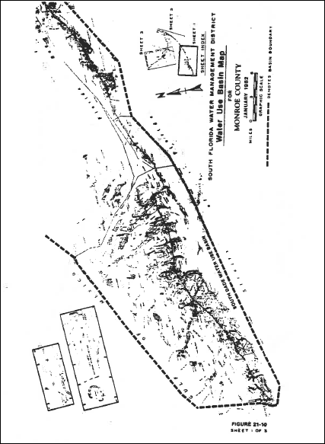
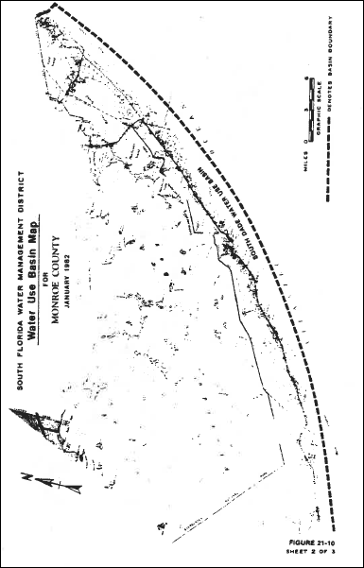
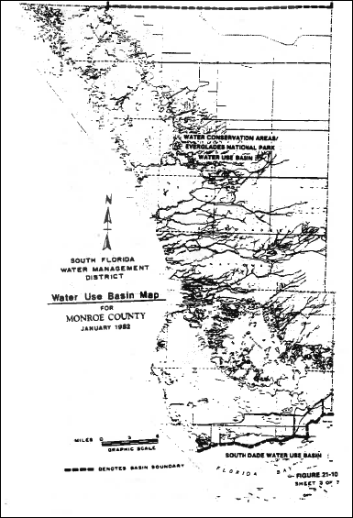
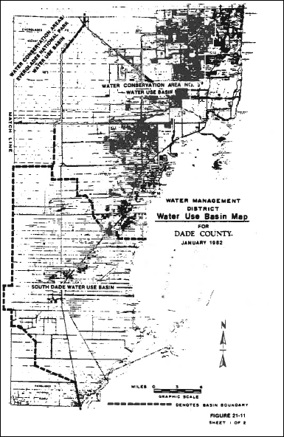
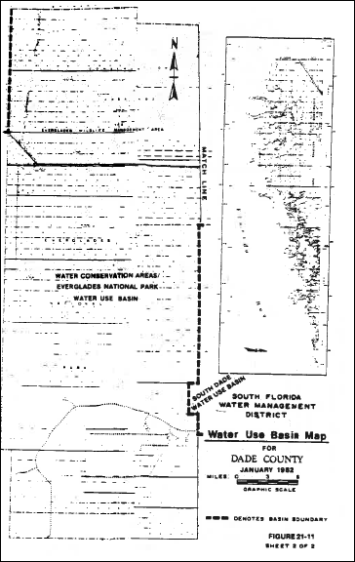
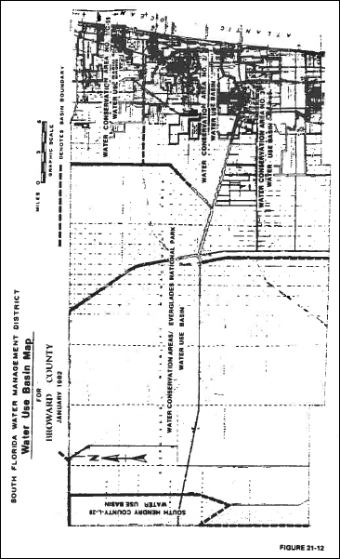
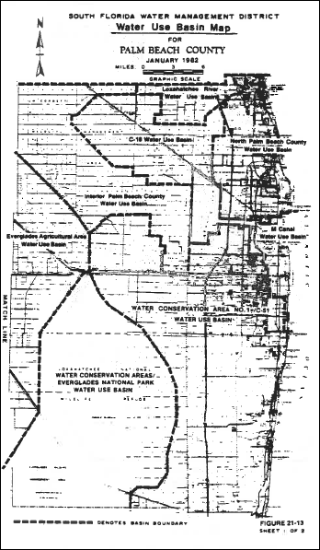
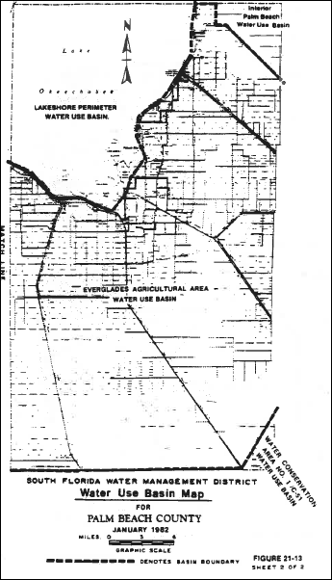
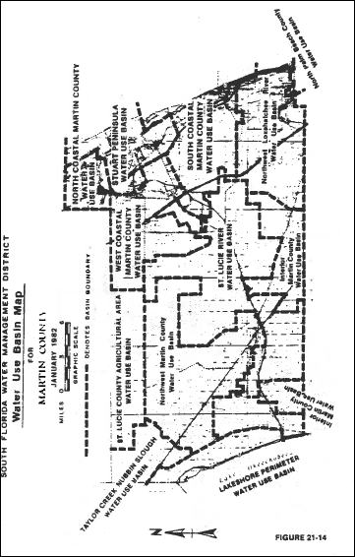
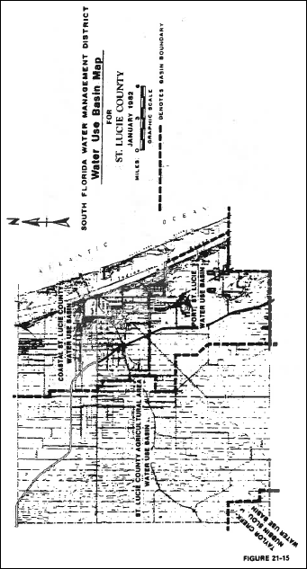
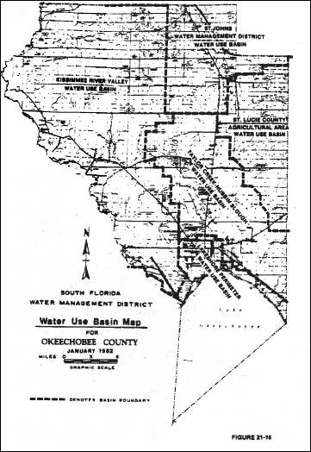
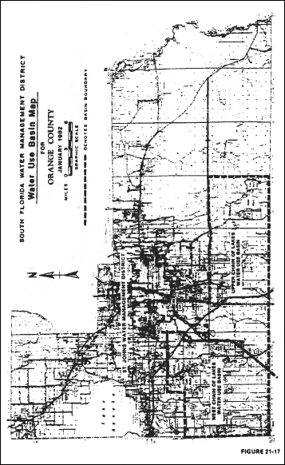
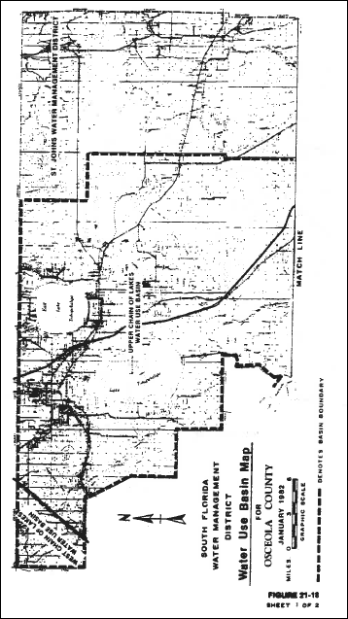
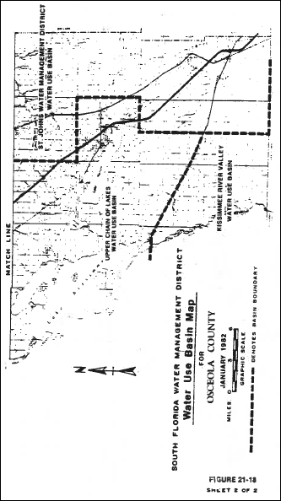
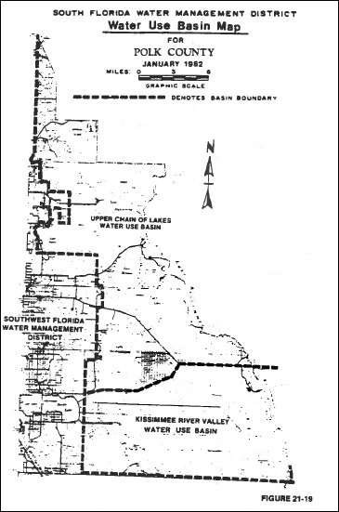
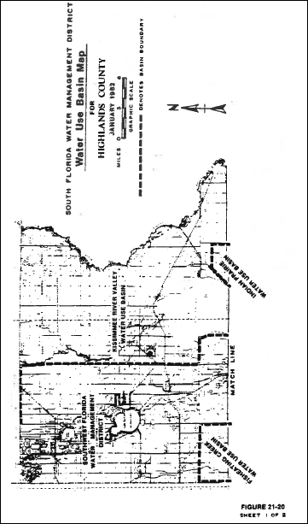
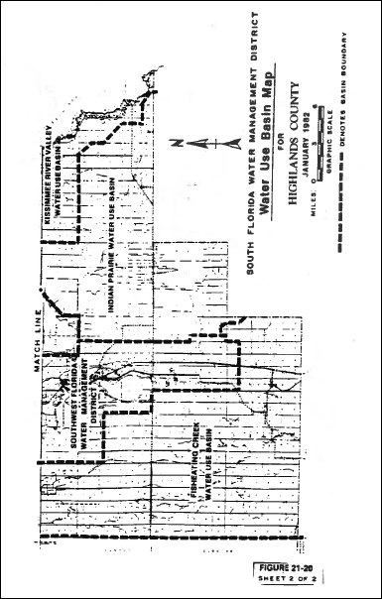
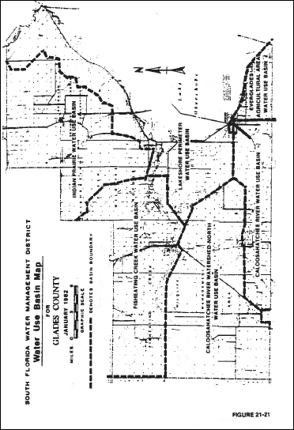
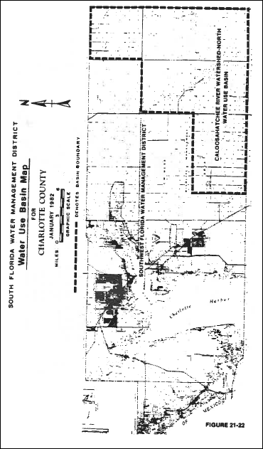
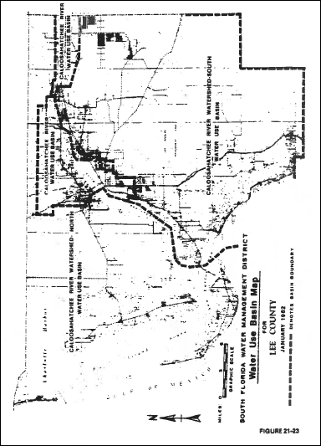
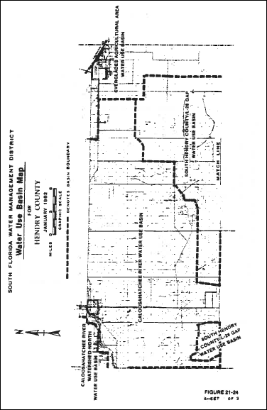
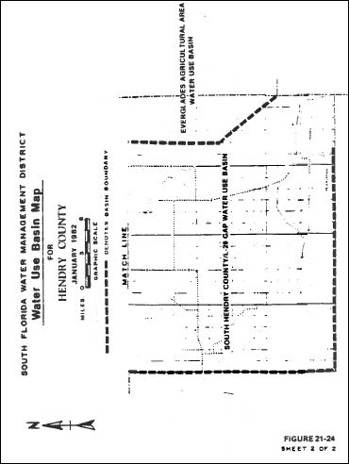
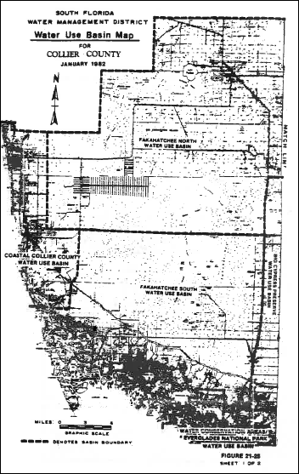
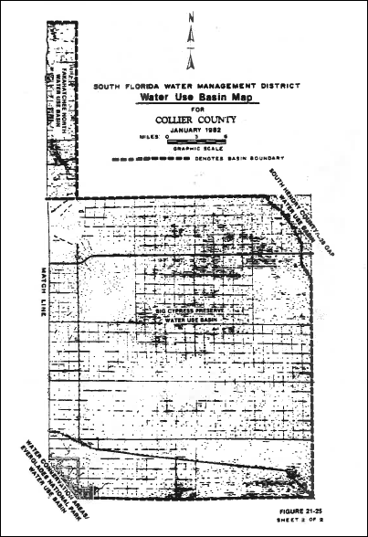
Rulemaking Authority 373.044, 373.113 FS. Law Implemented 373.175, 373.246 FS. History–New 5-31-82.

