40E-22.072 Minimum Levels.
The following minimum levels shall be maintained.
(1) Lake Istokpoga.
(a) The minimum levels for Lake Istokpoga are shown in Figure 22-2.
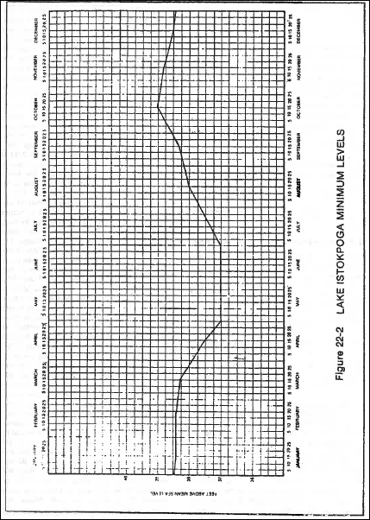

(b) The District may, after public notice, allow the minimum levels in Figure 22-2 to be temporarily lowered for environmental or water quality reasons.
(2) Primary Canals | (feet above mean sea level)
(a) Canal 39-A above Structure 75 | 22.5
(b) Canal 40 above Structure 72 | 17.7
(c) Canal 41 above Structure 71 | 17.0
(d) Canal 41 above Structure 70 | 22.5
(e) Canal 41-A above Structure 84 | 21.7
(f) Canal 41-A above Structures 82 and 83 | 29.0
(g) Borrow Canal of Interceptor Levee 59 | 17.7
(h) Borrow Canal of Interceptor Levee 60 | 17.7
(i) Borrow Canal of Interceptor Levee 61 | 17.0
Rulemaking Authority 373.044, 373.113 FS. Law Implemented 373.042, 373.086, 373.103(4) FS. History–New 9-3-81, Formerly 16K-30.03, 16K-30.05, 40E-22.072.

