Notice of Proposed Rule

WATER MANAGEMENT DISTRICTS
South Florida Water Management District
RULE NO.: RULE TITLE:
40E-63.091 Publications Incorporated by Reference
40E-63.104 EAA Basin Boundaries
40E-63.106 Works of the District within the Everglades
PURPOSE AND EFFECT: The purpose of this rulemaking is to update methods used to assess compliance with a requirement for best management practice (BMP) implementation to achieve a reduction in phosphorus load in discharges from the Everglades Agricultural Area (EAA). The update is necessary to account for completed projects that affect EAA Basin boundary data used in the calculations.
SUMMARY: These rules establish the methods used to calculate the phosphorous in discharges from the Everglades Agricultural Area (EAA) Basin, as required by the Everglades Forever Act (EFA), Section 373.4592, Florida Statutes. The EFA directs the District to assess compliance with a requirement for a 25% reduction in phosphorus load in discharges in comparison with the phosphorus levels measured during an established period prior to the BMP program being implemented. Since the rules were last amended the District has completed several construction projects, such as STA-3/4, the STA-2 expansion, the A-1 Flow Equalization Basin, and the Lake Okeechobee Diversion Project structures. These projects have resulted in new data, and basin boundary inflow and outflow points, that must be considered in these calculations. Amendments to Rules 40E-63.091, 40E-63.104, and 40E-63.106, F.A.C., will account for these projects and include hyperlinks to incorporated materials in accordance with Section 120.54(1)(i)3., F.S., and Rule 1-1.013, F.A.C.
SUMMARY OF STATEMENT OF ESTIMATED REGULATORY COSTS (SERC) AND LEGISLATIVE RATIFICATION:
The Agency has determined that this will not have an adverse impact on small business or likely increase, directly or indirectly, regulatory costs in excess of $200,000 in the aggregate within one year after the implementation of the rule. A SERC has not been prepared by the Agency.
This determination is based on the proposed amendments incorporating new data into existing statutorily mandated regulatory activities. The use of new data in the existing compliance calculations, including acreage and phosphorus loads from monitored inflow and outflow stations, are necessary because of the completion of associated construction projects. No additional regulatory costs are expected as a result of the amendments, because the permittee and District activities and requirements previously established in the rules are unchanged. The proposed changes relate to the presentation and use of data or information already required to be collected under other programs.
The Agency has determined that the proposed rule is not expected to require legislative ratification based on the statement of estimated regulatory costs or if no SERC is required, the information expressly relied upon and described herein: The District has completed the Governor’s Office of Fiscal Accountability and Regulatory Reform (OFARR) the “Is a SERC Required?” form, which is available upon request. Based on the completed “Is a SERC Required?” form, the proposed rule amendments are not expected to require legislative ratification pursuant to the subsection 120.541(3), F.S.
Any person who wishes to provide information regarding a statement of estimated regulatory costs, or provide a proposal for a lower cost regulatory alternative must do so in writing within 21 days of this notice.
RULEMAKING AUTHORITY: 373.044, 373.113, FS.
LAW IMPLEMENTED: 373.016, 373.085, 373.086, 373.451, 373.453, 373.4592, FS.
IF REQUESTED WITHIN 21 DAYS OF THE DATE OF THIS NOTICE, A HEARING WILL BE HELD AT THE DATE, TIME AND PLACE SHOWN BELOW (IF NOT REQUESTED, THIS HEARING WILL NOT BE HELD):
DATE AND TIME: March 8, 2018, beginning at 9:00 a.m. PLACE: South Florida Water Management District, B-1 Auditorium, 3301 Gun Club Road, West Palm Beach, FL 33406
Pursuant to the provisions of the Americans with Disabilities Act, any person requiring special accommodations to participate in this workshop/meeting is asked to advise the agency at least 5 days before the workshop/meeting by contacting: South Florida Water Management District Clerk's Office (800) 432-2045, ext. 6805, or (561)682-6805. If you are hearing or speech impaired, please contact the agency using the Florida Relay Service, 1(800)955-8771 (TDD) or 1(800)955-8770 (Voice).
THE PERSON TO BE CONTACTED REGARDING THE PROPOSED RULE IS: Carmela Bedregal, P.E., Section Lead, Bureau of Everglades Technical Support, Everglades Policy and Coordination Division, South Florida Water Management District, 3301 Gun Club Road, West Palm Beach, FL 33406, telephone: (561)682-2737, email: cbedrega@sfwmd.gov. For procedures regarding the rulemaking process, contact Jan Sluth, CP, FRP, Sr. Paralegal, South Florida Water Management District, 3301 Gun Club Road, West Palm Beach, FL 33406, telephone: (561)682-6299, email: jsluth@sfwmd.gov.
THE FULL TEXT OF THE PROPOSED RULE IS:

40E-63.091 Publications Incorporated by Reference.
(1) “Appendix A1 – Description: Regulated Portion of Everglades Agricultural Area S-5A, S-6, S-7 and S-8 Basins Palm Beach, Broward and Hendry Counties”, dated [to be determined] January 2001, [HYPERLINK].
(2) “Appendix A2 – No Change.
(3) “Appendix A3 – EAA Basin Compliance”, dated [to be determined] January 2001, [HYPERLINK], and setting forth the procedures the District will follow to determine whether the entire EAA Basin has met the applicable total Phosphorus reduction goals based upon mathematical data analysis.
(4) “Appendix A3.1 – FORTRAN Program for Calculating EAA Basin Flows and Phosphorus Loads”, dated [to be determined] January 2001, [HYPERLINK].
(5) “Appendix A3.2 – Flow Computation Methods Used to Calculate EAA Basin Flows”, dated [to be determined] January 2001, [HYPERLINK], providing applicable mathematical formulas for calculating flow rates through water management structures.
(6) “Appendix A4 – EAA Basin Farm Scale Allocation”, dated [to be determined] January 2001, [HYPERLINK], setting forth the procedure the District will follow to regulate total Phosphorus loads from individual farms when the EAA Basin has been determined to be not in compliance with applicable requirements.
(7) “Appendix A5” – No Change.
(8) “Appendix A6” – No Change.
(9) South Florida Water Management District Form 0779, dated January 2001, entitled “Application for a Works of the District Permit”.
(10) “South Florida Water Management District Guidance for Preparing an application for “A Works of the District” Permit in the Everglades Pursuant to Chapter 40E-63, F.A.C.” – No Change.
(11) The documents listed in subsections (1) through (10) are hereby incorporated by reference herein, are published by the District and are available at no cost by contacting the South Florida Water Management District Clerk, on the District’s website (sfwmd.gov) or from the District at 3301 Gun Club Road, West Palm Beach, FL 33406, (800) 432-2045, ext. 6805 or (561) 682-6805 686-8800, upon request.
Rulemaking Authority 373.044, 373.113 FS. Law Implemented 373.016, 373.451, 373.453, 373.4592 FS. History–New 7-3-01, Amended .

40E-63.104 EAA Basin Boundaries.
(1) The Everglades Protection Area is generally described as: Water Conservation Areas 1, 2A, 2B, 3A and 3B, the Arthur R. Marshall Loxahatchee National Wildlife Refuge, and the Everglades National Park. It is depicted on maps and legally described in “Appendix A1,” which is incorporated by reference in Rule 40E-63.091, F.A.C. of Chapter 40E-63, F.A.C., which is published by reference and incorporated into this chapter.
(2) The EAA is generally described as:
(a) the area including, but not limited to, the drainage basins of S-2, S-3, S-5A, S-6, S-7, S-8 and S-150. The EAA is depicted on maps and legally described in “Appendix A1,” which is incorporated by reference in Rule 40E-63.091, F.A.C.; and of Chapter 40E-63, F.A.C.
(b) The Everglades Construction Project diversion basins, consisting of the areas within the boundaries of the South Florida Conservancy District, South Shore Drainage District, East Shore Water Control District, East Beach Water Control District, and Closter Farms (also known as 715 Farms or the lessee of agricultural lease number 3420). These basins previously released stormwater to Lake Okeechobee, but stormwater was redirected as new releases to Works of the District within the Everglades under Rule 40E‐63.108, F.A.C., when the diversion projects were completed. The Everglades Construction Project Diversion Basins are depicted on maps and described in “Appendix A1,” which is incorporated by reference in Rule 40E-63.091, F.A.C.
(3) The areas described in subparagraphs (2) (a) and (b) are regulated under Part I of this Chapter and are included in calculating phosphorus load reductions as set forth in “Appendix A3” and “Appendix A4,” which are incorporated by reference in Rule 40E-63.091, F.A.C.
Rulemaking Authority 373.044, 373.113 FS. Law Implemented 373.016, 373.085, 373.086, 373.451, 373.453, 373.4592 FS. History–New 1-22-92, Amended 7-3-01, .

40E-63.106 Works of the District within the Everglades.
The following Works of The District within the Everglades Agricultural Area Basin include are or have been used for calculating compliance with the phosphorus load reduction objectives of the Everglades program: S-2, S-3, S-5A, S-6, S-7, S-8, S-150, G-88, G-136, G-200, G-344A, G-344B, G-344C, G-344D, G-349B, G-350B, G-357, G-404, G-410, G-402-A, G-402-B, G-402-C, G-402-D, G-605, G-606, Miami Canal, North New River Canal, Hillsboro Canal, C-51 (at both current and ultimate discharge locations into the Everglades Protection Area), and their open channel connections. The Works of the District and other structures which are or have been used for calculating compliance with the phosphorus load reduction objectives of the Everglades program are set forth in “Appendix A3,” which is incorporated by reference in Rule 40E-63.091, F.A.C.
Rulemaking Authority 373.044, 373.113 FS. Law Implemented 373.016, 373.085, 373.086, 373.451, 373.453, 373.4592 FS. History–New 1-22-92, Amended 7-3-01, .
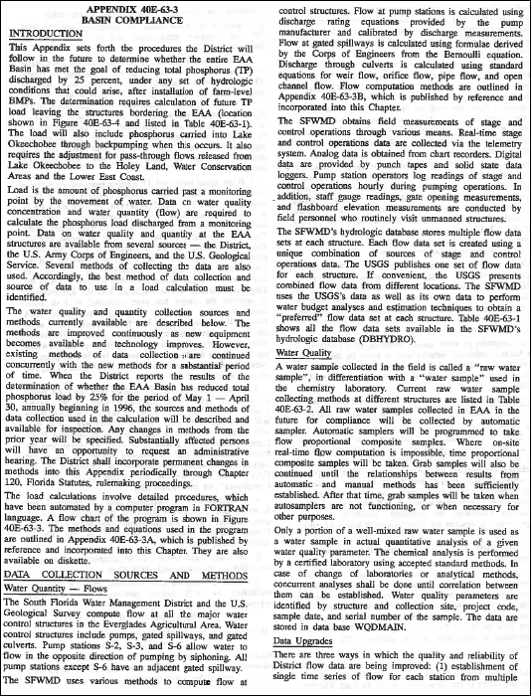
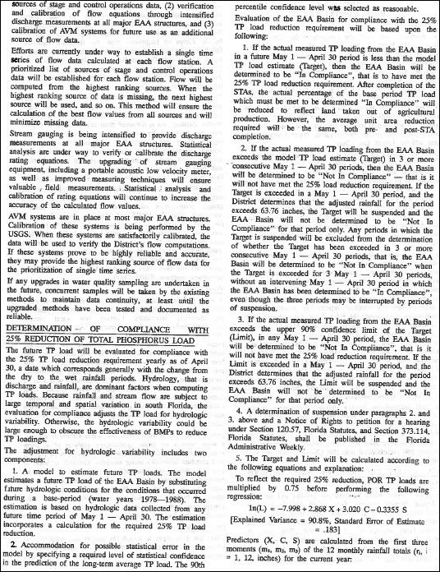
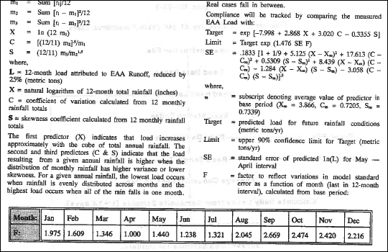

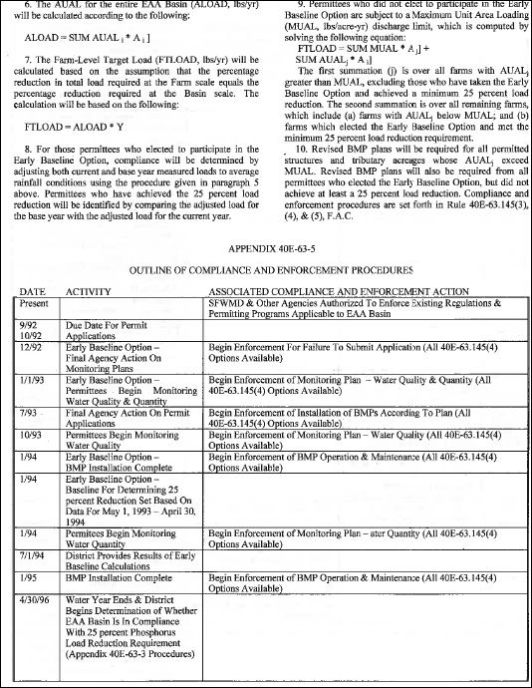

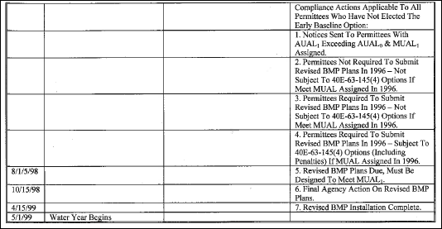

Amendments to Appendices A1, A3, A3.1, A3.2 and A.4 are available online at https://www.sfwmd.gov/sites/default/files/documents/draft_40E_63_draft_rev_appendices_20171214.pdf, or may be requested by contacting Carmela Bedregal or Jan Sluth at the phone numbers provided in this notice.
NAME OF PERSON ORIGINATING PROPOSED RULE: Eva Velez, Division Director, Everglades Policy and Coordination Division
NAME OF AGENCY HEAD WHO APPROVED THE PROPOSED RULE: South Florida Water Management District Governing Board
DATE PROPOSED RULE APPROVED BY AGENCY HEAD: December 14, 2017
DATE NOTICE OF PROPOSED RULE DEVELOPMENT PUBLISHED IN FAR: July 28, 2017

