JOE NEGRON RICHARD CORCORAN
President Speaker
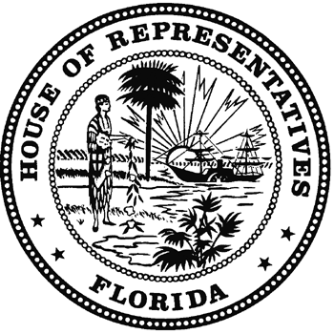
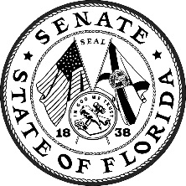
THE FLORIDA LEGISLATURE
JOINT ADMINISTRATIVE
PROCEDURES COMMITTEE

Senator Kevin Rader, Chair KENNETH J. PLANTE
Representative George R. Moraitis, Jr., Vice Chair COORDINATOR
Senator Daphne Campbell Room 680, Pepper Building
Senator George B. Gainer 111 W. Madison Street
Senator Rene Garcia Tallahassee, Florida 32399-1400
Senator Keith Perry Telephone (850) 488-9110
Representative Jason Fischer Fax (850) 922-6934
Representative Michael Grant www.japc.state.fl.us
Representative Sam H. Killebrew joint.admin.procedures@leg.state.fl.us
Representative Amy Mercado
Representative Barrington A. “Barry” Russell

COMMITTEE MEETING AGENDA

February 5, 2018

301 Senate Office Building

2:30 p.m. – 4:00 p.m.

CALL TO ORDER AND ROLL CALL

CHAIR’S REMARKS

NEW OBJECTIONS:

TAB 1 Department of Health
Existing Rule 64-4.011, F.A.C.

TAB 2 Department of Health
Emergency Rule 64ER17-1 (64-4.001), Definitions.

TAB 3 Department of Health
Emergency Rule 64ER17-2 (64-4.002), Application Requirements for Medical Marijuana Treatment Centers.

TAB 4 Department of Health
Emergency Rule 64ER17-6, Disciplinary Guidelines and Fines.

TAB 5 Presentation by the Department of Health, Office of Medical Marijuana Use, on the status of the implementation of section 381.896, Florida Statutes.

REPORTS AND APPEARANCES

