40C-41.023 Basin Boundaries.
(1) The Upper St. Johns River Hydrologic Basin is that area generally depicted in Figure 41-1 and defined in “Environmental Resource Permit Applicant’s Handbook Volume II: For Use Within the Geographic Limits of the St. Johns River Water Management District,” (June 1, 2018), Appendix B which is hereby incorporated by reference available at [https://www.flrules.org/Gateway/reference.asp?No=Ref-06353] and upon request from the St. Johns River Water Management District, 4049 Reid Street, Palatka, FL 32177-2529.
(2) The Oklawaha River Hydrologic Basin is that area generally depicted in Figure 41-1 and defined in “Environmental Resource Permit Applicant’s Handbook Volume II: For Use Within the Geographic Limits of the St. Johns River Water Management District,” Appendix B.
(3) The Wekiva River Hydrologic Basin is that area generally depicted in Figures 41-1 and 41-6 and defined in “Environmental Resource Permit Applicant’s Handbook Volume II: For Use Within the Geographic Limits of the St. Johns River Water Management District,” Appendix B.
(4) The Wekiva Recharge Protection Basin is that area generally depicted in Figure 41-6 and defined in “Environmental Resource Permit Applicant’s Handbook Volume II: For Use Within the Geographic Limits of the St. Johns River Water Management District,” Appendix B.
(5) The Econlockhatchee River Hydrologic Basin is that area generally depicted in Figure 41-1 and defined in “Environmental Resource Permit Applicant’s Handbook Volume II: For Use Within the Geographic Limits of the St. Johns River Water Management District,” Appendix B.
(6) The Tomoka River and Spruce Creek Hydrologic Basins are the areas generally depicted in Figure 41-1 and defined in “Environmental Resource Permit Applicant’s Handbook Volume II: For Use Within the Geographic Limits of the St. Johns River Water Management District,” Appendix B.
(7) The Sensitive Karst Areas Basin is that area generally depicted in Figures 41-2, 41-3, and 41-4 and defined in “Environmental Resource Permit Applicant’s Handbook Volume II: For Use Within the Geographic Limits of the St. Johns River Water Management District,” Appendix B.
(8) The Lake Apopka Hydrologic Basin is that area generally depicted in Figure 41-5 and defined in “Environmental Resource Permit Applicant’s Handbook Volume II: For Use Within the Geographic Limits of the St. Johns River Water Management District,” Appendix B.

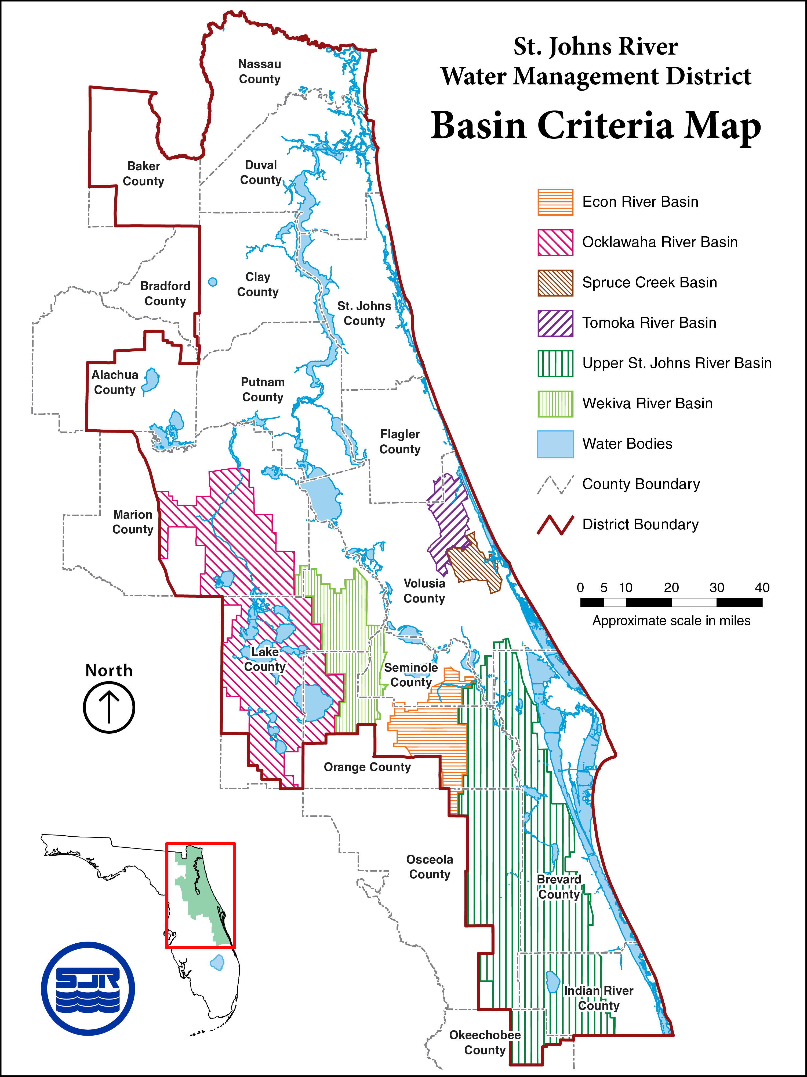
Figure 41-1 Basin Criteria Map

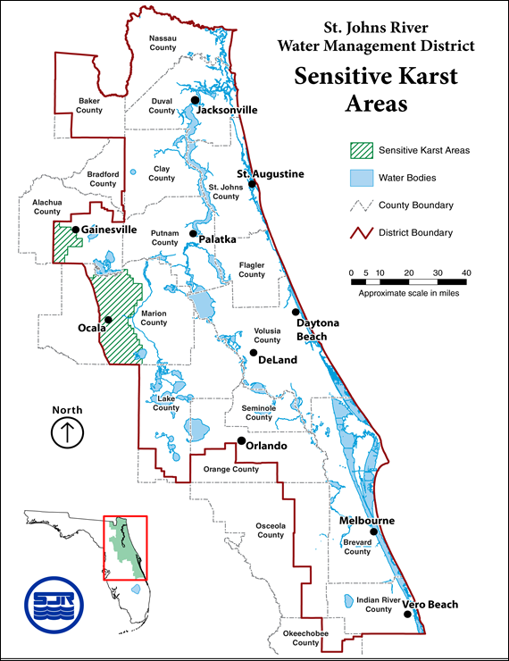

Figure 41-2 Sensitive Karst Areas in the St. Johns River Water Management District

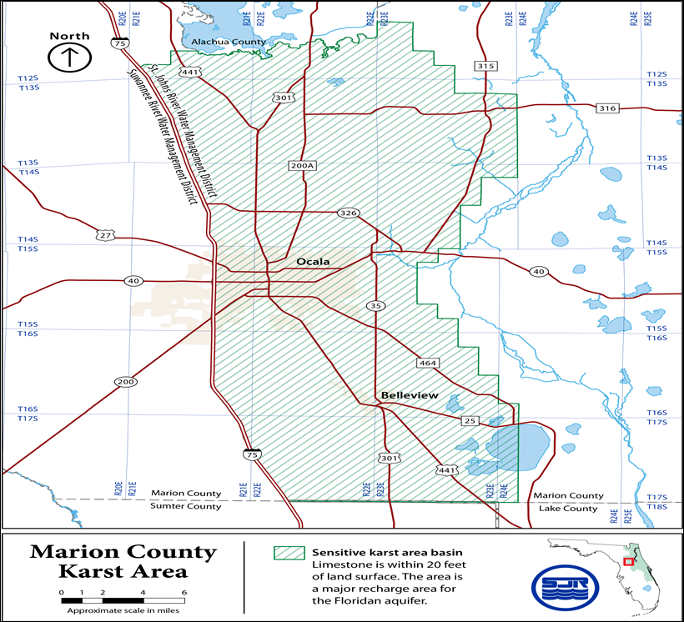

Figure 41-3 Alachua County Karst Area

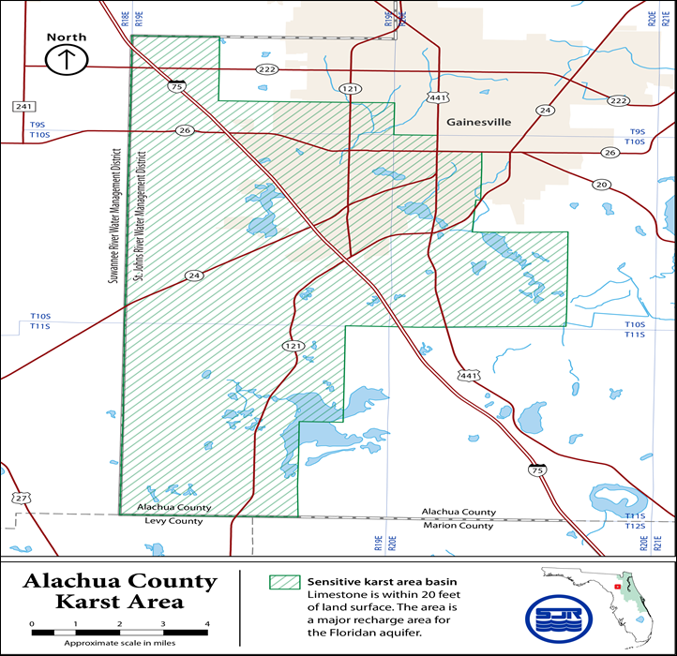

Figure 41-4 Marion County Karst Area
Rulemaking Authority 369.318, 373.044, 373.113, 373.4131, 373.414, 373.415, 373.418 FS. Law Implemented 369.318, 373.413, 373.4131, 373.414, 373.415, 373.416, 373.418, 373.426, 373.461 FS. History–New 12-7-83, Amended 5-17-87, 4-3-91, 9-25-91, 11-25-98, 3-7-03, 12-3-06, 10-1-13, 6-1-18.

