62B-34.050 General Conditions.
(1) The terms, conditions, requirements, limitations, and restrictions set forth in this section are general conditions and are binding upon the permittee for all General Permits in this rule chapter. These conditions are enforceable under chapter 161, F.S.
(2) Prior to commencing construction activities under this rule chapter, which are authorized by this Department, a formal notification from the Department must be received authorizing the proposed activity. The notice form, DEP Form 73-102 (Updated 7/05), entitled “General Permit Notice to Proceed” is hereby incorporated by reference.
(3) A copy of the Notice to Proceed and the approved plans shall be conspicuously displayed at the project site for the duration of the activity.
(4) A pre-construction conference shall be held at the site between the contractor, the owner or authorized agent, and a staff representative of the Department prior to the initiation of any work permitted under this rule chapter. The purpose of this conference is to establish the manner in which the proposed work will be performed to ensure adequate protection of the beach and dune system and native vegetation. The optimum siting of the construction fence and any walkover shall be determined during the pre-construction conference by the staff representative in order to provide maximum protection to the existing vegetation located on the site. The locations of the proposed structures shall be staked out for the pre-construction conference.
(5) A foundation location certification shall be completed by the applicant, signed by a surveyor licensed in the state of Florida, and submitted to the Department immediately following installation of the foundation piles for the most seaward major structure authorized by this General Permit. This certification shall be submitted using DEP Form 73-114B (Updated 9/05) entitled “Foundation Location Certification,” which is hereby incorporated by reference. The Department shall perform such verification within seven (7) working days of receipt of the certification. If the Department does not respond to the certification within seven (7) working days then construction may proceed. No further work may proceed until the Department has verified the foundation location information and authorized additional work to proceed.
(6) The permittee shall carry out the construction or activity for which the permit was granted in accordance with the plans and specifications that were approved by the Department as part of the permit. No other construction or activities shall be conducted. No modifications to project size, location, or structural design are authorized.
(7) Permits shall be suspended or revoked for good cause, in accordance with section 161.053(19), F.S. In addition, a permit shall be suspended, revoked or modified by the Department if shoreline changes occurring subsequent to issuance of the permit render the previously authorized activities inconsistent with chapter 161, F.S., or chapter 62B-34, F.A.C.
(8) The assessment of civil fines or issuance of an order to alter or remove any work, or both, may result from work performed that was not authorized in the permit, pursuant to section 161.054, F.S., and chapter 62B-54, F.A.C.
(9) The permittee shall conduct the construction or activity authorized under the permit using extreme care to prevent any adverse impacts to the beach and dune system, marine turtles and their nests and nesting habitat, and adjacent properties and structures.
(10) The permittee shall allow any duly authorized member of the staff to enter upon the premises associated with the project authorized by the permit for the purpose of ascertaining compliance with the terms of the permit and with the rules of the Department.
(11) The state of Florida, the Department, or its officers and employees shall in no way be liable for any damage, no matter how occasioned and no matter what the amount, to persons or property which might result from the construction or activity authorized under the permit and from any and all claims and judgments resulting from such damage.
(12) The permittee shall not disturb existing beach and dune topography and vegetation except as expressly authorized in Part II of this rule chapter. Before the project is considered complete, any disturbed topography or vegetation shall be restored as prescribed in the permit with suitable fill material or revegetated with appropriate beach and dune vegetation.
(13) No construction, operation, transportation, or storage of equipment or materials is authorized seaward of the dune crest or rigid coastal structure within marine turtle nesting habitat during marine turtle nesting season (May 1 through October 31 of each year for all counties except for Brevard, Indian River, St. Lucie, Martin, Palm Beach and Broward. Nesting season for these counties is the period from March 1 through October 31 of each year).
(14) All fill material placed seaward of the Coastal Construction Control Line shall meet the requirements of subsection 62B-33.005(7), F.A.C., and shall consist of sand that is similar to that already existing on the site in both coloration and grain size. All such fill material shall be free of construction debris, rocks, clay, or other foreign matter, and shall be obtained from a source landward of the Coastal Construction Control Line.
(15) To ensure compliance with this rule, all topographic restoration and revegetation work is subject to the approval and acceptance by the Department staff.
(16) No temporary lighting of the construction area is authorized during the marine turtle-nesting season (May 1 through October 31 of each year for all counties except for Brevard, Indian River, St. Lucie, Martin, Palm Beach and Broward. Nesting season for these counties is the period from March 1 through October 31 of each year.).
(17) This permit is issued to a specified property owner and is not valid for any other person.
(18) This General Permit does not eliminate the necessity to obtain any required federal, state, local, and special district authorizations prior to the start of activity authorized by Part II of this rule chapter.
(19) Elevated walkovers that provide access to the beach shall meet the following design criteria:
(a) The decking of the walkover structure shall be elevated a sufficient distance above the existing vegetation to allow for sand build-up and clearance above the vegetation and not exceed 4 feet in width.
(b) The piles for the walkover structure shall not be greater that 4-inch by 4-inch posts and shall not be encased in concrete.
(c) The walkover shall extend at least up to the existing line of vegetation but not farther than 10 feet seaward of the vegetation.
(d) Where armoring exists and no vegetation line exists seaward of the armoring, the walkover shall extend a maximum of 5 feet seaward of the armoring.
(e) The optimum siting of the walkover structure shall be determined by the staff representative during the pre-construction conference to provide maximum protection to the existing dune topography and vegetation located on the site and to avoid interference with public beach access and nesting sea turtles.
(20) Sand fencing used in dune restoration projects shall be located no farther seaward than the toe of the restored dune and shall consist of either wooden slats wired together with space between the slats or woven fabric fencing. The fencing must contain a 40 percent to 60 percent open space to closed space ratio. Sand fencing shall be

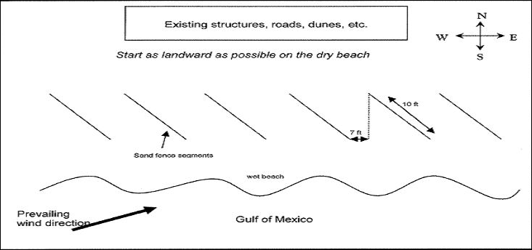

a minimum of two feet to a maximum of four feet high. Sand fencing located seaward of the crest of the primary dune shall not be placed in a shore-parallel configuration and shall be designed and installed as follows: a maximum of 10-foot long spurs of sand fencing spaced at a minimum of seven feet on a diagonal alignment (facing the predominate wind direction) for the shore-parallel coverage of the subject property as shown in the diagram below. Fallen or derelict sand fencing shall be removed from the beach when replacing with new fencing.
(21) Final certification, by a a registered professional, shall be provided to the Department within 30 days following completion of the work on major structures or projects requiring a Sediment QA/QC Plan. Final certification, by an engineer licensed in the State of Florida, shall be provided to the Department within 30 days of completion of the work on armoring. This certification shall state that all locations and elevations specified by the permit have been verified, all major structures, including exterior lighting, are specifically constructed in accordance with chapter 62B-34, F.A.C., other construction and activities authorized by the permit have been performed in compliance with the plans and project description approved as a part of the permit, and all conditions of the permit, or shall describe any deviations from the approved plans, project description or permit conditions, and any work not performed. Such certification shall not relieve the permittee of the provision contained in subsection 62B-34.050(6), F.A.C. The final certification shall be submitted using DEP Form 73-115B (Updated 7/05), entitled “Final Certification,” which is hereby incorporated by reference.
Rulemaking Authority 161.053(18), (20), 161.054 FS. Law Implemented 161.052, 161.053(4), (18), (21) FS. History–New 3-27-03, Amended 11-21-05, 11-28-18.

