BILL GALVANO JOSE R. OLIVA
President Speaker
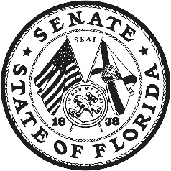
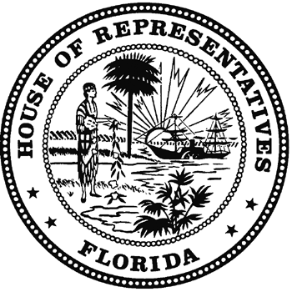
THE FLORIDA LEGISLATURE
JOINT ADMINISTRATIVE
PROCEDURES COMMITTEE

Representative Erin Grall, Chair KENNETH J. PLANTE
Senator Linda Stewart, Vice Chair COORDINATOR
Senator Janet Cruz Room 680, Pepper Building
Senator Ed Hooper 111 W. Madison Street
Senator Keith Perry Tallahassee, Florida 32399-1400
Senator Tom A. Wright Telephone (850) 488-9110
Representative Vance Arthur Aloupis, Jr. Fax (850) 922-6934
Representative James “J.W.” Grant www.japc.state.fl.us
Representative Brett Thomas Hage joint.admin.procedures@leg.state.fl.us
Representative Cindy Polo
Representative Holly Raschein
Representative Clovis Watson, Jr.

COMMITTEE MEETING AGENDA

February 7, 2019

404 House Office Building

1:30 p.m. – 3:30 p.m.

CALL TO ORDER AND ROLL CALL

INTRODUCTORY COMMENTS BY THE CHAIR

TAB 1 Workshop on Chapter 120, Florida Statutes

Presentations by Committee Staff

Presentations by stakeholders/interested parties

REPORTS AND APPEARANCES

